Knowledge-based environments in the city: Design and urban form in the Helsinki Metropolitan Area

PhD Heli Ponto
Department of Geosciences and Geography
PO Box 64, 00014-University of Helsinki
heli.ponto@helsinki.fi
Tel: +358 50 314 9248

Professor Tommi Inkinen*
Centre for Maritime Studies, Brahea-Centre
20014-University of Turku
tommi.inkinen@utu.fi
Tel: +358 400 882 818
* Corresponding author

Knowledge-based development is of interest to cities, as it promotes economic growth and boosts dynamic urban image. Creative environments are arguably highly dependent on sociality, and they are usually located near city centres. The focus of this study is on three knowledge-based locations in the Helsinki Metropolitan Area (HMA) in Finland. The research material composes of field observation data and photographs. Results indicate that knowledge-intensive environments include several elements of good city design, for example, pedestrian-friendly street networks and green areas, but they tended to lack vibrant urban life, that is, human activity. The findings support the claim that ICT-based companies are not very dependent on the sociality of environment. As cities are spaces for individuals working, studying and visiting, attention must be paid to the urban design of these areas.

Keywords: Knowledge-based urban development, Urban design, Planning, Qualitative research, Visual methods

- Introduction

Urban life is practiced by people who live, dwell and experience different places in a city. The design and functionality of urban environments matter to all (workers, residents and visitors) who use them daily. The target of this paper is two-fold. It studies 1) how knowledge-based environments are composed in terms of their planning and functionality, and 2) how good city design qualities exist, and are identifiable. The study refers to earlier research, drawing on urban design, urban development, and human geography.

In recent decades, the development of cities has become more reliant on intangible forms of capital. Despite the increased possibilities of using information and communication technologies (ICTs), face-to-face contact remains a crucial factor of the economy (see Storper & Venables 2004). Knowledge-environments, as geographical places, have particular locations within city spaces, where these face-to-face contacts transpire. These locations are also often determined in the formal processes of city planning. In this context, knowledge is considered a strategic source of wealth and growth creation in business scenarios (Schiuma & Lerro 2008; Inkinen & Ponto 2018). This phenomenon has been described as knowledge-based development (KBD) (Yigitcanlar & Lönnqvist 2013) or as a knowledge economy paradigm (Powell & Snellman 2004), to explain how intangible forms of knowledge boost economic growth and accelerate the innovative capacity of cities. Researchers and planners have used the term ‘knowledge-based urban development’ (KBUD) (see e.g. Yigitcanlar et al. 2010; Yigitcanlar et al. 2014) to describe ‘the transformation of knowledge resources into local development’ (Knight 1995: 225-226).

In the context of urban studies and urban planning, modern cities are considered pluralised and networked, and polycentric. Polycentrism, which is ‘basically denoting the existence of multiple centres in one area’ (Kloosterman & Musterd 2001: 623), is linked to economic development. It is defined as ‘one of the defining characteristics of the urban landscape in advanced economies’ (Kloosterman & Musterd 2001: 623). This also means that companies tend to concentrate or cluster in certain locations. Urban planning is one reason for this, but co-location has also a competitive advantage: clusters tend to attract more similar companies, and thus, they experience increased benefits of scope (see Inkinen 2015; Inkinen & Kaakinen 2016). In the case of a polycentric city, companies defined as creative (e.g. arts, music) tend to cluster near the city centre, while science-based companies are more commonly located on the periphery. One reason for this is that creative companies tend to be more reliant on social networks than science-based companies (Spencer 2015).

Urban planning is nowadays characterised by pluralistic values and approaches. The general consensus, however, is that the quality of an urban environment should be human centred, regarding the perspective and experience of the users of space. While ‘quality’ has different meanings, a central element of a quality city (Ewing & Handy 2009; Gehl 2010; Kuoppa 2013) is often specified as walkability and accessibility. Walking has been studied from the perspective of well-being, to decrease congestion and pollution but also as a practice and experience (Middleton 2011; 2016). These notions of walkability are linked to discussions on mobility. For instance, the safety of mobility (Gehl 2010; Southworth 2005), along with the connectivity of the path network and linkages with the public transportation, are seen as definers of quality. In addition, the identification of the quality of pedestrian environments as a central factor has encouraged individuals to choose to walk instead of to drive. Along with mobility, some researchers have called for more socially vibrant spaces (Gehl 2010) and mixed land use patterns (Ewing & Handy 2009), also prescribed as definers of quality (also Gehl et al. 2006). This is a reason for studying walkability and urban vividness as recognisable parts of knowledge-based environments.

The wider societal topics of sustainability and social inclusion are involved in the desire for more social and walkable urban spaces in urban planning. Simultaneously, these spaces are also challenges for economic development, as there is a need for intangible and knowledge-intensive growth. While the aim of developing sustainable ‘soft values’, such as walkability, is important for urban planning (along with other aims), it not necessarily the most salient target of development for companies. This paper is motivated by the opinion that knowledge-based environments are rarely studied as environments of local urban space. While creative companies call for environments with social local buzz (Inkinen & Kuru 2004; Bathelt et al. 2004; Spencer 2015; Costa & Lopes 2015), which can be read as ‘places for people’ (Gehl 2010), it has been argued that companies applying science, for example, ICT, Biotechnology, and Medicine, are not highly dependent on sociality (Spencer 2015). The latter-mentioned knowledge-based environments are highly significant in Finland and in our study that focuses on their urban design and functionality.

The research questions set for this paper are:

- How are knowledge-based environments composed as physical spaces?
- How are urban design qualities recognisable in knowledge-based environments and what interpretations may be deduced from these qualities?

This study is an observational study on three knowledge-based environments in the Helsinki Metropolitan Area (HMA), Finland. HMA is an internationally recognised knowledge-based city including high-levels of technology and design clusters (Inkinen & Kaakinen 2016). HMA has been identified as an example of the best practice in its field (Yigitcanlar et al. 2015). We focus on elements of the physical environment and, on three forms of urban design: facades, walkability and visual elements.

- Knowledge-based environments, urban planning and cities as people’s places

Knowledge-based urban development is identified as a key to success for cities that compete within global economy (Yigitcanlar et al. 2010). While aiming to develop environmentally-friendly cities and cities that are inclusive and support social equality with scarce resources, KBUD is considered an outstanding example of constructing sustainable and economically active cities (also European Commission 2015). Yigitcanlar et al. (2008) recognise three broad aims of KBUD, including targets to support the economy (competitiveness), society (quality of life) and environment (sustainability).

Firstly, KBUD is an economic development strategy, which formulates knowledge related to the innovation of products and services. Secondly, KBUD aims to increase the quality of life by providing services for societal development (Yigitcanlar et al. 2010). Thirdly, KBUD aims at environmentally sustainable urban development and growth. It is claimed that:

‘KBUD is the possibility of a particularly resilient form of urban development secured in a network of connections anchored at local, regional, national and global coordinates. On the other hand, quality of life and place, defined not only by the level of public service (e.g. health and education) but also by the conservation and development of the cultural, aesthetic and ecological values, give cities their character and power to attract the creative class of knowledge workers.’ (Yigitcanlar et al. 2010: 231).

Despite the massive opportunities and potentials related to digitalisation, the importance and significance of the physical environment to knowledge economies have not disappeared (for example Porter 2000). Proximity is argued to increase the innovative capacity of companies, by entrepreneurs sharing their ideas, products and services with other companies working in the same field (Evers et al. 2010: 679). Creative industries (such as video industries, sound recording, radio and television broadcasting, performing and independent arts) tend to locate in city centres and on the periphery of urban cores (Costa & Lopes 2015). Science-based companies (for example ICT, pharmaceuticals, scientific research), however, more often locate in the suburbs or in more remote locations (Currid & Connolly 2008). This is much because creative industries are more reliant on social networks, urban tolerance and vividness (Florida 2005) than science-oriented clusters (Spencer 2015). Creative clusters are often more accessible by public transportation, and science-based clusters by private cars. Creative clusters often have a high density, and science-based clusters are usually more sparse and synthetic. The companies in creative clusters usually have wider social networks than their counterparts in science clusters. Employees working in the ICT business tend to spend time on commuting (van Oort et al. 2003).

Currid and Connolly (2008) have distinguished three agglomeration patterns of advanced service clusters a) central-city-led cities, where the leading cluster is located in the central city; b) region-led cities, where clusters are spread outside the city; and c) specialist cities, where companies are concentrated in certain areas. Whether the central city has the leading role (city-led places) or not (region-led places), commonly, these areas are poly-nucleated.

While the goal of urban planning is not exclusively to attract knowledge workers (Yigitcanlar et al. 2010: 231), the aims of urban planning and the KBUD concept have a number of similarities. One of these is the desire to support sustainable urban development, which, in the context of urban planning, can be translated as a walkable environment. In 1961, Jane Jacobs criticised the limitedness of social life in public space, resulting from the dominance of cars and modernistic urban planning. Jacobs (1961) wanted cities to be to be more socially diverse urban spaces, which would encourage walking and social interaction among citizens, rather than driving. Urbanists in the 1980s, as a part of a movement named New Urbanism, began proposing walkable, pluralistic and vivid urban spaces. They were inspired by pre-modern European and early American experiences (Hirt 2009). Their ideals, nevertheless, often resulted in nostalgic images and pseudo-pluralism (Gehl 2010: 200). Although the targets of these New Urbanism approaches have been criticised as ‘short-sighted’ (Till 2001; Zukin 2010), they represented a change in urban planning to involve the perspectives of the users of space in the planning process. This form of ‘humanism’ in urban planning is also recognisable in present-day urban planning, which aims at including the perspective of citizens in planning through participatory planning.

Sustainability is essential for KBUD. For instance, knowledge-based environments ideally are human- and nature-oriented, accessible and connective, diverse and user-friendly environments (see Yigitcanlar et al. 2010: 6). Drivers of sustainable urban development and knowledge-based cities are: quality of life (including services, environmental quality, crime level, transportation and cultural institutions); urban diversity (cosmopolitan atmosphere and the tolerance of difference); and social equity. Quality of life, in particular, involves the ability to attract knowledge workers (see Esmaeilpoorarabi et al. 2016). One goal of urban planners is to construct lively cities for citizens. KBUD aims to create an environment that allows citizens to exchange their ideas; provides opportunities to turn their ideas into products, services and innovative solutions to urban problems; and to support knowledge-based economic growth.

The role of public space is central to the aim of building citizen-friendly cities and human- sized architecture. Public space is not only considered as an arena for walking, but also as a realm for living and dwelling. Street-level space is an

‘exchange zone between building and city, here is where life inside and outside can meet and here is where pedestrians pass close by and have time to enjoy experiences large and small on their way.’ (Gehl 2010: 240).

Street-level spaces can be considered as realms strengthening life in the city, and increasing the attractiveness and functionality of the city. Recently, ground-floor design has suffered from the layout of large units, closed facades, blind windows and the lack of detail. These have arguably removed life from the streets, and taken the street-level away from casual pedestrians, and increased their feelings of insecurity and fear. Few studies focus on the facades of companies and other organizations that affect the physical environment encountered by users of space, and that influence the atmosphere of knowledge-based environments.

The perspective of citizens is among one of the most important dimensions in KBUD, as these environments are designed mainly for human activity (there are also exceptions such as intelligent warehouses, automated computer centres). The opposing opinions of some researchers studying KBUD is interesting. They claim that urban planning and design has tended to focus on physical form and the built environment (for example land use, zoning, infrastructure, aesthetics etc.), rather than on knowledge resources comprising the knowledge-base (Knight 2008). In addition, the discipline has traditionally lacked the vision and capacity to carry out sustainable- and knowledge-based development (Yigitcanlar et al. 2010). Whether urban space is designed from the perspective of people or is knowledge-based is disputable among researchers, however, identifiable contradictions and variations are generally conceded.

- Context: The knowledge-based urban development in the HMA

HMA is an area of 12 municipalities, including and surrounding the capital city of Helsinki. The three cities of Helsinki, Espoo and Vantaa constitute the heart of the HMA. The research areas of this study are located in Helsinki (Pitäjänmäki and Ruoholahti) and Espoo (Keilaniemi). Smaller municipalities of the HMA function as a regional context (for further research about the regional context, see Inkinen & Vaattovaara 2007; 2010; Merisalo et al. 2013; Makkonen & Inkinen 2014; Yigitcanlar et al. 2015; Kiuru & Inkinen 2017).

The HMA is often considered as a buffer periphery, due to its logistically important location between Stockholm, Sweden and Saint Petersburg, Russia. The HMA is the international hub of Finland, and therefore its cluster development has traditionally been a target of national policies. In particular, the HMA has been the centre of (inter)national ICT businesses, another reason why our study focuses on these areas. The growth of the ICT business dates back to a decision to privatise and open Finnish telephone industries to the international market. Along with a political decision to invest in higher education, this is generally considered to be the beginning of the internationalisation of the ICT business in Finland. In recent years, one of the most recognisable accelerators of business was the development of Nokia, and its subsequent success, which increased the local demand of components, networks, programs, services and contents (Vaattovaara 2009).

Commonly acknowledged social characteristics in the HMA region, include highly educated people, and the combination of a knowledge society with the goals of a Nordic welfare state (Yigitcanlar & Lönnqvist 2013). These goals involve social benefits and public services, but also egalitarian income rates (in international standards), achieved through progressive taxation. Housing has traditionally been mixed in the area, due to the goal of developing heterogeneous and balanced neighbourhoods, consequently preventing social segregation (Vaattovaara & Kortteinen 2003). While segregation of housing (Vilkama 2011) and education (Bernelius 2013) in the HMA has increased, the level of segregation is still moderate on an international scale. The weaknesses of the HMA are related to the relatively low urban density (Yigitcanlar & Lönnqvist 2013), the low appeal of the area to highly educated and talented international migrants (Eskelä 2013), and the aging population.

The HMA is also criticised for being car-centred. This relates to the geographic reality of the area: where distances are long, the effectiveness of construction and public transportation networks are weak (Söderström 2012: 109). The HMA is increasingly experiencing traffic and parking problems, mostly because of the continuous increase in the number of private cars (Jäppinen et al. 2013: 14). Commercial services have started to locate in car-dominant areas, simultaneously weakening pedestrian networks. To construct a network city with vivid urban spaces, it would be important to pay attention to the diversity of mobility opportunities, and the quality of the urban environment (Söderström 2010: 109).

- Research data and methods

The research material comprises semi-structured field observations, photographs and GIS-mappings (conducted February to April 2015). In addition, historical aerial photographs from different decades are used to contextualize the areal development. Field observations, comprising the main research data, were gathered via mobile phone- and tablet-based GISCloud-application (www.giscloud.com). Based on the GIS, the application enables the demarcation of locations on a map and the attachment of additional information concerning the observation point. We divided observations into quantitatively- and qualitatively-oriented observations. Quantitative observations included counting the numbers of certain elements in the environments (such as the number of companies), while qualitative observations involved structured subjective estimations. Qualitative observations, focused on the facades of buildings, walkability and visual elements in the research areas. The final products, map visualisations, were produced by using ArcGIS. As the observations were gathered by a group, we held several discussions about observations, both before and after the field work.

Photography has a long history as a social scientific research method (Pink 2007), but it is more rarely used as a method to study KBUD (Costa & Lopes 2015). While photographs are not representative of reality, they can be used as tools in helping to understand the context of a research phenomenon and its evolution (Bell 2001). We analysed the photographs using the content analysis method (Bell 2001; Jokela 2014). We used this as an analysis tool, to help to recognise qualitatively important aspects of the research material. During field work, 87 photographs were taken in the research areas (40 in Ruoholahti, 17 in Pitäjänmäki and 15 in Keilaniemi). Along with the photographs, we also applied open-source aerial photographs (Espoo Map Service 2015; Helsinki Map Service 2015). All photographs were taken during weekdays between 09:00–19:00, the most active hours in daily practices and movements.

- Cases: Three knowledge-based environments in the HMA

5.1 Centre driven knowledge-based location: Ruoholahti
Ruoholahti is located on the western part of central Helsinki. Historically, the area (Figure 1) has been used for stocking, industry and harbour purposes. The series of aerial photographs depict land filling process and the densifications of the area. The area was mostly planned on an ad hoc basis, resulting in incoherent warehouse land use (Pennanen 2002: 120). In the late 1930s, the first large scale industries arrived, in the form of the state-owned spirit factory and the Nokia cable factory. When traditional industries moved from the central city in the 1960s, one of these empty warehouses became a notorious night centre for alcoholics, and later was used as a place of youth culture. In the 1970s, the main function of the area began a transformation, changing from industrial to residential. The cable factory of Ruoholahti is presently a centre for music and art and it is a venue for concerts, exhibitions and festivals, also having some corporate functions. Ruoholahti has a mixture of differently aged housing and architecture, dominated by the housing constructed in the 1980s and 1990s. The functions of entrepreneurship, housing and higher education (applied university) are also mixed in the area. Ruoholahti has an extensive transportation network, including both public and private transportation.

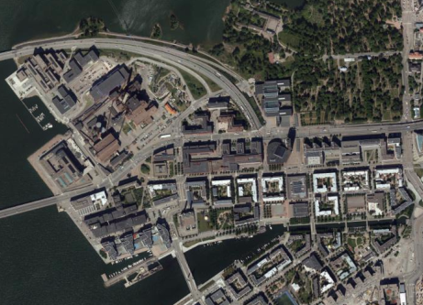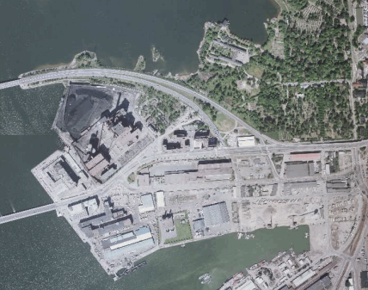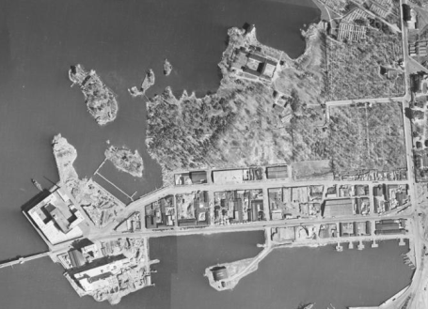

Figure 1. Aerial photographs depict changes in land use in Ruoholahti (from left to right years 2015; 1988; 1943). The change from an industrial area to a mixed urban space is visible in the photographs. Motorway connections were built in the early 1960s. In 2012, urban structure was organised much as it is nowadays.

5.2. Old industrial district: Pitäjänmäki
Pitäjänmäki (Figure 2) is in the north-eastern part of Helsinki, bordering the city of Espoo. The area has a long history in agriculture. The importance of the area increased following the establishment of a railway station and post office in the first half of the 20th century, which accelerated industrial development. The Valimo train station was originally built in 1949 for the employees of the Strömberg factory. The Strömberg foundry, established in 1916, was both a company and industrial community, and dominated the urban development of the area. Pitäjänmäki was incorporated into Helsinki in year 1946. In the 1970s, much of southern Pitäjänmäki was constructed, and construction densified in the 1980s. Nowadays, the area is divided into industrial, residential and recreational parts. Pitäjänmäki is well-connected by public transportation. Motorway connections were built in the early 1960s. During our field work, there were few construction sites in the southern parts of the area.

Figure 2. Aerial photographs depict Pitäjänmäki’s change from agriculture to industry (from left to right years 2012; 1988; 1944). The role of the Strömberg factory (in the north-west) is recognisable. In the late 1970s, Pitäjänmäki was already industrialised.

To understand the impact of the local context more, we must first pay attention to the physical topology of companies in knowledge-based environments. The physical environment at the local level is significant, as it is the interface of the city encountered by pedestrians. While the location of companies inside clusters plays a relatively small role for businesses, the physical construction of space is central for pedestrians. Accessibility was already a clear location factor several decades ago, and companies were often located in nodes that have traditionally been important regarding transportation. For instance, in Ruoholahti, business location has remained in northern Ruoholahti. On the other hand, in Pitäjänmäki, companies have mushroomed in the south and north of the area, mostly because eastern Pitäjänmäki in still used by ABB (the former Strömberg foundry), and there is no further unused space for new constructions.

5.3 Urban expansion and new business location: Keilaniemi
Keilaniemi (Figure 3), in the western part of the city of Espoo, lies on the border of Helsinki. The Keilaniemi area belonged to the Otaniemi mansions, owned by upper class private owners from the mid-1700. The lands were later sold to the city of Helsinki. The Technical University of Helsinki (now Aalto University) was built in Otaniemi in 1949, and the campus has since spread towards Keilaniemi. The first high-rise buildings were built in the 1970s, including the local landmark ‘Neste Oil headquarters’. Before this, the area was mostly forested, with open fields. When Nokia’s mobile phone business started to boom in the 1990s, it constructed buildings in Keilaniemi, deciding to locate its headquarters there in 1996. The area has no residential houses, but more high-rise business buildings are planned. Keilaniemi has relatively good public transportation connections, which will be enhanced by the upcoming metro line.

Figure 3. Keilaniemi has developed from a natural and agricultural area to an ICT-cluster (from left to right years 2011; 2001; 1969; 1950). It was dominated by natural elements until the 1970s, when corporate activities began there.

All the three example locations illustrate that knowledge-based environments always have their own unique contexts. Resonating with earlier research, knowledge-based environments include physical elements like the physical elements of urban spaces in general: paths (where people move), nodes (central places), edges (barriers dividing areas) and landmarks (physical characteristics with meanings) (Lynch 1960). As accessibility is one of the components of a knowledge city, companies in knowledge-based environments generally cluster around main nodes such is the case in all three locations.

Urban facades: activity and design

Earlier research has connected urban liveliness with social opportunities (Ewing & Handy 2009). Particularly, creative milieus are described as ‘the locations of conviviality and bohemia’, where restaurants and cafes to come to life during the night (Costa & Lopes 2015: 34). To capture elements describing urban liveliness and opportunities, this study observed the openness of facades in buildings located in the research areas (Gehl et al. 2006: 30, 240–241) (Figure 4). In practice, the number of facades (per 100 metres) was counted. In brief, the more open doors exists per 100 metres, the friendlier the user urban space experience (Gehl 2010: 240–241).

Knowledge-based environments are limited in terms of urban activity. Ruoholahti had the most street-level observation points defined as active (11 points), while Keilaniemi (5 points) and Pitäjänmäki (4 points) had only a few of them. Pitäjänmäki and Ruoholahti, nevertheless, had relatively several points defined as the mixture of positive and negative elements. Keilaniemi was dominated by passive street-level facades. Thus, the science-based business environments studied here were very different to the creative milieus (Costa & Lopes 2015), mostly because sociality was missing. When looking at the photographs, public space in the research areas was mostly devoid of people (Figure 5). The local context can explain this. For example, in Keilaniemi, the lack of daily services was one significant reason for a low visitor (or customer) attraction. In Pitäjänmäki, there were few places for social interaction, apart from the park. Ruoholahti had the most vibrant atmosphere, but not around companies located in unattractive places on the border of the area (as discussed below). Thus, resonating with earlier research, the claim that ‘ground-floor design has suffered a setback in the form of large units, many closed façades, blind windows and lack of detail’ (Gehl 2010: 240) can be extended to describe also knowledge-based environments.

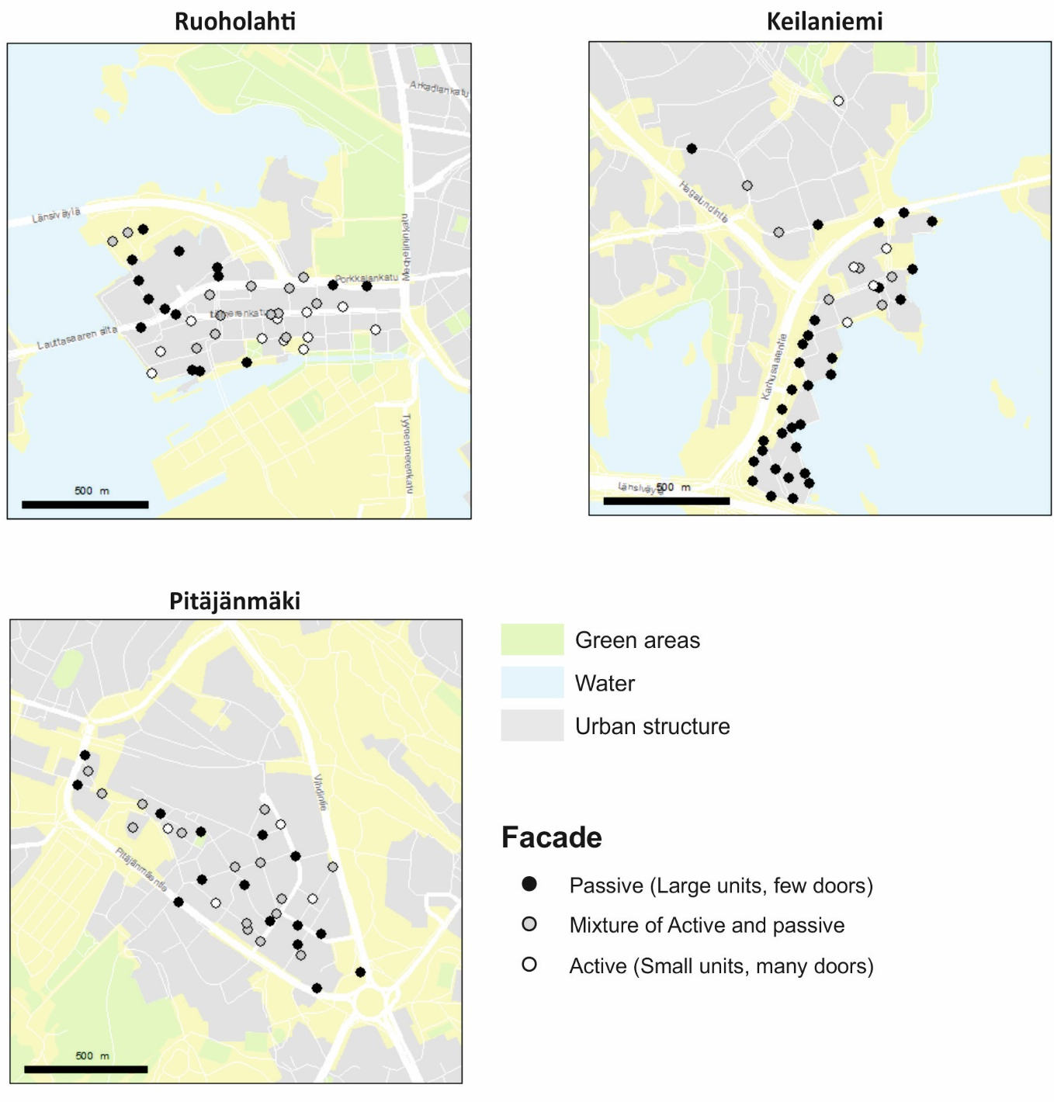

Figure 4. Observations describe the openness and vividness of the facades in the research areas. Most of the facades were defined as passive or mixed, and active facades were rare. Ruoholahti had the most vivid street-level facades.

Figure 5. Left: Closed facades in north-west Ruoholahti. The observers were the only pedestrians using the street which limited the “urban feeling” and attractiveness of the place. Right: Gated recreational area in Keilaniemi.

Our study not only shares the notion of emptiness, but also discusses the impression that the street-level was not for casual people, and the facades were open only to individuals who could enter the buildings. This impression particularly related to areas in southern Keilaniemi, north-western Ruoholahti and the centre and borders of Pitäjänmäki. While there were no security personnel, public urban space excluded individuals who allegedly did not belong to the area, even if in principle, the space should be open to everyone (Koskela 2000: 246). For instance, in Keilaniemi, access to the shore was privately owned and therefore inaccessible, which gave a signal that these places were not designed for passers-by, but for the needs of privately owned activity (see Figure 5 right).

Spaces for accessibility?

Accessibility is a central component of a knowledge city. Accessibility in KBUD commonly refers to location access by cars. In general, science clusters tend to be car-centric, having limited walking opportunities (Spencer 2015). To illustrate the perspective of pedestrians, the quality of footpaths was studied (width of the footpath, pedestrian crossings, cycle lanes, visibility) (Gehl 2010: 243–245), with supporting photographic material.

Contrary to some earlier findings (Spencer 2015) related to the built environment of knowledge-based environments, our study found that walking is a designed option of accessibility in all the locations under study (Figure 6). Areas in southern Keilaniemi (Figure 7 left) and southern Ruoholahti were particularly defined as pedestrian-oriented spaces. However, the walking experience was not always pleasant, due to the condition of the surroundings. Drawing on observations and photographic material, knowledge-based environments included a number of footpaths and cycle lanes, as well as public transportation connections (for example, bus and tram stops), but the footpaths themselves often were unpleasant, following the ‘minimum requirements’ set for footpaths (see Figure 5). In addition, observers encountered plenty of car space (for example, cars, motorways, parking lots, parking halls), meaning that footpaths were often located in car-dominated environments (Figure 7 middle). In these areas, the division between footpaths and motorways was sometimes unclear (Figure 7 right). These two transport realities (walking and driving) do not support each other, causing confusion for both modes of accessing urban space in the study locations.

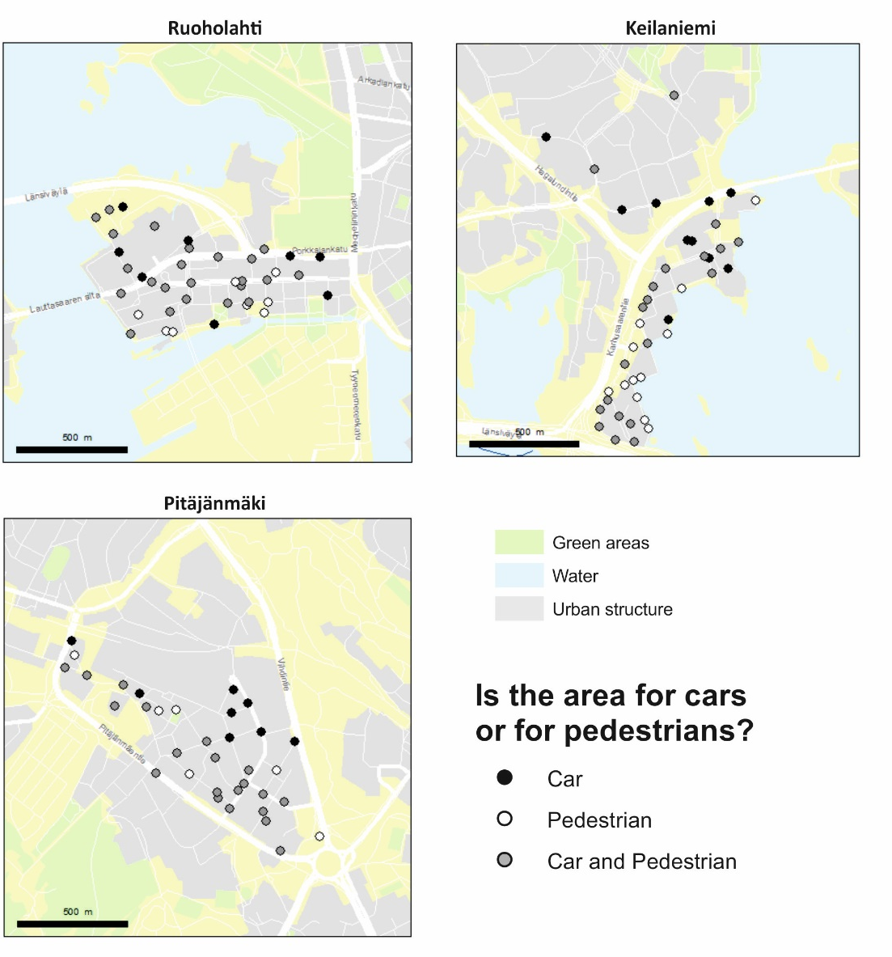

Figure 6. The maps illustrate the observations related to walkability.

Figure 7. Left: Boulevard in Keilaniemi where natural elements were present. While there were no cars, there were no people either. Middle: Footpath in Pitäjänmäki. Even if walking was possible, the surrounding environment provided only few positive sensory experiences. Right: An example of the obscurity of differences between walking and driving spaces in Keilaniemi.

While taking photographs and observing walking opportunities, we also paid attention to mobility limitations, related to the division of private and public space. In practice, this meant that the companies in the research areas had high control over the space surrounding the buildings. The CCTVs were more of a rule than an exception in the research areas. In addition, particularly the larger companies in the research areas were often segregated from other areas by gates, behind which often lay private tennis courts and beaches. These mobility limitations and issues of exclusivity increased feelings of being an outsider also in the public spaces of the research areas: pedestrians and by-passers felt they were not welcome. While security undoubtedly is a critical factor for companies (Neumann et al. 2012), electronic surveillance does not necessarily increase the subjective feelings of security. Instead, the ‘gaze’ of CCTV is a matter of power (Koskela 2000). While the atmosphere in research areas was calm and safe, the message that the gates and security cameras gave was simultaneously to ‘keep away’ and ‘be cautious’.

Visual elements: Urban disrepair and attractiveness

The study design also assessed visual elements, referring to structural design and material, views and natural elements (Gehl 2010; Figure 8). The findings are surprising when compared with the reflective analysis conducted thus far; the research areas included both positive and negative observation points. However, they were clustered and polarised to include either positive or negative observations: positive observations were related to the natural environment (for example, the sea and green areas) and negative observations were found in places that were most often car-dominated, having one-sided facades.

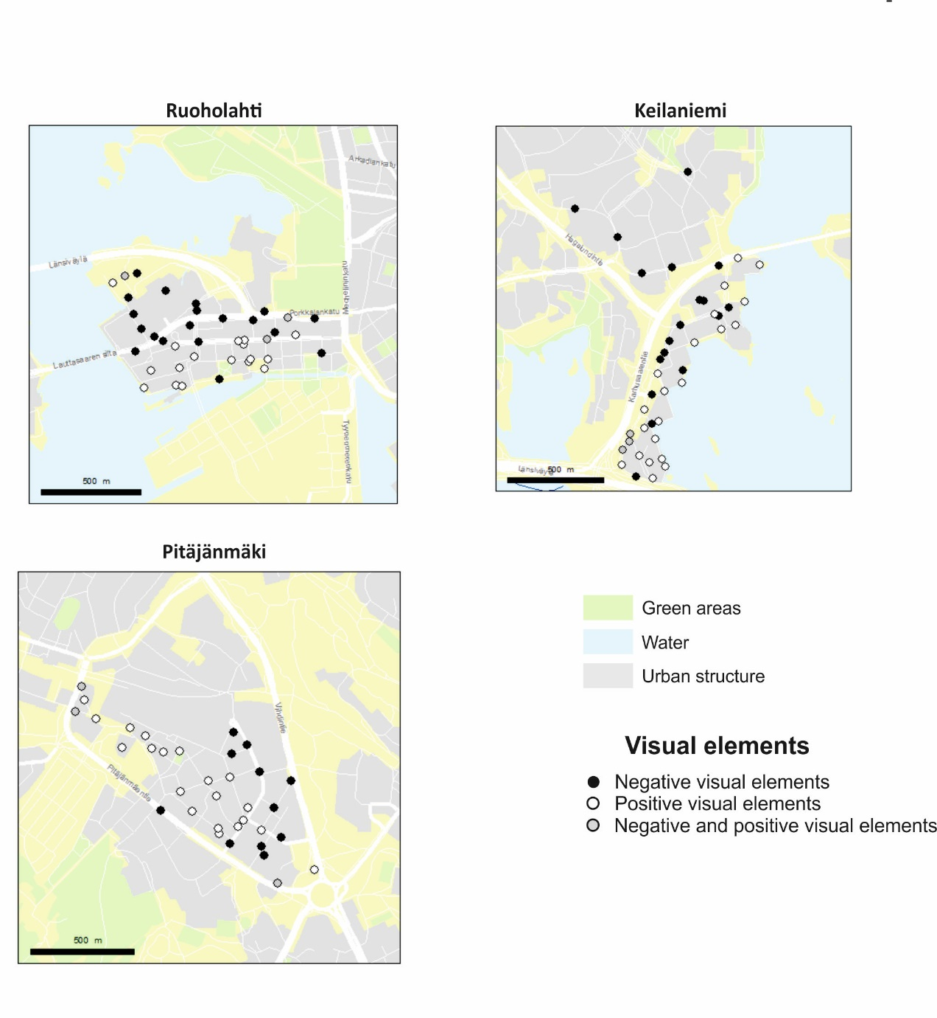

Figure 8. Visual sensory elements in the research areas. Places near the seaside in Ruoholahti and Keilaniemi and Strömberg’s park in Pitäjänmäki included the most positive experience points. Negative experience points were often located near motorways.

Comparing the findings of visual elements with the findings of facades, the research areas clearly included more positive visual elements (Figure 8) than open facades (Figure 4). This suggests that the research areas also included other positive elements than the ones related to the attractiveness of ground floor facades. While the areas had no urban buzz (Storper & Venables 2004; Florida 2005; Costa & Lopes 2015), their positive elements were often related to the urban natural environment (such as trees, plantings, lawn, parks, sea, river). In southern Ruoholahti and eastern Keilaniemi, natural elements referred to the sea and green areas, and in Pitäjänmäki, to the park and river. While natural areas in the city (for example, urban woodlands and water elements) are often considered to be restorative environments that help to overcome stress (Korpela et al. 2010), they are not usually elements associated with KBUD. Along with natural elements, positive observation points comprised special characteristics, such as distinct architecture and urban art. For instance, in Keilaniemi, there is a small harbour with sailboats and a large water spring in the sea. In Ruoholahti, there are old buildings, distinct architecture and urban art work (Figure 9 left) and in Pitäjänmäki, an old factory building (taken in use again), represents a text-book example of urban renewal of old industrial spaces.

Figure 9. Left: Art work in Ruoholahti. Middle: Fallen fence in Pitäjänmäki in an unfinished construction site. Right: A massive advertisement board by the footpath.

Negative observation points were mostly related to the domination of cars (as discussed earlier); other negative characteristics included the disrepair of the built environment. Disrepair refers to dilapidated houses, streets, gates, as well as to old advertising boards (Figure 9 middle and right). The disrepair of the environment was dominant in Pitäjänmäki, and to a lesser extent, in Ruoholahti and Keilaniemi.

The photographs also included elements that were not easily defined as either positive or negative. They were defined as depictions of spaces that could be used for different actions and for describing on-going development and changes in the research areas. On reflection, these spaces could be defined as loose space, where ‘people pursue a very rich variety of activities not originally intended for those locations’ (Franck & Stevens 2007: 2). Recently, researchers have more widely studied the uses of vacant or transitional spaces, which means spaces or places that are used temporarily and differently than originally planned (Iverson 2013; Németh & Langhorst 2014; Tardiveau & Mallo 2014). These are also spaces with potential for urban renewal, as they could be used to increase the attractiveness of the environment. Spaces in Ruoholahti, particularly the boulevard on the waterfront, are the best examples of this. While looseness requires a diversity of people and anonymity among strangers (Franck & Stevens 2007: 4), the spaces studied included very few people. Thus, the potential of these spaces has not been taken into use. While transitional spaces did not dominate the research environments, their presence suggests that knowledge-based environments included hidden possibilities.

- Discussion and conclusions

Regarding the first research question, the physical organisation of knowledge-based environments involved the concentrations of companies with unique characteristics (Table 1). The reasons for differences in topography were related to each area’s individual historical background, such as the planning and dwelling history, and also to their specific physical environment (for example waterfront). Companies located in Ruoholahti were clustered in the northern and south-western parts, mainly because of the sea and motorways. In Keilaniemi, companies were sprawled along the seaside and motorways, but were also divided into two smaller concentrations of built areas. Pitäjänmäki had a number of small concentrations of companies, mostly located in the southern parts of area. This resonates with earlier research, in that science-based agglomerations tend to be sparsely built and sprawled (Spencer 2015: 888, 894).

Table 1. The findings of the study.

 | Ruoholahti | Keilanimi | Pitäjämäki
Companies in the clusters | “Northern banana” | “Sprawled and divided cluster” | “Mixed cluster”
Facades | Few open facades. | Lack of open facades. | Few open facades.
Pedestrian- or car-dominated space | Both, walking experience often not pleasant. | Both, walking experience not pleasant. | Car-dominated, walking experience not pleasant.
Positive visual characteristics | Sea, parks, artwork | Sea | Parks, vegetation
Negative visual characteristics | Traffic, car space | Car space, lack of people | Urban disrepair
Potential (to become a knowledge-environment…) | …in a vivid urban environment. | …with a distinct (natural) environment. | …with a vivid urban environment with an industrial background.

Our results have the following implications: first we consider that researchers based inquiry concerning building elements, designs, and functionalities of urban space should be recognized more in the practices of urban planning. Second, the continuous pressure to lower the amount of private cars in the urban cores gives motivation for further critical assessments of contemporary planning and design. Dimensions of accessibility, walkability and user experience are essential in the future planning of knowledge-based locations. As Table 1 indicates, there are historical trajectories (e.g. related to car dominance and accessibility) underlying each case location. Therefore, the recognition of the existing spatial characteristics and location advantages should considered in the planning process of new business environments (for spatial scalar systems, see Ahlqvist & Inkinen 2007).

Our second research question refers to urban design qualities in the research areas (facades, walkability and visual elements). Our research supports the claim that knowledge-based environments differ from creative ones, as they are not designed to be excessively social (Table 2). The facades of these environments were mostly defined as not being human centred, thus not suitable as vibrant locations for urban buzz (Costa & Lopes 2015). Rather, they are quiet areas, with buildings made for and by (knowledge-based) companies. Mobility generally refers to a car-dominated urban space. Walking, nevertheless, was often possible, but it was not necessarily a pleasant or memorable experience. Walking distances were also long. If multi-modal accessibility is an important factor for successful knowledge locations, walkability was not competently accounted for in our case locations.

Table 2. The summary categories of the photograph contents.

Positive elements | Negative elements | Contradictory elements
Walkability, public transportation (e.g. footpath, cycle lane, bus or tram stop) | Car-dominant spaces (e.g. parking lots and halls, motorway) | Changes (e.g. construction site, empty office space)
Special characteristics (e.g. old factory, art work, fine architecture) | Disrepair (e.g. collapsed fence, outdated advertising boards, borders (e.g. fences, security cameras) | Space for action (e.g. stairs, places to sit down, wharf)
Nature (e.g. sea, trees, plants)

Table 2 indicates that there are several positive visual elements in our case data. They are often related to the natural environment and green areas. Negative visual elements were related to urban disrepair and the dominance of cars. We consider one important aspect to be the maintenance question: urban spaces degenerate quickly if maintenance of buildings and e.g. parks is neglected. This often results from property ownership changes. The positive place experiences are gained through combination of well maintained urban spaces. This is also a challenge for practical monitoring and quality assurance of build environments in general. Thus, knowledge-based environments also included potential targets of development. A prominent aspect is related to vacant urban space (empty office space, vacant public space), which could be taken into use. As urban planning and design have difficulties in dealing with social, economic and ecological urban crisis, different forms of temporary urbanism may help to handle these difficulties (Tardiveau & Mallo 2014: 456), by providing savings and increasing attractiveness.

Drawing on discussions revolving around urban design, this paper studied the physical environment and urban design elements in knowledge-based environments in the HMA. While local buzz is salient for creative knowledge-based business, the knowledge-based environments studied here were not very vibrant social environments. This finding implies that companies are not overly dependent on the social-spatial environment. However, while knowledge-based agglomerations compete for skilled workers, the built- and physical environment plays a central role. The goal of city planning is to build liveable multi-purpose locations, not only to plan locations for business. Monotonic environments and car-dominated environments are contrary to the commonly recognised as success factors for knowledge-based business in the planning literature.

Our study indicates continuous research demands for the future: first, similar case studies are needed in order to establish a platform for comparative analyses of knowledge-based environments in different cultural and societal contexts. Second, the need for critical analyses concerning the questions of environment and business district designs remains vivid and important topic. Third, the mixture of different research methods are needed: statistical and GIS analyses function as the quantifiable platform but the understanding of specific characteristics and the feeling of the city space needs field observations, stakeholder interviews and other qualitative data materials such as photographs applied in our study. Finally, the combination of location models into the consideration of accessibility and mobility is needed with sophisticated simulation tools.

Acknowledgements

This research was funded by the Helsinki Metropolitan Region Urban Research Program.

References

Ahlqvist, T. & T. Inkinen (2007). Technology foresight in scalar innovation systems: a spatiotemporal process perspective. Fennia. International Journal of Geography, 185 (1), 3–14.
Bathelt, H., Malmberg, A., and Maskell, P. (2004). Clusters and knowledge: local buzz, global pipelines and the process of knowledge creation. Progress in Human Geography, 28(1), 31–56.
Bell, P. (2001). Content analysis of visual images. In: Van Leeuwen, T. & Jewitt, C. (eds.). The handbook of visual analysis, 10–34. SAGE, London.
Bernelius, V. (2013). Segregating urban schools: Pupil’s background, family’s school selection and learning outcome related regional effects as parts of urban segregation in the elementary schools of Helsinki. In Finnish, English abstract. [Eriytyvät kaupunkikoulut: Helsingin peruskoulujen oppilaspohjan erot, perheiden kouluvalinnat ja oppimistuloksiin liittyvät aluevaikutukset osana kaupungin eriytymiskehitystä]. City of Helsinki Urban Facts, Helsinki.
Costa, P., & Lopes, R. (2015). Urban design, public space and the dynamics of creative milieux: A photographic approach to Bairro Alto (Lisbon), Gràcia (Barcelona) and Vila Madalena (São Paulo). Journal of Urban Design, 20(1), 28–51.
Currid, E., & Connolly, J. (2008). Patterns of knowledge: the geography of advanced services and the case of art and culture. Annals of the Association of American Geographers, 98(2), 414–434.
Eskelä, E. (2013). Migration decisions of skilled migrants. Nordic Journal of Migration Research, 3(3), 145–152.
Esmaeilpoorarabi, N., Yigitcanlar, T. & Guaralda, M. (2016). Towards an urban quality framework: Determining critical measures for different geographical scales to attract and retain talent in cities. International Journal of Knowledge-Based Development, 7(3), 290–312.
Espoo Map Service (2015) <http://kartat.espoo.fi/IMS/en/Map> (Accessed 28.11. 2016)
European Commission (2015). Quality of life in European cities 2015. (Accessed 01.11. 2016)
<http://ec.europa.eu/regional_policy/sources/docgener/studies/pdf/urban/survey2015_en.pdf>
Evers, H. D., Gerke, S., & Menkhoff, T. (2010). Knowledge clusters and knowledge hubs: designing epistemic landscapes for development. Journal of Knowledge Management, 14(5), 678–689.
Ewing, R., & Handy, S. (2009). Measuring the unmeasurable: Urban design qualities related to walkability. Journal of Urban Design, 14(1), 65–84.
Florida, R. (2005). The flight of the creative class. The new global competition for talent. HarperCollins, New York.
Franck, K. A. & Stevens, Q. (2007). Tying down loose space. In: Franck, K. A. & Stevens, Q. (eds.). Loose space, 1–12. Routledge, London.
Gehl, J. (2010). Cities for people. Island Press, London.
Gehl, J., Kaefer, L. J., & Reigstad, S. (2006). Close encounters with buildings. Urban Design International 11(1), 29–47.
Helsinki Map Service 2015 <http://kartta.hel.fi/?setlanguage=en> (Accessed 28.11. 2016)
Hirt, S. A. (2009). Premodern, modern, postmodern? Placing new urbanism into a historical perspective. Journal of Planning History, 8(3), 248–273.
Inkinen, T. (2015). Reflections on the innovative city: examining three innovative locations in a knowledge bases framework. Journal of Open Innovation: Technology, Market, and Complexity, 1(8), 1–23.
Inkinen, T. & Kaakinen, I. (2016). Economic geography of knowledge-intensive technology clusters: Lessons from the Helsinki Metropolitan Area. Journal of Urban Technology, 23(1), 95–114.
Inkinen, T. & P. Kuru (2004). Kansalaiset ja tietoyhteiskunnan sosiaaliset vaikutukset. Pirkanmaan tietoyhteiskuntatutkimus 2004. Tietoyhteiskuntainstituutin raportteja 2. 90 p. University of Tampere Press, Tampere.
Inkinen. T. & Ponto, H. (2018). Money matters? A qualitative study of the funding organizations as parts of smart cities and innovative development. In: Rodríguez Bolívar, M. P. (ed.): Smart technologies for smart governments. Transparency, efficiency and organizational issues. Public Administration and Information Technology 24, 169–189. Springer, New York.
Inkinen, T. & Vaattovaara, M. (2007). Technology and knowledge-based development. Helsinki Metropolitan Area as a creative region. ACRE report 2.5. University of Amsterdam, Amsterdam.
Inkinen, T. & Vaattovaara, M. (2010). Creative urban region in the Nordic country. Combining tradition with development in Helsinki. In Metaxiotis, K., F. J. Carrillo & T. Yigitcanlar (eds.): Knowledge-based development of cities and societies, 196–210. IGI Global, Hershey.
Iverson, K. (2013). Cities within the city: Do-it-yourself urbanism and the right to the city. International Journal of Urban and Regional Research, 37(3), 941–956.
Jacobs, J. (1961). The death and life of great American cities. Random House, New York.
Jokela, S. (2014). Turism, geography and nation-bulding. The identity-political role of Finnish tourism images. University of Helsinki, Helsinki.
Jäppinen, S., Toivonen, T., & Salonen, M. (2013). Modelling the potential effect of shared bicycles on public transport travel times in Greater Helsinki: An open data approach. Applied Geography, 43(1), 13–24.
Kiuru, J. & Inkinen, T. (2017). Predicting innovative growth and demand with proximate human capital: A case study of the Helsinki metropolitan area, Cities, 64, 9–17. (Online First DOI:10.1016/j.cities.2017.01.005)
Kloosterman, R. C., & Musterd, S. (2001). The polycentric urban region: towards a research agenda. Urban Studies, 38(4), 623–634.
Knight, R. (1995). Knowledge-based development: policy and planning implications for cities. Urban Studies, 32(2), 225–260.
Knight, R. (2008). Knowledge-based development: The challenge for cities. In: Yigitcanlar, T., Velibeyoglu, K. & Baum, S. (eds.): Knowledge-based urban development: Planning and applications in the information era. xiv–xix. IGI Global, Hershey.
Korpela, K. M., Ylén, M., Tyrväinen, L., & Silvennoinen, H. (2010). Favorite green, waterside and urban environments, restorative experiences and perceived health in Finland. Health Promotion International, 25(2), 200–209.
Koskela, H. (2000). ‘The gaze without eyes’: video-surveillance and the changing nature of urban space. Progress in Human Geography, 24(2), 243–265.
Kuoppa, J. (2013). Beyond vague promises of liveability: An exploration of walking in everyday life. In: Dietrich Henckel, D., Thomaier, S., Könecke, B., Zedda, R. & Stabilini, S. (eds.). Space–time design of the public city, 157-170. Springer, New York.
Lynch, K. (1960). The image of the city. MIT Press, Cambridge.
Makkonen, T. & Inkinen, T. (2014). Spatial scaling of regional strategic programmes in Finland: A qualitative study of clusters and innovation systems. Norsk Geografisk Tidsskrift–Norwegian Journal of Geography, 68(4), 216–227.
Merisalo, M., Makkonen, T. & Inkinen, T. (2013). Creative and knowledge-intensive teleworkers’ relation to e-capital in the Helsinki metropolitan area. International Journal of Knowledge-based Development, 4(3), 204–221.
Middleton, J. (2011). “I'm on autopilot, I just follow the route”: Exploring the habits, routines, and decision-making practices of everyday urban mobilities. Environment and Planning A, 43(12), 2857–2877.
Middleton, J. (2016). The socialities on everyday urban walking and the ‘right to the city’. Urban Studies. 1–20 (Online First DOI:10.1177/0042098016649325)
Németh, J. & Langhorst, J. (2014). Rethinking urban transformation: Temporary uses for vacant land. Cities, 40, B, 143–150.
Neumann, U., Geissler, H., Jakubowski, P., (2012). Agglomeration economies in the neighbourhood? Evidence from German cities. Local Economy, 28(1), 51–65.
van Oort, F., Weterings, A., & H. Verlinde (2003). Residential amenities of knowledge workers and the location of ICT-firms in the Netherlands. Tijdschrift voor Economische en Sociale Geografie, 94(4), 516–523.
Pennanen, P. A. (2003). Policies and impacts of urban regeneration: waterfront redevelopment in Helsinki, Finland 1980–2000. Doctoral dissertation, King's College London, University of London.
Pink, S. (2007). Doing visual ethnography. Images, media and representation in research. SAGE, London.
Porter, M. (2000). Location, competition, and economic development: Local clustersin in a global economy. Economic Development Quarterly 14(15), 15–34.
Powell, W. W., & Snellman, K. (2004). The knowledge economy. Annual Review of Sociology, 199-220.
Schiuma, G. & Lerro, A. (2008). Knowledge-based capital in building regional innovation capacity. Journal of Knowledge Management, 12(5), 121–136.
Southworth, M. (2005). Designing the walkable city. Journal of Urban Planning and Development, 131(4), 246–257.
Spencer, G. M. (2015). Knowledge neighbourhoods: Urban form and evolutionary economic geography, Regional Studies, 49(5), 883–898.
Storper, M., & Venables, A. J. (2004). Buzz: face-to-face contact and the urban economy. Journal of Economic Geography, 4(4), 351-370.
Söderström, P. (2012). Vibrant centres – Diversity and quality of the urban environment in the regional city’s centres. In Finnish, English summary. [Elävät kaupunkikeskukset. Kaupunkiympäristön monipuolisuus ja laatu verkostokaupungin keskuksissa]. The Finnish Environment 32/2012, Helsinki.
Tardiveau, A. & Mallo, D. (2014). Unpacking and challenging habitus: An approach to temporary urbanism as a socially engaged practice. Journal of Urban Design, 19(4), 456–472.
Till, K. E. (2001). New urbanism and nature: Green marketing and the neotraditional community. Urban Geography, 22(3), 220–248.
Vaattovaara, M. (2009). The emergence of the Helsinki Metropolitan Area as an international hub of the knowledge industries. Built Environment, 35(2), 204-211.
Vaattovaara, M. & Kortteinen, M. (2003). Beyond polarisation versus professionalisation? A case study of the development of the Helsinki region, Finland. Urban Studies, 40(11), 2127-2145.
Vilkama, K. (2011). Common city, segregating neighborhoods? Spatial segregation and migration of natives and immigrants in the Helsinki metropolitan area. In Finnish, English synopsis. [Yhteinen kaupunki, eriytyvät kaupunginosat? Kantaväestön ja maahanmuuttajataustaisten asukkaiden alueellinen eriytyminen ja muuttoliike pääkaupunkiseudulla]. City of Helsinki Urban Facts, Helsinki.
Yigitcanlar, T., Carrillo, F. J., Metaxiotis, K. & Ergazakis, K. (2010). Editorial: Knowledge-based develpoment of cities: A myth or reality? International Journal of Knowledge-Based Development, 1(3), 153–157.
Yigitcanlar, T., Inkinen, T. & Makkonen, T. (2015). Does size matter? Knowledge-based development of second-order city-regions in Finland. DisP: The Planning Review, 51(3), 62–77.
Yigitcanlar, T., & Lönnqvist, A. (2013). Benchmarking knowledge-based urban development performance: Results from the international comparison of Helsinki. Cities, 31, 357–369.
Yigitcanlar, T. Lönnqvist, A. & Salonius, H. (2014). Analysis of a city-region from the knowledge perspective: Tampere, Finland. VINE, 44(3), 445–466.
Yigitcanlar. T., Velibeyoglu, K., Martinez-Fernandez, C. (2008). Rising knowledge cities: the role of urban knowledge precincts. Journal of Knowledge Management 12(5), 5–15.
Zukin, S. (2009). Naked city: The death and life of authentic urban places. Oxford University Press, Oxford.

Themes found in the analysis: natural elements, mobility opportunities, urban spaces for activities, the special characteristics of urban space, car space, negative visual elements, incompleteness and edges.
The scale according to Gehl (2010: 241): a) active: small units, many doors (15–20 doors per 100 m), large variation in function, no passive units, lots of character in facade relief, vertical facade articulation, good details and materials; b) friendly: relatively small units, (10–14 doors per 100 m), some variation in function, few blind units, facade relief, good materials and details, c) mixture: large and small units (6–10 doors per 100m), some blind and passive units, modest facade relief, few details; d) boring: large units, few doors (2–5 doors per 100 m), almost no variation in function, many blind units, few or no details, e) inactive: large units, few or no doors (0–2 doors per 100 m), no visible variation in function, blind or passive units, uniform façades, no details, nothing to look at.

