Fracture-behavior of CAD/CAM ceramic crowns before and after cyclic fatigue aging

Sufyan Garoushi^{1*}, Eija Säilynoja^{1,2}, Pekka K. Vallittu^{1,3} and Lippo Lassila¹
¹Department of Biomaterials Science and Turku Clinical Biomaterial Center -TCBC
Institute of Dentistry, University of Turku, Turku, Finland

²Research Development and Production Department, Stick Tech Ltd – Member of GC Group, Turku, Finland

³City of Turku Welfare Division, Oral Health Care, Turku, Finland

*Corresponding author:
Dr. Sufyan Garoushi, BDS, PhD, Docent
Department of Biomaterials Science
Institute of Dentistry and TCBC
University of Turku
Turku, FINLAND
E-mail address: sufgar@utu.fi

Abstract
Purpose: The aim of this study was to evaluate the fracture-behavior of monolithic crowns made of lithium disilicate (IPS e.max CAD and Initial LiSi Block) and zirconia-reinforced lithium silicate (Celtra Duo and VITA SUPRINITY) materials before and after cyclic fatigue aging.
Materials and Methods: Four groups (n=22/group) of CAD/CAM fabricated upper incisor crowns were produced. All crowns were luted on metal dies with an adhesive dual-cure resin cement (G-CEM LinkForce). Half of crowns per each group (n=11) were statically loaded until fracture without aging. The remaining half were subjected to cyclic fatigue aging to 120.000 cycles (F_{max}=220 N), and then loaded statically to fracture. Fracture mode was then visually examined. SEM and EDS were used to evaluate the microstructure of CAD/CAM ceramic materials. The data were statistically analyzed with 2-way analysis of variance (ANOVA) followed by Tukey HSD test (α=.05).
Results: Before cyclic aging, no statistically significant difference in load-bearing capacity between the four groups (p=.371). After cyclic aging, load-bearing capacity significantly decreased for all groups (p=.000). While the e.max CAD blocks had significantly higher load-bearing capacity (1061 ±94 N) than both monolithic ceramic crowns (load-bearing capacities of the groups) (p<0.05), no significant difference obtained with Initial LiSi Block group (920 ±140 N) (p=.061, according to the Tukey HSD).
Conclusion: The mechanical performance of monolithic ceramic crowns fabricated from lithium disilicated was better than zirconia-reinforced lithium silicate after cyclic fatigue aging.

Keywords: Fracture behavior, CAD/CAM monolithic restoration, anterior crown, fatigue aging.

Introduction
Recent progress in the technology and research of new materials has widened the choice for esthetic monolithic crown restorations. Glass-ceramic materials incorporating crystals of lithium disilicate are currently used for computer aided design / computer aided manufacturing (CAD/CAM) and heat-pressing techniques.^{1,2} In view of progress in CAD/CAM technologies, the production process of dental prosthesis using blocks for CAD/CAM processing is simple and reduced time to manufacture it contrary to heat-pressing technique.³ These blocks enable dental prostheses to be fabricated by milling directly after scanning the prepared teeth in patient’s mouth. Thereby, the definitive restoration can be cemented inside the patient’s mouth within short time if only a monolithic restoration is demanded. However, for the reasons that glass-ceramics are brittle and prone to fatigue fracture in cyclic loading.^{3,4} An attempt to merge the superior esthetic performance of lithium disilicate and the strength characteristic of zirconia was made and a new class of CAD/CAM ceramics, zirconia-reinforced lithium silicate ceramics, have been presented.^{4,5} The manufacturer demands an enhanced strength for this class of material owing to the addition of about 10 wt.% zirconium oxide. It has been stated that their aesthetic characteristics are excellent, due to the high content of glass. However, little information is available on its laboratory or clinical performance.⁶⁻⁸
Static load to failure is an ordinary approach of testing materials used for dental prosthesis to evaluate their performance in various applications.⁹ Studies testing the fracture resistance of all-ceramic crowns have been described, and different elements have been considered responsible for the limited durability of all-ceramic restorations.⁹⁻¹² Studies revealed that cyclic fatigue is more informative than just static load test.^{11,13} Where cracks initiated from the contact area at the occlusal or incisal surface are slowly propagate and progress gradually over time, accelerating at higher stress levels and in the end leading to failure.
Today, a rapid development of new dental materials makes clinical verification of these innovative technologies difficult, and marketing interest are often overly optimistic. Consequently, laboratory or preclinical investigations aid to classify the mechanical and physical performance of these new materials. Thus, the purpose of this study was designed to compare the fracture-behavior of monolithic crowns made of lithium disilicate (IPS e.max CAD and Initial LiSi Block) and zirconia-reinforced lithium silicate (Celtra Duo and VITA SUPRINITY) materials before and after cyclic fatigue aging.
The null hypotheses were that the material type and aging procedure will have no effect on the load-bearing capacity of monolithic crowns.

Materials and methods
The CAD/CAM ceramic materials used in this study are listed in Table 1.
The fabrication of crown specimens
An experimental identical metal dies (abutments) for a crown restoration of the maxillary central incisor were cut from Cobalt Chromium blank (Sintermetall, Zirkonzahn GmbH, Taufers, Italy) using a CAD/CAM device (5-TEC, Zirkonzahn GmbH). Next, the dies were sintered in a furnace (Zirkonofen 700/UV, Zirkonzahn GmbH) according to the product instructions. After that, the metal dies were embedded in plastic tubes with auto-polymerized acrylic resin (Palapress, Heraus Kulzer, Wehrheim, Germany) except for 2 mm of the cervical area (Figure 1). A photoimpression was taken of the metal die using another dental CAD/CAM device (CEREC Omnicam AC, Dentsply Sirona, York, PA, USA). A monolithic crown restoration was designed, and a flat surface was established at the incisor edge area with objective to adapt the loading cell during the fracture load test.
A total of 88 monolithic crowns with a wall thickness of 1.5 mm were fabricated (CEREC MC XL, Dentsply Sirona) and allocated to four groups (n=22/group) according to the ceramic material used. At the incisor edge, the thickness of the monolithic crowns was 2 mm.
Afterward, crowns made of IPS e.max CAD and VITA SUPRINITY blocks were crystallized in a ceramic oven (Programat P310, Ivoclar Vivadent AG, Schaan, Liechtenstein) in accordance with the manufacturer’s instructions for use. The milled Celtra Duo and Initial LiSi Block crowns were not exposed to any firing after milling. Finishing and polishing for all crowns were conducted according to the manufacturers’ instructions.
Before cementation, the inner surface of all CAD/CAM fabricated crowns was acid etched by 9.6% Hydrofluoric acid (Pulpdent Corporation, Watertown, MA, USA) for 60 s followed by washing, air-drying and application of primer (G-Multi Primer, GC, Tokyo, Japan). The crowns were then cemented to the sandblasted metal abutment using a multi primer (G-Multi Primer, GC, Tokyo, Japan) and dual-cure resin cement (G-CEM LinkForce, GC, Tokyo, Japan). Followed by light curing from all directions using a hand-light curing unit (Elipar TM S10, 3M ESPE, Seefeld, Germany) for 20 s per segment (wavelength of the light was between 430 and 480 nm and light intensity was 1600 mW/cm²). The light source was placed in close contact with the crown surface. Prior to fatigue aging and testing, all crowns were stored dry for 24 h at 37°C.
Fracture load test

A static load was applied without aging to the half of crowns (n=11/group) with a universal testing machine (Lloyd model LRX, Lloyd Instruments Ltd, Fareham, UK) at a speed of 1 mm/min. The acrylic block containing the metal abutment and crown was tightly fixed to the inclined metal base to provide a 45-degree angle between the palatal surface of the incisal edge and the flat loading cell (Figure 1). In order to load onto the flat incisor surface under the same conditions for all tested crowns, sheets of aluminum foils were placed above the flat surface. The loading event was registered until restoration fracture (final drop in the load-deflection curve) and the fracture mode for each crown specimen was visually analyzed by two investigators.
Cyclic fatigue aging

Half of the crowns per each group (n=11) were subjected to cyclic fatigue aging before static fracture load test. The inclined metal base was fixed in the fatigue testing device (Cera Test 2K, SD Mechatronik, Feldkirchen, Germany), and the crowns underwent 120.000 cycles of mechanical dynamic loading with a force of magnitude F_{max}=220 N and frequency of 12 Hz. After cyclic fatigue aging, all crowns specimens were statically loaded until fracture occurred.

Fracture mode analysis
The fracture mode of crowns was observed using a stereomicroscope (Heerbrugg M3Z, Heerbrugg, Switzerland) with different magnifications (6.5, 10, 15x) and illumination angles to detect the cracks clearly. The representative fractured crown specimens were selected and examined by scanning electron microscopy (SEM) (GeminiSEM 450, Carl Zeiss, Oberkochen, Germany). Prior to observation, all the specimens were cleaned by alcohol and then coated with a gold layer using a sputter coater in vacuum evaporator (BAL-TEC SCD 050 Sputter Coater, Balzers, Liechtenstein). The analysis was started from the edge of the fractured crown specimen, from the upper loading part to the inner surface and ending at the adhesive interface.
Microstructure analysis
SEM and energy-dispersive spectroscopy (EDS) (GeminiSEM 450, Carl Zeiss, Oberkochen, Germany) provided the characterization of the microstructure of the investigated CAD/CAM ceramic materials. Polished specimen from each material was stored in desiccator for one day. Then, they were coated with a carbon layer using a sputter coater in vacuum evaporator (BAL-TEC SCD 050 Sputter Coater, Balzers, Liechtenstein) before the SEM/EDS examination. SEM observations were carried out at an operating voltage of 10 kV and working distance of 12 mm.
Statistical analysis
The data were statistically analyzed with 2-way analysis of variance (ANOVA) followed by Tukey HSD test (α=.05) to determine the differences between the groups using SPSS version 23 (SPSS, IBM Corp., NY, USA). Where material type and aging procedure were independent and fracture load values were dependent variables.

Results
None of the crowns failed during the cyclic fatigue aging. Therefore, all of the fatigued crowns were subjected to static loading to failure. Two-way ANOVA demonstrated that both material type and aging procedure (F=2.17; p=.045) had significant effect on the load-bearing capacity of tested crowns. The mean (± standard deviation) fracture load values of the crowns before and after cyclic fatigue aging are given in Figure 2. Before cyclic fatigue aging, there was no statistically significant difference in load-bearing capacity between the four groups (p=.371). After cyclic fatigue aging, load-bearing capacity was significantly decreased for all groups (p=.000). Data revealed that crowns made of e.max CAD blocks had the highest load-bearing capacities (1061 ±94 N) which was not significantly different (p=.061) from Initial LiSi Block group (920 ±140 N). No statistically significant differences (p=.993) were found between crowns made of zirconia-reinforced lithium silicate (Celtra Duo and VITA SUPRINITY). Visual inspection revealed bulk splitting fracture mode (two pieces fracture) along the labio-palatal plane for all crowns before and after cyclic fatigue aging (Figure 3). Stereomicroscope and SEM images of fractured crowns indicated that the crack path propagated from loading surface (incisal) to the inner margin at adhesive interface (Figure 3). SEM analysis revealed homogenous and smooth surfaces where crystals are uniformly distributed in glass matrix (Figure 4). Specimens showed different crystals size and quantity and this suggested an explanation for different toughening capability between tested materials. Chemical constituents of each investigated CAD/CAM ceramic material determined with EDS is presented in Table 2.

Discussion
In this investigation, cyclic fatigue aging reduced the mean load-bearing capacity of all the CAD/CAM crowns used. The highest load-bearing values after cyclic fatigue aging were recorded for lithium disilicate crowns. Therefore, the null hypotheses were rejected. The obtained load-bearing values after cyclic fatigue aging in this study were in range between 900-1000 N. Reported maximum chewing forces in the incisor area were in the range of 150–235 N with an average value of 206 N.^{14,15} Thus, all tested ceramic materials overcome this range.
When we compared our results with those of previous similar studies,^{10,12,16,17} it can be declared that load-bearing values achieved were in same range of that of similar studies with the final load-bearing values ranging between 400 and 1000 N. However, loading conditions between studies were different.
Based on their microstructure analysis, the four tested CAD/CAM ceramic materials have a minor dissimilar structure concerning the glassy and crystal phases. Zirconia-reinforced lithium silicate has a lower proportion of crystal phase (40–50%), in comparison to lithium disilicate ceramics (around 70%). Though, incorporated crystals inside zirconia-reinforced lithium silicate are smaller and the glass matrix is enhanced through melted zirconia, which is expected to improve the toughness and strength of the glassy phase.⁴ On the other hand, zirconium dioxide particles may increase the brittleness and serve as crack initiators, and promote in reducing the load-bearing capacity after cyclic fatigue aging. Fracture behavior of ceramics is strongly reliance on the microstructure of the material. In case the reinforcing particles are not proper distributed or linked to the matrix material, the reinforcing particles might serve as toughness and strength reducing factor.¹⁸ Previously has been demonstrated that fracture paths in the zirconia-reinforced lithium silicate material appeared to be mainly intergranular, seeking those orientations of the crystalline matrix where there was weaker bonding between adjacent larger-scale regions.¹⁹ In addition, pores formation as result of material processing may increase the possibility of failure as the role of pores is well known in ceramics as site of stress concentration for fracture initiation and propagation.¹⁹,²⁰
According to the EDS analysis results, the investigated materials within the same class have similar ratios of SiO₂ and only minor differences present on other oxides (Table 2), suggesting that the difference in the performance could be mainly depends on the morphology and distribution of the reinforcing crystals. SEM images of the materials illustrate the homogeneous distribution of the platelet-shaped crystals in an interlocking network but with different sizes (Figure 4). VITA SUPRINITY and Celtra are zirconia-reinforced, silica-based glass ceramic with a mean crystal size of approximately 0.4 µm and 0.6 µm respectively. Whereas, e.max CAD and LiSi Block are a lithium disilicate–based glass ceramic with a mean crystal size of 1 µm and 0.3 µm respectively. However, even in the same product, the crystals can vary in size according to the shade or opacity. Their size could depends also on the base glass composition and heat treatment.²¹
There is a lack of information about the load-bearing capacity of monolithic crowns made of recent CAD/CAM ceramic materials, in the current study, a newly developed lithium disilicate material (LiSi Block) was evaluated. Although, LiSi Block material has a higher crystal ratio and smaller crystal size (Figure 4), the performance before and after cyclic fatigue aging was comparable to e.max CAD group (Figure 2).
Our result is in accordance with Kashkari et al., study, which showed superior fatigue load-bearing capacity of lithium disilicated crowns over zirconia-reinforced lithium silicate crowns.¹⁹ On contrary, Schwindling and his colleagues showed that monolithic restorations made from zirconia-reinforced lithium silicate sustain high fracture resistance after comprehensive thermo-mechanical aging.¹²
However, it has to be clarified that, ceramic fatigue resistance is significantly influenced by several laboratory parameters, like abutment and antagonist design and material, amount and magnitude of cyclic loading, thermos-cycling variables and test conditions.²² Therefore, the diversity and absence of standardization in test conditions, research designs and tested materials make a comparison of data difficult to achieve.²²
According to literature our cyclic fatigue aging method is equivalent to only one year in vivo (300 inclined loading cycles at 220 N per day),^{12,22} though, our data might still be analyzed as clinically acceptable, especially for crowns made from zirconia-reinforced lithium silicate and lithium disilicate, for which load-bearing values are much more than the average chewing force in the anterior region (206 N). Nevertheless, after cyclic fatigue aging no macroscopic signs of failure were detected.
According to visual analysis of the fracture mode of the crowns, only typical radius splitting failure extended along the labio-palatal plane was observed (Figure 3). This seems to be median-radial cracks propagate from the load contact site through the entire crown thickness.²³⁻²⁵ Interestingly, fatigue aging did not alter the fracture mode. According to Zhang and his colleagues, fracture mode can dominate under certain test conditions depending on ceramic thickness, maximum load, and sphere radius.²⁶ Bulk or radial fracture propagating through the whole thickness of the restoration was the most frequent cause of mechanical failure in monolithic ceramic crowns in earlier studies.^{19,27-29}
In this study, the fracture forces were equally loaded to the incisor edge area, which is found to be the most critical region of the maxillary central incisor from a mechanical perspective.³⁰ Since the cracks in all crowns initiated from similar points, near the flat surface of the incisor edge region. This result may suggest that the aluminum foils that were placed between the crowns and the load cell provided constant loading condition.
Despite the fact that extreme loads were applied (way beyond the masticatory forced), none of the crowns failed adhesively, which may account for the high level of bonding achieved. The cohesiveness between the luting cement and the CAD/CAM materials can be explained by the combination of micromechanical interlocking (surface roughness created by acid etching) and chemical bonding through the use of the primer.
As previously mentioned, static load to common approach of testing dental materials used for dental prostheses to evaluate their mechanical stability for different application prior to clinical trials.^{9,31} Such in vitro investigations help to rank mechanical and physical properties of new materials. However, static test has been criticized and the clinical relevancy is being questioned as a consequence of the lack of clinical correlation.³² The current study applied cyclic fatigue aging test aiming to achieve more clinically relevant results. Correlation with the clinical fracture loads is complicated, as the die material (Cobalt Chromium alloy in our test, dentin in vivo) and its modulus of elasticity will significantly influence stresses within the crowns.³³ This could be consider as a major limitation of our study. A metal (Cobalt Chromium) model was used because it aids standardization of the crown abutment and the crown shape, allowing the effect of the material type to be the only variable factor. An oblique load (45° to the long axis of the tooth) was applied to the tested crowns, which seems to be the worst-case scenario in relation to the load-bearing capacity of anterior crowns.³⁴ To mimic more clinical environment and to have perfect view of material behavior under clinical conditions, long-term water storage and thermal aging should also be taken into consideration.

Conclusion

Within the limitation of the present study, it can be concluded that monolithic ceramic crowns fabricated from lithium disilicate showed higher load-bearing capacity than zirconia-reinforced lithium silicate after cyclic fatigue aging.

Acknowledgments
We are grateful to Tytti Syrjäkari for her assistance in crowns milling. This study belongs to the research activity of BioCity Turku Biomaterials Research Program (www.biomaterials.utu.fi).

Conflicts of Interests
Author Sufyan Garoushi declares to have no conflict of interests.
Author Eija Säilynoja works in research development and production Department at Stick Tech Ltd – Member of GC Group
Author Pekka Vallittu consults for Stick Tech - Member of GC Group in R&D and training.
Author Lippo Lassila declares to have no conflict of interests.

References
1. Li RW, Chow TW, Matinlinna JP. Ceramic dental biomaterials and CAD/CAM technology: state of the art. J Prosthodont Res 2014; 58(4):208–216.
2. Aldegheishem A, Ioannidis G, Att W, Petridis H. Success and Survival of Various Types of All-Ceramic Single Crowns: A Critical Review and Analysis of Studies with a Mean Follow-Up of 5 Years or Longer. Int J Prosthodont. 2017; 30(2):168-181.
3. Mello CC, Lemos CAA, de Luna Gomes JM, Verri FR, Pellizzer EP. CAD/CAM vs Conventional Technique for Fabrication of Implant-Supported Frameworks: A Systematic Review and Meta-analysis of In Vitro Studies. Int J Prosthodont 2019; 32(2):182-192.
4. Zarone F, Di Mauro MI, Ausiello P, Ruggiero G, Sorrentino R. Current status on lithium disilicate and zirconia: a narrative review. BMC Oral Health 2019; 19(1):134.
5. Alves DM, Cadore-Rodrigues AC, Prochnow C, et al. Fatigue performance of adhesively luted glass or polycrystalline CAD-CAM monolithic crowns. J Prosthet Dent 2020;S0022-3913(20)30250-X.
6. Zimmermann M, Koller C, Mehl A, Hickel R. Indirect zirconia-reinforced lithium silicate ceramic CAD/CAM restorations: preliminary clinical results after 12 months. Quintessence Int 2017; 48(1):19–25.

7. Saavedra GSFA, Rodrigues FP, Bottino MA. Zirconia-reinforced lithium silicate ceramic - a 2-year follow-up of a clinical experience with anterior crowns. Eur J Prosthodont Restor Dent 2017; 25(1):57–63.

8. Fathy SM, Swain MV. In-vitro wear of natural tooth surface opposed with zirconia reinforced lithium silicate glass ceramic after accelerated ageing. Dent Mater 2018; 34(3):551–559.

9. Özcan M, Jonasch M. Effect of cyclic fatigue tests on aging and their translational implications for survival of all-ceramic tooth-borne single crowns and fixed dental prostheses. J Prosthodont 2018; 27(4):364–375.

10. Gerogianni P, Lien W, Bompolaki D, et al. Fracture Resistance of Pressed and Milled Lithium Disilicate Anterior Complete Coverage Restorations Following Endodontic Access Preparation. J Prosthodont 2019; 28(2):163–170.

11. Liu Y, Gao S, Han Y, Yang Q, Arola D, Zhang D. Bearing capacity of ceramic crowns before and after cyclic loading: An in vitro study. J Mech Behav Biomed Mater 2018; 87:197–204.

12. Schwindling FS, Rues S, Schmitter M. Fracture resistance of glazed, full-contour ZLS incisor crowns. J Prosthodont Res 2017; 61(3):344–349.

13. Gierthmuehlen P, Rübel A, Stampf S, Spitznagel F. Effect of reduced material thickness on fatigue behavior and failure load of monolithic CAD/CAM PICN molar crowns. Int J Prosthodont 2019; 32(1):71-74.

14. Haraldson T, Carlsson GE, Ingervall B. Functional state, bite force and postural muscle activity in patients with osseointegrated oral implant bridges. Acta Odontol Scand 1979; 37(4):195–206.

15. Sathyanarayana HP, Premkumar S, Manjula WS. Assessment of maximum voluntary bite force in adults with normal occlusion and different types of malocclusions. J Contemp Dent Pract 2012; 13(4):534–538.

16. Kaweewongprasert P, Phasuk K, Levon JA, et al. Fatigue Failure Load of Lithium Disilicate Restorations Cemented on a Chairside Titanium-Base. J Prosthodont 2019; 28(9):973–981.

17. Elsayed A, Wille S, Al-Akhali M, Kern M. Effect of fatigue loading on the fracture strength and failure mode of lithium disilicate and zirconia implant abutments. Clin Oral Implants Res 2018; 29(1):20–27.

18. Quinn GD. Fractography of Ceramics and Glasses. National Institute of Standards and Technology, Washington DC 2016.

19. Kashkari A, Yilmaz B, Brantley WA, Schricker SR, Johnston WM. Fracture analysis of monolithic CAD-CAM crowns. J Esthet Restor Dent 2019; 31(4):346–352.

20. Scherrer SS, Quinn JB, Quinn GD, Kelly JR. Failure analysis of ceramic clinical cases using qualitative fractography. Int J Prosthodont 2006; 19(2):185-192.

21. Wang F, Chai Z, Deng Z, Gao J, Wang H, Chen J. Effect of heat-pressing temperature and holding time on the microstructure and flexural strength of lithium disilicate glass-ceramics. PLoS One 2015; 10(6):e0130919.

22. Nawafleh N, Hatamleh M, Elshiyab S, Mack F. Lithium Disilicate Restorations Fatigue Testing Parameters: A Systematic Review. J Prosthodont 2016; 25(2):116–126.

23. Ferruzzi F, Ferrairo BM, Piras FF, Borges AFS, Rubo JH. Fatigue survival and damage modes of lithium disilicate and resin nanoceramic crowns. J Appl Oral Sci 2019;27:e20180297.

24. Sorrentino R, Triulzio C, Tricarico MG, Bonadeo G, Gherlone EF, Ferrari M. In vitro analysis of the fracture resistance of CAD-CAM monolithic zirconia molar crowns with different occlusal thickness. J Mech Behav Biomed Mater 2016; 61:328–333.

25. Lassila L, Säilynoja E, Prinssi R, Vallittu PK, Garoushi S. Fracture behavior of Bi-structure fiber-reinforced composite restorations. J Mech Behav Biomed Mater 2020; 101:103444.

26. Zhang Y, Sailer I, Lawn BR. Fatigue of dental ceramics. J Dent 2013; 41(12):1135–1147.

27. Yu T, Wang F, Liu Y, Wu T, Deng Z, Chen J. Fracture behaviors of monolithic lithium disilicate ceramic crowns with different thicknesses. RSC Adv 2017; 7:25542-25548.

28. Silva NR, Bonfante EA, Martins LM, et al. Reliability of reduced-thickness and thinly veneered lithium disilicate crowns. J Dent Res 2012; 91(3):305–310.

29. Zhao K, Wei YR, Pan Y, Zhang XP, Swain MV, Guess PC. Influence of veneer and cyclic loading on failure behavior of lithium disilicate glass-ceramic molar crowns. Dent Mater 2014; 30(2):164–171.

30. Nagata K, Garoushi SK, Vallittu PK, Wakabayashi N, Takahashi H, Lassila LVJ. Fracture behavior of single-structure fiber-reinforced composite restorations. Acta Biomater Odontol Scand 2016; 2(1):118–124.

31. Özcan M, Höhn J, Araujo GM, Moura DM, Rodrigo OA, SOUZA RO. Influence of testing parameters on the load-bearing capacity of prosthetic materials used for fixed dental prosthesis: A systematic review. Braz Dent Sci 2018; 21(4):470-490.

32. Kelly JR, Benetti P, Rungruanganunt P, Bona AD. The slippery slope: critical perspectives on in vitro research methodologies. Dent Mater 2012 ;28:41-51.

33. Rosentritt M, Plein T, Kolbeck C, Behr M, Handel G. In vitro fracture force and marginal adaptation of ceramic crowns fixed on natural and artificial teeth. Int J Prosthodont 2000; 13(5):387–391.

34. Wandscher VF, Bergoli CD, Limberger IF, Ardenghi TM, Valandro LF. Preliminary results of the survival and fracture load of roots restored with intracanal posts: weakened vs nonweakened roots. Oper Dent 2014; 39:541–555.

Table 1. The CAD/CAM ceramic materials used in the study
Material (shade) | Manufacturer | Composition (wt%)
IPS e-max CAD (A2) | Ivoclar Vivadent AG, Schaan Liechtenstein | Silicon dioxide 57-80%, Lithium oxide 11-19%, Potassium oxide 0-13%, Phosphorus oxide 0-11% and other oxides
Initial LiSi Block (A3) | GC Corp, Tokyo, Japan | Not available
Celtra Duo (A2) | DeguDent GmbH, Germany | Zirconium-oxide 10.1%, Silicon dioxide 58%, Lithium oxide 18.5%, Phosphorus Pentoxide 5%, Alumina 1.9%
VITA SUPRINITY (A2) | VITA Zahnfabrik, Bad Sackingen, Germany | Zirconium-oxide 8–12%, Silicon dioxide 56–64%, Lithium oxide 15–21%, Potassium oxide 1-4%, Phosphorus oxide 3-8%

Table 2. Chemical constituents of investigated CAD/CAM ceramic materials determined with EDS analysis
Material | Atomic concentration
IPS e-max CAD | Silicon dioxide: 80.4%, Phosphorus oxide 5%, Postassium oxide 11.4%, Aluminum oxides 0.4%, Zinc oxide 1.4%, Cerium oxide 1.2% and Terbium oxide 0.2%
Initial LiSi Block | Silicon dioxide: 81%, Phosphorus oxide 8.1%, Postassium oxide 5.9%, Aluminum oxides 3.8%, Titanium oxide 0.5% and Cerium oxide 0.6%
Celtra Duo | Zirconium-oxide 12.7%, Silicon dioxide 80.4%, Potassium oxide 4.7%, Aluminum oxides 0.7%, Cerium oxide 1% and Terbium oxide 0.5%
VITA SUPRINITY | Zirconium-oxide 9.2%, Silicon dioxide 82.7%, Phosphorus oxide 5.8% and Aluminum oxides 2.3%

Figure legends:
Figure 1. A photograph showing test specimen and the load test setup.

Figure 2. Mean values of load-bearing capacity (N) and standard deviation (SD) of tested crowns before and after cyclic fatigue aging. Same upper-case letters inside the bars represent non-statistically significant differences (p>0.05) among the materials before aging. Same lower-case letters inside the bars represent non-statistically significant differences (p>0.05) among the materials after aging. Groups joined by a line are not significantly difference (p>0.05)
Figure 3. Images of fracture mode (splitting fracture) of crown specimen showing a radial cracks (arrow) propagated from the load application area to the inner margin at adhesive interface.
Figure 4. SEM photomicrographs with different magnifications of non-fracture polished surface of investigated CAD/CAM ceramic materials (scale bar= 1 µm and 500 nm). (A) VITA SUPRINITY; (B) e-max; (C) Celtra; (D) LiSi Block.

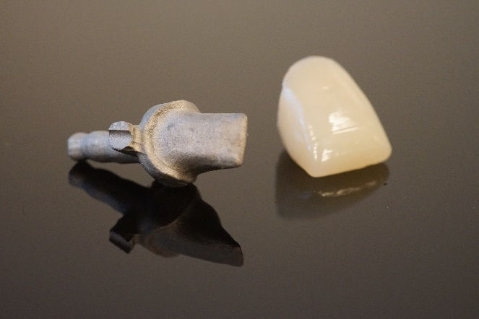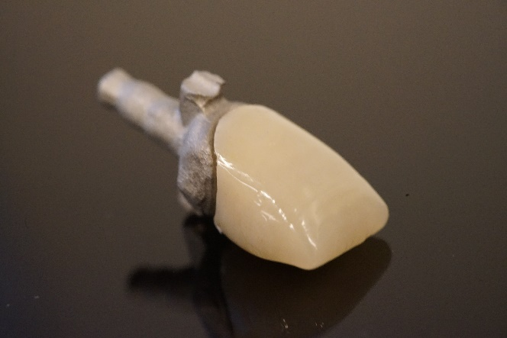
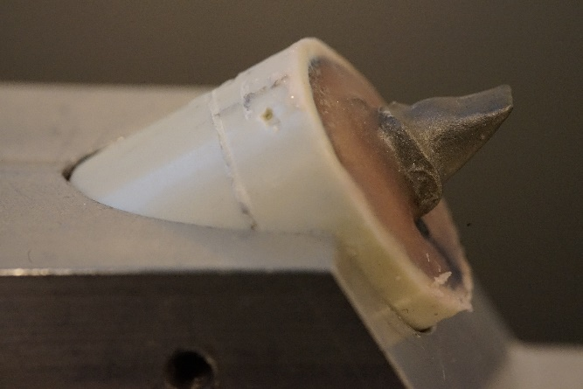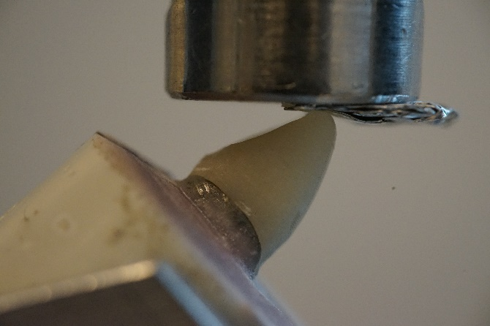

Figure 1

Figure 2

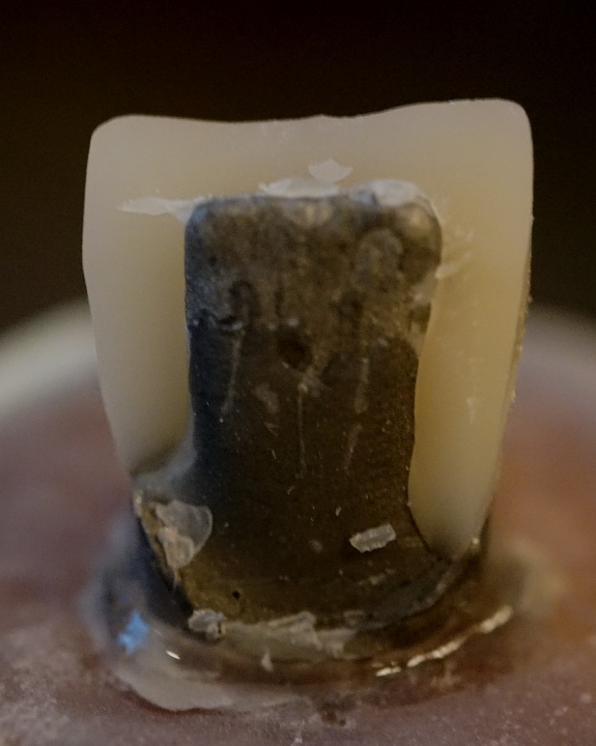
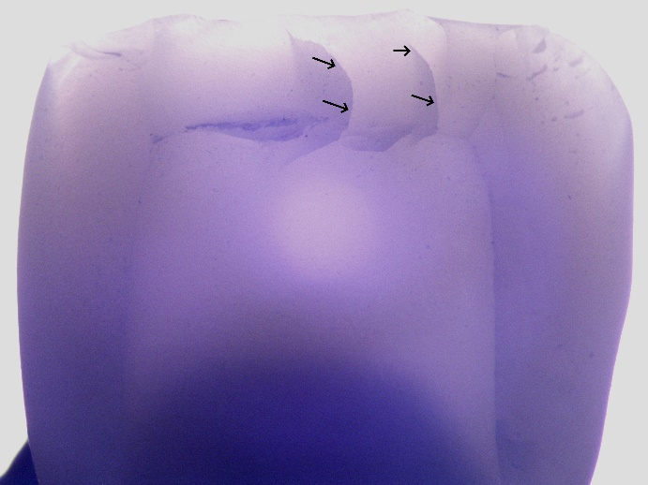

Figure 3

A
B
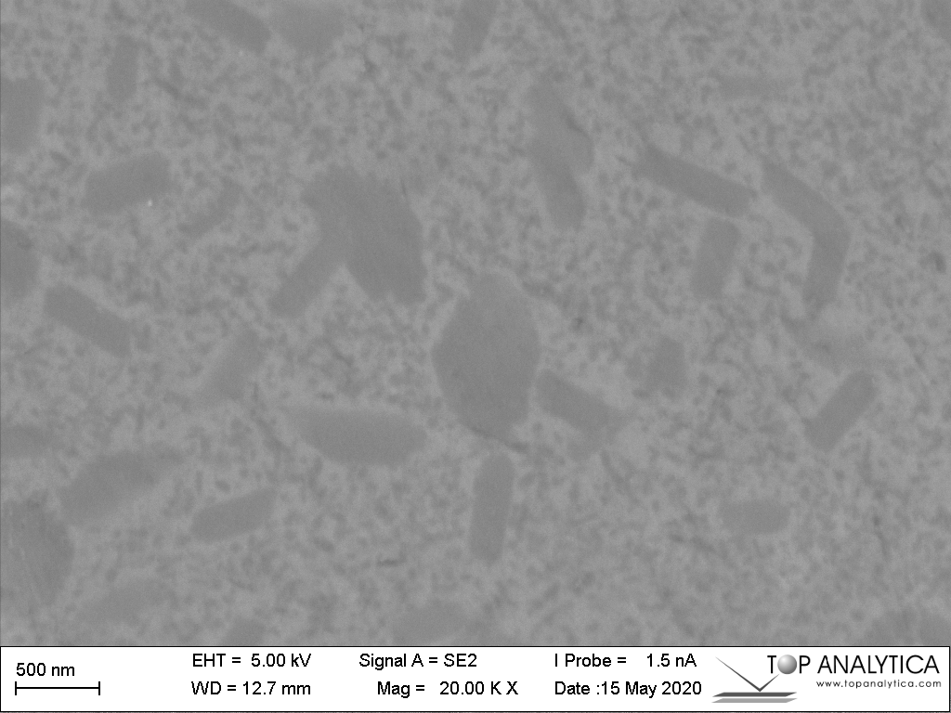
C
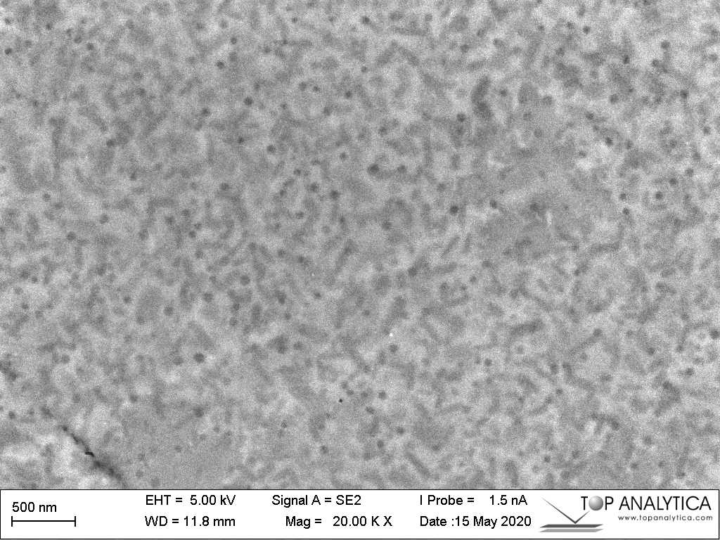
D

Figure 4

