Ideological Motives, Digital Divides, and Political Polarization: How Do Political Party Preference and Values Correspond with the Political Use of Social Media?

Abstract
Social media provides new platforms for political participation and ideological categorization. However, little research has been done on how party preference is related to politically active social media use. We begin with a consideration of how political participation on social media has evolved between various socio-economic and demographic groups in advanced information societies and especially in Finland. In our empirical analysis we examine the general use of social media as well as its use for political purposes with the aid of a nationally representative dataset, collected in 2017–2018 from 3,724 Finnish citizens. We argue that there are notable differences between parties when examining their supporters’ social media use for political purposes. The differences are related to the digital divides and political extremes. The results confirmed the idea that new political movements made up of younger and more educated supporters have been successful by leveraging social media. The study also revealed that the ideological gap between party supporters is greater in social media especially when examining new kinds of politics based on cultural questions, identity issues, quality of life concerns, and post-materialist values.
Keywords: social media, participation, political values, party supporters, Finland

Introduction
In this article, we analyze how Finnish party supporters follow and engage in political discussion on social media. We examine the digital public sphere and the societal and value-based premises of the multiparty context therein. We argue that there are several sociodemographic and value-based factors that suppress and provoke political discussion in the politically biased spaces of social media.
In the Finnish public sphere, the term extreme ends has become widely used when discussing political engagement on social media. The idea behind the term is that the Finnish political domain is filled with opinions from the opposite ends of a polarized political field. For example, during his presidential campaign, the current president of Finland, Sauli Niinistö, recommended that Finnish citizens avoid these extreme ends in their opinions to do with immigration policy. Additionally, the former Prime Minister Juha Sipilä supported the president’s recommendation and saw extreme ends as a harmful phenomenon for Finland’s societal cohesion.
The various social media platforms constitute the most visible and prominent social space for extreme ends. Today, almost all significant societal information is first spread through social media platforms—such as Facebook, YouTube, Twitter, and Instagram—that enable unparalleled participation in discourse and the emergence of new social movements. In this sense, social media has been a disruptive socio-technological actor in the political field as citizens have bypassed traditional informational or organizational gatekeepers (Di Gennaro and Dutton, 2006; Jenkins, 2006). Thus, social media can be understood as a new and important discursive space that has an enormous impact on which political issues are raised in the formal sphere of politics, what issues are reported on by traditional media, and what discourses are spread and popularized in Finnish public discussions.
Former theoretical and empirical research suggests that the development of social media has caused an enormous transformation of political participation and engagement. These new modes of political participation have been described as connective action (Bennett, 2012), networked individualism (Wellman et al., 2003), and participatory culture (Jenkins, 2006). Taken together, these concepts portray how new means of political participation and engagement differ from the traditional ones, such as voting, party membership, and contacting legislators, that were based on hierarchical party structures. Instead, the new means of political action are more likely to be based on individuals’ motivations (Bennett and Segerberg, 2012) and can be employed through activities such as sharing political information via social media networks (Vromen et al., 2015).
However, social media can also be a risky aspect of modern social life that works as an echo chamber that reinforces already-existing opinions and blocks divergent views from spreading (Colleoni et al., 2014; Hong and Kim, 2016; Ingrams, 2017). Notably, users of social media tend to be in contact with other users who share similar views and tend to search for information that supports already-accepted perspectives and beliefs (Gilbert et al., 2009; Boutyline and Willer 2017), which can polarize the social spectrum on any given issue (Gunnarsson Lorentzen, 2016; Strandberg et al., 2019). This sort of political polarization is as a fundamental component of the concept of extreme ends.
From the dawn of social media era, scholars have tried to determine whether social media is going to equalize the political field or normalize ever-present power-relations between the political actors (Enli and Skogerbø, 2013; Larsson, 2015; Larsson and Kalsnes, 2014; Lilleker et al., 2011). However, previous research on normalization or equalization of party differences on social media is mostly focused on politicians’ actions on social media especially during the political campaigning. This article contributes to the theoretical discussion about so called normalization and equalization hypotheses by spreading the scope from actions of political elite to social composition of party supporter groups, concentrating on the political context outside election campaign period, and placing the ideological aspects in the center of analysis. Simultaneously, this article portrays the mechanisms behind the political polarization from party political perspective.
By examining nationally representative survey data (n = 3,724), our empirical analysis focuses on how party preference is related to politically active social media use. We are primarily interested in the composition of the political space on social media in terms of different ideological standpoints. Additionally, we are interested in determining whether some political views are either over- or under-represented in these digital discursive spaces. We propose the following research questions:
RQ1) To what extent does a clear party preference motivate citizens to engage in politics on social networking platforms?
RQ2) How do the consistent values related to party preference motivate citizens to engage in politics on social networking platforms?
However, knowing that political engagement on social media as well as party preferences and social media use in general have a strong correlation with different structural factors—such as age, socioeconomic position, education level, and gender—we are also interested in how different demographic factors affect political engagement on social media. Thus, we also ask:
RQ3) To what extent is political engagement on social media confounded by sociodemographic factors?
The article is structured as follows. First, we clarify how political participation has transformed during the 21st century and how political participation on social media has evolved between various socio-economic and demographic groups in advanced information societies. We then conduct the literature review by developing hypotheses for party differences based on previous research on party cleavages and digital participation in terms of demographic patterns and value dimensions in the Finnish political spectrum. Afterward, in our empirical analysis we examine the general use of social media as well as its use for political purposes. In the discussion section, we present the implications of our findings and consider the location and functions of the extreme ends in the Finnish multi-polar and complex political field. We also take into account potential limitations and further research avenues.

The evolution of online participation
Traditionally, political participation has been understood as citizens’ engagement that involves the selection of government representatives and actions like voting, campaign activity, and contacting officials or legislators (Verba et al., 1978). As these traditional ways of collective participation have diminished in significance, especially among younger generations (Kestilä-Kekkonen and Korvela, 2017), new forms of participation have begun to emerge that are distinct from conventional institutional structures (Holt et al., 2013).
The transformation behind these new means of political participation has been described with concepts such as participatory culture (Jenkins, 2006), networked individualism (Wellman et al., 2003), and connective action (Bennett, 2012). In Henry Jenkins’ (2006) concept of participatory culture, citizens of contemporary Western democracies are described as active participants. Citizens now use social media not only to access certain content but also to produce and share their own content about political issues, which can spread to broad publics and catch the attention of journalists and even legislators. Notably, by creating and sharing content, citizens are actualizing new forms of online political participation (Gil de Zúñiga et al., 2012; Vromen et al., 2015), where the aim is to achieve one’s political goals by participating in the public sphere on social media. In this sense, the internet’s high level of interactivity and the vast number of alternative channels have outstripped traditional gatekeepers, encouraging citizens to engage politically (Jenkins, 2006).
Barry Wellman et al. (2003) have conceptualized the transformation of citizen networks during the internet era. Wellman argues that networked individuals are embedded in loosely knit networks rather than being members of traditional social groups. In this sense, networked individualism and personalization of politics have also transformed the networks where current political actions are actualized.
In their article, Bennett and Segerberg (2012) compare differences between traditional and new forms of political action. According to Bennett and Segerberg, traditional collective action mainly refers to political action and participation that occur through strong organizational coordination, while new connective action has little or no organizational control. Instead, connective action is more likely to be based on individuals’ action frames, and political identification is more likely to be based on their lifestyles, values, and views (ibid.). Instead of traditional political collectives where organizational hierarchies can be detected (like political parties), new political collectives seem to be more likely to be formed as loose networks, where different personalized premises are connected to larger political goals rather than explicit ideological and interest-based struggles.
The transformation of individuals’ political and social lives has had an impact on how citizens are engaged politically. Earlier research suggests that social media platforms are especially popular spaces for political action among the youth and young adults, especially in Western countries. Ariadne Vromen and her research group (2015) carried out group interviews with young adults in Australia, the United Kingdom, and in the United States. Their research showed that young citizens feel that social networking sites offer a communicative space that does not occur elsewhere. Additionally, the event organizing, information sharing, and especially everyday political talk on social media platforms were highly essential means to engage politically for young citizens in all three countries. In their research, Vromen and her team emphasize everyday political talk as the most important mode of contemporary political engagement (ibid.).
Additionally, Kjerstin Thorson (2014) highlights the concept of social politics curators, which underlines the high impact of information sharing online. Here, social media users are actively framing and disseminating all manner of political content on their networks based on personal preference, again illustrating the impact potential of the individual in the digital age (ibid.). It is important to note that the new means of political action are not only about what citizens produce but also about what they transmit.
Internet and social media have had an enormous impact on citizens’ social lives and political engagement. In Finland, young people especially are not actively joining parties or workers’ unions, and as voters they are more passive (Kestilä-Kekkonen and Korvela, 2017). However, social media and other social spaces on the internet offer new means for citizens to participate in politics. These extensive changes in politics are challenging the traditional political parties. Therefore, parties need to adapt if they wish to prosper. Next, we are going to clarify the current setup of the Finnish political field.

Party preference and political values in the Finnish online public sphere
There has been a notable shift as new politics-related values have been gained in prominence in terms of party choice in the Finnish multiparty system (Westinen, 2015; Knutsen, 2018). The traditional Nordic political cleavage based on social and economic issues and class-based interests has been partly replaced with a new divide based on post-materialist values concerning, for instance, minority rights and environmentalism (Inglehart, 1990; Knutsen, 2018, p. 256). In the Western context, the shift toward post-materialist values has given rise to a counter-revolutionary cultural backlash among conservatives who are actively rejecting the post-materialist values while supporting neoconservative politics related to authoritarianism, nativism, and nostalgia for the past society (Norris and Inglehart, 2019). This new political dimension has also been described as the GAL–TAN-dimension, derived from the words Green, Alternative, Libertarian – Traditional, Authoritarian, Nationalist (see Hooghe et al., 2002).
In Finland, the cultural backlash truly became apparent in the parliamentary elections 2011 and 2015, in which the populist party, the Finns Party (FP), was voted the third largest party (Arter, 2011; 2015). In contrast to other Finnish parties, the FP, in particular, has been underlining neoconservative and center-right values, populist politics, and, for instance, skepticism toward gender equality and multiculturalism (see Hatakka, 2017; Jungar and Jupskås, 2014). As with other European populist parties, the FP’s supporters and members have more generally represented the working class and those of lower social status (Keipi et al., 2017; Norris and Inglehart, 2019). However, a significant proportion of the FP voters worked as professionals in the beginning of 2018 (Sivonen et al., 2018a), which indicates that the FP has also become an option for the middle class. Still, this contradiction between the supporters’ societal status and the emphasis of center-right values in terms of social and economic issues reveals the distance between the FP’s political agenda and traditional class-based politics in Finland.
In public discussion, supporters of the FP have been straightforwardly positioned against the green liberals and the political left. Partly deservedly, the Green League (GL) has been considered to be the clearest discursive opponent to the FP. First of all, the supporters and members of the GL are predominantly composed of urban youth and the highly educated (Keipi et al., 2017). Secondly, in contrast to FP, the Greens strongly emphasize post-materialist values (Saarinen et al., 2018). However, as with FP, the GL is also without common class interests or a visible orientation in the left–right scale (Mickelsson, 2015).
As these new identity parties, the FP and the GL, have diverged from the traditional left–right spectrum, the Left Alliance (LA) has also actively developed from a traditional working-class party into a so-called new left party. Nowadays the LA is—alongside with the GL—firmly based on shared post-materialist values and opinions concerning, for example, equality, tolerance, and minority rights, especially in terms of gender, ethnicity, and sexuality (Koivula et al., 2019; Lönnqvist et al. 2019). This transformation can also be detected in the changed background of the party’s members and supporters: the LA’s new members and supporters in this decade are more likely to be highly educated, young, and female (Keipi et al., 2017).
Before the rise of the new parties, the National Coalition Party (NCP), the Social Democratic Party of Finland (SDP), and the Centre Party of Finland (CPF) had been the largest parties for over three decades, leaving a significant mark on the Finnish political system. According to the classic work of Valen and Rokkan (1974), the political core of Finnish society is still strongly formed around various group-based class interests (Saarinen et al., 2018). The left-wing party SDP still represents the interests of workers and their unions, while the right-wing NCP still has the most positive attitudes toward the interests of entrepreneurs and the upper strata. The CPF promotes the interests of farmers and other people living in rural regions (Karvonen, 2014, p. 29; Koiranen et al., 2017).
In addition to the major parties, there are also the two parliament groups, namely the Christian Democrats (CD) and Swedish People's Party (SPP), that have continued to maintain two notable and traditional cleavages: the church–state division and ethnolinguistic one (Westinen, 2015). Moreover, several minor parties, such as the two communist parties, outside of the conventional parliamentary decision-making can be seen as relics from prior decades. However, there are some minor parties from the 21st century whose agendas are linking up with the new political questions. In the margins of the Finnish political field, there are, for example, the Feminist Party, the Animal Justice Party, and the Pirate Party. The core political questions of these parties are far from the traditional socio-economic cleavages and the collective-interest groups of the Finnish society.
When these aspects of the transformation of political participation and changes in the Finnish political field have considered, it is crucial to determine how political parties and their supporters are blended in these loosely structured networks of social media. To sum, the significance of social media arises from large social networks, which provide diverse information and offer new opportunities for political and civic action and for different population and ideological groups to form. In this sense, the Finnish multi-polar multi-party system provides a sophisticated setting to define the aforementioned extreme ends.

Divides and incentives of online participation
Scholars have argued that one of the most striking threats to modern democracies is the development that political participation is narrowing to only well-off and small elites positioned at the highest strata of society (Hindman, 2009; Giger et al., 2012; Rosset et al., 2013). Earlier research shows that high societal status is an essential factor in having both the motivation to participate in political processes and the skills to do so. It seems that those in the highest societal strata are in the best position to promote their interests. (Butler, 2014.)
Inequality in participating and promoting one’s interests can also be seen as a crucial problem in participation on social media platforms. Differences in the use of technology among various population groups within a society have been described by the term digital divides. The term illustrates how technology and internet use, use potential, motivations, necessary skills for productive use, use purposes, and benefits gained from the use are unevenly distributed depending on various socio-demographic characteristics (see DiMaggio et al., 2001; Norris, 2001; Schradie, 2011; van Dijk, 2005). Indeed, younger, highly educated, and wealthier population groups tend to have more experience with technology use and a better ability to take advantage of new platforms. Additionally, they are also more capable of improving their consumption, leisure activities, and activities connected to civic and political participation through the internet (see DiMaggio et al., 2001; Schradie, 2011; van Deursen and van Dijk, 2011; van Deursen and Helsper 2015; van Dijk, 2005).
Here, in the case of social media use, differences in usage patterns mean differences in access to information and valuable interaction among users even when everyone has access to the platforms in question. Furthermore, there is significant inequality in the population groups represented in the public discourse that happens through social media (Hargittai and Walejko, 2008; Jungherr, 2016; Schradie, 2011). Notably, as digitalization has continued in Western countries, divisions in social media use in terms of access have greatly lessened, but the differences in beneficial use practices, such as civic and political participation, have grown among population groups in Finland (Koiranen et al., 2019). Due to this uneven distribution of access and use, social media’s informational and societal benefits are divided unequally in society (van Deursen and Helsper, 2015).
In this respect, it is crucial to know whom the digitalization of society has driven to various modern forms of political participation and who can improve their societal position in modern society through these new ways of civic engagement. The polarization of possibilities and opportunities in participation can lead to inequality between people within democracies, and, in turn, place limits on representation and expression depending on demographic and structural issues.
Due to the sociodemographic structures of Finnish parties, digital divides affect how parties can utilize new means of communication and how their political goals gain popularity through social media platforms. In the Finnish context, there is evidence that the new identity parties’ supporters and members are more embedded in social media when compared to traditional interest parties (Hatakka, 2017; Koiranen et al., 2017; Koiranen et al., 2018).
In addition to explanation models derived from parties’ sociodemographic composition and structures, there are also possible explanations connected to cultural and organizational elements of parties. One important aspect is that politicians’ and party elites’ active use of social media may activate their supporters to engage politically and, for example, use social media for political purposes (Enli and Skogerbø, 2013; Larsson, 2015). In this respect, differences in political social media use between parties’ supporter groups may be partly derived from organizational aspects of Finnish parties, i.e. how parties and their representatives are engaging digital political sphere molded by the changes in participatory culture.
In earlier research there are mixed results how parties, party elites, and representatives are utilizing social media for politically effective purposes. First of all, there are empirical evidence supporting the equalization hypothesis, that social media is offering an alternative channel to affect publics especially for those politicians who are in marginalized position in mainstream politics and traditional news media (Enli and Skogerbø, 2013; Hong et al., 2019; Larsson and Kalsnes, 2014). For example, Larsson and Kalsnes (2014) found that Swedish and Norwegian politicians who were younger, who lack attention in traditional media channels, and who were representing opposing parties utilize social media more actively. Nonetheless, there are also evidence supporting opposed perspective known as the normalization hypothesis, that social media is more likely maintaining similar power relations between political actors as in offline sphere (Lilleker et al., 2011; Larsson, 2015).
Previous empirical findings in Finnish context are more evidently supporting the latter hypothesis. For instance, Kim Strandberg’s (2013, 2016) research has shown that parliament candidates from bigger parties with greater party support are more active users of different digital campaign methods and platforms, such as social media. Similarly, former MPs who had consolidated their position in Finnish political elite were significantly more active in social media when compared to new contenders (ibid.). Additionally, Railo and Vainikka (2017) showed that the most active and important Twitter users in Finnish political context were part of well-established political elite with substantial resources for campaigning. In this sense, it may be that parties’ organizational abilities to offer support and guidance for their representatives to utilize social media platforms is reflected also on how actively party supporters use social media platforms.
Thus, when reflecting to previous empirical evidence of Finnish politicians’ use of social media, this paper generates new information related with the gap between so called supply and demand side of politically active social media use: even though parties’ organizational efforts, content may not become viral since audience’s characteristics. However, if parties’ supporters are highly embedded in social media networks and produce and share political content actively, parties are more able to turn this attention to concrete results, for example, in elections. This may also extensively transform the power relations between the political parties, primarily in the public spaces of social media but also in the broader societal context, specifically in the public sphere of Finnish society. For this reason, it is essential to find out how the party supporters are engaging politically through social media.

Hypotheses
Past research on the dynamics of political participation in social media and the changes in the Finnish political spectrum provides a baseline for the formation of our hypotheses. Arguably, social media plays a crucial role in new political forms of action (Bennett, 2012; Bennett and Segerberg, 2012; Loader et al., 2014; Vromen et al., 2015). Also, active users of social media tend to be predisposed to political news through their networks (Boulianne, 2015). In this respect, social media enables access to political issues and information without requiring users to seek them out (Pasek et al., 2009; Xenos et al., 2014), which further expands the meaning of user-generated political content on social media. These developments have been particularly significant in the formation of a new digital public sphere constituted on the social media platforms.
Earlier research suggests that political awareness and clear political values encourage citizens to participate in political action and to follow political events (Bekkers, 2005; Gil de Zuniga et al., 2012). Therefore, we suggest that (H1) citizens with a clear party preference are more likely to be politically active on social media. Additionally, earlier research suggests that new identity parties’ supporters in Finland are more connected to social media and different online communities (Hatakka 2017; Koiranen et al. 2017). In this respect, we also expect that unlike parties’ political elites (H2) supporters of the new identity parties are more likely to be politically active on social media compared to the supporters of the traditional interest parties.
The Finnish political spectrum can still be seen as quite strongly reflecting different group-based class interests (Karvonen, 2014), but it has also shifted toward the post-materialist and neoconservative values (Norris and Inglehart, 2019). In this respect, we assume that both socioeconomic issues and post-material questions have great importance in the formation of the political sphere on social media. Therefore, we expect that (H3) politically active social media users are more likely to be positioned at either end of the socioeconomic and post-material value scale.
In the context of digital divides, political participation on social media can be comprehended as a mode of usage, which is highly connected to different motivational aspects and skill sets and can produce a broad set of different societal benefits. Political participation is also more common among younger generations insofar as it occurs online (e.g. Schradie, 2011; van Deursen and van Dijk, 2014). Also, recent research shows that men and the highly educated people of higher socioeconomic status are more likely to be politically active online (Gil de Zuniga et al., 2012; Jungherr, 2016). Simultaneously, these sociodemographic factors strongly correlate with citizen’s party preferences (Westinen, 2015). Hence, we expect that (H4) demographic factors, namely age, gender, and education, confound party differences in politically active social media use. We also expect that (H5) those demographic factors confound the differences between those who participate and those do not.
Although party supporters’ sociodemographic background is crucial in defining party visibility on social media, we expect that (H6) party supporter groups have cultural differences connected to political use of social media. Party supporters are in a privileged position to spread political topics, content, attitudes, and values organically through social media networks. By controlling for different important sociodemographic factors behind the political use of social media, it is possible to assess participatory culture, connective action, and networked individualism that are embedded in party supporter groups on social media.

Study design
Our analyses are based on survey data that included 3,724 respondents, of whom 66% were from the probability sample. We distributed the first part by mail to a simple random sample of 18- to 74-year-old Finnish speakers (8,000 in all). We obtained 2,452 responses, which amounted to a 31% response rate. In order to guarantee enough observations from social media users, we improved the data with 1,200 volunteer respondents aged 18 to 74 from a nationally representative online panel that a market-research company administered. (*Removed for blind review*.)
The technical report suggests that the data represent the demographic distribution of Finnish people, although the oldest groups are slightly overrepresented and the lowest-educated groups are underrepresented (*Removed for blind review*). The report also indicates that the nonprobability sample reinforces the demographic representativeness of the probability sample; however, there are qualitative differences between samples, such as people’s interest in various types of news, which indicate a potential sampling error. We took that into account and conducted a robustness check for the main effects by obtaining the estimates separately from the two samples. We also controlled the bias related to age and education distribution by weighting the sample’s demographic distribution to correspond with the official population distribution of Finnish citizens according to Official Statistics of Finland (*Removed for blind review*).
Measures
We formed three dependent variables to measure the general use of social media, the following of political discussion on social media, and the participation in political discussion on social media. Initially, respondents were asked how often they spend time on social media, how often they follow political discussion, how often they participate in political discussion on social media, how often they share political content on social media, and how often they create political content on social media. Participants were given six options to choose the intensity of usage. Variables were recoded as two-class variables, as a value of 0 was given to respondents who were not active at all and a value of 1 was given those who were active at least sometimes. Our primary independent variable is a measure of online political engagement. This variable involves various types of social media participation, such as sharing or creating political content and participating in political discussion. When analyzing party supporters’ following of political content and activity of participation, we focus solely on social media users. Descriptive statistics for dependent variables are shown in Table 1.
Table 1. Descriptive statistics for dependent variables
 | N | %
Use of social media
Not at all | 1,171 | 32,4
At least sometimes | 2,442 | 67,6
Following discourse*
Not at all | 525 | 22,5
At least sometimes | 1,805 | 77,5
Participation in discourse*
Not at all | 1,204 | 51,6
At least sometimes | 1,131 | 48,4
* Social media users only

We defined party preference by determining the political party that the respondents felt most closely matched their beliefs. In analyses, we focused on the six largest parties: the Centre Party of Finland, the National Coalition Party, the Finns Party, the Social Democratic Party of Finland, the Green League, and the Left Alliance. Due to lack of data, the supporters of other parliamentary parties—the Swedish People’s Party, the Christian Democrats, and the Blue Reform—were grouped with other minor parties in the “Other” category. Those who did not prefer any party we grouped in the “None” category.
In terms of control variables, we accounted for respondents’ gender, age, education, and interest in political affairs. We determined the respondents’ age via an open question in which the respondents reported their year of birth. We categorized the respondents’ education following the International Standard Classification of Education. Because interest in politics is one of the most prominent factors behind political engagement, we also wanted to standardize this effect (see Bimber et al., 2015). Descriptive statistics of applied demographic variables are shown also in Table 2.
Table 2. Descriptive statistics for categorical independent variables
 | N | %
Party preference
Centre (CPF) | 410 | 11.5
Finns (FP) | 257 | 7.2
Coalition (NCP) | 585 | 16.5
Social Democrats (SDP) | 467 | 13.1
Green league (GL) | 507 | 14.3
Left Alliance (LA) | 243 | 6.8
Other (OT) | 238 | 6.7
No identification / refused (NO) | 846 | 23.8
Gender
Male | 1,838 | 50.7
Female | 1,788 | 49.3
Age
18–30 | 458 | 12.6
31–45 | 571 | 15.7
46–55 | 559 | 15.4
56–65 | 636 | 17.5
66–84 | 706 | 19.5
Education level
Primary | 597 | 16.7
Secondary | 2,021 | 56.7
Tertiary | 947 | 26.6

After the analysis of demographic patterns, we focused more intensively on the effects of respondents’ political activity and views. First, we measured interest in political affairs by the respondents’ self-ratings of their interest in politics. The scores, which ranged from 0 (very little) to 10 (very interested), were used as a continuous variable. Political values and views were measured by applying the Social and Economic Conservatism Scale (Everett, 2013), which was modified to fit the Finnish context. For example, social and economic questions result in more prominent political cleavages in Finland, which is why such questions were added to the questionnaire. In addition, we reduced an initial response scale from 100 to 10, where 0 represents very negative and 10 very positive.
We concentrated on the most crucial political cleavages in Finland—namely, the socioeconomic value scale (LEFT–RIGHT) and the new important political cleavage, the post-material (GAL–TAN) value scale. The socioeconomic value scale was formed from questions concerning cuts in social security and welfare, dissolving the welfare state, privatization of public services, and increasing the individual responsibility in securing one’s livelihood. The GAL–TAN scale was formed from questions concerning abortion rights, gender-neutral marriage, environmental policy, patriotism, traditional values, funding of defense forces, and immigration policy. Descriptive statistics of applied variables are shown in Table 3.
Table 3. Descriptive statistics for continuous in/dependent variables
 | Mean | SE
Socioeconomic value scale (LEFT–RIGHT) | 2.82 | 0.032
Post-material value scale (GAL–TAN) | 4.88 | 0.027
Interest in political affairs | 5.54 | 0.047

Figure 1 shows how the supporters of the largest parties are positioned on the socioeconomic and the post-material value scales. This figure provides a starting point for our analyses. On the socioeconomic value scale, the most extreme parties are the LA and the NCP. The supporters of the SDP and the GL are slightly on the left side of the scale when compared to the population mean, and the CPF and the FP are slightly to the right. As mentioned before, the most noticeable difference on the post-material value scale is found between the supporters of the GL, the LA, and the FP. The SDP’s and the NCP’s supporters are close to the population mean, and the CPF’s supporters are slightly closer to neo-conservative values. When adjusted for the confounding effects of the sociodemographic variables and the interest in politics, differences between the parties are slightly narrower but mostly remain the same.
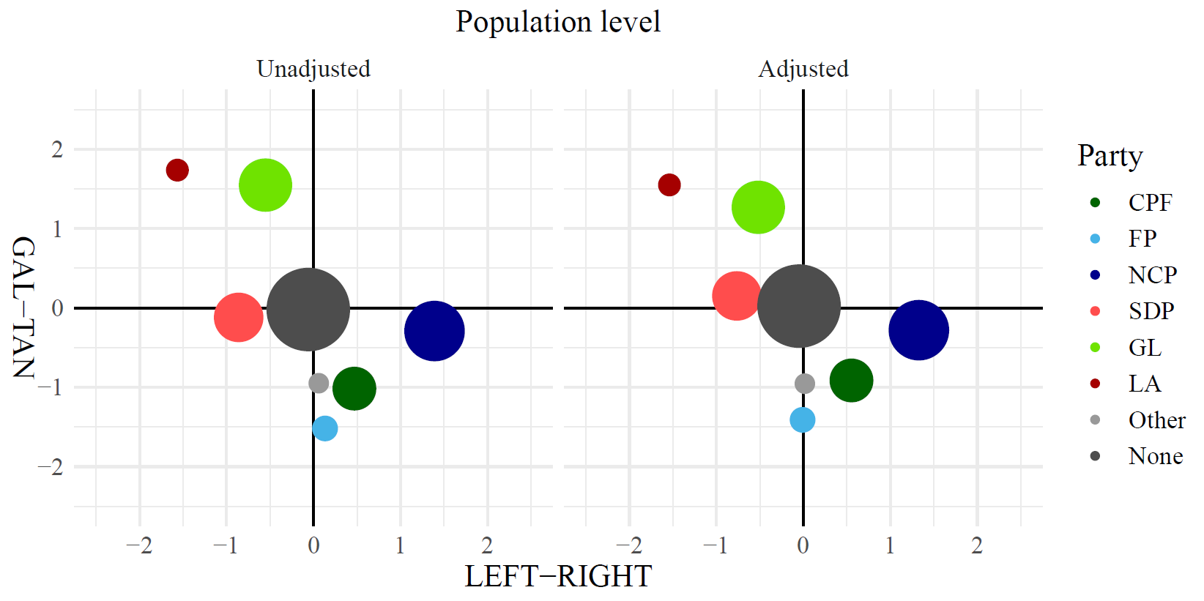
Figure 1. Finnish parliamentary party supporters’ average position on the post-material value scale (GAL–TAN) and on the socioeconomic value scale (LEFT–RIGHT).
Statistical techniques
We began our empirical analysis by running a multinomial logit regression, which allowed us to assess the likelihood of party supporters using social media in general and for political purposes. We also considered how sociodemographic factors—namely age, gender, and education—and general political interest confounded these associations. The main results of logit regressions are illustrated in the figure, while the full models are presented in the appendices.
In the second phase of the empirical study, we assessed the direct effect of online political participation on the value scales. We also tested the sample effect by using separate models for the probability and nonprobability samples. To gain a better understanding of the variance across subscales, we used standardized values for each dependent variable. We conducted the statistical tests using analysis of variance (ANOVA) and calculated parameter estimates for non-participants and participants by supporter groups.
Finally, we also tested the interaction effects of party groups and online participation by utilizing ordinary least square (OLS) regression. In general, the interaction effect assumes that the effect of the independent variable on the dependent variable is modified by the value of a third variable (Jaccard et al., 2003). We hypothesized that the party preference modifies the relationship between online participation and the position on the value scales.

Results
We began our analysis by examining what kind of party differences existed based on social media use. We specifically focused on party supporters’ activity in using social media, following political content, and engaging politically on social media. In Figure 2 we present odds ratios (OR) and 95 percent confidence intervals for differences between party supporters and those who do not identify party at all. The first hypothesis (H1) was confirmed as supporters with a definite party preference were generally more active in participating and following political discourse on social media than those who had no clear party preference. Interestingly, there were only minor differences in the general use of social media between politically consistent and inconsistent citizens.
The second hypothesis (H2) was also confirmed. First, the supporters of the GL and other minor parties were the most active groups in terms of general social media use and differed primarily from the supporters of CPF and SDP. Second, the supporters of the LA were found to be the most active group in terms of following political discourse. Finally, the supporters of the FP, the LA, and the GL were more active in terms of participating in political discourse when compared to traditional interest parties’ supporters.
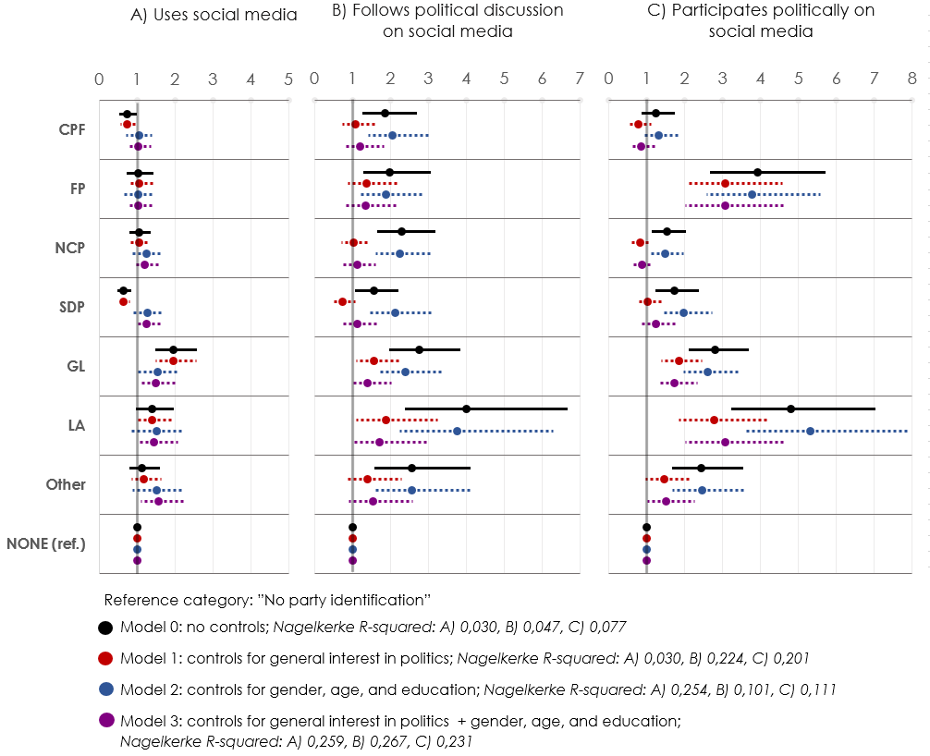
Figure 2. Odds ratios and 95 percent confidence intervals for party supporters’ social media use, following of political content, and politically active social media use. Full models presented in Tables A1–A3.
Additionally, we tested the extent to which party differences are confounded by crucial background factors, namely gender, age, and education. Confirming our fourth hypothesis (H4), the sociodemographic background did confound the effect of party preference. Here, we expected remarkable changes in party patterns as we know that there is substantial variation in party supporters’ demographic distributions. This is especially the case with the CPF and the SDP because we consider their supporters to be generally older than the supporters of other parties.
First, we added a variable measuring general interest in politics, and after that we added those background factors into the base model step-by-step and estimated their independent effect on the dependent variables. We found underlying divides in digital participation as the data emphasized that there were still remarkable differences between education groups, genders, and younger and older participants in terms of all dependent variables. Regarding education, these associations were especially apparent between those who had achieved at least a bachelor’s degree and the less educated. Also, younger participants were far more likely to follow political discourse and participate in it. There was also a modest difference between men and women, as women were more likely to use social media. Additionally, general interest in politics had a significant effect on differences between party supporter groups’ tendency to follow political content and participate on social media (see Tables A1, A2, & A3).
In the second part of the analysis, we tested how online political activity modifies party supporters’ placement in the socioeconomic (LEFT–RIGHT) and the post-material (GAL–TAN) value scales. Figures 3 and 4 illustrate the main results obtained from the models presented Tables A4 and A5. First, we found significant effects of online political activity among supporters of the NCP, the GL, the LA, and other minor parties when considering placement in the socioeconomic value scale. These effects were partly explained by party supporters’ social background, while difference on the socioeconomic scale grew between participants and non-participants in NCP’s, SDP’s and GL’s supporters. Additionally, adding social background variables into the model reduced the difference on the socioeconomic value scale in the LA’s and other minor parties’ supporter groups.
Additionally, interest in political affairs was facilitating the effects among the NCP’s, the SDP’s, the LA’s, and other minor parties’ supporter groups. The results indicate that those party supporters who are interested in political affairs use social media for political purposes, and they are also placed at greater extremes in the socioeconomic value scale.
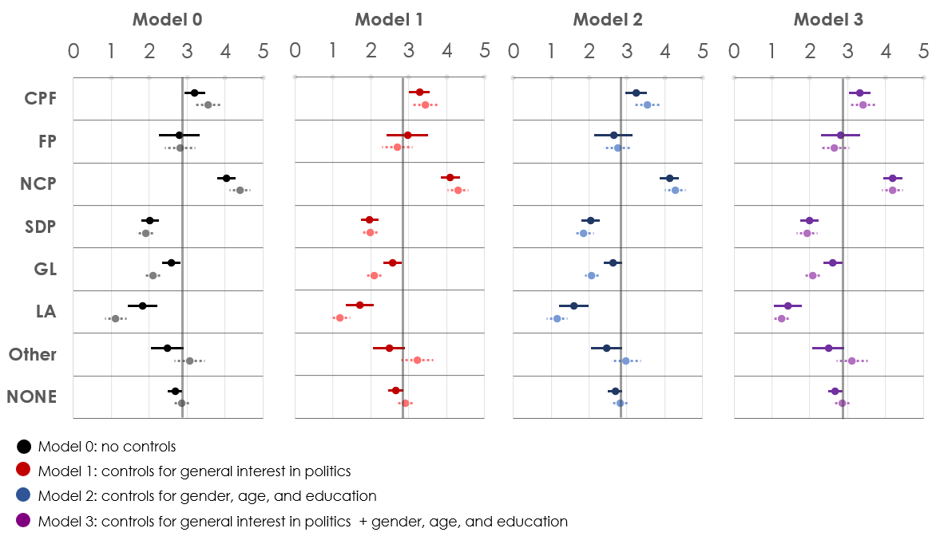
Figure 3. Predicting the position on the socioeconomic value scale (LEFT–RIGHT) for non-participants’ (dark colors) and participants’ (light colors); the parameter estimates with the 95 percent confidence intervals. The full multivariable models with F-values are presented in Tables A4-A5.
Online political activity was also apparent in terms of post-material values. Active social media users have generally placed more likely supporters of the NCP, the SDP, the GL, and the LA as GAL-values in the post-material value scale. However, we did not find confirmation for the polarizing effect, as the online political activity did not affect the FP supporters’ placement towards the TAN-values.
General interest in political affairs did have a strong confounding effect on the placement of the FP’s, the SDP’s, the GL’s, and the LA’s party supporters on the post-material value scale. Additionally, adding variables measuring respondents’ social background confounded the difference between participants and non-participants, especially in the LA’s supporter group.

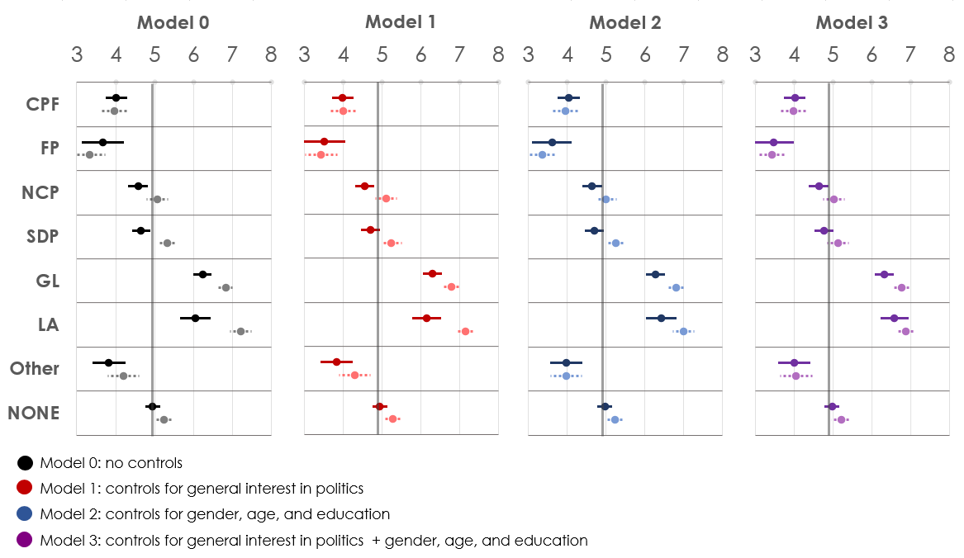
Figure 4. Predicting the position on the post-material value scale (GAL–TAN) for non-participants (dark colors) and participants (light colors); the parameter estimates with the 95 percent confidence intervals. The full multivariable models with F-values are presented in Tables A4-A5.
The result of the second analysis confirms the third hypothesis (H3) with some exceptions. In the case of the socioeconomic values, results supported the hypothesis, while respondents positioned at either end of the socioeconomic value scale were more likely to be politically active on social media. However, we did not find such an effect in the case of the post-material values. Instead, for the majority of party supporter groups, participants were located more toward the liberal end of GAL–TAN value scale than non-participants.
As seen in Figures 3 and 4, the fifth hypothesis (H5) was only partially supported, as demographic factors confound some party effects. Thus, respondents’ activity level could not be totally explained by gender, age, or education. In this sense, results support our sixth hypothesis (H6) that there are cultural differences affecting how party supports are embedded in connective action and forms of political participation.
Finally, we examined whether the party preference modifies the effect of online participation by analyzing the interaction effects between party preference and online participation when predicting the position on the value scales. As a reference group, we set those who did not have a party preference. The analysis presented in Table A6 confirms that the participation effect is more significant among the supporters of the CPF, the LA, the GL, and the FP when predicting scores on the post-material value scale. In terms of the socioeconomic value scale, the results indicated that the participation effect is more significant among the GL and the LA supporters when compared to those who did not have a party preference.
Figure 5 sums up our most important results from all of the empirical analyses. As our first analysis showed, the proportional share of new identity parties is significantly more prominent among those who participate in social media than on the population level. Additionally, those supporters who share or produce political content are positioned differently on the value scales when compared to the supporter groups’ position on a population level. As seen in the figure, left-wing parties’ participants are positioned more on the left, and right-wing party participants are more on the right. However, participants of almost every party—not including the CPF and the FP—are positioned closer to the GAL-pole than non-participants.
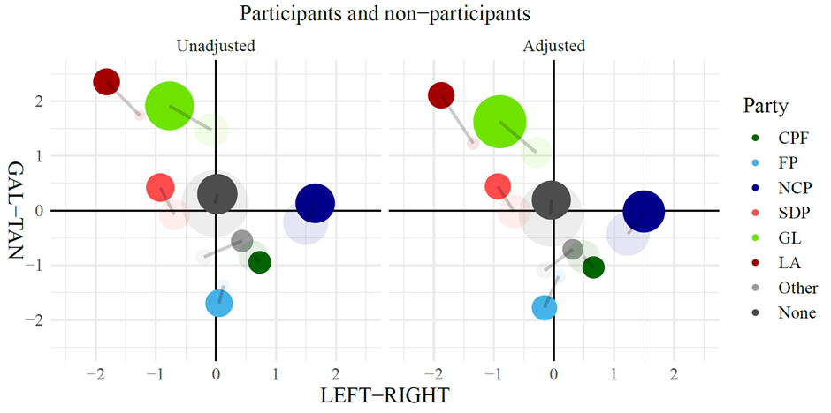
Figure 5. The average position of Finnish parliamentary parties’ social media participants (dark colors) and non-participants (light colors) on the post-material value scale (GAL–TAN) and on the socioeconomic value scale (LEFT–RIGHT).

Discussion and conclusions
After the major loss of the CPF in parliamentary elections in 2019, former Prime Minister Juha Sipilä attributed his party’s defeat to the success of the extreme ends (The Centre Party of Finland, 2019). According to Sipilä, the Centre party was not able to succeed with their overly moderate visions considering issues connected to post-material questions, such as immigration and climate change. For example, Sipilä stated that “Part of the voters felt that whole discussion (about climate change) is humbug—they voted for the Finns. Part of the voters felt that private cars, eating meat, and sauna heating should be banned, preferably today—they voted for the Greens” (ibid.). This quotation reveals important aspects of the transformation of the Finnish political field. First, it shows that the Finnish political field is increasingly molding itself according to post-material and neoconservative issues. Secondly, it shows how traditional interest parties are struggling with this transformation of the political sphere.
The Finnish discussion concerning the extreme ends is connected to the wider international discussion about political polarization. Prior research on political polarization suggests that polarization is gaining more momentum due to social media (Lee et al., 2014). In this study, we wanted to frame the situation behind political polarization in the Finnish social media sphere and to find out how consistent party preference and political values motivate citizens to engage on social media and how confounding background variables might explain these differences. Also, our goal was to determine whether there are differences between political party supporters when examining the political use of social media and whether confounding variables might explain these differences. In this manner, we were able to assess how political views and values are projected onto the digital social sphere and how this is transforming the wider political sphere in Finland.
The first part of the analysis showed important findings regarding the differences between politically consistent and inconsistent citizens. Confirming our first hypothesis (H1), people with a clear party preference are more active on social media. This finding lends itself to earlier discussions concerning the group dynamic effect of social media in two ways. First, easy access to reinforcing information and party ideology (Gilbert et al., 2009), may help to solidify party preference and, in turn, motivate online activity in terms of making those closely held views known on a wider scale. Second, this may also point to the possible political polarization effect of social media that has been part of recent research in that easy access to people with similar views combined with a strong reinforced preference can motivate users to become active in defending increasingly polarized positions (Lee et al., 2014). In both cases, it seems that the threshold for political activity is lower for those with clear party preference.
Confirming our second hypothesis (H2), we found that supporters of the new identity parties—of the GL, the FP, and the LA—were more active on social media. Supporters of the new identity parties were especially more active in participating in political discourse. Also, the supporters of other minor parties were more active when compared to supporters of traditional interest parties.
In this respect, it seems that social media has functioned as a redistributive force when it comes to political practices in Finland. It is a rather comforting thought that the most active participants are supporters from minor political movements whose political and societal position is generally lower when compared to traditional parties. In Finland, for example, traditional interest parties, like the CPF, the SDP, and the NCP, have significantly more essential positions in different institutions and far greater resources to affect voters during elections (Koiranen et al., 2017). According to our results, public discourse on social media does not underpin the status quo in terms of party politics. In this respect, social media has better served the political movements at the margins of society and our results are more likely strengthening the equalization hypothesis over normalization hypothesis, when focus is on party supporter level.
Thus, there seems to be an imbalance between supply and demand sides of social media use in Finnish politics. According to our results supporters of new identity parties are more actively utilizing social media for political purposes, while the political elite of these parties does not positively stand out from traditional interest parties’ representatives – more likely, it is vice versa (Railo & Vainikka, 2017; Strandberg 2013; Strandberg 2016). This disproportion may be derived from wider and stronger party organizations behind the bigger parties, which are having greater resources to offer advice and support for establishing social media accounts and personal web pages for their candidates and politicians. However, these sorts of organizational investments do not seem to pay off, while these organizational efforts do not switch over to productive actions of their supporters.
In addition to clear party preference, consistent values related to a certain preference had a vital relation to political participation on social media. Partially confirming our third hypothesis (H3), a consistent set of political values on both socioeconomic and post-material issues had effects on participating in political discourse on social media platforms. In the case of socioeconomic values, the most active participants represented either more right-wing or more left-wing values in social and economic matters. However, in the case of the post-material value scale, the results diverged from the left–right value scale. In almost every party—not including the CPF and the FP—the active participants were placed on the liberal end in the post-material value scale. In this respect, the post-material value scale does not seem to work as a robust distributive force as has been suggested. Similar results have been found in South Korea, where a panel study showed that the opinions of politically neutral and moderately liberal social media users turned to a more liberal direction over time (Lee et al., 2017). However, our interaction analysis revealed that participants’ and non-participants’ differences on the post-material value scale were significantly larger in the FP’s and the CPF’s supporter groups when compared to those without a clear party preference.
The socio-demographic profiles of parties partly explained party differences in political social media use. We analyzed demographic differences and, based on our fourth (H4) hypothesis, we found that younger people and the highly educated are more likely to follow political discourse and participate in political discourse via social media platforms, which is in line with previous research (Gil de Zúñiga et al., 2012; Jungherr, 2016; Schradie, 2011). Our analysis indicated that the party effects were partially related to the demographic composition of parties. Here, the most striking result was that the effects of older parties, namely the SDP and the CPF, are being significantly confounded by the age of supporters.
Similarly, the second analysis revealed that sociodemographic background also confounded the supporters’ placement on the value scales. Confirming our fifth hypothesis (H5), variance analysis showed that the difference on the value scales between those supporters who participated on social media and those who did not was confounded by sociodemographic factors. Gender had an effect on the CPF, the FP, and the NCP as men were more to the right on socioeconomic issues and more neoconservative. Additionally, gender had an effect on the LA’s supporters as women were more to the left on socioeconomic issues and supported post-material values more than men. Age was the most important confounding variable in almost every party’s supporter groups, not including the FP and the CPF. Interestingly, the impact of age was pronounced when it came to post-material values. Additionally, the confounding effect of education was highlighted in the supporter groups of the same parties and especially in post-material values. Also, general interest in politics confounded the placement on value scales in almost every party’s supporter groups.
These results indicate that digital divides are crucial in the shaping of the political sphere on social media. Different levels of digital divides—related to access, use, skills, and use purposes—filter those who create visible content and define ideological discourses from those who remain silent. In this respect, digital divides are in a prominent position to determine who gains different societal benefits from the use of social media and who does not.
The results show that differences in the political use of social media are connected to the sociodemographic composition of the party supporter groups—but not completely. Giving confirmation for our sixth hypothesis (H6), it is assumed that there are differences parties’ supporters are embedded in participatory culture and connective action. It seems that new kinds of politics based on cultural questions, identity issues, quality of life concerns, and post-materialist values (Inglehart, 1990; Norris and Inglehart, 2019) are the more prominent issues in digital surroundings. Simultaneously networked individualism, personalized politics, and connective action have transformed citizens’ political and social actions in the sense that traditional groups have been substituted by different interests and identities (Bekkers, 2005; Inglehart, 1996), which have now gained more meaning in the flexible spaces of social media (Bennett, 2012; Bennett and Segerberg, 2012).
This indicates that new identity parties operate differently when compared to traditional interest parties. Thus, due to the personalization of politics and social fragmentation, it can be argued that the FP, the GL, some minor parties, and the “new left” within the LA have been able to succeed partly because they are the furthest apart from traditional political collectives and traditional forms of political participation. These kinds of changes in party choice have become visible in supporter-based analyses in which parties have represented a growing number of groups and social classes (see Koivula, 2019; Westinen, 2015). Compared to the traditional Finnish parties, it seems that the ties of new parties and their supporters to influential traditional interest groups have more or less faded away in modern-day Finland.
Additionally, it seems that when political participation is separated from traditional groups, the parties most distant to these traditional collectives have been able to embrace the new forms of political action better. According to the results, the dominance of the post-material and neoconservative issues seen in the parliamentary elections is also highly visible in the social spaces of social media. New political movements with younger supporters have been successful due to social media and have most likely gained more benefits from digitalization and the emergence of social media. These notions indicate that both the political sphere and political action have been transformed into new forms in the 21st century (see Bennett, 2012; Norris and Inglehart, 2019).
It appears that this concurrent transformation of the political sphere and political action are mutually reinforcing each other. First, due to the broader distance to traditional group collectives and interest groups, it is easier for new identity parties to adapt to new kinds of personalized politics (Bennett and Segerberg, 2012). Second, because new political agendas connected to post-materialism and neo-conservatism are more critical to new identity parties and have become more important to people in general (Norris and Inglehart, 2019), the new identity parties have had more attention on social media where connective action is mainly taking place (Bennett and Segerberg, 2012) and where the public is more suitable for these issues due to the lower median age (Koiranen et al., 2017; Schradie, 2011). In this respect, the metamorphosis of civic action and political sphere can be comprehended as having sort of a symbiotic relationship with each other.
It should also be noted that our data focuses exclusively on the Finnish political spectrum, and as such findings cannot be directly generalized internationally. However, the findings do show a pattern that might be of use for future studies cross-nationally in developed ICT societies where social media use is commonplace and political dynamics have evolved at a quickened pace, primarily through young people’s political activity. We are rather convinced, that universal societal phenomena – such as rise of social media platforms, digital divides, inequality in participation, changes in participatory culture, and displacements of core political questions towards post-material and neoconservative values – occurring in most parts of Western societies offer suitable and prolific setting for applying and developing our findings. Additionally, our findings raise as many questions as they answer. Thus, there remain several important aspects waiting to be revealed related to the differences between party supporters political participation on social media. For example, psychological and social psychological theories and methods could afford more detailed knowledge related to the topic.
In future studies, among other things, it would be essential to determine how “real life” political and civic action is connected to new means of participation occurring in different layers of social media. It is presumed that new forms of politics and civic participation are linked to a greater extent in spaces of social media (see Bennett, 2012), when traditional political action, such as belonging to workers’ unions and political party membership, do not affect political participation on social media to the same extent. Additionally, it is important to determine in which digital spaces and networks people’s political actions occur. Various social media platforms offer restricted and moderated social spaces that gather together different networks and political ideologies. This requires more detailed surveys and also more specific research methods, such as social network analysis and qualitative analysis.

Funding details: (Removed for blind review)

References:
Arter, D., 2011. Taking the Gilt off the Conservatives’ Gingerbread: The April 2011 Finnish General Election. West European Politics, 34(6), 1284–1295.
Arter, D., 2015. A ‘Pivotal Centre Party’ Calls the Shots: The 2015 Finnish General Election. West European Politics, 38(6), 1345–1353.
Bekkers, R., 2005. Participation in voluntary associations: Relations with resources, personality, and political values. Political Psychology, 26(3), 439–454.
Bennett, W. L., 2012. The personalization of politics: Political identity, social media, and changing patterns of participation. The ANNALS of the American Academy of Political and Social Science, 644(1), 20–39.
Bennett, W. L., Segerberg, A., 2012. The logic of connective action: Digital media and the personalization of contentious politics. Information, Communication & Society, 15(5), 739–768.
Bimber, B., Cunill, M. C., Copeland, L., Gibson, R., 2015. Digital media and political participation: The moderating role of political interest across acts and over time. Social Science Computer Review, 33(1), 21–42.
Boulianne, S., 2015. Social media use and participation: A meta-analysis of current research. Information, Communication & Society, 18(5), 524–538.
Boutyline, A., Willer, R., 2017. The social structure of political echo chambers: Variation in ideological homophily in online networks. Political Psychology, 38(3), 551–569.
Butler, D. M., 2014. Representing the advantaged: How politicians reinforce inequality. New York: Cambridge University Press.
Colleoni, E., Rozza, A., Arvidsson, A., 2014. Echo chamber or public sphere? Predicting political orientation and measuring political homophily in Twitter using big data. Journal of Communication, 64(2), 317–332.
Di Gennaro, C., Dutton, W., 2006. The Internet and the public: Online and offline political participation in the United Kingdom. Parliamentary Affairs, 59(2), 299–313.
DiMaggio, P., Hargittai, E., Neuman, W. R., Robinson, J. P., 2001. Social implications of the Internet. Annual Review of Sociology, 27(1), 307–336.
Enli, G.S. and Skogerbø, E., 2013. Personalized campaigns in party-centred politics: Twitter and Facebook as arenas for political communication. Information, communication & society, 16(5), 757-774.
Everett, J. A., 2013. The 12 item social and economic conservatism scale (SECS). PloS one, 8(12), e82131.
Giger, N., Rosset, J., Bernauer, J., 2012. The poor political representation of the poor in a comparative perspective. Representation, 48(1), 47–61.
Gil de Zúñiga, H., Jung, N., Valenzuela, S., 2012. Social media use for news and individuals' social capital, civic engagement and political participation. Journal of Computer‐Mediated Communication, 17(3), 319–336.
Gilbert, E., Bergstrom, T., Karahalios, K., 2009. Blogs are echo chambers: Blogs are echo chambers. HICS’09. 42nd Hawaii International Conference on System Sciences. IEEE, 2009, 1-10.
Gunnarsson Lorentzen, D., 2014. Polarisation in political Twitter conversations. Aslib Journal of Information Management, 66(3), 329–341.
Hargittai, E., & Walejko, G., 2008. The participation divide: Content creation and sharing in the digital age. Information, Community and Society, 11(2), 239–256.
Hatakka, N., 2017. When logics of party politics and online activism collide: The populist Finns Party’s identity under negotiation. New Media & Society, 19(12), 2022–2038.
Hindman, M., 2009. The myth of digital democracy. Princeton: Princeton University Press.
Holt, K., Shehata, A., Strömbäck, J., Ljungberg, E., 2013. Age and the effects of news media attention and social media use on political interest and participation: Do social media function as leveller? European Journal of Communication, 28(1), 19–34. https://doi.org/10.1177/0267323112465369
Hong, S., Choi, H. and Kim, T.K., 2019. Why Do Politicians Tweet? Extremists, Underdogs, and Opposing Parties as Political Tweeters. Policy & Internet, 11(3), 305-323.
Hong, S., & Kim, S. H., 2016. Political polarization on Twitter: Implications for the use of social media in digital governments. Government Information Quarterly, 33(4), 777–782.
Hooghe, L., Marks, G., Wilson, C.J., 2002. Does left/right structure party positions on European integration? Comparative political studies, 35(8), 965-989.
Inglehart, R., 1990. Culture shift in advanced industrial society. Princeton: Princeton University Press.
Inglehart, R., 1996. Modernization and postmodernization. Princeton: Princeton University Press.
Ingrams, A., 2017. Connective action and the echo chamber of ideology: Testing a model of social media use and attitudes toward the role of government. Journal of Information Technology & Politics, 14(1), 1–15.
Jaccard, J., Turrisi, R., 2003. Interaction effects in multiple regression (Vol. 72). Sage.
Jenkins, H., 2006. Fans, bloggers, and gamers: Exploring participatory culture. New York and London: New York University Press.
Jungar, A. C., Jupskås, A. R., 2014. Populist radical right parties in the Nordic region: A new and distinct party family? Scandinavian Political Studies, 37(3), 215–238.
Jungherr, A., 2016. Twitter use in election campaigns: A systematic literature review. Journal of Information Technology & Politics, 13(1), 72–91.
Karvonen, L., 2014. Parties, Governments and Voters in Finland: Politics Under Fundamental Societal Transformation. Colchester: ECPR Press.
Keipi, T., Koiranen I., Koivula A., Saarinen, A., 2017. A deeper look at party members – Assessing members’ and supporters’ social structure. Research on Finnish Society, 10(2), 163–171.
Kestilä-Kekkonen, E., Korvela, P. E., 2017. Vaali-ja puolueosallistumisesta demokratiainnovaatioihin: Syventyykö vai heikentyykö demokratia?. In (Eds.) Kestilä-Kekkonen, E., Korvela, P.E. Poliittinen osallistuminen: vanhan ja uuden osallistumisen jännitteitä. Jyväskylä: SoPhi, 8–29.
Knutsen, O., 2018. The Impact of Social Structure and Value Orientations Compared. In Social Structure, Value Orientations and Party Choice in Western Europe (pp. 241–263). Palgrave Macmillan, Cham.
Koiranen, I., Koivula, A., Saarinen, A., Räsänen, P., 2017. Puolueiden rakenteet ja jäsenistön verkostot [Party structures and party members’ networks]. Helsinki: KAKS – Kunnallisalan kehittämissäätiön Tutkimusjulkaisu-sarjan julkaisu nro 103, 2017.
Koiranen, I., Koivula, A., Keipi, T., Saarinen, A., 2018. Shared Contexts, Shared Background, Shared Values – Homophily in Finnish-Parliament Members Social Networks on Twitter. Telematics and Informatics, 36, 117-131. https://doi.org/10.1016/j.tele.2018.11.009
Koiranen, I., Keipi, T., Koivula, A., Räsänen, P., 2019. Changing patterns of social media use? A population-level study of Finland. Universal Access in the Information Society, 1–15.
Koivula, A. 2019. The choice is yours but it is politically tinged. The social correlates of political party preferences in Finland. Turku: University of Turku
Koivula, A., Koiranen, I., Saarinen, A., & Keipi, T. 2019. Social and ideological representativeness: A comparison of political party members and supporters in Finland after the realignment of major parties. Party Politics, (online first)
Kriesi, H., 2010. Restructuration of partisan politics and the emergence of a new cleavage based on values. West European Politics, 33(3), 673–685.
Larsson, A.O., 2015. Pandering, protesting, engaging. Norwegian party leaders on Facebook during the 2013 ‘Short campaign'. Information, Communication & Society, 18(4), 459-473.
Larsson, A.O. and Kalsnes, B., 2014. ‘Of course we are on Facebook’: Use and non-use of social media among Swedish and Norwegian politicians. European Journal of Communication, 29(6), 653-667.
Lee, C., Shin, J., Hong, A., 2017. Does social media use really make people politically polarized? Direct and indirect effects of social media use on political polarization in South Korea. Telematics and Informatics, 35(1), 245–254.
Lilleker, D.G., Koc-Michalska, K., Schweitzer, E.J., Jacunski, M., Jackson, N. and Vedel, T., 2011. Informing, engaging, mobilizing or interacting: Searching for a European model of web campaigning. European Journal of Communication, 26(3), 195-213.
Loader, B. D., Vromen, A., Xenos, M. A., 2014. The networked young citizen: social media, political participation and civic engagement. Information, Communication & Society, 17(2), 143–150.
Lönnqvist, J. E., Mannerström, R., & Leikas, S. 2019. Divergence over conformity: Change in immigration attitudes after the electoral success of an anti‐immigration populist party in the Finnish 2015 parliamentary elections. International Journal of Psychology, 54(3), 287-291.
Mickelsson, R., 2015. Suomen puolueet: Vapauden ajasta maailmantuskaan [Finnish Parties: From Age of Freedom to Weltschmerz]. Tampere: Vastapaino.
Norris, P., Inglehart, R., 2019. Cultural backlash: Trump, Brexit, and authoritarian populism. Cambridge University Press.
Norris, P., 2001. Digital divide: Civic engagement, information poverty, and the Internet worldwide. Cambridge: Cambridge University Press.
Pasek, J., More, E., Romer, D., 2009. Realizing the social Internet? Online social networking meets offline civic engagement. Journal of Information Technology & Politics, 6(3-4), 197–215.
Railo, E. and Vainikka, E., 2017. A close-up on ‘top tweeters' in Finland: Relevance of the national context in political Twitter campaigning. Observatorio (OBS*), 11(4), 90-104.
Rosset, J., Giger, N., Bernauer, J., 2013. More money, fewer problems? Cross-level effects of economic deprivation on political representation. West European Politics, 36(4), 817–835.
Saarinen, A., Koivula, A., Koiranen, I., Sivonen, J., 2018. Highly educated but occupationally differentiated: the members of Finland’s Green League. Environmental Politics, 27(2), 362–372.
Schradie, J., 2011. The digital production gap: The digital divide and Web 2.0 collide. Poetics, 39(2), 145–168.
Sivonen, J., Koivula, A., & Saarinen, A., 2018a. Asiantuntijaluokan uusi jako perussuomalaisten vaalivoittojen taustalla. Politiikka-lehti, 60(3), 192–207.
Strandberg, K., 2013. A social media revolution or just a case of history repeating itself? The use of social media in the 2011 Finnish parliamentary elections. New Media & Society, 15(8), 1329-1347.
Strandberg, K., 2016. Ehdokkaiden ja kansalaisten internetin ja sosiaalisen median poliittinen käyttö vuosien 2003–2015 eduskuntavaaleissa. In Grönlund, K. & Wass, H. (Eds.) Poliittisen osallistumisen eriytyminen – Eduskuntavaalitutkimus 2015, Oikeusministeriö, Helsinki. 95-116.
Strandberg, K., Himmelroos, S., Grönlund, K., 2019. Do discussions in like-minded groups necessarily lead to more extreme opinions? Deliberative democracy and group polarization. International Political Science Review, 40(1), 41-57.
The Centre Party of Finland, 2019. Chairman Juha Sipilä’s speech in party delegate meeting. [Accessed 27.4.2019]: https://keskusta.fi/news/Puheenjohtaja-Juha-Sipila-puoluevaltuustossa-Riihimaella-2742019-Emme-saa-lannistua---113-vuotiasta-kansanliiketta-tarvitaan-enemman-kuin-koskaan/1avppnn2/2c5bafd2-cac3-4790-8ab4-6826f455b7e8
Thorson, K., 2014. Facing an uncertain reception: Young citizens and political interaction on Facebook. Information, Communication & Society, 17(2), 203–216.
Valen, H., Rokkan, S., 1974. Norway: conflict structure and mass politics in a European periphery. In Rose, R. (Eds.) Electoral Behaviour. A comparative handbook. The Free Press, New York.
Van Deursen, A. J., Helsper, E. J., 2015. The third-level digital divide: Who benefits most from being online?. In Communication and Information Technologies Annual (pp. 29–52). Emerald Group Publishing Limited.
Van Deursen, A., Van Dijk, J., 2011. Internet skills and the digital divide. New Media & Society, 13(6), 893–911.
Van Deursen, A. J., Van Dijk, J. A., 2014. The digital divide shifts to differences in usage. New Media & Society, 16(3), 507–526.
Van Dijk, J. A., 2005. The deepening divide: Inequality in the information society. London: Sage Publications.
Wellman, B., Quan-Haase, A., Boase, J., Chen, W., Hampton, K., Díaz, I., Miyata, K., 2003. The social affordances of the Internet for networked individualism. Journal of Computer-Mediated Communication, 8(3), JCMC834.
Verba, S., Nie, N. H., Kim, J-O., 1978. Participation and political equality: A seven-nation comparison. Chicago: Chicago University Press.
Westinen, J., 2015. Cleavages in contemporary Finland: a study on party-voter ties. Turku: Åbo Akademi University Press.
Vromen, A., Xenos, M. A., Loader, B., 2015. Young people, social media and connective action: From organisational maintenance to everyday political talk. Journal of Youth Studies, 18(1), 80–100.
Xenos, M., Vromen, A., Loader, B. D., 2014. The great equalizer? Patterns of social media use and youth political engagement in three advanced democracies. Information, Communication & Society, 17(2), 151–167.

Table A1. Social media users according to party preference, general interest in politics, and sociodemographic factors;odds ratios and 95% confidence intervals
 |  |  | Model 0 |  |  |  |  | Model 1 |  |  |  |  | Model 2 |  |  |  |  | Model 3
 |  |  | Exp(B) | 95% Confidence Interval |  |  |  | Exp(B) | 95% Confidence Interval |  |  |  | Exp(B) | 95% Confidence Interval |  |  |  | Exp(B) | 95% Confidence Interval
 |  |  |  |  | Lower | Upper |  |  |  | Lower | Upper |  |  |  | Lower | Upper |  |  |  | Lower | Upper
 | Party | CPF | 0,741 | * | 0,580 | 0,947 |  | 0,744 | * | 0,580 | 0,956 |  | 0,725 |  | 0,795 | 1,390 |  | 1,027 |  | 0,773 | 1,364
 |  | FP | 1,032 |  | 0,765 | 1,392 |  | 1,047 |  | 0,773 | 1,418 |  | 0,827 |  | 0,741 | 1,455 |  | 1,029 |  | 0,731 | 1,449
 |  | NCP | 1,051 |  | 0,839 | 1,318 |  | 1,045 |  | 0,826 | 1,323 |  | 0,081 |  | 0,972 | 1,627 |  | 1,212 |  | 0,929 | 1,581
 |  | SDP | 0,648 | *** | 0,513 | 0,818 |  | 0,648 | *** | 0,510 | 0,823 |  | 0,070 |  | 0,980 | 1,675 |  | 1,248 |  | 0,949 | 1,641
 |  | GL | 1,963 | *** | 1,512 | 2,549 |  | 1,965 | *** | 1,506 | 2,564 |  | 0,004 | ** | 1,148 | 2,053 |  | 1,492 | ** | 1,110 | 2,006
 |  | LA | 1,396 | * | 1,011 | 1,927 |  | 1,394 | * | 1,002 | 1,939 |  | 0,024 | * | 1,056 | 2,172 |  | 1,444 |  | 0,998 | 2,088
 |  | Other | 1,142 |  | 0,835 | 1,561 |  | 1,181 |  | 0,856 | 1,630 |  | 0,018 | * | 1,075 | 2,176 |  | 1,580 | * | 1,099 | 2,270
 |  | None (ref.)
 | General interest in politics |  |  |  |  |  |  | 1,002 |  | 0,975 | 1,029 |  |  |  |  |  |  | 1,024 |  | 0,993 | 1,056
 | Gender | Male |  |  |  |  |  |  |  |  |  |  | 0,634 | *** | 0,539 | 0,747 |  | 0,635 | *** | 0,504 | 0,799
 |  | Female (ref.)
 | Age group | 18—29 |  |  |  |  |  |  |  |  |  |  | 17,206 | *** | 11,806 | 25,077 |  | 19,539 | *** | 13,207 | 28,906
 |  | 30—39 |  |  |  |  |  |  |  |  |  |  | 7,675 | *** | 5,647 | 10,432 |  | 7,954 | *** | 5,837 | 10,839
 |  | 40—49 |  |  |  |  |  |  |  |  |  |  | 6,482 | *** | 4,818 | 8,721 |  | 6,750 | *** | 5,002 | 9,108
 |  | 50—59 |  |  |  |  |  |  |  |  |  |  | 3,056 | *** | 2,384 | 3,918 |  | 3,157 | *** | 2,457 | 4,056
 |  | 60—69 |  |  |  |  |  |  |  |  |  |  | 1,539 | *** | 1,226 | 1,933 |  | 1,570 | *** | 1,249 | 1,975
 |  | 70 and over (ref.)
 | Education | Primary |  |  |  |  |  |  |  |  |  |  | 0,419 | *** | 0,320 | 0,548 |  | 0,444 | *** | 0,338 | 0,585
 |  | Secondary |  |  |  |  |  |  |  |  |  |  | 0,566 | *** | 0,460 | 0,695 |  | 0,576 | *** | 0,468 | 0,710
 |  | Tertiary (ref.)
Constant (B, SE) |  |  | 0,709 | *** | 0,073 |  |  | 0,697 | *** | 0,092 |  |  | 0,173 |  | 0,151 |  |  | 0,022 |  | 0,170
Observations |  |  | 3525 |  |  |  |  | 3510 |  |  |  |  | 3437 |  |  |  |  | 3425
R-squared |  |  | 0,030 |  |  |  |  | 0,030 |  |  |  |  | 0,254 |  |  |  |  | 0,259
*** p < 0.001, ** p < 0.01, * p < 0.05

Table A2. Users who follow political content on social media according to party preference, general interest in politics, and sociodemographic factors; odds ratios and 95% confidence intervals
 |  |  | Model 0 |  |  |  |  | Model 1 |  |  |  |  | Model 2 |  |  |  |  | Model 3
 |  |  | Exp(B) | 95% Confidence Interval |  |  |  | Exp(B) | 95% Confidence Interval |  |  |  | Exp(B) | 95% Confidence Interval |  |  |  | Exp(B) | 95% Confidence Interval
 |  |  |  |  | Lower | Upper |  |  |  | Lower | Upper |  |  |  | Lower | Upper |  |  |  | Lower | Upper
 | Party | CPF | 1,856 | *** | 1,292 | 2,668 |  | 1,084 |  | 0,729 | 1,613 |  | 2,065 | *** | 1,411 | 3,024 |  | 1,213 |  | 0,800 | 1,838
 |  | FP | 1,991 | *** | 1,313 | 3,019 |  | 1,384 |  | 0,874 | 2,192 |  | 1,874 | ** | 1,205 | 2,915 |  | 1,341 |  | 0,825 | 2,181
 |  | NCP | 2,309 | *** | 1,688 | 3,158 |  | 1,023 |  | 0,720 | 1,454 |  | 2,251 | *** | 1,615 | 3,138 |  | 1,117 |  | 0,772 | 1,615
 |  | SDP | 1,557 | ** | 1,113 | 2,180 |  | 0,744 |  | 0,511 | 1,082 |  | 2,134 | *** | 1,478 | 3,079 |  | 1,128 |  | 0,752 | 1,693
 |  | GL | 2,764 | *** | 2,001 | 3,817 |  | 1,564 | * | 1,100 | 2,222 |  | 2,399 | *** | 1,718 | 3,349 |  | 1,405 |  | 0,976 | 2,022
 |  | LA | 4,000 | *** | 2,409 | 6,640 |  | 1,884 | * | 1,095 | 3,244 |  | 3,755 | *** | 2,241 | 6,294 |  | 1,721 |  | 0,992 | 2,984
 |  | Other | 2,569 | *** | 1,623 | 4,068 |  | 1,386 |  | 0,838 | 2,291 |  | 2,567 | *** | 1,599 | 4,122 |  | 1,532 |  | 0,908 | 2,584
 |  | None (ref.)
 | General interest in politics |  |  |  |  |  |  | 1,410 | *** | 1,351 | 1,471 |  |  |  |  |  |  | 1,426 | *** | 1,362 | 1,492
 | Gender | Male |  |  |  |  |  |  |  |  |  |  | 1,218 | * | 1,019 | 1,456 |  | 1,064 |  | 0,844 | 1,340
 |  | Female (ref.)
 | Age group | 18—29 |  |  |  |  |  |  |  |  |  |  | 2,044 | *** | 1,365 | 3,062 |  | 3,301 | *** | 2,114 | 5,155
 |  | 30—39 |  |  |  |  |  |  |  |  |  |  | 1,867 | ** | 1,234 | 2,826 |  | 3,000 | *** | 1,909 | 4,717
 |  | 40—49 |  |  |  |  |  |  |  |  |  |  | 1,481 |  | 0,987 | 2,223 |  | 2,371 | *** | 1,520 | 3,699
 |  | 50—59 |  |  |  |  |  |  |  |  |  |  | 1,129 |  | 0,765 | 1,666 |  | 1,544 | * | 1,010 | 2,360
 |  | 60—69 |  |  |  |  |  |  |  |  |  |  | 1,109 |  | 0,747 | 1,646 |  | 1,410 |  | 0,916 | 2,171
 |  | 70 and over (ref.)
 | Education | Primary |  |  |  |  |  |  |  |  |  |  | 0,302 | *** | 0,210 | 0,433 |  | 0,440 | *** | 0,297 | 0,652
 |  | Secondary |  |  |  |  |  |  |  |  |  |  | 0,629 | *** | 0,485 | 0,816 |  | 0,817 |  | 0,619 | 1,078
 |  | Tertiary (ref.)
 | Constant (B, SE) |  | 0,652 | *** | 0,091 |  |  | -0,557 | *** | 0,120 |  |  | 0,613 | ** | 0,219 |  |  | -1,158 | *** | 0,262
 | Observations |  | 2281 |  |  |  |  | 2275 |  |  |  |  | 2230 |  |  |  |  | 2225
 | R-squared |  | 0,047 |  |  |  |  | 0,224 |  |  |  |  | 0,101 |  |  |  |  | 0,267
*** p < 0.001, ** p < 0.01, * p < 0.05
Table A3. Users who participate politically on social media according to party preference, general interest in politics, and sociodemographic factors; odds ratios and 95% confidence intervals
 |  |  | Model 0 |  |  |  |  | Model 1 |  |  |  |  | Model 2 |  |  |  |  | Model 3
 |  |  | Exp(B) | 95% Confidence Interval |  |  |  | Exp(B) | 95% Confidence Interval |  |  |  | Exp(B) | 95% Confidence Interval |  |  |  | Exp(B) | 95% Confidence Interval
 |  |  |  |  | Lower | Upper |  |  |  | Lower | Upper |  |  |  | Lower | Upper |  |  |  | Lower | Upper
 | Party | CPF | 1,239 |  | 0,898 | 1,708 |  | 0,788 |  | 0,558 | 1,112 |  | 1,328 |  | 0,955 | 1,849 |  | 0,858 |  | 0,603 | 1,222
 |  | FP | 3,921 | *** | 2,704 | 5,685 |  | 3,063 | *** | 2,052 | 4,574 |  | 3,789 | *** | 2,574 | 5,577 |  | 3,072 | *** | 2,023 | 4,665
 |  | NCP | 1,527 | ** | 1,167 | 1,997 |  | 0,825 |  | 0,615 | 1,106 |  | 1,492 | ** | 1,127 | 1,974 |  | 0,870 |  | 0,643 | 1,178
 |  | SDP | 1,731 | *** | 1,277 | 2,346 |  | 1,022 |  | 0,736 | 1,419 |  | 1,979 | *** | 1,434 | 2,731 |  | 1,239 |  | 0,878 | 1,748
 |  | GL | 2,802 | *** | 2,143 | 3,665 |  | 1,846 | *** | 1,384 | 2,462 |  | 2,615 | *** | 1,985 | 3,447 |  | 1,736 | *** | 1,290 | 2,335
 |  | LA | 4,789 | *** | 3,276 | 7,001 |  | 2,772 | *** | 1,850 | 4,155 |  | 5,308 | *** | 3,572 | 7,887 |  | 3,076 | *** | 2,019 | 4,687
 |  | Other | 2,439 | *** | 1,694 | 3,512 |  | 1,452 |  | 0,981 | 2,147 |  | 2,458 | *** | 1,690 | 3,575 |  | 1,514 | * | 1,012 | 2,264
 |  | None (ref.)
 | General interest in politics |  |  |  |  |  |  | 1,307 | *** | 1,260 | 1,355 |  |  |  |  |  |  | 1,321 | *** | 1,271 | 1,373
 | Gender | Male |  |  |  |  |  |  |  |  |  |  | 1,105 |  | 0,925 | 1,321 |  | 0,893 |  | 0,738 | 1,080
 |  | Female (ref.)
 | Age group | 18—29 |  |  |  |  |  |  |  |  |  |  | 1,646 | ** | 1,191 | 2,275 |  | 1,530 | * | 1,053 | 2,221
 |  | 30—39 |  |  |  |  |  |  |  |  |  |  | 1,816 | *** | 1,322 | 2,493 |  | 1,894 | *** | 1,306 | 2,748
 |  | 40—49 |  |  |  |  |  |  |  |  |  |  | 1,801 | *** | 1,313 | 2,470 |  | 1,946 | *** | 1,345 | 2,816
 |  | 50—59 |  |  |  |  |  |  |  |  |  |  | 1,709 | *** | 1,254 | 2,329 |  | 2,038 | *** | 1,408 | 2,950
 |  | 60—69 |  |  |  |  |  |  |  |  |  |  | 0,812 |  | 0,588 | 1,120 |  | 1,023 |  | 0,698 | 1,498
 |  | 70 and over (ref.)
 | Education | Primary |  |  |  |  |  |  |  |  |  |  | 0,468 | *** | 0,336 | 0,652 |  | 0,581 | ** | 0,408 | 0,826
 |  | Secondary |  |  |  |  |  |  |  |  |  |  | 0,782 | * | 0,639 | 0,958 |  | 0,957 |  | 0,772 | 1,186
 |  | Tertiary (ref.)
 | Constant (B, SE) |  | -,656 | *** | 0,091 |  |  | -1,794 | *** | 0,128 |  |  | -0,724 | *** | 0,194 |  |  | -2,213 | *** | 0,231
 | Observations |  | 2284 |  |  |  |  | 2279 |  |  |  |  | 2235 |  |  |  |  | 2229
 | R-squared |  | 0,077 |  |  |  |  | 0,201 |  |  |  |  | 0,111 |  |  |  |  | 0,231
*** p < 0.001, ** p < 0.01, * p < 0.05

Table A4. Results of analysis of variance (ANOVA) with F-values for placement on socioeconomic and post-material value scales; CPF, FP, NCP and SDP
Party | Variables | The socioeconomic value scale (LEFT—RIGHT) |  |  |  |  |  |  |  | The post-material value scale (GAL—TAN)
 |  | Model 0 |  | Model 1 |  | Model 2 |  | Model 3 |  | Model 0 |  | Model 1 |  | Model 2 |  | Model 3
CPF | Online participation | 0,870 |  | 0,562 |  | 0,870 |  | 0,212 |  | 0,101 |  | 0,008 |  | 0,265 |  | 0,037
 | Interest in politics |  |  | 14,577 | *** |  |  | 11,403 | *** |  |  | 2,366 |  |  |  | 1,091
 | Gender |  |  |  |  | 9,192 | ** | 7,467 | ** |  |  |  |  | 4,481 | * | 4,216 | *
 | Age |  |  |  |  | 0,527 |  | 0,049 |  |  |  |  |  | 0,604 |  | 0,445
 | Education |  |  |  |  | 0,025 |  | 0,011 |  |  |  |  |  | 2,962 |  | 2,964
FP | Online participation | 0,004 |  | 0,634 |  | 1,997 |  | 0,237 |  | 3,658 |  | 0,198 |  | 1,997 |  | 0,052
 | Interest in politics |  |  | 6,398 | ** |  |  | 7,280 | ** |  |  | 18,268 | *** |  |  | 14,234 | ***
 | Gender |  |  |  |  | 3,969 | * | 1,537 |  |  |  |  |  | 6,825 | ** | 2,626
 | Age |  |  |  |  | 2,908 |  | 3,514 |  |  |  |  |  | 0,416 |  | 0,720
 | Education |  |  |  |  | 0,496 |  | 0,198 |  |  |  |  |  | 0,189 |  | 0,675
NCP | Online participation | 4,021 | * | 1,107 |  | 9,268 | ** | 0,000 |  | 17,642 | *** | 19,822 | *** | 9,268 | ** | 9,522 | **
 | Interest in politics |  |  | 10,712 | *** |  |  | 8,880 | ** |  |  | 2,481 |  |  |  | 0,534
 | Gender |  |  |  |  | 8,950 | ** | 6,078 | * |  |  |  |  | 2,680 |  | 2,340
 | Age |  |  |  |  | 10,887 | *** | 13,456 | *** |  |  |  |  | 40,785 | *** | 38,939 | ***
 | Education |  |  |  |  | 7,930 | ** | 7,714 | ** |  |  |  |  | 9,579 | ** | 9,903 | **
SDP | Online participation | 0,456 |  | 0,006 |  | 14,849 | *** | 0,163 |  | 23,714 | *** | 14,109 | *** | 14,849 | *** | 5,700 | *
 | Interest in politics |  |  | 4,790 | * |  |  | 3,2345 |  |  |  | 7,304 | ** |  |  | 13,986 | ***
 | Gender |  |  |  |  | 0,301 |  | 0,0359 |  |  |  |  |  | 1,254 |  | 3,4158
 | Age |  |  |  |  | 7,345 | ** | 6,7112 | ** |  |  |  |  | 12,259 | *** | 14,559 | ***
 | Education |  |  |  |  | 0,228 |  | 0,1517 |  |  |  |  |  | 4,165 | * | 5,122 | **
*** p < 0.001, ** p < 0.01, * p < 0.05

Table A5. Results of analysis of variance (ANOVA) with F-values for placement on socioeconomic, and post-material value scales; GL, LA, Other, and None
Party | Variables | The socioeconomic value scale (LEFT—RIGHT) |  |  |  |  |  |  |  | The post-material value scale (GAL—TAN)
 |  | Model 0 |  | Model 1 |  | Model 2 |  | Model 3 |  | Model 0 |  | Model 1 |  | Model 2 |  | Model 3
GL | Online participation | 11,810 | *** | 10,020 | ** | 19,793 | *** | 12,907 | *** | 23,884 | *** | 15,817 | *** | 19,793 | *** | 12,805 | ***
 | Interest in politics |  |  | 0,321 |  |  |  | 0,322 |  |  |  | 7,255 | ** |  |  | 8,336 | **
 | Gender |  |  |  |  | 1,978 |  | 1,772 |  |  |  |  |  | 0,181 |  | 0,369
 | Age |  |  |  |  | 7,908 | ** | 7,989 | ** |  |  |  |  | 40,289 | *** | 42,615 | ***
 | Education |  |  |  |  | 1,721 |  | 1,726 |  |  |  |  |  | 7,782 | ** | 5,613 | *
LA | Online participation | 9,648 | ** | 5,554 | * | 3,544 | * | 0,594 |  | 22,308 | *** | 17,121 | *** | 5,384 | * | 1,620
 | Interest in politics |  |  | 30,392 | *** |  |  | 37,184 | *** |  |  | 18,302 | *** |  |  | 34,298 | ***
 | Gender |  |  |  |  | 1,671 |  | 3,967 | * |  |  |  |  | 2,088 |  | 4,511 | *
 | Age |  |  |  |  | 2,239 |  | 0,745 |  |  |  |  |  | 23,709 | *** | 35,676 | ***
 | Education |  |  |  |  | 4,987 | * | 5,419 | * |  |  |  |  | 8,708 | ** | 9,581 | **
Other | Online participation | 4,194 | * | 6,522 | * | 3,176 |  | 4,622 | * | 1,889 |  | 2,848 |  | 0,000 |  | 0,042
 | Interest in politics |  |  | 0,157 |  |  |  | 0,010 |  |  |  | 0,360 |  |  |  | 0,127
 | Gender |  |  |  |  | 1,268 |  | 1,830 |  |  |  |  |  | 1,142 |  | 0,927
 | Age |  |  |  |  | 1,673 |  | 1,200 |  |  |  |  |  | 9,008 | ** | 11,580 | ***
 | Education |  |  |  |  | 16,605 | *** | 11,111 | *** |  |  |  |  | 8,164 | ** | 4,044 | *
None | Online participation | 1,485 |  | 2,869 |  | 0,709 |  | 1,302 |  | 8,139 | ** | 9,317 | ** | 6,497 | * | 5,166 | *
 | Interest in politics |  |  | 4,576 | * |  |  | 2,6321 |  |  |  | 0,227 |  |  |  | 1,1664
 | Gender |  |  |  |  | 1,318 |  | 1,2724 |  |  |  |  |  | 10,042 | ** | 9,7068 | **
 | Age |  |  |  |  | 24,866 | *** | 21,167 | *** |  |  |  |  | 84,271 | *** | 80,641 | ***
 | Education |  |  |  |  | 4,271 | * | 6,0528 | * |  |  |  |  | 18,072 | *** | 14,825 | ***
*** p < 0.001, ** p < 0.01, * p < 0.05

Table A6. The interaction effects of party groups and online participation for placement on the value scales, OLS regression table with regression coefficients and standard errors
 | The socioeconomic value scale (LEFT—RIGHT) |  | The post-material value scale (GAL—TAN)
Variables | COEF | SE | COEF | SE
Party preference
CPF | 0.545*** | (0.121) | -0.769*** | (0.041)
FP | 0.129 | (0.248) | -1.13*** | (0.048)
NCP | 1.283*** | (0.126) | -0.358*** | (0.056)
SDP | -0.615*** | (0.118) | 0.058 | (0.093)
GL | -0.246 | (0.130) | 1.136*** | (0.294)
LA | -1.293*** | (0.178) | 1.304*** | (0.483)
Other | 0.969 | (0.180) | -1.021*** | (0.054)
None (reference)
Online participation | 0.008 | (0.172) | 0.265* | (0.147)
Interactions
CPF x Online participation | 0.159 | (0.322) | -0.462* | (0.133)
FP x Online participation | -0.242 | (0.237) | -0.843*** | (0.088)
NCP x Online participation | 0.259 | (0.282) | 0.149 | (0.176)
SDP x Online participation | -0.275 | (0.177) | 0.194 | (0.202)
GL x Online participation | -0.611** | (0.124) | 0.297 | (0.214)
LA x Online participation | -0.545* | (0.141) | 0.611* | (0.448)
Other x Online participation | 0.459 | (0.338) | 0.120 | (0.296)
None x Online participation (reference)

Constant | 0.695* | (0.197) | 0.365 | (0.134)
Observations | 3,483 |  | 3,491
R-squared | 0.21 |  | 0.41
*** p < 0.001, ** p < 0.01, * p < 0.05
Models control for effects of age, gender, education, and interest in politics.

Extreme ends is our translation of the Finnish word ääripäät.
Finnish parliamentary elections were held on 14 April 2019. The CPF lost 18 seats (49 to 31) and their percentage of support fell from 21.1% to 13.8%. The biggest winners were the SDP (6 seats), the GL (5 seats) and the LA (4 seats). In addition, the FP were relatively successful by gaining 39 seats and becoming the second biggest party, even though the party split in May 2017.

