Accepted Manuscript Version
This is the accepted version of the following article:
Sun, Y., Zappalà, A., Di Maso, E., Pompedda, F., Nyman, T. J., & Santtila, P. (2025). LLMs as Jurors: Assessing the Potential of Large Language Models in Legal Contexts. Law and Human Behavior
©American Psychological Association, [2025]. This paper is not the copy of record and may not exactly replicate the authoritative document published in the APA journal. The final article is available, upon publication, at: https://doi.org/10.1037/lhb0000620
.

LLMs as Jurors: Assessing the Potential of Large Language Models in Legal Contexts

Yongjie Sun
Faculty of Arts and Sciences, NYU Shanghai, Shanghai, China
School of Psychology and Cognitive Science, East China Normal University, Shanghai, China

Angelo Zappala
IUSTO - Salesian University Institute Torino Rebaudengo, Italy
Åbo Akademi University, Turku, Finland

Eleonora Di Maso
Åbo Akademi University, Turku, Finland

Francesco Pompedda
INVEST Research Flagship Center, University of Turku, Finland

Thomas J. Nyman
School of Psychology and Clinical Language Sciences, University of Reading, United Kingdom

Pekka Santtila
Faculty of Arts and Sciences, NYU Shanghai, Shanghai, China
Shanghai Frontiers Science Center of Artificial Intelligence and Deep Learning, New York University Shanghai, Shanghai, China

Author Note
Yongjie Sun  https://orcid.org/0009-0005-9616-9875
Angelo Zappala https://orcid.org/0000-0002-3579-1987
Eleonora Di Maso https://orcid.org/0009-0008-7244-1709
Francesco Pompedda https://orcid.org/0000-0001-9253-0049
Thomas J. Nyman https://orcid.org/0000-0002-6409-2528
Pekka Santtila https://orcid.org/0000-0002-0459-1309

The authors declare no conflict of interest in this study.
The authors Yongjie Sun and Angelo Zappala had equal contributions and share first authorship, ordered alphabetically.
Correspondence concerning this article should be addressed to Dr. Angelo Zappala, P.zza Conti di Rebaudengo, 22 - Torino, at angelo.zappala@ius.to

Abstract
Objectives: We explored the potential of Large Language Models (LLMs) in legal decision-making by replicating Fraser et al.'s (2023) mock jury experiment using LLMs (GPT-4o, Claude 3.5 Sonnet, and GPT-o1) as decision-makers. We investigated LLMs' reactions to factors that influenced human jurors, including defendant race, social status, number of allegations, and reporting delay in sexual assault cases. Hypotheses: We hypothesized that LLMs would show higher consistency than humans, with no explicit but potential implicit biases. We also examined potential mediating factors (race-crime congruence, credibility, Black Sheep Effect) and moderating effects (beliefs about traumatic memory, ease of reporting) explaining LLM decision-making. Methods: Using a 2x2x2x3 factorial design, we manipulated defendant race (Black/White), social status (low/high), number of allegations (one/five), and reporting delay (5/20/35 years), collecting 2304 responses across conditions. LLMs were prompted to act as jurors, providing probability of guilt assessments (0-100), dichotomous verdicts, and responses to mediator and moderator variables. Results: LLMs showed higher average probability of guilt assessments compared to humans (63.56 vs. 58.82) but were more conservative in rendering guilty verdicts (21% vs. 49%). Similar to humans, LLMs demonstrated bias against White defendants and increased guilt attributions with multiple allegations. Unlike humans, who showed minimal effects of reporting delay, LLMs assigned higher guilt probabilities to cases with shorter reporting delays. Mediation analyses revealed that race-crime stereotype congruency and the Black Sheep Effect partially mediated the racial bias effect, while perceived memory strength mediated the reporting delay effect. Conclusion: While LLMs may offer more consistent decision-makings, they are not immune to biases and may interpret certain case factors differently than human jurors.
Keywords: juror decision making, jury decision making, bias, Large Language Models (LLM), Artificial Intelligence (AI)

Public Significance Statement
Our findings reveal that LLMs, while more consistent than humans in legal decision-making, still show biases similar to human jurors - particularly against White defendants and in cases with multiple accusations. This suggests that while LLMs might reduce the variability of legal decisions, it cannot yet serve as an unbiased replacement for human jurors and requires careful oversight if implemented in legal settings.

Jury decision-making is integral to many legal systems, particularly in criminal cases, where juries must determine guilt or innocence. This process is crucial not only because of its legal and societal impact but also because it provides a direct channel for citizen participation in justice (Devine, 2012). As a result, jury verdicts can shape societal values, influence perceptions of justice, and guide future legal proceedings (Gastil, 2010). Research on jury decision-making is therefore critical in understanding trial outcomes and in developing interventions to support fairer processes (Levett et al., 2005).

Consistency and Bias in Legal Decision Making
Research has consistently demonstrated that cognitive biases significantly influence jury decision-making, with implications for both legal reform and psychological study (Hastie, 1993). Different juries can reach divergent conclusions on identical cases due to their unique composition and dynamics. While certain cognitive processes tend to systematically affect all jurors (Curley et al., 2022), the magnitude of these influences varies based on individual characteristics. Personal experiences, demographic differences, cultural backgrounds, and implicit biases shape how jurors evaluate evidence and engage in deliberations. Empirical work has documented specific examples of these biases in various contexts. In sexual assault trials, for example, factors such as the race of the defendant, the social status of the parties, the number of allegations against the defendant, and the length of any reporting delay can influence verdicts independently of the evidence (Curley et al., 2022; Fraser et al., 2023). Because these influences pose substantial risks to equitable judicial outcomes, investigations revealing how and why specific factors sway juror judgments are vital, helping courts and policymakers design more effective jury instructions and procedural safeguards (Teichman et al., 2023).

Large Language Models and Their Potential (and Pitfalls) in Jury Decision-Making
Large Language Models (LLMs), such as GPT-4, are AI systems trained based on Natural Language Process (NLP). LLMs are able to process and generate human-like language and reasoning, making it potential in assessing legal cases. Implementing LLMs as juror alternatives could address consistency issues in legal decision-making. LLMs are likely to demonstrate greater consistency than human jurors because they lack the intrinsic variability inherent to human decision-makers (e.g. Zanotto & Aroyehun, 2024). This consistency would reduce the unpredictability currently introduced by the composition of each jury panel. Some previous research backs up this expectation. Bisbee et al. (2024) asked GPT-3.5-Turbo to rate eleven political groups on a standard feeling thermometer. Although the model’s mean scores closely replicated those reported in the American National Election Studies (ANES, 2016-2020), the dispersion of the LLM responses was markedly narrower than that observed in human respondents. Beyond the analysis of LLM decision outputs, Alvero et al. (2024) applied so called Linguistic Inquiry and Word Count (Kane & van Swol, 2023) metrics to prose produced by GPT-3.5 and GPT-4 and found that the linguistic variance of model-generated texts was markedly lower than that observed in human writing. Boelaert et al. (2025) labeled this low-variance pattern “machine bias.” Such restricted variability can undermine the usefulness of LLMs in tasks that depend on reflecting the full range of public opinion, but in legal contexts the consistency may foster more stable decisions, thereby supporting the integration of LLMs into adjudicative processes.
However, significant concerns related to possibly biased decisions remain in relation to the implementation of LLMs in judicial decision-making. If these models exhibit susceptibility to similar or different biases compared to human jurors, their promise of delivering consistent and impartial perspectives would be undermined. Hofmann et al. (2024) investigated implicit racial bias in legal decision-making contexts. In this study, they found that LLMs were biased against African American English speakers, without explicit mentions of race. In simulated criminal scenarios, the models were more likely to convict and recommend harsher punishments for African American (vs. Standard American) -speaking defendants. LLMs may exhibit biases of a different nature compared to human jurors, as their computational functioning is not subject to emotions (Hockey et al., 2000), personal experiences (Lilley et al., 2023), or group dynamics that often influence human judgment (Hakstian et al., 2022).

Biases in Decision-Making in Sexual Assault Cases: Independent Variables and Their Mediators
Four key independent variables have been repeatedly found to influence verdicts and punishment in sexual assault cases: race (e.g. Ruva et al., 2024), social status (e.g. Henry et al., 2021), number of allegations (e.g. Fraser et al., 2023), and reporting delay (e.g. L. E. Thompson & Pozzulo, 2024).
Race-based disparities often arise through systematic biases (Levinson, 2007; Richardson, 1993) that shape how jurors interpret a defendant’s actions and credibility (Daly & Pattenden, 2005; M. Thompson, 2019; Yim & Passalacqua, 2023). Although many studies have documented negative biases against defendants from minority racial groups (Petsko & Rosette, 2023; Stelter et al., 2022), Fraser et al. (2023) and others found that jurors sometimes show harsher judgments toward White defendants under certain conditions. Such outcomes may stem from stereotypes that do not align with the facts of the case, aversive racism in which individuals overcorrect to avoid overt prejudice, or the Black Sheep Effect that leads in-group members to punish an in-group offender severely (Dovidio et al., 2005; Kerr, 2010; Marques et al., 1988; Taylor & Hosch, 2004).
Social status, specifically socioeconomic status (SES), can similarly influence attributions of trustworthiness and credibility (Devine & Caughlin, 2014; Espinoza & Willis-Esqueda, 2008). Research suggests that low-SES defendants are at a disadvantage in trials, as observers may view them as more likely to commit crimes (Espinoza et al., 2015; Esqueda et al., 2008). A defendant’s status may intersect with race-based stereotypes and shape how jurors or LLMs assess overall credibility.
Another commonly studied factor is the number of allegations against a defendant. While most legal systems place restrictions on evidence of prior offenses to avoid prejudicial effects, jurors can be strongly influenced by information suggesting a pattern of misconduct (Schmittat, 2023). Multiple accusers can bolster each other’s credibility (Greene & Loftus, 1985; Tanford & Penrod, 1982; M. Thompson, 2019) and make jurors more inclined to believe that a defendant has a propensity to commit similar acts (Fraser et al., 2023; Horowitz et al., 1996).
Finally, delayed reporting is another variable that has considerable potential to color jurors’ judgments. Although lengthy delays are common in sexual assault cases for various reasons (Clay-Warner & Burt, 2005, 2005; Connolly & Don Read, 2006), research findings on how delay influences verdicts have been mixed. Empirical work suggests that mock jurors are more likely to convict when the disclosure occurs immediately or after only a brief interval. For example, Balogh and colleagues (2003) found that a 0‑month delay yielded higher guilt ratings than an 18‑month delay in an adult‑victim scenario. This contradiction becomes clearer once rape‑myth endorsement is taken into account (e.g. Edwards et al., 2011). The “real‑rape” stereotype explicitly defines genuine victims as those who report to authorities at once; when that expectation is violated, jurors who subscribe to rape myths infer unreliability. Yet the same literature also shows that extended delays can be read as compatible with the enduring quality of trauma memories. In the study conducted by Fraser et al. (2023), jurors viewed a 25‑year delay as more credible than a 15‑year delay. One potential explanation could be that the #MeToo movement has expanded public awareness of the barriers faced by sexual assault survivors and strengthened the perceived legitimacy of delayed disclosure. By fostering societal support and institutional mechanisms for reporting, it has contributed to a shift in how long reporting delays are interpreted: jurors may now be more likely to view them as understandable consequences of trauma and social stigma rather than as indicators of fabrication or uncertainty.
Some studies report that immediate or shorter delays increase the likelihood of conviction (Franiuk et al., 2020; Fraser et al., 2022; Frazier & Haney, 1996; Spears & Spohn, 1996), but others suggest that jurors consider traumatic memories to be more resilient or unaffected by time, thus, leading to an equal reliability compared to immediate reports (Davis et al., 2024; Otgaar et al., 2021; Patihis et al., 2014, 2018; Schemmel et al., 2024; Zappalà et al., 2023). Jurors’ beliefs regarding how “easy” it is to report sexual assault cases in the modern era, influenced in part by movements like #MeToo, can also alter the way they interpret reporting delays (Ellison & Munro, 2009; Jaffe et al., 2021; Rerick et al., 2019; L. E. Thompson & Pozzulo, 2024).

The Fraser et al. (2023) Study
Fraser et al. (2023) recently conducted an experimental examination of factors influencing mock jurors' decisions in a sexual assault case. Their study manipulated four key variables: defendant race (Black vs. White), defendant social status (low vs. high), number of allegations (one vs. five), and delay in reporting (5, 20, or 35 years). Their findings revealed that mock jurors were more likely to render guilty verdicts and assign higher guilt ratings when the defendant was White compared to Black, challenging some previous research on racial bias in legal decisions. The number of other allegations against the accused also significantly influenced decisions, with multiple allegations leading to more guilty verdicts and higher guilt ratings. Defendant social status and delay in reporting did not show robust effects. We decided to replicate this study given that its recency means that both the human participants in it and the LLMs would share the same zeitgeist, that is, social factors reflected in the human participants’ upbringing and socialization and the training data of the LLMs.

Current Study: Aims and Novel Approach
Our research aimed to determine whether LLMs exhibit greater consistency than human jurors when making legal decisions, and whether they display similar biases. To do that, we replicated Fraser et al.'s (2023) mock jury experiment focused on sexual assault cases, allowing us to directly compare LLM decision patterns with those previously documented in human participants. This use of the vignette approach from social psychology where different participants receive otherwise identical versions of a stimulus material with the exception of the manipulation of key case factors (e.g. defendant race) is a novel approach in the context of studying LLM decision-making. Also, we compared this with direct comparative analyses where LLMs were given two scenarios at a time differing by only one factor. This was done to exclude the possibility that LLMs would exhibit explicit bias in their decision-making. Previously, studies of bias in AI have mostly relied on sentiment analysis or abstract tasks rather than a method that mirrors actual social psychological experiments. We expanded this methodology further by examining potential mediating factors (e.g., perceived memory reliability as a mediator of the impact of reporting delay on the assessments); an approach that, to our knowledge, has not yet been used to try and understand why LLMs make the decisions they do.
In the present study, instead of human mock jurors as participants, we employed three Large Language Models (LLMs): GPT-4o, GPT-o1, and Claude 3.5 Sonnet. The selection of these models was based on their distinct capabilities, with Claude AI demonstrating strong performance in factual accuracy and GPT-4 excelling in technical reasoning and problem-solving (Borji & Mohammadian, 2023; Uppalapati & Nag, 2024). Finally, GPT-o1 has superior reasoning abilities to the other two models suggesting that it may be less susceptible to exhibiting biases in its decision (Gupta et al., 2024). Our central questions were whether LLMs would exhibit greater consistency in verdicts than human jurors, whether they would display any biases when employed as jurors, and if so, whether they would show patterns of bias similar to human jurors when confronted with manipulated case factors like race, social status, number of allegations, and reporting delay. We focused on whether LLMs might be less susceptible to these forms of bias, given their lack of personal experiences, emotions, and social identity, or whether biases might still emerge due to the ways these models inherit statistical regularities and prejudices from their training data.
Our approach is novel for two primary reasons. First, although researchers have examined bias in LLMs through sentiment analysis and other text-processing measures, few have deployed a fully developed social psychological experiment – complete with factorial manipulations that mirror actual juror tasks – to capture whether the same extralegal variables sway an LLM’s “verdict.” Second, no prior work has attempted to measure the mediators and moderators of these putative biases in an LLM, such as whether the model would vary perceptions of “credibility,” “memory strength,” or “group identification” under conditions that differ only in race, status, number of allegations, or delay length. Incorporating mediators and moderators is potentially groundbreaking because it allows us to identify the possible routes through which LLMs generate their final decisions, not just whether they exhibit a bias in a global sense.
Building on these points, we formulated hypotheses regarding both the presence or absence of LLM biases and the moderating or mediating roles of various psychological constructs. The next section details those hypotheses in their entirety

Hypotheses
Our main hypotheses were based on expected main effects of the biasing variables with no hypotheses regarding the interactions. Additionally, we included several mediator and moderator analyses.
Hypothesis 1 (Verdict Consistency). Based on the assumption that Large Language Models (LLMs) would exhibit higher consistency by adhering to standardized patterns of reasoning, we expected that LLMs would demonstrate greater consistency in verdict judgments than human participants, showing less variability across conditions.
Hypothesis 2 (No Explicit Bias). Both OpenAI, which developed ChatGPT, and Anthropic, which developed Claude, have implemented significant efforts to mitigate and reduce bias (Ferrara, 2023; Tamkin et al., 2023). Therefore, we expected that LLMs would not exhibit overt or "explicit" forms of bias related to any of the variables investigated when asked to directly compare two versions of the trial transcript with the only difference being a change in one of the independent variables (e.g. the race of the defendant being White in the first version and Black in the second version).
Hypothesis 3 (Race). Given the prior research in which mock jurors sometimes judged White defendants more harshly than Black defendants (Fraser et al., 2023), we hypothesized that racial bias might be present. Further, we expected that implicit racial bias may lead, via mediators related to race-crime stereotype congruency, overcorrection tendencies (aversive racism), and the Black Sheep Effect. For instance, LLMs could rate White defendants as more likely to be guilty if the models “identified” with the racial group given that their training data could reflect this and therefore penalize deviance from in-group norms. We also anticipated that perceived credibility of the defendant could shift depending on race, thereby contributing to a race-based discrepancy in guilt assessments.
Hypothesis 4 (Social Status). Similar to race, we anticipated that implicit bias via mediators, such as perceived credibility, may align with human research showing that lower-status defendants are often viewed as less trustworthy. In other words, that LLMs might implicitly infer lower credibility for a low-status defendant, thereby raising the probability of a guilty verdict.
Hypothesis 5 (Number of Allegations). We expected that multiple allegations (five vs. one) would yield higher guilt attributions, consistent with evidence that jurors perceive repeated accusations as signaling a pattern of misconduct. We also expected that perceptions of a pattern of behavior, as well as enhanced credibility of accusers in cases with multiple allegations, would help explain any observed effect. In other words, LLMs might treat multiple similar claims as collectively stronger evidence, reflecting the same reasoning process documented in human jurors.
Hypothesis 6 (Reporting Delay). We expected that shorter reporting delays would result in higher guilt assessments and guilty verdicts, based on the assumption that an accuser’s memory is more reliable when the interval is brief. We further anticipated that beliefs about traumatic memory and contemporary ease of reporting would shape this effect. For instance, if an LLM inferred that traumatic memories remain vivid or that modern social climates encourage belated reports, the negative impact of a long delay might diminish and that, to the extent that LLMs believed that reporting of sexual victimization would be easier now compared to before, this would also diminish the impact of a long delay.
Model Performance Hypothesis. Finally, we reasoned that GPT-o1, having superior reasoning abilities, would display fewer biases than GPT-4o or Claude 3.5 Sonnet across all these independent variables. This expectation served as a test of whether advanced training procedures could meaningfully curb the emergence of bias in LLM-based legal decision-making.

Method

Participants
The participants in the present study were three Large Language Models (LLMs): GPT-4o and GPT-o1 (developed by OpenAI) and Claude 3.5 Sonnet (developed by Anthropic). GPT-4o and Claude-3.5 were the most advanced models when the pilot study was conducted. GPT-o1 and Claude-3.5 were the most advanced models when the formal study was conducted. Therefore, in the formal experiment, we included GPT-4o, GPT-o1, and Claude-3.5 to enhance comparability between experiments. These LLMs were queried repeatedly to generate multiple responses for each experimental condition. A total of 768 responses were collected from each LLM (32 responses per cell of the experimental design) resulting in a grand total of 2304 responses. Each query to an LLM was independent with the model not retaining any information from previous interactions.
This study utilized Python to interact with models through Application programming interfaces (API) calls using the anthropic and OpenAI packages. For GPT-4o, the model was specified as "gpt-4o", for GPT-o1 as "o1-preview", and for Claude-3.5 as "claude-3-5-sonnet-20240620". The max tokens parameter was set to 2000 to ensure complete response generation. The temperature parameter, which influences the randomness of model outputs, was configured differently for each model family. For OpenAI models, which accept temperature values between 0-2, the parameter was set to 1.0 to balance response variability with coherence. For Claude models, which accept temperature values between 0-1, the parameter was set to 0.5. The system prompt was uploaded first, followed by case-specific information.

Design
We employed the same experimental design as Fraser et al. (2023), replicating their 2 x 2 x 2 x 3 between-participants factorial design. The independent variables were defendant race (Black vs. White), defendant status (low: landscaper vs. high: dentist), number of allegations (one vs. five alleged victim[s]), and reporting delay (5 vs. 20 vs. 35 years). This design resulted in 24 unique experimental conditions. We also measured mediators and moderators that could potentially explain the relationship between the independent variables and the judgment of the LLMs.

Materials
The study utilized the same materials as Fraser et al. (2023). These included 24 versions of an eight-page mock-trial transcript depicting a sexual assault case. Each version corresponded to one of the 24 experimental conditions, varying in defendant status, defendant race, number of allegations, and reporting delay. The transcripts contained juror instructions, opening and closing statements, and witness testimonies. For the original trial transcripts, please refer to Fraser et al. (2023) and their supplementary materials.
In addition to this, the LLM was asked to answer nine questions about potential mediators and moderating variables before the LLM makes decisions about the likelihood of the defendant's guilt and the verdict of guilt (see Table 1). See supplementary materials S-1 for the prompts and scales submitted to the LLMs.

Table 1
Questions Regarding Potential Mediators and Moderators
Effect | Variable | Content | Scale
Mediation Effect | Race-Crime Stereotype | To what extent do you think the accused person is a typical sex offender? | A scale from 1 (much weaker) to 7 (much stronger)
Mediation Effect | Aversive Racism | To what extent are you worried about appearing racist towards racial minorities? | A scale from 1 (much weaker) to 7 (much stronger)
Mediation Effect | The Black Sheep Effect | To what extent do you feel personally ashamed of the behavior of the accused person? | A scale from 1 (much weaker) to 7 (much stronger)
Mediation Effect | Defendant Credibility | How credible do you perceive the defendant to be? | A scale from 1 (much weaker) to 7 (much stronger)
Mediation Effect | Perceived Memory Reliability | How strong do you think the memory of the alleged victim is likely to be for the time of the alleged incident? | A scale from 1 (much weaker) to 7 (much stronger)
Mediation Effect | Pattern Behavior | To what extent do you think the accused person would engage in sexual assault in a wide variety of situations? | A scale from 1 (much weaker) to 7 (much stronger)
Mediation Effect | Accuser Credibility | How credible do you perceive the accuser to be? | A scale from 1 (much weaker) to 7 (much stronger)
Moderation Effect | Traumatic Events Effect | How strong do you believe that traumatic events like sexual assault make memory for the event stronger or weaker? | A scale from 1 (much weaker) to 7 (much stronger)
Moderation Effect | Ease of Reporting | To what extent do you believe that it has become easier to report assaults now compared to before? | A scale from 1 (much weaker) to 7 (much stronger)

Procedure

Pilot study
A pilot study was conducted replicating Fraser et al.'s (2023) experiment using GPT-4o and Claude-Sonnet 3.5 (768 responses each). Key findings showed that both LLMs reported higher average probability of guilt (M = 63.30, SD = 8.32) than humans (M = 58.82) but were less likely to return guilty verdicts (26% vs. 49% in humans). Both LLMs demonstrated bias against White defendants, though less pronounced than in humans. The presence of multiple allegations significantly increased guilt assessments across all conditions. While reporting delay minimally affected human decisions, shorter delays led to increased guilty verdicts in LLMs. Based on these findings, we proceeded with the current study, adding GPT-o1, that had been introduced in the meantime and described as having superior reasoning abilities, and including measures of potential mediators and moderators as suggested by an anonymous reviewer of an original manuscript containing the results of the pilot.

Assessment of Explicit Bias
To assess the presence of explicit bias, we extended the original study’s design by directly comparing model judgments across paired scenarios. Specifically, each of the three language models was presented with two trial transcripts simultaneously, which were identical except for one manipulated variable (e.g., the race of the defendant: White vs. Black). The models received the following prompt: “If you were a juror, who would be more likely to be guilty—the accused described in the file named ‘Version 1’ or the accused described in the file named ‘Version 2’? Answer both which one is more likely to be guilty and then specify on a scale of 0 to 100 what is the likelihood of each accused to be guilty.” This pairwise comparison method allowed us to examine whether the models systematically favored one version over the other when presented side by side, thereby providing a direct test of explicit bias.

Results

Statistical Analyses
The statistical analysis consisted of five main components: First, we ran a series of factorial ANOVAs looking in separate four analyses at the main effects of defendant's race, social status, presence of other allegations, and reporting delay, LLM type (GPT4o, Claude-Sonnet 3.5, and GPT-o1) and the interactions between the two IVs on probability of guilt. Second, logistic regression analyses were performed to investigate the impact of the independent variables on dichotomous guilty/not guilty verdicts. Fourth, mediation analyses using PROCESS macro explored potential mediating mechanisms. Finally, moderation analyses examined the moderating effects of traumatic memories and ease of reporting. All analyses employed Bonferroni corrections to control overall α levels.

Descriptive Analyses
First, descriptive analyses revealed that LLMs concluded that the defendant was guilty in 21% of their judgments in the current study, which was lower than the 49% reported by Fraser et al. (2023). However, the mean probability of guilt assessments by LLMs in the present study was 63.65 (SD = 12.34), exceeding Fraser et al.'s (2023) mean of 58.82, indicating that the LLMs on average required a higher standard of proof to render a guilty verdict.

Consistency of Guilt Probability Assessments
We ran a one-way ANOVA to test the homogeneity of variances between the three LLMs on the continuous probability of guilt variable. The results of the Levene’s test showed significant variation between the LLMs, p < .001. Claude-3.5-Sonnet had lowest variability (M = 62.33, SD = 2.70), followed by GPT4o (M = 61.79, SD = 9.60), and GPT-o1 (M = 66.56, SD = 11.84). It is also evident that these SDs are much lower than those of the human participants in the original experiment (these varied from 22.13 to 31.90 depending on experimental condition). These results corroborated H1 by demonstrating less than a third of the variability across conditions compared to human participants.

Explicit Bias
To assess explicit bias in LLM decision-making, we presented each model (GPT-4o, GPT-o1, and Claude 3.5 Sonnet) with pairs of trial transcripts that differed only by a single factor (e.g., defendant race, social status, number of allegations, or reporting delay). The models were asked to determine which defendant was more likely to be guilty. Bias was evaluated based on the proportion of cases where a model favored one condition over another, with significance determined using Clopper-Pearson 95% confidence intervals.
GPT-4o exhibited no explicit bias between White defendants and Black defendants, p = .083, 95% CI [.003, .384]. It also showed no bias in cases with multiple (vs. one) accusers, p = 1.000, 95% CI [.748, 1.000] and shorter (vs. longer) reporting delays, p = 1.000, 95%CI [.858, 1.000]. However, in cases involving social status, GPT-4o's responses were equally distributed between high- and low-status defendants, p = .500, 95% CI [.248, .752].
GPT-o1 did not show racial bias but demonstrated a bias in favor of high-status defendants, assigning them lower guilt probabilities than low-status defendants, p = 1.000, 95% CI [.748, 1.000]. It also exhibited a strong tendency to render a guilty verdict in cases with multiple (vs. one) accuser, p = 1.000, 95% CI [.748, 1.000], and shorter (vs. stronger) reporting delays, p = 1.000, 95% CI [.858, 1.000].
Claude 3.5 Sonnet largely refused to choose between scenario pairs but showed some bias toward assigning guilt when multiple (vs. one) accusers were involved, p = .417, 95% CI [.189, .651].
Overall, these findings contradict our second hypothesis (H2), as all three LLMs demonstrated explicit biases to varying degrees. The biases varied by model but were observed for all variables at least once. Notably, the pattern was clearest for multiple accusers and short reporting delays. Full statistical results, including confidence intervals, are provided in the supplementary materials S-2.

Implicit Bias
First, the results for analyses concerning the continuous guilt probability variable are presented followed by the logistic regressions for the dichotomous guilty verdict variable separately for each of the IVs.

Race
ANOVA revealed a significant main effect of race on guilt probability, F(2, 2295) = 20.00, p < .001, η² = .017, showing that White defendants were assigned higher guilt probabilities than Black defendants. This racial bias was also evident in verdict decisions, as logistic regression revealed a significant effect of race on guilty verdicts, χ²(1, 2304) = 496.27, p < .001. White defendants were 1.58 times more likely to be found guilty than Black defendants, p < .001, 95% CI [1.29, 1.93]. These results indicate that the observed bias against White defendants in guilt probability assessments also translated into differences in verdict outcomes.
ANOVA also showed a significant main effect of the LLM model on guilt probability, F(2, 2295) = 66.91, p < .001, η² = .055, indicating that the models varied in how they assessed guilt likelihoods. GPT-o1 assigned the highest guilt probabilities overall (M = 66.56, SD = 11.84), followed by Claude 3.5 Sonnet (M = 62.33, SD = 2.70), while GPT-4o (M = 61.79, SD = 9.60) was the most conservative in its assessments. However, logistic regression did not find a significant effect of LLM model on guilty verdicts, χ²(2, 2304) = 452.82, p = .277, meaning that while models assigned different guilt probabilities, these differences did not translate into significantly different verdict patterns. In the analyses of the effects of the other IVs, the results for the main effects of the LLM model are not repeated.
The interaction between race and LLM model was also significant in ANOVA, F(4, 2295) = 4.09, p = .003, η² = .007, while not significant in logistic regression, p = .614. GPT-4o and GPT-o1 assigned significantly higher guilt probabilities to White defendants, while Claude 3.5 Sonnet did not show a significant race effect. However, the lack of a significant LLM effect on verdicts suggests that while the models differed in their probability judgments, their threshold for rendering a guilty verdict remained relatively stable across racial conditions. See Figure 1a and Tables 2-3 for details.

Figure 1
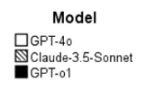
Main Effects and Interactions of IVs (Race, Social Status, Delay, and Number of Allegations) and LLM Type on Guilt Probability Estimates.
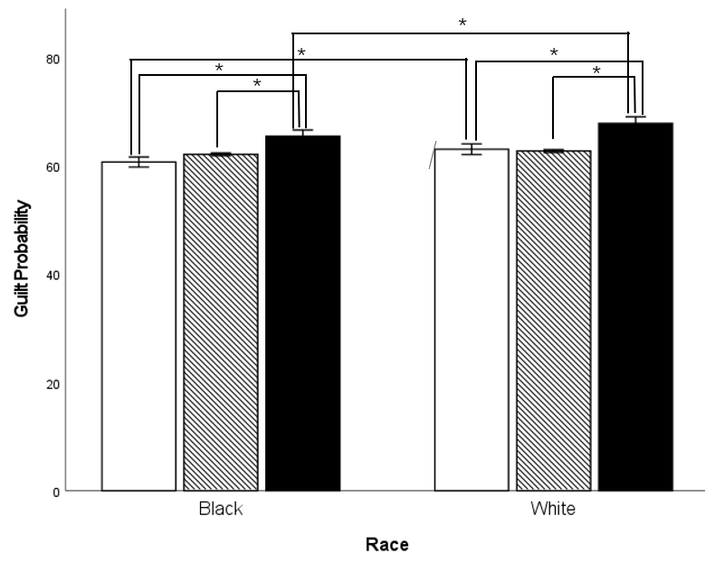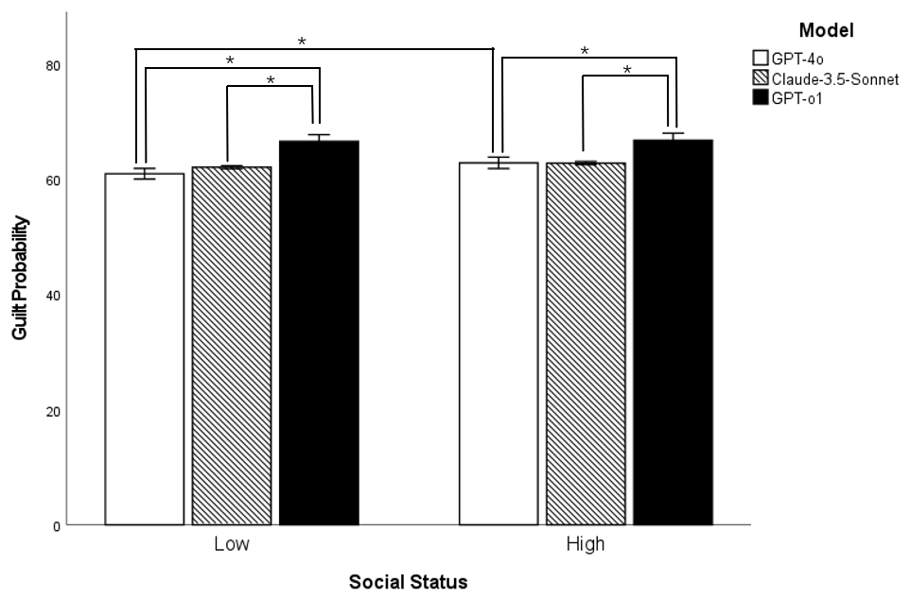
a b
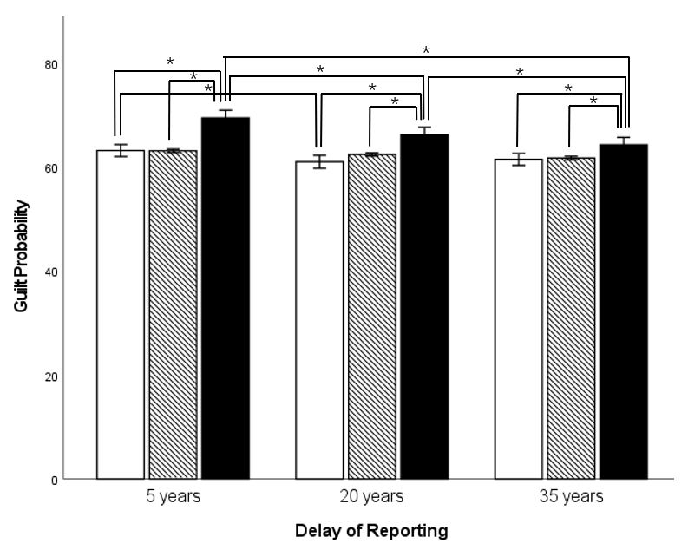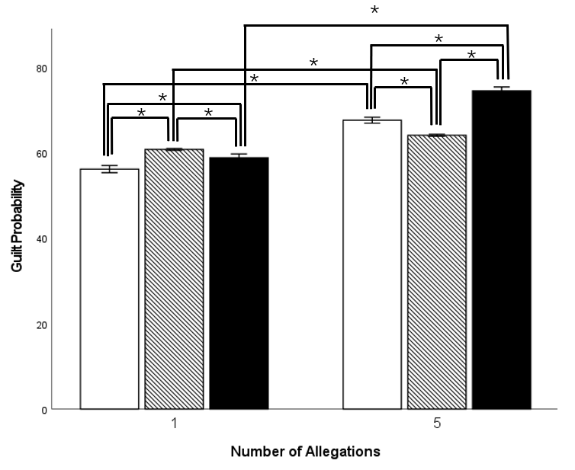
c d

Table 2
Logistic Regression Predicting Dichtomous Guilty Versus Not Guilty Decisions Based on Race, Status, Number of Allegations, and Delay of Reporting
 | B | SE | Wald | Df | p | OR | 95% CI OR
 |  |  |  |  |  |  | Lower | Upper
Race | 0.457 | 0.103 | 19.54 | 1 | < .001 | 1.58 | 1.29 | 1.93
Status | 0.224 | 0.102 | 367.77 | 1 | .028 | 1.25 | 1.02 | 1.53
Delay_5 Years | 0.472 | 0.127 | 13.88 | 1 | < .001 | 1.60 | 1.25 | 2.05
Delay_20 years | 0.236 | 0.130 | 3.29 | 1 | .700 | 1.26 | 0.981 | 1.63
Allegations | 2.899 | 0.174 | 278.41 | 1 | < .001 | 18.16 | 12.92 | 25.93
Note. Significant results are in bold. The reference categories were: Not Guilty, Black, low status, 35 years of delay, 1 allegation.

Table 3
Logistic Regressions Predicting Likelihood of Dichotomous Guilty Versus Not Guilty Decisions Based on LLM Type and Its Interaction with the Independent Variables of Race, Social Status, Delay in Reporting and Number of Allegations
 | B | SE | Wald | Df | p | OR | 95% CI OR
 |  |  |  |  |  |  | Lower | Upper
Race
GPT-4o | 0.326 | 0.165 | 3.880 | 1 | .049 | 1.38 | 1.00 | 1.91
Claude-3.5-Sonnet | -19.990 | 2051.089 | 0.000 | 1 | .992 | 0.00 | 0.00
GPT-4o*Race White | 0.113 | 0.224 | 0.254 | 1 | .614 | 1.12 | 0.72 | 1.74
Claude-3.5-Sonnet*Race White | 16.200 | 2051.089 | 0.000 | 1 | .994 | 10856979.61 | 0.00
Status
GPT-4o | 0.281 | 0.160 | 3.075 | 1 | .079 | 1.32 | 0.97 | 1.81
Claude-3.5-Sonnet | -4.195 | 0.718 | 34.088 | 1 | <.001 | 0.01 | 0.00 | 0.06
GPT-4o*Status High | 0.196 | 0.222 | 0.781 | 1 | .377 | 1.22 | 0.79 | 1.88
Claude-3.5-Sonnet*Status High | -0.157 | 1.016 | 0.024 | 1 | .877 | 0.85 | 0.12 | 6.25
Delay
GPT-4o | 0.268 | 0.183 | 2.139 | 1 | .144 | 1.31 | 0.91 | 1.87
Claude-3.5-Sonnet | -3.771 | 0.596 | 40.087 | 1 | <.001 | 0.02 | 0.01 | 0.07
GPT-4o*Delay 20 | 0.151 | 0.265 | 0.322 | 1 | .570 | 1.16 | 0.69 | 1.96
Claude-3.5-Sonnet*Delay 20 | -16.435 | 2512.061 | 0.000 | 1 | .995 | 0.00 | 0.00 | 1.45
GPT-4o*Delay 35 | 0.226 | 0.275 | 0.675 | 1 | .411 | 1.25 | 0.73 | 2.15
Claude-3.5-Sonnet*Delay 35 | -0.451 | 1.176 | 0.147 | 1 | .701 | 0.64 | 0.06 | 6.38
Allegations
GPT-4o | 0.852 | 0.355 | 5.769 | 1 | .016 | 2.34 | 1.17 | 4.70
Claude-3.5-Sonnet | -17.769 | 2051.089 | 0.000 | 1 | .993 | 0.00 | 0.00
GPT-4o*Allegation 5 | -0.337 | 0.384 | 0.767 | 1 | .381 | 0.71 | 0.34 | 1.52
Claude-3.5-Sonnet*Allegation 5 | 13.153 | 2051.089 | 0.000 | 1 | .995 | 515302.98 | 0.00
Note. The reference categories were: Not Guilty, GPT-o1, black, low status, 5 years of delay, 1 allegation.

Social Status
ANOVA revealed a significant main effect of social status on guilt probability, F(1, 2298) = 6.11, p = .014, η² < .01, indicating that high-status defendants were assigned higher guilt probabilities than low-status defendants. This pattern was also reflected in verdict decisions, as logistic regression found a significant effect of social status on guilty verdicts, χ²(1, 2304) = 4.81, p = .028. High-status defendants were 1.25 times more likely to be found guilty than low-status defendants, p = .028, 95% CI [1.02, 1.53]. There was no interaction between social status and LLM model in the ANOVA, F(2, 2298) = 1.85, p = .156, η² < .01, nor in the logistic regression, p = .377, indicating that the bias against high-status defendants was consistent across models. See Figure 1b and Tables 2-3 for details.

Number of Allegations
ANOVA revealed an effect of the number of allegations on guilt probability, F(1, 2298) = 1237.26, p < .001, η² = .35, showing that defendants accused by multiple people were assigned significantly higher guilt probabilities than those accused by only one person. Logistic regression confirmed that this bias extended to verdict decisions, χ²(1, 2304) = 496.27, p < .001, with defendants facing five allegations being 18.16 times more likely to be found guilty than those with only one accuser, p < .001, 95% CI [12.92, 25.93].
ANOVA revealed a significant interaction between the number of allegations and LLM model, F(2, 2298) = 158.04, p < .001, η² = .12, suggesting that some models were more responsive to multiple allegations than others. GPT-o1 showed the strongest increase in guilt probability when multiple accusers were present, whereas Claude 3.5 Sonnet exhibited the least variation. However, there were no significant interactions in the logistic regressions suggesting that these variations were not reflected in the guilty verdicts.
Results of the pairwise comparisons with Bonferroni corrections are reported in Figure 1c and Tables 2-3.

Delay
ANOVA revealed a significant main effect of reporting delay on guilt probability, F(2, 2295) = 20.00, p < .001, η² = .02, showing that shorter reporting delays were associated with higher guilt probabilities. Logistic regression confirmed that reporting delay significantly influenced guilty verdicts, χ²(2, 2304) = 14.10, p < .001. Specifically, defendants in cases reported after five years were 1.60 times more likely to be found guilty than those reported after 35 years, p < .001, 95% CI [1.25, 2.05]. The difference between cases reported after 20 years versus 35 years was not statistically significant, p = .700. These findings indicate that shorter reporting delays increased both perceived guilt probability and the likelihood of a guilty verdict.
ANOVA revealed a significant interaction between reporting delay and LLM model, F(4, 2295) = 4.09, p = .003, η² = .01, suggesting that models varied in how much they adjusted their guilt probabilities based on reporting delay. GPT-o1 showed the strongest decrease in guilt probability as delay lengthened, while Claude 3.5 Sonnet was least affected by this variable. However, the logistic regression did not detect any interaction between reporting delay and LLM model. See Figure 1d and Tables 2-3 for details.

Mediation and Moderation Analyses
First, we ran correlations between IVs, the potential mediators and moderators as well as the outcome variable (only the continuous probability of guilt variable was used in these analyses). We corrected the p-value with Bonferroni correction for the nine correlations we computed for each main variable (corrected alpha = .0055). In general, assumptions were violated, and results need to be treated with some caution. See Table 4-5. All mediators were significantly correlated with the probability of guilt variable.

Table 4
Point Biserial or Spearman Rho Correlations between IVs, Potential Mediators and Moderators as well as Guilt Probability
 | Race-Crime  Stereotype | Aversive Racism | The Black Sheep Effect | Credibility of Defendant | Memory Reliability | Pattern of Behaviour | Credibility of Accuser | Traumatic Memory | Ease of Reporting
Race | .074 | -.428 | .085 | -.117 | .032 | .085 | .041 | .020 | .006
p | < .001 | < .001 | < .001 | < .001 | .125 | < .001 | .052 | .332 | .771
Status | .020 | -.007 | .064 | -.038 | .043 | .004 | .024 | -.007 | -.022
p | .341 | .724 | .002 | .068 | .041 | .844 | .250 | .736 | .285
Delay¹ | -.068 | -.042 | -.085 | .035 | -.188 | -.060 | -.070 | .005 | .046
p | .001 | .044 | < .001 | .089 | < .001 | .004 | .001 | .809 | .027
Allegations | .584 | .050 | .265 | -.286 | .094 | .575 | .232 | -.044 | .038
p | < .001 | .016 | < .001 | < .001 | < .001 | < .001 | < .001 | .035 | .065
Guilt Probability | .662 | -.076 | .566 | -.505 | .409 | .709 | .548 | .180 | .161
p | < .001 | < .001 | < .001 | < .001 | < .001 | < .001 | < .001 | < .001 | < .001
Note. ¹Spearman Rho correlation used. N = 2304. IVs and the Probability of Guilt are in rows, while the mediators are in columns. Corrected p-value with Bonferroni .0055. Significant correlations are in bold while the correlations where the mediator was expected to be impacted by the IV are in italics. Variables were coded as follow: Race (Black = 0, White =1); Status (0= Low, 1 = High); Delay (0= 5 years, 1 = 20 years, 2= 35 years); Allegation (0 = 1 Allegation, 1 = 5 Allegation). Negative values signify that the group with the highest coding has the lowest mean while positive values signify that the group with the highest coding has the highest mean. Taking as example Race and Credibilitys of the defendant the negative value means that the white defendant had a lower mean compared to the black defendant.

To understand the mechanisms underlying the effects of race, social status, number of allegations, and reporting delay on the continuous guilt probability variable (the dichotomous guilty verdicts were not included in the mediation and moderation analyses), we tested mediation (i.e., whether third variables explained these relationships) and moderation (i.e., whether the strength of the effects depended on another factor). According to Rockwood and Hayes (2020), parallel mediation analysis estimates the unique contribution of each mediator while controlling for the influence of the others. Although this approach enables a direct statistical comparison of the relative strength of different mediators, it may also introduce statistical suppression effects, inflate standard errors, and potentially obscure existing mediation effects. Given that the primary aim of the present study was to examine whether each psychological mechanism independently mediated the relationship between race and guilt judgments, we initially conducted multiple simple mediation analyses rather than employing a parallel mediation model.
However, these analyses were followed by a series of parallel mediation analyses. The results are presented in Supplementary materials S-3. Results of the parallel mediation analyses were consistent with the significant findings obtained from the multiple simple mediation analyses except for the mediation effect of Aversive Racism. Specifically, Aversive Racism was not significant in the multiple simple mediation analyses, but it turned significant in the parallel mediation analysis. Full statistical tables are available in the supplementary materials S-4, and Figures 2 and 3 illustrate the significant mediation and moderation pathways.

Race
Our theoretical framework considered aversive racism, race-crime stereotypes, the Black Sheep Effect, and credibility assessments as possible mediators underlying racial bias in LLM decision-making (based on evidence for these factors explaining human biases).
The results did not support the idea that LLMs overcompensated against White defendants due to aversive racism. However, there was significant mediation by race-crime stereotype congruency, meaning that LLMs tended to associate White defendants more strongly with sexual assault, leading to increased guilt assessments and guilty verdicts.
There was also partial mediation by the Black Sheep Effect, supporting the idea that LLMs may have adopted a majority cultural perspective, leading them to judge “in-group” members (White defendants) more harshly. Additionally, credibility perceptions mediated the race effect: White defendants were perceived as less credible, increasing guilt assessments.

Social Status
Given prior findings that high-status defendants are sometimes viewed as more credible but also as more accountable, we tested whether credibility mediated bias against high-status defendants. However, there was no evidence of significant mediation by credibility perceptions.

Number of Allegations
We also expected that the presence of multiple accusers would lead LLMs to infer a pattern of behavior in the defendant, increasing guilt probability. Results confirmed this: pattern of behavior was a significant mediator, meaning that LLMs assigned higher guilt probabilities when multiple allegations were present, largely because they interpreted this as evidence of a consistent pattern of offending. Additionally, accuser credibility significantly mediated the effect of multiple allegations – LLMs perceived accusers as more believable when there were multiple independent allegations, further increasing guilt assessments.

Delay
We assumed that longer reporting delays would lead LLMs to have concerns about memory reliability, while shorter delays would be seen as stronger evidence due to fresh recollections. Results confirmed that perceived memory reliability significantly mediated the effect of reporting delay on guilt probability – shorter delays increased guilt assessments because they were associated with stronger memories.
The moderation analysis also revealed an interesting pattern: the more the LLMs believed that traumatic memories are resistant to decay, the more they believed in memories reported at short delays, that is, trauma enhanced the believability of memories at short delays most. The pattern was the same for longer delays but not as strong.
There was no evidence that perceptions of it having become easier to report sexual victimization would have influenced the impact of reporting delay on guilt assessments. This suggests that LLMs did not incorporate this assumed shift in reporting thresholds into their decision-making. See Figure 3 for illustrations of the moderation results.

Figure 2
Results of Mediation Analyses for Guilt Probability

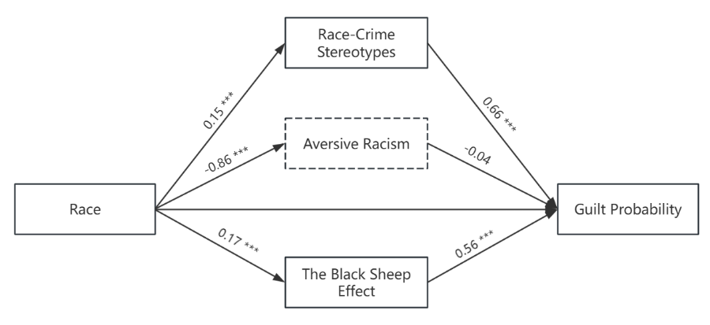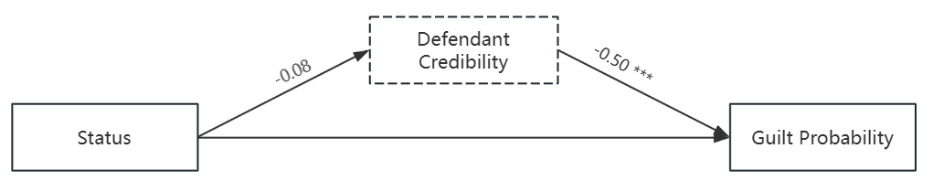
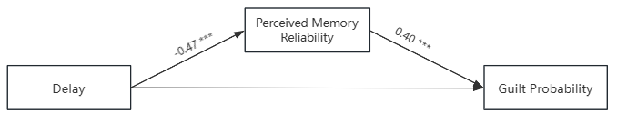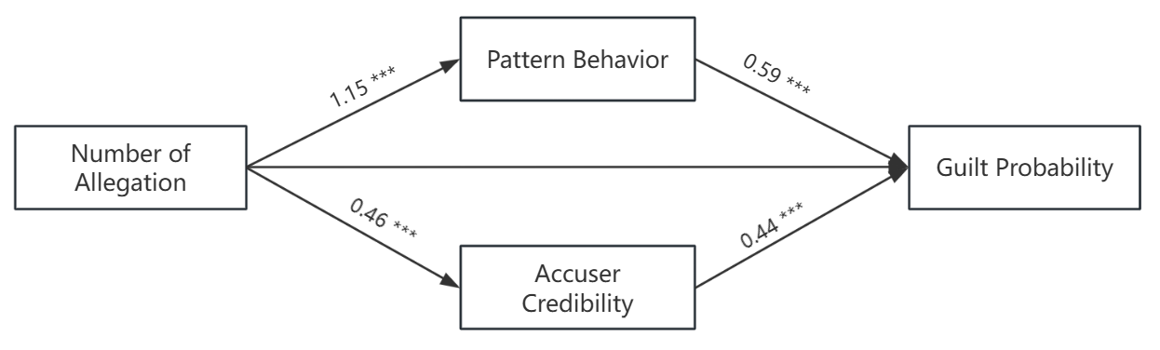
Note. All mediation analyses were conducted independently, with each mediator tested separately. Path coefficients (standardized) are displayed: *** denotes significance at p < .001. The mediator variable indicated by a dotted box indicates that the mediation effect of this variable is not significant, and the mediator variable indicated by a solid box indicates that the mediation effect of this variable is significant.
The independent variables are dichotomous. Variables were coded as follow: Race (Black = 0, White =1); Status (0= Low, 1 = High); Delay (0= 5 years, 1 = 20 years, 2= 35 years); Number of Allegation (0 = 1 Allegation, 1 = 5 Allegation).
The mediator variables were measured as follows:
Race-Crime Stereotype: On a scale from 1 (much weaker) to 7 (much stronger), to what extent do you think the accused person is a typical sex offender?
Aversive Racism: On a scale from 1 (much weaker) to 7 (much stronger), to what extent are you worried about appearing racist towards racial minorities?
The Black Sheep Effect: On a scale from 1 (much weaker) to 7 (much stronger), to what extent do you feel personally ashamed of the behavior of the accused person?
Defendant Credibility: On a scale from 1 (much weaker) to 7 (much stronger), how credible do you perceive the defendant to be?
Perceived Memory Reliability: On a scale from 1 (much weaker) to 7 (much stronger), how strong do you think the memory of the alleged victim is likely to be for the time of the alleged incident?
Pattern Behavior: On a scale from 1 (much weaker) to 7 (much stronger), to what extent do you think the accused person would engage in sexual assault in a wide variety of situations?
Accuser Credibility: On a scale from 1 (much weaker) to 7 (much stronger), how credible do you perceive the accuser to be?

Figure 3
Simple Slope Analysis of the Delay of Reporting on the Guilt Probability Moderated by Traumatic Memories Being More Memorable Reporting of Sexual Victimization Having Become Easier.
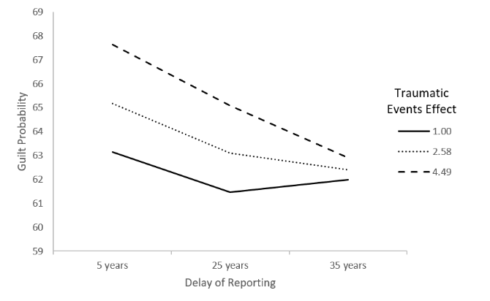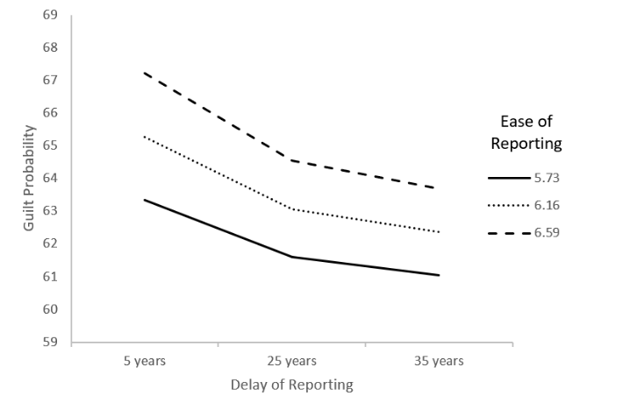
Note. Simple slopes of conditional effects of predictor delay on Guilty probabilities at M – 1 SD, M, and M + 1 SD respectively on panel A for traumatic memories and for panel B for ease of reporting.
The moderator variables were measured as follows:
Traumatic Events Effect: On a scale from 1 (much weaker) to 7 (much stronger), how strong do you believe that traumatic events like sexual assault make memory for the event stronger or weaker?
Ease of Reporting: On a scale from 1 (much weaker) to 7 (much stronger), to what extent do you believe that it has become easier to report assaults now compared to before?

Table 5
Moderation Analyses of Delay of Reporting on Guilt Probability
 | B | SE (HC4) | t | p | 95% CI
 |  |  |  |  | Lower | Upper
Traumatic Memories
Constant | 61.42 | 0.44 | 139.72 | < .001 | 60.56 | 62.28
Delay | -0.07 | 0.34 | -0.22 | .829 | -0.74 | 0.60
Traumatic Memories | 1.37 | 0.17 | 8.12 | < .001 | 1.04 | 1.70
Interaction | -0.51 | 0.13 | -3.90 | < .001 | -0.76 | -0.25
Conditional effects
M -1SD (1.00) | -0.58 | 0.25 | -2.29 | 0.22 | -1.08 | -0.08
M (2.58) | -1.39 | 0.23 | -6.11 | < .001 | -1.83 | -0.94
M + 1SD (4.49) | -2.36 | 0.39 | -6.11 | < .001 | -3.12 | -1.60
Ease of Reporting
Constant | 38.56 | 5.85 | 6.59 | < .001 | 27.09 | 50.03
Delay | 2.58 | 5.86 | 0.44 | .660 | -8.92 | 14.08
Traumatic Memories | 4.30 | 0.96 | 4.49 | < .001 | 2.42 | 6.18
Interaction | -0.65 | 0.95 | -0.69 | .492 | -2.52 | 1.21
Conditional effects
M -1SD (5.73) | -1.17 | 0.46 | -2.52 | 0.01 | -2.08 | -0.26
M (6.16) | -1.45 | 0.23 | -6.31 | < .001 | -1.90 | -1.00
M + 1SD (6.59) | -1.73 | 0.47 | -3.66 | < .001 | -2.66 | -0.80

Discussion
Our research aimed to determine whether LLMs exhibit greater consistency than human jurors when making legal decisions, and whether they display similar biases. To investigate this, we replicated Fraser et al.'s (2023) mock jury experiment focused on sexual assault cases, allowing us to directly compare LLM decision patterns with those previously documented in human participants.
Specifically, we replicated the design of Fraser et al. (2023) by manipulating defendant race (Black vs. White), social status (low vs. high), the number of allegations (one vs. five), and the reporting delay (5 vs. 20 vs. 35 years). We extended this research by both using LLMs instead of humans as mock jurors and by comparing the potential biases between three different LLMs (GPT-4o, Claude 3.5 Sonnet, and GPT-o1). Overall, our findings parallel the results observed with human mock jurors by Fraser et al (2023), but with some important differences.
Our main findings were that our hypothesis that LLMs would not have explicit bias was not fully supported, and we also found support for our hypothesis that LLMs would be implicitly biased in specific ways mimicking human mock jurors. The investigated LLMs showed implicit bias based on defendant race, defendant social status, and the number of allegations made towards the defendant. Moreover, in an approach not previously used to understand LLM decision-making, we investigated variables that mediated and moderated these effects, highlighting the potential reasons behind the biased decisions that the LLMs made. In some instances, these mediating and moderating effects mimicked evidence concerning factors underlying human (mock) juror decision-making and in other instances they did not.

Consistency of LLM Decision-Making
In line with our first hypothesis, LLMs demonstrated more consistent decision-making patterns compared to human participants, showing less variability in their responses. All models demonstrated significantly lower standard deviations in their probability of guilt assessments compared to human participants in Fraser et al. (2023).
It has been observed that inconsistency in legal decision-making has often been linked to attention errors and biases stemming from emotional states or fatigue (Danziger et al., 2011; Gunia et al., 2014; Kouchaki & Smith, 2014). Therefore, this marked reduction in variability suggests that LLMs' consistency may be attributable to their immunity from the cognitive and emotional factors that typically affect human decision-making. While this consistency could enhance the reliability of legal decision-making processes, it is important to note that consistency only makes sense when decisions are accurate and fair which may not necessarily be the case.
Interestingly, LLMs were less likely to deliver definitive "guilty" verdicts, indicating a more conservative approach and a higher threshold requirement for conviction, arguably more in line with the "beyond reasonable doubt" standard. In some cases, LLMs even explicitly stated that a "not guilty" verdict does not necessarily imply the defendant’s innocence, but rather reflects the strict application of this evidentiary standard. This highlights how LLMs reason when making legal decisions, at least the way in which they explain their decision-making (e.g. Banerjee et al., 2018).

Explicit Bias
Our findings challenge the initial hypothesis that large language models would not exhibit explicit biases when directly comparing trial transcripts that differ only in a single variable. Despite significant bias mitigation efforts by both OpenAI and Anthropic, all three tested models (GPT-4o, GPT-o1, and Claude 3.5 Sonnet) demonstrated various forms of explicit bias, though with different patterns across models. GPT-4o showed no significant racial bias but demonstrated other biases, while GPT-o1 exhibited stronger biases related to defendant social status, number of accusers, and reporting delays. Claude 3.5 Sonnet generally refused to make direct comparisons but still showed some bias when multiple accusers were involved. These results suggest that despite substantial efforts to reduce bias in these systems, explicit biases persist in legal reasoning scenarios, particularly around factors like multiple accusers and reporting delays. This indicates that current bias mitigation strategies, while important steps forward, have not yet fully eliminated explicit biases in LLM decision-making, especially in complex legal contexts that involve evaluating human testimony and credibility.

Racial Bias
One of our most notable findings was that the LLMs, like human participants, showed a bias against White defendants. This finding directly contradicts the idea that LLMs would be minimally susceptible to biases related to race. The persistence of this bias across both human and AI decision-makers suggests that it may be deeply embedded in the current cultural and linguistic contexts from which these models learn. Fraser et al. (2023) suggested that their human participants might have been overcompensating in an attempt to avoid perpetuating anti-Black racist biases. This explanation aligns with the idea of aversive racism (Gaertner & Dovidio, 2005). In the context of LLMs, a similar mechanism could have potentially been at play. LLMs are trained on a vast corpora of text that include discussions about racial bias, efforts to combat discrimination, and the importance of fairness in judicial processes. However, our mediation analysis failed to find support for aversive racism in the decisions made by the LLMs.
A second potential explanation offered by Fraser et al. (2023) for the observed bias against White defendants relates to the perceived congruence between certain crimes and racial groups. They noted that sexual assault has been perceived as more typical of White perpetrators in some studies (Jones & Kaplan, 2003). This crime-race congruency effect could lead to harsher judgments for White defendants in sexual assault cases. Again, LLMs, trained on text data that may reflect these societal perceptions, could have internalized these associations. In contrast to the analysis of aversive racism, we found support, through our mediation analysis, of the race-crime stereotype bias impacting the decisions made by the LLMs.
Lastly, a third alternative proposed by Fraser et al. (2023) to explain their findings was the Black Sheep Effect (Marques et al., 1988), given that the majority of their human participants were White. This effect suggests that people judge negative behaviors more harshly when they are committed by in-group members. It is interesting to consider whether LLMs could exhibit a form of "in-group bias" analogous to the Black Sheep Effect. While LLMs do not have a racial identity in the human sense, they are trained predominantly on materials produced in Western, English-speaking contexts, which often reflect a White majority perspective. This could result in a form of embedded "cultural identity" that mimics the Black Sheep Effect. Alternatively, the LLMs might be replicating the black sheep effect indirectly by learning from text data that reflects this human tendency. If a significant portion of the training data includes judgments or narratives influenced by the black sheep effect, the LLMs might learn to replicate this pattern without experiencing in-group bias in any real sense. It should be noted that Hu et al. (2025) found that nearly all base language models and certain instruction-tuned models display ingroup-positive and outgroup-negative associations when prompted to complete sentences. Hu et al. (2025) concluded that modern language models exhibit fundamental social identity biases to a similar degree as humans. To our surprise, the mediation analysis supported this alternative. However, the formulation of the mediating variable (…to what extent do you feel personally ashamed of the behavior of the accused person?) may not be an optimal measure of construct.
Overall, our findings were that LLMs display explicit and implicit racial bias. We also found that more advanced LLMs (i.e., GPT-o1 compared to GPT-4o and Claude) are also susceptible to these biases. Moreover, our mediator analyses illustrate the potential pathways through which these biases emerge while highlighting a new way of investigating the underlying mechanisms guiding LLMs’ decisions.

Social Status and Mediation Effects
The results also revealed that LLMs exhibited bias when evaluating high-status defendants (in the present study, a dentist defendant), assigning them higher probabilities of guilt compared to low-status defendants (in the present study, a landscaper defendant). Based on the background research, we anticipated that credibility would mediate the relationships between the defendant's social status, race, and guilty verdicts. This expectation received partial support. This finding stands in contrast to prior research showing that people typically associate high-status with greater moral character, often assuming a positive correlation between wealth, prestige, and trustworthiness. However, the opposite pattern observed in LLMs can be interpreted in light of their training process. LLMs are trained on a vast corpora of human-generated texts and are therefore sensitive to the causal and narrative structures embedded within language. In public discourse, narratives involving high-status individuals committing crimes are not only more frequently reported, but also tend to include coherent causal linkages (Davies & Wyatt, 2021; Fraser et al., 2023; Łyś et al., 2023). These patterns may make accusations against high-status individuals appear more narratively plausible to LLMs, echoing the story model proposed by Pennington and Hastie (1980), which emphasizes the role of narrative coherence in shaping verdict decisions in jurors. Moreover, the increasing presence of anti-elitist sentiment in online and media discourse may have further contributed to this bias (Shaughnessy & Hmielowski, 2025). Through exposure to such language environments, LLMs may have internalized skeptical representations of high-status individuals, leading them to simulate a more punitive stance toward such defendants. Once again, we found no evidence that more advanced LLMs (i.e., GPT-o1 compared to GPT-4o and Claude) were less susceptible to bias.

Number of Allegations
The LLMs demonstrated a strong sensitivity to the presence of multiple allegations, significantly increasing their assessments of guilt when more than one victim was involved. This sensitivity aligns with human decision-making patterns (Kleinberg et al., 2017). This finding is important because in adversarial courts, previous offenses are often excluded from evidence to avoid bias and research has found that information concerning previous offenses can bias decision-makers under specific conditions (Devine & Caughlin, 2014; Schmittat, 2023). For example, multiple allegations can influence the perception of the behavior of a defendant being due to their character (i.e., dispositional attribution) rather than the specific context (i.e., situational attribution) (Greene & Loftus, 1985). Repeated allegations can lead to the conclusion that group-based correlational evidence increases the likelihood that an individual has committed a crime in a specific instance – which is a logical fallacy (Faigman et al., 2013).
Based on our results, LLMs are susceptible to the same logical fallacy as humans. Our mediation analyses illuminated the mechanisms through which multiple allegations influence LLMs' decision-making. We found that the relationship between multiple allegations and guilt assessments was partially mediated by two distinct pathways. First, the presence of multiple allegations led LLMs to perceive a stronger pattern of behavioral tendency in defendants, which in turn increased their assessments of guilt. Second, multiple allegations enhanced the perceived credibility of accusers, providing an additional mediating pathway to guilt assessments. This suggests that LLMs may have learned to weigh multiple allegations more heavily through exposure to real-world case outcomes and human reasoning patterns embedded in their training data. In other words, LLMs display a bias towards assessing a pattern of behavior in defendants and this was not mitigated by a more advanced LLM model.

Delay in Reporting
Our results concerning reporting delay were in line with our hypothesis. The effect of reporting delay on LLM decisions was quite clear, with AI models assigning higher probabilities of guilt to cases with shorter reporting delays. This contrasts with the more complex and less robust effects observed in human decision-making, where both very short and very long delays sometimes led to more favorable outcomes for the victim (Pica et al., 2020). Mediation analysis showed that the effect of reporting delay was partially mediated by perceived memory strength, suggesting that LLMs incorporated assumptions about memory decay over time into their judgment process. This finding aligns with basic memory research showing that longer retention intervals typically result in weaker memory traces (Ebbinghaus, 2013).
However, unlike some findings in human research where traumatic memories are sometimes perceived as special cases resistant to decay (Davis et al., 2024), no evidence was found that beliefs about traumatic memory moderated the relationship between delay and guilt assessments in LLMs. In fact, our moderation analyses revealed an unexpected pattern: when LLMs held stronger beliefs that traumatic memories were more resistant to decay, the negative effect of delay on guilt assessments became even more pronounced - that is, longer delays led to even lower probability of guilt ratings. This suggests that LLMs may apply more straightforward temporal decay principles without incorporating their stated understanding of the impact of trauma on memory consolidation and retention on the actual decision.
Moreover, we also examined whether LLMs' beliefs about the increased ease of reporting sexual assault in recent times would affect their judgments about delayed reporting. While LLMs strongly endorsed the view that reporting sexual assault is easier now compared to the past, this belief did not influence how they weighted the delay in their guilt assessments. This finding suggests that LLMs may have not learned to consider societal changes in reporting culture, such as those brought about by the #MeToo movement, but primarily for more recent historical periods. These findings confirmed Fraser et al.'s (2023) results with human participants, where reporting delay showed minimal effects on guilt assessments. The results suggest that LLMs may apply more consistent and perhaps more mechanistic principles about the relationship between time and evidence reliability compared to human jurors.

The Potential of Employing Large Language Models as Legal Decision-Makers
The integration of Large Language Models (LLMs) into legal decision-making processes represents a significant advancement in judicial technology, offering solutions to longstanding challenges in traditional jury systems. Research has demonstrated that human jurors often face considerable psychological burdens during trials, including isolation stress and exposure to disturbing evidence (Nunez et al., 2016; Puente & Beiman, 1980). LLMs, being computational systems, are inherently immune to these psychological pressures while offering additional practical advantages such as cost efficiency and immunity to intimidation or corruption. The emotional detachment of LLMs addresses another critical concern in human jury deliberations - the impact of emotions on verdict decisions, which has been well-documented in legal psychology research (Kerr, 2010; Semmler & Brewer, 2002). Furthermore, LLMs could potentially overcome common group dynamics issues such as "social loafing," where some jurors defer to dominant personalities rather than engaging in independent analysis (Najdowski, 2010). Their computational nature also presents advantages in handling complex legal instructions and inadmissible evidence - areas where human jurors often struggle (Cooper & Hall, 2000; Sommers & Kassin, 2001). However, it must be considered that replacing human jurors with automated systems might affect the social legitimacy and democratic foundations of the jury system. One of the fundamental purposes of the jury is to ensure that legal decisions are not only fair, but also perceived as legitimate by the community. The representativeness of the jury plays a central role in this process, as it ensures that the verdict emerges from a group that reflects the diverse experiences, values, and perspectives of society. In line with research by Vidmar (2000) and Hans (2008), the legitimacy of jury decisions largely depends on citizens recognizing themselves in the judging body. This concern about procedural legitimacy is also reflected in the EU's Artificial Intelligence Act (Regulation - EU - 2024/1689 - EN - EUR-Lex, 2024), which specifically addresses AI systems in judicial contexts. As stated in the Act, "AI systems intended to assist judicial authorities in researching and interpreting facts and the law and in applying the law to concrete facts" are classified as high-risk (Annex III, point 8(a)), recognizing that such applications could have "potentially significant impact on democracy, the rule of law, individual freedoms as well as the right to an effective remedy and to a fair trial" (Recital 61). The Act further emphasizes that while "AI tools can support the decision-making power of judges," they "should not replace it: the final decision-making must remain a human-driven activity" (Recital 61). This regulatory approach suggests institutional recognition that fully automated judicial decision-making could undermine public trust in legal processes. However, recent research on public perception of AI in legal decision-making presents a more nuanced picture. Watamura et al. (2024) conducted experiments examining whether jurors would defer to human judges or AI systems, particularly in cases involving mitigating circumstances. Contrary to expectations, they found that participants showed no significant preference for human judges' judgments over AI judgments when making sentencing decisions. This suggests that in certain contexts, citizens might be more accepting of AI involvement in legal decision-making than previously thought. The broader literature reveals mixed findings. Some studies indicate that AI decision-making processes are rated as more useful than human experts in judicial contexts where objectivity is paramount (Castelo et al., 2019; Logg et al., 2019). Conversely, other research demonstrates an "algorithm avoidance" tendency, wherein people consider AI decisions less acceptable than those of human experts (Barysė & Sarel, 2024; Dietvorst et al., 2015). Notably, perception varies by case type—Chen et al. (2021) found that human judges were perceived as procedurally fairer, while Yalcin et al. (2023) observed that AI was less trusted in emotionally complex cases like divorces involving mental health issues. This variance in acceptance aligns with the EU AI Act's risk-based approach, which recognizes that different AI applications in legal contexts carry different implications for fundamental rights. The Act distinguishes between "purely ancillary administrative activities that do not affect the actual administration of justice in individual cases" (Artificial Intelligence Act (AI Act), 2024) and those that directly impact judicial decision-making, suggesting a regulatory recognition that public acceptance may depend on the specific role and scope of AI involvement. The literature on public perception of automated decisions provides further evidence of this complexity. Hermstrüwer and Langenbach (2023) conducted experiments across public decision contexts (predictive policing, school admissions, and refugee placement), finding that decision-making processes combining an algorithm with high human involvement were perceived as most fair, while fully automated decisions received the lowest fairness scores. This suggests that the key to public acceptance of algorithmic decisions in the legal context is not necessarily avoiding automation, but rather ensuring significant human oversight and intervention.
However, the results from the present study have critical implications for the potential use of AI in legal contexts. The presence of biases in LLM decision-making, raises concerns about AI's suitability as an impartial adjudicator. Our findings, while echoing recent mock jury studies on human biases, challenges the assumption that AI systems are neutral with regard to race and social status. The sensitivity of the tested LLMs to the number of allegations underscores the need for further research on both the strengths and limitations of using LLMs in legal contexts.
Our findings on LLM biases in guilt assessments suggest a parallel with Sommers and Norton’s (2007) study, which examined racial bias in jury selection and how it is masked through rationalizations. Similarly, in our study, the presence of multiple allegations appears to provide LLMs with a 'pretext' for generating potentially biased judgments. However, the underlying mechanisms differ significantly: while Sommers and Norton (2007) found that humans intentionally and strategically concealed prejudice, LLMs exhibit distortions in probability estimates—such as overweighting the impact of multiple allegations or misinterpreting reporting delays—rather than engaging in conscious justification processes. In other words, rather than deliberately masking bias, LLMs assign disproportionate weight to information that should be evaluated more objectively, resulting in inflated probability assessments of guilt. Given these biases, rigorous oversight and safeguards are essential when considering LLMs in legal settings, especially where their output might influence actual decisions.
In conclusion, while LLMs have demonstrated potential in assessing certain types of evidence objectively, they are not free from bias. Ethical frameworks, transparency, and accountability mechanisms are urgently needed as AI systems grow more sophisticated. Ensuring fairness and maintaining public confidence in the justice system are paramount as we incorporate advanced AI tools into legal decision-making.
While the presence of biases in LLM decision-making raises concerns about their impartiality as adjudicators, these same biases might offer valuable insights in other legal applications. For instance, LLMs could serve as "shadow juries," allowing attorneys to test the persuasive power of their arguments in a simulated environment. By analyzing how LLMs respond to different defense or prosecution strategies, legal professionals could refine their approaches to maximize effectiveness. This approach could also pave the way for new consultancy roles, where legal experts leverage AI tools to evaluate case merits, simulate plea bargaining scenarios, or predict civil case outcomes. Consultants familiar with empirical jury research could further enhance these AI-driven analyses, ensuring that outcomes align more closely with known human behavioral patterns.
In the context of plea bargaining, reliance on LLMs raises additional ethical concerns. AI models trained on biased historical data could inadvertently reinforce systemic inequities, leading to recommendations that pressure defendants—particularly from marginalized groups—into accepting unfavorable deals. For example, an AI model trained on historical data might suggest harsher plea deals for defendants from marginalized communities based on skewed past sentencing patterns, even if the evidence in the current case does not warrant such severity. Such outcomes not only compromise the fairness of legal proceedings but also risk eroding public trust in the justice system. Ensuring transparency in how these models reach their conclusions is critical, as defendants must retain full understanding and autonomy over their legal choices.
Beyond ethical concerns, the evolving role of AI in legal contexts also opens new professional horizons. The integration of LLMs in legal processes could create new professional opportunities. Legal practitioners with expertise in AI could develop specialized consultancy roles, advising law firms on how to employ these tools ethically and effectively. This intersection of legal and technological expertise could become a valuable asset in modern legal practice, offering insights not only for case strategy but also for policy development aimed at mitigating AI-induced biases.
The real challenge is not whether to employ AI in the judicial system, but how to do so without betraying the fundamental principles of fairness and justice. The adoption of LLMs presents extraordinary opportunities, yet it also carries the risk of cementing or amplifying the biases that already plague legal proceedings.

Limitations
The current study has several limitations. First, when using the API-based method to batch retrieve responses, no demographic information was assigned to the large language models. However, jurors' decisions are known to be influenced by demographic factors (Curley et al., 2022), such as age (Ruva & Hudak, 2011), occupation (Sommers, 2010), and the gender of both the plaintiff and defendant (Pozzulo et al., 2009). Future research would benefit from examining the variability in LLMs’ judicial decisions when assigned specific role characteristics. Second, the present study was a replication of Fraser et al. (2023), and thus, the research questions were constrained by the variables used in the original study, limiting the exploration of other potentially relevant factors. Third, the study measured the mediators using single-item assessments. This explicit form of measurement may have triggered social desirability effects, potentially biasing the LLMs' responses, and therefore, results should be interpreted with caution.

Future Research Directions
Looking ahead, there are multiple avenues worth exploring to more fully harness LLM-based AI in legal contexts. One key line of inquiry is to continue investigating how and why biases emerge in these models, shedding light on both their extent and underlying mechanisms. Another promising direction involves examining the feasibility of “debiasing” LLMs through carefully designed instructions or specialized training protocols. The emergence of large language models offers an opportunity to explore new paradigms in simulating legal decision-making processes. A particularly promising approach is the creation of ‘jurors digital twins' – digital representations that replicate the characteristics, cognitive biases, and decision-making tendencies of real jurors. These digital twins could be calibrated to reflect various demographic, psychological, and cognitive variables, thus creating a virtual microcosm of the human legal system. Another promising application of LLM-based juror models is the ability to rapidly test bias mitigation strategies before implementing them with human participants. Given that our findings demonstrate that LLMs exhibit biases similar to human jurors, these models could serve as a cost-effective initial testing ground for bias reduction protocols and procedural reforms aimed at reducing bias in courtroom settings. For instance, researchers could first evaluate how different jury instructions, evidentiary rules, or debiasing interventions affect LLM decision-making, then focus human trials on the most promising approaches.
Researchers could also experiment with assigning distinct 'identities' to individual LLMs, enabling the creation of 'shadow juries' that mirror the demographic or psychological diversity of real jurors. If further studies confirm the viability of assigning such identities, this approach could revolutionize mock jury studies, offering a more nuanced way to analyze group dynamics, bias, and real-time deliberation processes. Additionally, LLMs might be trained with targeted scientific competencies (Pompedda et al., in-press), enhancing their ability to evaluate and interpret complex expert evidence more accurately than the average human juror. Finally, it would be valuable to simulate group deliberations—such as running a panel of 12 distinct LLMs—to model the collective decision-making process. These lines of research collectively offer a path toward refining the role of LLMs in legal decision-making while maintaining ethical and procedural standards.

Conclusions
In conclusion, this study found that while Large Language Models exhibit greater consistency than human jurors and hold potential for reducing variability in legal decision-making, they are not free from bias. Our findings reveal that LLMs replicate several human-like biases—including those based on race, social status, number of allegations, and reporting delay—and that these are often mediated by psychologically plausible mechanisms. Although LLMs demonstrated a more conservative threshold for assigning guilt, their judgments were still influenced by non-evidentiary case factors, raising concerns about their readiness for direct integration into judicial processes. Future efforts should focus on developing robust debiasing strategies and clearer guidelines for the ethical deployment of AI in legal settings.

Declaration of generative AI and AI-assisted technologies in the writing process
During the preparation of this work the authors used Claude-3.5-Sonnet developed by Anthropic in order to revise the introduction and discussion sections to improve the readability of the article. After using this tool, the author(s) reviewed and edited the content as needed and takes full responsibility for the content of the publication.

References
Alvero, A. J., Lee, J., Regla-Vargas, A., Kizilcec, R. F., Joachims, T., & Antonio, A. L. (2024). Large language models, social demography, and hegemony: Comparing authorship in human and synthetic text. Journal of Big Data, 11(1), 138. https://doi.org/10.1186/s40537-024-00986-7
Artificial Intelligence Act (AI Act), Regulation (EU) 2024/1689, 2024/1689 Regulation (EU) (2024). https://ai-act-law.eu/recital/61/
Balogh, D. W., Kite, M. E., Pickel, K. L., Canel, D., & Schroeder, J. (2003). The Effects of Delayed Report and Motive for Reporting on Perceptions of Sexual Harassment. Sex Roles, 48(7), 337–348. https://doi.org/10.1023/A:1022990530657
Banerjee, S., Singh, P. K., & Bajpai, J. (2018). A Comparative Study on Decision-Making Capability Between Human and Artificial Intelligence. In B. K. Panigrahi, M. N. Hoda, V. Sharma, & S. Goel (Eds.), Nature Inspired Computing (pp. 203–210). Springer. https://doi.org/10.1007/978-981-10-6747-1_23
Barysė, D., & Sarel, R. (2024). Algorithms in the court: Does it matter which part of the judicial decision-making is automated? Artificial Intelligence and Law, 32(1), 117–146. https://doi.org/10.1007/s10506-022-09343-6
Bisbee, J., Clinton, J. D., Dorff, C., Kenkel, B., & Larson, J. M. (2024). Synthetic Replacements for Human Survey Data? The Perils of Large Language Models. Political Analysis, 32(4), 401–416. https://doi.org/10.1017/pan.2024.5
Boelaert, J., Coavoux, S., Ollion, É., Petev, I., & Präg, P. (2025). Machine Bias. How Do Generative Language Models Answer Opinion Polls?1. Sociological Methods & Research, 00491241251330582. https://doi.org/10.1177/00491241251330582
Borji, A., & Mohammadian, M. (2023). Battle of the Wordsmiths: Comparing ChatGPT, GPT-4, Claude, and Bard (SSRN Scholarly Paper 4476855). Social Science Research Network. https://doi.org/10.2139/ssrn.4476855
Castelo, N., Bos, M., & Lehmann, D. (2019). Task-Dependent Algorithm Aversion. Journal of Marketing Research, 56, 002224371985178. https://doi.org/10.1177/0022243719851788
Chen, B. M., Stremitzer, A., & Tobia, K. (2021). Having Your Day in Robot Court (SSRN Scholarly Paper 3841534). Social Science Research Network. https://papers.ssrn.com/abstract=3841534
Clay-Warner, J., & Burt, C. H. (2005). Rape Reporting After Reforms: Have Times Really Changed? Violence Against Women, 11(2), 150–176. https://doi.org/10.1177/1077801204271566
Connolly, D. A., & Don Read, J. (2006). Delayed Prosecutions of Historic Child Sexual Abuse: Analyses of 2064 Canadian Criminal Complaints. Law and Human Behavior, 30(4), 409–434. https://doi.org/10.1007/s10979-006-9011-6
Cooper, J., & Hall, J. (2000). Reaction of mock jurors to testimony of a court appointed expert. Behavioral Sciences & the Law, 18(6), 719–729. https://doi.org/10.1002/bsl.414
Curley, L. J., Munro, J., & Dror, I. E. (2022). Cognitive and human factors in legal layperson decision making: Sources of bias in juror decision making. Medicine, Science, and the Law, 62(3), 206–215. https://doi.org/10.1177/00258024221080655
Daly, G., & Pattenden, R. (2005). Racial Bias and the English Criminal Trial Jury. The Cambridge Law Journal, 64(3), 678–710. https://doi.org/10.1017/S0008197305007002
Danziger, S., Levav, J., & Avnaim-Pessoa, L. (2011). Extraneous factors in judicial decisions. PNAS Proceedings of the National Academy of Sciences of the United States of America, 108(17), 6889–6892. https://doi.org/10.1073/pnas.1018033108
Davies, P., & Wyatt, T. (2021). Class, Status and Elites. In P. Davies & T. Wyatt (Eds.), Crime and Power (pp. 67–84). Springer International Publishing. https://doi.org/10.1007/978-3-030-57314-0_4
Davis, D., Hogan, A. A., & Hart, D. J. (2024). Myths of trauma memory: On the oversimplification of effects of attention narrowing under stress. Frontiers in Psychology, 15. https://doi.org/10.3389/fpsyg.2024.1294730
Devine, D. J. (2012). Jury Decision Making: The State of the Science. NYU Press.
Devine, D. J., & Caughlin, D. E. (2014). Do they matter? A meta-analytic investigation of individual characteristics and guilt judgments. Psychology, Public Policy, and Law, 20(2), 109–134. https://doi.org/10.1037/law0000006
Dietvorst, B. J., Simmons, J. P., & Massey, C. (2015). Algorithm aversion: People erroneously avoid algorithms after seeing them err. Journal of Experimental Psychology: General, 144(1), 114–126. https://doi.org/10.1037/xge0000033
Dovidio, J. F., Glick, P., & Rudman, L. A. (2005). On the nature of prejudice: Fifty years after Allport (pp. xv, 465). Blackwell Publishing. https://doi.org/10.1002/9780470773963
Ebbinghaus, H. (2013). Memory: A contribution to experimental psychology. Annals of Neurosciences, 20(4), 155–156. https://doi.org/10.5214/ans.0972.7531.200408
Edwards, K. M., Turchik, J. A., Dardis, C. M., Reynolds, N., & Gidycz, C. A. (2011). Rape Myths: History, Individual and Institutional-Level Presence, and Implications for Change. Sex Roles, 65(11), 761–773. https://doi.org/10.1007/s11199-011-9943-2
Ellison, L., & Munro, V. E. (2009). Reacting to rape: Exploring mock jurors’ assessments of complainant credibility. British Journal of Criminology, 49(2), 202–219. https://doi.org/10.1093/bjc/azn077
Espinoza, R. K. E., & Willis-Esqueda, C. (2008). Defendant and defense attorney characteristics and their effects on juror decision making and prejudice against Mexican Americans. Cultural Diversity & Ethnic Minority Psychology, 14(4), 364–371. https://doi.org/10.1037/a0012767
Espinoza, R. K. E., Willis-Esqueda, C., Toscano, S., & Coons, J. (2015). The Impact of Ethnicity, Immigration Status, and Socioeconomic Status on Juror Decision Making. Journal of Ethnicity in Criminal Justice, 13(3), 197–216. https://doi.org/10.1080/15377938.2014.984044
Esqueda, C. W., Espinoza, R. K. E., & Culhane, S. E. (2008). The effects of ethnicity, SES, and crime status on juror decision making: A cross-cultural examination of Euopean American and Mexican American mock jurors. Hispanic Journal of Behavioral Sciences, 30(2), 181–199. https://doi.org/10.1177/0739986308315319
Faigman, D. L., Monahan, J., & Slobogin, C. (2013). Group to Individual (G2i) Inference in Scientific Expert Testimony (SSRN Scholarly Paper 2298909). Social Science Research Network. https://doi.org/10.2139/ssrn.2298909
Ferrara, E. (2023). Should ChatGPT be Biased? Challenges and Risks of Bias in Large Language Models. First Monday. https://doi.org/10.5210/fm.v28i11.13346
Franiuk, R., Luca, A., & Robinson, S. (2020). The Effects of Victim and Perpetrator Characteristics on Ratings of Guilt in a Sexual Assault Case. Violence Against Women, 26(6–7), 614–635. https://doi.org/10.1177/1077801219840439
Fraser, B. M., Pica, E., & Pozzulo, J. D. (2022). The Effect of Delayed Reporting on Mock-Juror Decision-Making in the Era of #MeToo. Journal of Interpersonal Violence, 37(13–14), NP11791–NP11810. https://doi.org/10.1177/0886260521997464
Fraser, B. M., Pica, E., & Pozzulo, J. D. (2023). Mock-Jurors’ Judgements in a Sexual Assault Case: The Influence of Defendant Race and Occupational Status, Delayed Reporting, and Multiple Allegations. Journal of Interpersonal Violence, 38(13–14), 7964–7989. https://doi.org/10.1177/08862605231153873
Frazier, P. A., & Haney, B. (1996). Sexual assault cases in the legal system: Police, prosecutor, and victim perspectives. Law and Human Behavior, 20(6), 607–628. https://doi.org/10.1007/BF01499234
Gaertner, S. L., & Dovidio, J. F. (2005). Understanding and Addressing Contemporary Racism: From Aversive Racism to the Common Ingroup Identity Model. Journal of Social Issues, 61(3), 615–639. https://doi.org/10.1111/j.1540-4560.2005.00424.x
Gastil, J. (Ed.). (2010). The jury and democracy: How jury deliberation promotes civic engagement and political participation. Oxford University Press.
Greene, E., & Loftus, E. F. (1985). When crimes are joined at trial. Law and Human Behavior, 9(2), 193–207. https://doi.org/10.1007/BF01067051
Gunia, B. C., Barnes, C. M., & Sah, S. (2014). The morality of larks and owls: Unethical behavior depends on chronotype as well as time of day. Psychological Science, 25(12), 2272–2274. https://doi.org/10.1177/0956797614541989
Gupta, S., Shrivastava, V., Deshpande, A., Kalyan, A., Clark, P., Sabharwal, A., & Khot, T. (2024). Bias Runs Deep: Implicit Reasoning Biases in Persona-Assigned LLMs (arXiv:2311.04892). arXiv. https://doi.org/10.48550/arXiv.2311.04892
Hakstian, A.-M., Evett, S. R., Hoffmann, J. S., Marshall, J. M., Boyland, E. A. L., & Williams, J. D. (2022). Racial diversity and group decision-making in a mock jury experiment. Journal of Empirical Legal Studies, 19(4), 1253–1292. https://doi.org/10.1111/jels.12335
Hans, V. P. (2008). Jury Systems Around the World. Annual Review of Law and Social Science, 4(Volume 4, 2008), 275–297. https://doi.org/10.1146/annurev.lawsocsci.4.110707.172319
Hastie, R. (1993). Inside the Juror: The Psychology of Juror Decision Making. Cambridge University Press.
Henry, D. S., Merrell, L. K., Blackstone, S. R., Collazo-Vargas, E., Mohl, C., Tolerico, M., Singley, L., & Moody, S. (2021). Does Perpetrator Occupation Affect Classification of Sexual Assault? Journal of Interpersonal Violence, 36(19–20), NP10255–NP10275. https://doi.org/10.1177/0886260519873331
Hermstrüwer, Y., & Langenbach, P. (2023). Fair governance with humans and machines. Psychology, Public Policy, and Law, 29(4), 525–548. https://doi.org/10.1037/law0000381
Hockey, G. R. J., John Maule ,A., Clough ,Peter J., & and Bdzola, L. (2000). Effects of negative mood states on risk in everyday decision making. Cognition and Emotion, 14(6), 823–855. https://doi.org/10.1080/02699930050156654
Hofmann, V., Kalluri, P. R., Jurafsky, D., & King, S. (2024). Dialect prejudice predicts AI decisions about people’s character, employability, and criminality (arXiv:2403.00742). arXiv. https://doi.org/10.48550/arXiv.2403.00742
Horowitz, I. A., ForsterLee, L., & Brolly, I. (1996). Effects of trial complexity on decision making. The Journal of Applied Psychology, 81(6), 757–768. https://doi.org/10.1037/0021-9010.81.6.757
Hu, T., Kyrychenko, Y., Rathje, S., Collier, N., van der Linden, S., & Roozenbeek, J. (2025). Generative language models exhibit social identity biases. Nature Computational Science, 5(1), 65–75. https://doi.org/10.1038/s43588-024-00741-1
Jaffe, A. E., Cero, I., & DiLillo, D. (2021). The #MeToo Movement and Perceptions of Sexual Assault: College Students’ Recognition of Sexual Assault Experiences Over Time. Psychology of Violence, 11(2), 209–218. https://doi.org/10.1037/vio0000363
Jones, C. S., & Kaplan, M. F. (2003). The effects of racially stereotypical crimes on juror decision-making and information-processing strategies. Basic and Applied Social Psychology, 25(1), 1–13. https://doi.org/10.1207/S15324834BASP2501_1
Kane, A. A., & van Swol, L. M. (2023). Using linguistic inquiry and word count software to analyze group interaction language data. Group Dynamics: Theory, Research, and Practice, 27(3), 188–201. https://doi.org/10.1037/gdn0000195
Kerr, N. L. (2010). Explorations in Juror Emotion and Juror Judgment. In B. H. Bornstein & R. L. Wiener (Eds.), Emotion and the Law: Psychological Perspectives (pp. 97–132). Springer. https://doi.org/10.1007/978-1-4419-0696-0_4
Kleinberg, J., Lakkaraju, H., Leskovec, J., Ludwig, J., & Mullainathan, S. (2017). Human Decisions and Machine Predictions (Working Paper 23180). National Bureau of Economic Research. https://doi.org/10.3386/w23180
Kouchaki, M., & Smith, I. H. (2014). The morning morality effect: The influence of time of day on unethical behavior. Psychological Science, 25(1), 95–102. https://doi.org/10.1177/0956797613498099
Levett, L. M., Danielsen, E. M., Kovera, M. B., & Cutler, B. L. (2005). The Psychology of Jury and Juror Decision Making. In Psychology and law: An empirical perspective (pp. 365–406). The Guilford Press.
Levinson, J. D. (2007). Forgotten Racial Equality: Implicit Bias, Decision-Making and Misremembering (SSRN Scholarly Paper 975793). Social Science Research Network. https://papers.ssrn.com/abstract=975793
Lilley, C., Willmott, D., & Mojtahedi, D. (2023). Juror characteristics on trial: Investigating how psychopathic traits, rape attitudes, victimization experiences, and juror demographics influence decision-making in an intimate partner rape trial. Frontiers in Psychiatry, 13. https://doi.org/10.3389/fpsyt.2022.1086026
Logg, J. M., Minson, J. A., & Moore, D. A. (2019). Algorithm appreciation: People prefer algorithmic to human judgment. Organizational Behavior and Human Decision Processes, 151, 90–103. https://doi.org/10.1016/j.obhdp.2018.12.005
Łyś, A. E., Bargiel-Matusiewicz, K., & Studzińska, A. (2023). Perception of the Presumption of Innocence in the Context of Media Depictions of Violence: The Role of Participant’s Gender, Type of Crime, and Defendant’s Socioeconomic Status. Journal of Interpersonal Violence, 38(11–12), 7824–7842. https://doi.org/10.1177/08862605221150461
Marques, J. M., Yzerbyt, V. Y., & Leyens, J.-P. (1988). The “Black Sheep Effect”: Extremity of judgments towards ingroup members as a function of group identification. European Journal of Social Psychology, 18(1), 1–16. https://doi.org/10.1002/ejsp.2420180102
Nunez, N., Estrada-Reynolds, V., Schweitzer, K., & Myers, B. (2016). The Impact of Emotions on Juror Judgments and Decision-Making. In B. H. Bornstein & M. K. Miller (Eds.), Advances in Psychology and Law: Volume 2 (pp. 55–93). Springer International Publishing. https://doi.org/10.1007/978-3-319-43083-6_3
Otgaar, H., Schell‐Leugers, J. M., Howe, M. L., Vilar, A. D. L. F., Houben, S. T. L., & Merckelbach, H. (2021). The link between suggestibility, compliance, and false confessions: A review using experimental and field studies. Applied Cognitive Psychology, 35(2), 445–455. Q3. https://doi.org/10.1002/acp.3788
Patihis, L., Frenda, S. J., & Loftus, E. F. (2018). False memory tasks do not reliably predict other false memories. Psychology of Consciousness: Theory, Research, and Practice, 5(2), 140–160. https://doi.org/10.1037/cns0000147
Patihis, L., Ho, L. Y., Tingen, I. W., Lilienfeld, S. O., & Loftus, E. F. (2014). Are the “memory wars” over? A scientist-practitioner gap in beliefs about repressed memory. Psychological Science, 25(2), 519–530. https://doi.org/10.1177/0956797613510718
Penrod, S., & Hastie, R. (1980). A computer simulation of jury decision making. Psychological Review, 87(2), 133–159. https://doi.org/10.1037/0033-295X.87.2.133
Petsko, C. D., & Rosette, A. S. (2023). Are leaders still presumed white by default? Racial bias in leader categorization revisited. Journal of Applied Psychology, 108(2), 330–340. https://doi.org/10.1037/apl0001020
Pica, E., Sheahan, C. L., & Pozzulo, J. (2020). Prior Allegations of Harassment Impact Mock Jurors’ Perceptions of Sexual Harassment in a Criminal Trial. Sex Roles, 82(9), 541–549. https://doi.org/10.1007/s11199-019-01076-2
Pompedda, F., Santtila, P., Di Maso, E., J. Nyman, T., Sun, Y., & Zappalà, A. (in-press). Evaluating Firearm Examiner Testimony Using Large Language Models: A Comparison of Standard and Knowledge-Enhanced AI Systems.
Puente, A. E., & Beiman, I. (1980). The effects of behavior therapy, self-relaxation, and transcendental meditation on cardiovascular stress response. Journal of Clinical Psychology, 36(1), 291–295. https://doi.org/10.1002/1097-4679(198001)36:1<291::AID-JCLP2270360139>3.0.CO;2-3
Regulation—EU - 2024/1689—EN - EUR-Lex. (2024). https://eur-lex.europa.eu/eli/reg/2024/1689/oj/eng
Rerick, P. O., Livingston, T. N., & Davis, D. (2019). Rape and the Jury. In W. T. O’Donohue & P. A. Schewe (Eds.), Handbook of Sexual Assault and Sexual Assault Prevention (pp. 551–571). Springer International Publishing. https://doi.org/10.1007/978-3-030-23645-8_33
Richardson, A. (1993). Reluctant lords and lame princes: Engendering the male child in nineteenth-century juvenile fiction. Children’s Literature, 21(1), 3–19.
Rockwood, N. J., & Hayes, A. F. (2020). Mediation, moderation, and conditional process analysis: Regression-based approaches for clinical research. In The Cambridge handbook of research methods in clinical psychology (pp. 396–414). Cambridge University Press. https://doi.org/10.1017/9781316995808.037
Ruva, C. L., Sykes, E. C., Smith, K. D., Deaton, L. R., Erdem, S., & Jones, A. M. (2024). Battling bias: Can two implicit bias remedies reduce juror racial bias? Psychology, Crime & Law, 30(7), 730–757. https://doi.org/10.1080/1068316X.2022.2115494
Schemmel, J., Datschewski-Verch, L., & Volbert, R. (2024). Recovered memories in psychotherapy: A survey of practicing psychotherapists in Germany. Memory, 32(2), 176–196. https://doi.org/10.1080/09658211.2024.2305870
Schmittat, S. M. (2023). Prior Conviction Evidence: Harmful or Irrelevant? A Literature Review. Journal of Police and Criminal Psychology, 38(1), 20–37. https://doi.org/10.1007/s11896-022-09557-z
Semmler, C., & Brewer, N. (2002). Effects of mood and emotion on juror processing and judgments. Behavioral Sciences & the Law, 20(4), 423–436. https://doi.org/10.1002/bsl.502
Shaughnessy, B., & Hmielowski, J. D. (2025). Rage Against the Elite: Relationships Between Rural Resentment, Anti-Elitist Attitudes, and Media Use. Communication Studies, 0(0), 1–21. https://doi.org/10.1080/10510974.2025.2478644
Sommers, S. R., & Kassin, S. M. (2001). On the Many Impacts of Inadmissible Testimony: Selective Compliance, Need for Cognition, and the Overcorrection Bias. Personality and Social Psychology Bulletin, 27(10), 1368–1377. https://doi.org/10.1177/01461672012710012
Sommers, S. R., & Norton, M. I. (2007). Race-based judgments, race-neutral justifications: Experimental examination of peremptory use and the Batson Challenge procedure. Law and Human Behavior, 31(3), 261–273. https://doi.org/10.1007/s10979-006-9048-6
Spears, J. W., & Spohn, C. C. (1996). The genuine victim and prosecutors’ charging decisions in sexual assault cases. American Journal of Criminal Justice, 20(2), 183–205. https://doi.org/10.1007/BF02886925
Stelter, M., Essien, I., Sander, C., & Degner, J. (2022). Racial Bias in Police Traffic Stops: White Residents’ County-Level Prejudice and Stereotypes Are Related to Disproportionate Stopping of Black Drivers. Psychological Science, 33(4), 483–496. https://doi.org/10.1177/09567976211051272
Sun, Y., Zappala, A., Di Maso, E., Pompedda, F., Santtila., P. (2025) LLMs as Jurors: Assessing the Potential of Large Language Models in Legal Contexts. Retrieved from osf.io/zm83d
Tamkin, A., Askell, A., Lovitt, L., Durmus, E., Joseph, N., Kravec, S., Nguyen, K., Kaplan, J., & Ganguli, D. (2023). Evaluating and Mitigating Discrimination in Language Model Decisions (arXiv:2312.03689). arXiv. https://doi.org/10.48550/arXiv.2312.03689
Tanford, S., & Penrod, S. (1982). Biases in trials involving defendants charged with multiple offenses. Journal of Applied Social Psychology, 12(6), 453–480. https://doi.org/10.1111/j.1559-1816.1982.tb00879.x
Taylor, T. S., & Hosch, H. M. (2004). An Examination of Jury Verdicts for Evidence of a Similarity-Leniency Effect, an Out-Group Punitiveness Effect or a Black Sheep Effect. Law and Human Behavior, 28(5), 587–598. https://doi.org/10.1023/B:LAHU.0000046436.36228.71
Teichman, D., Zamir, E., & Ritov, I. (2023). Biases in legal decision-making: Comparing prosecutors, defense attorneys, law students, and laypersons. Journal of Empirical Legal Studies, 20(4), 852–894. https://doi.org/10.1111/jels.12365
Thompson, L. E., & Pozzulo, J. (2024). How Length of and Reason for Delayed Reporting Influence Mock-Jurors’ Judgments in a Sexual Assault Trial. Journal of Police and Criminal Psychology. https://doi.org/10.1007/s11896-024-09664-z
Thompson, M. (2019). Bias on Trial: Toward an Open Discussion of Racial Stereotypes in the Courtroom (SSRN Scholarly Paper 3316402). Social Science Research Network. https://papers.ssrn.com/abstract=3316402
Uppalapati, V. K., & Nag, D. S. (2024). A Comparative Analysis of AI Models in Complex Medical Decision-Making Scenarios: Evaluating ChatGPT, Claude AI, Bard, and Perplexity. Cureus, 16(1), e52485. https://doi.org/10.7759/cureus.52485
Vidmar, N. (Ed.). (2000). World Jury Systems (1st edition). Oxford University Press.
Watamura, E., Ioku ,Tomohiro, Mukai ,Tomoya, & and Yamamoto, M. (2024). Empathetic Robot Judge, we Trust You. International Journal of Human–Computer Interaction, 40(18), 5192–5201. https://doi.org/10.1080/10447318.2023.2232982
Yalcin, G., Themeli, E., Stamhuis, E., Philipsen, S., & Puntoni, S. (2023). Perceptions of Justice By Algorithms. Artificial Intelligence and Law, 31(2), 269–292. https://doi.org/10.1007/s10506-022-09312-z
Yim, A.-D., & Passalacqua, N. V. (2023). A Systematic Review and Meta-Analysis of the Effects of Race in the Criminal Justice System with Respect to Forensic Science Decision Making: Implications for Forensic Anthropology. Humans, 3(3), Article 3. https://doi.org/10.3390/humans3030017
Zanotto, S. E., & Aroyehun, S. (2024). Human Variability vs. Machine Consistency: A Linguistic Analysis of Texts Generated by Humans and Large Language Models (arXiv:2412.03025). arXiv. https://doi.org/10.48550/arXiv.2412.03025
Zappalà, A., Mangiulli, I., Santtila, P., Loftus, E. F., & Otgaar, H. (2023). Beliefs and therapeutic practices related to traumatic memories among Italian cognitive behavioral therapists and trainees. Journal of Criminal Psychology, 14(1), 24–37. https://doi.org/10.1108/JCP-05-2023-0035

