Supplementary Data

Detection of Host Response to Viral Respiratory Infection by Measurement of mRNA for MxA, TRIM21, and Viperin in Nasal Swabs

Mohamed Yahya, Maris Rulli, Laura Toivonen, Matti Waris, and Ville Peltola

Contents: Page

Supplementary Table 1……………………………………………………….. 2

Supplementary Table 2……………………………………………………….. 2

Supplementary Figure 1……………………………………………………….. 3

Supplementary Figure 2……………………………………………………….. 4

Supplementary Table S1. Nasal MxA, Viperin, and TRIM21 Indexes According to Detected Viruses

Virus | MxA Index, Median (IQR) × 10⁻³ | Viperin Index, Median (IQR) × 10⁻³ | TRIM21 Index, Median (IQR) × 10⁻³
Rhinovirus (n = 34)ª | 2.93 (1.15–13.62) | 0.80 (0.17–2.09) | 0.21 (0.087–0.41)
Coronavirus 229E/NL63 or OC43/HKU1 (n = 11)^{b} | 5.78 (2.04–10.26) | 0.18 (0.040–2.04) | 0.51 (0.20–1.36)
Respiratory syncytial virus (n = 5) | 3.47 (2.01–18.95) | 2.51 (0.14–8.13) | 0.29 (0.15–0.47)
Influenza A virus (n = 4) | 6.69 (3.24–66.90) | 1.36 (0.41–3.06) | 0.38 (0.037–1.27)
Other virus^{c} (n = 6) | 2.69 (1.23–6.90) | 0.24 (0.026–0.88) | 0.16 (0.077–0.64)
2 viruses^{d} (n = 5) | 1.99 (1.40–13.14) | 0.60 (0.12–2.45) | 0.27 (0.13–0.37)
Virus negative (n = 72) | 1.04 (0.41–2.96) | 0.024 (0.00–0.088) | 0.15 (0.00–0.32)

ª For TRIM21 index, n = 30; for viperin index, n = 34.
^{b} For TRIM21 and viperin indexes, n = 10.
^{c} Parainfluenza type 1, 2, or 3 virus (n = 4), human bocavirus (n = 1), or human metapneumovirus (n = 1).
^{d} Two cases of coronavirus + rhinovirus, and one each of RSV + rhinovirus, bocavirus + rhinovirus, and parainfluenza virus + RSV.

Supplementary Table S2. Characteristics, Viruses, and Nasal MxA, Viperin, and TRIM21 Indexes in Asymptomatic Virus Positive Children (n = 8)

Sex, Age (y) | Virus | Vaccines Received < 30 Days before Sampling, Days from Vaccination | MxA Index | Viperin Index | TRIM21 Index
M, 0.2 | RSV | Rotavirus, 19 | 2.75ª | <0.001 | <0.001
M, 0.2 | PIV3 | No vaccine | 5.32ª | 0.10 | 0.57ª
M, 0.2 | Coronavirus OC43/HKU1 | PCV, 15 | 2.04ª | 0.016 | 0.16
M, 0.2 | Coronavirus OC43/HKU1 | Rotavirus, 27 | 0.58 | 0.048 | 0.32ª
F, 0.2 | Coronavirus 229E/NL63 | No vaccine | 2.48ª | 0.13 | 1.21ª
F, 0.3 | Coronavirus 229E/NL63 | No information | 0.21 | 0.068 | 0.22ª
M, 1.1 | Rhinovirus | No vaccine | 12.03ª | 1.85ª | ND
M, 1.2 | PIV2 | MMR, 19 | 2.26ª | 0.035 | 0.18ª

Abbreviations: F, female; M, male; MMR, measles, mumps, and rubella vaccine; ND, not determined; PCV, pneumococcal conjugate vaccine; PIV, parainfluenza virus; RSV, respiratory syncytial virus.
ª Index value is above the respective cut-off level. The cut-off level for MxA index is 1.21, for viperin index 0.157, and for TRIM21 index 0.162.

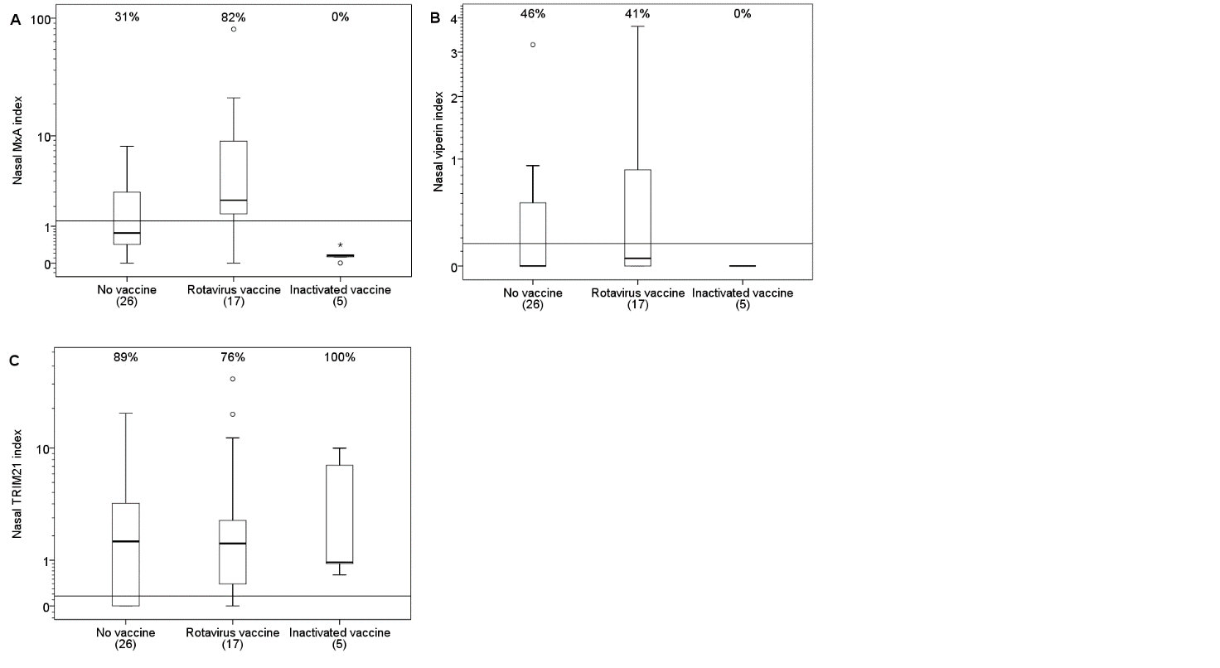

Supplementary Figure S1. The box plots represent A) nasal MxA, B) nasal viperin and C) nasal TRIM21 indexes in the asymptomatic virus negative children according to vaccinations < 30 days prior to sampling. Children with no information on vaccinations and one child with measles, mumps, and rubella (MMR) vaccine 14 days prior to nasal sampling (MxA index level of 1.51) were excluded. The median time point for the rotavirus vaccine administration was 14 days (interquartile range, 9-22 days) before nasal sampling. The inactivated vaccines included diphtheria, tetanus, acellular pertussis, inactivated polio virus, and H. influenzae type B conjugate (DTaP/IPV/Hib) vaccine (3 cases), hepatitis A vaccine (1 case), or influenza vaccine (1 case). The boxes represent the interquartile range and the whiskers the maximum and minimum values excluding outliers. Outliers are marked by a circle and extreme outliers by an asterisk. The percentages of values above the cut-off level (horizontal line), derived from the receiver operating characteristic (ROC) analysis, are shown above different groups. Numbers of children are given below the groups. The cut-off levels were set to 1.21 (A), 0.157 (B), and to 0.162 (C).

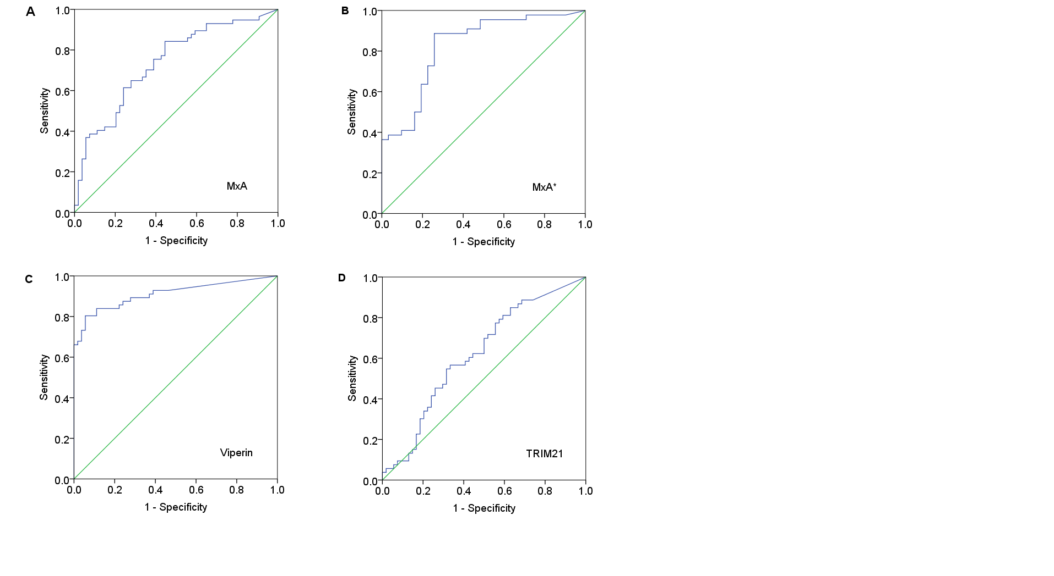
Supplementary Figure S2. Receiver operating characteristic (ROC) curves for the ability of the biomarker to distinguish symptomatic virus positive subjects from asymptomatic virus negative subjects. A) MxA index, all cases. Area under the curve (AUC), 0.736; 95% confidence interval (CI), 0.64 –0.829. B) MxA index, only cases without live virus vaccine within 30 days of sampling. AUC, 0.825; 95% CI, 0.728–0.922. C) Viperin index. AUC, 0.911; 95% CI, 0.853–0.968. D) TRIM21 index. AUC, 0.619; 95% CI, 0.512–0.726.

