Fast conversion of scFv to Fab antibodies using type IIs restriction enzymes
Hanna Sanmark, Tuomas Huovinen, Tero Matikka, Tiina Pettersson, Maria Lahti, Urpo Lamminmäki
Department of Biochemistry / Biotechnology, University of Turku, Turku, Finland

Corresponding author:
Hanna Sanmark
Department of Biochemistry / Biotechnology, University of Turku
Tykistökatu 6 A 6th floor
20520 Turku, Finland
E-mail: hansan@utu.fi
Tel: +358 2 3338084

Abstract
Single chain variable fragment (scFv) antibody libraries are widely used for developing novel bioaffinity reagents, although Fab or IgG molecules are the preferred antibody formats in many final applications. Therefore, rapid conversion methods for combining multiple DNA fragments are needed to attach constant domains to the scFv derived variable domains. In this study we describe a fast and easy cloning method for the conversion of single framework scFv fragments to Fab fragments using type IIS restriction enzymes. All cloning steps excluding plating of the Fab transformants can be done in 96 well plates and the procedure can be completed in one working day. The concept was tested by converting 69 scFv clones into Fab format on 96 well plates, which resulted in 93% success rate. The method is particularly useful as a high-throughput tool for the conversion of the chosen scFv clones into Fab molecules in order to analyze them as early as possible, as the conversion can significantly affect the binding properties of the chosen clones.

Keywords
scFv; Fab; antibody; high-throughput cloning; IIs restriction enzyme

Introduction
Human single chain variable fragment (scFv) antibody libraries are a useful tool for developing new therapeutic leads and anti-self antibodies (Griffiths et al., 1993), which is not directly achievable by hybridoma technology without extensive genetic manipulations. By using synthetic repertoires, the frameworks with the most favorable biophysical characteristics can be chosen as the library templates supporting the development of the retrieved antibodies into desirable final products (Tiller et al., 2013). However, scFv clones derived from synthetic libraries are sometimes unable to fold correctly or do not retain their affinity after conversion to a Fab or IgG format (Chan et al., 2011). Therefore, efficient and fast cloning methods are needed for the conversion of multiple clones from scFv to the more conventional formats to detect the best candidates for further development.
For the conversion of scFv to Fab fragments, the variable light and heavy (VL and VH) domains from scFv are linked to constant light (CL) and heavy 1 (CH1) domains, respectively. The conversion requires combining multiple DNA inserts, which is a laborious and time consuming process if the segments are joined in a sequential fashion. Several approaches have been used to streamline the assembly of multigene constructs. There are methods using site-specific recombination (Walhout et al., 2000,Liu et al., 1998), but the recombination sites, that are necessary for the assembly, remain in the final construct limiting usability of these methods. Also, the implementation of homologous recombination requires a careful predesign of the template sequence. In contrast, methods based on type IIs restriction enzymes, including FASTR (Kotera and Nagai, 2008) and Golden Gate cloning (Engler et al., 2008), enable an efficient assembly without any sequence manipulation of the target genes.
In this study, a modified version of FASTR cloning is described for the high-throughput conversion of scFv to Fab molecules. This method is especially convenient for single framework repertoires as a single primer set can be used for all source clones. For the Fab conversion, the variable light (VL) and heavy (VH) domains are amplified from the scFv clones by PCR and joined to the ready-made constant domain fragments (CL and vector-CH1) in an ordered manner. The correct assembly is based on the use of the IIs type restriction enzyme LguI containing a recognition sequence of 7 nucleotides and cutting outside of its recognition sequence leaving a 5´-protruding cohesive end of three nucleotides. The cohesive ends are designed to be unique to enable the unequivocal assembly of the four fragments into Fab molecules (Figure 1; Figure 2). The speed and simplicity of the FASTR reaction is based on the simultaneous addition of LguI enzyme and T4 DNA ligase that together drive the reaction towards the cleavage-resistant end products. This is achieved by the loss of the LguI recognition sites residing in the flanking sequences of the PCR products and the ligation of the newly generated compatible cohesive ends to restore the Fab genes (Kotera and Nagai, 2008).

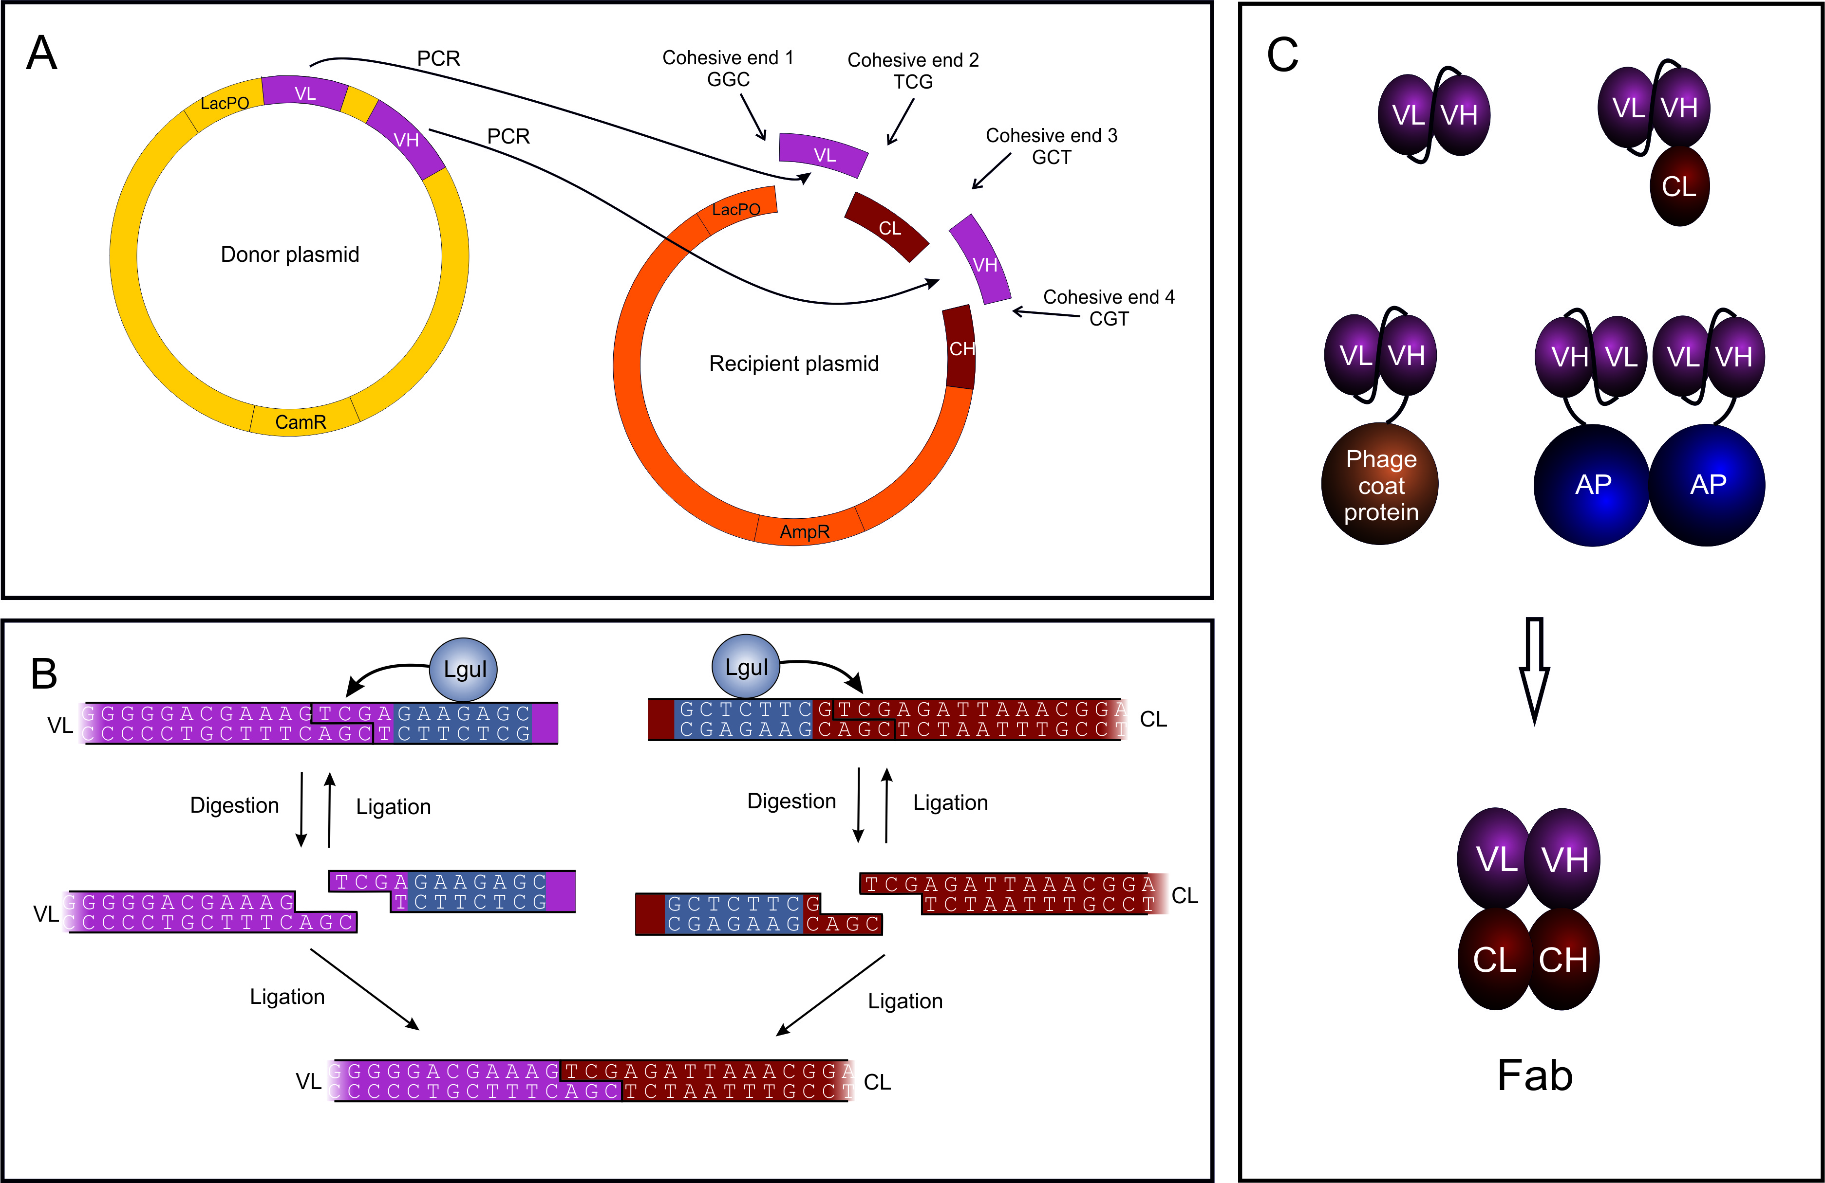
Figure 1. The concept of FASTR method for conversion of scFv fragments to Fabs. (A) The method involves combination of four DNA fragments in one digestion/ligation reaction. Each cloning site features different cohesive ends, forcing the fragments in the correct order and orientation. (B) As an example, the digestion/ligation reaction in one of the four ligation sites (interface of VL and CL fragments) is shown in detail. The restriction enzyme sites added by a PCR reaction are digested by a type IIS restriction enzyme, LguI, producing cohesive ends. Ligation happens in the same reaction. The restriction enzyme recognition sequence (showed in blue) is removed during digestion, leaving no additional sequence in the final product and stopping the reaction. This drives the equilibrium reaction towards the correct ligation product. (C) All VL and VH domains of the selected scFv clones originating from the same single framework library can be amplified with the same set of primers and cloned into Fabs regardless of the input format, e.g. scFv or scFv fused to constant light domain (CL), phage coat protein or bacterial alkaline phosphatase (AP).
Figure 2. DNA sequences of binder clone McLR1 in scFv and Fab formats. Variable domains are highlited in light gray, constant domains in dark gray. The scFv is converted to Fab using four cloning sites. The nucleotides forming the cohesive ends are underlined.

Materials and methods

Vectors
The scFv fragments to be cloned had been selected by phage display from libraries scFvP and scFvM (Huovinen et al., 2013). The scFv clones specific to glial cell line-derived neurotrophic factor (GDNF) or glutathione S-transferase (GST) were in alkaline phosphatase vector pAK600 (Krebber et al., 1997). In high-throughput cloning the first 21 scFv clones were from the primary anti-lysozyme phage screening and were in the phagemid vector pEB91 (Brockmann et al., 2011). The 12 anti-streptavidin (STR) clones were in the alkaline phosphatase (AP) vector pLK06 and the 17 anti-prostate specific antigen (PSA) clones were in the screening vector pLK06H, which is similar to pLK06 with an additional hexahistidine tag (Huovinen et al., 2013). The 12 anti-digoxigenin (DIG) scFvs and 7 anti-microcystin (McLR) scFvs were present as mouse CL domain fusions in the vector pLK01 and were earlier published (Huovinen et al., 2013), except for one anti-McLR clone.
In all clonings the target vector was pLK04 (Huovinen et al., 2011) with an unspecific Fab fragment to serve as a template for constant regions of Fab constructs.

Proof of concept experiment
Four antibody clones (three recognizing glial cell-derived neurotrophic factor (GDNF) and one binding to glutathione S-transferase (GST)) were subcloned from pAK600 to pLK04 vector and simultaneously converted from scFv to Fab fragments. The DNA fragments to be cloned, i.e. VL, CL, VH, and pLK04-CH1, were amplified by PCR using primers that introduce LguI restriction enzyme sites to both ends of PCR products. The PCR reactions (20 µl) contained 0.2 mM of dNTP’s (Finnzymes, Espoo, Finland), 0.2 µM of each primer (Biomers, Ulm, Germany), 1 U PfuUltra polymerase and 1x PfuUltra HF buffer (Agilent Technologies, USA) and 0.5 µl pAK600-scFv or pLK04-Fab DNA (50 – 150 ng). The pAK600-scFv template DNA was prepared from 3 mL overnight cultured XL1 Blue cells with a miniprep kit (Qiagen, Hilden, Germany). The PCR reactions were performed by first denaturing for 2 minutes at 95°C, cycling 25-30 times with denaturation for 30 s at 95°C, annealing for 30 s at 55 or 50°C and extension for 1.5 or 4.5 min at 72°C, followed by a final extension for 10 min at 72°C.
The amplified DNA fragments were digested and ligated in a single tube by FASTR method (Kotera and Nagai, 2008). The reactions contained 0.5x Tango buffer, 1x T4 DNA ligase buffer, 0.25 U/µl LguI, 1 U/µl DpnI, 0.1 U/µl T4 DNA ligase, 5 mM ATP, and 1 µl of each amplified DNA fragment VL, VH, CL, and pLK04-CH1 in 20 µl volume. The T4 DNA ligase and all restriction enzymes in this work were purchased from Fermentas (Vilna, Lithuania). The reaction was incubated 1 h at room temperature and inactivated at 65°C for 20 minutes. For analysis, 2 µl samples of each FASTR reaction were transformed to 20 µl of electrocompetent E. coli XL1-Blue cells and plated on LA with 100 µg/ml ampicillin and 0.5 % glucose.
After overnight incubation at 37°C, two colonies from each transformation were streaked on new selective agar plates for pure cultures, grown overnight at 37°C and inoculated into 5 ml LB medium with 100 µg/ml ampicillin and 1% glucose. The liquid cultures were incubated overnight at 37°C, 300 rpm, and plasmid DNA was extracted by High-Speed Plasmid Mini Kit (GeneAid, New Taipei City, Taiwan). Pure DNA (~200 ng) was digested by SfiI restriction enzyme and analyzed by gel electrophoresis on 1% agarose gel. One of the two clones was sequenced from each FASTR reaction at the sequencing service unit of the Center of Biotechnology (Turku, Finland).

High-throughput cloning of 69 clones
All steps excluding the plating of transformed cells were performed on 96 well microtiter plates. For cell lysis, 2 µl overnight cell culture samples of the scFv clones in pEB91, pLK01, pLK06 and pLK06H vectors were diluted with 50 µl H₂O and heated for 3 min at 98°C. The cell debris was pelleted by spinning for 5 min at 3220 x g and 2 µl of the lysis supernatant was taken as template for the VL and VH PCR. In addition, the 20 µl PCR reaction contained 0.2 mM dNTP’s, 0.2 µM primers, and 0.4 U Phusion Hot Start II DNA polymerase and 1x HF buffer from Finnzymes. After initial denaturation for 30 s at 98°C, the PCR reactions were cycled 25 times with denaturation for 5 s at 98°C, annealing for 20 s at 70°C and extension for 1.5 min at 72°C, or annealing and extension for 25 s at 72°C, followed by the final extension for 5 min at 72°C. The FASTR reactions were carried out in 10 µl volumes containing 0.5 µl of VL and VH PCR reactions, 20 ng of vector fragments CL and pLK04-CH1, 0.5x Tango buffer, 1x T4 DNA ligase buffer, 0.25 U/µl LguI, 0.5 U/µl DpnI, 0.1 U/µl T4 DNA ligase, and 5 mM ATP. The reactions were incubated for 1 h at room temperature, inactivated at 65°C for 20 minutes and 4 µl samples of reaction mixture were mixed with 40 µl of CaCl₂-competent E. coli XL1-Blue cells and transformed by heat shock. The cells were plated on LA plates containing 0.5 % glucose and 100 µg/ml ampicillin and incubated at 37°C overnight.

Analytical PCR
Two colonies from each transformation plate were analyzed by PCR. The cells were grown, lysed and spinned as before. The analytical PCR reactions contained 2 µl lysed cell supernatant, 0.2 mM dNTP’s, 0.5 µM of primers WO375 and pAK400 rev, 0.2 µl Phire II DNA polymerase (Thermo Scientific) and 1x Phire reaction buffer (Thermo Scientific) in 10 µl volume. The PCR program was as follows: 30 s at 98°C, 25 cycles of 5 s at 98°C, 15 s at 65°C and 20 s at 72°C, followed by 72°C for 5 min. The DNA fragments were analyzed by gel electrophoresis on 0.8% agarose gel.

Sequencing
For sequencing the Fab constructs, new PCR products were prepared as described for analytical colony PCR. The primers and unreacted dNTPs were eliminated by adding 20 U of Exonuclease I (Fermentas) and 2 U of FastAP Thermosensitive Alkaline Phosphatase (Fermentas) to 10 µl of the PCR reactions and incubating the reactions at 37°C for 15 min. The reactions were stopped by heating at 85°C for 15 min and sent for sequencing at Macrogen Europe (Amsterdam, Netherlands).

Fab production and immunoassays
For Fab production the clones verified by sequencing were inoculated in 160 µl SB with 0.05 % glucose and 100 µg/ml ampicillin on a 96 well tissue culture plate (Sarstedt, Newton, NC, USA) and incubated at 26°C with 900 rpm shaking for 24 hours. The Fab production was induced by the addition of 50 µM Isopropyl β-D-1-thiogalactopyranoside (IPTG) and the incubation was continued overnight as above. The cells were lysed by freezing and thawing two times and supplemented with 25 U/ml benzonase and 1 mM MgCl₂. The suspension was centrifuged at 3220 x g for 30 minutes and the supernatant was used for immunoassays.
The immunoassays, based on time-resolved fluorescence method (Lövgren and Pettersson, 1990), were done on microtiter wells coated with rabbit anti-mouse IgG (Kaivogen Oy, Turku, Finland). All dilutions were made in Kaivogen buffer solution red and the plates were washed with Kaivogen washing buffer (Kaivogen Oy) using DELFIA plate washer (Perkin Elmer, Turku, Finland). Assays were done as duplicates in 100 µl volume. Sample dilutions were added to the wells and incubated for 1 h on low shaking. The wells were washed four times. Fab concentration of the samples was determined by 0.1 µg/ml rabbit anti-mouse IgG (Sigma-Aldrich, St. Louis, MO, USA) labeled with europium chelate as a tracer. For the measurement of specific activity of Fab fragments the respective antigen of each binder labeled with europium chelate was used (1 µg/ml lysozyme, 0.1 µM STR, 0.065 µM DIG, 0.4 µg/ml PSA or 0.065 µM McLR). The plates were incubated for 1 h on low shaking and washed four times. DELFIA enhancement solution (Perkin Elmer) was added and, after 15 min incubation, time-resolved fluorescence was measured with 1420 Victor Multilabel Counter (Perkin Elmer).

Comparition of binder affinities in scFv and Fab formats
For affinity determination, selected McLR specific clones were produced as scFv-CL and Fab fragments. A colony of cells was inoculated in 4 ml SB with 1 % glucose, 10 µg/ml tetracycline and 100 µg/ml ampicillin and incubated at 30°C with 300 rpm shaking overnight. The overnight culture was diluted 1:10 in 4 ml of SB with 0.05 % glucose, 10 µg/ml tetracycline and 100 µg/ml ampicillin and incubated at 30°C with 300 rpm shaking until the cells reached logarithmic growth phase. The Fab production was induced by the addition of 200 µM IPTG and the incubation was continued overnight at 26°C. The cells were collected by centrifugation at 3220 x g for 15 minutes and the cell pellet was stored at -20°C before suspension in TBT buffer (50 mM Tris base, 150 mM NaCl, pH 7.5; 0.1% bovine serum albumin and 0.05% Tween). The cells were lysed by freezing and thawing two times. The suspension was centrifuged at 13000 x g for 10 minutes and the supernatant was used for affinity measurements.
The McLR immunoassays to compare immunoreactivity of the selected scFv-CL and Fab clones were done on streptavidin coated microtiter wells (Kaivogen Oy). Biotinylated McLR (10 nM) was immobilized in the wells by 30 min incubation with slow shaking. The wells were washed four times, and a serial dilution of antibody samples was added in the wells. After 1h incubation and four washes, the bound Fab or scFv-CL fragments were detected by 0.1 µg/ml rabbit anti-mouse IgG labeled with europium chelate. Time resolved fluorescence was measured as described above.
Affinities of the selected scFv-CL and Fab clones were determined by bio-layer interferometry technology using the Octet RED384 instrument (ForteBio, Menlo Park, CA, USA). Biotinylated McLR was diluted to 50 nM in TBT and loaded on streptavidin sensors (ForteBio) for 1 minute. The sensors were transferred to wells containing the antibody lysate diluted in TBT (2 min), and then to wells with TBT for dissociation (1 min). Signals of reference sensors that contained no McLR were subtracted from the sample sensor signals. Association and dissociation constants were calculated by the ForteBio data analysis software 8.2.0.7, applying a 1:1 interaction model.

Results

Conversion of single framework scFvs to Fab fragments
In a proof of concept experiment, four GDNF- and GST-specific scFv clones were cloned from pAK600 expression vector into pLK04 expression vector converting them simultaneously from scFv to Fab fragments by FASTR. The analysis of two transformants from each of the four reactions revealed that all clones contained the correct restriction pattern for a pLK04-Fab construction (Figure 3). The sequencing of one clone from each reaction confirmed the successful conversion by FASTR. No mutations were found in the analyzed DNA sequences covering the full extent of the Fab gene.
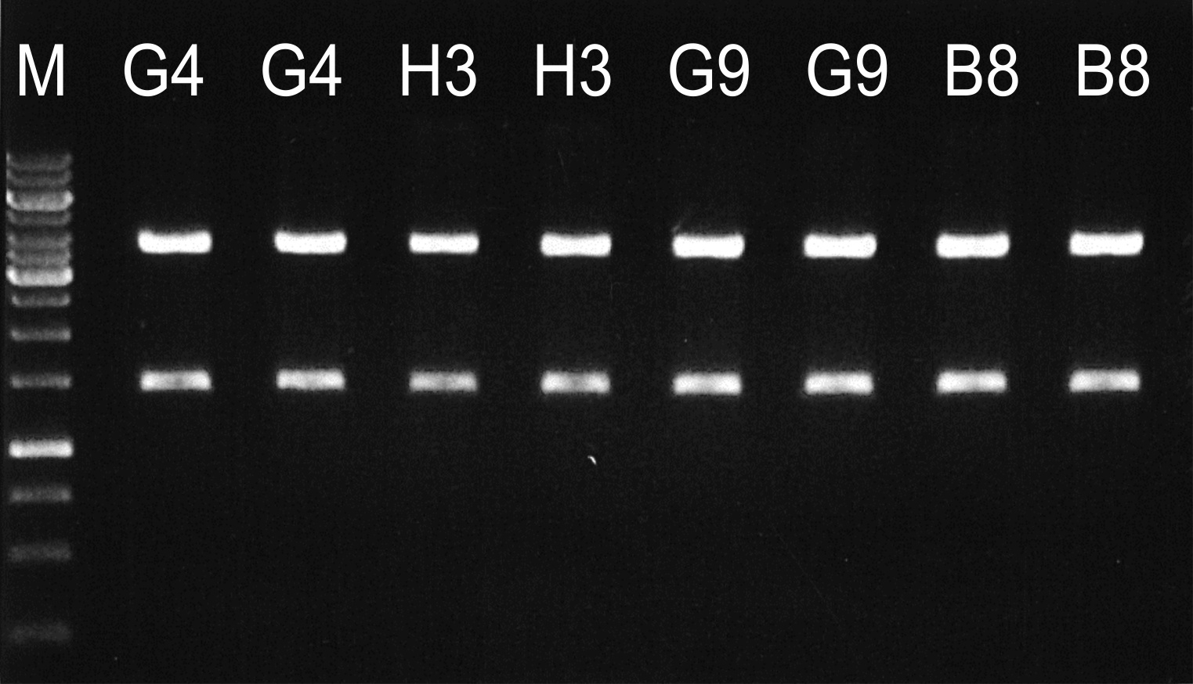
Figure 3. Restriction analysis of four Fab clones created by FASTR. Two colonies from each cloning were analyzed by digestion with restriction enzyme SfiI. All digestions produced the expected restriction pattern of 3753 and 1404 bp fragments. G4, H3 and G9 were GDNF specific clones and B8 was a GST specific clone. M = GeneRuler 1 kb DNA Ladder (Fermentas)

High-throughput cloning
The suitability of the method for high-throughput applications was tested with 69 scFv clones derived from phage display selections against lysozyme, STR, DIG, PSA and McLR.
The success rate of the high-throughput cloning is presented in Table 1. The PCR of the VL and VH domains was successful with all except one template clone. After FASTR, the samples were transformed on 96 well plate with CaCl₂ competent cells yielding 4–123 colonies per transformation on selective agar plates. Two colonies from each plate were analyzed by colony PCR. An amplicon corresponding to the correct size of the Fab fragment was obtained from both colonies in 60/68 transformations and the Fab amplicon was missed completely in only one reaction yielding a 99% success rate for the FASTR step. A clone was sequenced from each FASTR sample revealing that 61/67 sequenced clones were correct. In three cases the cloning had failed either due to incorrect ligation resulting in a reversed DNA fragment or due to a nonsense point mutation. In addition, there was a clone with an Ala to Gly missense mutation in the framework 2 region, but it was considered not to affect the Fab function. The three other failed sequencing samples contained more than one template causing a mixed trace data, or did not correspond to the original scFv identity, which was attributed to cross contamination. In three cases the correct Fab sequence was found by sequencing the other analyzed colony, bringing the total success rate of FASTR cloning to 93%.
Table 1. Success rates of FASTR cloning steps in high-throughput cloning.
Cloning step |  | Positive | Success rate per step | Cumulative success rate
PCR before FASTR (VL/VH) |  | 68/69 | 99% | 99%
Fab fragment found by analytical PCR after FASTR |  | 67/68 | 99% | 97%
 | Fab fragments in both analyzed clones | 60/68
Construct correct by sequencing one clone |  | 61/67 | 91% | 88%
 | Aberrations (deletion/inversion/nonsense mutation) | 3/67
 | Mixed clones | 3/67
Correct product found by sequencing 1-2 clones |  | 64/69 |  | 93%

Expression and binding of Fab fragments
The expression of the generated chimeric Fab molecules (containing human variable and mouse constant domains) was tested first by capture on rabbit anti-mouse IgG plate using europium-labeled rabbit anti-mouse IgG for the detection. In this assay, 59/61 Fabs were expressed at > 0.5 µg/ml concentration. The specific activity of Fab fragments was determined by immunoassay for 54 clones that had shown specificity to their respective antigens as scFv fragments. Before conversion to Fab fragments 11 of these had shown specific activity to lysozyme when they were displayed as scFv-p9 fusion proteins on surface of M13 filamentous phages in phage screening assay (signal/background >5). After conversion to Fab fragments, specific activity (signal/background >3 in Fab assay) for the target binding was observed only in five of them. 19 of the 30 clones, that had been verified as STR and PSA binders in scFv-AP format, showed specific activity as Fabs. The DIG and McLR binders, that were specific in scFv-CL format, retained their activity in 8 out of 12 cases. Thus only 32/53 Fab clones corresponding to 60% retained the binding activity.

Effect of scFv to Fab conversion on binder affinities
Selected McLR binders were further characterized to determine, how the conversion from scFv to Fab format affects affinity. In McLR immunoassay with varying binder concentrations all three tested scFv-CL binders produced fairly similar responces (Figure 4A). The same clones were assayed also in Fab format (Figure 4B). Clone McLR 1 showed elevated signal levels with significantly lower binder concentrations than as scFv-CL. With clone McLR 2 no specific signal was detected and with McLR 6 there was signal only with very high binder concentrations (>1 µg/ml).
A
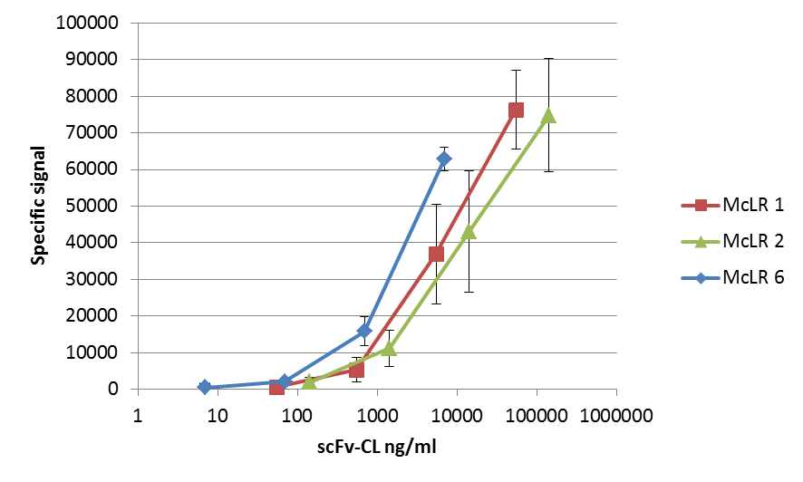
B
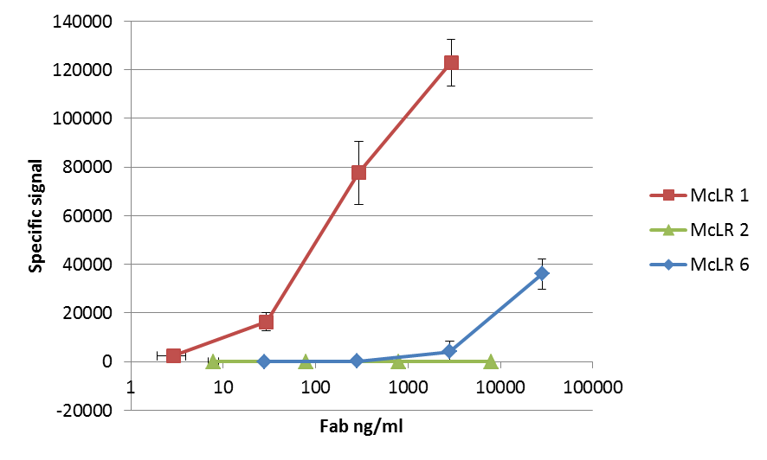
Figure 4. McLR immunoassay of selected anti-McLR clones. The plots represent the mean of three independent experiments with standard deviation. The signal levels in figures A and B can not be directly compared, due to differences in label binding to scFv-CL and Fab fragments. A. Immunoassay with scFv-CL fragments. B. Immunoassay with Fab fragments.
The affinities of the McLR binders were analyzed by bio-layer interferometry. The K_{D} value of clone McLR1 as scFv-CL fragment was 1.1E-6 M (K_{on} 4.4E+3 M⁻¹s⁻¹, K_{off} 4.8E-3 s⁻¹), whereas as Fab fragment the same clone had K_{D} of 7.6E-8 M (K_{on} 3.7E+4 M⁻¹s⁻¹, K_{off} 2.8E-3 s⁻¹). ScFv-CL fragments McLR 2 and McLR 6 showed K_{D} values of 8.2E-7 and 1.0E-7 M, respectively. For Fab clones McLR 2 and McLR 6 binding affinies could not be determined due to very low signal levels.

Discussion
The original report on FASTR described the method as a useful research tool to optimize the linker length between two protein fluorophores for the development of an efficient FRET pair applicable in protease screening (Kotera and Nagai, 2008). The selected application, however, underestimates the power of the technology as tackling specific research problems requires a new set of FASTR primers for each particular project. In this study, we wanted to highlight the utility of FASTR technology in antibody engineering as a general platform for the conversion of single framework library-derived scFvs into Fab molecules. The type IIs restriction enzyme used by Engler et al. (2008), BsaI, was not a suitable choice for our application, because our scFv template contained an internal BsaI site. Furthermore, it is also less probable that the 7-bp recognition sequence of LguI is regenerated in the template diversification phase than a 6-bp recognition sequence of BsaI.
In this study, FASTR was used to convert scFvs in various source vectors to Fab format. One possible use for the method is the possibility to replace the scFv-phage screening with Fab screening. This was studied with the third round output clones from the anti-lysozyme selection by cloning them from a phagemid display vector to the Fab expression vector. By this cloning method individual clones can be cloned from scFv to Fab format in a high-throughput manner and screening can be done with the Fabs. The phage vs. Fab screening demonstrates that 6 of the 11 clones that could be considered to be positive as phage clones failed to respond as Fab clones. Hundreds of fluorescent labeled anti-phage antibodies are able to bind to a single phage filament, whereas the detection of Fab binding is based on observing the signal from the antigen with a single label as is the case, e.g. with anti-DIG and anti-McLR clones. Therefore, the Fab screening yields inevitably lower hit rates than the phage clone screening, as the very weakly binding clones are visible in phage but not in the Fab screening assay.
Additionally, an array of scFv clones was converted from various soluble expression formats into Fab fragments. The functional evaluation of the Fabs showed that, although all successfully converted clones were active as scFvs, only 65% of the clones could be considered to bind the target as Fab molecules. Further analysis of selected McLR binders confirmed, that antibody clones respond to the scFv to Fab conversion in very different ways. One of the clones had higher affinity as Fab than as scFv-CL fragment, while the other two lost either some or all of their affinities. As suggested by Chan et al. (2011), structural changes might occur at variable domains upon conversion of the scFv to Fab, which may lead to change or loss of specificity. Also, in the case of the anti-STR and anti-PSA antibodies, the scFvs were analysed as fusions with alkaline phosphatase, which is known to form dimers. The avidity benefit is lost, when screening the clones as Fabs.
Overall, this study demonstrates that the genetic swapping of scFv via the four fragment assembly to Fabs proceeds with acceptable efficiency. Sequencing confirmed that 93% of the included clones were successfully converted to Fabs. Analysis of more colonies of the remaining transformations could have further increased the success rate.
In the original FASTR protocol (Kotera and Nagai, 2008) aphidicolin was used to inhibit the residual activity of DNA polymerase. In this study it was found, that polymerase inhibition was not needed with either of the DNA polymerases used, PfuUltra and Phusion Hot Start II.
As a summary, by using a single framework library we were able to use the same primer set for the conversion of the selected scFv clones to Fab molecules in a very cost-effective manner. According to our data FASTR is a suitable tool for the high-throughput conversion of clones between antibody formats. As there can be considerable changes in binding ability upon conversion from scFv to Fab, it is important to have an efficient tool for converting scFvs to Fabs, like the one presented here. The conversion of scFvs is recommended to be applied at an early stage in the product development in order to focus the future efforts to the most potential candidates performing well also as fused to constant Ig domains.

Acknowledgements
This study was supported by the Academy of Finland (Grant number 272621), the Finnish Funding Agency for Technology and Innovation (TEKES, 40100/10) and the Graduate School of Advanced Diagnostic Technologies and Applications (DIA-NET).

References
Brockmann, E.C., Akter, S., Savukoski, T., Huovinen, T., Lehmusvuori, A., Leivo, J., Saavalainen, O., Azhayev, A., Lovgren, T., Hellman, J., Lamminmaki, U., 2011. Synthetic single-framework antibody library integrated with rapid affinity maturation by VL shuffling. Protein Eng. Des. Sel. 24, 691-700.
Chan, C.E., Chan, A.H., Lim, A.P., Hanson, B.J., 2011. Comparison of the efficiency of antibody selection from semi-synthetic scFv and non-immune Fab phage display libraries against protein targets for rapid development of diagnostic immunoassays. J. Immunol. Methods 373, 79-88.
Engler, C., Kandzia, R., Marillonnet, S., 2008. A one pot, one step, precision cloning method with high throughput capability. PLoS One 3, e3647.
Griffiths, A.D., Malmqvist, M., Marks, J.D., Bye, J.M., Embleton, M.J., McCafferty, J., Baier, M., Holliger, K.P., Gorick, B.D., Hughes-Jones, N.C., 1993. Human anti-self antibodies with high specificity from phage display libraries. EMBO J. 12, 725-734.
Huovinen, T., Julin, M., Sanmark, H., Lamminmaki, U., 2011. Enhanced error-prone RCA mutagenesis by concatemer resolution. Plasmid 66, 47-51.
Huovinen, T., Syrjanpaa, M., Sanmark, H., Brockmann, E.C., Azhayev, A., Wang, Q., Vehniainen, M., Lamminmaki, U., 2013. Two ScFv antibody libraries derived from identical VL-VH framework with different binding site designs display distinct binding profiles. Protein Eng. Des. Sel. 26, 683-693.
Kotera, I., Nagai, T., 2008. A high-throughput and single-tube recombination of crude PCR products using a DNA polymerase inhibitor and type IIS restriction enzyme. J. Biotechnol. 137, 1-7.
Krebber, A., Bornhauser, S., Burmester, J., Honegger, A., Willuda, J., Bosshard, H.R., Pluckthun, A., 1997. Reliable cloning of functional antibody variable domains from hybridomas and spleen cell repertoires employing a reengineered phage display system. J. Immunol. Methods 201, 35-55.
Liu, Q., Li, M.Z., Leibham, D., Cortez, D., Elledge, S.J., 1998. The univector plasmid-fusion system, a method for rapid construction of recombinant DNA without restriction enzymes. Curr. Biol. 8, 1300-1309.
Lövgren, T., Pettersson, K., 1990. Time-resolved fluoroimmunoassay, advantages and limitations, in Van Dyke, K., Van Dyke, R. (Eds.), Luminescence Immunoassay and Molecular Applications. CRC Press, Boca Raton, USA, pp. 233-253.
Tiller, T., Schuster, I., Deppe, D., Siegers, K., Strohner, R., Herrmann, T., Berenguer, M., Poujol, D., Stehle, J., Stark, Y., Hessling, M., Daubert, D., Felderer, K., Kaden, S., Kolln, J., Enzelberger, M., Urlinger, S., 2013. A fully synthetic human Fab antibody library based on fixed VH/VL framework pairings with favorable biophysical properties. MAbs 5.
Walhout, A.J., Temple, G.F., Brasch, M.A., Hartley, J.L., Lorson, M.A., van den Heuvel, S., Vidal, M., 2000. GATEWAY recombinational cloning: application to the cloning of large numbers of open reading frames or ORFeomes. Methods Enzymol. 328, 575-592.

