Micro and Nano Structural Analysis of Dental Ceramic and Luting Resin Interface and the Effect of Water Exposure on Integrity of Cement Interface
Ravikumar Ramakrishnaiah^{1,}*, Abdulaziz A. Alkheraif¹, Darshan D. Divakar¹, Mohamed Alsharawy¹, Jukka P. Matinlinna², Pekka K. Vallittu³
¹Dental Biomaterials Research Chair, Dental Health Department, College of Applied Medical Sciences, King Saud University, P. O. Box 10219, Riyadh 11433, Kingdom of Saudi Arabia
²Dental Materials Science, Faculty of Dentistry, The University of Hong Kong, Hong Kong, SAR, People’s Republic of China, and King Saud University, Kingdom of Saudi Arabia
³Department of Biomaterials Science, Institute of Dentistry, University of Turku and City of Turku, Division of Welfare, FI-20014 Turku, Finland, and King Saud University, Kingdom of Saudi Arabia
*Correspondence: E-mail: rramakrishnaiah@ksu.edu.sa; Tel: +966531219850

Abstract:
The current study was aimed to evaluate - by micro and nano-structural analysis - the interface between dental ceramic and resin materials. The degree of resin impregnation into the etched micro patterns, the nano-mechanical properties of the resin-ceramic interface and the effect of subjecting to exposure in boiling water on resin-ceramic interface were studied. Three silica based glass ceramics were compared and contrasted: twenty samples from Computer Aided Design (CAD) blocks of each material were prepared. The specimens were finished, polished, ultrasonically cleaned, and etched with suitable acid. The specimens were randomly divided into two study groups to evaluate the effect of primer on resin cement impregnation. Each group of specimens were further divided into two subgroups to compare and contrast the difference in resin impregnation between adhesive resin and resin composite cement. The resin-ceramic interface was examined under scanning electron microscope and nano-mechanical properties were analyzed using a nano-indenter. The results were statistically analyzed using multivariate analysis of variance, a post hoc test, and regression analysis at a significance level of p<0.05. The results showed better resin impregnation of adhesive resin on primer treated specimens than resin composite cement. The specimens with the primer treatment and application of adhesive resin exhibited higher elastic moduli (46.07 GPa) and nano-hardness (2.02 GPa) even after subjecting to exposure in boiling water.
Keywords: Adhesive resin; Dental ceramics; Nano-mechanical properties; Resin-ceramic interface; Resin composite

1. INTRODUCTION
Dental ceramics are highly aesthetic restorative materials. Advances in the dental research have led to the development of high strength ceramics with significantly accurate fabrication techniques and predictable clinical results. Newer high strength glass ceramics, such as lithium disilicate, leucite reinforced, and zirconia reinforced glass ceramics are used to restore the high load bearing areas ranging from 400 to 620 MPa with great success¹. Relatively high static strength and excellent aesthetic characteristics have made dental glass ceramics highly preferred materials to restore teeth with various clinical conditions using inlays, onlays, veneers, crowns, and even short and long span fixed dental prostheses.
Although static strength of glass ceramics is in principle adequate for crowns and short span fixed dental prostheses, restorations may fail as a result of fracture. Fracture of ceramic restoration is mainly because of the presence of internal and external flaws such as internal porosities and surface scratches, respectively, and also due to dynamic loading conditions^{2, 3}. Given this, ceramic restorations are fabricated with great care, especially the final steps of finishing, polishing, and glazing are prepared with high precision in order to eliminate surface flaws which are the main cause for crack initiation and propagation. Apart from this, the fracture sometimes originates at the adhesive resin and ceramic interface and intaglio surface of the ceramic restoration¹. This kind of fractures occur due to the micro-porosities created by grit-blasting abrasion or acid etching process⁴.
Acid etching is carried out to enhance bonding of resin composite luting cements. The primary mechanism of bonding dental glass ceramics is by mechanical interlocking (retention) through resin cements. The internal surface of finished ceramic restoration is etched with suitable acid. Hydrofluoric acid etching creates nano-scale pores, resulting in rough internal surface with more surface area for bonding. The morphology and dimensions of the pores are directly related to the concentration and duration of acid etching⁵. However, the effect of pores on the nano-mechanical properties of the ceramics has not yet been reported. The porosities created as a result of acid etching may act as points of crack initiation or, may contribute to crack propagation^{6, 7}. Furthermore, the subsequently applied adhesive resin and resin composite luting cement are expected to penetrate the full depth of the micro-pores and only then the ideal bond strength and sealing of the micro-porosity may be achieved. Silane coupling agents, which are silicon esters, are known in the first instance to improve surface wetting of the ceramics by resin monomers and, secondly, for the oxygen atom mediated coupling between the ceramic surface and the methacrylate group mediated linking with the resin system^{5, 8-16}. However, a silane promoted adhesive interface is prone to hydrolysis and the bonding is usually weakened considerably over time^{17, 18}
With this background, the current study was designed to evaluate the interface between dental ceramic and resin materials for the degree of resin impregnation into the etched micro-patterns, and the nano-mechanical properties of the resin-ceramic interface. The research hypothesis were that (1) the resin impregnation by unfilled resin system is better than the filled resin composite, and that (2) the resin tags with better penetration to the mirco-patterns are better polymerized (i.e., have higher nano-hardness) at the deepest part of the micro-patterns. Furthermore, the effect of accelerated hydrolysis by exposure with boiling water to the materials at interface was also studied.
2. MATERIALS AND METHODS
2.1. Study design
The manufacturers’ details and the brief description of the materials used in this study are presented in Table 1. Silica (SiO₂) based glass ceramics were analyzed for the degree of resin impregnation and the effect of primer on the impregnation of etched micro-porosities by adhesive resin and resin composite, using a scanning electron microscope (SEM). Nano-mechanical properties (modulus of elasticity and surface nano-hardness) of resin-ceramic interface was evaluated using nano-indentation. Furthermore, the samples were subjected to accelerated hydrolysis by exposure to boiling water and the effect at adhesive resin and ceramic interface was examined under SEM.
2.2. Specimen preparation, organization and treatment procedure
Twenty cuboidal specimens measuring 7.0 ± 0.25 mm x 5.0 ± 0.25 mm x 4.0 ± 0.25 mm were cut from Computer Aided Design (CAD) blocks of each material using a low speed diamond wheel saw (Model 650, Ladd research industries, Williston, USA). The cut surfaces were polished up to 4000 grit FEPA (Federation of European Producers of Abrasives) in a sequential manner with silicon carbide paper and a polishing liquid using Labpol 8-12 (Extec, Enfiled, CT, USA) to remove gross surface irregularities and scratches. The specimens were ultrasonically cleaned in distilled water for 10 min using Quantex 140 (L and R manufacturing company, Kearny, New Jersey, USA) and air dried. All the specimens were etched with IPS etching gel for 40 s in a fume hood in a well ventilated laboratory (with all relevant safety measures) to avoid any hazards. The specimens were washed with a copious amount of water for 30 s to remove excess acid, and neutralized with a neutralizing agent for 1 min, rinsed with distilled water for 30 s and dried. Finally the specimens were dehydrated by dipping in absolute ethanol and dried.
The specimens were randomly assigned to two study groups (Figure 1), in the group 1 specimens’ etched surface was treated with a primer, and in the group 2 specimens’ etched surface received no treatment in order to study the effect of primer application, on penetration of luting resin cements into the etched micro pores. The specimens of each group were further randomly divided in two sub groups depending on the type of resin applied. Adhesive resin was applied on subgroup “A” specimens’ surface and resin composite was applied on subgroup “B” specimens’ surface to evaluate the difference in terms of penetration of resin into micro pores. After 15 s of impregnation time the resin cement was light cured for 20 s using a light curing unit (Elipar Free Light 2, 3M ESPE, Seefeld, Germany) with a wavelength of 420-540 nm and the power of 1505 mW/cm² (MARC system, Blue Light Analytics, Halifax, Canada).
Specimens were ground perpendicular to the adhesive interface and polished up to 4000 grit FEPA, ultrasonically cleaned and air dried to examine the resin-ceramic interface.
2.3. SEM analysis
The specimens were gold sputter coated in an argon plasma gold sputter coater (Polaron E-5200, Energy Beam Sciences, Agawan, USA). The ceramic and luting resin interfaces were visually analyzed using SEM (Jeol JSM-6360LV, JEOL, Tokyo, Japan) at 1000 magnification.
2.4. Nano-indentation
The modulus of elasticity and surface nano-hardness exactly at the resin-ceramic interface were measured using a nano-indenter (Bruker NH-2, 1041, Tucson, AZ, USA) equipped with a 3 sided Berkovich diamond indenter tip, one indentation was performed for each sample. During the nano-indentation test, the indenter tip was pressed onto the test surface at interface with preset loading and unloading values. The resin-ceramic interface of all the specimens was evaluated, and the response to the load was recorded as the load-displacement curve (P-h curve) with a high resolution displacement gauge. The test was performed at room temperature in low noise conditions, the loading and unloading rate was set at 0.01 mN/s and 0.02 mN/s, respectively, with a 5 s rest period at the maximum load of 10 mN.
2. 5. Boiling water exposure
The specimens were kept in water bath and the temperature of the water was gradually increased to 100⁰C and maintained for 24 h using a thermo-cycler machine (SD Mechatronik thermocycler, Huber, Peter Huber Kaltemaschinenbau, Offenburg, Germany). The resin-ceramic interface and the nano-mechanical properties were re-examined after the boiling water exposure as described above.
The results of the modulus of elasticity and surface nano-hardness of the experimental groups before and after boiling water exposure were analyzed using Statistical Package for Social Sciences version 22.0 (SPSS Inc., Chicago, IL, USA). A multivariate analysis of variance and a post hoc test was used to calculate the difference in the mean values between groups before and after accelerated hydrolysis at a significance level of p<0.05. Regression analysis was performed between the modulus of elasticity and surface nano-hardness.
3. RESULTS
Figure 2 shows the SEM images of the resin-ceramic interface of all the groups before the specimens were subjected to boiling water exposure. The primer treated specimens with the application of adhesive resin (1A group specimens) showed better penetration of resin into the etched porosities than other group specimens. The specimens with no primer treatment and resin composite applied specimens (2B group) demonstrated visible gap between ceramic and resin composite in all of the materials.
Figure 3 shows the SEM images of the specimens from all the groups after subjecting to exposure in boiling water. All the specimens showed some degree of disintegration of resin at the resin-ceramic interface, but the degree of disintegration and gap at the interface varied from one group to the other. The adhesive resin showed the least disintegration (1A and 2A group specimens) than resin composite, furthermore primer treated specimens showed least disintegration (1A group specimens). The specimens with no primer treatment and resin composite applied specimens (2B group specimens) showed the highest resin disintegration.
Table 2 and Table 3 show the mean values of modulus of elasticity and surface nano-hardness, respectively, in different groups of the all the materials tested before and after the specimens were subjected to exposure by boiling water. Figure 4 shows a typical nano-indentation load-penetration depth curves F-Δ. Figure 5 shows the correlation between modulus of elasticity and surface nano-hardness values. The primer treated specimens with an application of adhesive resin (Group 1A) showed significantly the highest hardness of 2.02 and 0.02 GPa (E max) before and after exposure to boiling water respectively, these specimens also showed highest modulus of elasticity of 46.07 and 6.14 GPa before and after exposure to boiling water respectively. The specimens with no primer treatment and with application of resin composite (Group 2B) had significantly the lowest nano-hardness of 0.30 and 0.01 GPa (Celtra) and modulus of elasticity of 16.59 and 1.25 GPa (Mark II) before and after exposure to boiling water respectively.
4. DISCUSSION
The bond strength of cemented ceramic restoration is influenced by several factors, such as the surface characteristics of ceramic, bonding substrate of dentin and enamel, etching, silane application, and type of resin cement used. Etching increases the surface free energy, improves wettability to resin cement, and exposes hydroxyl groups⁵. Application of an activated silane coupling agent improves also wettability and enables oxygen atom mediated adhesion of silane and resin cement system^{19, 20}. The ultimate bond strength also depends on the type of cement used, ideally the cement should completely wet the etched surface and flow into the full depth of micro porosities created by acid etching procedure^{5, 21-24}. The bonding cement should also have sufficient cohesive mechanical properties to withstand the forces which are transferred to the resin-cement interface. Given this, the current laboratory study was initiated and conducted to evaluate the degree of penetration of resin composite and adhesive resin, with the effect of a primer on degree of penetration of two cements. The study also investigated nano-mechanical properties and hydrolytic stability of resin-ceramic interface.
The ability of the luting medium, i.e., adhesive resin and resin composite luting cement, to impregnate micro pores of etched glass ceramics depends on the cement characteristics, such as surface tension, viscosity, hydrophobicity, and filler size and content²⁵. The cement with low filler content has lower surface tension than cement with high filler content. Similarly, unfilled adhesive resins will have low surface tension than filled resin composites. Even so, resin cements with low surface tension will have low viscosity and better wettability on the substrates which allow them to flow easily into the micro pores²⁶. In the current study the degree of resin impregnation and adaptation of the resin based material to the ceramic surface and its etched pores varied form one group to another group. The results showed higher resin impregnation in primer treated samples, which is mainly because of the ability of the primer to increase the surface wettability of cementing surface as has been found previously²⁷. Primer is a low viscosity solution with usually ca. 99 vol% of ethanol + water, and only ca. 1 vol% of silane. When cured (reacted), silanes form a molecular level 3D polysiloxane network on the surface of ceramic. Methacrylate groups of the silane molecules will turn the ceramic surface to be more hydrophilic and thereby increasing the surface wettability by the resin monomers. The thickness of the siloxane layer on the ceramic surface is dependent on, among others, the concentration of silane in the solution. A solution of silane of 0.25% on a glass surface results in the thickness of three to eight molecular layers corresponding thickness of 10 nm²⁸⁻³⁰.
Condensation of the silane molecules after being hydrolyzed to the hydroxyl group covered glass surface can occur to some extent at room temperature but the condensation reaction is more effective at elevated temperatures. It can be said that the better the degree of cure for the silane is, the better is the stability of the silane promoted adhesive interface^{31, 32}. That said, the extent of the condensation reaction is responsible for the hydrolytic stability of the silane coupling agent promoted adhesive interface. In the current study, the primer consisting of 3-methacryloxytrimethoxy silane (MPS) was used without prehydrolysing the silane and this has become the common way with dental silane primers since introduction of so-called one bottle silane primers. It can be expected that the function of silanes of this kind is predominantly based on improving the surface wettability rather than creating covalent bonds between the ceramic substrate and siloxane network. It has been demonstrated that water exposure at 37ºC for four years of time deteriorate effectively the silane coupling agent promoted adhesive interface^{33, 34}. To accelerate hydrolytic deterioration of adhesive interfaces, the test materials can be exposed to boiling water. This study used exposure of the adhesive interfaces to boiling water for the time period of 24 hours³¹.
Degradation of the interface between ceramic and resin based material is not only related to the silane coupling agents, but also to the possible hydrolysis of the resin based material. The hydrolytic stability of polymers based on dimethacrylates in the bis-phenol-A-glycidyl dimethacrylate – triethylene glycol dimethacrylate (bis-GMA-TEGDMA) monomer system is basically adequate due to their molecular structure where the glycidyl group in the bis-GMA molecule protects the molecule from hydrolytic degradation although degradation to some extent has been also reported³⁵. In fact, the study of this issue by Koin et al. has even more relevance to the present work. They studied hydrolytic stability of particulate filler resin composites where the focus was at the silane promoted adhesive interface of fillers and resin matrix. They also concluded that although the overlay of siloxane and the bis-GMA-TEGDMA system on the filler particle could potentially degrade at the ester groups adjacent to the aromatic rings or the ester group of the silane coupling agent, no such degradation products were found. This supports the findings of the present study that the bis-GMA-TEGDMA based flowable resin remained integrated to the ceramic surface the best after the accelerated hydrolysis test in boiling water. On the other hand, the monomer system of resin composite Variolink N™ is based on urethane dimethacrylate (UDMA) monomers. It is known the UDMA based resin composites are also prone for degradation and release of uncured monomers. However, is has been also stated that UDMA molecules are used in dental composites in several forms which may differ in terms of curing rate and degradation properties^{36, 37}.
The quantity and size of filler particles in the resin composites have a strong influence on the viscosity. The size of the micro irregularities (pores) on the surface of etched glass ceramics is 0.37 to 0.84 µm⁵ and it is in theory possible that filler particles close to the opening of the porosity and resin phase may penetrate into the pore. If this was be the case, there would be air bubble containing microenvironments under the resin composite layer and the molecular oxygen can inhibit the free radical polymerization of the resin composite cement³⁸⁻⁴¹. An inadequately polymerized resin system is more prone to degradation and leaching. This could relate to the finding of this study and hence the study hypothesis was accepted, resin composite exhibited higher gap formation than adhesive resin after being hydrolyzed by exposing the specimen to boiling water.
With regard to the nano-mechanical indentation findings of this study, it needs to be emphasized that the reduction of the mechanical properties are well in line with the aspects discussed above. However, from the methodological perspective it needs to be pointed out that an exact positioning of the indentation tip under the light microscope of the nano-indentation device was challenging. Having said this, further studies should be made to confirm the reduction of nano-mechanical properties of the resin based materials of different kinds by the boiling water exposure test. It would be also vital to differentiate what proportion of the reduced nano-mechanical properties are due to degradation of siloxane network by silane coupling agent or due to degradation of resin system itself.
5. CONCLUSIONS
- A combination of primer treatment and application of adhesive resin showed better resin impregnation into the etched micropores.
- Primer treated specimens with adhesive resin showed least cement disintegration on subjecting to exposure to boiling water.
- Primer treated specimens with application of adhesive resin showed statistically significant high nano-hardness and modulus of elasticity.
Conflicts of Interest: The authors declare no conflict of interest.
Acknowledgments: The authors are grateful to the Deanship of Scientific Research, King Saud University for funding through Vice Deanship of Scientific Research Chairs. Authors thank the BioCity Turku Biomaterials and Medical Device Research Program (www.biomaterials.utu.fi).
References
1. K. Pallis, J. A. Griggs, R. D. Woody, G. E. Guillen, and A. W. Miller, Fracture resistance of three all-ceramic restorative systems for posterior applications. J. Prosthet. Dent. 91, 561 (2004).
2. J. R. Kelly, R. Giordano, R. Pober, and M. J. Cima, Fracture surface analysis of dental ceramics: clinically failed restorations. Int. J. Prosthodont. 3, 430 (1990).
3. J. Y. Thompson, K. J. Anusavice, A. Naman, and H. F. Morris, Fracture surface characterization of clinically failed all-ceramic crowns. J. Dent. Res. 73, 1824 (1994).
4. D. D. Carrier and J. R. Kelly, In-Ceram failure behavior and core-veneer interface quality as influenced by residual infiltration glass. J. Prosthodont. 4, 237 (1995).
5. R. Ramakrishnaiah, A. A. Alkheraif, D. D. Divakar, J. P. Matinlinna, and P. K. Vallittu, The Effect of Hydrofluoric Acid Etching Duration on the Surface Micromorphology, Roughness, and Wettability of Dental Ceramics. Int. J. Mol. Sci. 17, 1 (2016).
6. D. Rekow and V. P. Thompson, Near-surface damage--a persistent problem in crowns obtained by computer-aided design and manufacturing. Proc. Inst. Mech. Eng. H. 219, 233 (2005).
7. D. Rekow and V. P. Thompson, Engineering long term clinical success of advanced ceramic prostheses. J. Mater. Sci. Mater. Med. 18, 47 (2007).
8. C. Y. K. Lung, J. P. Matinlinna, Aspects of silane coupling agents and surface conditioning in dentistry: An overview. Dent. Mater. 28, 467 (2012).
9. J. P. Matinlinna and L. V. Lassila, Enhanced resin-composite bonding to zirconia framework after pretreatment with selected silane monomers. Dent. Mater. 27, 273 (2011).
10. J. P. Matinlinna, L. V. Lassila, and P. K. Vallittu, Pilot evaluation of resin composite cement adhesion to zirconia using a novel silane system. Acta. Odontol. Scand. 65, 44 (2007).
11. J. P. Matinlinna, L. V. Lassila, and P. K. Vallittu, The effect of five silane coupling agents on the bond strength of a luting cement to a silica-coated titanium. Dent. Mater. 23, 1173 (2007).
12. J. P. Matinlinna, L. V. Lassila, and P. K. Vallittu, The effect of three silane coupling agents and their blends with a cross-linker silane on bonding a bis-GMA resin to silicatized titanium (a novel silane system). J. Dent. 34, 740 (2006).
13. J. P. Matinlinna, L. V. Lassila, and P. K. Vallittu, Evaluation of five dental silanes on bonding a luting cement onto silica-coated titanium. J. Dent. 34, 721 (2006).
14. J. P. Matinlinna, L. V. Lassila, and P. K. Vallittu, The effect of a novel silane blend system on resin bond strength to silica-coated Ti substrate. J. Dent. 34, 436 (2006).
15. J. P. Matinlinna, L. V. Lassila, I. Kangasniemi, A. Yli-Urpo, and P. K. Vallittu, Shear bond strength of Bis-GMA resin and methacrylated dendrimer resins on silanized titanium substrate. Dent. Mater. 21, 287 (2005).
16. J. P. Matinlinna, M. Özcan, L. V. Lassila, and P. K. Vallittu, The effect of a 3-methacryloxypropyltrimethoxysilane and vinyltriisopropoxysilane blend and tris(3-trimethoxysilylpropyl)isocyanurate on the shear bond strength of composite resin to titanium metal. Dent. Mater. 20, 804 (2004).
17. E. Sofan, A. Sofan, G. Palaia, G. Tenore, U. Romeo, and G. Migliau, Classification review of dental adhesive systems: from the IV generation to the universal type. Ann. Stomatol (Roma). 8, 1 (2017).
18. J. P. Matinlinna, and L. V. Lassila, Experimental novel silane system in adhesion promotion between dental resin and pretreated titanium. Part II: Effect of long-term water storage: Rapid communication. Silicon 2, 79 (2010).
19. Hijji SA B. H. Durgesh, H. A. Saleh, A. A. alkheraif, R. Ramakrishnaiah, S. Basavarajappa, M. Al Sharawy, and J. P. Matinlinna, A novel silane system as a primer for orthodontic bonding—A pilot study. Int. J. Adhes. Adhes. 62, 101 (2015).
20. B. H. Durgesh, A. H. Saleh, M. I. Hashem A. A. Alkheraif, M. M. Asmaa, D. D. Darshan, A. S. Obaid, M. A. Asmari, and J. P. Matinlinna, Evaluation of an Experimental Silane Primer System in Promoting Adhesion Between Orthodontic Bracket and Ceramic. J. Biomater. Tiss. Eng. 6, 236 (2016).
21. E. S. Abu Alhaija, I. A. Abu AlReesh, and A. M. AlWahadni, Factors affecting the shear bond strength of metal and ceramic brackets bonded to different ceramic surfaces. Eur. J. Orthod. 32, 274 (2010).
22. B. Kukiattrakoon and K. Thammasitboon, The effect of different etching times of acidulated phosphate fluoride gel on the shear bond strength of high-leucite ceramics bonded to composite resin. J. Prosthet. Dent. 98, 17 (2007).
23. K. Muller, C. do Nascimento, P. K. Miani, M. Goncalves, and R. F. de Albuquerque, Jr., Shear bond strength between different materials bonded with two resin cements. Gerodontology 29, e801 (2012).
24. B. H. Durgesh, A. A. Alkheraif, M. Al Sharawy, J. Varrela, and P. K. Vallittu, Damage of the Interface Between an Orthodontic Bracket and Enamel – the Effect of Some Elastic Properties of the Adhesive Material. Mech. Compos. Mater. 51, 805 (2016).
25. M. N. Aboushelib, M. Ghoniem,H. Mirmohammadi, and Z. Salameh, General principles for achieving adequate bond to all ceramic restorations. J. Dent. Oral. Hyg. 1, 36 (2009).
26. L. Han, A. Okamoto, M. Fukushima, and T. Okiji, Evaluation of physical properties and surface degradation of self-adhesive resin cements. Dent. Mater. J. 26, 906 (2007).
27. M. Wei, S. R. Bowman, J. L. Wilson, and O. R. Morrow, Wetting Properties and Stability of Silane-Treated Glass Exposed to Water, Air, and Oil. J. Colloid. Interf. Sci. 157, 154 (1993).
28. B. Arkles, Hydrophobicity, hydrophilicity and silkane surface modification, Gelest Inc, Maidstone, UK, (2011), p.4.
29. J. P. Matinlinna, K. Laajalehto L. V. J. Lassila, A. Yli-urpo and P. K. Vallittu, FT-IR and XPS surface characterization of allyltrimethoxysilane and 3-methacryloxypropyltrimethoxysilane mixture adsorbed onto titanium substrate, CRC Press, Boston, (2004), p. 21.
30. J. P. Matinlinna, K. Laajalehto, T. Laiho, I. Kangasniemi, L. V. J. Lassila, and P. K. Vallittu, Surface analysis of Co-Cr-Mo alloy and Ti substrates silanizated with trialkoxysilanes and silane mixtures. Surf. Interface. Anal. 36, 246 (2004).
31. E.P. Plueddemann, Silane Coupling Agents, Springer US, New York, (1991).
32. M. T. Shou-Jun Xiao, D. Nicholas, and Spencer, Covalent Attachment of Cell-Adhesive, (Arg-Gly-Asp)-Containing Peptides to Titanium Surfaces. Langmuir 14, 5507 (1998).
33. T. Heikkinen, University of Turku, (2011)
34. G. B. Guarda, A. B. Correr, L. S. Goncalves, A. R. Costa, G. A. Borges, M. A. Sinhoreti, and L. Correr-Sobrinho, Effects of surface treatments, thermocycling, and cyclic loading on the bond strength of a resin cement bonded to a lithium disilicate glass ceramic. Oper. Dent. 38, 208 (2013).
35. P. J. Koin, A. Kilislioglu, M. Zhou, J. L. Drummond, and L. Hanley, Analysis of the degradation of a model dental composite. J. Dent. Res. 87, 661 (2008).
36. O. Polydorou, A. Konig, E. Hellwig, and K. Kummerer, Long-term release of monomers from modern dental-composite materials. Eur. J. Oral. Sci. 117, 68 (2009).
37. O. Polydorou, A. Konig, E. Hellwig, and K. Kummerer. Urethane dimetacrylate: A molecule that may cause confusion in dental research. J. Biomed. Mater. Res. Part B. Appl. Biomater. 91B, 1 (2009).
38. J. Lewman, M. Pilkenton, and R. Chartoff, Effect of oxygen on the crosslinking and mechanical properties of a thermoset formed by free-radical photocuring. J. Appl. Polym. Sci. 119, 2359 (2011).
39. C. N. Bowman, and A. K. O Brien, Impact of oxygen on photopolymerization kinetics and polymer structure. Macromolecules. 39, 2501 (2006).
40. P. K. Vallittu, Unpolymerized surface layer of autopolymerizing polymethyl methacrylate resin. J. Oral. Rehabil. 26, 208 (1999).
41. J. Bijelic-Donova, S. Garoushi, L. V. Lassila, and P. K. Vallittu, Oxygen inhibition layer of composite resins: effects of layer thickness and surface layer treatment on the interlayer bond strength. Eur. J. Oral. Sci. 123, 53 (2015).

Figure Captions
Fig. 1. Flow chart of groups and the surface treatments.
Fig. 2. SEM photomicrographs of the ceramic and resin (A- adhesive resin, B-resin composite, C-ceramic, R-resin) interface with and without primer treatment (1-with primer treatment, 2-without primer treatment) before exposure to boiling water (original magnification: 1000x, bar=10µm).
Fig. 3. SEM Photomicrographs of the ceramic and resin (A- adhesive resin, B-resin composite, C-ceramic, R-resin) interface with and without primer treatment (1-with primer treatment, 2-without primer treatment) after exposure to boiling water (original magnification: 1000x, bar=10µm).
Fig. 4. Load-penetration depth curve (F-Δ) of the nano-indentation.
Fig. 5. Regression line and correlation between the surface nano-hardness and elastic modulus at the interface.

Ravikumar Ramakrishnaiah “Micro and nano structural analysis of the dental ceramic and luting resin interface and the effect of water exposure on integrity of cement interface”
Figures number 1
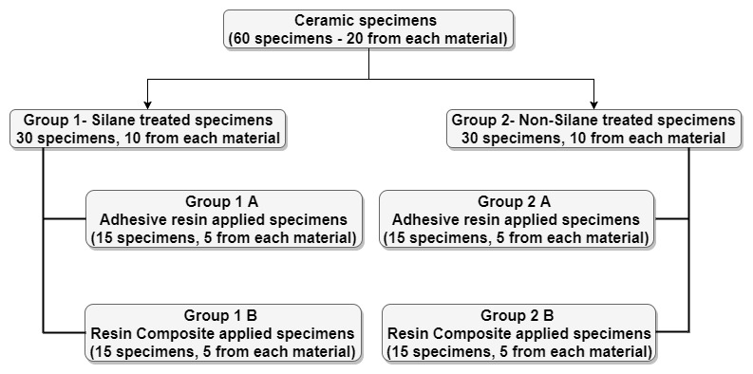
Fig. 1. Flow chart of groups and the surface treatments.

Ravikumar Ramakrishnaiah “Micro and nano structural analysis of the dental ceramic and luting resin interface and the effect of water exposure on integrity of cement interface”
Figure number 2
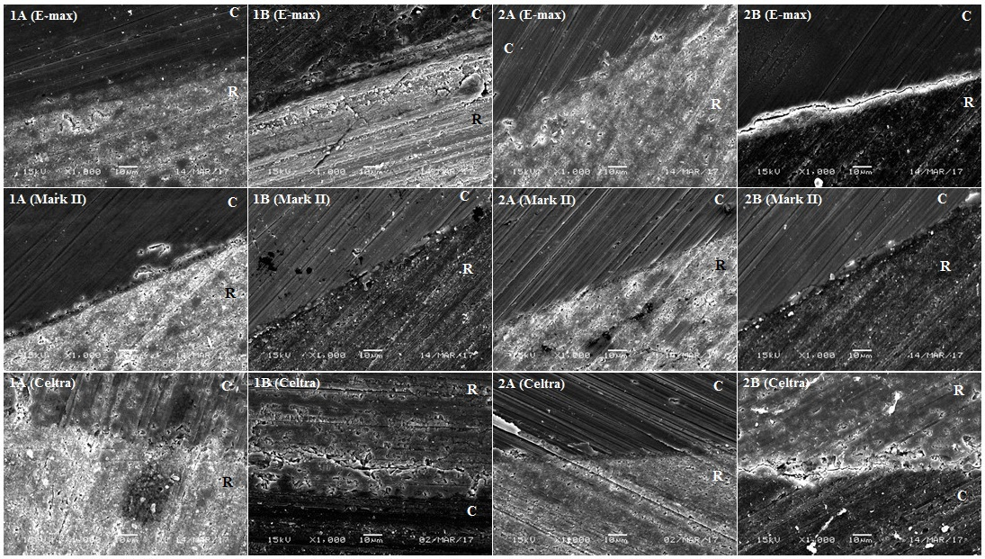
Fig. 2. SEM photomicrographs of the ceramic and resin (A- adhesive resin, B-resin composite, C-ceramic, R-resin) interface with and without primer treatment (1-with primer treatment, 2-without primer treatment) before exposure to boiling water (original magnification: 1000x, bar=10µm).

Ravikumar Ramakrishnaiah “Micro and nano structural analysis of the dental ceramic and luting resin interface and the effect of water exposure on integrity of cement interface”
Figure number 3
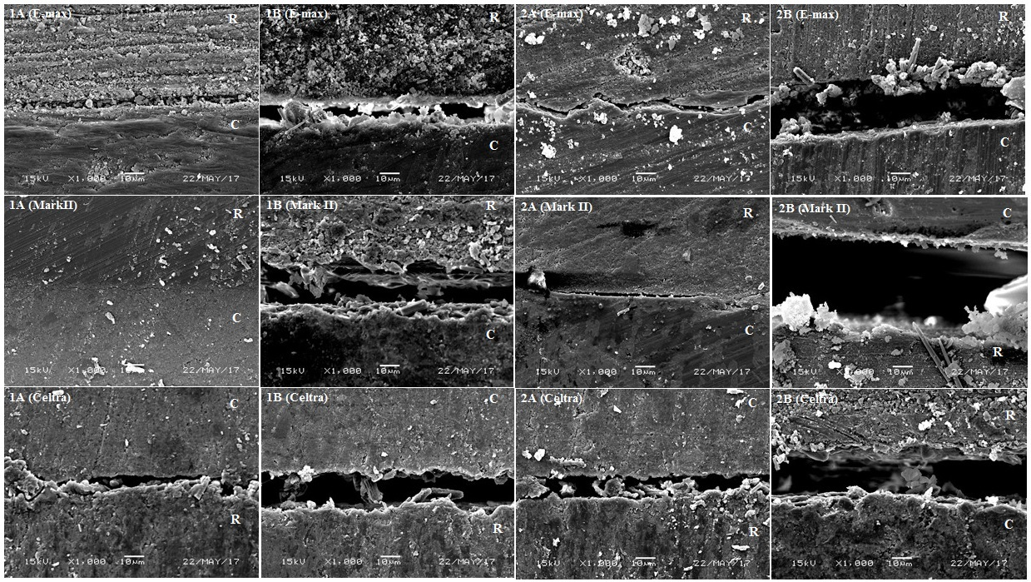
Fig. 3. SEM photomicrographs of the ceramic and resin (A- adhesive resin, B-resin composite, C-ceramic, R-resin) interface with and without primer treatment (1-with primer treatment, 2-without primer treatment) after exposure to boiling water (original magnification: 1000x, bar=10µm).

Ravikumar Ramakrishnaiah “Micro and nano structural analysis of the dental ceramic and luting resin interface and the effect of water exposure on integrity of cement interface”
Figure number 4
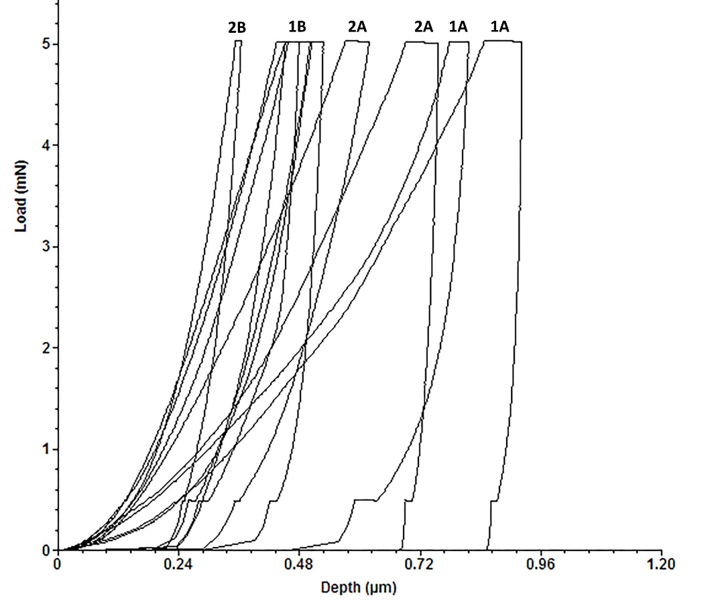
Fig. 4. Load-penetration depth curve (F-Δ) of the nano-indentation.

Ravikumar Ramakrishnaiah “Micro and nano structural analysis of the dental ceramic and luting resin interface and the effect of water exposure on integrity of cement interface”
Figure number 5
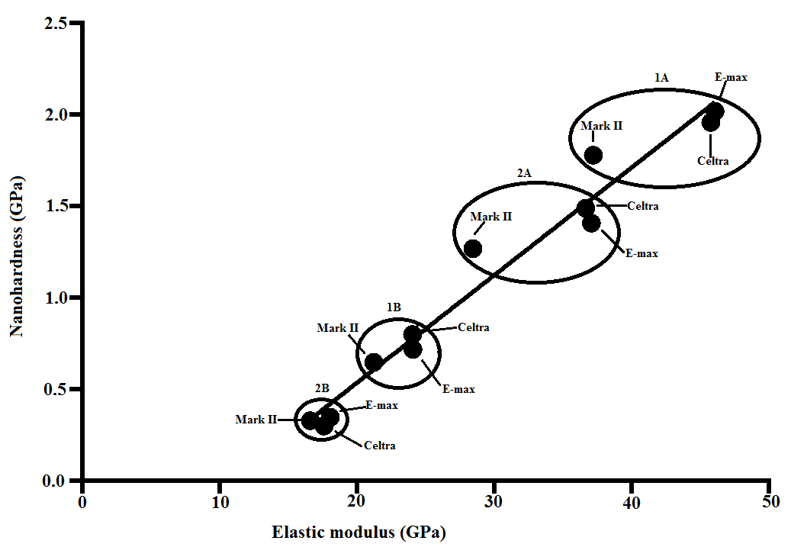
Fig. 5. Regression line and correlation between the surface nano-hardness and elastic modulus at the interface.

Tables
Table 1. Materials used in the study.
Product | Lot No. | Description | Manufacturer
E-max | T10332 | Lithium disilicate glass ceramic | Ivoclar Vivadent, Schaan, Liechtenstein.
Mark II | 43660 | Feldspathic ceramic | VITA Zahnfabrik, Bad Sackingen, Germany.
Celtra | 18017131 | Zirconia-reinforced (10% by weight) lithium silicate ceramic | DeguDent, Hanau, Germany.
IPS Ceramic etching gel | T02687 | 5% hydrofluoric acid | Ivoclar Vivadent, Schaan, Liechtenstein.
IPS Ceramic neutralizing powder | T02687 | Neutralizing agent | Ivoclar Vivadent, Schaan, Liechtenstein.
Monobond Plus | T07775 | Universal primer | Ivoclar Vivadent, Schaan, Liechtenstein.
Stick Resin | 121219I | Unfilled adhesive resin | Stick Tech Ltd, Finland
Variolink N | T18364 | filled resin composite | Ivoclar Vivadent, Schaan, Liechtenstein.

Table 2. Comparison of mean modulus of elasticity among different experimental groups (before and after refer to the boiling water exposure).
Materials | Mean elastic modulus GPa (Mean ± SD)
Materials | Group 1A |  | Group 1B |  | Group 2A |  | Group 2B |  | P-value
 | Before | After | Before | After | Before | After | Before | After
E-max | 46.07 ± .30 | 6.14 ± .05 | 24.05 ± .32 | 3.95 ± .08 | 37.06 ± .38 | 6.06 ± .04 | 18.05 ± .38 | 1.49 ± .05 | <0.001
Mark II | 37.21 ± .44 | 5.85 ± .03 | 21.21 ± .23 | 3.78 ± .05 | 28.42 ± .30 | 5.74 ± .04 | 16.59 ± .31 | 1.25 ± .03 | <0.001
Celtra | 45.75 ± .10 | 6.33 ± .12 | 24.08 ± .47 | 4.32 ± .03 | 36.66 ± .26 | 6.23 ± .03 | 17.61 ± .28 | 1.51 ± .01 | <0.001

Table 3. Comparison of mean surface nano-hardness among different experimental groups (before and after refer to the boiling water exposure).
Materials | Mean Nano-hardness GPa (Mean ± SD)
Materials | Group 1A |  | Group 1B |  | Group 2A |  | Group 2B |  | P-value
 | Before | After | Before | After | Before | After | Before | After
E-max | 2.02 ± .04 | 0.02 ± .00 | 0.80 ± .00 | 0.01 ± .00 | 1.41 ± .00 | 0.02 ± .00 | 0.35 ± .03 | 0.01 ± .00 | <0.001
Mark II | 1.78 ± .01 | 0.02 ± .00 | 0.65 ± .01 | 0.01 ± .00 | 1.27 ± .02 | 0.02 ± .00 | 0.33 ± .03 | 0.01 ± .00 | <0.001
Celtra | 1.96 ± .01 | 0.02 ± .00 | 0.72 ± .03 | 0.01 ± .00 | 1.49 ± .07 | 0.02 ± .00 | 0.30 ± .01 | 0.01 ± .00 | <0.001

