IMPLICATIONS OF SULPHUR REGULATION ON VESSEL USE IN FINNISH SEABORNE TRADE
Authors: Tuomas Kiiski, Sini Laari, Tomi Solakivi, Juuso Töyli, Lauri Ojala
Email: firstname.lastname@utu.fi
Operations & Supply Chain Management, Turku School of Economics at the University of Turku, Finland
ABSTRACT
Purpose
Shipping is facing tightening regulations to mitigate its environmental footprint. For example, the policy to restrict ships’ fuel sulphur content to 0.1 % became effective in the Baltic Sea on 1.1.2015. The consequences of this policy – initially suggested to lead to modal shifts and substantial increase in costs – are still much debated. The objective of this paper is to find out how do ships calling Finnish ports in 2010-2017 have reacted on the implementation of the Sulphur Emission Control Area (SECA) by IMO in the Baltic Sea.
Design/methodology/approach
Annual list of all vessel port calls in Finnish ports together with vessel-by-vessel technical data obtained from Clarkson World Fleet Register comprise the research data. Descriptive statistical analysis is the main research method.
Findings
The results indicate that Roll on - Roll off vessels are mostly affected by SECA regulation in terms of scrubber installations, while majority of ships calling at Finnish ports have switched to cleaner fuel grade. LNG appears to be an option involving only newbuildings.
Research limitations/implications
The implications of the SECA are analysed from the Finnish perspective. In the future, the analysis should be extended to other SECA countries to confirm the generalizability of the results.
Practical implications
The results provide insights to shippers and ship owners on how the transport flows in the Baltic Sea region have evolved in 2010-2017 in order to plan for future vessel investments.
Social implications
The results provide empirical evidence for policymakers on how the shipping market has adjusted on stricter sulphur regulations. These findings can be utilized when preparing for the global cap of 0.5% sulphur content in ships’ fuel, which will be effective by 2020.
Originality/value
The paper contributes to the discussion of economic impacts of environmental regulation in shipping by analysing how the implementation of the SECA has affected vessel distribution used in Finnish seaborne trade.
Keywords: Shipping, Sulphur Emission Control Area, Baltic Sea, Finland

INTRODUCTION
World seaborne trade accounts for more than 80 per cent of total world merchandise trade (UNCTAD, 2016). In addition to being the backbone of international trade and world economy, shipping has harmful impacts on health and environment. Fuel combustion of ship’s diesel engines ascribe much of the emissions. Due to the low quality of the fuel used in ships, even the most modern marine engines produce a range of emissions, which are more of a concern in shipping industry compared to other modes of transport (Cullinane & Bergqvist, 2014).
Although the environmental impacts caused by maritime transport are lower compared to other transport modes (e.g. air or road transport), shipping is characterized by a long history of tackling environmental issues (Lun et al., 2014). In order to reduce the environmental impacts of maritime transport, the International Maritime Organization (IMO) introduced global limits on the maximum sulphur content allowed in bunker oil used in ships under the revised MARPOL Annex VI in 2008. In addition, particularly vulnerable areas were declared Sulphur Emission Control Areas (SECAs). The SECA areas are located in the Baltic Sea, the North Sea, the North American and the United States Caribbean Sea (IMO, 2018a). The North American area and the Caribbean Sea area are also designated for controlling nitrous oxides emissions. This article focuses on the Baltic SECA, where a more stringent EU regulation have further reduced the allowed fuel sulphur content to 0.1 % in SECAs starting on 1 January 2015.
Due to the highly competitive environment, shipping companies tend to seek short-term profits while the adoption and implementation of environmentally sustainable solutions typically produce economic, social and environmental value in the long term (Parviainen et al., 2018). The consequences of SECA – initially suggested leading to modal shifts and substantial increase in costs – is still much debated among the academic community. Some of the previous studies expect a modal backshift from maritime transport to land-based transportation especially in shortsea shipping (e.g. Notteboom, 2011; Odgaard et al., 2013; Fagerholt et al., 2015). In contrast, Holmgren et al. (2014) and Zis and Psaraftis (2017) conclude that such a backshift from sea to road is unlikely to happen unless fuel prices increase.
Fagerholt et al. (2015) posit that environmental regulations affect routing of ships to avoid or to reduce sailing in SECAs. Sys et al. (2016) suggest that SECAs could also provoke potential port shifts if certain zones with more severe emissions caps become less attractive for maritime transport. Another possible side-effect is that ship operators may reduce their speed in the SECA areas to save on low-sulphur fuel and to speed up in non-regulated areas to compensate for the loss of time (Doudnikoff & Lacoste, 2014).
While the contemporary SECA areas have only limited geographical coverage, a global sulphur cap of 0.5% is due to enter in force by 2020 (IMO, 2018b). Given the current narrow scope of regulations, the impacts have spread unevenly across the countries. For countries like Finland, of which coastal waters are located entirely in a SECA area, and in which foreign trade relies largely on maritime transport (around 90%), has argued to bear the heaviest economic burden (Kalli et al., 2015; Antturi et al., 2016; Repka et al., 2017).
Traditionally sustainable shipping research has followed contemporary regulatory developments. IMO’s recent climate change strategy, that aims to cut the shipping’s greenhouse gas emissions by at least to half by 2050 (IMO 2018c) calls for intensified research on the subject. This paper reside in sustainable logistics and more specifically in sustainable shipping. As such, this study is one of the seminal works in regards to investigating the commercial implications of SECA regulations with using fresh empirical evidence.
The purpose of the paper is to understand how have ships calling Finnish ports between 2010 and 2017 reacted to the sulphur emission regulations, which entered in force on 1.1.2015. This objective is addressed by identifying all merchant vessels calling at Finnish ports from the port call list maintained by the Finnish Customs (Finnish Customs, 2018) and by obtaining the technical details of the respective vessels from the Clarkson World Fleet Register (CRSL, 2018), which is the most comprehensive repository of merchant vessel data in the world.
The paper has the following structure: the relevant literature is reviewed in Chapter 2, followed by research methods and the results of the study are presented in Chapter 3. Finally, the conclusions are drawn and future research areas are outlined in Chapter 4.

Literature review
The ongoing intensive discussion surrounding the climate change combined with the large role of maritime transport in the world economy is clearly visible in the academic literature addressing the environmental impacts of shipping, as it is mainly concentrated on the CO₂ emissions, with an exhausting list of authors either estimating the CO₂ emissions of shipping (see for example Winebrake et al. 2007) or the costs of reducing CO₂ emissions ( Eide et al. 2011). In 2009 onwards, there was a burst of articles (Corbett et al. 2009, Cariou 2011,) especially discussing the effects of slow-steaming on the emissions of shipping.
Recently this discussion has expanded towards alternative fuel options (Sofiev et al. 2018). The sulphur emissions, however, have attracted less interest from academia. For example, Mansouri et al. (2015) reviewed the (environmental) sustainability and maritime shipping literature and were able to identify 52 articles, of which only 2 addressed the sulphur emissions or the SECA areas. Since 2015 and the introduction of the SECA areas the topic has attracted more attention. For example Panagakos et al. (2014) applied a logit model to estimate the possible modal shift effects in a Mediterranean context, whereas Zis and Psaraftis (2017) took a wider perspective, analyzing the effects of sulphur limits to the European Ro-Ro –sector.

Emission abatement options
Presently, Ship operators can apply three main strategies to comply with the lower sulphur limits. Firstly, they can switch to low-suplhur fuel, such as (low sulphur) marine gas oil (MGO/LSMGO) that is more expensive than the currently used Heavy Fuel Oil (HFO) (Vierth et al., 2015). Second option is to switch to cleaner energy sources, such as liquefied natural gas (LNG), methanol or biofuels (Lindstad et al., 2017). The third option is to install a scrubber that removes sulphur from the exhaust to allow continued use of HFO (Vierth et al., 2015; Lindstad et al., 2017). The shift of fuel does not require any major capital investments in modifying ships, possibly a minor adjustment of tanks and engines (Bergqvist et al., 2015). Using LNG in an older vessel requires a modification (engines replacing, specially designed systems, larger fuel tanks, gas sensors etc.), which is difficult and expensive (Panasiuk & Turkina, 2015). Hence, LNG is mainly an option for new buildings.
A scrubber can be installed to existing or new vessels. In comparison to new vessels, retrofitting existing vessels has to be paid back in a shorter period of time (Lindstad et al., 2017). Furthermore, the vessel needs to stay in layup during retrofitting, which means loss of income (Bergqvist et al., 2015; Zis & Psaraftis, 2017). The decision on which abatement approach to choose is thus dependent on several factors, including fuel price, area in which the ship usually operates, remaining useful lifetime of the ship and a ships’ sailing pattern (e.g. speed and route choices) (Abadie et al., 2017; Gu & Wallace, 2017).
Today, heavy fuel oil (HFO) is used in majority of marine engines (Brynolf et al., 2014). In order to comply with SECA regulations, ships can use low-sulphur fuel, such as low sulphur marine gas oil (LSMGO) that contain less than 0.1 % sulphur. After 2020 HFO will be replaced by ultra-low sulphur fuel oil (ULSFO) that can be used when the ship sails outside SECA (Gu & Wallace, 2017). The use of low-sulphur fuel requires comparatively low investments. For a ship operating entirely in a SECA area, the capital cost of converting a ship to burning low-sulphur fuel is between 10,000 and 150,000 EUR, depending on the size and type of the ship (Antturi et al., 2016). However, the operating costs are considerably higher in the medium and long term because LSMGO is more expensive than HFO or ULSFO (Panasiuk & Turkina, 2015; Bergqvist et al., 2015; Gu & Wallace, 2017). Currently, LSMGO is approximately 40 % more expensive than HFO (Bunkerworld, 2018).
If a ship operates inside and outside SECA, the ship operator can may choose a hybrid solution which allows ships to switch between HFO and LSMGO (Gu & Wallace, 2017). Ships burn LSMGO within SECA while traditional HFO is used outside (Fagerholt et al., 2015). Fuel switching allows the introduction of speed differentiation leading to lower speed within SECA to consume less LSMGO and higher speed outside to maintain travel time (Zis & Psaraftis, 2017; Gu et al., 2018). Furthermore, a ship might apply SECA-evasion strategy. SECA evasion means that a ship does not take the shortest route between two ports situated within SECA but instead leave the SECA zone and take a longer sailing route with less involvement SECA sailing (Gu et al., 2018). Thus, the ship would reduce the consumption of expensive LSMGO.
Alternatively, ships can use cleaner energy sources. LNG is one of the best available options in terms of environmental performance (Bergqvist & Cullinane, 2013). Using LNG, a ship operator can avoid consumption of expensive LSMGO (Gu & Wallace, 2017). However, LNG involves high up-front investments so that the ship can store and burn it and making sure that there are adequate shoreside supply facilities at ports in which the vessel can refuel (Fagerholt et al., 2015). Only a few ports provide LNG as a maritime fuel at the moment (Brynolf et al., 2014). In addition, LNG tanks require more space than conventional fuel tanks, which reduces load capacity and makes such adjustment impossible or uneconomical for many existing vessels (Bergqvist et al., 2015). There is also a high uncertainty on the differential between the prices of LNG and conventional maritime fuels. Only if HFO was to become more expensive than today, could LNG become a more feasible option (Acciaro, 2014). It is possible to convert existing vessels to use LNG but conversion is very costly (around 12 to 16 million EUR) (Bergqvist et al., 2015). Hence, LNG is mainly used in new vessels.
Another alternative is to continue using HFO and install an exhaust gas cleaning system, a so-called scrubber that removes sulphur from exhaust gas. Scrubbers can be installed on new builds or older vessels can be retrofitted. There are two types of scrubbers: wet and dry. Wet scrubbers are considered more acceptable for ships due to lower price and smaller size of the units (Panasiuk & Turkina, 2015). Wet scrubber technology includes three types of exhaust gas cleaning systems: open loop, using only sea water; closed loop, using fresh water mixed with caustic soda; and hybrid (Abadie et al., 2017). In the Baltic Sea Region, a closed loop system must be used (Panasiuk & Turkina, 2015). Dry scrubbers use chemicals instead of water in the purification process (Bergqvist et al., 2015).
While scrubbers enable ships to continue using cheap high-sulphur fuel, the installation cost is significant. The cost of installing scrubbers starts at approximately 1.5 million EUR per vessel (Antturi et al., 2016; Lindstad et al., 2017) with the annual maintenance cost well over EUR 100,000. The feasibility of scrubber installations is also heavily dependent upon current fuel price and vessel’s fuel consumption.
It is estimated that the total cost of retrofitting the global merchant fleet would cost around 200 billion USD, while annual fuel switch cost, with current price differential around 230 USD per tonne, would be in a range of 46–69 billion USD (Wallis, 2018).
Some studies suggest that the payback time for the installation of a scrubber is 2-5 years compared to switching to LSMGO (Bergqvist et al., 2015), while some reports cite only 4 months periods for Capesize vessels (Stuart-Smith, 2018). Nevertheless, it is not feasible to install a scrubber to end-of-lifespan vessels (Jiang et al., 2014).
The market for scrubbers is still very dynamic and it is expected that the costs of scrubbers will decrease over time as the technology matures (Acciaro, 2014). Other downsides relate to scrubber’s fitting and cleaning, and subsequently its negative impact on ship’s trim and cargo carrying capacity (Panasiuk & Turkina, 2015; Wallis, 2018).
Furthermore, biofuels and methanol are emerging as ship fuels (Lähteenmäki-Uutela et al., 2017). Biodiesel is renewable and can be produced from various feedstocks, such as vegetable oils, recycled waste vegetable oils and animal fats (Lin, 2013). However, biofuels are not currently considered a serious alternative due to limited supply capacity (Holmgren et al., 2014). The technology related to using methanol as a fuel is still in development stage, meaning uncertain outcome, fuel prices and availability (Bergqvist et al., 2015). The energy requirements of the ship could also be covered at berth by supplying electrical energy from land-based grid (so-called cold ironing) (Sciberras et al., 2015). This means that the ship can shut down engines when sailing in a SECA area.

Implications on seaborne trade
The distribution of costs and benefits of environmental regulations has attracted a lot of discussion. Geographically isolated countries at the end of the Baltic Sea have claimed to be the net payers. Antturi et al. (2016) studied the costs of benefits of the SECA regulation and concluded that net benefits were negative and that the countries located far from Central European markets bear most of the costs while the countries with high population and closer to the main shipping routes and markets are the main beneficiaries. Antturi et al. (2016) concluded that Sweden and Finland will bear the largest proportion of costs. In Finland, the share of fast ships, such as RoRo ships using a lot of fuel, is large, and they suffer economically more than slower ships (Kalli et al., 2015). Repka et al. (2017) estimate that the direct impact of sulphur regulations will be around 175 million EUR for Finnish seaborne trade in 2013-2025, without taking into consideration the cost differential of fuels used in the vessels.
It has been suggested that the costs to comply with SECA will be ultimately payed by peripheral northern industries, such as paper, forest or metal industries (Kalli et al., 2015; Lähteenmäki-Uutela et al., 2017). The increasing operating costs may be passed on to shippers by increasing freight rates, which could trigger a modal shift from sea to road (Notteboom, 2011; Zis & Psaraftis, 2017). Certain routes may become less viable economically due to increasing operating costs and loss of market share and, as a result, some ship operators may have to shut down certain services, which leads to even higher modal shifts (Zis & Psaraftis, 2017).

DATA AND RESULTS
The vessel movements of Finnish foreign trade between 2010 and 2017 were analyzed by obtaining the port call data from the Finnish Portnet information system (Finnish Customs 2018), which includes detailed information of all the vessels calling port in the Finnish ports on a level of individual port calls. In order to approach the relevant data concerning sulphur emission abatement mechanisms, the technical data of all the identified vessels was obtained from the Clarkson World Fleet Register (Clarkson Research Services Limited, 2018) database. The technical details included for example the year of build, vessel type, engine power, fuel type and possible installation of exhaust scrubber.
Figure 1 presents the number of port calls and number of different vessels visiting Finnish ports between 2010 and 2017. As can be seen in the figure, both the number of port calls and the number of individual vessels have remained practically on the same level during the entire decade. Therefore, it would seem that there have not been any major changes in the vessel movements at least on a general level.

Figure 1 Cargo volumes of Finnish ports in 2010-2016 and number of merchant vessels and port calls in Finnish ports in 2010-2017 (Finnish Transport Agency, 2017 and Finnish Customs, 2018)
As the SECA limitations are expected to be more difficult to fulfil for the older vessels, it is assumed that introducing the SECA regulations would increase the share of younger, technically more advanced vessels. This should be visible in the average age of the vessels calling port in Finland. Table 1 presents the average year of build and the average age of vessels visiting the Finnish ports in 2010-2017.
Table 1 Average year of build and age of vessels visiting Finnish ports in 2010-2017 (Clarkson Research Services Limited, 2018)
 | 2010 | 2011 | 2012 | 2013 | 2014 | 2015 | 2016 | 2017
Average year of build | 1999 | 2000 | 2001 | 2001 | 2002 | 2002 | 2003 | 2003
Average age (years) | 11 | 11 | 11 | 12 | 12 | 13 | 13 | 14

Unlike expected, it seems that the average age of vessels visiting the Finnish ports has not decreased, but rather increased during the observation period. In 2010, the average age was 11 years, whereas in 2017 the average age of vessels visiting the Finnish ports has increased into 14 years. Figure 2. illustrates the share of port calls with vessels either equipped with scrubbers, or alternatively capable of running with LNG.

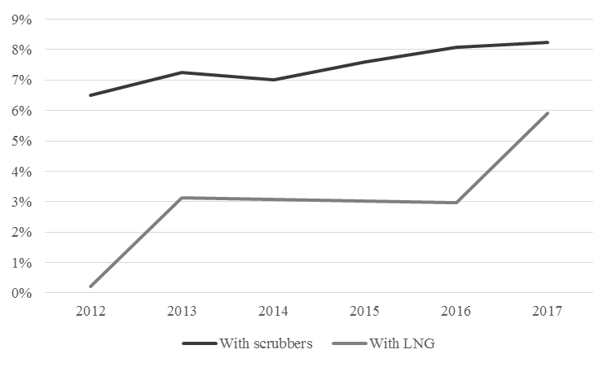
Figure 2 Share of port calls (%) of vessels equipped with scrubbers (black line) or capable of running with LNG (grey line) (Finnish Customs, 2018; Clarkson Research Services Limited, 2018)
In 2017 around 8% of port calls in Finnish ports were from vessels with installed scrubbers. Another indication is that the share of scrubber-equipped vessels has steadily been increasing. This has also happened to LNG –driven vessels. In 2013, the share of port calls of LNG driven vessels was around 3%, and in 2017 their share had increased to 6%. At the same time, the other side of the coin is that still over 85 % of port calls was handled with vessels running with low sulphur fuels.
There are large differences between vessel types on how the requirements of SECA have been approached. Figure 3 illustrates the share of vessels with an installed scrubber by vessel type. Of the cargo vessels, two vessel types clearly differ from others. The share of RoRo (roll on/roll off) vessels was close to 50%. Among other vessel types, the share of scrubber-equipped vessels is practically non-existent, excluding the cruise vessels.
The explanation to this may lie in the different market characteristics of the vessel types. RoRo ships and container vessels are typically in liner operation, with permanent routes within the Baltic Sea SECA area. Therefore, the investment decisions have been based on the fact that the installment of scrubbers would create savings large enough to cover the investment and maintenance costs. Vessels in other categories, on the contrary, operate more on tramp shipping and thus also outside the SECA area, therefore creating a situation where they are able to at least partly use HFO or other fuel grades with higher sulphur content.
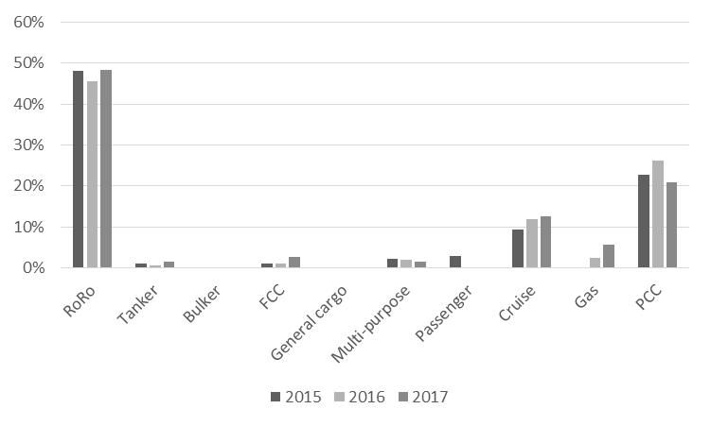
Figure 3 Share of vessels (%) equipped with a scrubber by vessel type. (Clarkson Research Services Limited, 2018)
Even as the share of scrubber –installed vessels in RoRos is higher than in other vessel categories, it is still an interesting question, why over 50% of RoRos are still running with more expensive low sulphur fuel. As the share of RoRos with installed scrubbers is close to 50%, they form the most interesting vessel category for further study.
Figure 4 illustrates the age structure of RoRo vessels with port calls in Finland in 2017. As can be seen from the figure, the vessels with scrubbers installed seem to be younger than vessels without scrubbers installed. They have been built 1998 and 2012, with an average age of 12.6 years. Vessels without installed scrubbers have been built between 1979 and 2015, with an average age of 21.3 years. Of those vessels, the two newest ones were identified to be able to operate with alternative, low sulphur fuels.

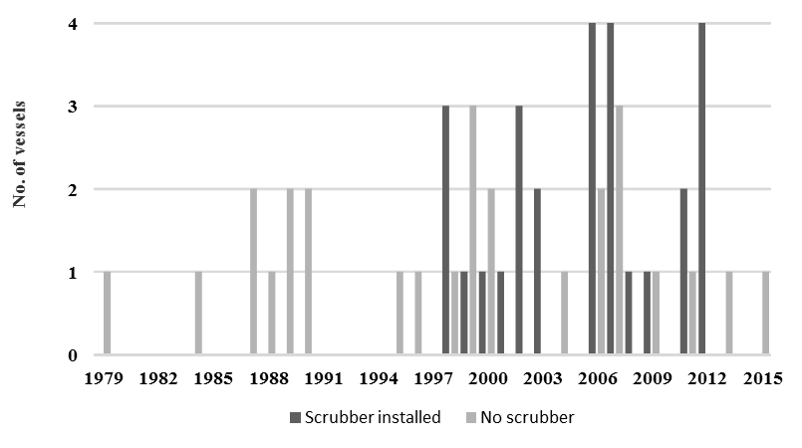
Figure 4 Age structure of RoRo vessels with port calls in Finland in 2017, with and without scrubbers (number of ships) (Clarkson Research Services Limited, 2018)
Considering the discussion preceding the introduction of the SECA regulation, the low share of vessels equipped with scrubbers can be considered at least partly surprising. After all, the effect of stricter sulphur limits were anticipated to lead to major cost increases due to the higher price of the LSMGO compared to traditional marine fuels. Even as the age structure of the fleet is a partial explanation to the low willingness to investment in scrubbers, it is not the entire truth. Figure 5 illustrates the price development of a “traditional” marine fuel, the IFO380 as well as the MGO/ LSMGO for the similar period.

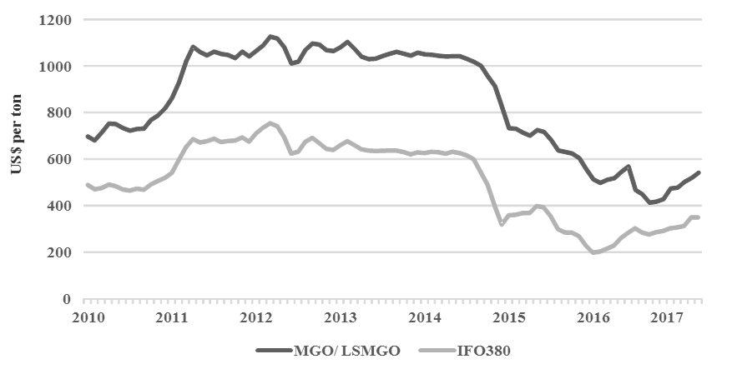
Figure 5 Price development of IFO380 and MGO/LSMGO in 2010-2017 (Bunkerworld, 2018; Bunker Index, 2018)
Obviously, a clear price differential between the IFO and MGO can be observed. Moreover, this price differential has been a stable 170 USD / tonne for the most of the observation period. Another, more interesting observation is the decline of marine fuel prices in 2015. For example, between November 2014 and November 2015 the price of LSMGO dropped from 914 USD / tonne to 605 USD / tonne, which was close to prices of IFO380 in 2014. Combined, even as switching the LSMGO increased the relative fuel costs, the absolute costs remained on the same level, therefore diminishing the incentives to invest.

DISCUSSION AND CONCLUSIONS
The objective of this paper was to find out how the ships calling Finland’s ports in 2010-2017 have reacted on the implementation of the SECA in Baltic Sea.
The results show that annual transport volumes have varied between 89 and 98.5 million tonnes during the eight-year investigation period, while the number of port calls have remained on a same level (around 35,000). Similarly, the number of ships has not changed much as around 1,600 ships annually visit the ports of Finland. The average age of vessels has increased from 11 years in 2010 to 14 years in 2017. This finding is somewhat unexpected as typically changes in ships technical requirements would increase dismantling and hence decrease fleet’s average age. The reasons behind this can only be speculated, but tight shipping market conditions together with cheap fuel prices may have allowed older ships to continue trading (Agnolucci et al. 2014). Moreover, the special requirements of Baltic Sea in regards to ships ice-class may have slowed down the enthusiasm to answer the regulatory pressure through newbuildings.
It seems that the main adjustment way of shipping industry on the SECA regulations in the Baltic area has been switching to lower sulphur content fuel grades. Between 2010 and 2017 the share of such ships calling Finland’s ports has been in a range of 86% – 93%. However, this figure has to be treated with caution as, for example, the number may include also ships that decide not comply with regulations. So far – in spite of the introduction of particular sniffing technology in ports – there are very few reports on such infringements taking place (see Kattner et al. 2015 and Johansson and Jalkanen 2017). It is possible that some firms have reduced the costs of using LSMGO either financially by hedging the fuel price or operationally by reducing the speed of the vessel, for example (Stevens et al., 2015). The share of other emission abatement solutions has been constantly rising but still remained on a low level, for example in 2017 amounting at 14%. The share of ships equipped with scrubbers has been around 7% while the share of LNG-powered have only recently increased to 6 %.
Bergqvist et al. (2015) estimate that the payback time of a scrubber would be 2-5 years. At the same time, Solakivi et al. (2017) report that the current average demolition age of commercial vessels is around 25 years. Our findings indicate that most of the scrubber installations have concentrated on ships aged around 10 years, whereas some have been installed to ships close to 20 years of age, which is well in line with the findings and estimates of both Bergqvist et al. (2015) and Solakivi et al. (2017).
As our study focus mainly on empirical statistics from the Finnish perspective, future analysis should be extended to other SECA countries to confirm the generalizability of the results. In addition, future studies should include more of the economic analysis of different emission abatement techniques. Technical development has substantially reduced the price of scrubbers, which warrants update on the previous feasibility calculations. For example, the previous estimates of the European Commission used by Jiang et al. (2014) would seem to severely overestimate the investment costs and thus underestimate the feasibility of scrubbers as an abatement technique. At the same time, the price spread between low sulphur and regular fuel grades has diminished below 200 dollars per ton, which is well below the “break-even point” presented by Jiang et al. (2014). Other previous estimates have to be treated with a similar limitation in mind. For example, the previous estimates of modal shift (see for example Panagakos et al. 2014 or Zis and Psaraftis 2017) were based on similar price spread or cost differential, and therefore could be overestimated considering the current cost level. At the same time, the different sub-markets of the seaborne trade are likely to react differently, as pointed out by Ojala (2017).
One of the most interesting feature of this study is the possibility of expanding them into a global scale. The current sulphur limits are imposed on restricted geographical areas, whereas the upcoming sulphur limits will be imposed globally. Currently, the abatement mechanisms chosen by major players are subject to corporate strategy and to the operating area of the vessel, which explains the different abatement mechanisms of RoRos and other vessels. Of note, small share of container ships using scrubbers is arguably result of technical challenges relating to fitting and trim issues together with the older fleet applied in the Baltic Sea trade. The world’s largest container shipping line, APM Moller Maersk, has reportedly chosen strategy relying on low-sulphur fuels (Safety4Sea.com, 2018). On the other hand, Finnlines, part of Europe’s largest RoRo operator Grimaldi Group, recently order three new Ro-Ros equipped with exhaust gas scrubbers for the Baltic Sea trades (Finnlines, 2018).
While it may be premature to predict SO_{x} abatement mechanisms of the global shipping industry will directly resemble the ones of liner shipping in the Baltic Sea Region, it is fair to argue that there is demand for exhaust gas scrubbers at least as a mid-term solution. This argument is supported by recent industry reports (Wallis 2018; Stuart-Smith 2018). The demand is subject to a complex set of variables including the availability and price of low-sulphur fuel.
In the short run, the oldest vessels will be phased out, and the ones with enough life ahead will be equipped with scrubbers, at least assuming that the fuel prices recover together with the global economy. In the long run, however, scrubbers will most likely remain a temporary solution, as future vessels will be designed and equipped with technologies and/or energy sources able to cope with both the SO_{x}-limitations as well as all the other upcoming environmental regulations.
Overall, the solutions on how to comply with the tightening sulphur and other upcoming environmental regulations create a multifaceted and complex phenomenon. The situation is further complicated by practically a universal lack of uniform standards or guidelines and operational procedures on how to inspect and enforce these regulations. Understanding these interactions and their impacts to both the shipping business and the international trade is an important topic to be studied during the coming years.

References
Abadie, L.M., Goicoechea, N. and Galarraga, I. (2017), “Adapting the shipping sector to stricter emissions regulations: Fuel switching or installing a scrubber?”, Transportation Research Part D: Transport and Environment, Vol. 57, pp. 237-250.
Agnolucci, P., Smith, T., Rehmatulla, N. (2014) Energy efficiency and time charter rates: Energy efficiency savings recovered by ship owners in the Panamax market, Transportation Research Part A: Policy and Practice, Vol. 66, pp. 173-184.
Acciaro, M. (2014), “Real option analysis for environmental compliance: LNG and emission control areas”, Transportation Research Part D: Transport and Environment, Vol. 28, pp. 41-50.
Antturi, J., Hänninen, O., Jalkanen, J.-P., Johansson, L., Prank, M., Sofiev, M. and Ollikainen, M. (2016), ”Costs and benefits of low-sulphur fuel standard for Baltic Sea shipping”, Journal of Environmental Management, Vol. 184, Part 2, pp. 431-440.
Bergqvist, R. and Cullinane, K. (2013), “SECA regulations, modal shift and transport system effects: The case of Sweden”, Report for the Swedish Transport Administration (Trafikverket), Stockholm, available at: https://www.researchgate.net/publication/270395236_SECA_Regulations_Modal_Shift_and_Transport_System_Effects_The_Case_of_Sweden (Accessed 20.2.2018).
Bergqvist, R., Turesson, M. and Weddmark, A. (2015), “Sulphur emission control areas and transport strategies -the case of Sweden and the forest industry”, European Transport Research Review, Vol. 7 No. 10, pp.
Brynolf, S., Magnusson. M., Fridell, E. and Andersson, K. (2014), “Compliance possibilities for the future ECA regulations through the use of abatement technologies or change of fuels”, Transportation Research Part D: Transport and Environment, Vol. 28, pp. 6-18.
Bunker Index (2018), “BIX Bunker Index”, available at http://www.bunkerindex.com/prices/index.php (Accessed 3.3.2018)
Bunkerworld (2018), “Fuel prices”, available at: http://www.bunkerworld.com/prices/ (Accessed 20.2.2018).
Cariou, P. (2011) Is slow steaming a sustainable means of reducing CO₂ emissions from container shipping?, Transportation Research Part D: Transport and Environment, Vol. 16 No. 3, pp. 260-264.
Clarkson Research Services Limited – CRSL (2018) World Fleet Register.
Corbett, J.J., Wang, H., Winebrake, J.J. (2009) Te effectiveness and costs of speed reductions on emissions from international shipping, Transportation Research Part D: Transport and Environment, Vol. 14 No. 8, pp. 593-598.
Cullinane, K. and Bergqvist, R. (2014), “Emission control areas and their impact on maritime transport”, Transportation Research Part D: Transport and Environment, Vol. 28, pp. 1-5.
Eide, M.S., Longva, T., Hoffmann, P., Endresen, Ø., Dalsøren, S.B. (2011) Future cost scenarios for reduction of ship CO₂ emissions, Maritime Policy & Management, Vol. 38 No. 1, pp. 11-37.
Fagerholt, K., Gausel, N.T., Rakke, J.G. and Psaraftis, H.N. (2015), “Maritime routing and speed optimization with emission control areas”, Transportation Research Part C: Emerging Technologies, Vol. 52, pp. 57-73.
Finnlines (2018) “Finnlines invests in sustainability – three new green ro-ro vessels ordered.” <https://www.finnlines.com/newsroom/finnlines-invests-sustainability-three-new-green-ro-ro-vessels-ordered>, Accessed 3.5.2018.
Finnish Customs (2018), “Port call list 2010-2017”.
Finnish Transport Agency (2017) Statistics on international shipping 2016, Statistics from the Finnish Transport Agency 3/2017.
Gu, Y. and Wallace, S.W. (2017), “Scrubber: A potentially overestimated compliance method for the Emission Control Areas: The importance of involving a ship’s sailing pattern in the evaluation”, Transportation Research Part D: Transport and Environment, Vol. 55, pp. 51-66.
Holmgren, J., Nikopoulou, Z., Ramstedt, L. and Woxenius, J. (2014), “Modelling modal choice effects of regulation on low-sulphur marine fuels in Northern Europe”, Transportation Research Part D: Transport and Environment, Vol. 28, pp. 62-73.
IMO (International Maritime Organization) (2018a) Sulphur oxides (SOx) and Particulate Matter (PM) – Regulation 14. < http://www.imo.org/en/OurWork/Environment/PollutionPrevention/AirPollution/Pages/Sulphur-oxides-%28SOx%29-%E2%80%93-Regulation-14.aspx>, Accessed 7.2.2018.
IMO (Internation Maritime Organization) (2018b) “The 2020 global sulphur limit.” <http://www.imo.org/en/MediaCentre/HotTopics/GHG/Documents/FAQ_2020_English.pdf >, accessed 3.3.2018.
IMO (Internation Maritime Organization) (2018c) “UN body adopts climate change strategy for shipping.” <http://www.imo.org/en/MediaCentre/PressBriefings/Pages/06GHGinitialstrategy.aspx>, accessed 23.4.2018.
Jiang, L., Kronbak, J. and Christensen, L.P. (2014), “The costs and benefits of sulphur reduction measures: Sulphur scrubbers versus marine gas oil”, Transportation Research Part D: Transport and Environment, Vol. 28, pp. 19-27.
Johansson, L., Jalkanen, J.-P. (2017) Emissions from Baltic Sea Shipping in 2016, Baltic Marine Environment Protection Commission.
Kalli, J., Repka, S. and Alhosalo, S. (2015), ”Estimating costs and benefits of sulphur content limits in ship fuel”, International Journal of Sustainable Transportation, Vol. 9 No. 7, pp. 468-477.
Kattner, L., Mathieu-Üffing, B., Burrows, J.P., Schmolke, S., Seyler, A., Wittrock, F. (2015) Monitoring compliance with sulphur content regulations of shipping fuel by in situ measurements of ship emissions, Atmospheric Chemistry and Physics, Vol. 15 pp. 10087-10092.
Lin, C.-Y. (2013), “Strategies for promoting biodiesel use in marine vessels”, Marine Policy, Vol. 40, pp. 84-90.
Lindstad, H.E., Rehn, C.F. and Eskeland, G.S. (2017), “Sulphur abatement globally in maritime shipping”, Transportation Research Part D: Transport and Environment, Vol. 57, pp. 303-313.
Lun, Y.H.V., Lai, K., Wong, C.W.Y. and Cheng, T.C.E. (2014), ” Green shipping practices and firm performance”, Maritime Policy & Management, Vol. 41 No. 2, pp. 134-148.
Lähteenmäki-Uutela, A., Repka, S., Haukioja, T. and Pohjola, T. (2017), ” How to recognize and measure the economic impacts of environmental regulation: The Sulphur Emission Control Area case”, Journal of Cleaner Production, Vol. 154, pp. 553-565.
Notteboom, T. (2011), “The impact of low sulphur fuel requirements in shipping on the competitiveness of roro shipping in Northern Europe”, WMU Journal of Maritime Affairs, Vol. 10 No. 1, pp. 63-95.
Odgaard, T., Frank, C., Henriques, M. and Bøge, M. (2013). The impact on short sea shipping and the risk of modal shift from the establishment of a NOx emission control area in the North Sea. North SEa Consultation Group. < http://mst.dk/media/90033/TheimpactonshortseashippingandtheriskofmodalshiftfromtheestablishmentofaNECAfina%20(1).pdf>, Accessed 7.2.2018.
Ojala, L. (2017) ”Merenkulun rahtimarkkinoiden pelkistetty rakenne havainnollistettuna erityisesti Suomen viennin ja tuonnin osalta, jossa käytössä useiden lippuvaltioiden aluksia” Chapter 3 in: Repka, S., Ojala, L., Jalkanen, J.-P., Alhosalo, M., Niemi, J., Pöntynen, R., Solakivi, T., Pohjola, T., Haavisto, R., Lensu, M., Erkkilä-Välimäki, A., Haukioja, T. and Kiiski, T. (2017) ”Merenkulun kansainvälisen ilmasto- ja ympäristösääntelyn vaikutukset Suomen elinkeinoelämälle” (The impact of international maritime climate and environmental regulation on the Finnish economy), Publications of the Government´s analysis, assessment and research activities 55/2017, Helsinki, Finland. .
Panagakos, G.P., Stamatopoulou, E.V., Psaraftis, H.N. (2014) The possible designation of the Mediterranean Sea as a SECA: a case study, Transportation Research Part D: Transport and Environment, vol. 28, pp. 74-90.
Panasiuk, I. and Turkina, L. (2015), “The evaluation of investments efficiency of SOx scrubber installation”, Transportation Research Part D: Transport and Environment, Vol. 40, pp. 87-96.
Parviainen, T., Lehikoinen, A., Kuikka, S. and Haapasaari, P. (2018), ”How can stakeholders promote environmental and social responsibility in the shipping industry?”, WMU Journal of Maritime Affairs, Vol. 17 No. 1, pp. 49-70.
Repka, S., Ojala, L., Jalkanen, J.-P., Alhosalo, M., Niemi, J., Pöntynen, R., Solakivi, T., Pohjola, T., Haavisto, R., Lensu, M., Erkkilä-Välimäki, A., Haukioja, T. and Kiiski, T. (2017) ”Merenkulun kansainvälisen ilmasto- ja ympäristösääntelyn vaikutukset Suomen elinkeinoelämälle” (The impact of international maritime climate and environmental regulation on the Finnish economy), Publications of the Government´s analysis, assessment and research activities 55/2017, Helsinki, Finland. Available at: http://tietokayttoon.fi/julkaisu?pubid=21102 (Accessed 21.2.2018).
Review of Maritime Transport 2016. United Nations Conference on Trade and Development. United Nations Publications E.16.II.D.7. < http://unctad.org/en/PublicationsLibrary/rmt2016_en.pdf>, Accessed 7.2.2018.
Safety4Sea.com (2018) Maersk will not use scrubbers for 2020 sulphur cap compliance. <https://safety4sea.com/maersk-will-not-use-scrubbers-for-2020-sulphur-cap-compliance/>, Accessed 6.5.2018.
Sciberras, E.A., Zahawi, B. and Atkinson, D.J. (2015), “Electrical characteristics of cold ironing energy supply for berthed ships”, Transportation Research Part D: Transport and Environment, Vol. 39, pp. 31-43.
Sofiev, M., Winebrake, J.J., Johansson, L., Carr, E.W., Prank, M., Soares, J., Vira, J., Kouznetsov, R., Jalkanen, J-P., Corbett, J.J. (2018) Cleaner fuels for ships provide public health benefits with climate tradeoffs, Nature Communications.
Solakivi, T., Kiiski, T., Kuusinen, T., Ojala, L. (2017) Estimating the ship dismantling capacity in compliance with the European Union’s Ship Recycling Regulation, Supply Chain 4.0 Challenges and Prospects, International Conference on Logistics and Transport. Edited by Banomyong, R., Sopadang, A., Chao, P.
Stuart-Smith, P. (2018) “Scrubbers the solution to sulphur cap, says industry veteran”, IHS Fairplay 19.4.2018. <https://fairplay.ihs.com/commerce/article/4300281/scrubbers-the-solution-to-sulphur-cap-says-industry-veteran >, accessed 19.2018.
Sys, C., Vanelslander, T., Adrianssens, M. and Van Rillaer, I. (2016), ” International emission regulation in sea transport: Economic feasibility and impact”, Transportation Research Part D: Transport and Environment, Vol. 45, pp. 139-151.
Vierth, I., Karlsson, R. and Mellin, A. (2015), “Effects of more stringent sulphur requirements for sea transports”, Transportation Research Procedia, Vol. 8, pp. 125-135.
Wallis, K. (2018) “Older vessels to be phased out within two to three years of IMO sulphur cap”, IHS Fairplay 16.4.2018 <https://fairplay.ihs.com/bulk/article/4300106/older-vessels-to-be-phased-out-within-two-to-three-years-of-imo-sulphur-cap>, accessed 16.4.2018.
Winebrake, J.J., Corbett, J.J., Meyer, P.E. (2007) Energy Use and Emissions from Marine Vessels: A Total Fuel Life Cycle Approach, Journald of The Air & Waste Management Association, Vol. 57 No. 1, pp. 102-110.
Zis, T. and Psaraftis, H.N. (2017), “The implications of the new sulphur limits on the European Ro-Ro sector”, Transportation Research Part D: Transport and Environment, Vol. 52, pp. 185-201.

