2. 45 Ga break-up of the Archaean continent in Northern Fennoscandia: Rifting dynamics and the role of inherited structures within the Archaean basement

Pietari Skyttäª, Simo Piippo^{b}, Armelle Kloppenburg^{c}, Giacomo Corti^{d}
ª Department of Geography and Geology, Geology Section, FI-20014 University of Turku, Finland
^{b} Department of Geosciences and Geography, FI-00014 University of Helsinki, Finland
^{c} 4DGeo/Structural Geology, Daal en Bergselaan 80, 2565 AH The Hague, The Netherlands
^{d} Consiglio Nazionale delle Ricerche (CNR), Istituto di Geoscienze e Georisorse (IGG), UOS Firenze, Via G. la Pira 4, 50121 Firenze, Italy

Abstract
Constraints from restoration of minor rift-related faults preserved from subsequent Palaeoproterozoic overprint along the southern margin of the Peräpohja Belt, northern Fennoscandia indicate local NE-SW extension directions prevailed at the time of 2.44 Ga rifting of the Archaean continent. This palaeostress field is attributed to pull-apart setting of the Peräpohja Belt at a left overstepping zone of major sinistral N-S trending deformation zones. Consequently, the variably overprinted NW-SE trending structures of the Peräpohja Belt, including the NW-SE central graben were originally generated as normal faults. The proposed setting is compatible with a conducted reconnaissance sandbox analogue model where the orientation of the major normal faults was controlled by the ambient stress field within the step-over zone between strike-slip faults. By contrast, the faults bounding E-W to ENE-WSW trending basement horsts are the result of reactivation of older basement structures underlying the pull-apart basin. Based on the results, we infer that the final break-up of the Archaean continent in northern Fennoscandia utilized the 2.44 Ga rift-related NW-SE trending crustal anisotropy (parallel with dyke swarms), with pre-existing Archaean N-S trending structures reactivated as second-order shear zones in-between. The voluminous syn-rift 2.5-2.4 Ga and later pulses of mafic magmatism (2.32-1.98 Ga) are considered indicative of active-type rifting which onset was controlled by a mantle plume centred within a supercraton formed by the Superior, Hearne and Karelian (-Kola) cratons. The presented model supports the continuity of the Archaean craton beyond the Caledonian Orogen towards north-west and explains its segmentation, suggesting a model for the localization of the Palaeoproterozoic supracrustal belts of Northern Fennoscandia. Moreover, this paper provides an approach to understand the basement-cover relationships and the structural signatures within these relatively shallow supracrustal belts which are highly prospective for mineral deposits.

Keywords: Rifting; structural inheritance; supercontinents; Palaeoproterozoic; reflection seismics

1. Introduction
Continental rifting marks the first stage in a series of events leading to opening of ocean basins and separation of continents. Rift-related structures exert a major control over the topography of areas under active rifting and over the palaeotopography and stratigraphy of passive continental margins and other ancient rifts, and rifts are important sites of seismic activity and mafic magmatism (e.g. Corti, 2009; Acocella, 2014). Understanding the rifting processes has been greatly enhanced through the investigation of active continental rifts, such as the East African, Baikal and Gulf of Corinth rifts (Morley, 1989; Ghisetti and Vezzani, 2005; Corti, 2009; Jolivet et al., 2013), and inactive but well-preserved rifts such as Oslo and Rio Grande systems (e.g. Tandon et al., 1999; Larsen et al., 2008;). Based on their mode of formation, rifts have been subdivided into two types: Passive rifting is governed by far-field stresses arising from the movement and interaction of lithospheric plates and the localization of rifts is controlled by lithospheric discontinuities (Ziegler, 1992; Ziegler and Cloetingh, 2004; Will and Frimmel, 2018). Active rifts generate due to thermal lithospheric upwelling above a mantle plume or a hot-spot, and associated with active volcanism (Ziegler and Cloetingh, 2004; Acocella, 2014). However, the role of active rifting is questioned by the ability of hot-spots alone to generate rifts, but are instead seen to contribute to thermal weakening, regional uplift and development of deviatoric tensional stresses promoting rifting within the lithosphere (Ziegler and Cloetingh, 2004). Moreover, the rift type subdivision may be considered overly simplistic as rifts may evolve from an initial passive stage to active rifting (Acocella, 2014) which, in turn, has a bearing on the style and character of the rift architecture: An ideal active rifting model involves propagation and merging of radially arranged rift arms nucleating above hot-spots, with some of the rift arms left inactive and thus forming failed rifts or aulacogens typically striking at large angles to the main rift orientations (Burke, 1977; Fahrig, 1987; Pirajno and Santos, 2015). Within passive rift zones, the developed structural geometries are strongly controlled by the orientation of the principal stress axes during rifting and the existence of earlier formed structural anisotropies within the crust such as foliations, shear zones and fractures (e.g. Corti et al., 2007; Bladon et al., 2015; Fossen and Rotevatn, 2016). The orientation of the stress field with respect to inherited structures is largely considered to govern whether old structures are reactivated or new structures are formed (Ziegler and Cloetingh, 2004), normal faults within the rift are linked and rifts may become segmented (e.g. Ziegler and Cloetingh, 2004; Ghisetti and Vezzani, 2005; Jolivet et al., 2013; Fossen and Rotevatn, 2016).
In contrast to modern rifts, ancient rift systemscharacteristically display more prolonged histories in which rifting is superseded by multiple tectonic phases, and syn-rift extensional structures may be reactivated and/or overprinted . For these reasons, their primary characteristics are poorly known and require further attention. This paper focusses on the transition from the Archaean to Proterozoic which is associated with the initial 2.5-2.4 Ga break-up of one or more Archaean supercontinents or supercratons (Williams et al., 1991; Aspler and Chiaranzelli, 1998; Bleeker, 2003; Bleeker and Ernst, 2006; Pehrsson et al., 2013). This global Siderian rifting event was associated with voluminous mafic magmatism manifested by the ultramafic-mafic layered intrusions and swarms of coeval mafic dykes that occur within dispersed continental fragments now in Australia (Parker et al., 1987), Northern America (Heaman, 1997), Scotland (Heaman and Tarney, 1989), Antarctica (Collerson and Sheraton, 1986) and Northern Fennoscandia (Halkoaho, 1993; Alapieti et al., 1990; Il and Hanski, 2005; Iljina et al., 2015; Vuollo and Huhma, 2005; Kullerud et al., 2006).
The target of this study is the Archaean basement underlying the Palaeoproterozoic Peräpohja Belt (PB) in northern Finland (Fig. 1a) where the Archaean-Proterozoic contact (AP-contact hereafter) is preserved and is only relatively mildly overprinted by later deformation as indicated by its gentle to moderate dip and relatively coherent, curvilinear nature. The main objective of this work is to understand the geometric and kinematic properties of structures associated with continental-scale rifting at approximately 2.45 Ga, which in the study area have been initially attributed to either E-W or NE-SW extension and the generation of ~N-S or NW-SE trending rifts (Laajoki, 2005; Hanski and Malezhik, 2013), with the orthogonal Peräpohja Belt considered a Palaeoproterozoic failed rift or an aulacogen (Gaál, 1990; Kohonen and Marmo, 1992; Alapieti and Lahtinen, 2002; Kyläkoski et al., 2012). In this context, we provide a tectonic framework for Piippo et al. (2019) which recognized the control of rift-related basement structures over the evolution of the overlying 2.4-1.9 Ga cover rocks including their deposition, erosion and tectonic deformation. Such relationships have been previously inferred from strain partitioning at regional scales (Silvennoinen, 1972; Ward et al., 1988; Kärki and Laajoki, 1995) and within the Peräpohja Belt (Lahtinen et al., 2015), and from local variations in the attitudes of the 2.44 Ga layered intrusions (Iljina et al., 1989), but have not systematically been investigated in an integrated way.
To reach the goals, we interpret the structural framework from geophysical maps and geological observations available from the databases of the Geological Survey of Finland and the industrial collaborators , and focus upon reinterpretation of seismic reflection data acquired by GTK in the early 2000’s as part of the Finnish Reflection Experiment (FIRE) project (Kukkonen et al., 2006; Patison et al., 2006). Moreover, we review the regional geological evolution of the Peräpohja Belt and its Archaean depositional basement from the initial break-up of the Archaean continent at 2.45 Ga to the deposition of the 2.14 Ga Petäjäskoski formation (Kyläkoski et al., 2012) which encloses the Petäjäskoski detachment zone (PDZ; Fig. 1b) separating the domains of contrasting Palaeoproterozoic structural overprint: rocks stratigraphically below PDZ are characterized by rift-related faulting and fault reactivations whereas overlying rocks were subjected to penetrative ductile folding (Piippo et al., 2019). To understand the possible palaeostress field during the onset of rifting at 2.44 Ga, accommodated in part by faults cutting the AP-contact and their subsequent reactivation, we conduct structural restorations on the faults and on the basal parts of the PB stratigraphy and correlate the outcome with preliminary analogue modelling results and structural information and interpretations presented in an associated paper by Piippo et al. (2019).’
In this paper, we delineate the structural patterns within the Archaean basement and propose a model explaining how these features controlled the evolution of the overlying supracrustal Peräpohja Belt. Considering the high prospectivity of the area (Eilu et al., 2016; Nykänen et al., 2017), the result of this work may be applied to the exploration of PGE mineralization within mafic-ultramafic layered intrusions and Cu-Au -mineralization within the supracustal successions and more widely within the Palaeoproterozoic supracrustal belts of northern Fennoscandia. Furthermore, we provide insight into the dynamics and the mode of the Palaeoproterozoic rifting of the Archaean continent at around 2.45 Ga and discuss its implications for the break-up of the Archaean continents or supercratons (Williams et al., 1991; Bleeker, 2003; Bleeker and Ernst, 2006).

2. Geological setting
2.1. Overview
The Palaeoproterozoic Peräpohja Belt in northern Finland (Fig. 1) comprises metamorphosed and deformed sedimentary and volcanic successions deposited in a failed intra-continental rift-type setting. The sparsely outcropping Archaean basement and the 2.44 Ga PGE-bearing layered ultramafic intrusions form the depositional basement for the Peräpohja supracrustal rocks. The 2.1-1.77 Ga Central Lapland Granitoid Complex (Perttunen et al., 1996; (Alapieti and Lahtinen, 2002; Laajoki, 2005; Ahtonen et al., 2007,) bounds the belt in the north while the approximately N-S striking Pajala shear zone “Baltic-Bothnian megashear” of Berthelsen and Marker, 1986) in the west is inferred to represent a major suture zone separating the Norrbotten and Karelian cratons (Fig. 1a; e.g. Lahtinen et al., 2015). The Archaean basement consists of the 3.5-2.7 Ga Pudasjärvi Complex characterized by deformed, metamorphosed and migmatized felsic para- and orthogneisses with inclusions of banded gneisses and amphibolites (Perttunen, 1991; Mutanen and Huhma, 2003) and sporadically occurring greenstone belts, such as the N-S striking 2.82–2.80 Ga (Huhma et al., 2012) Oijärvi greenstone belt (OGB). The OGB is dominated by mafic and ultramafic volcanic rocks and pelitic and graphitic metasedimentary rocks, and structurally characterized by highly-strained contacts and localized high-strain zones, associated with hydrothermal alteration and quartz-carbonate brecciation (Sorjonen-Ward and Luukkonen, 2005). The crustal thickness within the Archaean domains of Finland typically exceeds 40 km (Kukkonen et al., 2006). The basement rocks are intruded by the 2.44 Ga layered mafic-ultramafic, chromite and PGE-bearing intrusions defining a semi-continuous intrusive complex along the contact between the Archaean and Palaeoproterozoic rocks extending from Tornio to Näränkävaara (Fig. 1b; Alapieti et al., 1990; Iljina and Hanski, 2005; Laajoki, 2005). The basement rocks are further intruded by mafic dykes that cause distinct positive magnetic anomalies within the exposed Pudasjärvi Complex (e.g. Perttunen, 1991). The dykes represent several periods of crustal extension and mafic magmatism between 2.45 and 1.98 Ga (Vuollo and Huhma, 2005).
The Peräpohja Belt supracrustal rocks are subdivided into three groups (Fig. 1c): The older (Rhyacian) 3-4 km thick sediments and volcanics of the Early and Middle Basin Stages were deposited in shallow water or subaerial environment (Ojakangas, 1965; Perttunen and Hanski, 2003) whereas the 1-2 km thick succession of the younger (Lower Orosirian) Late Basin Stage is characterized by deposition within a deepening oceanic basin. (Perttunen, 1991; Kyläkoski et al., 2012; Vanhanen et al., 2015). Together, the supracrustal rocks cover an approximately 500 Myr period of deposition from initial rifting at 2.45 Ga through to continental break-up events at 2.1-2.06 and 1.98 Ga (Perttunen and Vaasjoki, 2001; Karhu et al., 2007; Hanski et al., 2005; Kyläkoski et al., 2012; Ranta et al., 2015; Vanhanen et al., 2015).
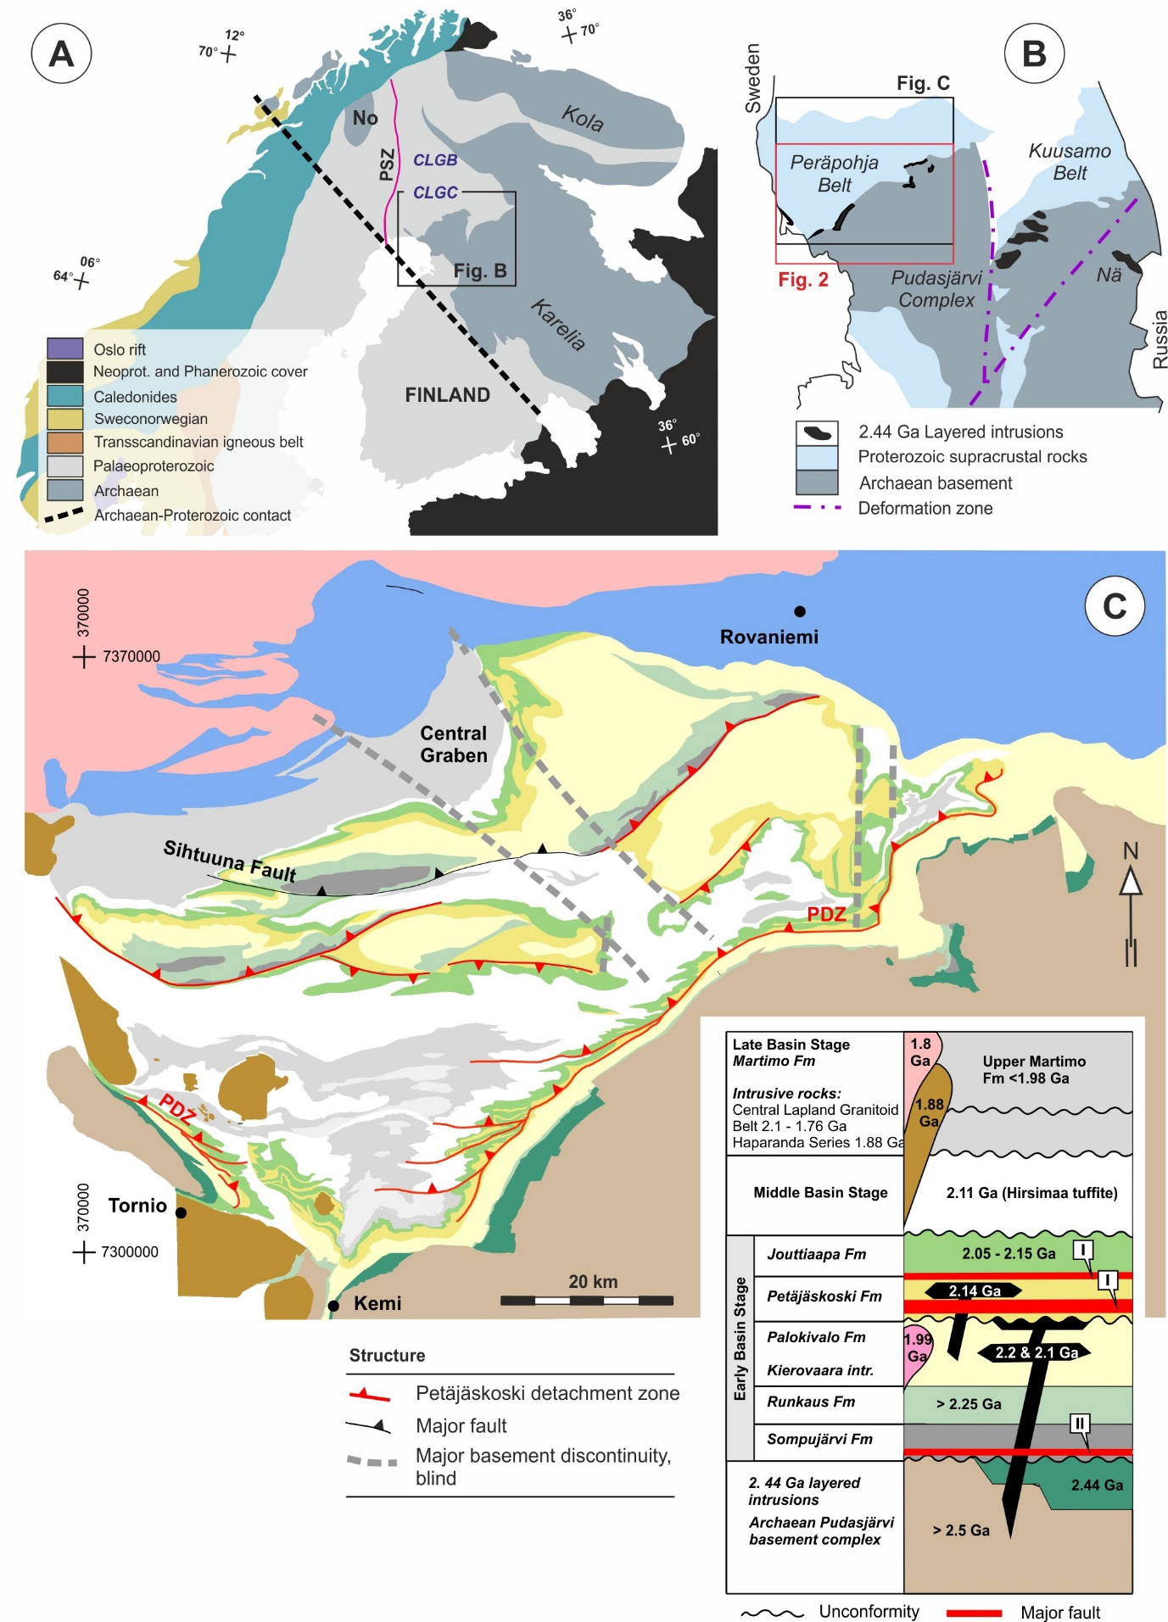

Fig. 1. A: An overview of the major geological domains of Fennoscandia. CLGB = Central Lapland Greenstone Belt, CLGC = Central Lapland Granitoid Complex, PSZ = Pajala Shear Zone. No = Norrbotten craton. B: The location of the 2.44 Ga layered intrusions and the Peräpohja and Kuusamo Belts with respect to their Archaean basement. Nä = Näränkävaara intrusion. C: Geological map and stratigraphy of the Peräpohja Belt (simplified after Piippo et al., 2019). PDZ = Petäjäskoski Detachment Zone. Coordinates are given in EUREF-FIN.

The Early Basin Stage supracrustal units relevant to this study comprise the following: The 2.35 Ga Sompujärvi formation (Fm) overlies the layered intrusions and the basement complex rocks, and is overlain by subaerial basalts of the 2.32 Ga Runkaus Fm (Huhma et al., 1990; Vuollo and Huhma, 2005). The thickness of the above formations is limited to ≤ 100 m within their occurrence along the southeastern boundary of the Peräpohja Belt but the thicknesses are significantly higher in the central parts of the belt (Piippo et al, 2019). The Runkaus fm is overlain by the homogeneous quartzites of the 2.22 Ga Palokivalo fm which ranges in thickness between 1 and 2 km across the Peräpohja Belt (Perttunen, 1991). The several hundreds of metres thick 2.22-2.14 Ga Petäjäskoski fm, (Hanski et al., 2010; Kyläkoski et al., 2012) overlies the Palokivalo fm and hosts the major Petäjäskoski detachment zone (PDZ) separating the domains of contrasting structural character. For more details on PDZ and the upper part of the PB stratigraphy the reader is referred to Piippo et al. (2019).

2.2. Initial rifting, uplift and erosion
Break-up of the Archaean continent within the northern segment of the Fennoscandian Shield started with rifting and associated mafic magmatism in the Kola Peninsula in north-western Russia at 2.5 Ga (Melezhik and Sturt, 1994; Amelin et al., 1995), and continued from 2.46-2.44 Ga in Kola and northern Finland (Alapieti et al., 1990; Bayanova and Balashov, 1995; Balashov, 1996; Lobach-Zhuchenko et al., 1998; Mertanen et al., 1999; Iljina and Hanski, 2005) and to 2.40 Ga in northern Norway (Kullerud et al., 2006). Rift-related volcano-sedimentary deposits’predating mafic magmatism have been observed only within the the north-eastern margin of the Karelian craton (Kulikov et al., 2010; Melezhik and Hanski, 2013) and locally along the southwestern margin of the Peräpohja Belt (Lundmark, 1984). The decreasing trend of age of mafic magmatism from east to west led Kullerud et al. (2006) to conclude that the locus of crustal extension and magmatism shifted progressively during the large-scale rifting event. Major NW-SE trending rift systems were generated south-west of the Kola craton and along the north-eastern margin of the Karelian craton (Melezhik and Hanski, 2013), reflecting an overall approximately NE-SW rifting direction (Laajoki, 2005; Strand and Köykkä, 2012). Within the Peräpohja area, Nironen (2017) attributed the emplacement and subsequent tilt of the mafic-ultramafic layered intrusions to a NW-SE syn-emplacement extension that generated a series of half-grabens, followed by NE-SW post-emplacement extension generating minor faults transecting the intrusions. Further east of the present study area, the emplacement of 2.45 Ga dyke swarms have been attributed to an initial stage of NNW-SSE extension followed by NNE-SSW extension (Vuollo & Huhma, 2005).
Rifting associated with the deposition of the Sumian tectofacies (2505–2430 Ma) was followed by a depositional phase of physical weathering and deposition of the Sariolan tectofacies (2430–2300 Ma) at around 2.35 Ga, characterized by in situ Archaean granitoid breccias passing into immature Sompujärvi formation sediments and the deposition of the Sompujärvi bottom conglomerates directly on top of the eroded layered intrusions (Perttunen, 1991; Hanski and Melezhik, 2012). Erosion of the layered intrusions and their hanging-wall rocks is shown by petrological evidence, including the presence of PGE-bearing clasts among the Sompujärvi conglomerates (Perttunen, 1991). Development of the “sub-Sariola unconformity” (Laajoki, 2005) above the layered intrusions has been attributed to the shallow emplacement depth and subsequent rapid exhumation of the intrusions (Iljina and Hanski, 2005). In Russia, the exhumation has been attributed to rift inversion (Melezhik and Sturt, 1994). Subsequently, another period of rifting associated with mafic magmatism followed at 2.2 Ga, with subsequent continental break-up and dispersal at approximately 2.1 Ga (e.g. Lahtinen et al., 2005).

2.3. Structural framework
The origin of the sub-vertical Pajala Shear Zone (Fig. 1) bounding the study area to the west has been attributed to development of a divergent plate boundary or a transform fault system separating two major continental cratonic terranes (Lahtinen et al., 2015), with later reactivations characterized by strike-slip deformation (Berthelsen and Marker, 1986; Kärki et al., 1993). The mainly NE-trending AP contact and the base of the Peräpohja Belt is defined by distinct gently to moderately NW-dipping seismic reflectors parallel with the 2.44 Ga layered intrusions (Patison et al., 2006; Iljina and Salmirinne, 2011). The 2.44 Ga layered intrusions are structurally characterized by the connection of individual intrusions by dykes or intermediate magma chambers (Iljina and Hanski, 2005), whereas2.44 Ga mafic dykes within the Archaean Pudasjärvi complex strike parallel with the known AP-contact orientations (i.e. NE-SW and NW-SE), apparently controlled by the internal structural grain of the complex (Perttunen, 1991; Vuollo and Huhma, 2005). The AP-contact defining the southeastern margin of PB is dominated by the erosional sub-Sariola unconformity (Perttunen, 1991), or, where the 2.44 Ga intrusions are overlaying the Archaean basement, by preserved intrusive textures including basal chilled margins (Halkoaho et al., 2005) and zones of emplacement-induced mixing of the mafic magma and the Archaean host rocks (Iljina, 2005; Iljina and Salmirinne, 2011). By contrast, the basal contacts of the dome-shaped Tornio and roughly planar Kemi intrusions along the southwestern and southern PB margin are characterized by up to 50 m thick mylonite zones (Söderholm and Inkinen, 1982; Huhtelin and Alapieti, 2005).
In seismic images, the Peräpohja Belt forms the southern part of the wider “Southern Proterozoic belt” which shows a faulted base indicative of horizontal movements with unknown magnitudes and kinematics (P1-3 in Fig. 3a; Patison et al., 2006). The concave-up Peräpohja Belt reaches a maximum depth of 4-5km, is characterized by seismic signatures indicative of thin-skinned deformation and has an overall asymmetric structure with thickening towards the north (Patison et al., 2006). Within the Archaean domain, clear Proterozoic overprint is indicated by faulted basal contacts of crustal blocks distinct bright linear reflections originating from Proterozoic mafic dykes (e.g. A1b and c in Fig. 3a), and transparent seismic zones arising from rift-related thinning, magmatism and shearing (E1a in Fig. 3a; Patison et al., 2006).
The compressional overprint of the Peräpohja Belt supracrustal rocks is characterized by thin-skinned fold-and-thrust belt style deformation (Perttunen, 1991; Piippo et al., 2015) occurring above the basal Petäjäskoski detachment zone (PDZ; Piippo et al., 2019), under greenschist to amphibolite facies metamorphic conditions (Hölttä and Heilimo, 2017). Most deviations from these fold-and-thrust style structures are attributed to basement involvement which caused heterogeneous strain localization during a major south-verging compressional event (see Piippo et al., 2019 for a detailed description).

3. Methodology and available data
3.1 Regional-scale structural interpretations
To improve understanding of the character of the ~2.45 Ga rifting event and potential subsequent fault inversion and/or reactivation, we compiled structural interpretations and restorations within the basal parts of the Peräpohja Belt (in its southeastern part), the adjoining AP-contact zone and the Archaean basement (Fig. 2). Firstly, we compiled regional-scale structural form line interpretations of the ductile structures, structural discontinuities and potential feeder dykes within the basement, based on aeromagnetic maps from the Geological Survey of Finland (GTK) and lithological and structural observations accessible though the databases of GTK and the industrial collaborators (Mawson Resources Ltd and First Quantum Minerals Ltd) . We reviewed and re-interpreted the appximately N-S aligned FIRE 4 and E-W aligned FIRE Suhanko seismic profiles (Patison et al., 2006; Iljina and Salmirinne, 2011) to constrain the 3D attitudes of major structures and to recognize structurally significant domains (Fig. 2). Secondly, we reviewed existing literature to clarify the evolution of the AP-contact and further constrainevidence for syn-rift slip of the faults transecting the 2.44 Ga layered intrusions by studying the correlation between the faults and thickness variations within the intrusions (Section 4.3).

3.2 Fault restoration modelling
Subsequently, we constrained the layer thickness variations within the basal parts of the PB below the Petäjäskoski detachment zone by restoring the thicknesses of the lower PB stratigraphic units with the aim to recognize reactivation of the 2.44 Ga faults. Another restoration involved rotation of the layered intrusions and faults truncating them into their palaeogeometry at 2.44 Ga. As these faults preserve the primary rifting signatures (Section 4.3), they provide unique information about the palaeostresses during rifting, assuming the layered complex intruded horizontally, and the truncating faults were of dip-slip character. Since no direct fault dip observations were available, we used foliation measurements in the fault vicinity as dip constraints when developing the fault traces into 3D-surfaces. For this reason, the fault dips are the most uncertain components of this investigation and the derived uncertainty will affect the resulting palaeostress constraints. To decrease this uncertainty we developed conceptual structural scenarios, with contrasting dips of the 2.44 Ga faults, to explain the structural setting at the onset of rifting at 2.44 Ga. Finally, we utilized the results of an associated paper (Piippo et al., 2019) to provide a wider structural framework for the 2.44 Ga normal faults. In restoration modelling, we used MOVETM software package from the Midland Valley Exploration Ltd.

3.4 Analogue sand box modelling
To test the applicability of the suggested structural setting of the Peräpohja Basin, we conducted a preliminary strike-slip analogue model and correlated these results with those based on the structural analysis. The sandbox model was performed at the Tectonic Modelling Laboratory of the CNR-IGG, at the Department of Earth Sciences of the University of Florence, Italy. The model had dimensions of 30cm (length) x 10cm (width) x 5cm (thickness) and was progressively deformed with a deformation rig made of basal Plexiglas whose geometry reproduced two parallel strike-slip faults arranged in a left-handed overstepping geometry with offset angle of 45° (Fig. 9b). The strike-slip motion of the basal plates, driven by a stepper motor, generated a pull-apart basin in the area of overstep between the two major transcurrent fault segments. For the experiment, we used a 4 cm-thick layer made of a mixture of quartz and K-feldspar sand with grain size of < 250 μm (Montanari et al., 2017) to reproduce the uppermost brittle crust; a 1 cm-thick layer of silicon (PDMS) was placed at the base of the sand in the overstepping zone to distribute deformation in the developing pull-apart (see Dooley and Schreurs, 2012). In order to analyse the influence of pre-existing discrete brittle structures on deformation, we introduced regularly-spaced vertical E-W anisotropies in the model, by cutting the model with a knife every 4 cm. These cuts created a zone of dilation in the sand as a result of grain re-arrangements, acting as a zone of weakness in the brittle model (e.g., Bellahsen and Daniel, 2005).

4. Structural interpretation
4.1. Regional-scale structural signatures
The Archaean-Proterozoic (AP) contact south of the Peräpohja Belt may be subdivided into two major segments separated by the N-S trending Kemi Fault Zone (Piippo et al., 2019) which collectivelydefine a funnel-shaped geometry for the contact zone (Fig. 2a-b). The shorter western segment close to Tornio trends NW-SE and dips moderately towards north-east. The curvilinear eastern segment shows an overall NE -SW trend, moderate north-westerly dip (Table 1), deflection into an E-W trend around the Kemi intrusion and open flexure in the Portimo complex area (Fig. 2b). The small-scale 2.44 Ga faults (see Section 4.3) with NW-SE, E-W and N-S strikes display parallel, fanning and conjugate arrangements and define distinct fault blocks along the AP-contact zone (Figs. 2a,c and 5). The N-S and NW-SE striking sets are dominant within the Portimo complex area whereas the NW-SE and E-W striking sets, including a large fault separating the Penikat and Kemi intrusions prevail further west. Very few to no cross-cutting faults exist within the central and westernmost parts of the contact zone. Basement discontinuities located further away from the AP-contact (Fig. 2a,d), as recognized from breaks and lows within the aeromagnetic data, share the N-S and NW-SE sets with the 2.44 Ga faults but lack the E-W trends. Spatially, the NW-SE trending set occurs predominantly within the western part of the area whereas the more continuous and north-south trending features prevail east of the Oijärvi Greenstone Belt (OGB).
The distinct magnetic anomalies are linear to curvilinear features delineating the potential orientations and locations of mafic dykes including the potential feeder dykes of the 2.44 Ga layered intrusions (see Perttunen, 1991). The anomalies display overall SW-NE trends and deflection towards the OGB and other roughly N-S trending structural zones (Fig. 2a). Deviations from the dominant orientations include the distinct WSW-ENE and NW-SE trending anomalies occurring below the Penikat and Kemi intrusions, respectively (Fig. 2a). Ductile trends based upon both continuous magnetic anomalies and foliation strikes are characterized by a central domain with sub-parallel NE-SW to NNE-SSW trending anomalies and elongate domes (Figs. 2a,b). The NE-SW grain is apparently truncated by the N-S to NNW-SSE structures associated with OGB and the other approximately N-S trending structural zones. In the easternmost part of the study area the regional NE-SW fabric is locally preserved but the dominant structures trend NW-SE to NNW-SSE.
Foliation data from the whole study area display overall steep dips, a relatively wide scatter of strikes, with two recognizable main sets with approximately NW-SE and NE-SW trends (Fig. 2a,b,g; see Table 1 for summary of the defined foliation clusters). The cluster of NW-SE striking foliations show a clear maxima indicating steep dips towards WSW and a secondary clustering indicating steep to moderate northeasterly dips (Fig. 2g). The SW-NE foliations dip moderately-steeply towards NW to NNW and, to a lesser extent, steeply and moderately towards south-east and south (Fig. 2g). Within a 15-20 km wide structural domain B1 (Fig. 2b) and immediately below the AP-contact (see Section 4.2. and Fig. 3) foliation data show two distinct sets with steep southwesterly and northeasterly dips, whereas the SW-NE striking foliations are nearly absent (Fig. 2b,h). Correlation of the foliation attitudes and the structural form line trends suggests that the 2.44 Ga faults occur as two oppositely dipping conjugate sets along the AP-contact and within domain B1. The dominant ductile “background” structure within the Archaean Pudasjärvi Complex has dominant SW-NE trends with moderately northwesterly dips. More gentle NW dips are attributed to the attitude of the AP-contact, and the southeasterly dips to the SE-dipping flanks of the regional-scale dome structures (Fig. 2a). The effect of the OGB and other N-S features is visible as a pronounced scatter of the approximately SW-NE -striking foliations. Correlation of individual foliation measurements or groups of measurements with the spatially associated form lines (black triangles in Fig. 2a) are in line with the above presented regionally derived correlations as shown by the pole densities of the derived 3D-surfaces (Fig. 2 f).

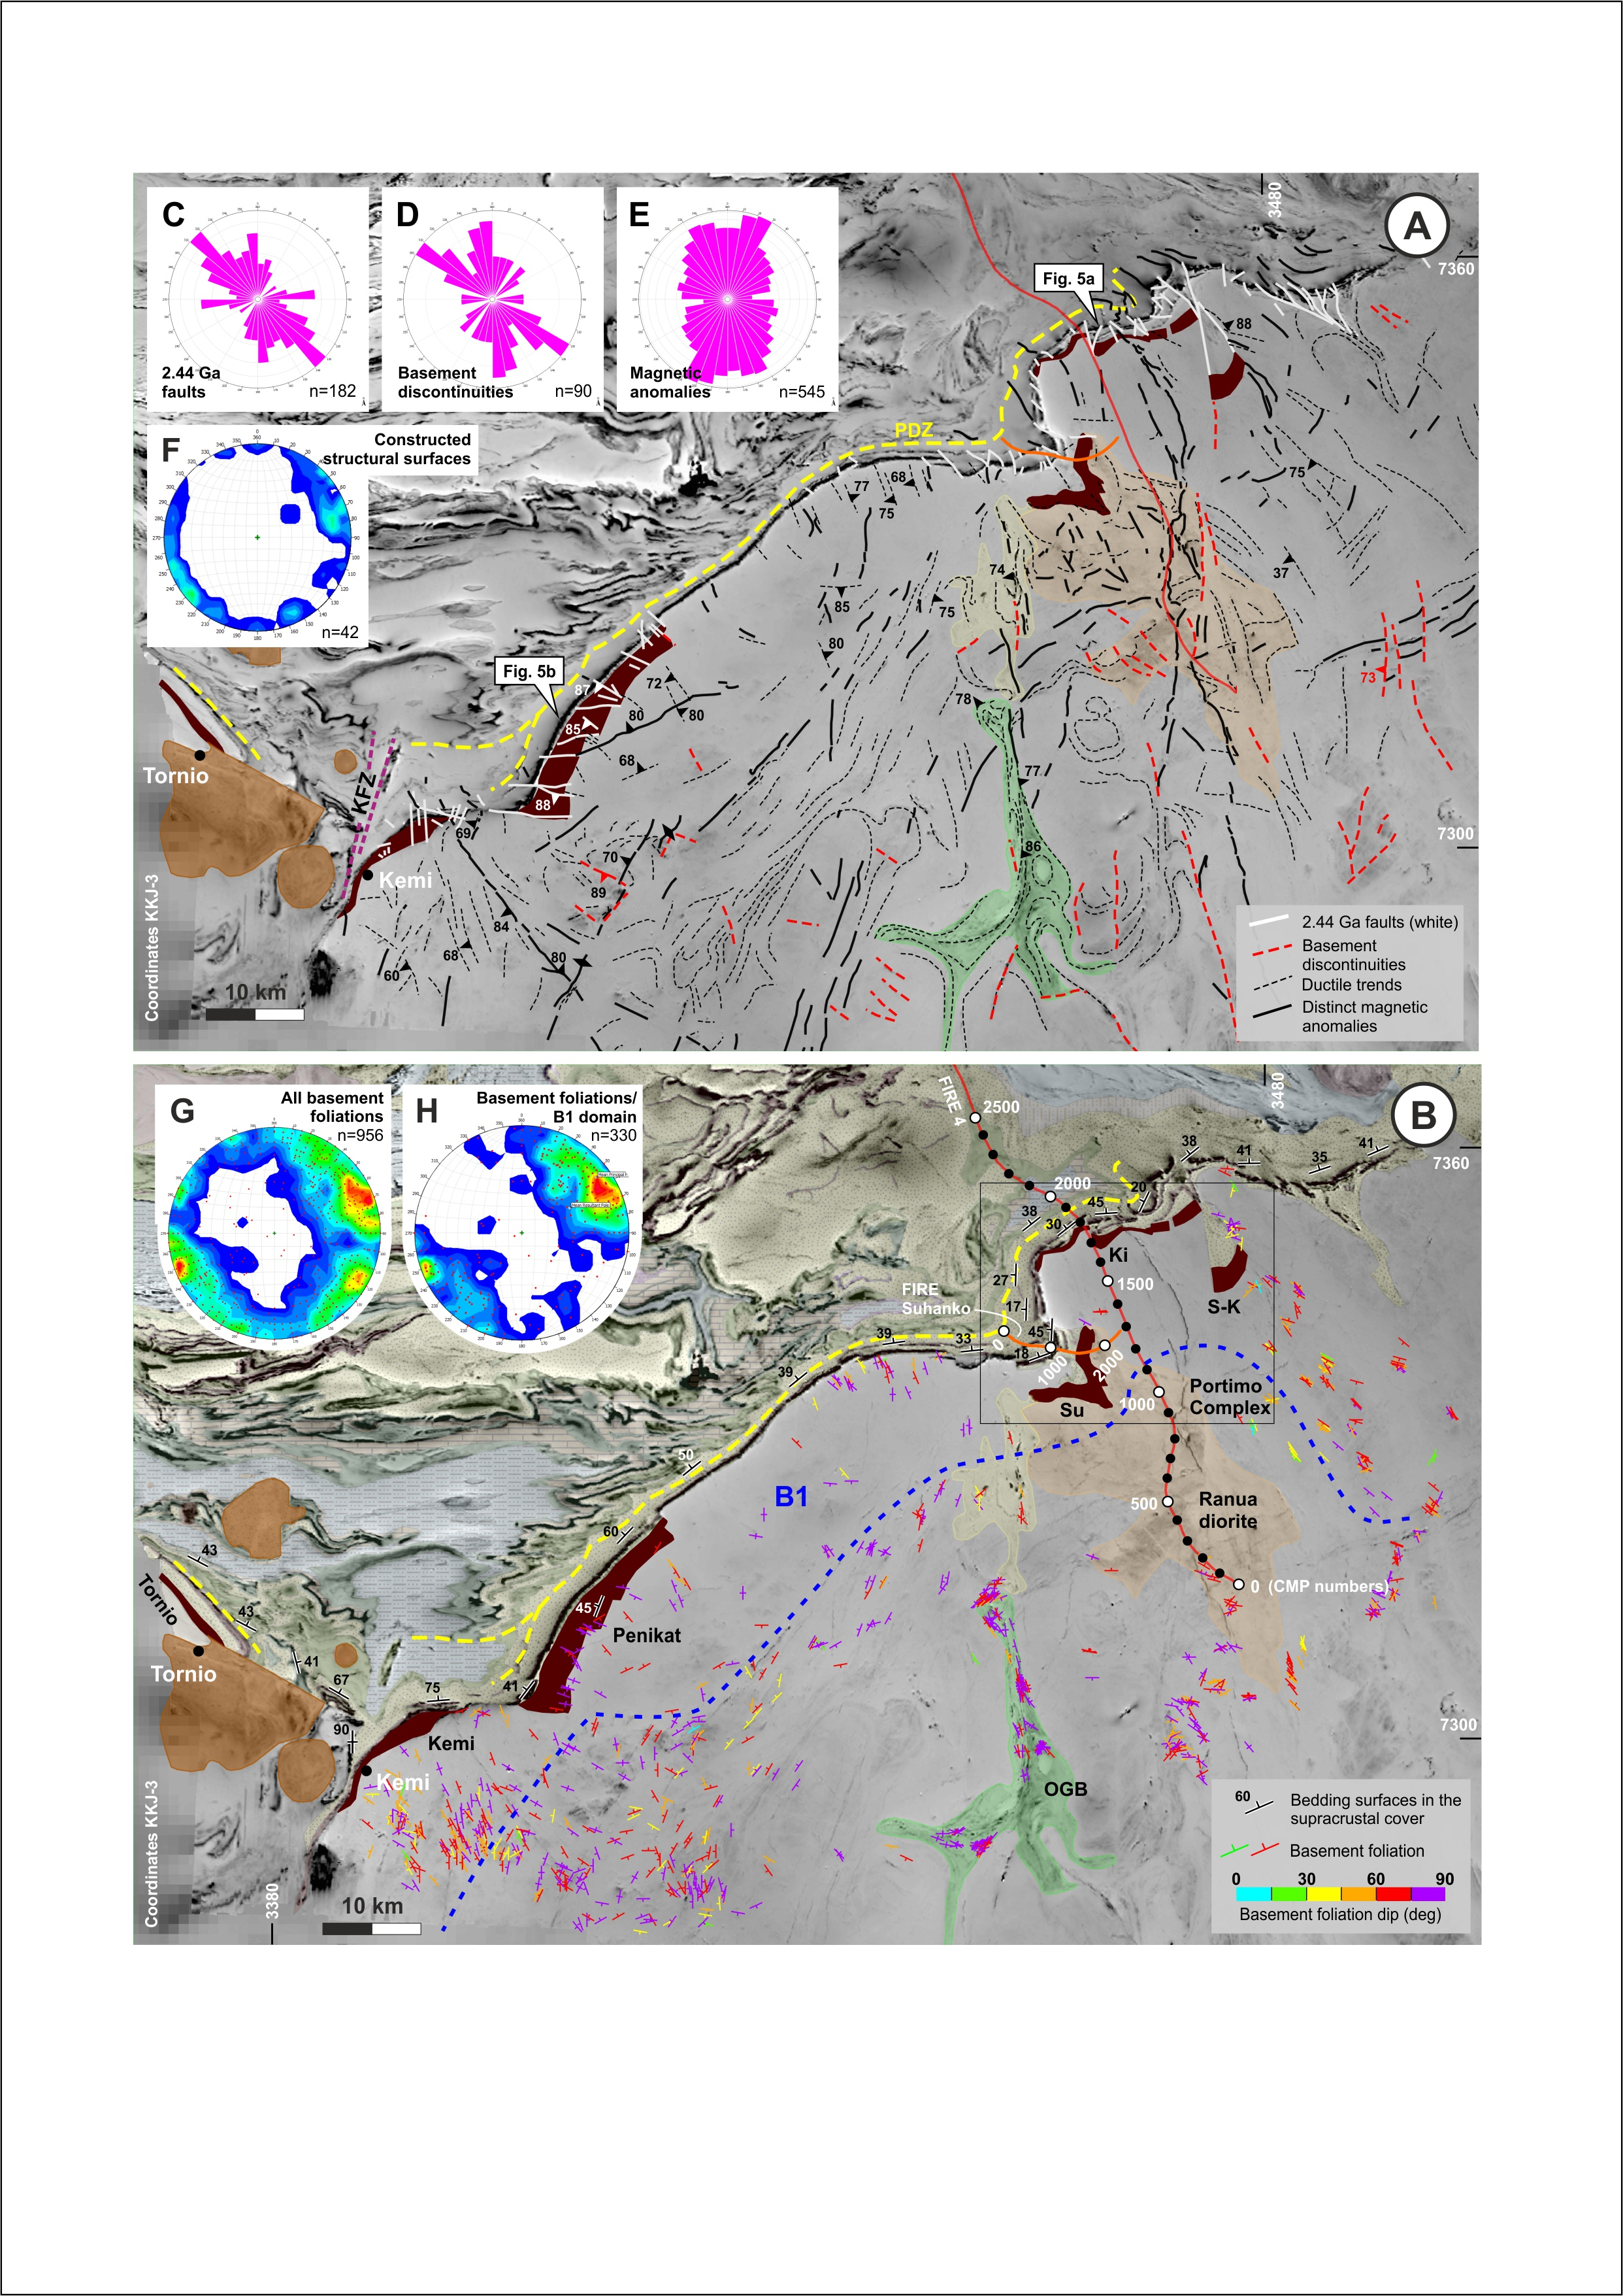

Fig. 2. Structural interpretation of the Archaean basement and its contact zone with the overlying Proterozoic crust. A: Form line interpretation of the basement structures. B: Foliation data from the basement and the dominant dip of the layering above the AP -contact. B1 denotes the area of preserved rift-related structures (see Fig. 3 and Section 4.2). Colouring of the Peräpohja Belt units is illustrative only; for details, see Piippo et al. (2019). C-E: Rose diagrams showing the strikes of structural elements interpreted from the maps: C: the small-scale 2.44 Ga faults, D: basement discontinuities, E: distinct magnetic anomalies (dykes). F: Orientation of the surfaces constructed by correlating form lines with proximal foliation data (shown by the filled black triangles in A). G and H: Foliation data from the whole basement (G) and from B1 domain (H). (Lower hemisphere projections). KFZ = Kemi Fault Zone, PDZ = Petäjäskoski detachment zone (Piippo et al., 2019). Mafic layered intrusions: Ki = Kilvenjärvi, S-K = Siika-Kämä, Su = Suhanko. Geophysical maps by Geological Survey of Finland (Airo, 2005).

4.2 Interpretation of reflection seismic profiles and correlation with previous interpretations
The FIRE 4 seismic reflection line (Patison et al., 2006; Kukkonen et al., 2006) was acquired in 2003, images reflections down to 80 km, is more than 200 km long and crosses nearly orthogonally the AP-contact within the Portimo Complex area (Fig. 2b). Our structural interpretation of FIRE 4 line focused on the uppermost southern part of the profile (CDP 0-2900, depth 0-16 km) comprising the units A1a-c, P1 and E1a of the existing regional-scale interpretation (Fig. 3a-c; Patison et al., 2006). The main recognized features comprise two south-dipping zones (R1, R2) which truncate the sub-horizontally dipping reflective fabric within the Archaean domain (R3; Fig. 4b,c). Towards the north, a younger, narrow listric north-dipping reflector (R4) truncates R2, flattens into a horizontal attitude, extends below the 2.44 Ga layered intrusions and defines the base of the Peräpohja Belt at a depth of approximately 5 km (Fig. 3c,d). R4 is associated with deflection of other reflectors into the zone from above and below, and with asymmetric thrust style folding (F1) similar to that observed above the 2.44 Ga layered intrusions (F2). Furthermore, R4 is distinguished from the wider R1 and R2 zones by its discrete narrow character. The northern margin of the Peräpohja Belt is loosely defined by a steeply S-dipping disruption in the reflectivity pattern (R5).
From a regional perspective, we concur with the general pattern of strain partitioning proposed by Patison et al. (2006) comprising a a shallower crustal domain (P1, A1c) affected by Proterozoic ductile deformation and deeper domains characterized predominantly by Archaean signatures overprinted by rift-related dyke magmatism and faulting (A1a, E1a, E1b; Fig. 3a). In contrast to Patison et al. (2006), we attribute the Proterozoic overprint within the Archaean block A1c to localized shearing along the major deformation zone R4, which contrast with the more widely distributed thin-skinned thrust-style overprint within block P1. We attribute the dissimilar style of the overprinting to the contrasting composition of the crustal blocks A1c and P1, the latter comprising the Petäjäskoski detachment zone (PDZ) which specifically promoted low-angle thrusting evident from two klippe structures recognized by Piippo et al. (2019).” Based on the spatial association and similar type of deformation, we interpret that R4 is a controlling detachment fault and the PDZ is a splay of it. As a consequence of recognizing R4, we define a new crustal block B1 that, based on distinctive foliation and fault signatures, preserves structures related to the 2.44 Ga rifting of Archaean rocks within its upper part (Section 4.3). Based on their similar attitudes and seismic signatures, we correlate R1 and R2 with the major south-dipping deformation zones C1 and C2 of Patison et al. (2006). We further attribute the tapering and deflection of the southern margin of E1b to extensional faulting along C1, in line with the overall thickening of the Peräpohja sub-unit towards the north (Patison et al., 2006).
The FIRE Suhanko reflection seismic profile (Iljina and Salmirinne, 2011) is an approximately 10 km long E-W line transecting the Suhanko intrusion. It images the subsurface down to approximately 8 km and is characterized by a distinct gently west-dipping package of reflections representing the Suhanko intrusion and the overlying Proterozoic dykes and quartzites in its uppermost part (B1a,b; B2 in Fig. 4a; Iljina and Salmirinne, 2011). The underlying Archaean basement is characterized by wavy, gently-dipping to horizontal reflections cut by moderately-dipping discontinuities (Fig. 4b). The largest discontinuity (R6) dips towards the east, and constrains the depth extent of the larger number of overlying west-dipping discontinuities (e.g. R7 and R8). We consider the flexure of the planar reflector P1 at the apparent shallow termination of R6 to support the existing interpretation of east-dipping features representing pre- or syn-rifting faults (P2a,b by Iljina and Salmirinne, 2011). We further attribute the occurrence of several sub-parallel west-dipping structures aligned with the contact of the Ranua diorite (Fig. 2b; P3, P4a,b by Iljina and Salmirinne, 2011) to the development of a series of antithetic extensional faults above the controlling major fault (R6), that define an overall extensional rift-related signature for the basement (Fig. 4b).

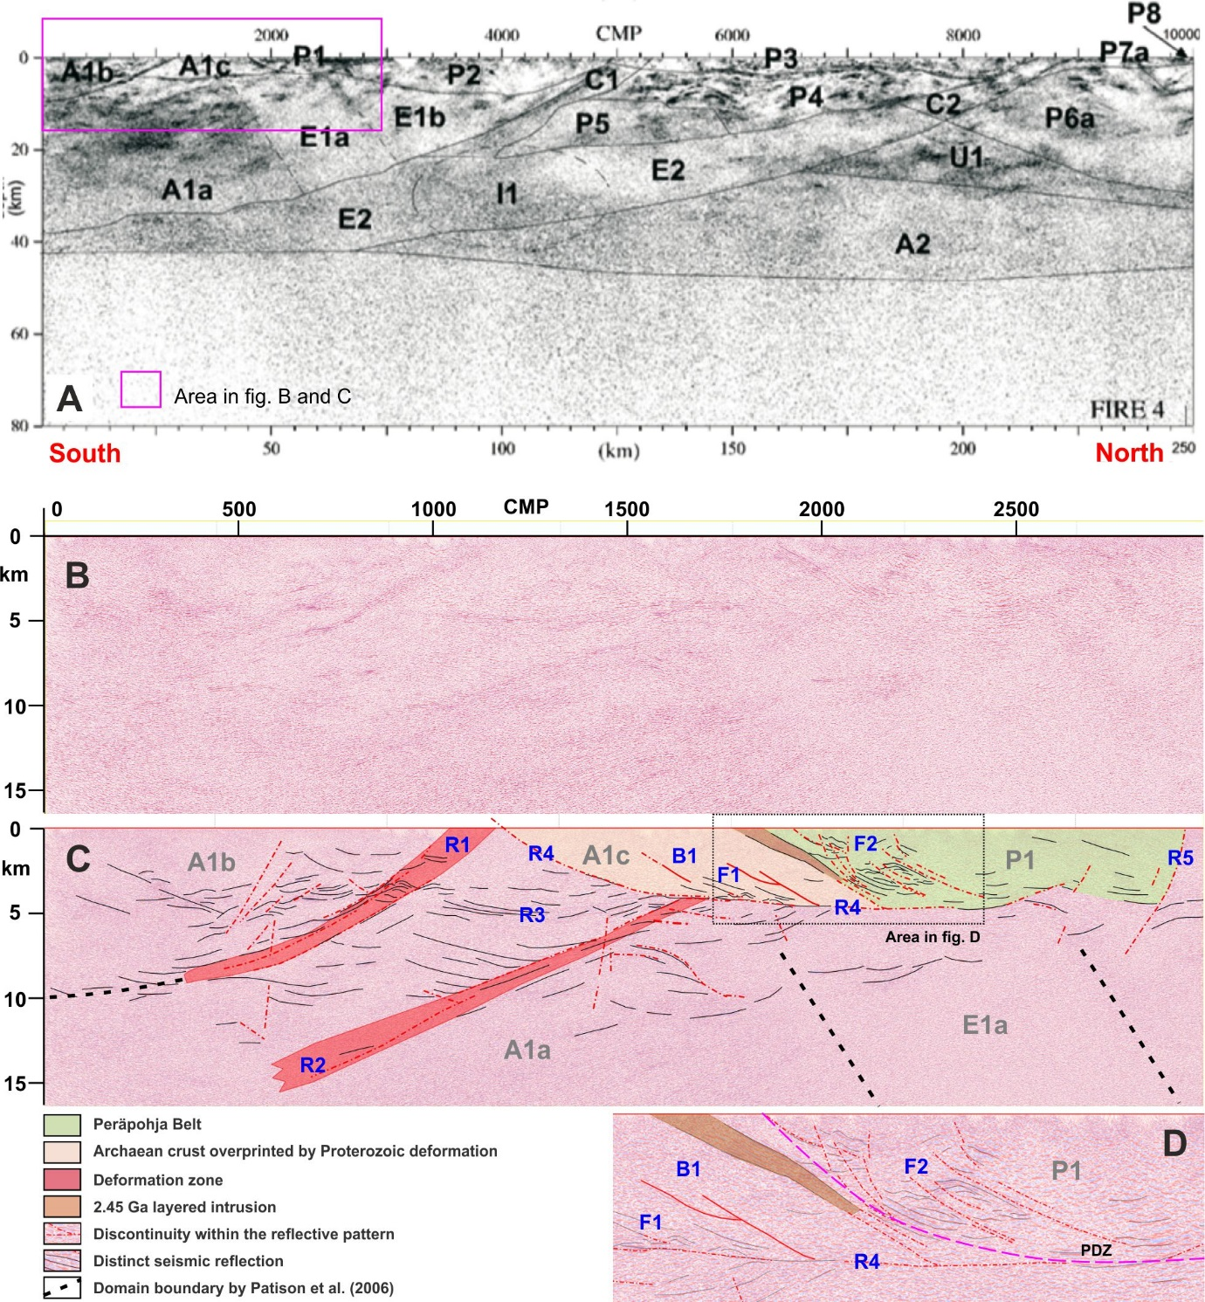
Fig. 3. Interpretation of the southern part of the FIRE 4 reflection seismic profile. A: The regional-scale interpretation by Patison et al. (2006). B: Blank migrated section. C: Interpreted section (this study). The annotations in grey correspond to the features in A whereas the blue annotations refer to features interpreted within this investigation. D: Detail of C highlighting the fold-and-thrust belt style deformation within the supracrustal rocks of the Peräpohja Belt (P1) and the inferred geometry of the Petäjäskoski detachment zone (PDZ).

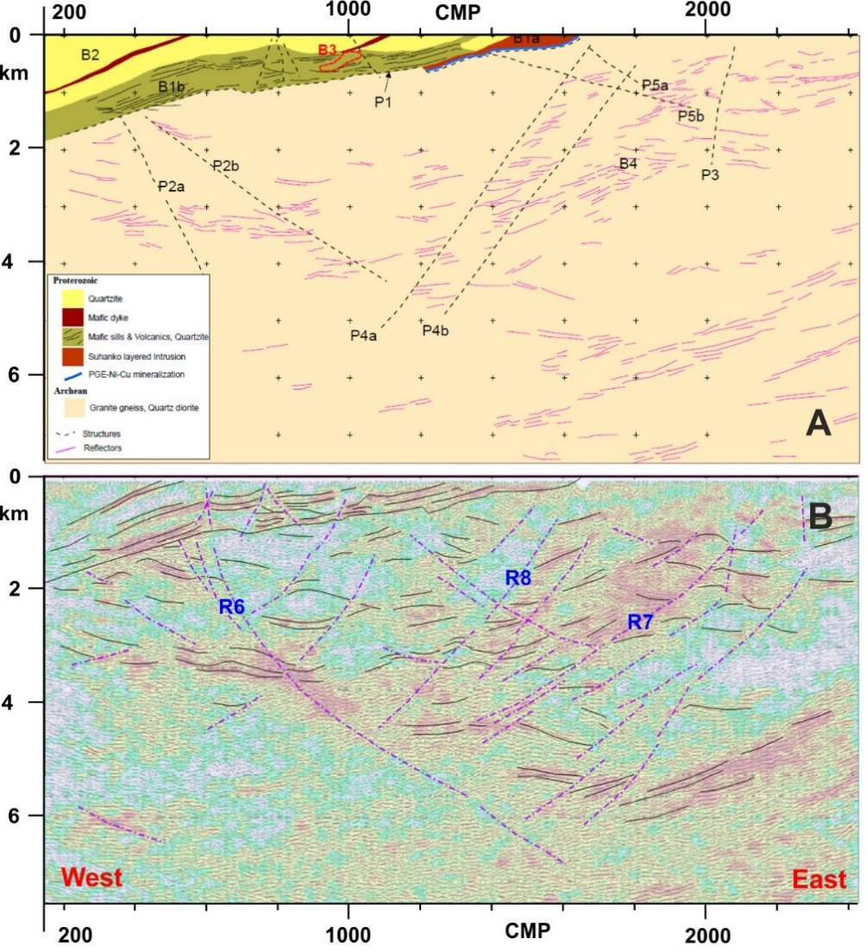
Fig. 4. FIRE Suhanko. A: Geological interpretation by Iljina and Salmirinne (2011). B: Revised structural interpretation.

4.3. Timing of the faults transecting the 2.44 Ga layered intrusions
Iljina and Salmirinne (2011) characterized the thicker sequence of the layered intrusion at Kilvenjärvi block with respect to the dominantly sheet-formed intrusions within the Portimo complex as a structural embayment (Figs. 2b, 5a). Based on the systematic increase of layer thicknesses towards the cross-cutting faults within the Kilvenjärvi block, in particular within the lowermost megacyclic units unaffected by subsequent erosion (MCU1&2; Fig. 5a), we conclude that the faults must have originated or been reactivated during the emplacement of the intrusions at 2.44 Ga, not after the emplacement as proposed by Nironen (2017). This interpretation also constrains the age of the faults within the preserved B1 zone which is delineated from the seismic reflection data (Section 4.2.). The observed thickness variations within the Penikat intrusion, with the thickest layers of megacyclic unit 1 occurring within the fault-bound Keski-Penikat and Kilkka blocks (Fig. 5b), also indicates that primary curvature of the intrusion base may not control the thickness variations but they must be fault-related. The schematic restoration of the Penikat intrusion (Fig. 5c; Laajoki, 2005) illustrates the variable erosional level of the sub-Sariola unconformity, and as present-day map patterns display no apparent signs of significant fault inversion (Fig. 5a,b), the changes in the erosional level are most likely due to normal faulting, subsequent uplift and erosion. At Kilvenjärvi, the unconformity is approximately conformable with the underlying magmatic layering, whereas the Penikat intrusion experienced significant tilting during uplift (and potential inversion), contributing to the angular nature of the sub-Sariola unconformity. The absence of layered intrusion between the Penikat and Portimo area along the present map level is attributed either to the heterogeneous uplift and erosion responsible for the angular unconformity, or that the intrusions were not emplaced continuously, controlled instead by bounding structures.

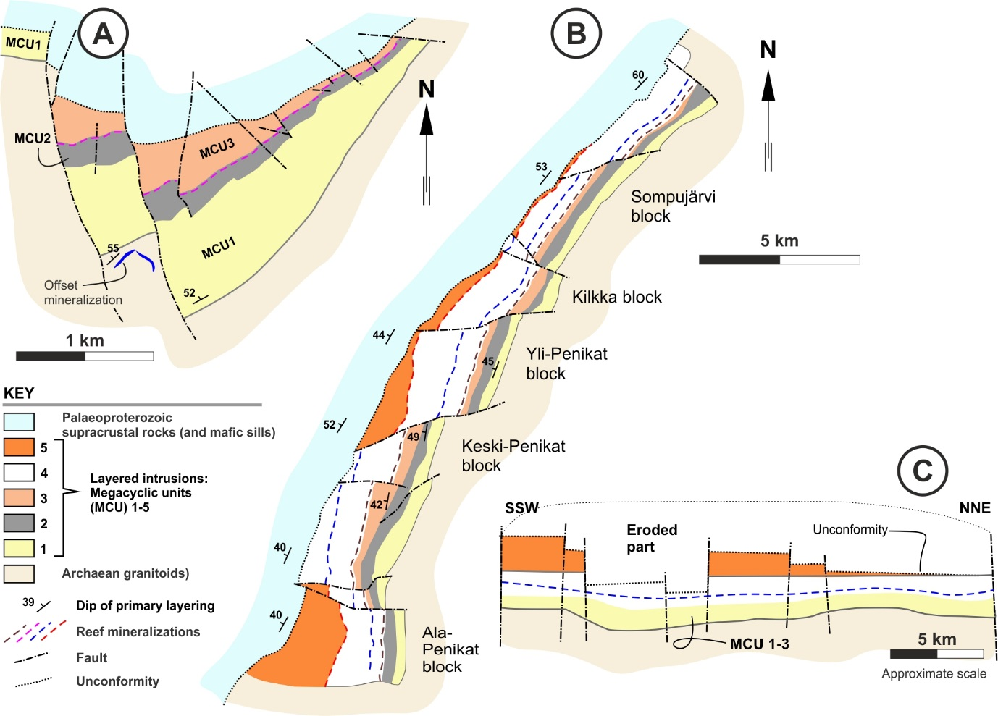
Fig. 5. A: Half-graben shape of the Kilvenjärvi layered intrusion (after Huhtelin et al., 1989; Iljina and Hanski, 2005) within the Portimo complex is indicative of fault activity during the emplacement of the intrusion. B: Developent of structural blocks within the Penikat intrusion (Halkoaho, 1993). C: Schematic restored vertical section of the Penikat intrusion highlighting the heterogeneous erosional level between the neighbouring blocks (after Laajoki, 2005). See Fig. 2 for locations.

Table 1. Summary of the major structural orientations within the Archaean basement and the AP-contact zone with the Peräpohja Belt.

5. Structural restorations
The first part of structural restorations (Section 5.1) investigates the exploitation of the 2.44 Ga faults by linking them with the layer thickness changes within the basal parts of the PB stratigraphy. We assume that faults with significant reactivations were among the largest faults also during the 2.44 Ga rifting. The second part (Section 5.2) aims at restoring the 2.44 Ga faults into their primary orientations. Assuming they were dominantly of dip-slip type, we can derive palaeo-extension direction at the time of their formation.

5.1. Fault reactivation
Set-up and workflow: Within the AP-contact zone below the Petäjäskoski detachment zone, apparent deformation post-dating the uplift and erosion at approximately 2.35 Ga has in general been mild as recognized from the overall continuous and relatively straight nature of the sub-Sariola unconformity (Figs. 4,5). However, small irregularities and localized distinct faults along the unconformity indicate reactivation after their generation at 2.44 Ga. Fault reactivation was assessed through restoration of the cross-faulted stratigraphic units occurring below the Petäjäskoski detachment zone (Sompujärvi fm to Palokivalo fm), the resulting thickness variations spatially coinciding with the faults highlighting which faults or fault zones experienced significant reactivation. The stratigraphic thicknesses were determined using 3D surfaces interpolated from average local dips derived from clusters of structural measurements along the AP-contact (see Fig. 2b for simplified dip data), and the apparent thicknesses on the map by using a function for Euclidean distance to top of the Palokivalo Fm, which calculates the shortest distance to the top of the Palokivalo horizon line for every determined point along the horizon lines at the stratigraphically lower levels. The determined true thicknesses were further used to form a simple illustrative restored section of the AP-contact zone at approximately 2.22 Ga, prior to the deposition of the Petäjäskoski Fm. Due to the uncertainty in fault dips, the faults were treated as vertical, and their relative timing was interpreted by inspecting which formations they affected.
Results: The total thickness of the analyzed formations ranges between 600m and 2.6 km (Fig. 6a). The largest thickness variation (200-2000 m) of the individual formations is observed within the Palokivalo fm, with greatest thicknesses above the layered intrusions (Fig. 6). The same applies for the Sompujärvi and Runkaus formations, although the absolute thickness changes (20-100m combined thickness on average) are significantly smaller. The presence of the thickest strata above the layered intrusions indicates that the faults bounding the semi-continuous intrusions, as opposed to the individual fault-bound blocks, also experienced significant reactivations, and are hence considered the most significant of the 2.44 Ga faults. However, more detailed inspection reveals that reactivation may not have necessarily occurred along the bounding faults but rather along narrow zones parallel to the bounding faults (Fig. 6c).
The faults display varying amounts of (vertical) displacement and they could be classified into three groups based on their relative timing of reactivation: i) The faults of the first group (purple in Figs. 6b,c) cut the 2.44 Ga layered intrusions, display insignificant overall displacements or do not extend into the overlying formations (see also Nironen, 2017). For this reason, these faults did not experience post-rift reactivation and preserve their primary extensional signature. ii) The second group of faults (green in Figs. 6b,c) shows evidence for syn-rifting activity during emplacement of the layered intrusions but also reactivation during the deposition of the Sompujärvi and Runkaus formations at approximately 2.35-2.32 Ga. Faults belonging to this group show several hundreds of metres of vertical displacement, and most of them have become passive prior to deposition of the Palokivalo fm. iii) The third group faults (orange in Figs. 7b,c) show varying vertical displacements from less than 100 metres to several hundreds of metres, and typically cut through all units in the AP-contact zone, from the Archean basement into the Palokivalo Formation, but do not transect the top of the Palokivalo fm. Furthermore, these faults are not associated with significant changes in the thickness of the Sompujärvi and Runkaus formations. Consequently, the major period of reactivation of the faults within this group occurred after the deposition of the 2.32 Ga Runkaus fm and prior to the deposition of the Petäjäskoski fm at ≥ 2.22 Ga.
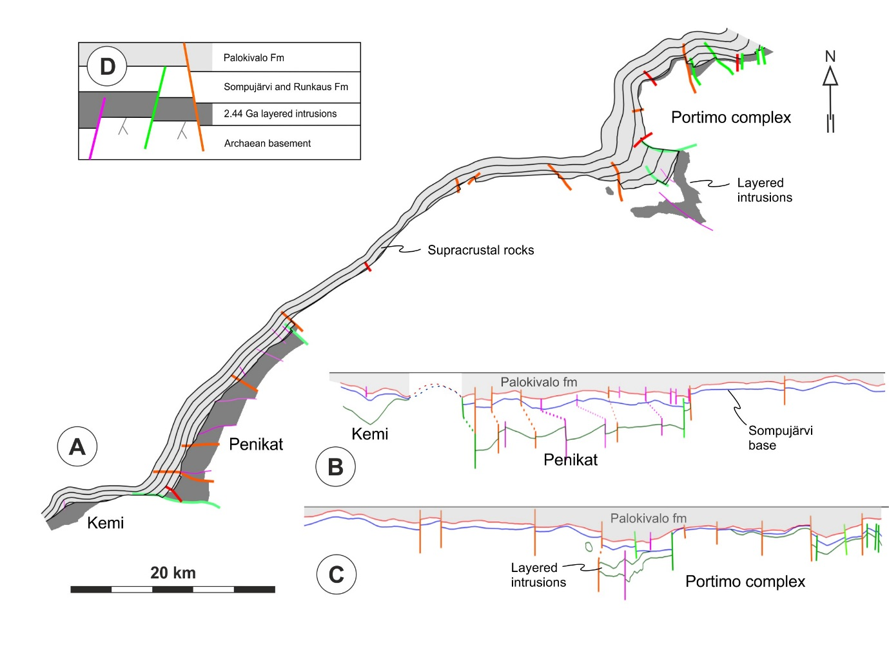
Fig. 6. A: The true total thickness of the Peräpohja supracrustal succession from the Archaean basement and the layered intrusions to the base of the Petäjäskoski formation. The contours represent 500m intervals. B and C: Restored sections (B = southwestern part, C = northeastern part) illustrating the correlation between the faults, the extent of the layered intrusions and the stratigraphic thickness changes within the basal part of the Peräpohja stratigraphy. Only the true thicknesses were calculated, the restoration did not involve any slip along the faults, and all faults except the E-W striking major fault near Kemi were considered orthogonal to the horizon lines with no interpretation on their past or present dips. D: Schematic diagram illustrating the timing of activity of the fault sets with respect to the main stratigraphic units. The purple faults did not experience notable post-rift reactivation, whereas the green faults were reactivated prior to, and the orange ones during the deposition of the Palokivalo formation.

5.2. Palaeostress analysis
Set-up and workflow: The starting hypothesis for the restoration of the 2.44 Ga faults (Section 4) is that the layered intrusions were originally emplaced into approximately horizontal attitudes and the PGE reefs delineating the megacyclic units were laterally continuous during their formation, as inferred for the coeval Koillismaa intrusion in the Kuusamo Belt (e.g. Karinen, 2010 and references within). We attribute the re-orientation of the intrusions into their present-day attitudes to regional-scale rotational strain as indicated by the following features: i) the lack of ductile tectonic deformation along the AP-contact due to strain localization into the overlying PDZ instead (Piippo et al., 2019), ii) the lack of distributed overprinting within the B1 zone and strain partitioning into the lithospheric-scale structural zones (detachment fault R4 and the south-dipping zones R1+R2, C1+C2; Section 4.2), iii) correlation with rotation of other layered intrusions further north (Sorjonen-Ward, 1993), and iv) recognition of the E-W to WSW-ENE trending basement highs associated with major normal faults underlying the PB supracrustal rocks, associated with rotation of the hanging-wall strata (Piippo et el., this issue). Moreover, the assessment of fault reactivation (Section 5.1) indicates that the 2.44 Ga faults along the AP-contact were not subjected to any substantial ductile deflections or local rotational strains affecting their mutual angular relationships, and, for this reason, preserve their primary rifting signatures and reflect the palaeostress field during the rifting.
To restore the 2.44 Ga faults into their primary orientations, we rotated the layered intrusions and the overlying, roughly conformable sub-Sariola unconformity occurring along the south-eastern margin of PB to horizontal along a straight line reflecting the overall trend of the AP-contact (trend 055; Figs. 2, 7, Table 1), and let the faults rotate as passive objects, reflecting the rotational-style tilting of the layered intrusions (see above; Sorjonen-Ward, 1993). We used a rotation angle of 35 degrees representing the dominant bedding attitudes above the unconformity (Fig. 2b). The detail of restoration was kept on a schematic level as the dip constraints of the 2.44 Ga faults are poor. For this reason, the curvature of the AP-contact, arising from either folding or primary curvature, was neglected. Prior to the restoration, the 2.44 Ga faults were grouped into sets according to their strikes, and dips for these fault sets were assigned according to two alternative structural scenarios (#1-2; Fig. 7, Table 2). Subsequently, fault surfaces with a total vertical extent of 1000m were generated by mesh surface extrusions from map trace polylines with uniform node spacing allowing correlation of orientation data. Orientation parameters dip & dip direction) for the fault surfaces were calculated and visualized on stereographic projections, both for the present-day and the restored configurations. Furthermore, mean orientations of the developed (conjugate) faults sets were delineated, and an estimate on the orientation of the tensional stress during the rifting was provided by determining the bisector of the obtuse angle between the mean plane orientations (Fig. 8).

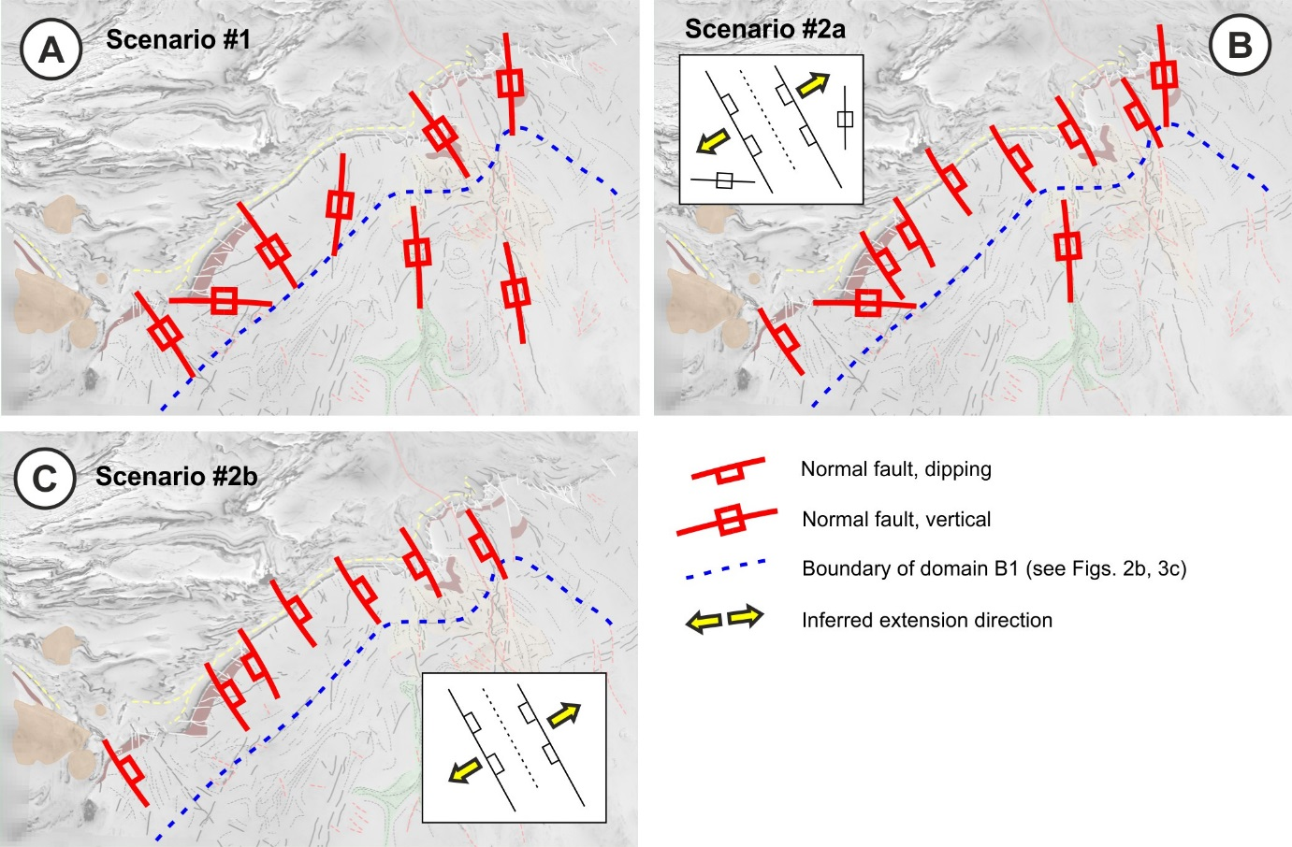
Fig. 7. Structural scenarios for fault restorations. See Table 2 for motivation of the selected fault orientations.

Interpreted orientations of the 2.44 Ga faults – alternative scenarios: Due to the poor direct orientation constraints, we provide two alternative scenarios (Fig. 6) for the attitudes of the 2.44 Ga faults which are used in structural restorations (Table 2). Scenario #1: In this scenario, all the faults have vertical dips, supported by the scatter of dips with sub-vertical orientation around a vertical average. This is geologically the least constrained scenario but was selected to provide a baseline for the other alternative. Scenario #2a: The two main fault populations have roughly parallel ESE-WNW strikes but opposing dip directions, as shown by the two orientation maxima in Figure 3h, and the N-S and E-W trending faults are vertical. This scenario is preliminary considered compatible with approximately WSW-ENE extension parallel with the AP-contact, potentially linked with a sub-horizontal detachment zone defining the southeastern extent of the B1 domain (Figs. 2b, 3c, 6b). Moreover, scenario #2 is supported by the pattern of syn-and antithetic normal faults within the FIRE Suhanko seismic profile (Fig. 4). Scenario #2b is identical to scenario #2a but the vertical E-W and N-S faults have been excluded to better highlight the conceptual model of two opposingly dipping fault populations.
Results: Restoration of the 2.44 Ga faults with vertical orientations of Scenario #1 resulted in two orientation maxima with a relatively wide scatter in dip directions (Fig. 8c). In contrast, the restored faults of scenarios #2a and #2b results in tighter orientation clusters (Fig. 8d,e). Palaeostress constraints based on the conjugate relationship of the faults, with maximum extension aligned along the plane intersecting the obtuse angle of the fault sets, are indicative of approximately horizontal NE-SW extension directions, within a range of approximately 20 degrees depending on the selected set-up (Figs. 7, 8c-e). Exclusion of the E-W and N-S faults (Scenario #2b) allows tighter clustering of the faults with respect to Scenario #2a, which result in nearly the same palaeoextension orientations. We conclude that restoration of the geologically better constrained scenario #2 faults with a conjugate arrangement results in the best estimation on the palaeostress orientation at the onset of the Archaean rifting at 2.44 Ga, and the uncertainty related to the attitude of the N-S and E-W trending faults don’t have a major effect on the results.

Table 2. Assignment of orientations for the 2.44 Ga faults based on alternative fault orientations. Letters in the in the third column refer to Table 1.
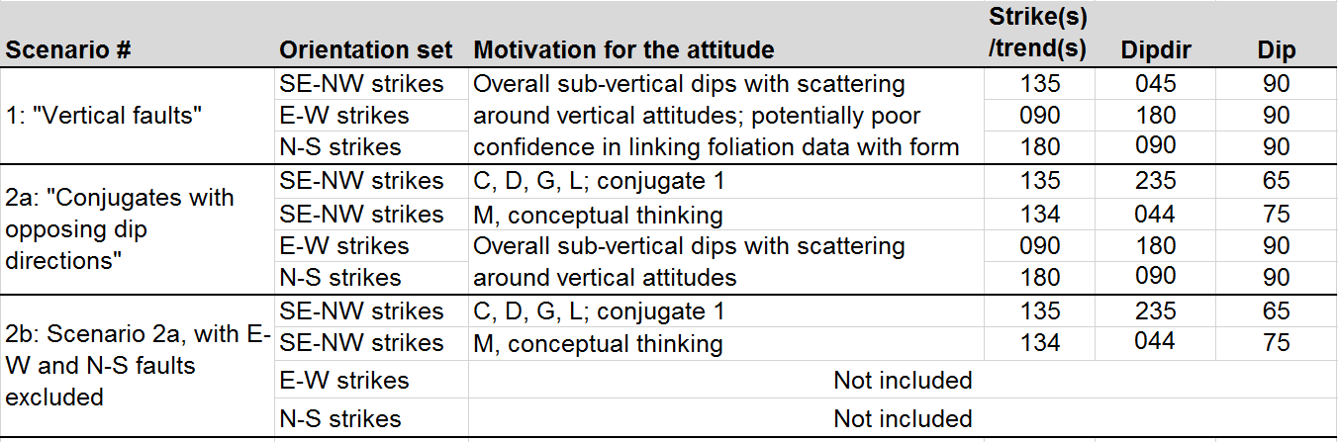

5.3. Source of error (in modelling and interpretations)
Sources of uncertainty in in the fault restoration results relates to the lack of direct constraints for the orientations of the 2.44 Ga faults, which affects the reliability of both the conducted restorations. Due to major distortion to the Euclidean distance associated with the E-W striking fault separating the Kemi and Penikat intrusions and the resulting complete transposition of the local bedding structures, this fault line was treated as a part of the basement. Furthermore, as no slip along the faults was considered, the resulting thicknesses from this particular location do not represent the true bedding thickness at the end of deposition of the Palokivalo fm. The workflow utilized in the palaeostress analysis probably is an oversimplification as it does not account for the curvature of the AP-contact, whereas the remaining geological uncertainty relates to the scarcity of data within the Archaean basement, and the subjectivity of structural interpretation and analysis (Table 1). Despite these uncertainties, the results are considered to provide important guidelines towards understanding rifting of Archaean continental basement in the study area at around 2.45 Ga.

6. Discussion
Correlation of the restoration results (this paper) with the geological evolution of the Peräpohja Belt (see Piippo et al., 2019) suggests that structures controlling the geological evolution of the belt were generated within an extensional pull-apart basin (Fig. 9). Below we discuss the motivation for the pull-apart model, and further correlate it with a conducted reconnaissance strike-slip analogue model testing the viability of our extensional scenario. Finally, we discuss the implications of our proposed rifting model for the PB in understanding the broader structural patterns within Paleoproterozoic supracrustal belts in northern Fennoscandia, and with respect to the break-up of the Archaean supercontinents or supercratons, including discussion about the mode of rifting.

6.1. Correlation with the results of the associated paper (Piippo et al., 2019)
Piippo et al. (2019) attributed the development of the two recognized nearly orthogonal fault sets largely controlling the evolution of the supracrustal Peräpohja Belt to an extensional tectonic setting characterized by synchronous extension in NNW-SSE and WSW-ENE directions. The NE-SW palaeoextension direction derived from the restoration of the 2.44 Ga faults (this paper) similarly suggests that the central graben (“I” in Fig. 9a, Fig. 3 in Piippo et al., 2019) developed via normal faulting in response to the same extensional event. Moreover, we infer that the similarly oriented but intensely overprinted NE and SW margins of the Peräpohja Belt were originally also normal faults. The overprint is characterized by strike-slip dominated deformation associated with development of sub-horizontal lineations (II) and doming of the Archaean Tornio intrusion and intense shearing along its base (III), which are both attributed to preferential strain localization into the NW-SE trending syn-rift normal faults during Palaeoproterozoic overprint. For this reason, the NE-SW trending AP -contact (IV) was left tectonically principally intact. An exception is the Kemi intrusion where shearing of the basal contact probably relates to pronounced localisation of compressional strain, including corner flow, at the termination of the funnel-shaped southern contact of the PB (Piippo et al., 2019).

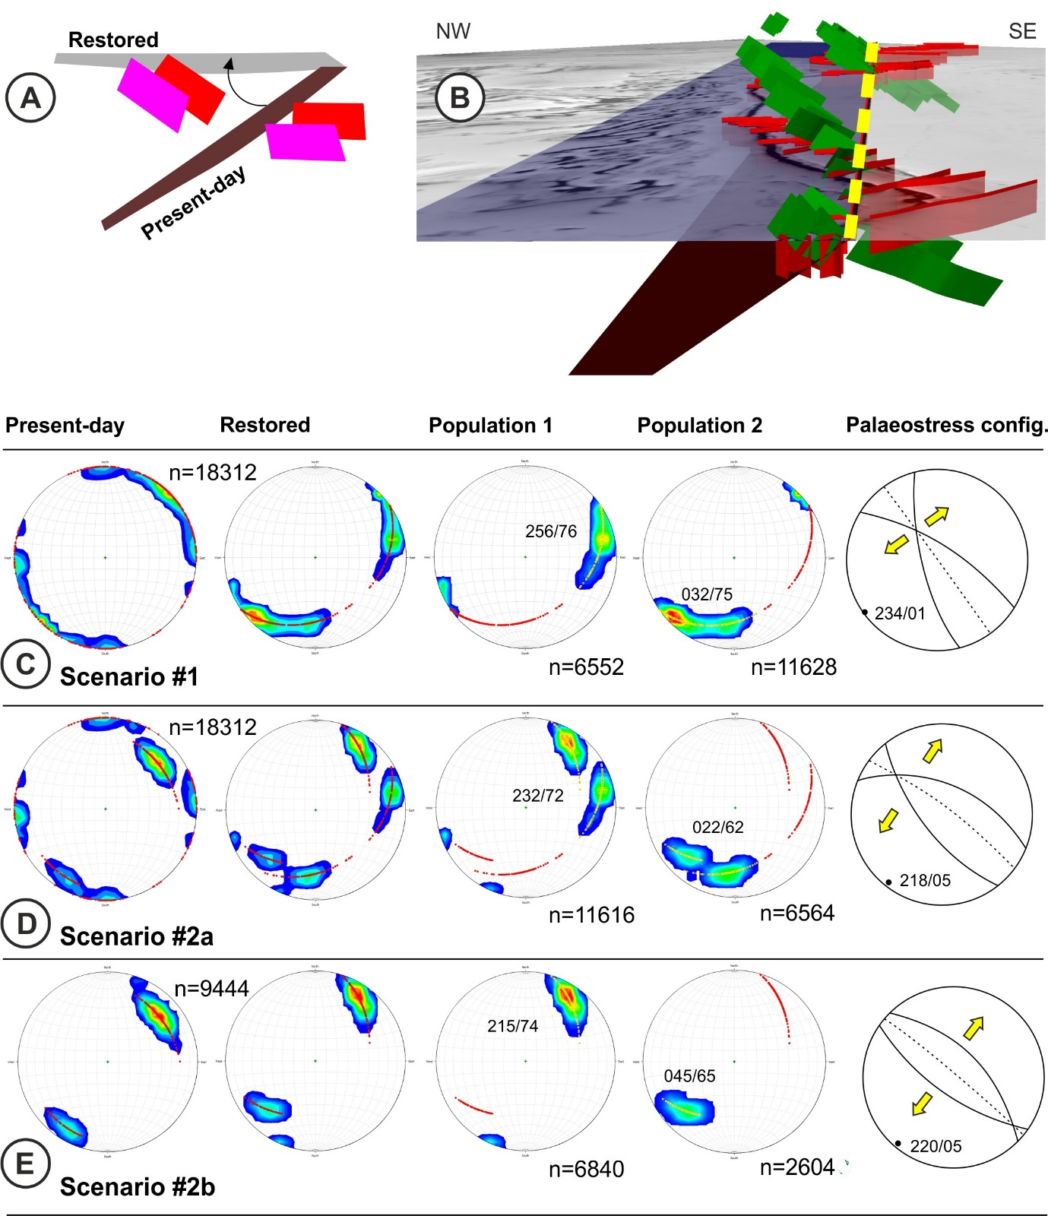

Fig. 8. Restoration of the 2.44 Ga faults into their primary orientations. A: The principle of restoration involving passive rotation of 2.44 Ga faults around the AP-contact trace shown in a cross-sectional view. B: An oblique view towards NE illustrating the present-day (red) and the restored (green) orientation of the 2.44 Ga faults. The dashed yellow line is the rotation axis. C-E: Orientation distributions of the triangulated faults surfaces prior to and after the restoration according to the two main scenarios, whereof the Scenario #2 has been further separated into two alternatives 2a and 2b. The restored faults have been further subdivided into two fault populations corresponding to conjugate faults with opposing dip directions. The right-hand side figure illustrates the derived palaeostress orientation based on the orientation of the conjugates. The number of the plotted orientations (“n”) refers to individual triangles of the constructed planes.

We propose that the recognised NE-SW extension resulted in as response to sinistral slip along large-scale sub-vertical deformation zones (V), making the Peräpohja Belt a pull-apart basin occurring at a left-handed step-over between major N-S faults (Fig. 9a). This model is well in line with the expected structural patterns at fault-zone step-overs (Woodcock and Fischer, 1986) and with the overall thickening of the Peräpohja sequence towards SW (Piippo et al., 2019). The latter suggests that the normal fault along the southwestern margin of the Peräpohja Belt accommodated the greatest extensional strains and had the main responsibility over the development of a half-graben geometry for the pull-apart basin. Faults along the NE margin of PB and those bounding the Central Graben made a secondary contribution to the bulk extension. The limited overprint of the central graben occurring in the middle of the PB likely indicates that the more intensely overprinted SW and NE margins of the PB (II and III) approximately define the original extent of the basin, and hence supports the pull-apart model.
Contrasting to the NW-SE normal faults, development of the E-W to WSW-ENE striking normal faults (VI), the parallel horsts and the resulting NNW-SSE extension is attributed to reactivation of pre-existing structures within the Archaean basement (VII, e.g. Bonini et al., 2012). Potential structures with suitable orientations comprise E-W to WSW-ENE trending mafic dykes and the dominant foliation with ENE-WSW trends (Fig. 2), which both provide planes of anisotropy to localize the extensional strain at the onset of the rifting. The only rarely observed direct linkage of the reactivated rift-related 2.44 Ga faults (Section 5.1) and the recognized structural features within the PB supracrustal rocks is here attributed to slip along the Petäjäskoski detachment zone which likely reoriented and translated most of the cover sequences away from their original positions.

6.2. Correlation with reconnaissance sandbox model
The results of the analogue model show a reasonably good overall correlation with the geological model: in particular, the normal faults bounding the pull-apart have a similar orientation to those inferred in nature, and the pre-existing E-W structures were reactivated. More specifically, a small-scale sub-basin comparable to the central graben was developed due to interaction of two normal faults (“X” in Fig. 9c). Moreover, the reactivated pre-existing structures were cut by the NW-SE -oriented normal faults, causing segmentation but also reorientation of the faults (Y), comparable to the transition from the E-W to ENE-WSW trending horsts across the central graben (Fig. 9a). The reactivated structures showed significantly lower dip-slip displacements with respect to the NW-SE trending normal faults, locally still resulting in horst structures (“Z” in Fig. 9b).
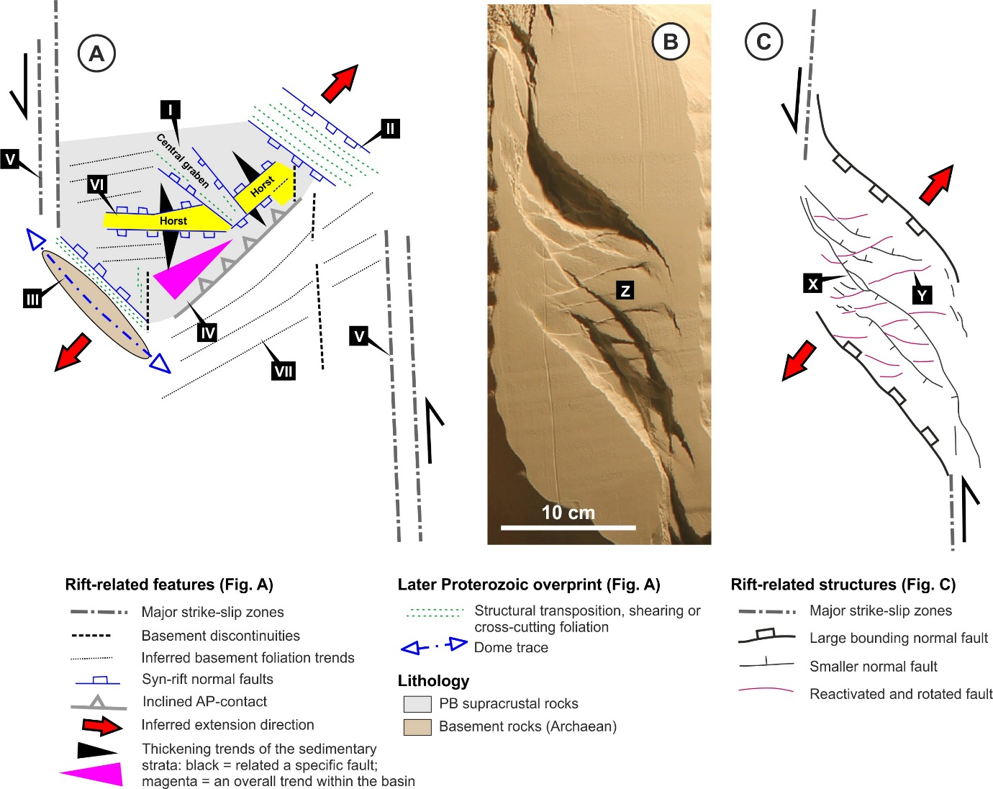

Fig. 9. A) Inferred PB setting as a pull-apart basin at the step-over of two major N-S striking transtensional faults. B) Map view of the conducted analogue model. C) Line drawing after the analogue model in B.
The main difference between the model and the natural setting within the PB is that the greatest extensional strains were accommodated by the syn-extensional normal faults in the analogue models, whereas the reactivated basement structures are dominant features within the geological model. This probably relates to the degree of overlapping/underlapping of the main faults which has been shown to have a major effect on the developed fault networks within pull-apart basins (Dooley and McClay, 1997). Moreover, other parameters (e.g., dip, width and orientation of pre-existing faults) are expected to significantly influence the reactivation of inherited fabrics (e.g., Bellahsen and Daniel, 2005): for instance, wider pre-existing structures are expected to promote a more important reactivation. Despite the minor inconsistencies with the geological model, the analogue model clearly shows that a pull-apart setting with strain localization into stress-controlled syn-extensional normal faults and reactivated pre-existing structures during a single event is a plausible setting to accommodate synchronous extension in approximately two nearly orthogonal orientations observed as observed in the study area.

6.3. Implications for delineation for major crustal domains of northern Fennoscandia
The Archaean outliers in the Lofoten and Troms area, along the NW coast of Norway (Fig. 10a), have been recently associated with the Archaean cratons of Fennoscandia, not Laurentia, due to the gravity-magnetic trends and extrapolation of tectonic windows beneath and within the Caledonides, and their age constraints and tectono-magmatic evolution (Hölttä et al., 2008; Bergh et al., 2014). The extrapolated margin of the Archaean craton hence coincides with the margin of the poorly-constrained Norrbotten craton (Hölttä et al., 2008), the transition of the Nd-isotopic signatures indicative of mature Archaean material underlying the Proterozoic crust (Lundqvist et al., 1996; Wikström et al., 1996a; Mellqvist et al., 1999) and the gently south-dipping subsurface crustal reflector imaged by the BABEL reflection seismic profile (Fig. 1; BABEL Working Group, 1990). As a result, the southwestern margin of the Archaean domain of Fennoscandia has a substantial continuity of > 1000 km, occurring as a relatively straight but disrupted NW-SE trending linear feature (Fig. 10a) aligned with the Raahe-Ladoga zone in its eastern part. This is the first-order structural orientation in large portions of Fennoscandia, controlling major orogenic trends all the way south of the Baltic Sea (Bogdanova et al., 2015).
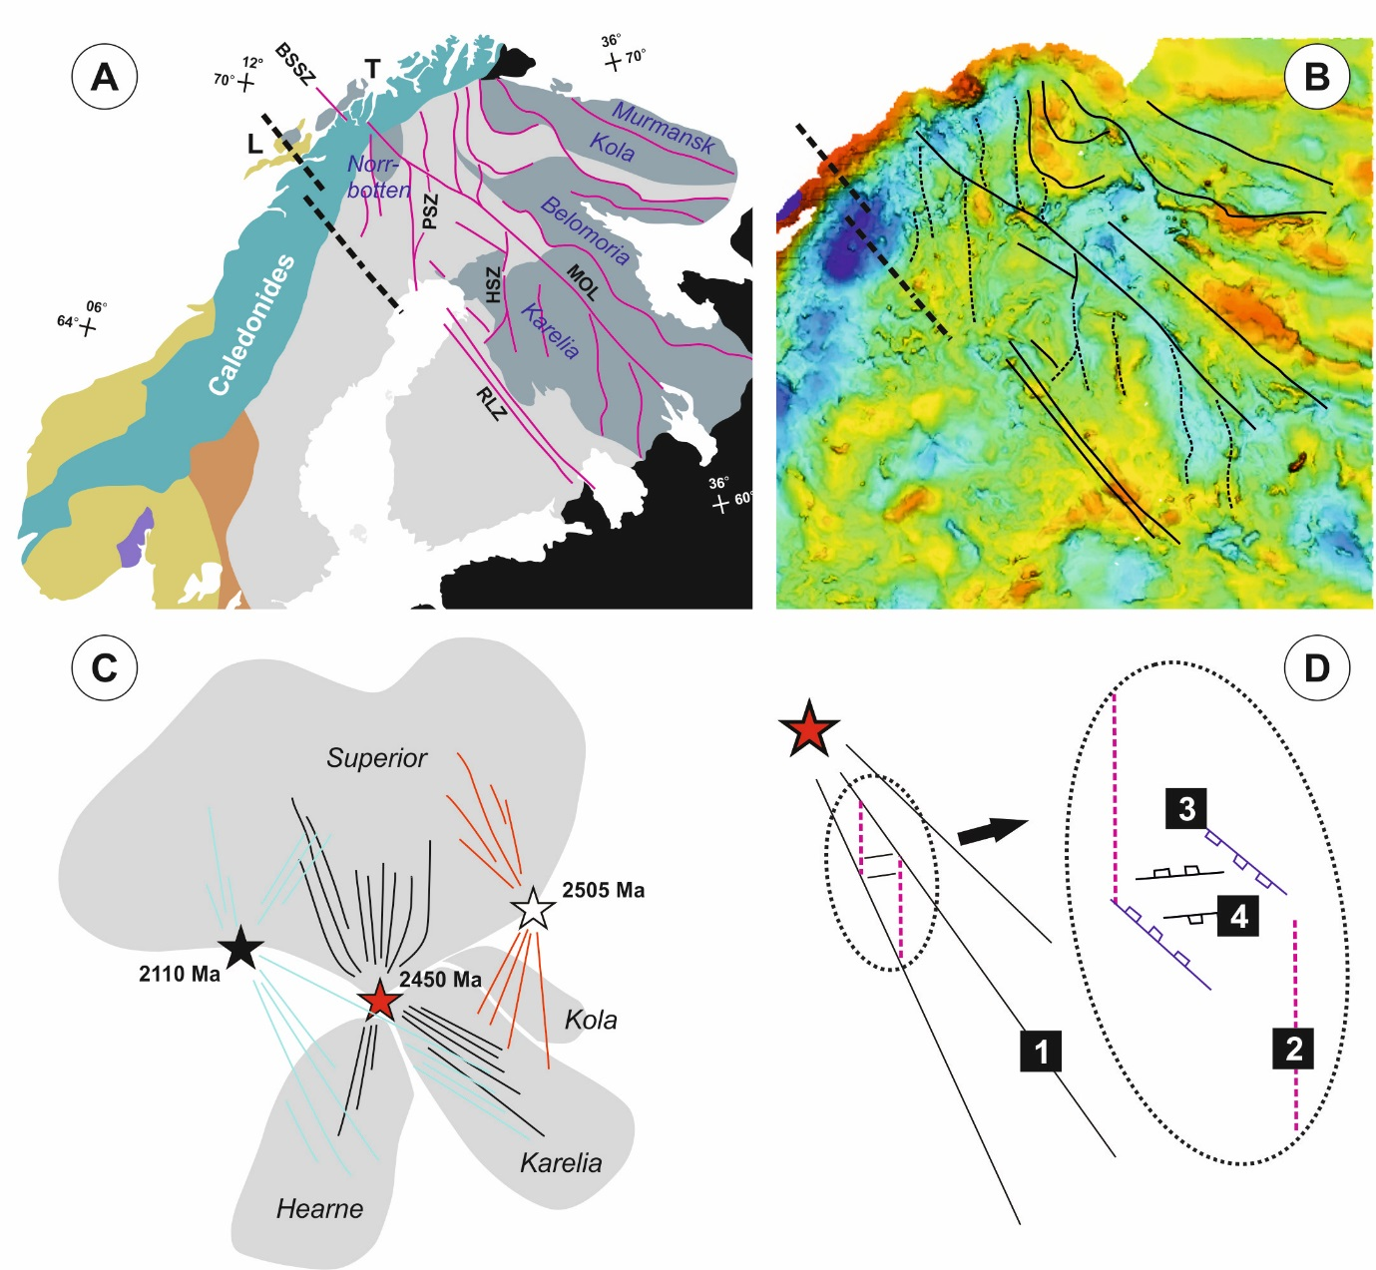

Fig. 10. A) An outline of the Archaean components and major deformation zones of the northern Fennoscandia modified after Bergh et al., 2014. The purple lines are major deformation zones and the thick dashed line indicates the extent of the concealed Archaean crust (Mellqvist et al., 1999). BSSZ = Bothnia-Senja shear system, HSZ = Hirvaskoski Shear Zone, MOL = Malangen-Onega Lineament, PSZ = Pajala Shear Zone, RLZ = Raahe-Ladoga Zone. L = Lofoten-Westerålen area, T = western Troms area. B: The gravimetric signatures of the northern Fennoscandia (Korhonen et al., 2002) display the continuity of the NW-SE structures which constrain the length of the N-S trending deformation zones. C: The suggested pattern of mafic dykes truncating the Superia supercraton (simplified after Bleeker and Ernst, 2006). D: A schematic illustration of the structural order of the rift-related structures in northern Fennoscandia: 1 = Rift-parallel dykes and tension fractures, 2 = N-S basement structures reactivated as strikes-slip zones, 3 = normal faults controlled by the ambient stress-field within the pull-apart basin developed between the N-S faults (2), 4 = basement structures more locally reactivated within the pull-apart basin.

In contrast, the distinct N-S deformation zones occurring in particular within northern Fennoscandia (e.g. Bergh et al., 2014), including those responsible for generation of the Peräpohja pull-apart basin (this paper), are clearly seen to be truncated by the continuous NW-SE features on the gravimetric maps (Fig. 10b). For this reason, we infer that the N-S zones are second-order structures constrained by the first-order NW-SE trending RLZ and the parallel Malangen-Onega Lineament (Fig. 10b), while generation of the first-order NW-SE structures is initially attributed to the development of radial patterns of mafic dykes at 2.45 Ga, centred within a supercraton formed by the Superior, Hearne and Karelian (-Kola) cratons (Fig. 10c; Bleeker and Ernst, 2006; Mertanen and Korhonen, 2011). Subsequently, some of the dykes and the derived continent-scale anisotropy provided suitable weakness planes causing the progression towards passive rift margins. In the Lofoten area of Norway, also the originally Neoarchaean structures with Proterozoic reactivation (Bergh et al., 2014) were probably utilized during the 2.45 Ga rifting, enhancing the NW-SE rift-related structural grain. The N-S zones do not in a comparable way define extensively continuous craton margins but rather segment the dominant NW-SE trends and allow Palaeoproterozoic deposition of supracrustal sequences into shallow basins (PB, Kuusamo, Central Lapland area). For this reason, origin of the N-S -aligned Pajala shear zone as a major transfer fault or a comparable structure linking major normal faults is preferred over tinterpretations attributing the zone to the development of a divergent plate boundary (Lahtinen et al.,2015) or relatively young (1.9-1.8 Ga Svecofennian or Svecokarelian) deformation (Luth et al., 2018). Strike-slip displacements along the N-S faults required to generate pull-apart basins (e.g. the Peräpohja Belt) are expected to be limited as the basins are shallow, and displacements could have been accommodated by deflection of the N-S zones into the 1st order NW-SE zones and transfer of the displacement into the NW-SE zones.
Summing up, the primary rift-related features within the Karelian craton are type I fractures controlled by the regional plume-induced stress and allowing the emplacement of 2.5-2.4 Ga mafic dykes. Synchronously with this, the Archaean greenstone Belts and sub-parallel zones of distinct anisotropy (Fig. 3) were activated as transtensional strike-slip zones causing the development of pull-apart basins of variable and prolonged histories of at least from 2.45 Ga to 1.99 Ga sizes at their step-overs (Fig. 9). This interpreted strain localization and rift segmentation is in line with the observed coupling between the along‐axis rift segmentation, the characteristics of the rift margins and the basement fabrics of the rifts (Corti et al., 2018). Within the developed basins, the development of major structures were controlled both by the local stress field but also by reactivation of suitably oriented pre-existing structures. Hence, the apparently separate events of NW-SE to NNW-SSE and approximately NE-SW extension based on dyke swarms and Peräpohja half graben structure (Vuollo & Huhma, 2005, Nironen, 2017) are considered being part of one major extensional event at around 2.45 Ga. Moreover, the conflicting kinematics of the presented model with other works, such as the dextral sense of the Hirvaskoski Shear Zone (Fig. 10a; Kärki et al., 1993), relate to the compressional overprint and are not discussed in this paper.
Conflicting evidence not directly in support of our model comprises i) the presence of the thrust package comprising continental margin and oceanic units in central Lapland that led Lahtinen et al. (2015) to conclude that two separate continental blocks (Karelia and Norrbotten) existed instead of one coherent continent and ii) new palaeomagnetic data (Salminen et al., 2014) which does not support the previously suggested proximity of the Karelian and Superior cratons.

6.4. Implications for rifting of the Archaean continent
“The syn-rift generation of voluminous magmatism (Alapieti et al., 1990; Kullerud et al., 2006; Kulikov, 2010) featuring consistent negative ɛNd values and minor to moderate contamination by crustal material (Huhma et al., 1990; Amelin and Semenov, 1996; Hanski et al., 2001), the uplift and erosion following the deposition of the mafic layered intrusions (Hanski, 2012; Iljina et al., 2015), and the interpreted structural framework (this paper) together indicate that plume-related mafic magmatism was the predominant driving force of extension, i.e. rifting was of the active type (Ziegler and Cloetingh, 2004; Santosh et al., 2009). This is in concert with the overall thick crust within the Archaean domains of Fennoscandia (Kukkonen et al., 2006), which promotes focused thinning in the mantle lithosphere and leads to magmatism prior to the continental breakup (Petersen and Schiffer, 2016). In a case of a plume-associated geographical magmatic centre, radially oriented but likely also spherical fractures and dykes are expected (Ernst et al., 2001). The presence of continuous swarms of radial dykes is evident, but depends on the palaeocontinent configuration (e.g. Bleeker and Ernst, 2006), but these are unlikely as such to govern where the margin of the broken-apart continent is subsequently localized. For this reason, a complimentary contribution from a suitably oriented (i.e. NW-SE) pre-existing structures such as those in the Lofoten area (Section 6.3) is likely required. Conversely, the lack of suitably oriented pre-existing anisotropy within the Archaean basement within the Peräpohja area explains the deviations, including the NE-SW trending complex of 2.44 Ga layered intrusions, from the dominant linear NW-SE structural grain: the distinct N-S zones including the Oijärvi Greenstone Belt (Fig. 2) were inherited and utilized as transtensional strike-slip zones, and the WSW-ENE grain of the basement contributed to the development of the horst-and-graben geometry within the pull-apart basins. The N-S Pajala shear zone could in theory represent a spherical fracture zone between the plume-induced radial fractures, but as the non-orthgonal angular relationship does not support this model. The interpretation of the Peräpohja Belt as a failed rift arm or aulacogen (Gaál, 1990) is valid at a general level (Pirajno and Santosh, 2015) but the presence of Kuusamo, Peräpohja and Central Lapland Belts requires a very complex configuration of several unsuccessful rift arms, and the presented pull-apart model is a much simpler solution. The presented idea of rifting progression towards west to south-west (Kullerud et al., 2006) is not quite compatible with a model of linked triple points as it requires proceeding of rifting progress towards S-SW, not supported by the presented structural model. However, a model of rifting along NW-SE radial dykes is not plausible either as the magmatic ages should not get younger towards the magmatic centre if all the dykes relate to the same event. For this reason, we infer that the 2.5-2.4 Ga mafic plume event comprised several individual events or pulses.
The conducted sandbox modelling is in line with the previous works highlighting the significance of the pre-existing structures for the development of fault zones (Corti et al., 2007; Bladon et al., 2015, Fossen and Rotevatn, 2016), in particular with respect to their significance early during the rift-evolution, and at local scales (Manatschal et al., 2015). Structural inheritance is dependent not only by the orientation of the stress field with respect to the structures (Ziegler and Cloetingh, 2004), but also by the nature of the pre-existing structures. For example. recrystallized mylonites exert a strong anisotropy on the crust and promote structural reactivation (Ring, 1994; Tommasi and Vauchez, 2001). In the case of Peräpohja, it is evident that the highly strained N-S trending Oijärvi Greenstone Belt show highly contrasting mechanical properties with respect to the dominantly meta-intrusive bulk of the cratons. The nature of the inferred ENE-WSW basement anisotropy underlying the Peräpohja Belt is not known, but mylonitic shear zones along the limbs of ENE-WSW trending regional-scale folds are a plausible explanation with respect to the known structural character of the exposed Arcahaean basement in the south-east (Fig. 2).
Will and Frimmel (2018) concluded the zones of inherited lithospheric weaknesses to control the development of passive-type rifts. Potential evidence for passive rifting models comprises the deviating orientation of the rifting and generation of the half grabens (Nironen, 2017), in line with the seismic interpretations (Patison et al., 2006). However, the evidence for development of extensional basins prior to the mafic magmatism is limited (Lundmark, 1984; Melezhik and Hanski, 2013) and the lack of inversion of the small-scale 2.44 Ga faults further suggests that the early rifting took place tectonically under relatively stable conditions. Moreover, the rift-assigned transparent seismic zone E1a (Fig. 3; Patison et al., 2006), is discontinuous towards the lower crust and does hence not represent a continuous zone of lithospheric weakness. Also the kilometres to to- tens of kilometres spacing between the normal faults defining the horst and graben geometry reflects more the limited extension related to the initial stretching phase of rifting thanthe more evolved later stages of the continental rifting (Naliboff et al., 2018).

6.5 Implications for understanding the basement-cover relationships in other supracrustal belts
Recognition of the basement-cover interactions within the Peräpohja area, together with the suggested craton-scale structural framework (Section 6.3), provides a new line of thinking in understanding the structural and morphological character of Palaeoproterozoic supracrustal belts within northern Fennoscandia. Similarly to the Peräpohja Belt, the Kuusamo and Central Lapland Greenstone Belt (CLGB) have limited stratigraphical thicknesses of 2.5 - 9 km (Niiranen et al., 2014; Nironen, 2017), indicative of moderate extension of the Archaean basement (Ward et al., 1988) and hence, compatibible with localisation controlled by second-order structures such as pull-apart basins. Basement-cover relationships governed by reactivation of primary half-grabens and related transfer faults (Ward et al., 1988) and movement of Archaean basement blocks (Silvennoinen, 1972) have been demonstrated for the CLGB and Kuusamo Belts. The coupling of the basement block movements in the Kuusamo Belt with strain localisation into a basal decollement zone (Silvennoinen, 1972), further supports the model of intimate basement-cover relationships during a single major deformation event as the reason for the observed structural complexities of the supracrustal belts (Piippo et al., 2019). A review of the structural evolution of the above belts is beyond the scope of this paper, but utilizing the available and new regional structural interpretations and strain partitioning patterns for the Peräpohja Belt, coupled with new constraints on belt-scale thickness changes of the stratigraphy, and the presented model of the 2.44 Ga rifting dynamics and patterns providing constraints on the basement structure (this paper), an understanding of the evolution of the supracrustal belts in northern Fennoscandia is further developed.
Recognition of (deep-seated) basement structures, particularly within rifted basins (Pirajno and Santosh, 2015), are important from the perspective of mineral exploration within the prospective northern Fennoscandian area (Eilu et al., 2016; Nykänen et al., 2017). The overall tectonic evolution involving detachment of variable size blocks of the Archaean continent by rifting (Nironen, 2017), recognized not only within the belts of supracrustal rocks, but probably reflected also by the presence of a number of structural blocks underneath the Central Lapland Granitoid Belt with inherited Archaean zircons and negative epsilon-Nd values (Huhma, 1986; Patison et al., 2006; Lahtinen et al., 2015), indicates that the results of this study may be applied to other Palaeoproterozoic rift-related basins in northern Fennnoscandia.

7. Conclusions
This investigation provides a structural interpretation of the Archaean basement underlying the Peräpohja Belt in northern Finland. Together with an associated paper (Piippo et al, 2019), it characterizes the geological evolution related to the rifting of the Archaean continent at 2.45 Ga, the influence of the rift-related structures on the deposition of the Peräpohja Belt supracrustal successions (2.45-1.9 Ga) and, finally, on the subsequent overprint of compressional deformation at 1.9-1.8 Ga. Within this work, we conducted regional-scale structural interpretations on geological and reflection seismic data, addressed the fault generation, reactivation and palaeostress orientations by fault restoration modelling, and tested the viability of the proposed structural models by analogue sandbox modelling. The main results of this work indicate that the Peräpohja Belt developed into a pull-apart basin at an overstepping of major N-S trending strike-slip zones and that the dominant normal faults within the belt were controlled by both the orientation of the stress field and the presence of pre-existing structures within the underlying Archaean basement.

The following main conclusions were drawn:
- The first-order structures related to the rifting of the Archaean continent in northern Fennoscandia had NW-SE orientations, supporting inclusions of the isolated Archaean outliers along the Norwegian NW coast to the Karelian-Kola cratons, and active-type rifting driven by plume magmatism
- N-S deformation zones utilized pre-existing Archaean structures as they were reactivated as (transtensional) strike-slip zones during rifting. These zones caused segmentation of the NW-SE trending Archaean crustal domains
- A zone of preserved faults related to the 2.45 Ga rifting was identified in proximity to the Archaean-Proterozoic contact. These faults are indicative of NE-SW extension at 2.45 Ga, show evidence for selective reactivations until approximately 2.2 Ga but were not subjected to later overprint during the main compressional Scecofennian deformation at 1.9 – 1.8 Ga
- The palaoestress constraints and the interpreted anisotropy of the Archaean basement have been utilized to propose a pull-apart basin model for the generation of the Peräpohja Belt. This model links i) the crustal-scale deformation zones, ii) the structural signatures within and underlying the Palaeoproterozoic Peräpohja Belt (see also the accompanying paper), and iii) the basement-cover relationships between the faulted Archaean basement and the overlying relatively thin Palaoeproterozoic supracrustal successions within northern Fennoscandia
- The delineated major basement structures and their control over the structural evolution of the overlying cover sequences helps in addressing the large-scale evolution of the northern Fennoscandia during the Palaeoproterozoic, and provides new concepts for exploration of mineral resources

8. Acknowledgements
We want to acknowledge K.H. Renlund foundationfor funding, First Quantum Minerals Ltd. and Mawson Resources Ltd. for funding, access to data and collaboration and Midland Valley Exploration Ltd. for the use MOVETM under the Academic Software Initiative. The analogue modelling was conducted in the Tectonic Modelling Laboratory of the CNR-IGG in Florence. Timo Kilpeläinen is acknowledged for comments on the early version of the manuscript and the journal editor Randall Parrish and two anonymous journal reviewers for critical reviews which substantially improved the manuscript.

9. References
Acocella, V., 2014. Structural control on magmatism along divergent and convergent plate boundaries: Overview, model, problems. Earth-Science Reviews 136, 226–288.
Ahtonen, N., Hölttä, P., Huhma, H., 2007. Intracratonic Paleoproterozoic granitoids in northern Finland: prolonged crustal melting revealed by Nd isotopes and U-Pb ages on zircon. Bulletin of the Geological Society of Finland 79, 143–174.
Airo, M.-L., (ed.) 2005. Aerogeophysics in Finland 1972–2004. Methods, system characteristics and applications. Geological Survey of Finland, Special Paper 39, 197.
Alapieti, T. and Lahtinen, J. 2002. Platinum-Group Element Mineralization in Layered Intrusions of Northern Finland and Kola Peninsula, Russia. In: Cabri, L.J. (Ed.) The Geology, Geochemistry, Mineralogy and Mineral Beneficiation of Platinum-Group Elements. Canadian Institute of Mining, Metallurgy and Petroleum, Special Volume 54, 507–546.
Alapieti, T.T., Filèn, B.A., Lahtinen, J.J., Lavrov, M.M., Smolkin, V.F., Voitsekhovsky, S.N., 1990. Early Proterozoic layered intrusions in the northeastern part of the Fennoscandian Shield. Mineralogy and Petrology 42, 1–22.
Amelin, Y.V. and Semenov, V.S. 1996. Nd and Sr isotopic geochemistry of mafic layered intrusions in the eastern Baltic shield: implications for the evolution of Paleoproterozoic continental mafic magmas. Contributions to mineralogy and petrology 124, 255–272.
Amelin, Yu.V., Heaman, L.M., Semenov, V.S., 1995. U–Pb geochronology of layered mafic intrusions in the eastern Baltic shield: implications for the timing and duration of Paleoproterozoic continental rifting. Precambrian Res. 75, 31–46.
Aspler, L., Chiarenzelli, J.R., 1998. Two Neoarchean supercontinents? Evidence from the Paleoproterozoic. Sedimentary Geology 120, 75–104.
BABEL Working Group, 1990. Evidence for early Proterozoic plate tectonics from seismic reflection profiles in the Baltic shield. Nature 348, 34–38.
Balashov, Y.A., 1996. Paleoproterozoic geochronology of the Pechenga-Varzugastructure, Kola Peninsula. Petrology 4, 1–22.
Bayanova, T.B., Balashov, Y.A., 1995. Geochronology of Palaeoproterozoic layered intrusions and volcanites of the Baltic Shield. Nor. Geol. Unders. Special Publ. 7, 75–80.
Bellahsen, N., Daniel, J.M., 2005. Fault reactivation control on normal fault growth: an experimental study. Journal of Structural Geology 27, 769–780.
Bergh, S.G., Kullerud, K., Myhre, P.I., Corfu, F., Armitage, P.E.B., Zwaan, K.B., Ravna, E.J.K., 2014. Archaean elements of the basement outliers west of the Scandinavian Caledonides in Northern Norway: architecture, evolution and possible correlation with Fennoscandia. In: Y. Dilek, H. Furnes (Eds.), Evolution of Archean Crust and Early Life, Modern Approaches in Solid Earth Sciences, vol. 7, Springer Science + Business Media, Dordrecht, pp. 103-126. (Chapter 4).
Berthelsen, A., Marker, M., 1986. 1. 9–1.8 Ga old strike-slip megashears in the Baltic Shield, and their palte tectonic implications. In: Galson, D.A., Mueller, St. (Eds.), The European Geotraverse. Part 2. Tectonophysics 128, 163–181.
Bladon, A.J., Clarke, S.M., Burley, S.D., 2015. Complex rift geometries resulting from inheritance of pre-existing structures: Insights and regional implications from the Barmer Basin rift. Journal of Structural Geology 71, 136–154.
Bleeker, W., 2003. The late Archean record: a puzzle in 35 pieces. Lithos, 99–134.
Bleeker, W., Ernst, R., 2006. Short-lived mantle generated magmatic events andtheir dyke swarms: the key unlocking Earth’s paleogeographic record back to2.6 Ga. In: Hanski, M., Rämö, Vuollo (Eds.), Dyke swarms – time markers of crustalevolution. A.A. Balkema.
Bogdanova, S., Gorbatschev, R., Skridlaite, G., Soesoo, A., Taran, L., Kurlovich, D., 2015. Trans-Baltic Palaeoproterozoic correlations towards the reconstruction of supercontinent Columbia/Nuna. Precambrian Research 259, 5–33.
Bonini, M., Sani, F., Antonielli, B., 2012. Basin inversion and contractional reactivation of inherited normal faults: A review based on previous and new experimental models. Tectonophysics 522–523, 55–88.
Burke, K., 1977. Aulacogens and continental breakup. Ann. Rev. Earth Planet. Sci. Lett. 5, 371–396.
Collerson, K.D., Sheraton, J.W., 1986. Age and geochemical characteristics of a mafic dyke swarm in the Archean Vestfold block, Antarctica—inferences about Proterozoic dyke emplacement in
Gondwana. Journal of Petrology 27, 853–886.
Corti, G., 2009. Continental rift evolution: from rift initiation to incipient break-up in the Main Ethiopian Rift, East Africa. Earth-Sci. Rev. 96, 1–53.
Corti, G., van Wijk, J., Cloething, S., Morley, C.K., 2007. Tectonic inheritance and continental rift architecture: numerical and analogue models of the East African Rift System. Tectonics 26, TC6006. http://dx.doi.org/10.1029/2006TC002086.
Corti, G., Molin, P., Sembroni, A., Bastow, I. D., Keir, D., 2018. Control of pre-rift lithospheric structure on the architecture and evolution of continental rifts: Insights from the Main Ethiopian Rift, East Africa. Tectonics 37, 477–496.
Dooley, T., McClay, K.R., 1997. Analog modeling of pull-apart basins. AAPG Bulletin 81, 1804–1826.
Dooley, T.P., Schreurs, G., 2012. Analogue odelling of intraplate strike-slip tectonics: A review and new experimental results. Tectonophysics 574-575, 1–71.
Eilu, P., Bergman, T., Bjerkgård, T., Feoktistov, V., Hallberg, A., Korsakova, M., Krasotkin, S., Muradymov, G., Nurmi, P. A., Lauri, L. S., Often, M., Perdahl, J.-A., Philippov, N., Sandstad, J. S., Stromov, V., Tontti, M. (comp.), 2016. Metallogenic Map of the Fennoscandian Shield 1:2 000 000. Second edition. Geological Survey of Finland, Geological Survey of Norway, Geological Survey of Sweden, The Federal Agency of Use of Mineral Resources of the Ministry of Natural Resources and Ecology of the Russian Federation.
Ernst, R.E., Grosfils, E.B., Mège, D., 2011. Annual Review of Earth and Planetary Sciences 29, 489–534.
Fahrig, W.F. 1987. The tectonic settings of continental mafic dyke swarms: failed arm and early passive margin. In: Halls, H.C. and Fahrig, W.F. (eds) Mafic dyke swarms. Geological Association of Canada Special Paper 34, 331–348.
Fossen, H., Rotevatn, A., 2016. Fault linkage and relay in extensional settings – A review. Earth-Science Reviews 154, 14–28.
Gaál, G. 1990. Tectonic styles of Early Proterozoic Ore Deposition in the Fennoscandian Shield. Precambrian Research 46, 83–114.
Ghisetti, F., Vezzani, L., 2005. Inherited structural controls on normal fault architecture in the Gulf of Corinth (Greece). Tectonics 24, TC4016.
Halkoaho, T.T.A., 1993. The Sompujärvi and Ala-Penikka PGE reefs in the Penikat layered intrusion, northern Finland: implications for PGE reef-forming processes. Acta Univ. Oul.A 249, Univ. of Oulu, Oulu, Finland.
Halkoaho, T., Alapieti, T.T., Huhtelin, T., 2005. The Sompujärvi, Ala-Penikka and Paasivaara PGE Reefs in the Penikat Layered Intrusion, Northern Finland. In: Alapieti, T.T., Kärki, A.J. (Eds.): Field Trip Guidebook: Early Proterozoic (2.5-2.4 Ga) Tornio-Näränkävaara layered intrusion belt and related chrome and platinum-group mineralization, northern Finland. Geological Survey of Finland Guide 51a, 33–77.
Hanski, E.J., Walker, R.J., Huhma, H. and Suominen, I. 2001. The Os and Nd isotopic systematics of c. 2.44 Ga Akanvaara and Koitelainen mafic layered intrusions in northern Finland. Precambrian Research 109, 73–102.
Hanski, E., Huhma, H., & Perttunen, V. 2005. SIMS U-Pb, Sm-Nd isotope and geochemical study of an arkositeamphibolite suite, Peräpohja Schist Belt: evidence for ca. 1.98 Ga A-type felsic magmatism in northern Finland. Bulletin of the Geological Society of Finland 77, 5–29.
Hanski, E., Huhma, H. and Vuollo, J. 2010. SIMS zircon ages and Nd isotope systematics of the 2.2 Ga mafic intrusions in northern and eastern Finland. Bulletin of the Geological Society of Finland, 82, 31–62.
Hanski, H. and Huhma, H. 2005. Central Lapland greenstone belt. In: Lehtinen, M., Nurmi, P.A. and Rämö, O.T. (eds) The Precambrian Bedrock of Finland – Key to the evolution of the Fennoscandian Shield. Elsevier, Amsterdam, 139-194.
Hanski, E. and Melezhik, V. 2012. Litho- and chronostratigraphy of the Karelian formations. In: Melezhik, V., Prave, A., Hanski, E., Fallick, A., Lepland, A., Kump, L. and Strauss, H. (Eds.) Reading the Archive of Earth’s Oxygenation. Volume 1: The Palaeoproterozoic of Fennoscandia as Context for the Fennoscandian Arctic Russia – Drilling Early Earth Project, Springer-Verlag, Berlin, 39–110.
Hanski, E.J. 2012. Evolution of the Palaeoproterozoic (2.50–1.95 Ga) Non-orogenic Magmatism in the Eastern Part of the Fennoscandian Shield. In: Melezhik, V.A., Prave, A.R., Hanski, E.J., Fallick, A.E., Lepland, A., Kump, L.R. and Srauss, H. (eds) Reading the archive of Earth’s oxygenation. Volume 1: the Palaeoproterozoic of Fennoscandia as context for the Fennoscandian arctic Russia – Drilling Early Earth Project, 179–245.
Heaman, L.M., 1997. Global mafic magmatism at 2.45 Ga; remnants of an ancient large igneous province? Geology 25, 299–302.
Heaman, L.M., Tarney, J., 1989. U–Pb baddeleyite ages for the Scourie dyke swarm, Scotland. Evidence for two distinct intrusion events. Nature 340, 705–708.
Hölttä, P. and Heilimo, E. 2017. Metamorphic map of Finland. In: Nironen, M. (Ed.) Bedrock of Finland at the scale 1:1 000 000 – Major stratigraphic units, metamorphism and tectonic evolution Geological Survey of Finland, Special Paper 60, 77–128.
Hölttä, P., Balagansky, V., Garde, A., Mertanen, S., Peltonen, P., Slabunov, A., Sorjonen-Ward, P., Whitehouse, M. 2008. Archaean of Greenland and Fennoscandia. Episodes 31, 13–19.
Huhtelin, T.A., Alapieti, T.T., 2005. The Kemi Intrusion and Associated Chromitite Deposit. In: Alapieti, T.T., Kärki, A.J. (Eds.): Field Trip Guidebook: Early Proterozoic (2.5-2.4 Ga) Tornio-Näränkävaara layered intrusion belt and related chrome and platinum-group mineralization, northern Finland. Geological Survey of Finland Guide 51a, 13–33.
Huhtelin, T.A., Lahtinen, J.J., Alapieti, T-.T., Korvuo, E., Sotka, P., 1989. The Narkaus intrusion and related PGE and sulphide mineralizations. In: Alapieti (Ed.), 5th International Platinum Symposium. Guide to post-symposium field trip, August 4-11, 1989. Geol. Survey Finland, Guide 29, 145–161.
Huhma, H., Cliff RA, Perttunen, V., Sakko, M., 1990. Sm-Nd and Pb isotopic study of mafic rocks associated with early Proterozoic continental rifting: the Peräpohja schist belt in northern Finland. Contributions to Mineralogy and Petrology 104:3, 369–379.
Huhma, H., Mänttäri, I., Peltonen, P., Kontinen, A., Halkoaho, T., Hanski, E., Hokkanen, T., Hölttä, P., Juopperi, H., Konnunaho, J., Lahaye, Y., Luukkonen, E., Pietikäinen, K., Pulkkinen, A., Sorjonen-Ward, P., Vaasjoki, M. and Whitehouse, M. 2012. The age of the Archaean greenstone belts in Finland. Geological Survey of Finland, Special Paper 54, 74–175.
Iljina, M., 1989. Iljina, M., Alapieti, T., Lahtinen, J. Lerssi, J., 1989. The Suhanko-Konttijärvi intrusion and related sulphide and PGE mineralizations. In: Alapieti, T.T. (ed) 5th International Platinum Symposium. Guide to the post-symposium field trip, Geol. Surv. Finland, Guide 29, 163-187.
Iljina, M., 2005. Portimo Layered Intrusion Complex. In: Alapieti, T.T., Kärki, A.J. (Eds.): Field Trip Guidebook: Early Proterozoic (2.5-2.4 Ga) Tornio-Näränkävaara layered intrusion belt and related chrome and platinum-group mineralization, northern Finland. Geological Survey of Finland Guide 51a, 77–101.
Iljina, M. & Hanski, E. 2005. Layered mafic intrusions of the Tornio–Näränkävaara belt. In: Lehtinen, M., Nurmi, P. A. & Rämö, O. T. (eds) Precambrian Geology of Finland – Key to the Evolution of the Fennoscandian Shield. Amsterdam: Elsevier, 101−138.
Iljina, M., Salmirinne, H., 2011. Suhanko seismic reflection profile and integrated geological-geophysical model of the Portimo area. Geological Survey of Finland, Report of Investigation 189, 20 pp.
Iljina, M., Maier, W.D., Karinen, T., 2015. PGE-(Cu-Ni) Deposits of the Tornio-Näränkävaara Belt of Intrusions (Portimo, Penikat, and Koillismaa). In: Maier, W.D., Lahtinen, R., O’Brien, H. (Eds.), Minerals Deposits of Finland, Elsevier, 2015, 133–164.
Jolivet, M., Arzhannikov, S., Chauvet, A., Arzhannikova, A., Vassallo, R., Kulagina, N., Akulova, V., 2013. Accommodating large-scale intracontinental extension and compression in a single stress-field: A key example from the Baikal Rift System. Gondwana Research 24, 918–935.
Karhu, J., Kortelainen, N.M., Huhma, H., Perttunen, V. and Sergeev, S. 2007. New time constraints for the end of the Paleoproterozoic carbon isotope excursion. 7th International Symposium on Applied Isotope Geochemistry, September 10-14, 2007, Stellenbosch, South Africa, 76–77.Karinen, T. 2010. The Koillismaa intrusion, northeastern Finland – evidence for PGE reef forming processes in the layered series. Geological Survey of Finland, Bulletin 404, 176 pp.
Kärki, A., Laajoki, K., 1995. An interlinked system of folds and ductile shear zones-late stage Svecokarelian deformation in the central Fennoscandian Shield, Finland .Journal of Structural Geology 17, 1233–1247.
Kärki, A., Laajoki, K., Luukas, J., 1993. Major Palaeoproterozoic shear zones of the central Fennoscandian Shield. Precambrian Research 64, 207–223.
Kohonen , J., Marmo, J., 1992. Proterozoic lithostratigraphy and sedimentation of Sariola and Jatuli-type rocks in the Nunnanlahti-Koli-Kaltimo area, eastern Finland; implications for regional basin evolution models. Geological Survey of Finland Bulletin 364, 67 pp.
Korhonen, J.V., Aaro, S., All. T., Elo, H., Haller, L.Å., Kääriäinen, J., Kulinich, A., Skilbrei, J.L., Solheim, D., Säävuori, H., Vaher, R., Zhdanova, L., Koistinen, T. (comp.) 2002. Bouguer anomaly map of the Fennoscandian Shield: ISGN 71 gravity system, GRS80 normal gravity formula. Bouguer density 2670 kg/m3, terrain correction applied. Anomaly continued upwards to 500 m above ground, scale 1:2,000,000. Espoo: Geological Survey of Finland, Trondheim: Geological Survey of Norway, Uppsala: Geological Survey of Sweden, Moscow: Ministry of Natural Resources of Russia.
Kukkonen, I.T., Heikkinen, P., Ekdahl, E., Hjelt, S.-E., Yliniemi, J., Jalkanen, E. & FIRE Working Group 2006. Acquisition and geophysical characteristics of reflection seismic data on FIRE transects, Fennoscandian Shield. In: Kukkonen, I.T. & Lahtinen, R. (eds.), Finnish Reflection Experiment FIRE 2001–2005. Geological Survey of Finland, Special Paper 43, 13–43.
Kulikov, V.S., Bychkova Ya.V., Kulikova ,V.A., Ernst, R., 2010. The Vetreny Poyas (Windy Belt) subprovince of southeastern Fennoscandia; An essential component of the ca. 2.5–2.4 Ga Sumian large igneous province. Precambrian Res 183, 589–601.
Kullerud, K., Skjerlie, K.P., Corfu, F., de la Rosa, J.D., 2006. The 2.40 Ga Ringvassøy mafic dykes, West Troms Basement Complex, Norway: The concluding act of early Palaeoproterozoic continental breakup. Precembrian Research 150, 183-200.
Kyläkoski, M., Hanski, E. and Huhma, H. 2012. The Petäjäskoski Formation, a new lithostratigraphic unit in the Paleoproterozoic Peräpohja Belt, northern Finland. Bulletin of the Geological Society of Finland 84, 85–120.
Laajoki, K., Tuisku, P., 1990. Metamorphic and structural evolution the Early Proterozoic Puolankajärvi formation, Finland. Part I, Structural and textural relations. Journal of metamorphic geology 8, 357–374.
Larsen, B., Olaussen, S., Sundvoll, B., Heeremens, M., 2008. The Permo-Carboniferous Oslo Rift through six stages and 65 million years. Episodes 31, 52–58.
Lobach-Zhuchenko, S.B., Arestova, N.A., Chekulaev, V.P., Levsky, L.K., Bogomolov, E.S., Krylov, I.N., 1998. Geochemistry and petrology of 2.40–2.45 Ga magmatic rocks in the north-western Belomorian Belt, Fennoscandian Shield, Russia. Precambrian Research 92, 223–250.
Lundmark, C., 1984. Kukkola Resultat av diamantborrningen 1984. SGAB PRAP 84122. (In Swedish).
Lundqvist, T., Vaasjoki, M., Skiöld, T., 1996. Preliminary Note on the Occurrence of Archaean Rocks in the Vallen-Alhamn Area, Northern Sweden, vol. C 828. Sveriges Geologiska Undersökning, pp. 32–33.
Laajoki, K. 2005. Karelian supracrustal rocks. In: Lehtinen, M., Nurmi, P.A. and Rämö, O.T. (Eds.) Precambrian Geology of Finland – Key to the evolution of the Fennoscandian Shield. Elsevier, Amsterdam, 279–342.
Lahtinen R., Korja A. & Nironen M. 2005. Proterozoic tectonic evolution. In: Lehtinen, M., Nurmi, P.A. & Rämö, O.T. (eds.), Precambrian Geology of Finland: Key to the evolution of the Fennoscandian Shield. Developments in Precambrian Geology 14, 481–531.
Lahtinen, R., Huhma, H., Lahaye, Y., Jonsson, E., Manninen, T., Lauri, L.S., Bergman, S., Hellström, F., Niiranen, T. and Nironen, M. 2015. New geochronological and Sm-Nd constraints across the Pajala shear zone of northern Fennoscandia: Reactivation of a Paleoproterozoic suture. Precambrian Research 256, 102–119.
Lauri, L.S., Andersen, T., Räsänen, J. and Juopperi, H. 2012. Temporal and Hf isotope geochemical evolution of southern Finnish Lapland from 2.77 Ga to 1.76 Ga. Bulletin of the Geological Society of Finland 84, 121–140.
Luth, S., Jönsson, C., Jönberger, J., Grigull, S., Berggren, R., van Assema, B., Smoor, W., Djuly, T., 2018. The Pajala Deformation Belt in northeast Sweden: Structural geological mapping and 3D modelling around Pajala. In: Bergman, S. (ed): Geology of the Northern Norrbotten ore province, northern Sweden. Rapporter och Meddelanden 141, Sveriges geologiska undersökning, p. 259–285.Manatschal, G., Lavier, L., Chenin, P., 2015. The role of inheritance in structuring hyperextended rift systems: Some considerations based on observations and numerical modeling. Gondwanan Research 27, 140–164.
Melezhik, V.A., Sturt, B.A., 1994. General geology and evolutionary history of the early Proterozoic Polmak-Pasvik-Pechenga-Imandra/Varzuga-Ust'Ponoy Greenstone Belt in the northeastern Baltic Shield. Earth-Science Reviews 36, 205–241.
Melezhik V.A., Hanski E.J., 2013. 3.1 The Early Palaeoproterozoic of Fennoscandia: Geological and Tectonic Settings. In: Melezhik V. et al. (eds) Reading the Archive of Earth’s Oxygenation. Frontiers in Earth Sciences. Springer, Berlin, Heidelberg.
Mellqvist, C., Öhlander, B., Skiöld, T., Wikström, A., 1999. The Archaean–Proterozoic Paleoboundary in the Luleå area, northern Sweden: field and isotope geochemical evidence for a sharp terrane boundary. Precambrian Research 96, 225–243.
Mertanen, S., Halls, H.C., Vuollo, J.I., Personen, P.J., Stepanov, V.S. 1999. Paleomagnetism of 2.44 Ga mafic dykes in Russian Karelia, eastern Fennoscandian Shield—implications for continental reconstructions. Precambrian Research 98: 197-221.
Mertanen, S., Korhonen, F., 2011. Paleomagnetic constraints on an Archean–Paleoproterozoic Superior–Karelia connection: New evidence from Archean Karelia. Precambrian Research 186, 193–204.
Morley, C.K., 1989. Extension, detachments, and sedimentation in continental rifts (with particular reference to East Africa). Tectonics 8, 1175–1192.
Montanari, D., Agostini, A., Bonini, M., Corti, G., Ventisette, C.D., 2017. The Use of Empirical Methods for Testing Granular Materials in Analogue Modelling. Materials 2017, 10, 635.
Mutanen, T., Huhma, H. 2003. The 3.5 Ga Siurua trondhjemite gneiss in the Archaean Pudasjärvi Granulite Belt, northern Finland. Geological Society of Finland, Bulletin 75, 51–68.
Naliboff, J.B., Buiter, S.J.H., Péron-Pinvidic, G., Osmundsen, P.T., Tetreault, J., 2018. Complex fault interaction controls continental rifting. Nature Communications 8:1179
Niiranen, T., Lahti, I., Nykänen, V. & Karinen, T. 2014. Central Lapland Greenstone Belt 3D modeling project final report. Geological Survey of Finland, Report of Investigation 209, 78 pp.
Nironen, M. 2017. Structural interpretation of the Peräpohja and Kuusamo belts and Central Lapland, and a tectonic model for northern Finland. Geological Survey of Finland, Report of Investigation 234, 53 pp.
Nykänen, V., Niiranen, T., Molnar, F., Lahti, I., Korhonen, K., Cook, N., Skyttä P., 2017. Optimizing a knowledge driven prospectivity model for gold deposits within Peräpohja Belt, Northern Finland. Natural Resources Research; DOI: 10.1007/s11053-016-9321-4
Ojakangas, 1965 Ojakangas, R.W., 1965. Petrography and sedimentation of the Precambrian Jatulian quartzites of Finland. Bull. Comm. géol. Finlande 214.
Parker, A.J., Rickwood, P.C., Baillie, P.W., McClenaghan, M.P., Boyd, D.M., Freeman, M.J., Pietsch, B.A., Murray, C.G., Myers, J.S., 1987. Mafic dike swarms of Australia, in: Halls, H.C., Fahrig, W.F. (Eds.), Mafic Dike Swarms. Geol. Ass. Can. Spec. Pap. 34, 401–417.
Patison, N. I., Korja, A., Lahtinen, R., Ojala, V. J. & the FIRE Working Group 2006. FIRE seismic reflection profiles 4, 4A and 4B: Insights into the Crustal Structure of Northern Finland from Ranua to Näätämö. In: Kukkonen, I. T. & Lahtinen, R. (eds) Finnish Reflection Experiment FIRE 2001−2005. Geological Survey of Finland, Special Paper 43, 161−222.
Pehrsson, S., Berman, R.G., Eglington, B., Rainbird, R., 2013. Two Neoarchean supercontinents revisited: The case for a Rae family of cratons. Precambrian Research 232, 27–43.
Perttunen, V. 1991. Pre-Quartenary rocks of the Kemi, Karunki, Simo and Runkaus map-sheet areas. Explanation to the Maps of Pre-Quartenary Rock, Sheets 2631 and 2633. Geological Map of Finland 1:100 000, Geological Survey of Finland, Espoo, 80 pp (in Finnish with English summary).
Perttunen, V., Hanski, E., Väänänen, J., Eilu, P. and Lappalainen, M. 1996. Pre-Quartenary rocks of the Rovaniemi map-sheet area. Explanation to the Maps of Pre-Quartenary Rock, Sheets 2631 and 2633. Geological Map of Finland 1:100 000, Geological Survey of Finland, Espoo, 63 pp (in Finnish with English summary).
Perttunen, V. and Hanski, E. 2003. Pre-Quartenary Rocks of the Törmäsjärvi and Koivu Map Sheet Areas. Explanation to the Maps of Pre-Quartenary Rock, Sheets 2631 and 2633. Geological Map of Finland 1:100 000, Geological Survey of Finland, Espoo, 88 pp (in Finnish with English summary).
Perttunen, V. and Vaasjoki, M. 2001. U-Pb geochronology of the Peräpohja schist belt, northwestern Finland. In: Vaasjoki, M. (Ed.) Radiometric age determinations from Finnish Lapland and their bearing on the timing of Precambrian volcano-sedimentary sequences. Geological Survey of Finland, Special Paper 33, 45–84.
Petersen, K.D., Schiffer, C., 2016. Wilson cycle passivemargins: Control of orogenic inheritance on continental breakup. Gondwana Research 39, 131–144.
Piippo, S., Skyttä, P. and Holma, M. 2015. Recognising the structural control of mineral deposits in complexly deformed Precambrian terranes. 13th SGA Biennial Meeting: “Mineral Resources in a Sustainable World”, August 24–27, Nancy, France.
Piippo, S., Skyttä, P., Kloppenburg, A. (2019). 2. 45 Ga break-up of the Archaean continent in Northern Fennoscandia, Part I (cover): Recognition of rift signatures from the evolution of the Palaeoproterozoic Peräpohja Belt, northern Finland. The accompanying paper.
Pirajno, F., Santosh, M., 2015. Mantle plumes, supercontinents, intracontinental rifting and mineral systems. Precambrian Research, 259, 243–261.
Ranta, J.P., Lauri, L.S., Hanski, E., Huhma, H., Lahaye, Y. and Vanhanen, E. 2015. U-Pb and Sm-Nd isotopic constraints on the evolution of the Paleoproterozoic Peräpohja Belt, northern Finland. Precambrian Research 266, 246–259.
Ring, U., 1994. The influence of preexisting structure on the evolution of the Cenozoic Malawi rift (East African rift system). Tectonics 13, 313–326.
Santosh, M., Maruyama, S., Yamamoto, S. 2009. The making and breaking of supercontinents: Some speculations based on superplumes, super downwelling and the role of tectosphere. Gondwana Research 15: 324–341.
Salminen, P., Halls, H.C., Mertanen, S., Pesonen, L.J., Vuollo, J., Söderlund, U., 2014. Paleomagnetic and geochronological studies on Paleoproterozoicdiabase dykes of Karelia, East Finland—Key for testing the Superiasupercraton. Precambrian Research 244, 87–99.
Silvennoinen, A. 1972. On the stratigraphic and structural geology of the Rukatunturi area, northeastern Finland. Gological Survey of Finland Bulletin 257. 48 pp.
Söderholm, K., Inkinen, O., 1982. The Tornio layered intrusion – A recently discovered intrusion with chromitite horizons in Northern Finland. Bulletin of the Geological Society of Finland 54, 15–24.
Sorjonen-Ward, P. and Luukkonen, E.J. 2005. Archean rocks. In: Lehtinen, M., Nurmi, P.A. and Rämö, O.T. (eds.) Precambrian Geology of Finland – Key to the evolution of the Fennoscandian Shield. Elsevier, Amsterdam, 19–99.
Strand, K., Köykkä, J. 2012. Early Paleoproterozoic rift volcanism in the eastern Fennoscandian Shield related to the breakup of the Kenorland supercontinent. Precambrian Research 214-215, 95–105.
Tandon, K., Brown, B., Hearn, T., 1999. Deep structure of the northern Rio Grande rift beneath the San Luis basin (Colorado) from a seismic reflection survey: implications for rift evolution. Tectonophysics 302, 41–56.
Tommasi, A., Vauchez, A., 2001. Continental rifting parallel to ancient collisional belts: an effect of the mechanical anisotropy of the lithospheric mantle. Earth and Planetary Science Letters 185, 199–210.
Vanhanen, E., Cook, N.D.J., Hudson, M.R., Dahlenborg, L., Ranta, J.P., Havela, T., Kinnunen, J., Molnár, F., Prave, A.R. and Oliver, N.H.S. 2015. The Rompas prospect, Peräpohja Schist Belt, northern Finland. In: Maier, W.D., Lahtinen, R. and O’Brien, H. (Eds.) Mineral Deposits of Finland. Elsevier, Amsterdam, 467–484.
Vuollo, H. & Huhma, H. 2005. Paleoproterozoic mafic dikes in NE Finland. In: Lehtinen, M., Nurmi, P.A., & Rämö, O.T. (eds.), Precambrian Geology of Finland: Key to the evolution of the Fennoscandian Shield. Developments in Precambrian Geology 14, 195–236.
Ward, P., Härkönen, I., Nurmi, P. A., Pankka, H. S. 1988. Structural studies in the Lapland greenstone belt, northern Finland and their application to gold mineralization. In: Autio, S. (ed.), Geological Survey of Finland: Current Research 1988. Geological Survey of Finland, Special Paper 10, 71–77.
Will, T.M., Frimmel, H., 2018. Where does a continent prefer to break up? Some lessons fromthe South Atlantic margins. Gonadwana Research 53, 9–19.
Williams, H., Hoffman, P.F., Lewry, J.F., Monger, J.W.H., Rivers, T., 1991. Anatomy of North America; thematic geologic portrayals of the continent. Tectonophysics 187, 117–134.
Wikström, A., Mellqvist, C., Barbarin, B., 1996a. An Archaean Megaxenolith and a Proterozoic Fragment within the Bälinge Magmatic Breccia, Luleå, northern Sweden, vol. C 828. Sveriges Geologiska Undersökning, pp. 48–56.
Ziegler, P.A., 1992. Plate tectonics, plate moving mechanisms and rifting. Tectonophysics 215, 9 – 34.
Ziegler, P.A., Cloetingh, S.A.P.L., 2004. Dynamic processes controlling evolution of rifted basins. Earth Science Reviews 64, 1–50.

