The Luostarinmäki Adventure
An Augmented Reality Game in an Open-air Museum
Lauri Viinikkala, Olli I. Heimo, Timo Korkalainen, Tuomas Mäkilä, Seppo Helle, Veijo Pönni, Juha-Pekka Arimaa, Frans Saukko, Juho Pääkylä, Sami Jokela, and Teijo Lehtonen, University of Turku, Finland
Olli-Pekka Leskinen, The Museum Centre of Turku, Finland
http://ar.utu.fi/project/luostarinmaki-adventure/
Abstract: Our paper deals with the creation of an augmented reality (AR) adventure game in Luostarinmäki open-air museum in Turku, Finland, as a part of the Futuristic History research project. The focus of this case study was to research how to create an informative yet engaging and entertaining AR game within a museum environment.
The Luostarinmäki Handicrafts Museum consists of 18 blocks of original late 18th century–early 19th century buildings on their original location – the largest part of the city to survive the great fire of 1827. The museum represents crafts and town life in early 19th century.
Provided with an iPad, the player of the Luostarinmäki Adventure can explore the area and be able to see not only the buildings that are actually there, but also the people and the life in the 1850’s as digital layers added on top of the camera view. The game mechanics are based on interaction between the player, the virtual characters, and the real-world environment. Several technical and usability issues have been identified and improved during the development of the adventure, which cannot yet be considered complete.
Keywords: augmented reality, mixed reality, open air museums, visualization, virtual reconstructions, games, gamification, engagement
Introduction
Imagine yourself in an open-air museum consisting of 18 blocks of an 18th century city. The buildings around you are preserved on their original location. Every object is an authentic remnant of the past. Everything you see has something to tell about life more than 200 years ago. But yet, something is missing: the life itself. Streets are quiet and the buildings are empty with the exception of other visitors and guides. You experience more like a ghost town than life in the 18th century city. Imagine then that everything comes to life. You can see the people and the animals of the past and feel the bustle of the city. You can discuss with the people you meet and have an effect in what happens around you.
This is not a scene from a science fiction story, but instead, using a tablet computer, already reality in part at the Luostarinmäki Handicrafts Museum in Turku in 2014. An augmented reality adventure game shows the museum visitor the life in the city in 1850’s by combining the reality and the virtual, the physically existing contemporary buildings and digitally created characters (image 1). The game was created as a part of the Futuristic History project.
Somewhat similar research projects applying mixed reality technology to location-based games have been reported previously. (Herbst & al 2007), (Carrigy & al. 2010). One main objective for our project was to search for cost-efficient, co-operative production workflows and tools for such applications.
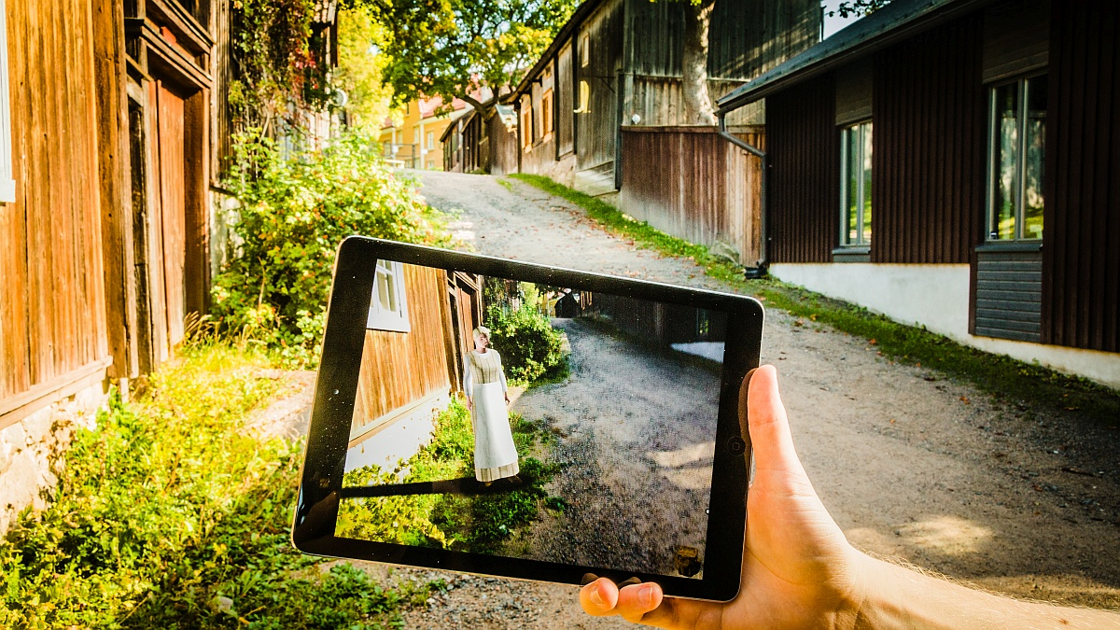
Image 1. Looking through the tablet application, museum visitor meets digitally created characters in the streets of the Luostarinmäki museum.
Futuristic History is a research project conducted by the University of Turku and the VTT Technical Research Centre of Finland. The multidisciplinary project has studied the possibilities offered by mixed reality technologies for representing and recreating past events, people and life. The two-year project started in January 2013 and ends in December 2014, and it is funded by TEKES, the Finnish Funding Agency for Technology and Innovation. (Mäkilä & al. 2013)
Augmented reality and mixed reality

Augmented reality (AR) is a technique that layers digital effects on top of real-life spaces in real time using computers and mobile devices such as smart phones, tablet computers and data glasses. Some of the augmented digital effects can be physically manipulable by the person viewing them (Cabiria 2012). AR is a subdivision of mixed reality (MR) which stands for the continuum between reality and artificial environment, as illustrated in figure 1. Virtual reality (VR) is a pure computer generated environment that can simulate a real or imagined world (Milgram & Kishino 1994), while augmented reality and augmented virtuality are set between the fully virtual and entirely real environments.
Figure 1: Reality-virtuality continuum.
Modern Augmented Reality technologies are built upon mobile devices. A common practice is to use the cameras on these devices to capture video, include additional virtual content over it, and display the result on the screen of the same device. All this is done in real time and possibly with complex modification to the original video feed involving virtual 3D models and imaging algorithms.
The Luostarinmäki Handicrafts Museum
In 1827 the city of Turku in southwestern Finland was mostly destroyed in the most devastating fire in the Nordic countries through history. The only larger part to remain intact was the Luostarinmäki area on the outskirts of the city. The area was sheltered by a high hill located between the area and the city center. (Viitaharju 1990).
On those days Luostarinmäki consisted mainly of the dwellings of workers and craftsmen. The houses were built between 1785 and 1803, and due to the limited wealth of the owners and occupants they were rather modest and cramped. Since most of the residents in the city had lost their homes, many of them took a room in Luostarinmäki, which became very crowded until the city was rebuilt. In a new city plan drawn after the fire, the Luostarinmäki area was rearranged and thus the old houses were ordered to be demolished (Viitaharju 1990).
Rebuilding of the city took time and the demolition of the old houses in Luostarinmäki was never carried out, and the houses preserved their 18th century features. In the first half of the 20th century the cultural-historical value of the area was recognized and the buildings were conserved. The Luostarinmäki Handicrafts museum was opened in 1940 to represent traditional handicrafts and life of the people of limited means in 18th and 19th century city. (Sjöberg-Pietarinen 1990).
Game-based museum education
According the definition set out by ICOM, the duties of a museum include promoting education, providing enjoyment and communicating information about humanity and its environment (ICOM Statutes). Museums are also particularly suitable places to provide education, experiences and information to a wide range of groups. At its best, a museum is also an experiential and creative place where learners can investigate and experiment firsthand.
Seen from this context, it is interesting to consider how an augmented reality game serves the learning environment of the Luostarinmäki Handicrafts Museum. What kinds of potential influences could gamification and augmented reality have on the museum experience and learning at the site?
A place like the Luostarinmäki Museum can be an unfamiliar and challenging learning environment to present-day people, many of whom have never lived without running water, electricity and other necessities of modern housing. Few visitors know how or for what purpose the tools they see were once used. Augmented reality and gamification can help visitors to process the historical details and connect them with things learned earlier.
Gamification, the use of video game elements in non-gaming systems to improve user experience and user engagement (Deterding & al. 2011), is participatory and experiential, and as a rule makes use of progressive inquiry methods. Learning and assimilation of new things can take many forms, and learning through experience has long been recognized as of great significance (Hooper-Greenhill 2007). Games can help learners find the motivation needed for all learning. In the game there is a main aim, possible intermediate aims, and challenges. Overcoming the challenges results in the player being rewarded. By experimenting and practising, everyone has the opportunity to succeed, which gives different kinds of learners the opportunity to learn. A successful game engages the player, becomes personalised with experience, motivates, and creates strong memory traces (see e.g. Kapp, Blair & Mesch 2012).
Although the Luostarinmaki game is fictional and tied to a storyline, learners are provided with a lot of information about history, objects and life in the olden days. The game motivates learners to investigate and look for more information about the site. The combination of physical and digital environment gives learners new opportunities to see, hear, feel and experience things that would not be possible without augmented reality.
The Story
The focus of the Luostarinmäki Adventure lies in representing the daily life in 19th century city through an entertaining experience. The aim was to create a mobile adventure game for young adults, which would be entertaining enough to keep the player engaged in playing.
The museum staff was asked to list things in the 1850s life they considered worth representing but which have been impossible to bring forward until now. Already the first version of the manuscript was based on these wishes and written by history and museology students in co-operation with the museum staff and history researchers at the University of Turku. The aim was to integrate interesting facts within the events and the plot, instead of presenting them traditionally in textual form.
The events in the game take place on one Saturday in the summer of 1855. The player takes the role of Frans Hakala, a 23-year-old man from the countryside, coming to Luostarinmäki to take part in the wedding of his cousin. Because the character comes from countryside, he, just like the player, is unfamiliar with many things in a 19th century city, and people he meets must explain them to him. The first task is to deliver the wedding crown of the family to the bride’s mother (image 2). It is soon revealed that the wedding ring has been stolen from the groom. The game then takes a form of a detective story in which the player has to follow clues and find the thief and the ring to save the day.
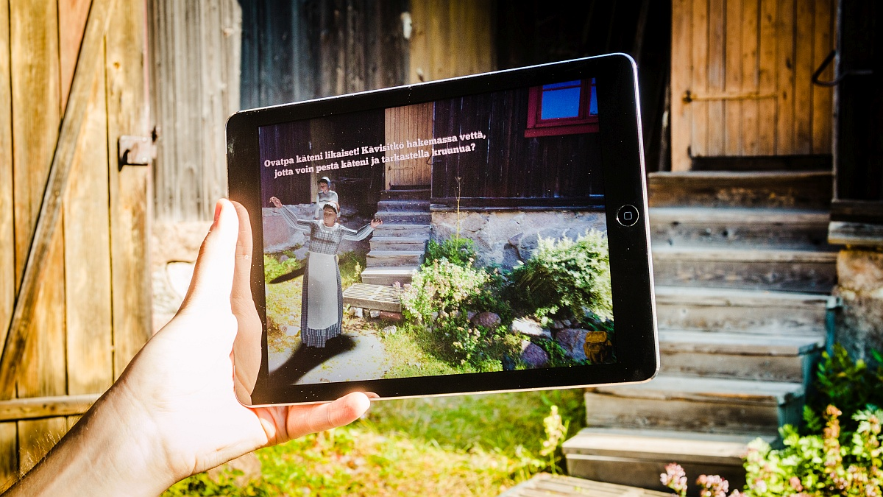
Image 2. Attempting to deliver the wedding crown.
During the first task the player will among other things learn that there were no street addresses in the 19th century city, that nearly every house had some domestic animals, that master and mistress had the right to discipline their servants, that water had to be brought from a distance and that there were saunas inside some town houses.
The Luostarinmäki adventure seems to turn a tablet computer into a window to history. Yet, there lies a risk in being too realistic. Representations of the past are always only interpretations made by the museum staff, the historians, the artists and the engineers. The more complete the given interpretation, the less the users need to make their own (Marcus, Stoddard & Woodward 2012). At worst this may lead to an oversimplified and one-dimensional picture of the past. Visitors have to be encouraged to be critical, and it should be made clear that the representation is not the absolute truth about the history. In the case of the Luostarinmäki adventure this means explaining the player the all but self-evident relationship between fact and fiction in the story.
The tools and processes
For augmented reality, it is essential to accurately measure the location of the device in relation to the environment. For this the system may rely on data from device’s sensors, such as GPS, compass, gyroscope and the camera. When the exact location is found the system is able to calculate how the virtual elements must be drawn on screen to merge them with the real view of the camera. Keeping track of the location is called tracking and if it gets lost, the augmented content can’t be accurately displayed until the tracking is recovered.
The goal with the Luostarinmäki application was to allow the user to experience the augmented world while moving freely around the museum. There are several AR solutions readily available, but many do not fulfill our initial requirements. Many solutions are based on highly visible graphic prints (markers, triggers or targets) placed in the environment to aid the tracking process. Such markers would not be acceptable in the museum environment, so a solution without added visual aids was needed. Some such solutions are available, too, and eventually the choice was one from VTT Technical Research Centre of Finland called point cloud tracking. From a large amount of photographs of the environment a virtual representation of the area is calculated algorithmically. This virtual version, the so-called point cloud, is then used as the tracking target, eliminating the need for any additional markers in the environment.
Development tools
An application targeted to wide audiences should work in a variety of mobile devices, thus the concept of multi-platform development was adopted from the start. The Unity3D game engine (see Unity) was chosen as the main software development tool. Unity provides much of the initial architecture needed in complex 3D games and supports common desktop and mobile platforms.
Requirements for immersive and successful AR applications resemble the ones of modern video games. These set the expectations for content quality especially among the game-playing youth and young adults. In addition the professionals of history and learning set their own high demands on the authenticity of the content. To meet these expectations on limited budget, new work methods and efficient tools are needed.
The initial script from student writers was refined with a scripting tool called Articy:draft2 (see Nevigo). With it the storylines can be visualized (image 3) and the non-technical script writing process integrated into the actual implementation of the application.
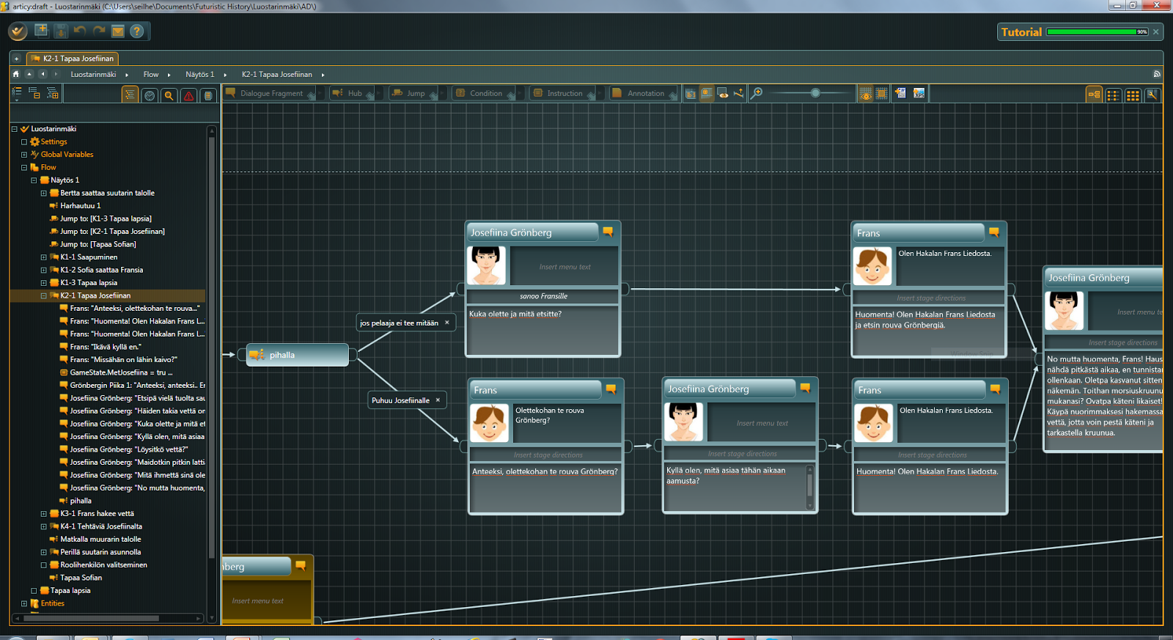
Image 3. Articy:draft2 tool was used to create the script for the story with all the discussions and user choices. The visual interface helps planning the optional routes through the story.
Creating realistic human characters is very time-consuming. A single lifelike 3D model of a person, with realistic clothing, fluid motions, and natural voice can require weeks of work by several skilled professionals. Limited-budget work requires more efficient methods.
New tools have emerged that utilise data created using high-fidelity 3D scanners and stored as base models, from which artists can more effectively make new characters by modifying the body and facial features of the models. Also specialized clothing tools exist that allow creating generic clothes that fit different characters and make it possible to share them among different productions. Extensive libraries of characters, accessories, animations, and other components may play a key role in cost-efficient making of high-quality applications in the future, and also offer new business opportunities.
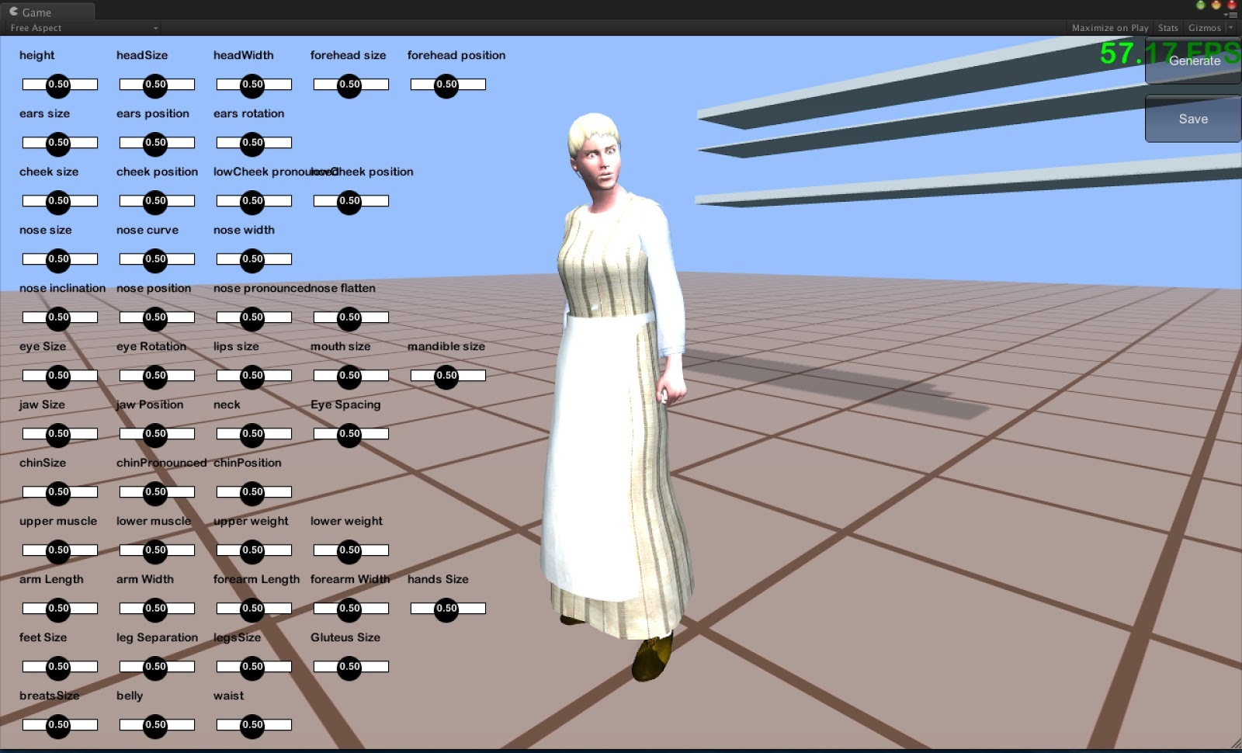
To achieve a workflow similar to one based on content database, we used the Unity plugin Unity Multipurpose Avatar (see UMA) that provided us with all the necessary basic functionality to reuse and mix both character and cloth base models (image 4). For animating the characters we used data from the CMU Motion Capture Database (see Mocap). No proper database of clothes of the era exists, and hence they were modelled within the project.
Image 4. A simple interface for UMA to customize characters.
A crucial aspect was co-operation between specialists of different disciplines, most importantly historians, museum personnel and application developers. The clothing, for example, was chosen by museum staff from the museum’s wardrobe. The costumes were worn by museum guides, photographed, and then modeled using the open source tool Blender (see Blender) (image 5). The process was iterative, so that certain simplifications could be made for technical reasons while keeping the essential characteristics accurate. Similar kind of co-operation was also used in scripting of the entire story and locations of the events in the museum.
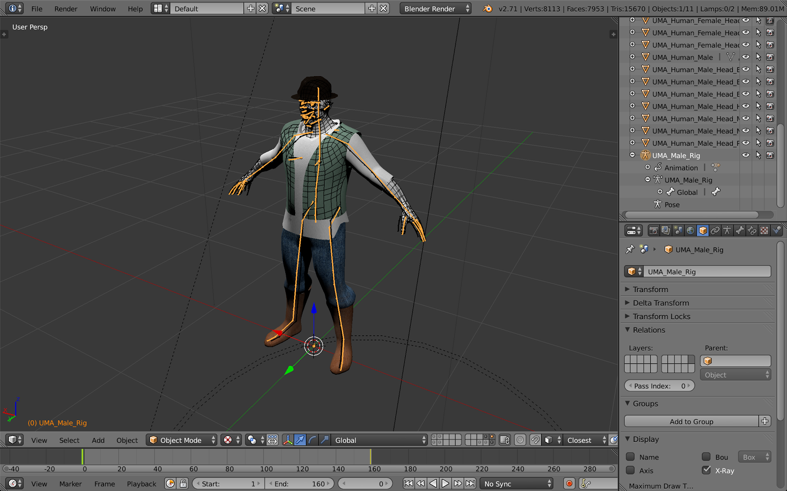
Image 5. Clothes for the characters were modeled using Blender.
User interface in the game
The goal of the project was to develop a gamified adventure, inheriting elements from the adventure games genre but still "not obviously being a game". Many of the users of such an application are first-time users, so it must be easy to adopt, yet efficient and – while being an entertainment software – error-proof and satisfying to use. (Nielsen 1993, p. 26-36, 40-42.)
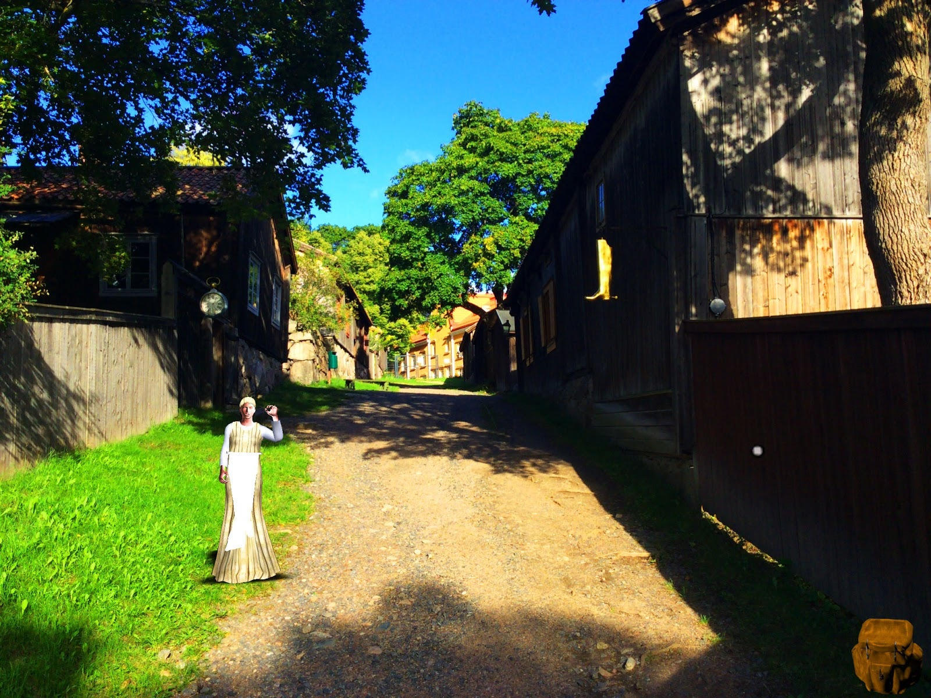
Visual design was to skip traditional game elements such as crosshairs, health bars and minimaps. Although such elements serve for usability and utility, they were scrapped in favor of a clutter-free interface of the main adventure view (image 6). One compromise is the dialogue interface: the virtual characters' lines of speech are drawn visible over their heads, and the user can reply by tapping on one of the alternative sentences (image 7).
Image 6. The main interface was kept as clean as possible of any additional graphical elements.

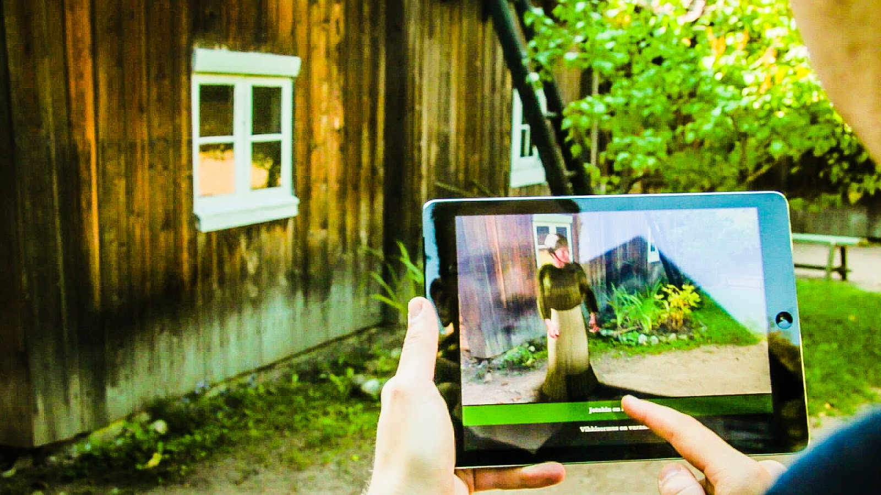
Image 7. Dialogue interface. While discussing with game characters, the user chooses one of the alternative lines as his/her reply.
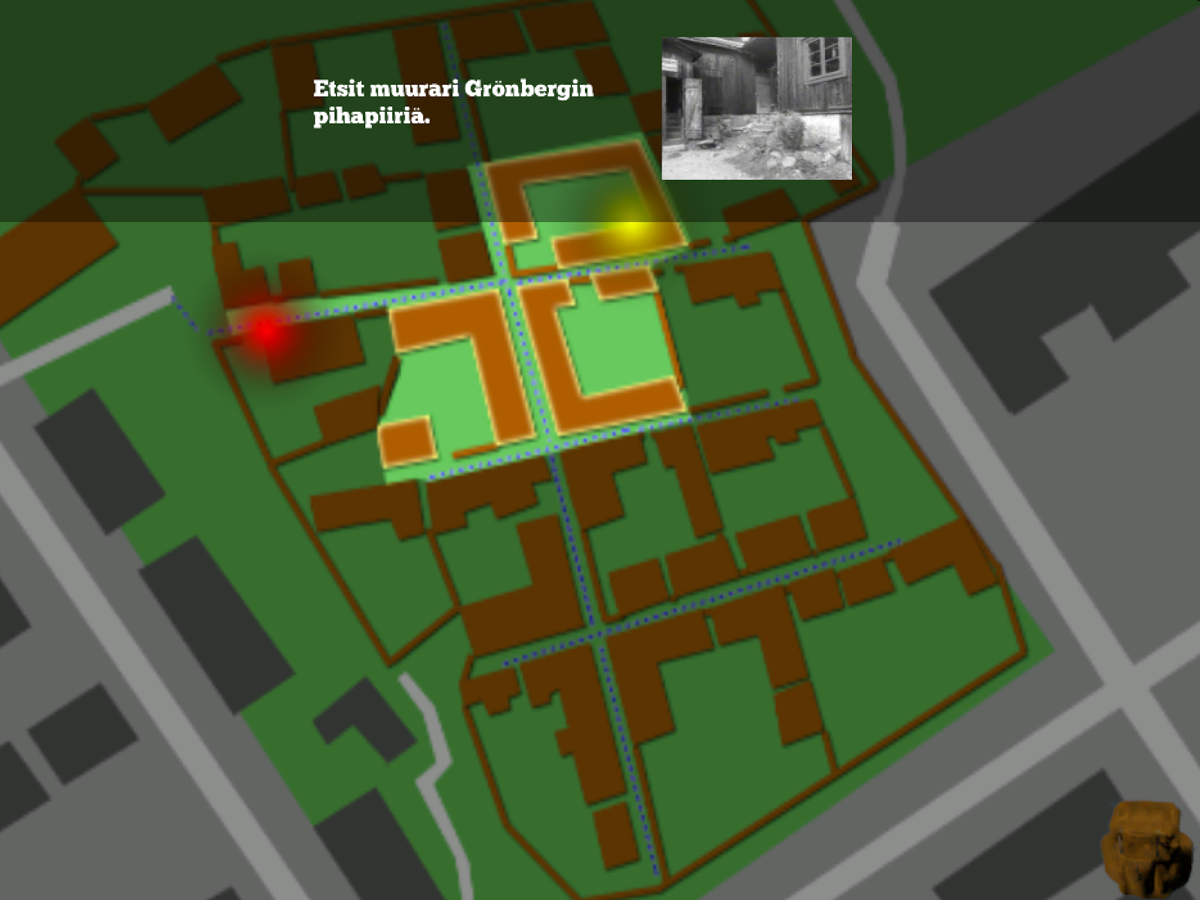
Supporting elements like task hints and a map were placed into a separate view (image 8) that appears when the tablet is leveled down into horizontal orientation.
Image 8. Map view. Holding the tablet horizontally, user sees the map of the area with indications of the current location and the place that should be found next. The small photo gives a further hint of the place to look for.
When the user gets involved in a task, there is typically some interaction with virtual objects. Those things are carried in a virtual “backpack” (image 9), and they can be given to the virtual characters.
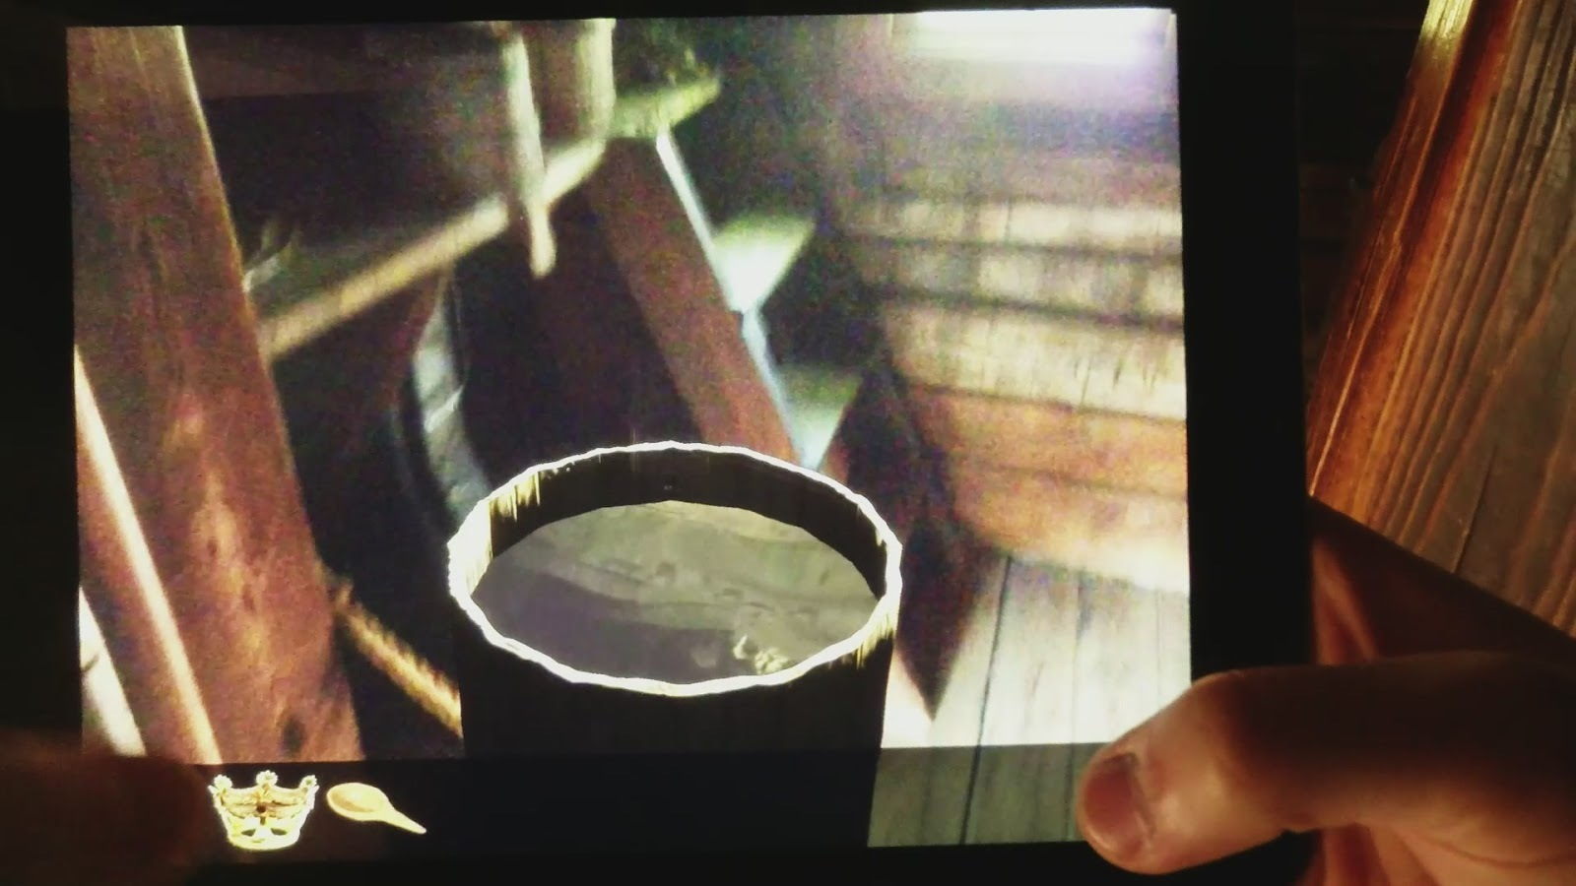
Image 9. The inventory can be opened by tapping the backpack icon in the bottom right corner of the screen (see image 6). The items carried are now seen on the bottom area of the screen.
User Testing Results & Discussion
After the initial software development phase, some user tests were carried out in parallel with UI (User Interface) and application development. Someone from the development team was always following the test user and helping with technical or usage problems. Opinions of the test users were also collected with a simple questionnaire about the content, usability and user experience of the application. A few questions concerning commercialization of the application were also posed. However, since the game and the questionnaire were both modified through the testing period, and since most test persons were in some way connected to either the museum or the research unit, the results can only be considered indicative. The testing primarily served for development of the user interface and technical solutions.
The main phase of tests comprised of 56 users in total. According to the questionnaires, 86% of the users thought the first impression of the application was interesting or rather interesting. 73% found the experience of augmented reality pleasant or rather pleasant, and 63% thought that the application provided added value to the museum tour.
Users with previous experience with adventure games were typically quicker to learn the UI conventions than total novices. Still, we saw that the details of UI design should be easier to learn, and for some actions more than one supported means of interaction would be needed, as different users will try different ways of accomplishing tasks.
The storyline of the game was considered clear, interesting and long enough. Only the number of playable areas and dialogue was considered somewhat scarce. The maximum length of the story for adult audiences seems to lie between 30 and 60 minutes. For younger audiences the optimum length is likely to be shorter. Naturally this depends heavily on how interesting and addictive the story itself is.
Our primary design of the adventure relied on users picking on information from the conversations with the virtual characters and then head out doing the “missions”. Soon it was noticed that people were not that adept in parsing the “missions” from the conversation text and required help to find out how to continue. The application should help the user forward considerably more than was the case in the development phase.
According to preliminary assumptions, the tablet was thought quite heavy and thus the users’ hands got tired after some time. Moving from one place to another was a welcome relief to some of the users. One practical issue was that the scenes occurring in the courtyards could interfere with other visitors. Therefore scenes should be arranged at the sides and corners of the courtyards. The tracking was also found to work more reliably when the camera would not see moving people in the area.
A clear source of frustration for the users was losing the tracking; they both blamed the software and questioned their own computer skills – usually simultaneously. The loss of tracking made the users move the pad more rapidly, only making the reacquisition of tracking harder. This is an example of a serious technology issue that can consume the whole experience. Technical problems were common, and they obviously affected the opinions.
One important issue noticed during the user testing was some kind of loss of the traditional museum experience while using the adventure. Some users felt they were too immersed in the application and forgot to pay attention to the surrounding museum. Similar findings have been reported in a study by Carrigy & al (Carrigy 2010).
Most of the respondents seemed to be willing to pay for this type of application. The suitable price level remains unclear, as there are currently few points of reference.
Conclusions and further work
An important issue found during the project is the notion that users tend to forget the museum around them while concentrating in the game. Our view is that the tablet should not be the be-all-and-end-all solution, but instead more about enhancing the experience. It should only be used occasionally, and otherwise the users should be let to rest their hands, move safely, and enjoy the new, spiced-up museum experience.
We learned that the application should guide the user better in the game. Since this could lead to a more game-like experience than was the initial idea, more study is needed to find good solutions.
Technical issues have affected user experience significantly during development as the tracking technology was often not robust enough. We do not consider the application complete at this point. Development has continued until the writing of this paper, and work is planned to continue in another project starting after Futuristic History closes. Especially more complete user studies are planned as part of further work.
Using AR technology, information can be provided without interfering with the physical reality in museums like Luostarinmäki, where outside areas and interiors have been kept as authentic as possible. It also allows for a much more diverse provision of multimedia learning content than physical solutions could offer. Technology can open up things that are difficult to understand or topics that are abstract, making them as concrete and easy to understand as possible. Augmented reality and gamification will probably transform museum education. Combining physical and digital environments gives new opportunities to learning experiences.
References
Blender: http://www.blender.org
Cabiria, J. (2012) Augmenting engagement: Augmented reality in education. In Increasing Student Engagement and Retention using Immersive Interfaces: Virtual Worlds, Gaming, and Simulation. Vol 6, part C. Edited by Charles Wankel and Patrick Blessinger. Bingley: Emarald.
Carrigy, T., Naliuka, K., Paterson, N., Haahr, M. (2010) Design and evaluation of player experience of a location-based mobile game. NordiCHI ‘10, Proceedings of the 6th Nordic Conference on Human-Computer Interaction, Reykjavik, Iceland, October 16-20, 2010.
Deterding, S., Sicart, M., Nacke, L., O'Hara, K., Dixon, D. (2011) Gamification. using game-design elements in non-gaming contexts. CHI '11 Extended Abstracts on Human Factors in Computing Systems
Herbst, I., Braun, A-K., McCall, R., Broll, W. (2008) TimeWarp: Interactive time travel with a mobile mixed reality game. In the Proceedings of Mobile HCI 2008. Amsterdam, Netherlands.
Hooper-Greenhill, E. (2007) Museums and Education. Purpose, Pedagogy, Performance. New York and London: Routledge.
ICOM Statutes, Article 3, Section 1 : definitions of terms
Kapp, K., Blair, L., Mesch, R. (2012). The Gamification of Learning and Instruction: Game-based Methods and Strategies for Training and Education. San Francisco: John Wiley & Sons.
Marcus, A.S., Stoddard, J.D., Woodward W.W. (2012) Teaching History with Museums. Strategies for K -12 Social Studies. New York and London: Routledge.
Milgram, P., Kishino, F. (1994). A taxonomy of mixed reality visual displays. IEICE Transactions on Information Systems, Vol E77-D, No.12 December 1994.
Mocap: The [motion capture] data used in this project was obtained from mocap.cs.cmu.edu. The database was created with funding from NSF EIA-0196217.
Mäkilä, T., Helle, S., Lehtonen, T., Viinikkala, L., Korkalainen, T., Arimaa, J.P., Pönni, V., Heimo, O. (2013). Futuristic History Project Presentation - Recreating History with Augmented Reality Solutions. In Beyond Control – The Collaborative Museum and Its Challenges. NODEM Digital Repository http://repo.nodem.org?objectId=158
Nevigo: http://www.nevigo.com/en/articydraft/overview/
Nielsen, J. (1993). Usability Engineering. San Francisco: Morgan Kaufmann Publishers.
Sjöberg-Pietarinen, S. ”Fröken gör ju snart hela stan till museum” In T. Bergroth and M. Söderström (Ed.) ”Först kom skomakaren”. Hantverksmuseet på Klosterbacken 50 år. Åbo: Åbo landskapsmuseum.
UMA: http://u3d.as/content/uma-steering-group/uma-unity-multipurpose-avatar
Unity: http://unity3d.com/
Viitaharju, J. (1990). Stadens bakgård. In T. Bergroth and M. Söderström (Ed.) ”Först kom skomakaren”. Hantverksmuseet på Klosterbacken 50 år. Åbo: Åbo landskapsmuseum.

