Emotional Contagions: Franz Liszt and the Materiality of Celebrity Culture in the 1830s and 1840s
Hannu Salmi, University of Turku

[final manuscript of the chapter published in Feelings Materialized: Emotions, Bodies, and Things in Germany, 1500–1950. Edited by Derek Hillard, Heikki Lempa, and Russell Spinney. New York: Berghahn, 2020]

The concert which took place in the Music Hall, on last Thursday, was beyond all doubt one of the most remarkable and interesting that we ever attended in this town. We have rarely witnessed a similar enthusiasm amongst our music-loving public. But who could possibly remain cold on hearing such a performer as Franz Liszt? Who would not be carried away by the fire and intenseness which pervades his play, or listen with delight to the harp-like tones which he draws from his instrument, as they softer and softer fall upon the ear, and gently die away. Cold critics, who affect a sober judgment, may find such a performance too wild and extravagant, but to us it is no such thing. For we not alone recognise in Liszt the great performer, who overcomes incredible technical difficulties, but we see in him the deeply reflecting artist, who well knows what stress to lay upon every individual note, and who stamps upon every composition which he plays, however various it may be, a distinct character. He intended to have concluded with the overture to “Wilhelm Tell,” but, as the public by loud encores insisted on his re-appearing, he finished with “God save the Queen”, in a style not to be excelled in grandeur.

This is how The Leeds Mercury described the concert of Franz Liszt (1811–1886) in Leeds on 10 December 1840. The critic emphasized the great enthusiasm of the "music-loving public" and "the fire and intenseness" of Liszt’s art. There was irresistible emotionality in his playing, and he was able, at will, to transform the strings of the piano into a harp that gently swept the ear. At the same time, Liszt’s music, but also his figure and his presence, was too "wild and extravagant" for the "cold," obviously unemotional, critics.
His biographer Derek Watson has characterized Liszt as "a dazzling wizard, a showman and superman of the keyboard." In a world that was divided by political borders, Liszt travelled smoothly from place to place with his own wagon, later by train, and was recognized without any travel documents. According to the contemporary Viennese music critic Eduard Hanslick, Liszt’s face was probably the most well-known in Europe at the time. In his fame, Liszt equalled to the Italian violinist Niccolò Paganini, but he was able to target a wider geographical area in Europe than his colleague, thrilling audiences from Scotland to Spain, from France to Russia. Franz Liszt was born in the village of Doborján in the Kingdom of Hungary. He was a child prodigy who aroused enthusiasm in London as early as 1824, as echoed by, amongst others, the Dutch daily Arnhemsche courant and the Finnish Finlands Allmänna Tidning. Liszt became known for his extraordinary skills, tricks and technique and his amazing bravura.
In his book The Invention of Celebrity 1750–1850, the French historian Antoine Lilti has traced the origins of celebrity culture and stressed the era of enlightenment as a decisive turning point. Already Voltaire became a celebrity through the printing press and was known throughout Europe. Still, as I argue, as cultural phenomena, celebrities like Paganini and Liszt embarked on something new. They travelled at a hectic pace and allowed massive audiences to experience their performances. They usually performed in opera houses and other large venues. Literary figures, like Voltaire, were known through their writings, but Paganini and Liszt really toured around the continent and met tens of thousands of people, or even more. In this respect, Liszt was particularly active, and his fame was fostered and intensified by the rise of transport technology, newspaper publishing and bourgeois music culture. Liszt seemed to have a strange appeal to the audiences: they were not only tempted to follow him on stage but were eager to know about his deeds also in private life. The mysterious attraction of these star-like figures was sometimes explained in terms of magnetism and other natural forces, sometimes, as in the case of Paganini, by supernatural and invisible diablerie, a pact with the devil. Heinrich Heine coined the term “Lisztomania” to describe the active, even fanatic audiences who participated in the performances and were ready to express openly their emotions. A devotion to Liszt was a mania, an obsession.
I have previously written on the rise of musical celebrities in nineteenth-century Europe and its resonance with and intervention in the concept of culture. My aim is now to concentrate on Franz Liszt and especially on his emotional gravitation; with "gravitation" I refer to the ways in which his emotional appeal was amplified in mid nineteenth-century culture, besides his music and musical performances, especially through technological changes in musical instruments as well as in both transport and media. I argue that this gravitation had striking, and complex, material ramifications, not only from the perspective of the emotional responses of the audience but already in regard to Liszt’s body as a performer. Liszt became an emotional power field, fuelled by the on-going process of modernization. This chapter analyzes the materiality of emotions both from the perspective of the emotionality of the audience but also by focusing on how Liszt was interpreted, and how he functioned in the end, as a generator of emotionality, as an assemblage of human and non-human forces. As already argued in the introduction of this book, mind does not form the limits of emotions. Therefore Liszt’s emotionality has to be studied not only by analyzing his body and its immediate extensions, like the piano, but also the larger environment that enabled and participated in the amplification of his emotional appeal. In this task, the chapter draws on contemporary public discourse, on books and articles, on digital newspaper repositories, and also on images and caricatures of his physical appearance.

The Body of the Performer
Alan Walker, the author of the seminal Franz Liszt biography, has emphasized the influence of Paganini on the young Liszt. In April 1832, cholera was raging in Paris which generated widespread anxieties, but it did not prevent Paganini from presenting his concerts for large audiences. In one of these concerts, Franz Liszt was in the auditorium and was thrilled by the performance, especially by the inseparability of the virtuoso and his instrument. As a result, he began to exercise frantically to become "the Paganini of the piano."
Liszt’s teacher Carl Czerny has documented the great rapidity with which his pupil finally learned to master his instrument. Liszt became "an expert sight-reader that was capable of publicly sight-reading even compositions of considerable difficulty and so perfectly as though he had been studying them for a long time." Liszt’s technical virtuosity also aroused criticism, and it was sometimes seen as exaggerated, as an aim per se. Similar arguments were often presented against Paganini who developed dashing tricks to astonish his audiences and seemed to have a completely new relationship to his instrument. Paganini, and later his follower Liszt, wanted to draw the attention of his audience exclusively. This created something new compared to other contemporary entertainments like grand opera where the audience itself had to be visible and had to have the possibility for socializing. Erika Quinn has pointed out how Paganini, and Liszt, aimed to become spectacles themselves. Paganini forced the audience to watch him rather than each other.
According to the contemporary sources, the audience genuinely paid attention to the physical appearance of both Paganini and Liszt. In Paganini’s case, this is no wonder since his body was distorted by diseases. In 1822–23 he did not perform while recovering from syphilis. He had intestinal problems too and lost all teeth of his lower jaw. When Paganini was touring in Bohemia in 1828, the local critic Joseph Sedlazek wrote that "his body is so strangely contorted that one fears any moment the feet will part company with the rest of him, and the whole frame fall suddenly to the ground, a heap of bones."
At the same time, Paganini’s physiognomy was described as an automaton, as a machine that could play forever. This metaphor probably referred also to his inexhaustible pace in touring. His corporeality extended beyond his physical body; a man-machine could reach out his travels into the most distant areas in Europe. In fact, Liszt was finally able to tour even more extensively than Paganini, thanks to the rapid changes in transport technology in the 1830s and 1840s. There was much more to be harvested that had been possible for Paganini. In this respect Liszt’s career was an epitome of modernity, also in an emotional sense since through his extensive itineraries he was able to address a wider audience than anyone before him.
Franz Liszt, like Paganini, was an eye-catcher among the public. When he visited Vienna after a long break in 1838, his presence was immediately noticed. Newspapers wrote on the “internal unrest” of the genius and on his majestic outer appearance. His bodily fluids were in restless motion, but still he had particular calmness in his public behavior. On the other hand, his physicality was harshly critiqued during the concerts. In Paris, François-Joseph Fétis, one of the most powerful music critics of the nineteenth century, argued that Liszt had "converted music into a shell-game and conjuring show." There are many caricatures that portray Liszt in action. The collections of the University Library of Strasbourg include an image entitled Liszt jouant “Grand galop chromatique” (1843, Image 1), where Liszt seems to be unable to sit behind his piano and is jumping up during the course of the energetic gallop. His fingers are almost unnaturally long, and his gestures look edgy. Liszt himself seems to be taken away by his own compositions, and other musicians try to follow as well as they can. Liszt is paralleled with a galloping rider, as in some other contemporary images. He is in a seemingly uncontrolled motion, and only he seems to be able to follow the logic of this restless ride. In this image, Liszt is not a star as an object of desire, but more like an irresistible artist, a natural phenomenon that cannot be controlled or held back.

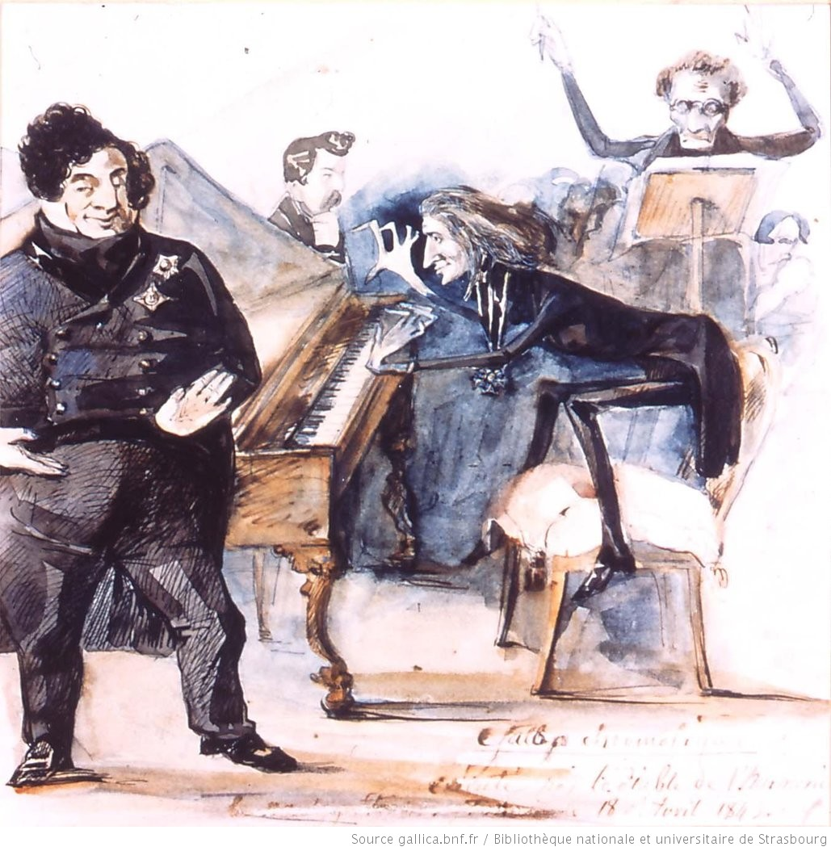
Image 1: Liszt jouant “Grand galop chromatique”, Bibliothèque nationale et universitaire de Strasbourg, NIM35493, http://catalogue.bnf.fr/ark:/12148/cb41932328g

The image above is from 1843. There is evidence however that Franz Liszt became increasingly conscious of his body already in the 1830s, after his first successes in Paris. In fact, many later portraits show him in rather calm positions, playing an aristocratic type. Dana Gooley argues that already the critiques Liszt confronted in Paris made him control his virtuosity, or merely the way he presented his skills for the audience during the shows. Because he was in search of affirmation as an artist, he gradually replaced his inspiration of Paganini with the commitment to Beethoven who was obviously a more noble figure to follow. It was important to emphasize that he, Franz Liszt, was not only a virtuoso. He wanted to be recognized both as a man of letters and as a composer. All this shows that Liszt not only fashioned his body to arouse the interest of his audiences but he also aimed at influencing on how his body and his emotionality were perceived by the public.
Despite these efforts, as the image from 1843 suggests, Franz Liszt’s virtuosity remained essential for his reception. Liszt’s amazing bravura occurred in conjunction with the development of piano as an instrument. This, in turn, offers the possibility to analyze the materiality of Liszt’s emotionality not only in relation to his body but also from the perspective of his tangible instrument. In recent literature on the history of emotions, materiality has gained much attention, although there are less studies on early nineteenth-century music and materiality. In the 1820s, the so-called repetition lever was introduced to enable clear articulation and rapid playing of notes which was particularly important for Liszt. It was also a precondition for his own compositions which included very rapid passages and many notes within short timeframes. While the piano was ready to respond to its player’s virtuosity more precisely, it seems that the player and the piano looked like an inseparable whole for the audience. Liszt himself stresses the inseparability of his body and his instrument: “Mein Klavier ist für mich, was dem Seemann seine Fregatte, dem Araber sein Pferd – mehr noch… meine Sprache, mein Leben.” This material entanglement reminds of Gilles Deleuze and Félix Guattari’s discussion on human/non-human assemblages: a rider on a horse is a ‘man-horse’ who gets new faculties and is thus more than a sum of its parts. Liszt on stage was a ‘man-piano’, an assemblage of human and non-human forces that was capable of producing unexpected outcomes. Thus, if we interpret emotionality as communication, there was an essential material element to it in a piano recital by Franz Liszt. The new instrument with a repetition lever was more sensitive and nuanced in responding to the emotions of the artist and, at the same time, the pianist had to be quicker, sharper and, in the end, more physical to be able to fully exploit the potential of the instrument. For the audience, the ‘man-piano’ was an inseparable entity that could produce something that previously had been unheard and unseen. The emotionality of both the instrument and the body, their close entanglement, constituted what I call the emotional gravitation of Liszt's presence in the concert hall.

The Audience Overwhelmed
In the case of Franz Liszt, the body of the performer and its material extensions is only one platform for the materiality of emotions. It is equally important to pay attention to the audience and its reactions. Liszt became one of the most celebrated public figures in nineteenth-century Europe. As already noted, he travelled extensively throughout the continent, especially in his so-called Glanzperiode, after 1839.
The Image 2 shows Liszt’s concert sites between 1839 and 1847. As the map indicates, he occupied an amazingly vast area through his personal activity. These tours were probably the most extensive and wide-reaching among the musicians of the time. They also reveal the interest of Liszt to build a relationship with audiences. He produced celebrity culture through his efforts to reach his listeners in different countries and language regions and to create an audience that was particularly devoted to his music. Liszt’s fandom was based on his physical presence which, in end, had an impact on a much wider geographical region because of the mobility of the audience. He did not only go to his audience, but people came to listen to him from even further away. This continued well into his later life. He never visited Norway, for example, but he met Edvard Grieg in Rome in 1870. Liszt showed his ability to play fluently directly from the notes and performed Grieg’s piano concerto ad hoc. Liszt did not visit Finland either but the German-born musician Richard Faltin visited the first Bayreuth festival in 1876 and heard Liszt’s playing in Villa Wahnfried. He wrote an article on this experience for a Finnish music journal and told that "even today the maestro is able to put all his apprentices into his pocket."

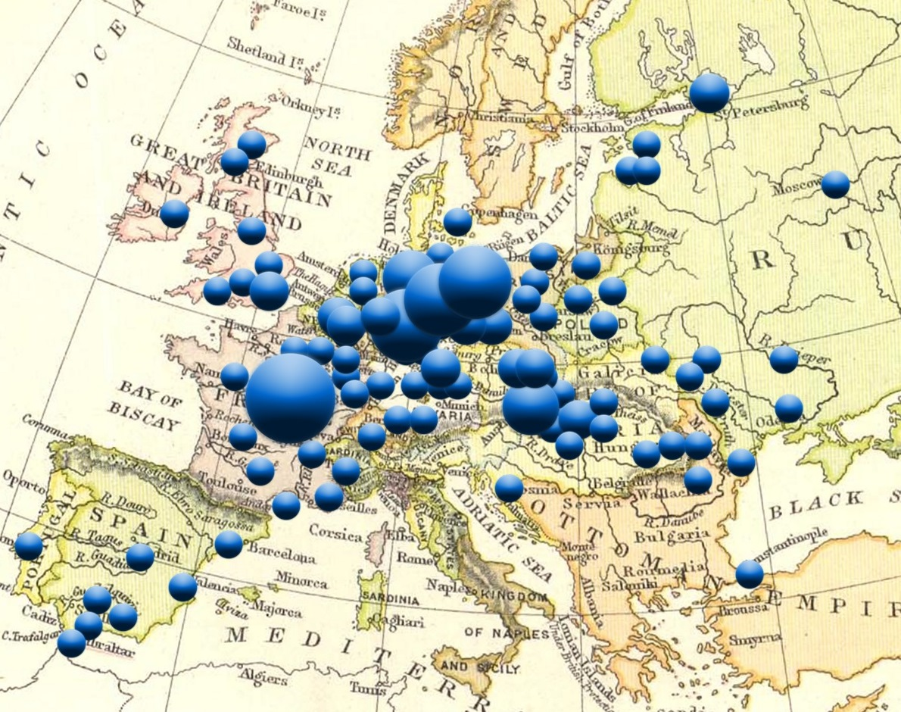
Image 2: The sites of Franz Liszt’s concerts 1839–1847. The size of the ballot refers to the frequency of concerts during the time span.

The contemporary audiences celebrated Liszt, as they had celebrated Paganini before. Still, the irresistible appeal that drew people towards him was bound together with astonishment upon those forces that actually gave birth to this particularly powerful, unexpected interest among the public. The spectators were drawn to him, to experience his performances, which the press and other spectators already proclaimed as astonishing. The Paris-based, German-born author Heinrich Heine used the term “Lisztomania” to describe the hysterical relationship of the audience towards the famous pianist. In Liszt’s Glanzperiode, especially the visit to Berlin after Christmas 1841 became the climax of his popularity. The recital in Singakademie on 27 December evoked particularly strong emotions among the listeners, and Liszt decided to stay as long as ten weeks in the city. He performed at a hectic pace, and soon Lisztomania was like a virus among the public. Fervent admirers tried to cut curls from his hair, and even collected his cigar butts from the street.
Liszt’s concert at Singakademie has become an image of a turning point. The most famous depiction of this moment is a colored lithography, which is probably made a few years later in 1847 (Image 3). The main focus of the image is not actually on Liszt who is playing in a rather calm and relaxed manner but instead on the audience that openly expresses its devotion.

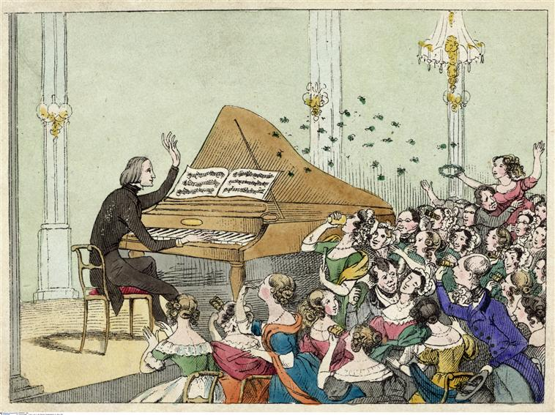
Image 3: Franz Liszt at the Singakademie in Berlin. Image: bpk – Bildagentur.

It is obvious that the drawing wants to emphasize the great number of women in the audience. There are a few men, but only to take care of the fainting women or to observe the strange performance that is going on. Many of the women are using binoculars to have a closer look on their idol. Even in the first row, there seems to be a fan who has reserved a good place for viewing but still uses her binocular. Some of the women are sending blowing kisses, some are throwing flowers. The concert situation is full of bodily activities, gestures and facial expressions. Some members of the audience are so eager that they have stood up out of excitement. Some have raised their hands. There is even one woman listener who seems to want to leave the auditorium and rush onto the stage. According to this image, Liszt’s concert was an emotionally loaded event where the ‘man-piano’ evoked strong emotions by the audience, and the audience in turn responds by expressing its devotion to the star.
Heinrich Heine’s notion “Lisztomania,” or in French Lisztomanie, was a commentary on Liszt’s huge success in Berlin. It originally appeared in one of Heine’s Parisian musical feuilletons, dated on 25 April 1844. It seems that, as a concept, Lisztomanie spread immediately around Europe. Already on 22 June 1844 Wiener Zeitung in Vienna published a short novella by an author who has given only his initials J. D. The story is entitled "Die Hand des Herrn Liszt," the Hand of Mr Liszt. A two-page anecdote tells a story of Lelia, a girl who is completely devoted to Liszt. The author writes that piano as an instrument does not exist for Lelia without Liszt: they form an inseparable whole. Without Liszt, a piano will remain completely silent and non-existent. To express her love for Liszt, she has a model of Liszt’s hand which she treasures like a holy relic. The setting seems to anticipate the novel Madame Bovary (1857) by Gustave Flaubert: like Bovary, Lelia is married and feels tempted to live in her own escapist fantasy world. Her husband argues that Lelia is a fool, but she only answers that, then, the princess N. is a fool too, because she has a similar ‘hand’ in her boudoir. Lelia’s husband concludes that his wife’s Lisztomanie has developed into a monomanie. Finally, it appears that the hand is actually not Liszt’s at all but a fake.
As the previous example shows, Lisztomanie was conceived as a women’s disease in the same manner as bovarisme. Heine’s original analysis of Lisztomania had also political ramifications. He saw the Berlin frenzy as "an indication of the politically unfree situation on that side of the Rhine." Instead of Georg Herwegh, it was easy to turn to Liszt who was not a threat. Heine’s feuilleton includes also a medical and physical view on Liszt’s emotional contagiousness, with an ironic twist. After concluding that "the solution of this question belongs to the domain of pathology rather than that of aesthetics," he consulted a physician whose specialty was female diseases. The doctor "smiled in the strangest manner, and at the same time said all sorts of things about magnetism, galvanism, electricity, of the contagion of a close hall filled with countless wax lights and several hundred perfumed and perspiring human beings, of historical epilepsy, of the phenomenon of tickling, of musical cantherides, and other scabrous things."
The culture of fame is here explained as a contagion, as an infectious disease that seems to spread in an uncontrolled manner in the crush of the concert halls. If music lovers in the 1830s had to be afraid of cholera on their way to the concert hall, in the 1840s they had to be aware of another kind of disease.
In trying to understand the infectiousness of Lisztomanie, Heine’s physician friend paralleled the transmission of this contagion with physical forces like magnetism. In contemporary reviews, too, the notion of magnetism was associated with those mysterious powers that drew people towards Franz Liszt. This was articulated already before Heine’s famous diagnosis. After Liszt had performed in Milan, the German Allgemeine Musikalische Zeitung wrote on 9 May 1838 that he was "a physiological-psychological-artistic triad," "an aggregate of all forces acting in his body with their peculiar circumstances, especially electricity and animal magnetism." If this description is interpreted from the perspective of present-day cultural theory, the notion of an "aggregate" can be paralleled with Deleuze and Guattari’s idea of an assemblage of human and non-human forces. Liszt was a machinery that gained new faculties through its complicity with the instrument. Allgemeine Musikalische Zeitung mentioned also the notion of "animal magnetism." It refers to the late eighteenth-century idea of the German physician Franz Mesmer that there was an invisible force exerting from all animals and that this force could have concrete effects, for example, for healing. Mesmerism and animal magnetism had a profound impact on nineteenth-century art and literature, also the interpretation of early celebrities and their appeal. In the early nineteenth century, there was an idea that this invisible force between human beings had social implications. According to Alison Winter, there was a common claim that communication was in fact a kind of transfer of vital fluids between bodies and that people’s minds touched each other in mysterious ways. Furthermore, in the discussion on mesmerism, it was stressed that there were people who could develop the use of these forces in creating emotional connections between people. Clearly, these different conceptual thoughts, mesmerism as well as the idea of infection and contagion were efforts to try to get hold of the strange gravitation that drew people to the concert hall. There was new materiality in this emotional realm, corroborated by the changes in media landscape.

Affects beyond the Body
Franz Liszt’s success took place at the time of turmoil. The 1830s and 1840s were characterized by revolutionary activities and political struggles, by the frightening cholera pandemic that eclipsed Europe from East to West, by monetary capitalism and the rise of stock exchanges, and by many technological leaps, the consequences of which were difficult to foresee. Both Paganini and Liszt took advantage of the new opportunities for travelling and exploited the new musical markets that had been emerging. Heinrich Heine had interpreted Lisztomanie as a Berlin phenomenon, but clearly Liszt’s fandom had wider geographical resonance.
Steamboat and railway connections contributed in transforming the itineraries of early celebrities. It would be too straightforward to interpret these cultural ramifications as direct results of modernization. Instead, it seems that the culture of celebrity and the new mobile culture were constructed simultaneously. Transport technology had agency in shaping sense of spatiality, not only by enabling the mobility of bodies but also by fostering flows of information and goods. An ever-growing number of people could see Liszt in person, but through the printing press they could also read on how he had given concerts somewhere beyond their everyday environment and attracted people in different corners of Europe. When we consider the role of emotional contagiousness, these conditions must be taken under consideration. In his classic book Understanding Media (1964), Marshall McLuhan interpreted media as "extensions of man." He also discussed railway as a medium, not as something that necessarily produced new, but as something that accelerated or amplified previous processes. It seems that, in the 1830s and 1840s, transport technology was a material platform for emotional contagiousness of celebrity culture and participated in amplifying it into unexpected proportions. The technological change becomes obvious if Liszt’s tours are compared to Paganini’s tours a bit earlier. Paganini’s itineraries were not yet based on railways. He used mainly horse-drawn transport, and of course maritime connections when crossing the English Channel and the North Channel. Liszt used horse-drawn carriages as well but he was able to employ the emerging railway network efficiently and to extend his travels wider than Paganini. Therefore, Liszt’s gravitation developed into a stronger field of power compared to Paganini’s supposed diablerie.
Franz Liszt was able to reach also remote areas of Europe, performing in Lisbon and Moscow, Dublin and Constantinople within only a few years (Image 2). The Mediterranean region and countries like Sweden, Finland and Norway were out of his scope already because of travel conditions. Christopher Rueger has pointed out that, although Liszt fever exploded in the era of the emergent railway networks, his Glanzperiode was not yet able to completely rely on train connections. On the other hand, in 1837, the first long-distance railway was launched between Leipzig and Dresden, which were focal points of musical life in Germany. By 1849, there were already 5,000 kilometres of track in Germany, which was more than a double compared to the network in France. It is evident too that, in choosing his places of residence, Liszt had to carefully consider transport connections since he led a mobile lifestyle. Weimar became his asylum from 1848 onwards, and it is hardly a coincidence that the city opened its first railway line two years earlier. Liszt could easily make a trip to Leipzig or Berlin and return back home within the same day. He could visit Düsseldorf and Cologne with an overnight stop. There was demand for Liszt’s presence, and Weimar was an ideal node in the transportation network. It was probably favorable also because it was outside the already "infected" Berlin.
Liszt’s tours were also molded in conjunction with the rising capitalism and culture of money. London and Paris were cradles of musical life, but they were also centers for stock exchange and business markets. These were the places to go if someone in the early nineteenth century wanted to make a profit. In cities such as London and Paris, there were wealthy members of the bourgeoisie who could afford the high prices of tickets. It is important to note however that it was not only the public sphere that tempted virtuosos but the semi-public salon scene was very much still alive, and Liszt in particular mingled easily in this society and gave concerts for smaller circles too. In this sense, Berlin was an important venue as well, and it seems that Liszt’s success in Berlin had many indirect economic benefits, and the emotional turbulence he aroused was a vehicle in this process.
In the formation of music culture, it is obvious that new modes of business became visible in salons and private homes. Salonmusik was at its heights in the 1830s and 1840s, at the time when the salons of the high society in particular became stages for piano virtuosos. Short pieces, of which Frédéric Chopin’s nocturnes, waltzes and mazurkas are excellent examples, were composed for salon use. Many of Franz Liszt’s compositions served similar purpose, let us only think of his six solo piano pieces entitled Consolations. At the same time, the production of pianos rapidly increased together with the commercialization of easy arrangements and piano transcriptions. Franz Liszt participated in this material flow, as a musician and a composer, as a man of letters and an idol of his audience. Liszt was doubtless conscious of this on-going change of conditions. Furthermore, it has to be noted that, in his musical production, Liszt emphasized programmatic ideas. He provided explicit programs for many of his piano pieces, like the series Années de pèlerinage, and he was also the initiator of symphonic poems that strongly opposed the idea of absolute music. His music entangled with poems, prose and also visual arts, like in the case of Hunnenschlacht. Therefore his works were perhaps emotionally more accessible to the audience than the non-programmatic music of the time.
In critical theory, there has been recent discussion on affective capitalism, on how capitalism appeals to emotions through a plethora of things. In his book Parables of the Virtual: Movement, affect, sensation (2002) Brian Massumi has emphasized that the ability of affect produces "an economic effect more swiftly and surely than economics itself" which means that "affect is itself a real condition, an intrinsic variable of the late-capitalist system, as infrastructural as a factory." This might be the case in "late-capitalist system," but it seems that already in early nineteenth century this condition was taking shape and the ability to affect had obvious economic effects. It may be argued, too, that the nineteenth-century culture of emotions formed a material, bodily "infrastructure" for the rising economy. Such artists as Paganini and Liszt were well aware of their emotional magnetism and its economic ramifications. They both produced also musical pieces that appealed to emotions and further radiated their fame.
Already Heine noted Franz Liszt’s magical skills and his striking appeal to the audience. Heine was convinced that Liszt had organized not only his tours but their almost unavoidable successes: "It seems to me at times that all this sorcery may be explained by the fact that no one on earth knows so well how to organize his successes, or rather their mise en scene, as our Franz Liszt. In this art he is a genius, a Philadelphia, a Bosco, a Houdin, yes, a Meyerbeer!" For Heine, Liszt was a master of spectacle and trompe l’œil. Heine refers to the famous magician, alchemist and juggler Jacob Philadelphia (1735–1795), the illusionist Bartolomeo Bosco (1793–1863), the legendary magician Jean Eugène Robert-Houdin (1805–1871) and the master of grand opéra Giacomo Meyerbeer (1791–1864), whose works were often spectacular entertainment for bourgeois audience. They all made also economic success. The magic for the eye was not everything, as Heine argued, it required actions behind the scene: "The most distinguished persons serve him gratis as his colleagues, and his hired enthusiasts are models of training. Popping champagne corks, and a reputation for prodigal generosity, trumpeted forth by the most reliable newspapers, lure recruits to him in every city." It is dubious if there ever were "hired enthusiasts," as Heine suspects, but already Heine’s idea about a machinery, tailored to produce enthusiasm and Lisztomanie, reveals the possibility of evoking and even manipulating emotions through material conditions. Heine’s reference to the press is of interest as well. The "most realiable press" seemed to be not particularly reliable in the way it amplified such phenomena as celebrity culture. It circulated information without critical editing. This was very much the case in the newspaper business of the nineteenth century since there was no effective copyright law: papers were used to copy texts from other papers which lead to the fact that some texts were reprinted hundreds of times or even more. It seems that newspapers were keen to report on Liszt’s success in other cities and also on his plans for the future, so that editors either consciously or without further consideration promoted Liszt’s tours. An illuminating example is a letter by Liszt, written in French, which was reprinted in the Hamburger Nachrichten on 3 April 1840: here Liszt revealed that he will come to Hamburg next November and thus the reprinted letter cultivated a seed for his success by making locals to wait for his appearance.
Newspaper business was under rapid growth during the first decades of the nineteenth century. From the 1830s onwards, high-speed presses allowed the printing of tens of thousands of newspaper copies in a day. Papers were shipped to faraway regions and distant continents. This information flow occurred in parallel, and was entangled with, the increase in transportation, the exploitation of new sources of power and the growth of capitalism.
It is today possible to trace transcontinental information flows through digitized newspaper collections worldwide. They include many references to Liszt’s globalizing fame. During his visit to Spain, for example, Liszt was honored with an exceptional prize. This was announced as far as in Singapore on 13 March 1845: "Liszt, the celebrated pianist, has had the supernumerary cross of Charles III. conferred upon him by the Queen of Spain, who presented him at the same time with a rich diamond pin, worth 1,000 piastres." Liszt was already at the height of musical life. The previous year, in 1844, Gustav Schilling had published his biography, entitled Franz Liszt: Sein Leben und Wirken, aus nächster Beschauung dargestellt, although Liszt was only 33 years of age at the time of publication. The book was noted as part of Liszt’s success on the other side of the globe, when Adelaide Observer in Australia told its readers on 14 December 1844 about the publication of Schilling’s biography. It also published Schilling’s listing of all honorary titles Liszt had received so far. Liszt’s fame, his fandom and admiration to his deeds spread in an intermedial manner and was promoted by music, books, and newspapers.
The audience around the globe was also interested in Liszt’s personal life. In New Zealand, The Wellington Independent gossiped in October 1847 that Liszt had just been married in Prague to "the daughter of a wealthy jeweller." Many stories about Liszt stressed his success in the society, but they also highlighted his hectic concert tours and astounding skills as a pianist. In Brazil, the paper Diario Novo drew its reader’s attention in February 1848 to his recent soirée in Constantinople. It is obvious that Franz Liszt became known through his newspaper coverage in areas where he never performed or visited, from Finland to Australia, from Mexico to Singapore. Liszt remained a public figure for decades. It did not restrict itself only to his Glanzperiode, and his deeds were followed by the press until his death in 1886. In fact, he was discussed after that as well almost as intensively as at the time he was still living.

Conclusion
This chapter has focused on the history of emotions from the perspective of the rise of musical celebrities in the early nineteenth-century Europe. It has concentrated on Franz Liszt and his affective gravitation, especially on his relationship with the active, often fanatic audience who participated in the performances and was ready to express its emotions and, of course, love for its idol. Heinrich Heine coined the term Lisztomanie to describe the hysterical relationship of the audience towards the famous virtuoso. This gravitation was not something inherent, however: as already discussed, it emerged from the complex assemblage of human and non-human elements.
As we have seen, in many contemporary reviews Liszt’s emotional contagiousness and those mysterious powers that drew people towards him were intensively discussed. In 1838, the Allgemeine Musikalische Zeitung had described him as "an aggregate of all in his body acting forces." This aggregate was like an inexhaustible engine that functioned without a break during the subsequent years. He toured particularly actively from 1839 to 1847. He stopped in places where the audience was emotionally committed and also economic benefits could be gained. In Berlin he played ten weeks in a row. He became famous all over Europe, and soon in other continents too through the press.
This chapter has emphasized three aspects in the materiality of emotions. Firstly, Liszt’s body was under continuous scrutiny, just like Paganini’s distorted body before him. Liszt was a generator of emotionality, whose gravitational field lured members of the audience, drew them closer but also relieved them again after a while. Another material dimension, or the second pillar of the materiality of emotions, was the audience that was thrilled on Liszt’s bravura and his skillful tricks on stage, the audience that expressed its emotions through shouts and gestures, and developed distinctive practices of fandom, like Lelia in the Austrian short story on the hand of Liszt. My argument has been that this emotional gravitation cannot be understood only in terms of emotional standards of the time, nor as an interconnecting glue of an emotional community, formed by a star and his fans. Early nineteenth century was an era of rapid political, social and economic changes. The third aspect of the Liszt case, or the ways in which materiality played a role in Lisztomanie, was the effectiveness of the mobile age itself, its increasing flows of money, information and goods. Liszt’s affective materiality is an expression of early nineteenth-century culture as a whole. That world lived in the process of continuous becoming, structuring and restructuring, cultural explosion with its new forms of communication and transport. In this setting, an emotional aggregate called Franz Liszt reached its affective contagiousness far beyond his physical body, his musical impulses, and the societies where he resided and travelled.

Bibliography

Newspapers and Magazines
Adelaide Observer, 14 December 1844.
Arnhemsche courant, March 1824.
Diario Novo, 1 February 1848.
Finlands Allmänna Tidning, 10 July 1824.
‘Franz Liszt in Wien.’ Österreichisches Bürgerblatt für Verstand, Herz und gute Laune, 22 June 1838.
Hamburger Nachrichten, 3 April 1840.
‘Heinrich Heine’s Musical Feuilletons.’ The Musical Quarterly 8 (July 1922): 458–59.
J. D. ‘Der Hand des Herrn Liszt.’ Wiener Zeitung, 22 June 1844.
‘Liszt in Mailand.’ Allgemeine Musikalische Zeitung, 9 May 1838.
Neues Archiv für Geschichte, Staatenkunde, Literatur und Kunst, 5 January 1829.
‘Paganini.’ The Gentleman’s Magazine 1 (1837): 68.
The Leeds Mercury, 12 December 1840.
The Singapore Free Press and Mercantile Advertiser, 13 March 1845.
Wellington Independent, 30 October 1847.

Literature
Ballstaedt, Andreas, and Tobias Widmaier. Salonmusik: Zur Geschichte und Funktion einer bürgerlichen Musikpraxis. Stuttgart: Steiner, 1989.
Bernstein, Susan. Virtuosity of the Nineteenth Century: Performing Music and Language in Heine, Liszt, and Baudelaire. Stanford: Stanford University Press, 1998.
Chanan, Michael. Musica Practica: The Social Practice of Western from Gregorian Chant to Postmodernism. London: Verso, 1994.
Cordell, Ryan. ‘Reprinting, Circulation, and the Network Author in Antebellum Newspapers.’ American Literary History 27 (2015): 417–45.
Davies, J. Q. Romantic Anatomies of Performance. Berkeley: University of California Press, 2014.
De Landa, Manuel. Deleuze: History and Science. New York and Dresden: Atropos Press, 2010.
Deleuze, Gilles, and Félix Guattari. A Thousand Plateaus: Capitalism and Schizophrenia, translation and foreword by Brian Massumi. Minneapolis: University of Minnesota Press, 1987.
Downes, Stephanie, Sally Holloway, Sarah Randles (eds.). Feeling Things. Objects and Emotions through History. Oxford: Oxford University Press, 2018.
Eck, Caroline van. Art, Agency and Living Presence: From the Animated Image to the Excessive Object. Boston: De Gruyter, 2015.
Gooley, Dana. ‘From the Top: Liszt’s Aristocratic Airs’. In Constructing Charisma: Celebrity, Fame and Power in Nineteenth-Century Europe, 69–85. New York: Berghahn Books, 2010.
Gooley, Dana. The Virtuoso Liszt. Cambridge: Cambridge University Press, 2009.
Jik Cha, Sung. Railroads in 19th Century Europe: Great Britain, France, Germany, and Russia, http://www.zum.de/whkmla/sp/0910/csj/csj1.html, accessed 13 February 2015.
Kaplan, Fred. ‘“The Mesmeric Mania”: The Early Victorians and Animal Magnetism.’ Journal of the History of Ideas 4 (1974): 691–702.
Karppi, Tero, and Lotta Kähkönen, Mona Mannevuo, Mari Pajala, Tanja Sihvonen. ’Affective capitalism: Investments and investigations.’ Ephemera: Theory and Politics in Organization 16(4), November 2016: 1–13.
Kregor, Jonathan. Program Music. Cambridge: Cambridge University Press, 2015.
Lilti, Antoine. The Invention of Celebrity 1750–1850. Cambridge: Polity, 2017.
Massumi, Brian. Parables of the Virtual: Movement, affect, sensation. Durham, NC: Duke University Press, 2002.
McLuhan, Marshall. Understanding Media: The Extensions of Man. Cambridge: MIT Press, 1994.
Metzner, Paul. Crescendo of the Virtuoso: Spectacle, Skill, and Self-Promotion in Paris during the Age of Revolution. Berkeley: University of California Press, 1998.
Prod’homme, J. G. Nicolo Paganini. New York: Fischer, 1911.
Quinn, Erika. Franz Liszt: A Story of Central European Subjectivity. Leiden: Brill, 2014.
Rueger, Christopher. Franz Liszt: Des Lebens Widerspruch. Munich: Langen Müller, 1997.
Salmi, Hannu. Nineteenth-Century Europe: A Cultural History. Cambridge: Polity Press, 2008.
Salmi, Hannu. Wagner and Wagnerism in Nineteenth-Century Sweden, Finland, and the Baltic Provinces: Reception, Enthusiasm, Cult, Eastman Studies in Music. Rochester, NY: University of Rochester Press, 2005.
Salmi, Hannu. ‘Viral Virtuosity and the Itineraries of Celebrity Culture.’ In Travelling Notions of Culture in Early Nineteenth-Century Europe, eds. A. Nivala, H. Salmi & J. Sarjala, 135–53. Routledge, New York 2016.
Schilling, Gustav. Franz Liszt. Sein Leben und Wirken, aus nächster Beschauung dargestellt. Stuttgart: A. Stoppani, 1844.
Schivelbusch, Wolfgang. The Railway Journey: The Industrialization of Time and Space in the Nineteenth Century. Berkeley: The University of California Press, 2014.
Schottky, Julius Max.Paganini. Prag: Taussig & Taussig, 1830.
Schwarz, Ori. ‘Emotional Ear Drops: The music industry and technologies of emotional management.’ In Emotions as Commodities: Capitalism, Consumption and Authenticity, ed. E. Illouz, 56–78. New York: Routledge, 2017.
Smith, David A., and Ryan Cordell, Elizabeth Maddock Dillon. ‘Infectious Texts: Modeling Text Reuse in Nineteenth-Century Newspapers.’ Proceedings: 2013 IEEE International Conference on Big Data, 6–9 Oct 2013, Santa Clara, CA, USA, eds. Xiaohua Hu et al. Piscataway, NJ: Institute of Electrical and Electronics Engineers, 2013, 86–94, DOI: 10.1109/BigData.2013.6691675
Timbs, John. Stories of Inventors and Discoveres in Science and the Useful Arts. London: Kent and Co., 1860.
Walker, Alan. Franz Liszt, Vol. 1: The Virtuoso Years 1811–1847, revised edition. Ithaca, NY: Cornell University Press, 1987.
Walker, Alan. Franz Liszt, Vol. 2: The Weimar Years 1848–1861, revised edition. Ithaca, NY: Cornell University Press, 1993.
Watson, Derek. Liszt. London: J. M. Dent & Sons, 1989.
Vesanto, Aleksi, and Asko Nivala, Heli Rantala, Tapio Salakoski, Hannu Salmi, Filip Ginter. ’Applying BLAST to Text Reuse Detection in Finnish Newspapers and Journals, 1771–1910.’ Proceedings of the 21st Nordic Conference of Computational Linguistics. Gothenburg, Sweden, 23–24 May 2017. Linköping 2017, 54–58, http://www.ep.liu.se/ecp/133/010/ecp17133010.pdf
Williams, Adrian. Portrait of Liszt: by himself and contemporaries. Oxford: Clarendon Press, 1990.
Winter, Alison. Mesmerized: Powers of Mind in Victorian Britain. Chicago: University of Chicago Press, 1998.

The Leeds Mercury (12 December 1840).
Derek Watson, Liszt (London: J. M. Dent & Sons, 1989), 49.
Antoine Lilti, The Invention of Celebrity 1750–1850 (Cambridge: Polity, 2017), 236. Here, Lilti refers to Dana Gooley, ‘From the Top: Liszt’s Aristocratic Airs’, Constructing Charisma: Celebrity, Fame and Power in Nineteenth-Century Europe (New York: Berghahn Books, 2010), 69–85.
For a visualization of Franz Liszt’s tours in 1839–1847, see https://www.youtube.com/watch?v=GnnnaYaBXPc
Arnhemsche courant (6 March 1824); Finlands Allmänna Tidning (10 July 1824).
In Liszt’s case this was accompanied by technological changes in piano construction. In the 1820s, the so-called repetition lever was introduced to enable clear articulation and rapid playing of notes which was particularly important for Liszt. For further details, see Michael Chanan, Musica Practica: The Social Practice of Western from Gregorian Chant to Postmodernism (London: Verso, 1994), 204.
On Franz Liszt’s magnetism, see ‘Liszt in Mailand’, Allgemeine Musikalische Zeitung (9 May 1838). On Paganini’s diablerie, see ‘Paganini’, The Gentleman’s Magazine 1 (1837): 68.
‘Heinrich Heine’s Musical Feuilletons’, The Musical Quarterly 8 (July 1922), 458–59; Dana Gooley, The Virtuoso Liszt (Cambridge: Cambridge University Press, 2009), 203.
Hannu Salmi, ‘Viral Virtuosity and the Itineraries of Celebrity Culture’, Travelling Notions of Culture in Early Nineteenth-Century Europe, eds. A. Nivala, H. Salmi & J. Sarjala (Routledge, New York 2016), 135–153.
Alan Walker, Franz Liszt, Vol. 1: The Virtuoso Years 1811–1847, revised edition (Ithaca, NY: Cornell University Press, 1987), 173.
Quoted by Paul Metzner, Crescendo of the Virtuoso: Spectacle, Skill, and Self-Promotion in Paris during the Age of Revolution (Berkeley: University of California Press, 1998), 137–8.
Erika Quinn, Franz Liszt: A Story of Central European Subjectivity (Leiden: Brill, 2014), 31.
English translation in J. G. Prod’homme, Nicolo Paganini (New York: Fischer, 1911), 15. These words have been addressed to Paganini’s biographer Julius Max Schottky who quoted them in his 1830 book Paganini (Prag: Taussig & Taussig, 1830). The quotation was however copied from Neues Archiv für Geschichte, Staatenkunde, Literatur und Kunst (5 January 1829), from the report of Sedlatzek, dated on 4 December 1828. I have previously discussed Paganini’s physiognomy in Salmi, ‘Viral Virtuosity and the Itineraries of Celebrity Culture’, 135–153.
In 1837, the French inventor Marreppe presented his automaton violin-player that performed airs à la Paganini. For further detail, see John Timbs, Stories of Inventors and Discoveres in Science and the Useful Arts (London: Kent and Co., 1860), 49.
‘Franz Liszt in Wien’, Österreichisches Bürgerblatt für Verstand, Herz und gute Laune (22 June 1838).
Quoted by Metzner, Crescendo of the Virtuoso, 139.
National Library of France, Gallica, http://gallica.bnf.fr/ark:/12148/btv1b10219978h
See, for example, Quinn, Franz Liszt, 47.
Gooley, The Virtuoso Liszt, 22–4.
See, for example, Stephanie Downes, Sally Holloway, Sarah Randles (eds.), Feeling Things. Objects and Emotions through History (Oxford: Oxford University Press, 2018), and Caroline van Eck, Art, Agency and Living Presence: From the Animated Image to the Excessive Object (Boston: De Gruyter, 2015),
An important contribution is Susan Bernstein, Virtuosity of the Nineteenth Century: Performing Music and Language in Heine, Liszt, and Baudelaire (Stanford: Stanford University Press, 1998), which also pays attention to Liszt’s materiality (pp. 75–6). Liszt’s anatomy is discussed in J. Q. Davies, Romantic Anatomies of Performance (Berkeley: University of California Press, 2014).
For further details, see Michael Chanan, Musica Practica: The Social Practice of Western from Gregorian Chant to Postmodernism (London: Verso, 1994), 204.
Rueger, Franz Liszt, 74.
Gilles Deleuze & Félix Guattari, A Thousand Plateaus: Capitalism and Schizophrenia, translation and foreword by Brian Massumi (Minneapolis: University of Minnesota Press, 1987), 89–90.
Adrian Williams, Portrait of Liszt: by himself and contemporaries (Oxford: Clarendon Press, 1990), 452–3.
For further detail, see Hannu Salmi, Wagner and Wagnerism in Nineteenth-Century Sweden, Finland, and the Baltic Provinces: Reception, Enthusiasm, Cult, Eastman Studies in Music (Rochester, NY: University of Rochester Press, 2005), 206.
Walker, Franz Liszt, 371–72.
J. D., ‘Der Hand des Herrn Liszt’, Wiener Zeitung (22 June 1844).
Hannu Salmi, Nineteenth-Century Europe: A Cultural History (Cambridge: Polity Press, 2008), 82–3.
J. D., ‘Der Hand des Herrn Liszt’, Wiener Zeitung (22 June 1844).
‘Heinrich Heine’s Musical Feuilletons’, The Musical Quarterly 8 (July 1922), 458–59
’Heinrich Heine’s Musical Feuilletons’, The Musical Quarterly 3 (1922): 458.
Liszt in Mailand, Allgemeine Musikalische Zeitung (9 May 1838).
Manuel De Landa, Deleuze: History and Science (New York and Dresden: Atropos Press, 2010), 10–13.
On animal magnetism, see Fred Kaplan, ‘“The Mesmeric Mania”: The Early Victorians and Animal Magnetism’, Journal of the History of Ideas 4 (1974): 691–702.
Alison Winter, Mesmerized: Powers of Mind in Victorian Britain (Chicago: University of Chicago Press, 1998), 119..
Winter, Mesmerized, 118–20.
On the changes in the notion of time and space, see Wolfgang Schivelbusch, The Railway Journey: The Industrialization of Time and Space in the Nineteenth Century (Berkeley: The University of California Press, 2014), xxiii.
Marshall McLuhan, Understanding Media: The Extensions of Man (Cambridge: MIT Press, 1994), 8.
Christopher Rueger, Franz Liszt: Des Lebens Widerspruch (Munich: Langen Müller, 1997), 100.
Sung Jik Cha, Railroads in 19th Century Europe: Great Britain, France, Germany, and Russia, http://www.zum.de/whkmla/sp/0910/csj/csj1.html, accessed 13 February 2015.
Alan Walker, Franz Liszt, Vol. 2: The Weimar Years 1848–1861, revised edition (Ithaca, NY: Cornell University Press, 1993), 6.
Andreas Ballstaedt and Tobias Widmaier, Salonmusik: Zur Geschichte und Funktion einer bürgerlichen Musikpraxis (Stuttgart: Steiner, 1989), 34–38, 60–78. See Salmi, Wagner and Wagnerism in Nineteenth-Century Sweden, Finland, and the Baltic Provinces, 34–35.
Jonathan Kregor, Program Music (Cambridge: Cambridge University Press, 2015), 99–128, 137.
Tero Karppi, Lotta Kähkönen, Mona Mannevuo, Mari Pajala, and Tanja Sihvonen, ’Affective capitalism: Investments and investigations’, Ephemera: Theory and Politics in Organization 16(4), November 2016: 1–13. On music, emotions, and capitalism, see Ori Schwarz, ‘Emotional Ear Drops: The music industry and technologies of emotional management.’ In Emotions as Commodities: Capitalism, Consumption and Authenticity, ed. E. Illouz (New York: Routledge, 2017), 56–78.
Brian Massumi, Parables of the Virtual: Movement, affect, sensation (Durham, NC: Duke University Press, 2002), 45.
’Heinrich Heine’s Musical Feuilletons’, The Musical Quarterly 3 (1922): 458.
’Heinrich Heine’s Musical Feuilletons’, The Musical Quarterly 3 (1922): 458.
For further details, see for example David A. Smith, Ryan Cordell, and Elizabeth Maddock Dillon, ‘Infectious Texts: Modeling Text Reuse in Nineteenth-Century Newspapers’, Proceedings: 2013 IEEE International Conference on Big Data, 6–9 Oct 2013, Santa Clara, CA, USA, eds. Xiaohua Hu et al. (Piscataway, NJ: Institute of Electrical and Electronics Engineers, 2013), 86–94, DOI: 10.1109/BigData.2013.6691675; Ryan Cordell, ‘Reprinting, Circulation, and the Network Author in Antebellum Newspapers’, American Literary History 27 (2015): 417–45; Aleksi Vesanto, Asko Nivala, Heli Rantala, Tapio Salakoski, Hannu Salmi ja Filip Ginter, ’Applying BLAST to Text Reuse Detection in Finnish Newspapers and Journals, 1771–1910’, Proceedings of the 21st Nordic Conference of Computational Linguistics. Gothenburg, Sweden, 23–24 May 2017 (Linköping 2017), 54–58, http://www.ep.liu.se/ecp/133/010/ecp17133010.pdf
Hamburger Nachrichten (3 April 1840).
The Singapore Free Press and Mercantile Advertiser (13 March 1845).
Gustav Schilling, Franz Liszt. Sein Leben und Wirken, aus nächster Beschauung dargestellt (Stuttgart: A. Stoppani, 1844).
Adelaide Observer (14 December 1844).
Wellington Independent (30 October 1847).
Diario Novo (1 February 1848).

