Political party preference and social trust in four Nordic countries

Abstract

This article examines how the level of social trust varies between different party supporters in four Nordic countries. We aim to offer new interpretations concerning the associations between party preference and social trust by examining social activity, social status and institutional confidence of political party supporters. Our data are derived from the Danish, Finnish, Norwegian and Swedish sections of the European Social Survey (ESS) including three recent rounds with over 20,000 observations. We found that the level of trust among the supporters of populist parties is relatively low in each country. Differences between parties may not be explained completely by respondents’ perceived social activity or institutional trust. Our results also suggest that higher societal status does not affect social trust similarly across party groups. In country comparison, we found that the supporters of populist parties are not as isolated in Finland as elsewhere. The article concludes with a discussion on interconnectivity between social trust and cultural homology, which is channeled by citizens’ political preference.

Keywords: Party preference, Social trust, Nordic countries, European Social Survey, Comparative analysis

Introduction

Trust plays a key role in all social relations and is one of the most studied topics in social science (e.g. Coleman, 1988; Rothstein, 2005; Möllering, 2006). Trust can be interpreted as the glue that keeps societies and communities together, making daily life easier and helping to achieve desired goals (see Putnam, 2000; Freitag and Traunmüller, 2009). At the macro-level, a high level of generalized trust associates with income equality, low corruption and democracy (Wilkinson & Pickett, 2009). Along similar lines, nations reporting high levels of trust also tend to perform better in terms of social equality, levels of corruption and economic growth (Rothstein, 2005; Rothstein & Uslaner, 2005; Bjørnskov, 2012). Similarly, on the micro-level, individuals who report high levels of trust are usually happier, relatively tolerant towards different minorities, healthier and more active in voluntary work than those who express a low level of trust. According to the worldwide comparative study conducted by Delhey and Newton (2005) trust is strongest in the Nordic countries.

Several studies have indicated that voting is an individual choice affected by individual preferences and attitudes (e.g Petrocik, 2009; Walczak et al, 2012) as well as short-term predictors such as one’s economic condition (Dassonneville & Hooghe, 2015). However, especially in western democracies, scholars have also emphasized the role of social structure and networks in determining party preferences (Zuckerman, 2005; Sinclair, 2012). In this study, we are interested in how the level of social trust varies between different party supporters in four Nordic countries, in addition to the potential factors behind this association. By analyzing party supporters from different Nordic countries, our research contributes to ongoing discussions on the Nordic political model.

It is noteworthy that party preference and political behaviour are impacted directly or indirectly by the actors’ social networks (e.g. Huckfeldt & Sprague, 1987). Earlier studies show that people often segregate themselves into like-minded groups. This means that several social networks are shared between users with similar interests (e.g. Christakis & Fowler, 2009). Traditionally, political ideologies are based on certain group-based interests and different ideologies that have a tendency to distinguish individuals from one another.

Even though trust is such an essential part of social and political behaviour, while also keeping in mind that the positive effects of social trust have been indicated in a number of empirical studies, a smaller body of research has been carried out on how social trust is associated with political party preference. Some related studies have focused on explaining the motivations behind voting for right-wing populists (e.g. Rydgren, 2009; Rydgren, 2011; Berning & Ziller, 2016). These studies have not detected a coherent association between party affiliation and social trust. The conclusions discovered vary across studies depending on the research context and measures used. For example, in the case of the Netherlands, Berning and Ziller (2016) argued that higher individual social trust decreased radical right-wing Populist Party preferences, with neighborhood social trust having a similar effect. Rydgren (2009) and Jesuit et al. (2009) have reported similar results across other Western European countries. However, in a follow-up study, Rydgren (2011) did not find strong associations between wider social capital and the radical right-wing populists in Eastern European countries. Similarly, Vanhoutte & Hooghe (2013) did not find an association between community context and party preference when analyzing Flanders in Belgium.

In order to contribute to this gap in research, we aim to offer new interpretations concerning the associations between party preference and social trust by examining social activity, social status and institutional confidence of political party supporters. These perspectives will be discussed in depth, followed by an empirical analysis. By placing special focus on comparative studies in the Nordic and European contexts, we establish a theoretical model for explaining associations between party preference and social trust. In the section of empirical research design, we present the research questions, methods and descriptive statistics for dependent and independent variables. Afterward, we reveal the results of explanatory analysis in the tables and the figures. Finally, the article concludes with a discussion on the changing political party divisions in Nordic countries and possible consequences at the societal level, especially in terms of social trust.

How do political preferences associate with social trust?

Network effects
The very first implication of a positive association between political preference and social trust is presented in the classic work of de Tocqueville, who suggested that the relevant way to converge people’s interests is to have them participate in the democratic decision making process (Tocqueville, 2003 [1835-1840]). Putnam (2000) has suggested that participation through activity in party organizations and other civic engagement efforts can have positive effect on the constitution of trust.

However, recent studies have argued that there is only a weak association between civic engagement and social trust. Similarly, there is a weak association between civic engagement and political orientation, especially in the context of higher levels of trust (Nannestad, 2008; Rothstein & Stolle, 2008, 44; van Ingen & Bekkers, 2015; van Ingen & van der Meer, 2016). Here, Putnam’s implications make it possible for us to draw on the idea of influential social networking. Social networks are seen as essential factors behind the divergent formation of trust (Glanville et al, 2013; Paxton & Glanville, 2015). This kind of approach to the formation of trust is typically referred to as the experiential perspective, denoting that the accumulation of trust continues throughout one’s lifetime, especially through participation in voluntary organizations (Lim, 2008; Dinesen, 2012; Söndersko & Dinesen, 2016).

Scholars have also suggested that social networks have a positive association on the formation of political orientation (Levine, 2005; Sinclair, 2012; Sokhey & McClurg 2012). At the formal level of political behaviour, networks mobilise people to take part in various activities (Kotler-Berkovitz, 2005; van Ingen & van der Meer 2016), which encourages individuals to meet new people and, in turn, broadens networks (Quintelier, Stolle & Harell, 2011). We can also assume that people who have high trust are most likely to be in contact with people from other social strata due to their pro-social and open personality (Rözer et al, 2016).

At an informal level, large-scale networks also increase the probability of having more political conversations, which has been linked to encouraging political participation (e,g Ikeda et al 2012; Klofstad 2015; Pattie & Johnston 2016). It has been argued that talking about politics transfers important information among citizens (Eveland, 2004), impacts the political choices of individuals (Schmitt-Beck et al, 2016), expands both political knowledge and spectrum (Lupton et al, 2015), and increases social trust (e.g. Ikeda & Richey, 2009; Ikeda et al, 2012). In other words, social networks have a positive effect on various kinds of political participation, thus facilitating citizens to tolerate unknown people (Sullivan & Transue 1999, 644; Bloom et al, 2015). Thus, given the literature which suggests an association between political orientation and social networks, as well as between political participation and social trust, it can be expected that wider social networks made up of weak ties are likely to alter the determinants of political orientation and, therefore, interact with party preference when explaining social trust.

Institutional effects
Despite the rise of individual explanations, we know from a significant base of research that institutional explanations are still crucial determinants of the accumulation of social trust (e.g. Rothstein & Stolle 2008; Dinesen 2013; Nannestad et al, 2014). It is, for example, argued that positive effects of social standing are more significant in the context where a high level of institutional context exists where there is low corruption and no favouritism toward certain people (Charron & Rothstein, 2016). It is also suggested that negative effects of low socioeconomic status on political efficacy is mediated in countries with high welfare state generosity, high levels of economic development, low unemployment rates, and income inequality (Marx & Nguyen, 2016). In addition, according to Bjørnskov’s (2007) analysis of institutional level determinants of generalized trust, income inequality was the most crucial reason for low generalized trust at the societal level.

Notably, theoretical implications of individuals’ institutional confidence are simultaneously perceptions of the fairness and effectiveness of state institutions (Rothstein & Stolle, 2008; Sønderskov & Dinesen, 2014). Recent individual level studies based on the panel design have argued that institutional confidence has a causal impact on social trust, whereas the evidence for a reverse relationship is limited (Sönderskov & Dinesen 2016). It has also been suggested that there is a weak or non-existent association between trust dimensions (e.g. Newton 2001; Kumlin & Rothstein 2005; van Ingen & Bekkers 2015) Therefore, it is reasonable to examine trust dimensions separately. Furthermore, it is also more valid to explain social trust by institutional trust rather than the reverse.

Previous macro-level studies have indicated that the Nordic model of the universal service institution seems to contribute positively to a high level of institutional and interpersonal trust (e.g. Kouvo & Räsänen, 2015) However, it seems that there are also some new tendencies in Nordic welfare states. The dissatisfaction and distrust towards parliamentary politics has grown in Nordic countries since the 1990s, especially in geographical areas and demographic groups that face unemployment due to structural economic changes (eg. Rydgren, 2010; Erlingsson et al, 2013; Karvonen, 2014, 148-149).

Similar to elsewhere in Europe, the dominance of traditional mass parties in all Nordic countries, excluding Iceland, appears to be under threat because of new populist parties (see Arter, 2012). Right-wing populist parties have gained major electoral success in Denmark, Finland, Norway and Sweden over the last 15 years. As such, these populist parties have offered an anti-establishment alternative for expressing political dissatisfaction over the last 15 years (e.g. Bäck & Kestilä-Kekkonen 2014). The populists underline the significance of conservative values, skepticism toward gender equality and criticism of multiculturalism (e.g. Jungar & Jupskås 2014). The rise of populist parties has likely changed older political bubbles in several ways in the Nordic context. This change also likely carries implications for interpersonal relations and mutual trust between the people who support different political parties.

Effects of social status
In addition to institutional context and the prevalence of social networks, one of the most influential insights regarding the formation of social trust derives from social success and well-being theory (Delhey & Newton 2003) in which trust is seen as the result of high socioeconomic status, well-being and satisfaction with life, among other things (e.g. Inglehart 1999; Helliwell & Putnam 2007). Again, the same factors are considered crucial determinants behind individuals’ political participation (Rolfe 2012, 141-145) and orientation (e.g. Van der Eijk et. al. 2005). Here, we will concentrate on the impact of income and education.

Higher education provides the opportunity to be better informed and competent in handling various modes of information, which should in turn increase social trust (Keefer & Knack 2005; Charron & Rothstein 2016). It is also argued that education has an impact on the amount of political discussion carried out, as well as on individuals’ political choices and preferences (e.g. Kemmelmeier et al. 2005; Nieuwelink et al, 2016). As argued in the previous section, diversity of political discussion may have a positive impact on the formation of social trust.

According to recent studies, it is also reasonable to take individuals’ income level into account when discussing social trust. Studies suggest that people with higher incomes spend more time with their friends (Bianchi & Vohs 2016), have wider networks (Dieckhoff & Gash 2015), and have higher subjective well-being (Kouvo & Räsänen 2015). Therefore, these individuals are also more likely to accumulate social trust than people with a lower income.

Thus, those who have been economically successful, especially in terms of education and income level, are more likely to trust than those who are less successful, especially those who are relatively poor or unemployed. Additionally, high-status people may also benefit from certain network effects, e.g. higher levels of social trust compared to their lower-status counterparts (DiMaggio & Garip 2012). When addressing these assumptions, combined with the recent discussion on the dividing lines in political spheres, we can expect that individuals’ social status has a mediating impact on the association between political orientation and social trust.

Research design

Research questions and hypotheses

The main purpose of the article is to evaluate how different party preferences are associated with social trust of individuals in Denmark, Norway, Finland and Sweden. The last Nordic country, Iceland, was excluded from the analysis because the European Social Survey was not carried out there during the same years as other Nordic countries.

Nordic countries are fairly similar in their legislation and normative values, in addition to being linked by geographic and cultural factors. They also have many political similarities such as a multi-party system, strong welfare state and similar class-based interest groups (Arter, 1999; Bengtsson et al, 2014). However, as is the case with western countries, traditional class-based Nordic parties have recently faced different challenges in the form of a decline in party membership and populism (e.g. van Biezen & Poguntke, 2014). It seems that there is growing distrust towards traditional politics and political parties (e.g. Karvonen, 2014). These new tendencies could also affect interpersonal trust, as some studies have argued that institutional confidence has a causal impact on social trust (Sönderskov & Dinesen 2016). These changes in the political situation give us a prolific starting point to study associations between party preferences and social trust. We summarize our approach with the following research questions and hypotheses:

RQ 1. How do party preference associate with social trust?
Regarding RQ1, we expect that findings support our hypothesis about the influential role of party preference when explaining social trust. We expect that the populist parties’ rise to power has stemmed from a lack of social trust, as well as a lack of trust in institutions and traditional political parties (e.g. Canovan 1999; Bäck & Kestilä-Kekkonen 2014; Berning & Ziller 2016).

RQ 2. How does party preference interact with respondents’ social networking, institutional trust and social status when explaining social trust?
In terms of RQ2, we focus on the contribution of different intermediary factors to social trust. According to previous studies (e.g. Sinclair 2012, 137), social networking is likely to alter the determinants of political orientation and, therefore, it can be thought to have an interaction effect with party preference when explaining social trust. Secondly, we look at how individuals’ confidence toward institutions affects social trust among different party groups. We do also acknowledge that social trust, as well as political orientation, is crucially dependent on respondents’ societal status. All in all, we expect that all these factors have a mediating impact on the association between social trust and party preference.

RQ 3. How can these associations be detected in different Nordic countries?
Despite the homogenous cultural and institutional spheres of Nordic countries, we have also conducted a statistical comparison of countries utilizing interaction regression models. In this respect, we expect similarities between countries especially when examining populist parties.

Data and methods
Our data come from the Danish, Finnish, Norwegian and Swedish sections of the European Social Survey (ESS). We have utilized one merged data set from rounds 5 (2010), 6 (2012), and 7 (2012) with a total of 20,633 observations. In order to correct for the sample bias and compare Nordic countries to each other, we have used a combined weight variable including population and design weight (see details ESS 2015, 8-9).

We measure party preference by analysing respondents’ party identification. This refers to the political party that respondents feel is closest to their preference. We use that measure instead of actual voting behaviour for several reasons. Firstly, previous literature suggests that party identification refers to more permanent and ideological choice than e.g. actual voting behaviour (e.g. Sinclair 2012; Thomassen & Rosema 2014). This is practical when we consider our research frame based on the pooled data set from different ESS rounds. It is also essential that the measure of party identification enable us to argue a more constant and coherent effect than voting behaviour. However, secondly, it is also indicated that party identification is associated with individuals’ voting behaviour (Bartels, 2000). Regarding our research questions, it is also essential that the question asked about party identification come close to individual political parties unlike questions about political preference via left-right scale. Thus, we can provide concrete information about the profile of parties’ supporters and interpret the significance of single parties by analysing individuals’ party identification.

We have grouped respondents into the five cross-country party groups. Our classification is formulated on the basis of the classic five party model conducted by Berglund and Lindström, (1978). The political field has changed since the 1980s and some old parties are grouped differently from Berglund and Lindström’s model. Green parties and populist parties have been especially significant in changing the classic party model. In addition to Berglund and Lindström’s (1978) grouping, we formed own group for Populists. We treated the Greens, which are nowadays fairly popular in Finland and Sweden, together with Left parties. Here, we followed, in part, Oddbjorn Knutsen’s classification (2001) and also addressed David Arter’s (2012) conceptualization of the new “party families” in Scandinavia.

We grouped the green parties among the left and socialist parties into the one party group named Left and Greens. Social Democrats and Labour Party (NO) are grouped into their own group named Social Democrats (SD). The third group, Centre parties (Centre), consists of the centre parties, the liberal parties and the Christian democrats. Conservative parties (DK and NO), Venstre (DK), The National Coalition Party (FI) and the Moderate Party (SE) are grouped in one category named Conservatives. Finally, we grouped Danish people's party (DK), The Finns (FI), Progress Party (NO), and Sweden Democrats (SE) as the Populists. The party grouping and descriptive statistics for single items are shown in Table 1.

Table 1. Party groups

As for dependent variables, we use sum-variables measuring respondents’ social trust. Some earlier studies (e.g. Berning & Ziller, 2016) have measured social trust through the following questions: a) In general, most people can be trusted, b) When dealing with other people, you can’t be too careful, c) Most people try to take advantage of others and d) If you help others, you mostly get disappointed. We used slightly different single items. Variables are shown with the original questions, means and standard deviations of each item by country in Table II.

Table 2. Descriptive statistics for dependent variable

We formulated regression models on the basis of four main predictors of social trust. We will analyse how respondent’s social activity, societal status and institutional trust affect social trust among different party groups. Descriptive statistics for these variables are shown in Table 3, including more detailed instructions in the main questionnaire (European Social Survey [ESS] 2014). First, we analyse social activity, which is measured by respondents’ own perceptions about their social activity when comparing it to others of the same age group. The original question asked was “Compared to other people of your age, how often would you say you take part in social activities?. The given answers were: 1 “Much less than most”, 2 “Less than most”, 3”About the same”, 4”More than most” and 5 “Much more than most” (ESS 2014, 15).

Secondly, we analyse the effect of institutional trust measured by respondents’ trust in parliament, trust in the legal system, trust in the police, trust in politicians and trust in political parties. Respondents were asked to tell on a scale of 0–10 how much they personally trust each of the institutions, with 0 meaning they do not trust an institution at all, and 10 meaning that they have complete trust (ESS 2014, 7).

Thirdly, we turn to the effect of societal status by comparing the supporters of parties at the different level of income and education. The education variable consisted of five categories founded on ISCED classification: 1) “Less than lower secondary”, 2) “Lower secondary”, 3) “Upper secondary”, 4) “Advanced vocational” and 5) “Tertiary (Low and high)”. Household income is based on ESS classification in which respondents are grouped into the country level income deciles, which we merged into the quantiles before analysis.

Table 3. Descriptive statistics for independent variables

In addition to the main predictors, we have controlled for a set of variables consisting of respondents’ age, gender, residence and occupational status. In addition, we use country and year as additional control variables in the analysis. Respondents’ age was used as a continuous variable. Residential area was measured in the ESS by asking respondents to choose from five options, namely “A big city”, “Suburbs or outskirts”, “Town or small city”, “Country village” or “Farm or home in country”. We recoded the income variable into quintiles by merging two deciles. On the basis of ISCO-88 classification and respondents’ economic activity, we recoded occupational status into seven groups: “Managers and high professionals (including large employers)”, “Lower professional and supervisors”, “Self-employed”, “Routine workers”, “Students”, “Retirees” and “Unemployed”. The frequencies and the means of background variables are given in the table III.

Our dependent variable is normally distributed, which enables the use of parametric models in order to analyse associations between party preference and trust. Models with country and year fixed effects are conducted by using OLS (Ordinary Least Squared) regression. Countries and surveyed years are included in the models as dummies for enabling us to take into account the country and year level heterogeneity by the means of included dummy variables. This method is performs fairly well with a small number of groups to be compared (McNeish & Stapleton, 2016). Interaction models are shown as adjusted predictive margins for different party affiliations at the different levels of predicting variables. Predictive margins are illustrated as coefplots in Figures 1–4 (for more details on the coefplots, see Jann 2014).

Table 4. Descriptive statistics for control variables

Results

Our first task was to evaluate associations between party affiliation and social trust. The results are shown as predictive margins in Figure 1, and regression coefficients in the Appendix table (for Model 1). We find that the supporters of the Left and Green, as well as the Centre parties, clearly trust more than the population in general (6.7; b=0.3; p<0.001). It is also noteworthy that two other traditional party groups, namely the Social Democrats (SD) and Conservatives (CR), score significantly higher than the population (6.6; b=0.2; p<0.001).

However, the most significant result is that the supporters of populists clearly have the lowest score in social trust (5.9; b=-0.5; p<0.001). As we can see in the Figure 1, they differ significantly from all other parties, and they are far from the population mean.

Figure 1. Social trust by party preference, country fixed (Denmark, Finland, Norway and Sweden) estimates and 95 confidence intervals with the population mean (xline).
[ESS 2010-2014, pooled data]

These findings provide support for further analysis, in which we test whether the party effect is affected by different essential factors emphasized in the formation of social trust. Our first step is to evaluate the effect of social activity. We added the variable in the base model and estimated interaction effects between party preferences. The results are reported in the appendix table (Model 2) and in Figure 2.

We find that social activity has a slight effect on party differences when examining social trust. However, even after controlling for respondents’ social activity, the supporters of the populist parties have a significantly lower score than other party supporters and the population mean (b=-0.5; p<0.001). The comparison of the regression coefficients also indicates that the effect of social activity is strongest among the supporters of the centre and liberal parties. Interaction effects, illustrated in the Figure 2, report that social activity increases linearly with social trust. The effect is similar among all party groups. However, the findings indicate that the differences between the populists (significant at p<0.001) and others remain strong at the different levels of social activity.

Figure 2. The Effect of social activity on social trust by party preference, adjusted predictive margins and confidence intervals (95 %).

Next, we run our models with the effect of respondents’ institutional trust. Results are reported in Table A1 (Model 3) and Figure 3. As we expected, according to previous research, there is an essential relationship between institutional and social trust. It is also revealed that institutional trust is a strong intermediating effect factor behind the relationship between party preference and social trust. The effect of those identifying with the Left and the Green parties seem to remain strongly positive (b=0.2; p<0.001), even after controlling for institutional trust. Instead, the effects of identifying with the Social Democrats (SD) or the Centre (Cen) are no longer statistically significant. In contrast to previous models, identifying with the Conservatives (CR) is changed into negative effect (b=-0.13; p<0.001) after controlling for institutional trust.

Figure 3 reveals that institutional trust has a strong impact on social trust among different party groups. However, the supporters of the populists differ significantly from the all other party groups at most levels of institutional trust.

Figure 3. The Effect of Institutional trust on Social Trust by party preference. Predictive margins with confidence intervals (95%).

Next we analyze the effects of societal status on the formation of social trust. We add income and education variables into the base models. As we can see from Table A1 (Model 4), there are fairly clear associations between respondents’ education and social trust, as well as between income and social trust. Controlling for these variables reveals that respondents’ societal status and party preference is clearly associated when examining social trust, but the effect is not strong among the populist group.

Figure 4 is made up of illustrated interaction models. As we can see on the left plots, there is a strongly positive linear relationship between education and social trust, except those identifying with the populist parties. The plots on the right side reveal that the effect is fairly similar in terms of respondents’ income. It is also revealed that a higher income level strongly increases social trust among the supporters of Social Democrats (LC) and Conservatives (CR), whereas education has a strong effect on social trust among the supporters of the Left and Green (LG) parties.

Figure 4. The Effects of Income and Education on Social Trust by party preference. Predictive margins with confidence intervals (95%).

Finally, we take a look at differences between Nordic countries. In order to arrive at more easily interpreted results, we focus on low, medium and high levels of dependent variables by estimating margins at specified values of covariates. Analysis of social activity, education and income are centralized on every third point scale of dependent variables starting from the score of 1 and ending at the score of 5. Regarding institutional trust, analyses are centralized on points 2, 6, and 10. We focus strictly on the differences between the left and green group and the populist group, because they scored the highest and the lowest scores in the previous analysis stages.

The results for those identifying with the left and green (LG) and the populists (POP) along with the all other respondents (Others) are reported in Figure 5. Mainly, the results are in line with the analysis made by using pooled data. The supporters of the populists seem to have the lowest score in social trust at a different level of other covariates in different countries. However, it is also revealed that the differences between the populists and others are lowest in Finland, where there are no statistically significant differences between party groups in terms of different levels of social activity or institutional trust. Instead, the greatest differences can be detected in Sweden, where the Populist Party differs strongly from others and especially from the supporters of the left and green parties.

What is noteworthy here is that the interaction effects revealed in the previous analysis sections can be detected in the comparison of countries as well. Social activity and institutional trust increase social trust among all the party groups, but the positive effect of social status (in terms of education and income) is restricted for all others except for the populists.

Figure 5. The Effects of social activity, institutional trust, education and income on social trust among the left and green groups, and the populist groups in Denmark, Finland, Norway and Sweden. Predictive margins with confidence intervals (95%).
Discussion
This paper examined how party preference is associated with social trust of citizens in Nordic Countries. Despite the growing dissatisfaction and distrust towards parliamentary bodies, our results are in line with previous studies where social trust remained relatively high in Denmark, Finland, Norway and Sweden through turbulent times over recent decades. However, we found multiple significant results, which should be taken into account in further research. Regarding our first research question, our main finding is that party preference seems to be an influential social factor behind people’s social trust across Nordic countries. It can be concluded that the populists do not trust as much as others do. On the one hand, this is in the line with the assumption about the association between political preferences and social categories (see e.g. Sinclair 2012; Sokhey & McClurg 2012); and on the other hand, the results underline previous results on the relationship with the low social trust and the Populist Party preferences (e.g. Rydgren 2009; Bergning & Ziller 2016).
When considering our second research question on mediating factors, our results suggest that the association between party preferences and social trust may not be explained completely by respondents’ perceived social activity. According to previous research (see Rydgren 2009; Berning & Ziller 2016), we expected that populists are more socially isolated than others, and therefore it could be assumed that they also display lower social trust than others. In this respect, the differences between the populists and others should decline after controlling for social activity. However, our results indicate that the differences remain fairly steady at different levels of social activity.
We must bear in mind that the institutional factors perceived at the national level are often directly connected with the individuals’ experiences and therefore have an effect on social trust (e.g. Rothstein and Stolle 2008; Nannestad et al. 2014; Sönderskov & Dinesen 2016). In this respect, our results suggest that the difference between populist parties and others remains statistically significant, even after controlling for interactions between institutional trust and party preference. However, the positive effect of institutional trust is similar across party groups in each country.
We found that the effect of societal status is very different across party groups. Even though higher education or income increase social trust among the Social Democrats and Conservatives, they do not affect social trust among the supporters of the Populist Party. The results can be illustrated by recent assumptions about the network effects of political orientation. Studies in political communication have suggested that people tend to have contact with others holding different political views (Levinsen & Yndigegn 2015). It is also argued that smaller networks can lead to ideologically homophile network ties, which can lead to increased polarisation and drives individuals to relative political extremes (see e.g. Rapp & Freitag 2015; Pattie & Johnston 2016). Here, it is also notable that previous studies have suggested that citizens become more engaged in certain parties as they perceive an increase in societal polarization (Lupu 2015).
In Western countries, political spheres have polarized into new social cleavages based more and more on libertarian-universalistic and traditionalist-communitarian values (Kriesi 2010, 638). For example, in Finland this became concrete after the parliamentary elections in the spring of 2015, when the cleavages between the red-green parties and the right-wing populists increased dramatically. In this respect, we found that there are extreme differences between the red-green parties and the populist parties when examining social trust. However, in terms of our third research question, party differences were more significant elsewhere than in Finland. In contrast to other countries, Finns’ social activity and institutional trust clearly have mediating effects on social trust when examining differences between the populists and others. According to this, our results do not underline previous studies on the unitary Nordic political model (Jungarr & Jupskås 2014). Here, we can assume that the populists have changed the structure of political cleavages considerably in Nordic nations during recent years.
Our study naturally has its limitations. In addition to the perspectives employed in this paper, one of the most influential insights into the formation of trust is the so-called cultural perspective in which trust is seen as resulting from things learned early in life, mainly from parents and other close relatives (Uslaner 2002; 2008). In terms of the cultural perspective, trust remains fairly steady throughout one’s lifespan, being largely resistant to subsequent experiences after its formation in childhood (ibid). If we consider the socialization effect of political orientation (see e.g. Wolak 2009; Rico & Jennings 2015), we could also focus on the cultural factors adopted in adolescence driving the association between political orientation and social trust. Accordingly, further research should take into account temporal changes in individuals’ perceived social trust by employing high quality panel datasets. Otherwise, it will not be possible to make strong statements about the direction of causality between social trust and political party identification.

Conclusion
This study points out that identification with a political party is an ideological factor that continues to have an impact on interpersonal trust. When examining the associations between political party identification and the level of social trust, a clear observation is that the level of trust among Populist Party supporters is relatively low in each country. Even though institutional trust has a strong impact on social trust across party cleavages, it is obvious that the responses of the Populist Party supporters cannot be explained simply by their distrust towards societal institutions. Other interpretations are also possible. For instance, populist ideologies might generally attract those individuals who are typically not interested in politics. Simultaneously, some of those who have been interested in more extreme ideologies may end up in close proximity to populist parties in Nordic countries. These interpretations are in line with our observations regarding the overall associations between social trust and political preference.
Overall, this study supports the idea of interconnectivity between social trust and cultural homology. Interpersonal trust among Nordic citizens is channelled by their political preference, which becomes established in their identification with a party. Furthermore, this preference appears to be organised along the left-right and populist-other spectrum. The effects of other socio-demographic factors appear to work as confounding factors and are in line with differences by party identifications.

References
Arter, D. (1999) Scandinavian politics today. Manchester University Press.
Arter, D. (2012) ´Big Bang` Elections and Party Systems Change in Scandinavia: Farewell to the `Enduring Party System´? Parliamentary Affairs 65, 822 – 844.
Bartels, L. M. (2000). Partisanship and voting behavior, 1952-1996. American Journal of Political Science, 35-50.
Bengtsson, Å., Hansen, K., Harõarson, Ó. Þ., Narud, H. M., & Oscarsson, H. (2013). The Nordic voter: myths of exceptionalism. Ecpr Press.
Berglund, S. & Lindström, U. (1978) The Scandinavian Party System(s). Lund: Studentlitteratur.
Berning, C. & Ziller, C. (2016) Social trust and radical right-wing populist party preferences. Acta Politica 00 (0), 1 – 20
Bianchi, E. C., & Vohs, K. D. (2016). Social Class and Social Worlds Income Predicts the Frequency and Nature of Social Contact. Social Psychological and Personality Science, 7(5), 479-486.
Bjørnskov, C. (2007). Determinants of generalized trust: A cross-country comparison. Public choice, 130(1-2), 1-21.
Bjørnskov, C. (2012). How does social trust affect economic growth? Southern Economic Journal, 78(4), 1346-1368.
Bloom, P. B. N., & Bagno-Moldavsky, O. (2015). The conditional effect of network diversity and values on tolerance. Political Behavior, 37(3), 623-651.
Bäck, M. & Kestilä-Kekkonen, E. (2014) Owning protest but sharing distrust? Confidence in the political system and anti-political-establishment party choice in the Finnsih 2011 parliamentary elections. Research on Finnish Society 7 (1), 21 – 35.
Canovan, M. (1999) Trust the people! Populism and the two faces of democracy. Political studies 47(1),2-16.
Charron, N., & Rothstein, B. (2016). Does education lead to higher generalized trust? The importance of quality of government. International Journal of Educational Development, 50, 59-73.
Christakis, N. A., & Fowler, J. H. (2009). Connected: The surprising power of our social networks and how they shape our lives. New York, NY: Little Brown.
Coleman, J. S. (1988) Social capital in the creation of human capital. American journal of sociology, 94, 95-120.
Dassonneville, R. & Hooghe, M. (2015) Economic indicators and electoral volatility: Economic effects on electoral volatility in Western Europe, 1950–2013. Comparative European Politics. DOI: 10.1057/cep.2015.3.
De Tocqueville, A. (2003) Democracy in America (Vol. 10). Regnery Publishing.
Delhey, J., & Newton, K. (2003). Who trusts?: The origins of social trust in seven societies. European Societies, 5(2), 93-137.
Delhey, J. & Newton, K. (2005) Predicting cross-national levels of social trust: global pattern or Nordic exceptionalism? European sociological review, 21 (4), 311 – 327.
Dieckhoff, M., & Gash, V. (2015). Unemployed and alone? Unemployment and social participation in Europe. International Journal of Sociology and Social Policy, 35(1/2), 67-90.
DiMaggio, P., & Garip, F. (2012) Network effects and social inequality. Annual Review of Sociology, 38, 93-118.
Dinesen, P. T. (2012) Does Generalized (Dis) Trust Travel? Examining the Impact of Cultural Heritage and Destination‐Country Environment on Trust of Immigrants. Political Psychology, 33(4), 495-511.
Dinesen, P. T. (2013) Where you come from or where you live? Examining the cultural and institutional explanation of generalized trust using migration as a natural experiment. European sociological review, 29(1), 114-128.
Erlingsson, G. Ó., Vernby, K., & Öhrvall, R. (2014) The single-issue party thesis and the Sweden Democrats. Acta Politica, 49(2), 196-216.
European Social Survey (2015). ESS Round 7 (2014/2015) Technical Report. London:ESS ERIC
European Social Survey, (2014). ESS Round 7 Source Questionnaire. London: ESS ERIC Headquarters, Centre for Comparative Social Surveys, City University London.
Eveland, Jr, W. P. (2004) The effect of political discussion in producing informed citizens: The roles of information, motivation, and elaboration. Political Communication, 21(2), 177-193.
Freitag, M., & Traunmüller, R. (2009). Spheres of trust: An empirical analysis of the foundations of particularised and generalised trust. European Journal of Political Research, 48(6), 782-803.
Glanville, J. L., Andersson, M. A., & Paxton, P. (2013). Do social connections create trust? An examination using new longitudinal data. Social Forces, sot079.
Grönlund, K. & Setälä, M. (2007) Political Trust, Satisfaction and Voter Turnout. Comparative European Politics (5), 400 – 422.
Huckfeldt, R., & Sprague, J. (1987). Networks in context: The social flow of political information. American Political Science Review, 81(4), 1197-1216.
Jann, B. (2014). Plotting regression coefficients and other estimates in Stata. The Stata Journal 14(4): 708-737.
Jungar, A.-C. & Jupskås, A. R. (2014) Populist radical right parties in the Nordic region: a new and distinct party family? Scandinavian political studies, 37 (3), 215-238.
Karvonen, L. (2014). Parties, Governments and Voters in Finland: Politics Under Fundamental Societal Transformation. ECPR Press.
Kemmelmeier, M., Danielson, C., & Basten, J. (2005). What’s in a grade? Academic success and political orientation. Personality and Social Psychology Bulletin, 31(10), 1386-1399.
Klofstad, C. A. (2015). Exposure to political discussion in college is associated with higher rates of political participation over time. Political Communication, 32(2), 292-309.
Kotler-Berkowitz, L. (2005). Friends and politics: Linking diverse friendship networks to political participation. In A. S. Zuckerman (eds.), The social logic of politics: Personal networks as contexts for political behaviour. Philadelphia, PA: Temple University Press, 152-170.
Kouvo, A., & Räsänen, P. (2015). Foundations of subjective well-being in turbulent times: a comparison of four European countries. International Journal of Sociology and Social Policy, 35(1/2), 2-17.
Knutsen, O. (2001). Social class, sector employment, and gender as party cleavages in the Scandinavian countries: A comparative longitudinal study, 1970–95. Scandinavian Political Studies, 24(4), 311-350.
Kriesi, H. (2010). Restructuration of partisan politics and the emergence of a new cleavage based on values. West European Politics, 33(3), 673-685.
Kuisma, M., & Ryner, M. (2012). Third Way decomposition and the rightward shift in Finnish and Swedish politics. Contemporary Politics, 18(3), 325-342.
Levine, J. (2005). Choosing alone? The social network basis of modern political choice. In: Zuckerman, A. S. (eds.) The social logic of politics: Personal networks as contexts for political behavior. Temple University Press.
Levinsen, K., & Yndigegn, C. (2015). Political discussions with family and friends: exploring the impact of political distance. The Sociological Review, 63(S2), 72-91.
Lim, C. (2008). Social networks and political participation: How do networks matter?. Social forces, 87(2), 961-982.
Lupton, R. N., Singh, S. P., & Thornton, J. R. (2015). The moderating impact of social networks on the relationships among core values, partisanship, and candidate evaluations. Political Psychology, 36(4), 399-414.
Lupu, N. (2015). Party polarization and mass partisanship: A comparative perspective. Political Behavior, 37(2), 331-356.
Marx, P., & Nguyen, C. (2016). Are the Unemployed Less Politically Involved? A Comparative Study of Internal Political Efficacy. European Sociological Review, jcw020.
McNeish, D., & Stapleton, L. M. (2016). Modeling Clustered Data with Very Few Clusters. Multivariate behavioral research, 1-24.
Nannestad, P. (2008) What have we learned about generalized trust, if anything?.Annu. Rev. Polit. Sci., 11, 413-436.
Nannestad, P., Svendsen, G. T., Dinesen, P. T., & Sønderskov, K. M. (2014) Do institutions or culture determine the level of social trust? The natural experiment of migration from non-western to western countries. Journal of Ethnic and Migration Studies, 40(4), 544-565.
Newton, K. (2001) Trust, social capital, civil society, and democracy. International Political Science Review 22 (2), 201–214.
Nieuwelink, H., Dekker, P., Geijsel, F., & Ten Dam, G. (2016) Adolescents’ Experiences with Democracy and Collective Decision-making in Everyday Life. Political Engagement of the Young in Europe. Youth in the Crucible, 174-198.
Pattie, C., & Johnston, R. (2016) Talking with one voice? Conversation networks and political polarisation. The British Journal of Politics and International Relations, 18(2), 482-497.
Paxton, P., & Glanville, J. L. (2015) Is trust rigid or malleable? A laboratory experiment. Social Psychology Quarterly, 78(2), 194-204.
Petrocik, J. R. (2009) Measuring party support: Leaners are not independents. Electoral Studies, 28(4), 562-572.
Putnam, R. D. (2001) Bowling alone: The collapse and revival of American community. New York: Simon & Schuster.
Rapp, C., & Freitag, M. (2015). Teaching tolerance? Associational diversity and tolerance formation. Political Studies, 63(5), 1031-1051.
Rico, G., & Jennings, M. K. (2015). The Formation of Left‐Right Identification: Pathways and Correlates of Parental Influence. Political Psychology 37(2), 237-253.
Rolfe, M. (2012). Voter turnout: A social theory of political participation. Cambridge University Press.
Rothstein, B. (2005). Social traps and the problem of trust. Cambridge University Press.
Rothstein, B., & Uslaner, E. M. (2005). All for all: Equality, corruption, and social trust. World politics, 58(01), 41-72.
Rothstein, B., & Stolle, D. (2008). The state and social capital: An institutional theory of generalized trust. Comparative politics, 40(4), 441-459.
Rydgren, J. (2010). Radical right-wing populism in Denmark and Sweden: explaining party system change and stability. SAIS Review of International Affairs, 30(1), 57-71.
Rydgren, J. (2011). A legacy of ‘uncivicness’? Social capital and radical right-wing populist voting in Eastern Europe. Acta Politica, 46(2), 132-157.
Rydgren, Jens. 2009. Social isolation? social capital and radical right-wing voting in Western Europe. Journal of Civil Society 5 (2), 129 – 150.
Sinclair, B. (2012). The social citizen: Peer networks and political behavior. University of Chicago Press.
Schmitt-Beck, R., & Partheymüller, J. (2016). A Two-Stage Theory of Discussant Influence on Vote Choice in Multiparty Systems. British Journal of Political Science, 46(02), 321-348.
Sokhey, A. E., & McClurg, S. D. (2012). Social networks and correct voting. The Journal of Politics, 74(03), 751-764.
Sønderskov, K. M., & Dinesen, P. T. (2016). Trusting the state, trusting each other? The effect of institutional trust on social trust. Political Behavior, 38(1), 179-202.
Sullivan, J. L., & Transue, J. E. (1999). The psychological underpinnings of democracy: A selective review of research on political tolerance, interpersonal trust, and social capital. Annual review of psychology, 50, 625.
Thomassen, J. & Martin R. (2014) Party identification revisited. In: Bartle, J. & Bellucci. P (eds.) Political parties and partisanship: Social identity and individual attitudes. Routledge
Van Biezen, I., & Poguntke, T. (2014). The decline of membership-based politics. Party Politics, 20(2), 205-216.
Van der Eijk, C., Schmitt, H. & Binder, T. (2005). Left–right orientations and party choice. In: J. Thomassen (ed.), The European voter: A comparative study of modern democracies. Oxford: Oxford University Press.
Van Ingen, E., & Bekkers, R. (2015). Generalized trust through civic engagement? Evidence from five national panel studies. Political Psychology, 36(3), 277-294.
Van Ingen, E., & van der Meer, T. (2016). Schools or pools of democracy? A longitudinal test of the relation between civic participation and political socialization. Political Behavior, 38(1), 83-103.
Vanhoutte, B., & Hooghe, M. (2013). The influence of social structure, networks and community on party choice in the Flemish region of Belgium: A multilevel analysis. Acta Politica, 48(2), 209-236.
Walczak, A., van der Brug, W., & de Vries, C. E. (2012). Long-and short-term determinants of party preferences: Inter-generational differences in Western and East Central Europe. Electoral Studies, 31(2), 273-284.
Wilkinson, R. G., & Pickett, K. E. (2009). Income inequality and social dysfunction. Annual Review of Sociology, 493-511.
Wolak, J. (2009). Explaining change in party identification in adolescence. Electoral Studies, 28(4), 573-583.
Zuckerman, A. S. (2005). The social logic of politics: Personal networks as contexts for political behavior. Temple University Press.

Table A1. Effects of party preferences and covariates on social trust. Regression coefficients with standard errors.

Tables
Table1

 | Left & Greens (LG) | Social Democrats (SD) | Centre parties (CEN) | Conservative (CR) | Populists (POP) | Other (OT) | No identification (NA)
Denmark | Socialist People's Party | The Danish social democrats | Danish Social-Liberal Party | Conservative | Danish people's party
 | The Red-Green Alliance | The Danish social democrats | Christian democrats | Venstre
 |  |  | Liberal Alliance
Finland | Green League | Social Democratic  Party | The Swedish People's Party | The National Coalition Party | The Finns
 | Left Alliance | Social Democratic  Party | The Centre Party | The National Coalition Party
 |  |  | Christian Democrats | The National Coalition Party
Norway | The Party Red | Labour Party | Liberal party | Conservative Party | Progress Party
 | Socialist Left Party |  | Christian Democratic Party | Conservative Party
 |  |  | Centre Party
Sweden | Green Party | Swedish Social Democratic Party | Centre Party | Moderate Party | Sweden Democrats
 | Left Party | Swedish Social Democratic Party | Christian Democrats
 |  | Swedish Social Democratic Party | Liberals
N (%) | 1 732 (8.6) | 3 321 (16.4) | 2 171 (10.7) | 3 495 (17.3) | 1349 (6.7) | 232 (1.2) | 7 926 (39.2)

Table 2
 | Total |  | Denmark |  | Finland |  | Norway |  | Sweden
 |  | sd |  | sd |  | sd |  | sd |  | sd
 | x̅ | sd | x̅ | sd | x̅ | sd | x̅ | sd | x̅ | sd
Social trust (sum variable) | 6.5 | 1.5 | 6.8 | 1.5 | 6.4 | 1.5 | 6.6 | 1.4 | 6.3 | 1.5
Most people can be trusted | 6.5 | 1.9 | 6.9 | 1.9 | 6.6 | 1.9 | 6.7 | 1.8 | 6.2 | 2
Most people try to be fair | 6.9 | 1.8 | 7.2 | 1.8 | 6.8 | 1.8 | 6.9 | 1.7 | 6.7 | 1.9
Most of the time people helpful | 6.0 | 1.9 | 6.1 | 1.9 | 5.9 | 1.9 | 6.1 | 1.8 | 6.1 | 1.9
Cronbach Alpha | 0.72 |  | 0.71 |  | 0.73 |  | 0.7 |  | 0.72

Table 3
Variable | Obs | Mean | Std. Dev. | Min | Max
Social activity | 20,527 | 2.9 | 0.9 | 1 | 5
Education | 20,558 | 3.4 | 1.3 | 1 | 5
Income | 18,932 | 3.1 | 1.4 | 1 | 5
Institutional Trust | 20,612 | 6.1 | 1.7 | 0 | 10

Table 4
Variable | Obs | Mean | Std. Dev. | Min | Max
Gender | 20,633 | 1.5 | 0.5 | 1 | 2
% | Male |  |  |  | 50.5
 | Female |  |  |  | 49.5
Age | 20,633 | 48.5 | 19.0 | 15 | 114
Occupational status | 20,272 | 4.0 | 2.1 | 1 | 7
% | Large employers, managers and high prof |  |  |  | 21.9
 | Lower professionals and supervisors |  |  |  | 11.3
 | Self-employed (under 10 employees) |  |  |  | 4.7
 | Routine workers |  |  |  | 16.0
 | Students |  |  |  | 12.1
 | Retired |  |  |  | 22.8
 | Unemployed and others |  |  |  | 11.3
Domicile | 20,609 | 3.0 | 1.3 | 1 | 5
% | A big city |  |  |  | 16.8
 | Suburbs or outskirts of big city |  |  |  | 18.3
 | Town or small city |  |  |  | 31.0
 | Country village |  |  |  | 18.3
 | Farm or home in countryside |  |  |  | 15.6

Table A1
VARIABLES | Model 1 | Model 2 | Model 3 | Model 4
Party groups
LG (Left and green) | 0.313*** | 0.305*** | 0.252*** | 0.267***
 | (0.0405) | (0.0402) | (0.0370) | (0.0416)
SD (Social democrats) | 0.195*** | 0.188*** | 0.0185 | 0.181***
 | (0.0302) | (0.0300) | (0.0277) | (0.0309)
CEN (Center parties) | 0.295*** | 0.267*** | 0.0633* | 0.226***
 | (0.0358) | (0.0357) | (0.0330) | (0.0367)
CR (Conservatives) | 0.149*** | 0.122*** | -0.0684** | 0.0656**
 | (0.0299) | (0.0297) | (0.0275) | (0.0309)
POP (Populists) | -0.481*** | -0.480*** | -0.243*** | -0.445***
 | (0.0458) | (0.0455) | (0.0420) | (0.0468)
OT (Other) | -0.0107 | -0.00345 | 0.0251 | -0.00291
 | (0.0983) | (0.0976) | (0.0898) | (0.100)
Country and year
Denmark | 0.474*** | 0.464*** | 0.304*** | 0.467***
 | (0.0284) | (0.0282) | (0.0261) | (0.0297)
Finland | 0.179*** | 0.197*** | 0.0795*** | 0.163***
 | (0.0282) | (0.0281) | (0.0258) | (0.0289)
Norway | 0.271*** | 0.261*** | 0.143*** | 0.272***
 | (0.0288) | (0.0287) | (0.0264) | (0.0298)
Year 2012 | -0.0562** | -0.0614** | -0.0661*** | -0.0701***
 | (0.0254) | (0.0252) | (0.0232) | (0.0261)
Year 2014 | 0.00842 | 0.00542 | -0.00708 | -0.0185
 | (0.0250) | (0.0249) | (0.0229) | (0.0258)
Confounding variables
Social Activity |  | 0.179***
 |  | (0.0116)
Institutional trust |  |  | 0.371***
 |  |  | (0.00587)
Education |  |  |  | 0.134***
 |  |  |  | (0.00977)
Income |  |  |  | 0.0758***
 |  |  |  | (0.00879)
Constant | 6.322*** | 5.767*** | 3.984*** | 5.347***
 | (0.0436) | (0.0565) | (0.0543) | (0.0709)
Observations | 20,254 | 20,162 | 20,239 | 18,581
R-squared | 0.054 | 0.065 | 0.210 | 0.072
Notes:
*** 0.001; ** 0.01; * 0.05
Omitted variables: ”No party identification”, ”Sweden”, ”Year 2010”;
Controlled variables: gender, age, domicile and occupational status
Standard errors in parentheses

Figures

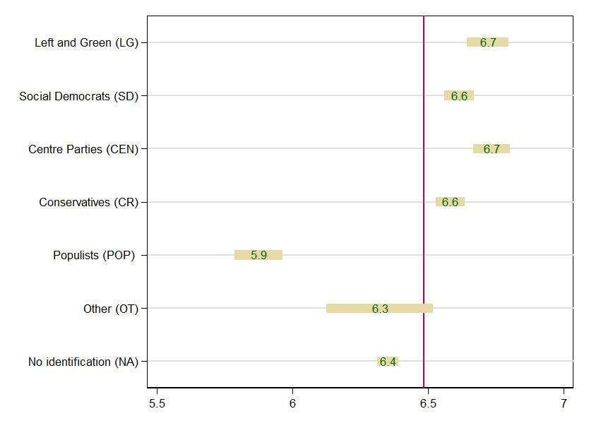
Figure 1

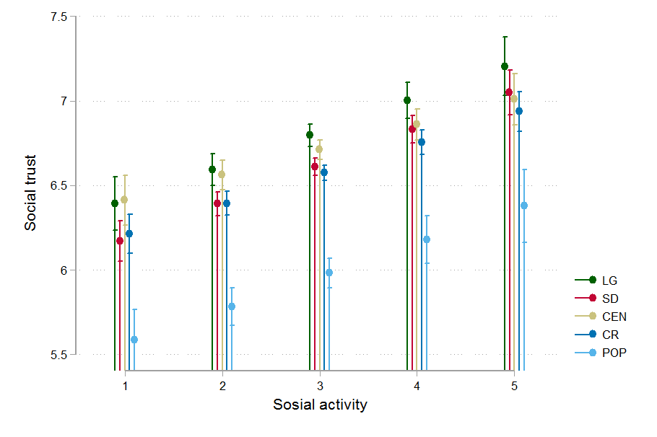
Figure 2

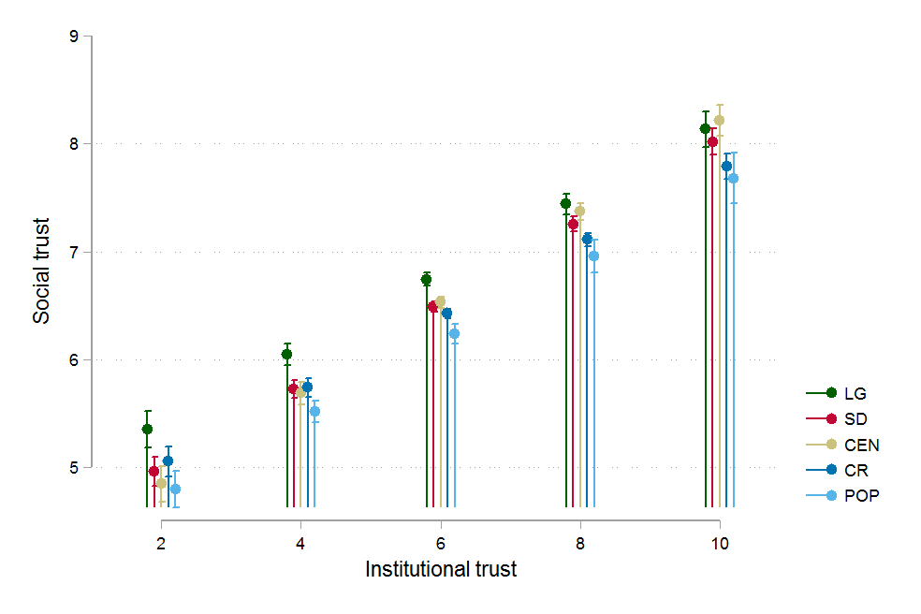
Figure 3

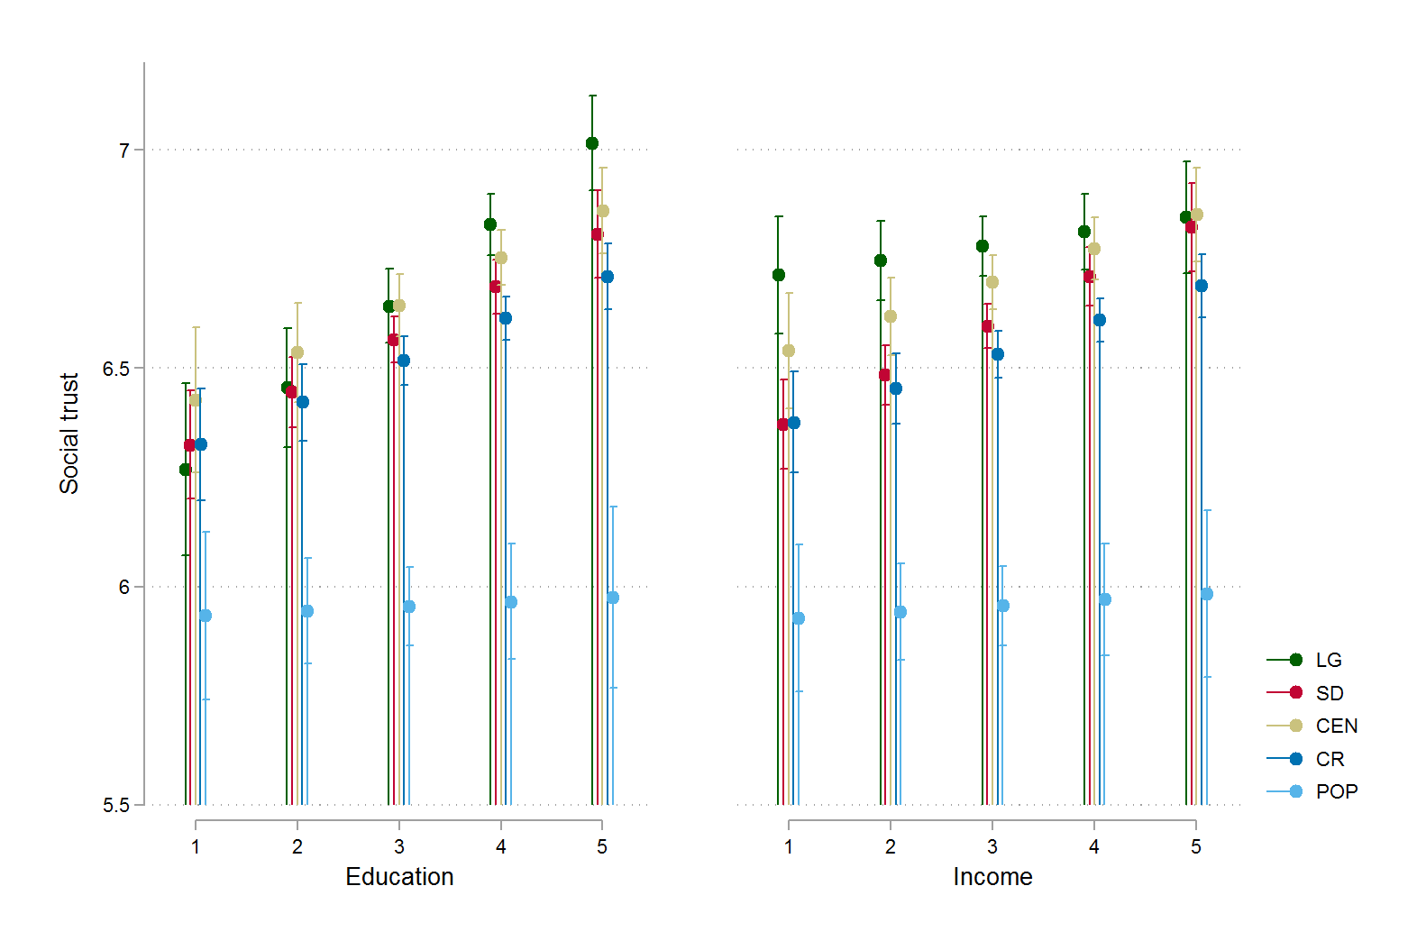
Figure 4

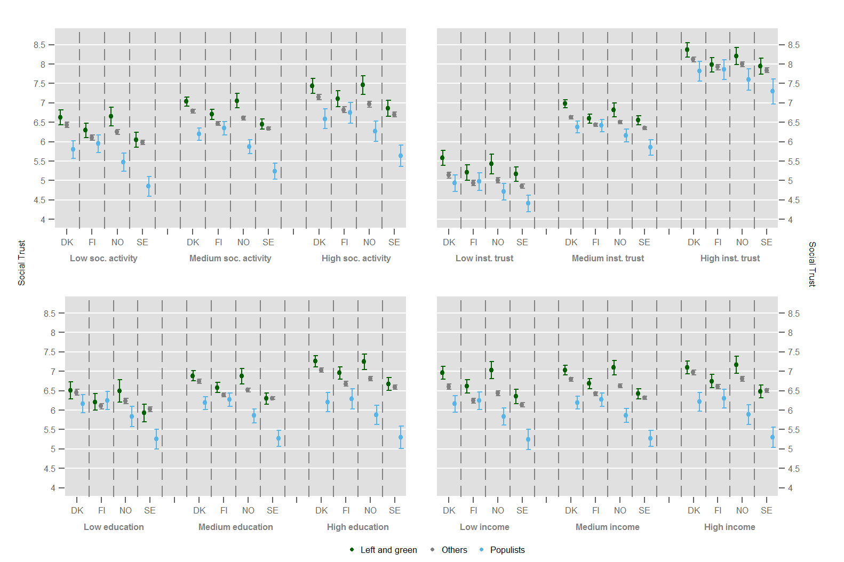
Figure 5

The group of populist parties in these four Nordic countries are: The Finns, Progress Party (Norway), Danish People’s Party, Sweden Democrats.

