Linkage of crustal deformation between the Archaean basement and the Proterozoic cover in the Peräpohja Area, northern Fennoscandia

Simo Piippoª, Pietari Skyttä^{b}, Armelle Kloppenburg^{c}

ª Department of Geosciences and Geography, FI-00014 University of Helsinki, Finland
^{b} Department of Geography and Geology, Geology Section, FI-20014 University of Turku, Finland
^{c} 4DGeo/Structural Geology, Daal en Bergselaan 80, 2565 AH The Hague, The Netherlands

Abstract
Reconstructed variations in stratigraphic thicknesses combined with mapped variations in fold-and-thrust belt structural styles and patterns of the entire Palaeoproterozoic Peräpohja Belt in northern Finland show that both the deposition of the 2.4-1.9 Ga supracrustal rocks and the structural evolution during the subsequent Svecofennian Orogeny (1.9-1.8 Ga) have been tightly controlled by (i) the palaeo-topography of the Archaean (>2.5 Ga) basement, and (ii) the reactivation of Archaean basement faults during the multiple stages of rifting and deposition of the supracrustals, as well as during subsequent basin inversion and fold-and-thrust belt development. Folds and thrusts in the supracrustal sequence are found to be largely detached from the underlying basement along the Petäjäskoski Detachment Zone (PDZ) that formed within a mechanically weak stratigraphic unit in the basal part of the Peräpohja Belt stratigraphy. The pattern of contractional structures is complex, but developed during one phase of simple, progressive south-vergent thrusting. Two styles of basement-cover linkage are recognised: The hard-linked style is best illustrated by the reverse Sihtuuna Fault currently defining the northern margin of the E-W to ENE-WSW trending basement horsts and the overlying anticlines, and juxtaposing the stratigraphically lowermost Peräpohja Belt rocks with higher-up stratigraphy, indicating the fault is inherited after a pre-existing basement structure. Based on the distribution and thickness variation of the Palaeoproterozoic supracrustal units, the faults bounding the basement horst were active as extensional faults during deposition. The soft-linked style relationship is evident as abrupt terminations of thrust-related elongate domes and localisation of the compressional overprint into the NW-SE trending central graben. Understanding the basement architecture and basement-cover linkages is highly significant because the majority of the known mineralizations of the belt are located along or close to the basement faults.

Keywords: Fold-and-thrust belt; detachment; structural inheritance; strain partitioning; Palaeoproterozoic

1. Introduction
Many known mineralized areas are part of contractional belts, with structures including folds and thrusts that are laterally discontinuous (e.g. Selley et al., 2005). Where these contractional belts are formed following closure and inversion of extensional basins — be it a passive margin, a continental, or a back-arc basin — they are often underlain by the extensional structures of the initial basin, including rotated extensional fault blocks, accompanying extensional faults and their accommodating transfer structures. Inherited extensional structures influence the location and geometry of the overlying folds and thrusts, whether the inherited faults are reactivated or not (thick- vs. thin-skinned thrust belts; e.g. Rodgers, 1949; Coward, 1983; Butler et al., 2006). As such, both the contractional but particularly the inherited extensional faults contribute to the network of conduits that tap into deeper crustal fluid sources, forming a primary structural control on resource plays, whether it is a mineral, a hydrocarbon, or a geothermal systems (e.g. Barnicoat et al., 2009; Hitzman et al., 2010; Bauer et al., 2014; Faulds and Hinz, 2015; Molli et al., 2015). For this reason, understanding the geometry and linkage of the extensional structures underlying any targeted fold and thrust belt is essential for optimizing exploration. Where prospective areas are of Archaean and Proterozoic age, the interpretation of the overall structural architecture is a particular challenge; not only do these areas have a longer and more complex geological history, also the nature of the Archaean crust, its tectonic style and structural behaviour is less well known.
Linkage between the basement extensional architecture and the overlying strata during ocean closure, basin inversion and development of fold and thrust belts has been long recognised and documented (e.g. Coward, 1994, Turner and Williams, 2004; Bonini et al., 2010; 2012; Pfiffner, 2016). Such basement-cover linkages include for example fold-and-thrust belts where pre-thrusting structures controlled the deposition and extent of the unit that then forms the basal decollement, leading to the generation of zones of mechanical weakness during thrusting (Laubscher, 1985; 1987; Homberg et al., 2002). Recognition of decollement zones is a key factor governing strain partitioning within orogeny as exemplified by e.g. in the Cape Smith thrust-fold belt and the Helvetic Nappes of the Alps (Picard et al., 1990; St-Onge et al., 1999; Pfiffner, 2016). Understanding the linkage between the decollement zones and pre-existing structures may further reveal where second-order structures like thrust ramps and folds are localised (e.g. Nussbaum et al., 2017), and for this reason, the observed compressional structures may be used as a tool to map out and understand the underlying, often less well exposed pre-compressional structures.
The Palaeoproterozoic Peräpohja Belt in northern Finland (Fig. 1) is an inverted, low to medium-grade failed rift with good potential for mineralization, including known sedimentary copper and gold deposits (Eilu, 2016; Vanhanen et al., 2015; Nykänen et al., 2017), as well as chromium and PGE deposits in the underlying 2.44 Ga layered intrusions (Halkoaho, 1993; Alapieti et al., 1990; Alapieti and Lahtinen, 2002; Iljina and Hanski, 2005; Huhma et al., 2018). The inferred origin as a failed rift (Gaál, 1990) links the Peräpohja Belt to the break-up of the Archaean continent and, hence, the important transition from the Archaean to the Proterozoic at around 2.5 Ga (Williams et al., 1991; Bleeker, 2004; Van Kranendonk et al., 2012; Kamber, 2015). Extensive stratigraphic studies over the Peräpohja Belt have been conducted (Perttunen, 1991; Perttunen et al., 1996; Perttunen and Hanski, 2003; Perttunen, 2006), and the recent recognition of the evaporitic depositional environment (Kyläkoski et al., 2012) is of high significance within the context of sediment-hosted copper deposits (Hitzman et al., 2010). Results from new geochronological constraints on the (sedimentary) evolution (Ranta et al., 2015) and structural investigations (Lahtinen et al., 2015a,b; Nironen, 2017) have been reported but, as yet, coupling the structural and stratigraphic evolution at the scale of the belt as a whole has not been sufficiently made.
The aim of this paper is to characterise the structural signatures within the Peräpohja Belt which is the cover sequence of the underlying Archaean basement, and to recognise potential basement-cover linkages. Furthermore, we delineate which basement structures had the greatest influence over the evolution of the cover sequences and whether the interactions are characterized by hard-link or soft-link type structures. To characterise the structural signatures and finally the basement-cover relationship, we first delineated the major deformation zones and correlated them with the belt-scale patterns of strain partitioning, and the occurrence and thickness variation of the main stratigraphic units. Subsequently, we characterised the thrust-and-fold-belt style deformation and linked the recognised structural style and vergences with the map-scale patterns of folds and secondary deformation zones. Moreover, we observed and interpreted the deviations from the characteristic fold-and-thrust-style deformation and evaluated whether they were potentially linked to inherited basement discontinuities. The primary aim was to recognize individual extensional faults and discontinuities, and larger depositional sub-basins controlled by such faults, and the derived basement palaeotopography. In the process of coupling the structure with the stratigraphy we further distinguished between the faults rooted in the basement and those controlled by the heterogeneous mechanical strength of the cover sequence.
The results of this work indicate that the first-order strain partitioning within the Peräpohja Belt was defined by a previously unrecognised major detachment zone (Petäjäskoski detachment zone, PDZ) developed within a mechanically weak layer. The PDZ separates the shallower and deeper crustal domains of penetrative folding and rigid block faulting, respectively, but also controls over the generation of the secondary faults and asymmetric folds of the belt. The results also indicate that further deformation localisation during the compressional overprint of the Peräpohja Belt was caused by faults rooted at the discontinuities within the Archaean basement.
As a consequence of the recognised basement control, much of the contractional structural variability and overprinting within the Peräpohja Belt may be explained by one major south-verging thrusting event instead of several compressional events with highly contrasting stress orientations (e.g. Kyläkoski et al., 2012; Lahtinen et al., 2015). The reconstructed 3D extensional fault network within the Archaean basement (Skyttä et al., 2019), with an understanding of the reactivations and the subsequent development of compressional structures (faults and folds) at 1.9-1.8 Ga provides the structural framework for understanding the preferential transport routes and emplacement locations of metals in the crust and may hence provide new concepts for mineral exploration, that allow further fine-tuning of structural layers in prospectivity mapping (Nykänen et al., 2017).

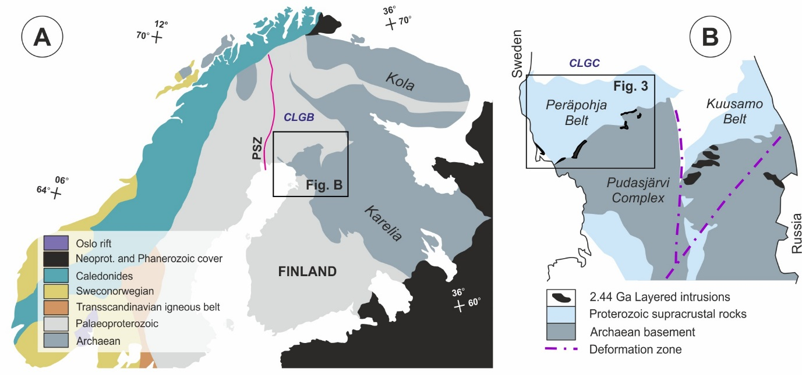
Fig. 1. A: A geological overview of the Fennoscandian Shield. CLGB = Central Lapland Greenstone Belt, PSZ = Pajala Shear Zone. B: The location of the supracrustal Peräpohja and Kuusamo Belts with respect to their Archaean basement and the 2.44 Ga layered intrusions. CLGC = Central Lapland Granitoid Complex.

2. Geological setting
The Palaeoproterozoic Peräpohja Belt (PB) in Northern Finland is an intracontinental rift characterized by prolonged depositional history from 2.4 to 1.9 Ga, moderate tectonic overprint under greenschist to amphibolite facies metamorphic conditions during the Svecofennian orogeny at 1.9 -1.8 Ga, and the presence of gold and base metal mineralizations and prospects (Perttunen, 2006; Kyläkoski et al., 2012; Eilu et al., 2016; Vanhanen et al., 2015). The sparsely outcropping Archaean basement and the 2.44 Ga PGE-bearing layered ultramafic intrusions (Alapieti and Lahtinen, 2002) form the depositional basement for the Peräpohja supracrustal rocks.
The sedimentary record of PB indicates an early subaerial or shallow water depositional environment (Ojakangas, 1965; Perttunen and Hanski, 2003) including evaporitic conditions (e.g. Kyläkoski et al., 2012) and a later progression to deeper water environment (Perttunen, 1991; Vanhanen et al., 2015). Based on correlation of the PB stratigraphy with the apparently similar stratigraphy in NW Russia, the depositional history has been divided into three major basin stages (Vanhanen et al., 2015 and references therein): i) The Early Stage (2.4-2.1 Ga) with a continental margin, dominated by non-marine siliciclastic rocks and mafic volcanism, ii) The Middle Stage (2.1 Ga) resulting in deposition of shallow to non-marine carbonate rocks and quartzites, and iii) The Late Stage (2.0-1.88 Ga) characterized by development of considerable topographic relief and deposition in the oceanic environment. The changes in the depositional environments and the long history of the PB lead to the development of several regional unconformities within the Belt (Vanhanen et al.; 2015). The sediments and volcanic material of the Early and Middle Basin Stages total approximately 3-4 km in thickness, whereas the thickness of the Late Basin Stage is 1-2 km. Together the supracrustal rocks cover a 500 Ma period of deposition stretching through initial rifting at 2.45 Ga thorough continental break-up at 2.1-2.06 Ga, all the way to 1.98 Ga (Perttunen and Vaasjoki, 2001; Karhu et al., 2007; Hanski et al., 2005; Kyläkoski et al., 2012; Ranta et al., 2015; Vanhanen et al., 2015). This paper adopts the use of the three major basin stages (see above), but in handling the stratigraphy within PB, the more detailed stratigraphic column reviewed by Kyläkoski et al. (2012) is used.

2.1. Early Basin Stage
The 2.4-2.1 Ga Early Basin Stage comprises the Sompujärvi, Palokivalo, Petäjäskoski and Jouttiaapa formations (Fig. 2). The Sompujärvi Formation (Fm) is the lowest stratigraphical unit of the Peräpohja Belt, deposited on top of the Archaean Pudasjärvi Basement Complex and the PGE-bearing 2.44 Ga mafic layered intrusions (Alapieti et al., 1990; Alapieti and Hanski, 2002; Iljina and Hanski, 2005; Perttunen, 1991; Hanski and Melezhik, 2012). The Sompujärvi Fm consists of arkoses, quartzites and polymictic conglomerates with pebbles of granite, layered plutonic rocks, and PGE bearing layered intrusion rocks (Perttunen, 1991; Perttunen and Hanski, 2003). The rocks of the Sompujärvi Formation occur dominantly along the SW-NE trending Archaean-Proterozoic (AP) contact in the South-East, with 50 m maximum thicknesses. The mafic volcanic rocks of the >2.25 Ga Runkaus Fm (Huhma, 1991; Perttunen and Hanski, 2003) occur close to the AP-contact and totals 40-100m in thickness (Perttunen, 1991). Isolated occurrences of both Sompujärvi and Runkaus Fm rocks have been recognised also within the central parts of the PB (Perttunen and Hanski, 2003). The Palokivalo Formation comprises clastic orthoquartzites deposited in subaerial or shallow water conditions (e.g. Perttunen 1991), ranges approximately between 1-2 km in thickness (Perttunen, 1991; Kyläkoski et al., 2012), and its minimum depositional age is c. 2.22 Ga (Hanski et al., 2010).
The 2.22–2.14 Ga Petäjäskoski Formation is a mechanically weak package of fine-grained and intensely deformed phlogopitic-sericitic and albitic schists with abundant hematite, with dolomite and quartzite interbeds. Geochemical data and primary features including crackle-type breccias deforming the primary beds and up to tens of meters thick stratabound collapse breccias have been attributed to deposition within an evaporitic environment. The thickness of this Fm is several hundreds of meters, but exact constraints may not be given as its base is not exposed. The formation is only exposed at one locality but can be recognised elsewhere by its distinct electromagnetic signature (Kyläkoski et al., 2012). The 2105 ± 50 Ma (Huhma et al., 2018) tholeiitic basalts of the Jouttiaapa Formation comprise a 300-1000 meters thick succession of basin-wide continental flood basalts, which are geochemically virtually uncontaminated and exceptionally rich in PGE (Hölttä et al., 2003; Kyläkoski, 2007). The basal contact with the overlying quartzites of the Kvartsimaa Fm is sheared and hydrothermally altered (Kyläkoski, 2007).
Formations with ambiguous relationships to other PB units include the Kaisavaara Formation and the superimposed Santalampi Formation (Perttunen and Hanski, 2003; Kyläkoski et al., 2012). The Kaisavaara Fm has been tentatively correlated to the Palokivalo Fm (Perttunen and Hanski, 2003; Vanhanen et al., 2015), while no unanimous belt-scale correlations for the Santalampi Fm have been presented. For this problematic interpretation of Kaisavaara Fm to be correct, the Santalampi Fm must represent a geochemically unique part of the Jouttiaapa Formation (Perttunen and Hanski, 2003).

2.2. The Middle Basin Stage
The approximately 2.1 Ga Middle Basin Stage comprises the relatively thin Kvartsimaa, Tikanmaa, Poikkimaa, Rantamaa, Hirsimaa and Lamulehto Formations, that together form a usually < 2 km thick sequence. Heterogenic arkoses and quartzites of the Kvartsimaa Formation (Perttunen, 1991) represent a considerable change in the depositional environment, and were probably deposited on an unconformity (Vanhanen et al., 2015). Most of the mafic tuffites in the PB belong to Tikanmaa Formation, which is typically 200-300 meters thick, but completely absent at some locations (Perttunen, 1991). The geochemical signatures of the Tikanmaa rocks resemble those of the Jouttiaapa Formation basalts (Perttunen, 1989). The rest of the Middle Basin Stage sequence mostly comprises dolomites of the Poikkimaa and Rantamaa Formations (Perttunen, 1991), together with the mafic tuffite interlayers of Hirsimaa Formation (Perttunen and Hanski, 2003). The uppermost rocks of the Middle Basin Stage are the mafic tuffites of Lamulehto Formation (included in the “Late Basin Stages” by Vanhanen et al., 2015), that causes a distinct positive magnetic anomaly (Perttunen and Hanski, 2003

2.3. The Late Basin Stage
The 2.0-1.88 Ga Late Basin Stage comprises the Martimo, Pöyliövaara, Korkiavaara and Väystäjä Formations totalling 1-2 km in thickness, and reflects deposition in a deepening oceanic basin. The Martimo Formation consists of turbiditic greywackes, phyllites and mica schists, some of which are carbon- and sulfide-bearing and cause clear continuous electromagnetic anomalies (Perttunen, 1991; Perttunen and Hanski, 2003). The upper parts of Martimo Formation represent the youngest supracrustal rocks of the area with a maximum age of 1.91 Ga obtained from youngest detrital zircons (Ranta et al., 2015). The Pöyliövaara, Korkiavaara and Väystäjä Formations occur solely in the northern parts of the Belt (Kyläkoski et al., 2012), and their stratigraphic positions relative to Martimo Formation are unclear (Perttunen, 2006; Ranta et al., 2015).

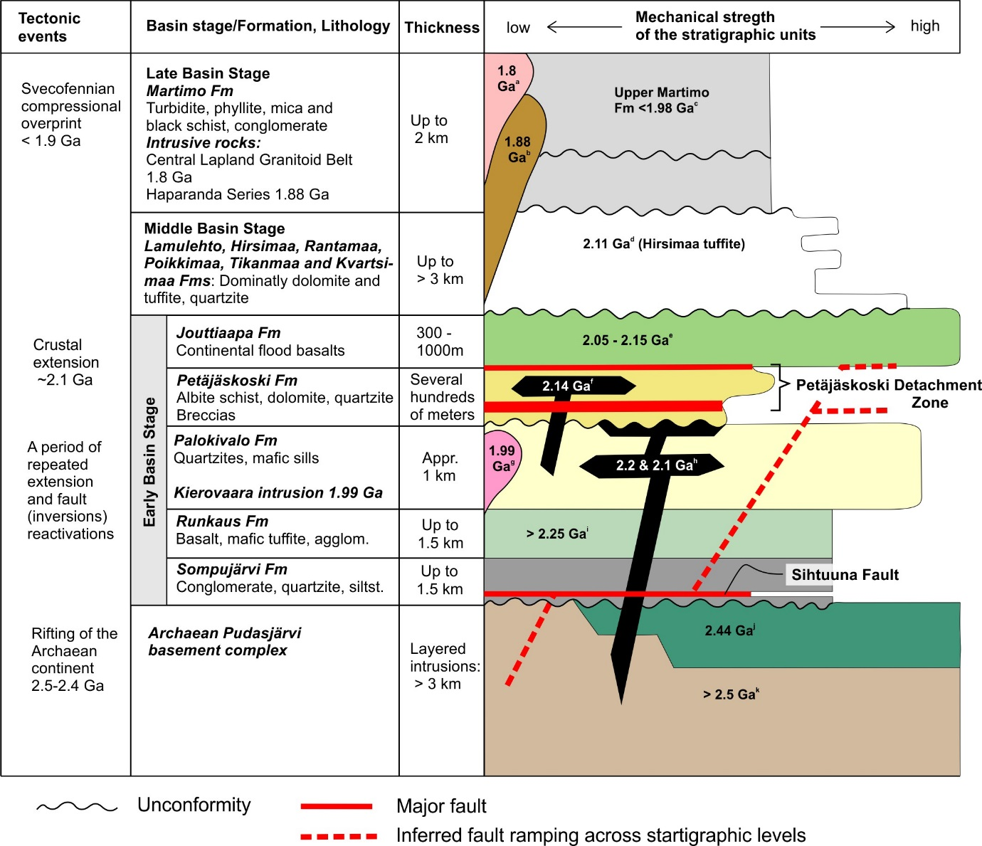

Fig. 2. A summary of the Peräpohja Belt stratigraphy including the major tectonic events, the first-order faults as recognised in this study, and inferred mechanical strengths of the formations. Stratigraphic column is mostly based on Perttunen (1991), Perttunen and Hanski (2003) and Kyläkoski et al. (2012). Age determinations from: a) e.g. Lauri et al. (2012), b) e.g. Lehtonen et al. (1998), and Perttunen and Vaasjoki (2001), c) Ranta et al. (2015), d) Karhu et al. (2007), e) Hölttä et al. (2003), f) Kyläkoski et al. (2012), g) Ranta et al. (2015), h) Perttunen and Vaasjoki (2001), and Hanski et al. (2010), i) Huhma et al. (1990), j) Kouvo (1977), and k) Perttunen and Vaasjoki (2001).

2.4. Intrusive rocks cutting the Peräpohja supracrustal rocks
At least three groups of mafic sills and dykes can be recognised in the PB: 1) c. 2.22 Ga dykes usually hosted by the Palokivalo or Runkaus Formations (Perttunen and Hanski, 2003; Hanski et al., 2010); 2) the c. 2.1 Ga sills and dykes intruding the Palokivalo quartzites (Perttunen and Vaasjoki, 2001); and 3) the c. 2140 Ma sill within the Petäjäskoski Formation (Kyläkoski et al., 2012). The group 3 sill is potentially comagmatic with the upper parts of the Jouttiaapa Fm (Ranta et al., 2015 and references therein), whereas Groups 1 and 2 are not related to the stratigraphically upper volcanic units (Perttunen, 1989). Intrusions within the PB area comprise the 1989 ± 6 Ma anorogenic Kierovaara granite (Ranta et al., 2015), the 1.88 Ga syntectonic Haaparanta Series (Lehtonen et al., 1998; Perttunen and Vaasjoki, 2001) and the 2.1-1.76 Ga Central Lapland Granitoid Complex (e.g. Ahtonen et al., 2007; Lauri et al., 2012) rocks in the North.

2.3. Structural and metamorphic framework
The PB is a large synclinorium comprising several contiguous major anticlines and synclines with roughly E-W trending fold axes, characterized by a fold-and-thrust belt style deformation (Perttunen, 1991; Piippo et al., 2015). In seismic images, the Peräpohja Belt forms the southern part of the wider “Southern Proterozoic belt” which shows a faulted base indicative of horizontal movements with unknown magnitudes and kinematics (Patison et al., 2006). The concave-up Peräpohja Belt reaches a maximum depth of 4-5km, is characterized by seismic signatures indicative of thin-skinned deformation and an asymmetric overall structure with thickening towards the north (Patison et al., 2006). The contact of the Peräpohja Belt and the underlying >2.5 Ga Archaean depositional basement with the 2.44 Ga PGE-bearing layered intrusions in the Southeast is primary depositional whereas the contact towards North-Northeast with the Central Lapland Granitoid Complex (CLGC) is tectonised, and the Western margin of the Belt is bound by the major Pajala Shear Zone (Fig. 1; Perttunen, 2006; Lahtinen et al., 2015a). PB shows a progressive increase from low to medium metamorphic grade from South to Northeast, respectively, which has allowed preservation of primary structures particularly in the South (Perttunen and Hanski, 2003; Hölttä and Heilimo, 2017).
The structural evolution of the PB has been previously divided into three to five separate deformation phases, based on local studies (Salonsaari, 1990; Lappalainen, 1995; Perttunen et al., 1996; Kyläkoski, 2007; Kyläkoski et al., 2012), considered to reflect near-orthogonally shifting principal stress orientations during successive events at 1.92-1.77 Ga (Lahtinen et al., 2015b). The deformation phases D₁ to D₃ can be generalized to major belt-scale events: D₁ produced recumbent isoclinal folds and pervasive layer-parallel schistosity (S₁). The details of this event are unclear, and it has been attributed to either N-S oriented compression (Salonsaari, 1990; Kyläkoski et al., 2012), Southeast-vergent thrusting (Lappalainen, 1995; Perttunen et al., 1996) or East-vergent deformation (Lahtinen et al., 2015b; Nironen, 2017). D₂ generated upright to inclined folds with E-W trending axial planes during major N-S compression (e.g. Kyläkoski et al., 2012; Nironen, 2017) attributed to South-vergent thrusting (Piippo et al., 2015) and is responsible for the distinct map-scale fold patterns within the PB (Figs. 3-5). D₃ was characterized by a shift to E-W oriented compression and generation of open folds with N-S trending axial planes (e.g. Kyläkoski et al., 2012; classified as D₄ in Nironen, 2017).
Vanhanen et al. (2015) attributed the variable transpressional and -tensional stress conditions resulting in both uplift and basin formation to strike-slip tectonics, and further inferred that extensional stages were followed by an inversion already during the Late Basin Stages, i.e. prior to the Svecofennian orogeny. Vanhanen et al. (2015) proposed a 1.95 Ga age for the deformation at Rompas area, in the northern part of the PB, whereas Lahtinen et al. (2015b) constrained the age of their D₁ at ≤ 1.91 Ga. The dominating N-S compression at D₂ is constrained at approximately 1.88 Ga by the syn-tectonic Haaparanta Series intrusive rocks (Lehtonen et al., 1998; Perttunen and Vaasjoki, 2001; Kyläkoski et al., 2012), and D₃ at 1.88-1.86 Ga (Lahtinen et al., 2015b), while the younger events are less well constrained.

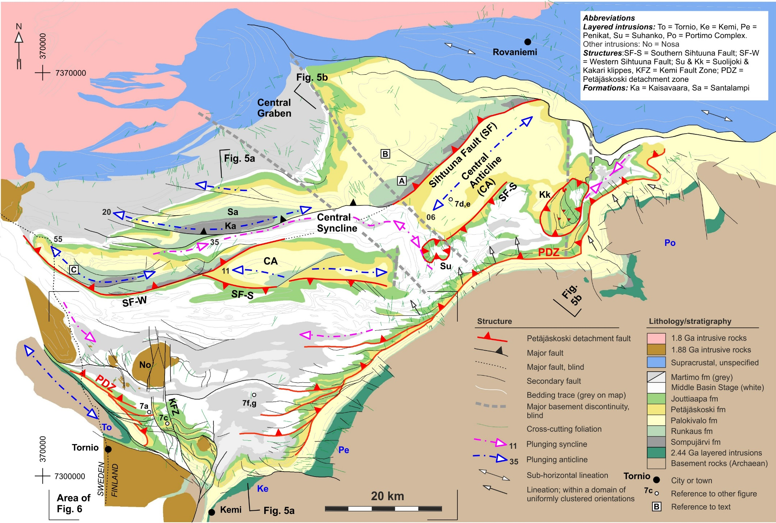
Fig. 3. (overleaf) Structural map of the Peräpohja Belt. Lineation data has been shown only in those areas with distinctly uniform orientations. Coordinates are in EUREF-FIN.

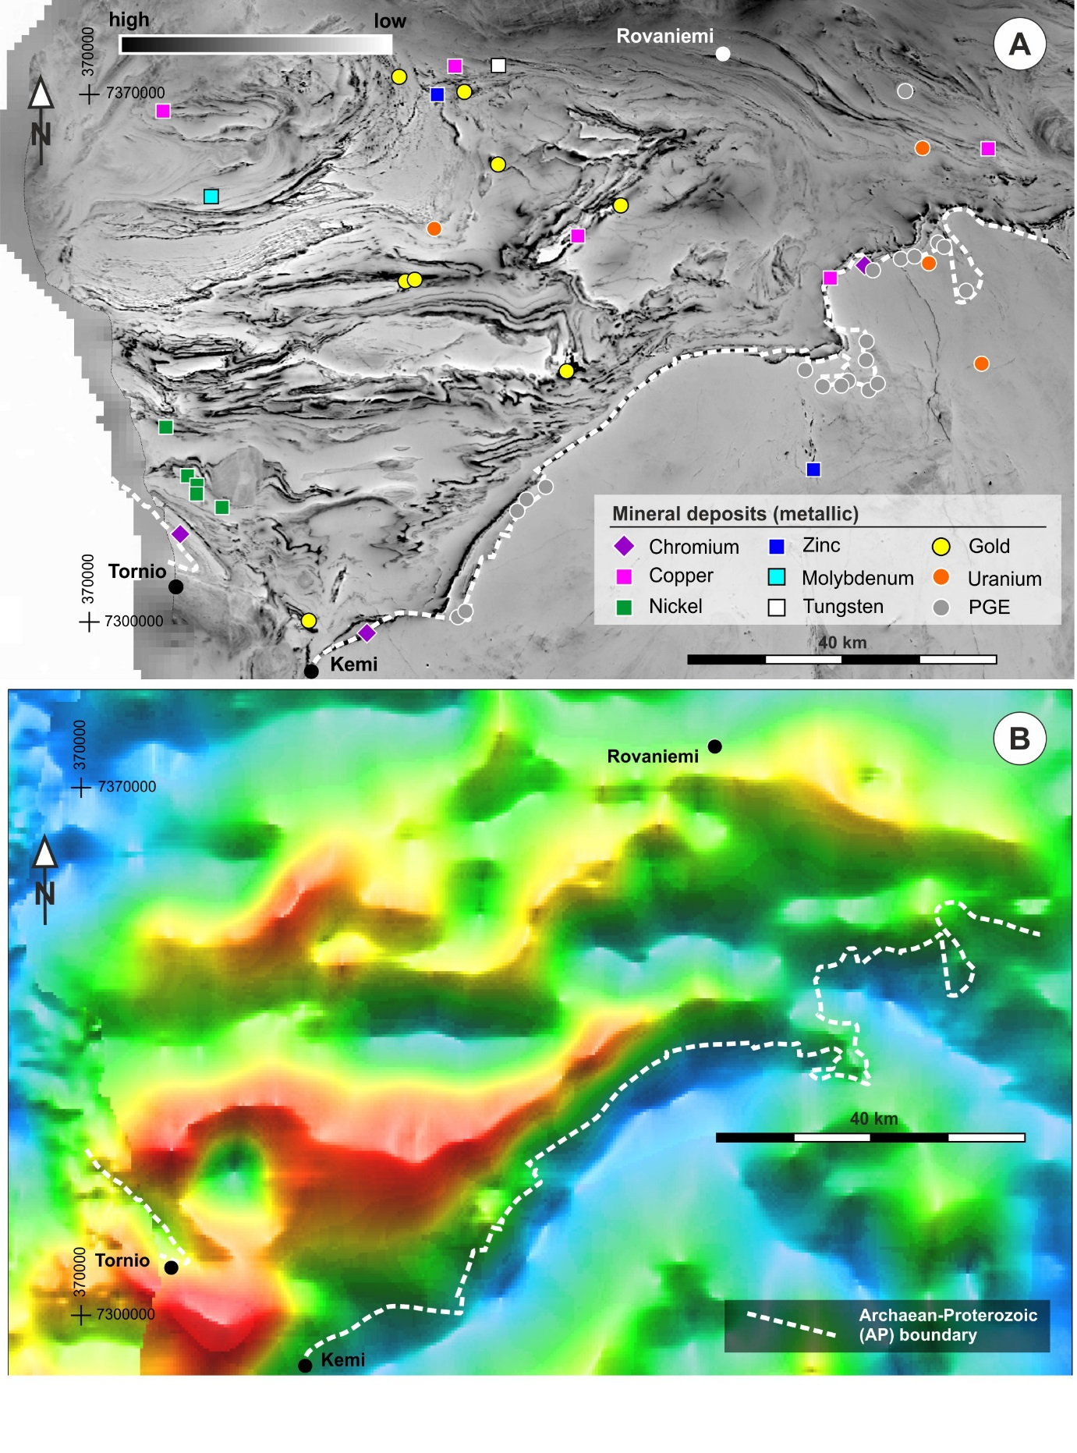
Fig. 4. A: Low-altitude aeromagnetic map over the study area, providing a key data source for the interpolation of the field data, and the distribution of the metallic mineral deposits. B: Regional-scale low-resolution gravimetric map (red, yellow and blue stand for positive, neutral and negative gravity anomalies, respectively). Data source Geological Survey of Finland (http://hakku.gtk.fi). Coordinates are in EUREF-FIN.

3. Methods and data
Within this study, we integrated existing geological and geophysical maps and data with additional detailed field observations and local drill core data to characterize the structural elements and patterns across the Peräpohja Belt (Fig. 3). Within the Peräpohja Belt supracrustal succession, the structural analysis comprised delineating major deformation zones and addressing their effect for the overall strain partitioning, and their correlation with the regional stratigraphy. In doing this, we evaluated the tectonic juxtaposition of the stratigraphic units and reassigned the stratigraphic position of specific units which correlation with the regional stratigraphy had previously been problematic. We further characterised i) the overall fold-and-thrust-belt style folding of the PB to understand the regional-scale structural geometry, including the relationship between the folds and faults, and ii) deviations from the dominant structural patterns to shed further light on the strain partitioning as potentially controlled by the structural discontinuities within the underlying basement. Finally, we analysed the thickness variations of the formations within the PB, and utilized the causal relationship between extensional faulting and creation of depositional space in interpreting the results. As a result, we recognised previously unknown faults (exposed and blind) and delineated sub-basins with contrasting depositional infills, including lacking parts of the stratigraphic pile and significant stratigraphic thickness variations.
The core of the used data was formed by geological field observation data (structural elements, lithology), and geological maps at the scales of 1:100 000 and geophysical (aeromagnetic, electromagnetic, gravity) maps with raster grid size ranging from 25 m to 400 m by the Geological Survey of Finland (GTK). Descriptions for the 1:100 000 geological map sheets by the Geological Survey of Finland (Perttunen, 1991; Perttunen et al., 1996; Perttunen and Hanski, 2003; Perttunen, 2006) provided important information used in analysing the coupling between the structure and the stratigraphy. These data were complemented by a more limited set of field data from the industrial collaborators (Mawson Resources Ltd. and First Quantum Minerals Ltd.). New field mapping conducted during this investigation comprised geological observations at 491 localities with a higher density within the well-preserved, low-grade southern part of the Peräpohja Belt, from which the structural interpretations were extrapolated regionally. Acquisition of new field data in the other parts of PB was focused on selected localities and transects to understand the structural styles, fold vergences and contact relations. Drill core data (National Drill Core Archive of GTK) was used where available to constrain the formation dips and thicknesses.

4. Structural signatures of the cover sequences
Ductile deformation within the Peräpohja Belt (PB) was largely controlled by the Petäjäskoski detachment zone above which the deformation is characterized by ductile asymmetric folds and thrusts with an overall southerly vergence. Furthermore, other recognised deformation zones and their coupling with the stratigraphy are indicative of an intimate basement-cover relationship.

4.1. Strain partitioning into, and characterization of, significant deformation zones
4.1.1. Petäjäskoski detachment zone, PDZ
An abrupt change from penetrative folds and faults within the upper parts of the Peräpohja Belt stratigraphy into laterally continuous, apparently undeformed underlying strata is defined by the Petäjäskoski detachment zone (PDZ; Figs. 2-4). The PDZ is hosted predominantly within the upper, but also along the lower parts of the Petäjäskoski Formation (Fig. 2), and occurs as a continuous NE-SW striking zone along the whole length of the south-eastern margin of PB, along the flanks of the central antiforms, and as a shorter and less pronounced SE-NW striking segment along the southwestern PB margin (Figs. 3 and 6). The zone generally is of low relief and outcrops only at one locality, but the available drill core data shows that the zone is a mica-rich, mechanically weak unit characterized by intense deformation (Kyläkoski et al., 2012).
Within the southern part of the study area (Fig. 3), the PDZ is characterized by a large number of E-W striking fault splays rooted along the basal detachment. The splays are associated with intense folding causing local stacking of the stratigraphy (Figs. 3 and 6). Furthermore, the Petäjäskoski Fm rocks have been squeezed tightly into the fold hinges, completely detached from their depositional basement in places. Development of asymmetric folding, minor apparent lateral displacements and localized tectonic repetition of the strata is frequently associated with splay-style fault termination (Figs. 3 and 6). Folding associated with the thrust splays is less pronounced along the southwestern than along the southeastern PB margin. No clearly discernible splays were developed along the flanks of the central anticline, but the PDZ may be recognised from the irregular detachment-style folding of the Jouttiaapa Fm throughout the belt, in particular along the southern flank of the central anticline.
Further expressions of strain localization into the weak detachment zone is provided by the two small (<10km) klippe structures, Suolijoki and Kakari, located within the eastern central parts of PB (Fig. 3). At Suolijoki, the thrusting localised along the top of Petäjäskoski Fm and displaced the Jouttiaapa Fm over the Middle Basin Stage strata, whereas the Kakari klippe is characterized by several bedding-parallel thrusts within the Petäjäskoski Fm, causing tectonic repetition of it and the Jouttiaapa Fm, and their separation from the underlying formations. At both occurrences, the allochthonous faulting has been overprinted by open folding correlated with the formation of the major syn- and anticlinal folding within PB (Section 4.3.), indicating progressive contraction, thrusting and folding.
The presence of PDZ has an important implication to the interpretation of the asymmetric folds along the AP-contact along the southern part of PB: folds associated with PDZ splays along the NW-SE and NE-SW trending contact segments have opposing asymmetries and axial plunges (Fig. 3; domains W1 and W2a vs. E in Fig. 6b). We attribute this to the development of two contrasting oblique thrust ramps forming the funnel-shaped Archaean-Proterozoic contact within the southern part of PB during the overall south-vergent thrusting (see Section 4.3.). As a result, the lateral component of slip along the basal detachment and its splays have sinistral and dextral senses along the SW-NE and SE-NW striking ramps, respectively (Figs. 3 and 6). By contrast to the southwest, the northeastern segment of the PDZ is not associated with apparent folding or development of fault splays. The straight and continuous character of the PDZ and the SE vergence (Section 4.3) of the major folds within the Palokivalo Fm rocks to the northwest suggests that the PDZ within this segment was a reverse slip fault with negligible strike-slip components as seen from the dominantly orthogonal orientation of the distinctly clustered lineations with respect to the PDZ (Fig. 3).

4.1.2. Other important zones and their bearing on the regional stratigraphy and fault systems
We have extended a previously recognised E-W striking major fault (hereafter Sihtuuna Fault, SF) within the central part of the belt towards the ENE by assigning the previously unclassified conglomerates with granite pebbles (“A” in Fig. 3; Perttunen and Hanski, 2003) to the Sompujärvi Fm, justified by their occurrence below the Runkaus Fm and juxtaposition with the underlying, intensely deformed Petäjäskoski Fm rocks. The stratigraphic order, clear aeromagnetic discontinuity and the steeply-dipping to subvertical and locally overturned character of layering within the above contact zone indicates that the Sihtuuna Fault is a NW-dipping reverse fault (Fig. 5). In line with the reverse faulting along the SF, several other occurrences of the Sompujärvi Fm rocks have been inferred within the cores of elongated domes whose southern flanks are bound by SF and which display continuous stratigraphic younging towards north (Figs. 3 and 5). The largest of the above occurrences has previously been known as the Kaisavaara Fm. Its deviating sedimentary material with respect to the Palokivalo Fm quartzites (Perttunen and Hanski, 2003) and the continuous stratigraphic record towards north support its inclusion within the Sompujärvi Fm. Another adjustment to regional stratigraphy is the assignment of the Santalampi Fm to the Runkaus Fm (North of Kaisavaara in Fig. 3), based upon: i) similar magnetic signatures arising from the presence of numerous mafic dykes and ii) similar geochemical signatures (Figs. 29-31 in Perttunen and Hanski, 2003).
Another large, approximately E-W striking fault is located south of the western SF termination. Based on the similar style of deformation, we infer it to be the western segment (SF-W) of the main SF. Recognition of the Runkaus Fm rocks within the core of the western central anticline (Fig. 3), associated with a ENE-WSW striking fault highlights the significance of the ENE-WSW to NE-SW structural orientations within the cover sequences. Consequently, we infer that SF-W is the southwestern branch of SF, soft-linked to the main SF branch by a blind ENE-WSW relay structure occurring below the central syncline (Fig. 3). The western part of the main SF terminates by development of successive splays whose orientation is parallel to the westernmost part of SF-W. We attribute the flexure of the westernmost parts of the Sihtuuna fault system into NW-SE strikes to the penetrative NW-SE structural trends within the footwall rocks of the fault, reflecting the presence of the Archaean basement in the southwest. This implies that the NW-SE striking elongate Archaean dome extending to the northwest on the Swedish side of the border represents the primary orientation of the AP-contact and the western margin of the Peräpohja Belt. The spatial correlation of the gravity anomaly and the central anticline suggests that the anticline is underlain by an approximately symmetric basement horst (Figs. 4 and 5). Consequently, we interpret that the southern edge of the horst is defined by the Southern Sihtuuna Fault (SF-S) which is a conjugate to the main Sihtuuna Fault (Figs. 3 and 5).
Summing up, two fault styles have been recognised: Firstly, development of the observed detachment surfaces related to the PDZ and the klippe structures indicate that the incompetent Petäjäskoski Fm caused significant deformation localization. The geometry and relationship with the stratigraphy indicates that the faults are (mainly) controlled by the weak lithological layers and any basement control on them is indirect (soft-linked; see Section 6.1). Secondly, belt-scale reinterpretation of the extent of the Petäjäskoski Fm (Fig. 3) shows that it frequently occurs along the footwalls of most reverse faults such as the Sihtuuna fault, and hence likely contributed to their localization as well. By contrast to PDZ and the faults bounding the klippes, localized entirely within the Petäjäskoski Fm, the reverse faults exposing the Sompujärvi Fm must have deeper roots, from where they cut upwards through the stratigraphy and merge with the deformation zones within the Petäjäskoski Fm. This suggests that SF represents an inverted normal fault that originated along a basement discontinuity that affected the whole stratigraphic package (hard-linked), and also contributed to depositional thickness variations (Section 5). Recognition of the significantly thicker successions of the Sompujärvi and Runkaus Formations within the central parts of PB with respect to their previously known occurrences (Perttunen, 1991), and their spatial correlation with the major faults suggests that coupling between the structure and stratigraphy is of wide extent and significance.

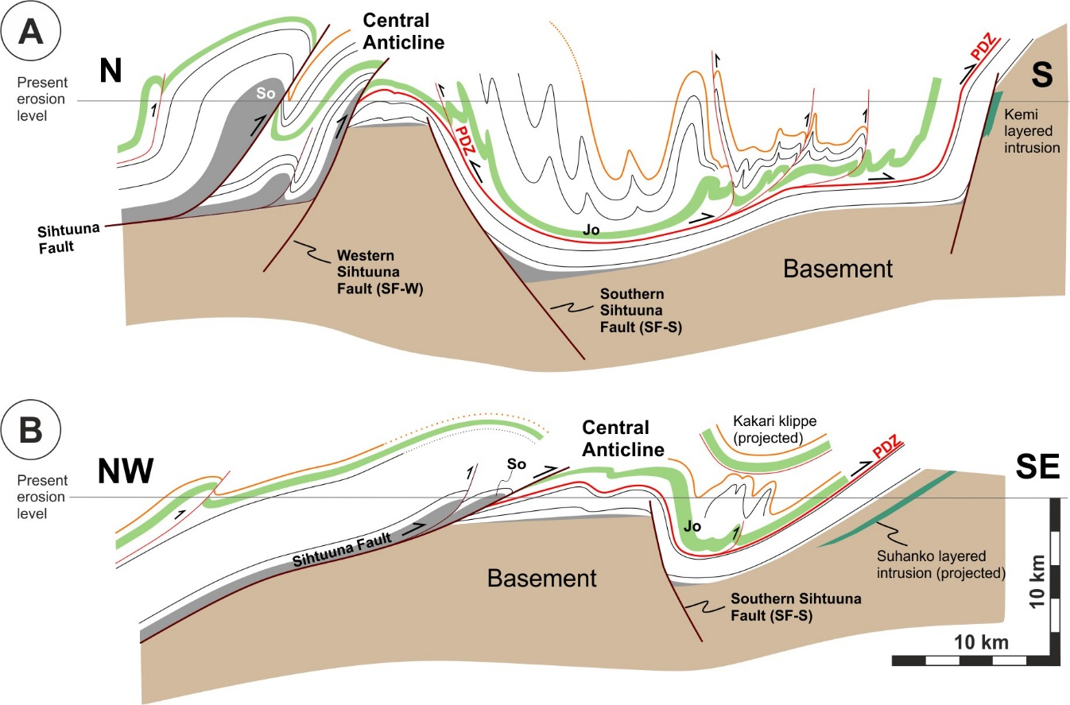
Fig. 5. Cross-sections illustrating the structure and stratigraphy of the Peräpohja Belt. See Fig. 3 for locations of the sections. So = Sompujärvi Fm, Jo = Jouttiaapa Fm. Top of the Middle Basin Stage sequence is marked with the orange line and the black lines represent sedimentary contacts between other formations. The Suolijoki klippe is not shown and the lithology is simplified after Fig. 3 for clarity.

4.2. Compartmentalisation of the belt based on cross-cutting structural features
The most distinct structural discontinuities that cut across the regional structural grain are the approximately N-S striking faults extending from the AP-contact in the south towards the central parts of the belt as the loosely defined Kemi fault zone (KFZ; Figs. 3 and 6). In the south, the zone is characterized by one N-S fault bounding the SE-NW trending segment of the AP-contact zone in the west, associated with tight synclinal folding on its eastern side. Further north, a series of faults delineate the contact between the Middle and Late Basin Stage rocks, and branches towards NNW to form a fault zone which causes compartmentalization of the crust, shown as stratigraphic repetitions and contrasting structural orientations between the compartments (Figs. 3 and 6). Specifically, the N-S fault delineates a narrow NNW-SSE trending zone where a set of fold axes displays moderate to steep northerly plunges clearly deviating from the dominant E-W to NW-SE fold axial trends (Fig. 6b). Moreover, the atypically oriented NW-vergent thrust of Fig. 7c is located within this zone, and is here interpreted as a back-thrust. The western branches of the KFZ terminate within the Late Basin Stage rocks, after transecting the 1.88 Ga Nosa intrusion as discrete N-S faults.
In contrast to the KFZ, the other recognised N-S structural features occur as blind structures which define the abrupt eastern termination of the central anticline and pinching of the Early Basin Stage strata North of the Kakari klippe (Fig. 3). One further set of major blind structures defines a wide NW-SE trending zone within the central part of the belt. In the south, the zone is delineated by the flexure of the central syncline where it cross-cuts the central anticline. Towards northwest, the margins of the widening zone are defined by the ductile dextral drag and structural transposition into NW-SE trends in the southeast and northwest, respectively. Cross-cutting relationship with SF indicates that the NW-SE zone is an old feature (hereafter “central graben”) and, for this reason, inferred to arise from basement discontinuities. The patterns of foliation cross-cutting the primary layering but not associated with the axial surfaces of the folds are spatially associated to the minor NW-SE trending faults transecting the AP-contact, the KFZ faults, and in particular, with the NW-SE trending central graben (Fig. 3). Strong ductile structural transposition into NW-SE to WNW-ESE trends characterizes the northeastern margin of the Peräpohja Belt in the Rovaniemi area (Figs. 1 and 3), and overprints any primary features. Based on the dominantly sub-horizontal lineations within this domain (Fig. 3), we attribute the overprint to strike-slip deformation along the belt margin.

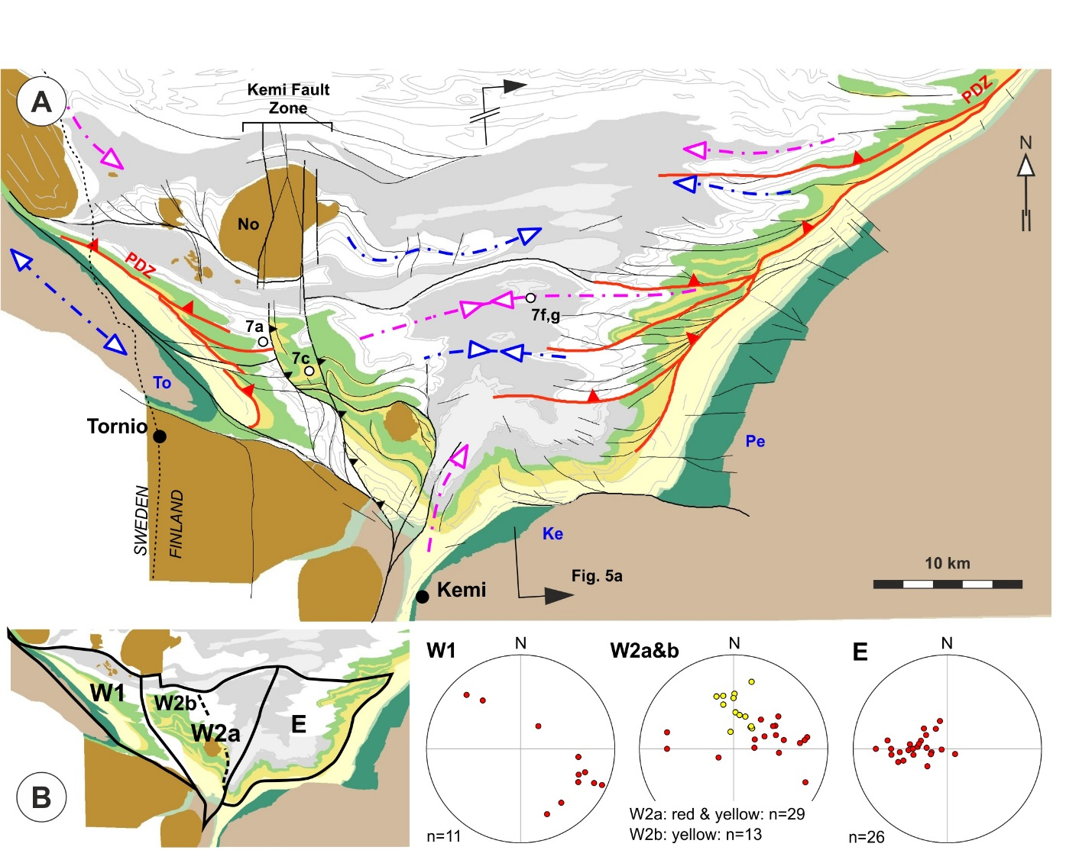

Fig. 6. A: Structure and simplified stratigraphy within the southern part of the belt. The symbology is as in Figure 3. B: Structural compartments with contrasting fold axis attitudes (red circles) reflecting the strain partitioning by opposingly dipping oblique fault ramps, and the effect of the Kemi Fault Zone structures (yellow circles). The stereographic projections are all lower hemisphere, equal-area projections.

Based on the pattern of the stratigraphic thickness variations within the PB (Fig. 5), we infer that a basement configuration of two horsts separated by a transfer zone (central graben), together with a few less continuous N-S structures controlled the deposition of the supracrustal successions. Timing-wise, the early extensional activity of the SF is evident from the spatially associated occurrence of thick Sompujärvi and Runkaus Fm successions. In contrast, the timing of the other compartment-bounding faults is less constrained. Faults delineating the central graben pre-date the reverse faulting along the SF, but as they do not cross-cut the Archaean-Proterozoic boundary in the south-east, they may not be unequivocally attributed to an extensional stage. Initially, we attribute the recognised fault pattern to rifting of the Archaean basement at around 2.5-2.4 Ga (e.g. Laajoki, 2005), and subsequent reactivation of the rift faults.

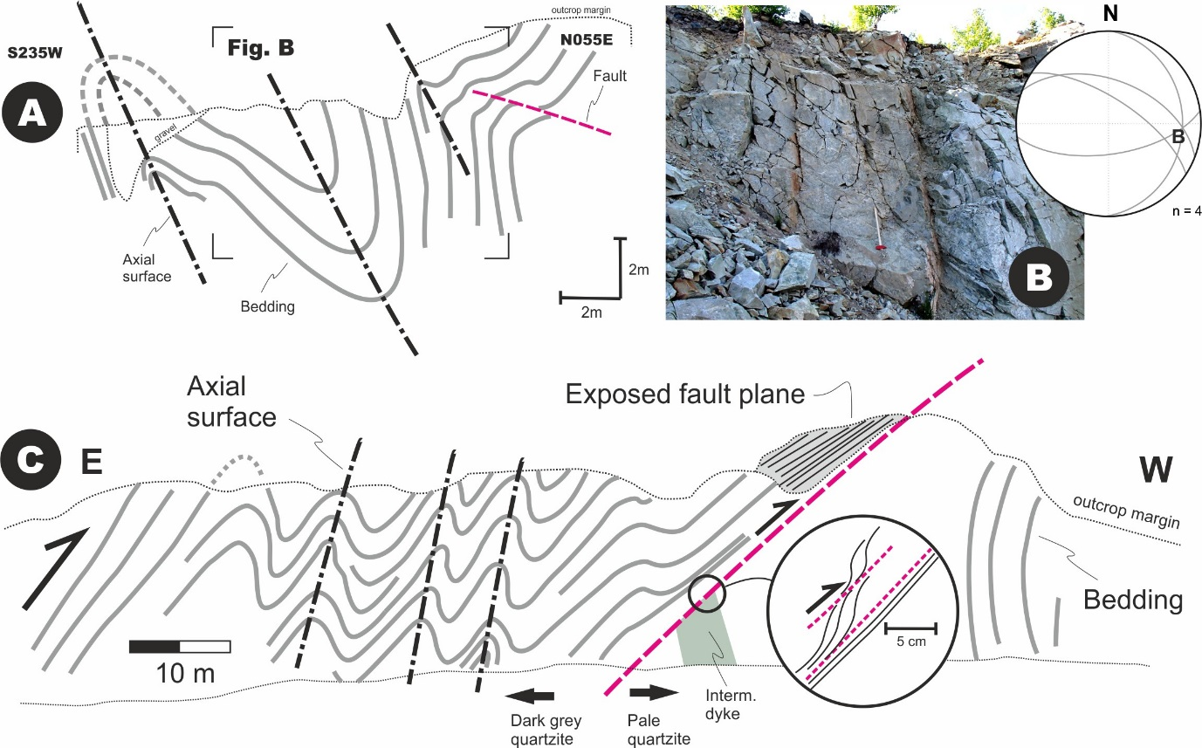
Fig. 7. Part 1, caption overleaf.

4.3. Character of the folding
Ductile deformation of the Peräpohja supracrustal rocks is characterized by asymmetric, roughly parallel-style folds with dominant southerly to south-easterly vergences (Fig. 7a-b; Nieminen, 2016). The close relationship between folding and faulting is evident from a > 50 m transect across a folded sequence in a quarry wall, where a discrete reverse fault separates asymmetrically folded, locally overturned strata within the hanging-wall from the subvertically dipping rocks in the footwall (Fig. 7c). Similar relationships are observed throughout the belt as the majority of the folds are bound by the PDZ and its splays along their short, steeply-dipping to overturned, frequently disrupted southern limbs (Figs. 3, 5). Towards NW, fold axial surfaces display SW-NE strikes and less pronounced map patterns, the latter reflecting the overall lower strain in the northeastern part of the belt (Figs. 3, 5b).
The folds are curvilinear, with dominantly sub-horizontal to gently-plunging axes. The doubly-plunging nature of the anticlines and synclines is responsible for the map pattern characterized by elongate domes and basins, particularly distinctive in the southern and central part of the PB (Fig. 3). Pronounced sub-vertical extrusion is observed in the southernmost part of PB where south-vergent thrusting and funnel-shaped geometry of the AP-contact resulted in a domain of sub-vertical corner flow as illustrated by the steepening of the fold axes towards sub-vertical plunges within the Martimo Fm metasedimentary rocks (Figs. 6b, 7g), and the more circular character of the fold patterns with respect to the dominant elongate ones further north (Figs. 3 and 6). Analogously, we attribute the steep plunges of the anticline hinges within the hanging-wall of the SF-W to strain localization into, and increased vertical stretching within, the flexure of SF-W during the south-vergent thrusting.
Open parallel-style folds with rounded hinges characterize the competent lithological units (Fig. 7d) whereas the mechanically weaker turbiditic sequences display tight to isoclinal similar folds, crenulations and a stronger overall transposition of bedding planes (Figs. 7f,g). Contrasting to the relatively open nature of the anticlines, the western central syncline (Figs. 3 and 5) shows a nearly isoclinal geometry. The cross-cutting nature of the eastern part of this syncline with respect to other regional folds is here proposed to arise from the basement structures, as discussed in the previous sections.

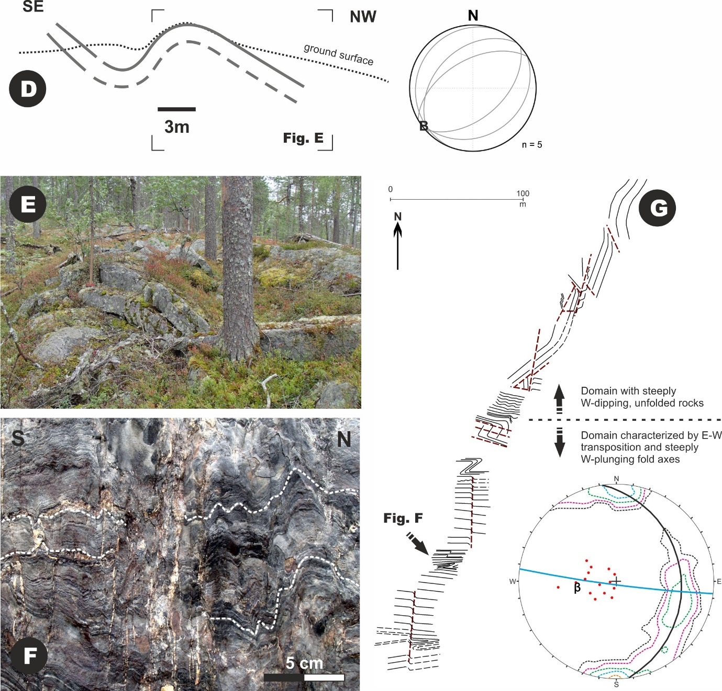

Fig. 7. Characteristic fold styles within the Peräpohja Belt. See Fig. 3 for locations of the figures. A and B: Southwest-vergent asymmetric parallel-style fold with a gently ESE-plunging fold axis. C: A transect showing the relationship between gently to moderately dipping reverse faults and asymmetric folding. The lower hemisphere stereographic projection shows the orientation of involved structural elements and highlights the contrasting bedding attitudes with the hanging-wall and the foot-wall. Figure C after Piippo et al. (2015). D and E: Open asymmetric, southeast-vergent folding within the competent Palokivalo quartzites. The stereogram shows the bedding surfaces and the β-axis. F and G: Intensely folded Martimo Fm metasedimentary rocks with steeply west-plunging axes with quartz veins along the fold axial surfaces. All stereograms are lower hemisphere projections.

5. Stratigraphic constraints on structure
Thickness variations within the PB are associated with larger normal faults (Section 4.1.2) and involve generation of sub-basins with contrasting depositional infills, including lacking parts of the stratigraphic pile and significant stratigraphic thickness variations between the sub-basins.

5.1. Principles of the thickness determinations
Thickness variations of the stratigraphy would ideally be presented as an isochron-contour map, but this is difficult due to the dominantly steeply-dipping attitude of bedding surfaces, inhomogeneous strain and mechanical heterogeneity of the stratigraphy of the Peräpohja Belt. For these reasons, the thickness analysis was conducted, and is presented along selected profiles. The analysis was performed individually for the Sompujärvi, Runkaus and Palokivalo formations, whereas the Middle Basin Stage sequence was treated as one unit due to the relatively poor control over the thickness of the individual formations across the whole PB. The thickness determinations utilized the apparent thicknesses of the formations according to the new map interpretations (Figs. 3,5) and the generalization of the bedding dips. Reliable thickness determinations require that the overprinting folding was of parallel style with negligible thinning of the fold limbs (Figs. 7a-e) and that enough structural data to constrain the bedding dips was available. Moreover, selection of the suitable measurement profiles involved avoiding isoclinal folds with thinned limbs, such as within the central syncline (Fig. 3) and zones of intense shearing, possibly associated with duplication of the primary strata. Due to the low mechanical strength promoting the localization of detachment faults, the Jouttiaapa and Petäjäskoski formations were not included in the analysis. Besides potential problems with structural constraints over the selected profile locations, further errors in the layer thickness determinations may arise from the resolution of the geophysical data (50 m grid size) used in the structural interpretation and from the potentially uneven distribution of mafic sills and dykes intruding the supracrustal units, included in the thickness analysis of the Runkaus and Palokivalo formations. Bearing in mind the above limitations, thickness determinations were performed along 53 profiles and the results are shown in Figure 8. Overall, the results for the mechanically competent Sompujärvi and Palokivalo units are considered to have the highest relative certainty, whereas the certainty for the Runkaus and the Middle Basin Stage determinations are decreased by their tendencies to strain localization and potential tectonic repetitions.

5.2. Observed stratigraphic thickness changes and interpreted sub-basins
Distinct thickness variations within the PB stratigraphy occur across the larger faults (Section 4; Figs. 3 and 5) which have consequently been utilized to delineate geological sub-basins within the PB, further segmented into 9 crustal compartments. The Sihtuuna Fault splits the PB into two major domains with the occurrence of the thickest Sompujärvi and Runkaus formations occurring north of the SF, within the Northern sub-basin. The thickness of the Sompujärvi and Runkaus Fms in the Northern sub-basin reaches up to 1.9 and 1.8 km which is highly contrasting to their thicknesses reaching typically up to some tens of metres close to the Archaean-Proterozoic boundary in the south-east. Thickness variation of the Sompujärvi and Runkaus Fms within the western part of the Northern sub-basin (compartment N1) is caused by the heterogeneity of the compressional overprint. In contrast, thickness variations associated with the NW-SE trending central graben, with thick Middle Basin Stage succession and the absence of the Sompujärvi Fm, is used to divide the Northern sub-basin into three compartments, N1-N3.

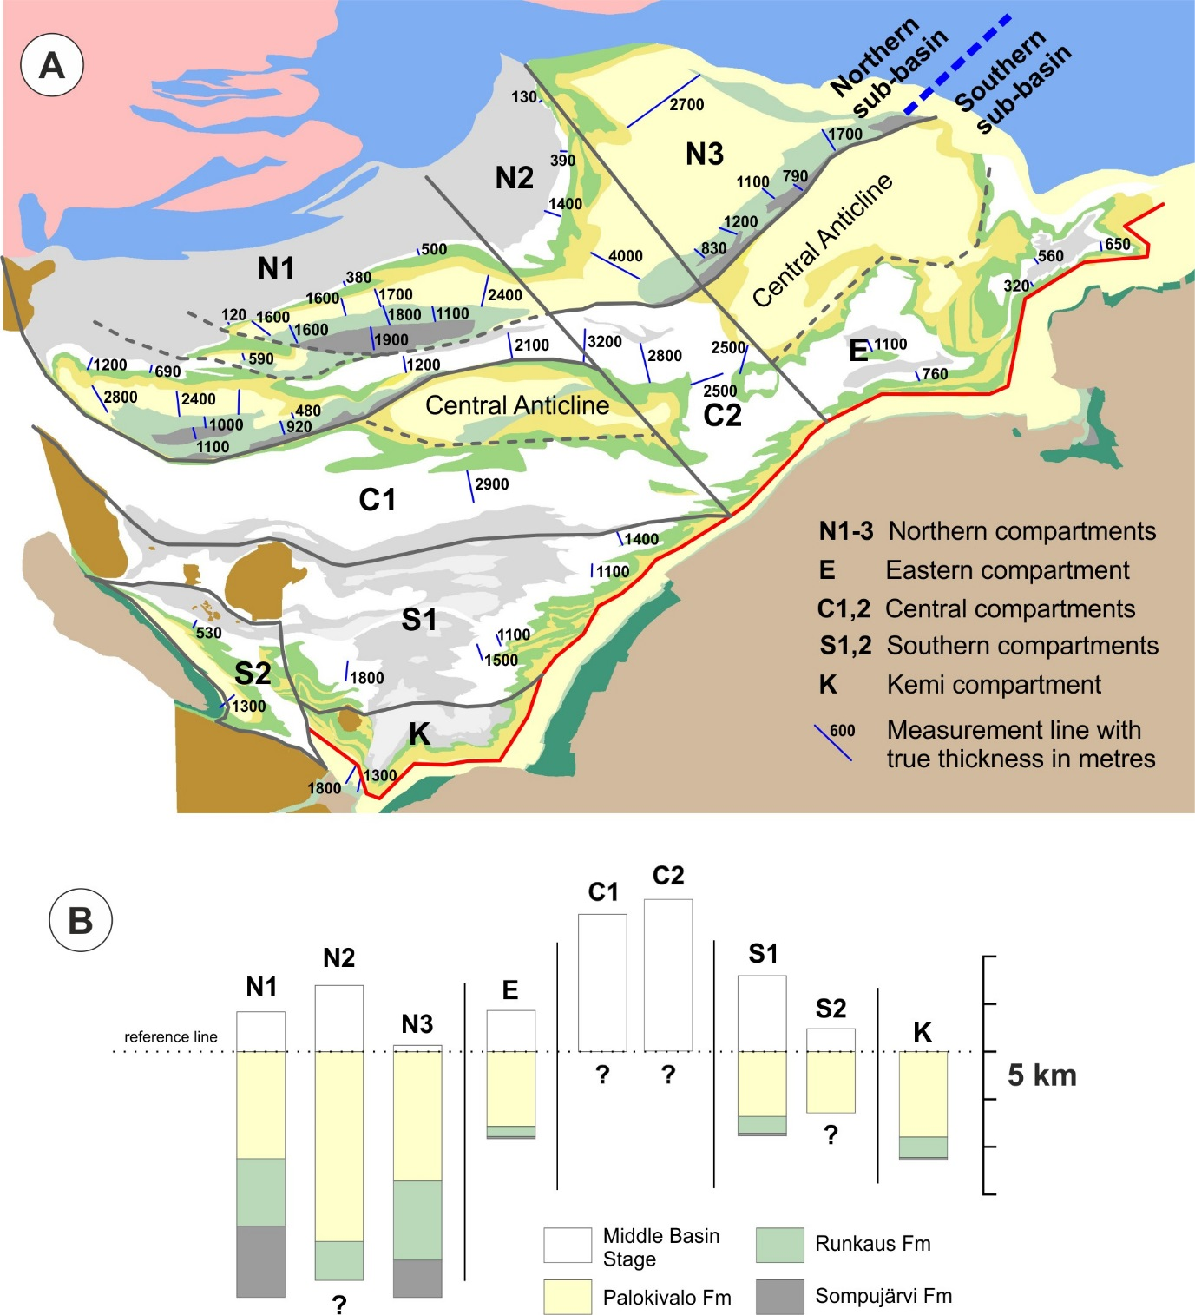

Fig. 8. A: Delineation of stratigraphically contrasting sub-basins and layer-thickness changes within the Peräpohja Belt. Lithology as in Fig. 3. B: Stratigraphic thicknesses of the selected key formations or sets of formations within the defined compartments. See the accompanying paper (Skyttä et al., 2019) for thickness data south of the thick red line occurring roughly along the Petäjäskoski Detachment Zone.

Within the Southern sub-basin, South of the Sihtuuna Fault, the thickness of the Palokivalo Fm is relatively uniform (where possible to determine), and the subdivision into compartments is based on thickness variations of the Middle Basin Stage sequence. The central compartments (C1, C2) are characterized by the thickest measured layers of the Middle Basin Stage sequence with thicknesses up to and exceeding 3 km in C1 and C2, respectively. Along the lateral eastward continuation of C1 and C2, the thickness of the Middle Basin Stage sequence is abruptly decreased across the eastern margin of the central graben, reaching up to 1100 m thicknesses within the Eastern compartment (E). The southern compartment S1 is separated from C1 by a large syncline and an E-W striking thrust originated as a splay from the Petäjäskoski detachment zone, and further compartmentalization is evident from the small thickness of Middle Basin Stage sequence in compartment S2 separated from S1 by the Kemi fault zone. Furthermore, the small Kemi compartment (K) is stratigraphically unique within the PB, as the whole of Middle Basin Stage sequence between the Jouttiaapa and Martimo formations is completely absent. Trends of stratigraphic thickening within some compartments straightforwardly suggesting syn-extensional timing and extensional kinematics for the compartment-bounding faults are few, and do not as such provide solid evidence for the origin of the individual faults.

6. Discussion
The new findings about the basement-cover relationship, as presented in this paper, allow interpretation of the significant basement structures. The structural and stratigraphic evolution of the Peräpohja Belt and comparison of the results with other exposed detachment structures is discussed below. The results of this paper are utilised and placed within a wider tectonic context within an associated paper focusing on rifting of the Archaean continent within northern Fennoscandia (Skyttä et al., 2019).

6.1. Compressional deformation of the PB rocks
We attribute the compressional overprint of the Peräpohja Belt to one progressive main compressional event. Much of the heterogeneity of the main compressional deformation was shown to relate to the geometry of pre-existing basement-controlled structures (the “funnel”-shaped AP-contact and the flexure of the western Sihtuuna fault; Section 4). Localized zones of steeply-dipping bedding surfaces, associated with the exposure of key stratigraphic units indicate that there is a hard link between the basement and cover inversion along the Sihtuuna Fault and Kemi Fault Zone. Furthermore, several indications for a soft link exist: i) The preferential occurrence of cross-cutting foliation within the central graben (Fig. 3). We attribute this fabric, known to overprint the axial surface parallel fabrics of the main E-W trending folds (Lahtinen et al., 2015b), to progression of the main compressional event which was localized into the zones of basement discontinuities during the later stages of deformation. Moreover, we attribute the dextral drag of bedding along the southwestern margin of the central graben to deformation localization and reactivation of the graben-bounding fault during progressive south-vergent thrusting. ii) The two-fold distribution of fold axial plunges in domain W2 in Fig. 6b likely reflects the progressive stages of the same deformation event: The “regular” E (-W) axial trends relate to the early stage of compression, whereas the deviating northerly plunges relate to reverse faulting along (one) KFZ branches which acted as accommodation faults within the southwards-tapering basin during the progressing compression.
Structural vergences during the compressional deformation within the western part of the PB are oriented towards South, whereas east of the central graben the vergences are towards Southeast, and characterized by milder compressional overprint with respect to the western part of the PB (Figs. 3,5). Since there is no lateral displacement between the basement horsts or no evidence for significant rotational strains, it is most likely that central graben originated as a transfer zone between the two horsts. As the graben does not extend across the Archaean-Proterozoic boundary in the south, it may be rooted at the PDZ, and not directly linked to the structures within the underlying Archaean domain. Alternatively, strike-slip deformation along the PDZ may have displaced the whole supracrustal sequence away from its original position, hence obscuring the basement-cover linkage.

6.2. Extensional evolution
6.2.1. Normal faults and basement topography
The sub-basins (Section 5.2) are inferred to be bound by normal faults in the basement. Based on the greatest thickness variations, the most significant (first order) faults border the Northern sub-basin and the Central Graben. Together with the steepening of the structures on the southern side of the Central Anticlines, the strongly positive Bouguer anomaly (Fig. 4b) below compartment C1 indicates that the deepest basin (present-day) is separated from the central anticline by a large south-dipping, originally extensional fault comparable to the Sihtuuna Fault. The results from Northern sub-basin indicate that thick-skinned growth faults governed the thickness variations of the lowermost units (stratigraphically below the Petäjäskoski Fm). The faults bordering the sub-basins recognised from the variations in the Middle Basin Stage formations can be either thick-skinned or connected to a detachment in the Petäjäskoski Fm, possibly already active during extension. Regardless, we attribute also these sub-basin borders to normal faults originating from the basement, either as thick-skinned or blind faults. Consequently, the recognised basement faults form a network with approximately orthogonal orientations reflecting extensional deformation in both approximately N-S and ENE-WSW orientations (Fig. 10a).
Even though the basal parts of the PB stratigraphy (Sompujärvi and Runkaus Formations) are absent immediately south of the E-W trending horst, we interpret that these formations are present within the subsurface and attribute their deep present-day structural position to selective reactivation of the basement structures. South-vergent thrusting was preferentially localized at the north-dipping faults bounding the horst in the north, whereas the less favourably oriented, south-dipping faults in the south experienced much more limited reverse dip-slip displacements, resulting in a soft-link between the basement and the cover. The interpreted reactivation is in line with the analogue models over selective reactivation of opposingly dipping normal faults during inversion (Bonini et al., 2012).

6.2.2. Timing of the compartment formation
In the Northern sub-basin, the large thickness (in relation to elsewhere) of the Sompujärvi and Runkaus Formations, and the thin Middle Basin Stage sequence, suggest that the Sihtuuna fault was most active during the early development of the Peräpohja Belt with a minor role during the later extensional stages. In contrast, thicknesses in the Central and Eastern sub-basins indicate significant subsidence also during the later extension. It is probable that the unexposed Sompujärvi and Runkaus Formations close to the southern side of the Central Anticline have similar thicknesses as in the north, thinning southwards towards the AP-contact and the inferred rollover anticline (Figs. 5 and 10a).
The complete absence of the Middle Basin Stage sequence in the Kemi sub-basin could be caused by i) different depositional environment compared to the bordering Southern sub-basin, followed by coeval but very different lithologies (shallow sea in the S1 to S3, deep sea in the Kemi sub-basin), or ii) a true hiatus and disconformity due to a higher palaeotopography. The continuity of the magnetic anomaly above the lower parts of the Martimo Fm indicate a coeval widespread deposition of the deep sea lithologies of the Martimo Fm across the whole southern part of the belt, thus in conflict with the prior option. The hiatus and disconformity is further supported by the inferred weathering of the top of the Jouttiaapa Fm (Perttunen, 1991; Kyläkoski, 2007), as inferred also by Vanhanen et al. (2015 and the references therein). We attribute the present geometry of the Kemi sub-basin and the continuity of the Martimo Fm to a very late-stage reactivation of the presently E-W striking, pre-existing normal fault separating the Kemi and Penikat layered intrusions, and an abrupt change in depositional environment due to possible basin-wide subsidence or marine transgression.

6.3. Comparable detachment zones and implications for understanding the structural style of other supracrustal belts in northern Fennoscandia
Similar to the Petäjäskoski detachment zone, the Cape Smith Thrust-Belt of the Trans-Hudson Orogen in Canada exposes a major detachment zone separating the Archaean basement and the overlying parautochthonous sedimentary rocks from the overlying allochthonous units (Fig. 9a; Picard et al., 1990; St-Onge et al., 1999). The allochthonous units of the Trans-Hudson orogen have been transported along the detachment surface distances exceeding 160 km, whereas the extent of the PDZ and the amount of displacement along it are presently not known. The apparently similar deformation style within the Kuusamo Belt (Fig. 1b) in Northern Fennoscandia, including strain localisation along a basal decollement (Silvennoinen, 1972), could be correlated with the PDZ, together indicating the presence of a several hundred kilometres wide detachment zone which was subsequently overprinted and now exposed within isolated basins (Fig. 9b). The styles of the overprint are though quite contrasting as the detachment faulting within the Cape Smith Thrust-Belt was succeeded by shear deformation involving generation of basement thrust slices of several kilometres thicknesses (St-Onge et al., 1999), whereas the northern Fennoscandian cases display significant block movements associated with reactivation of pre-existing, typically steeply-dipping faults.

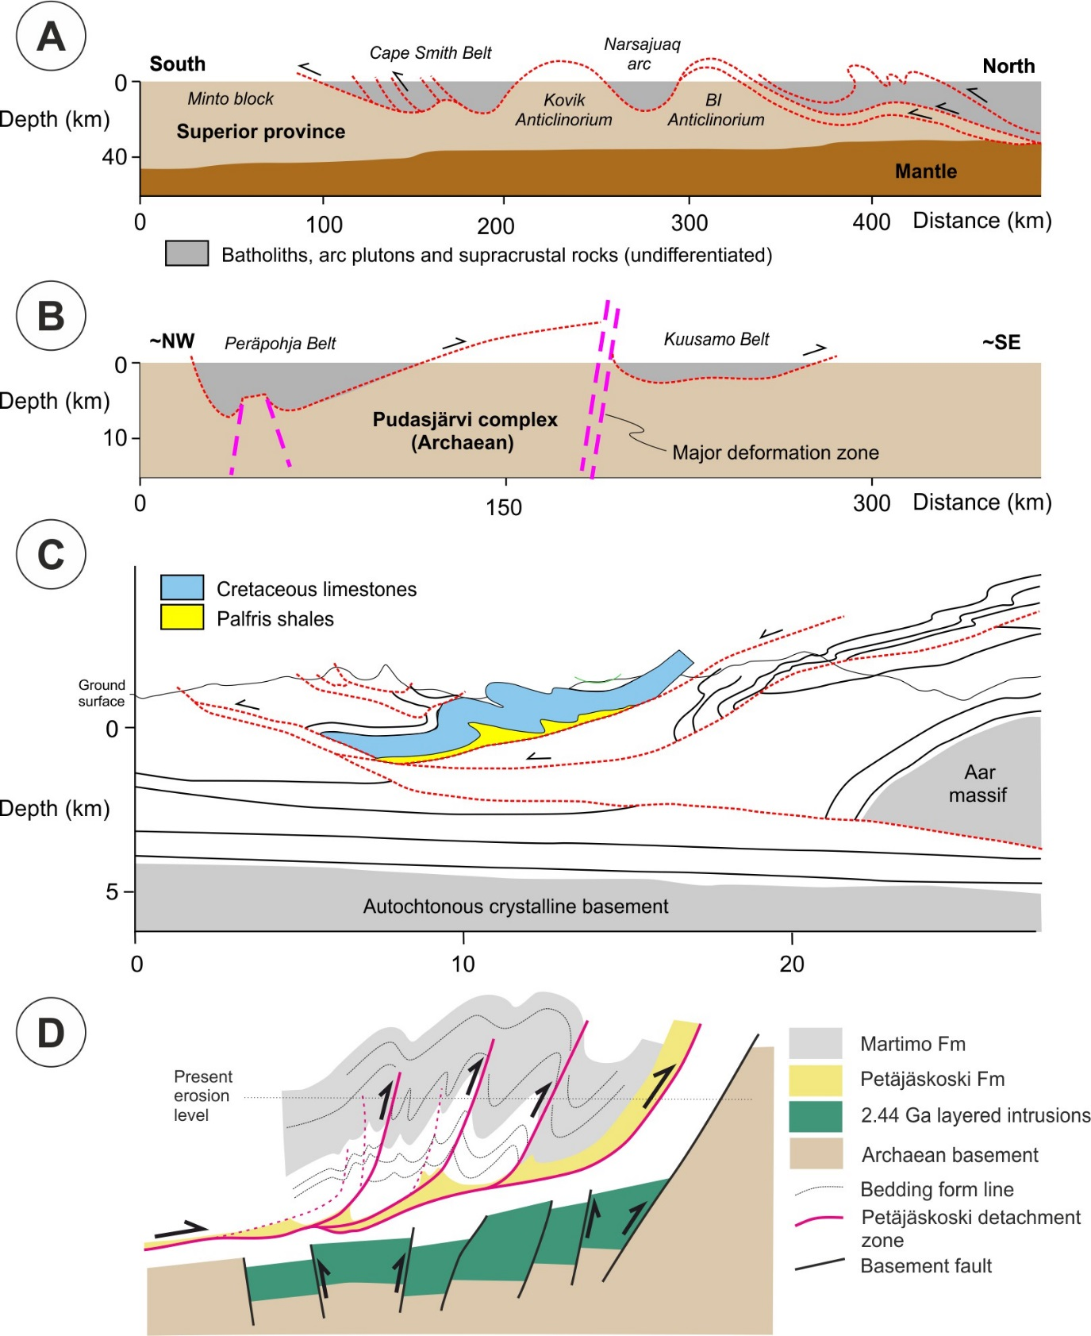
Fig. 9. A: The character of the major detachment zones (red dashed) occurring along the Archaean-Proterozoic interface in the Trans-Hudson Orogen in Canada (simplified after St-Onge et al., 1999). B: A schematic correlation of the detachment zones within the Peräpohja and Kuusamo Belts in Northern Fennoscandia. C: A geological cross-section of the Helvetic Nappes in the Alps showing comparable deformation styles of the Palfris shales and their underlying detachment zones with the Petäjäskoski Detachment Zone in the Peräpohja Belt. Cross-section has been simplified after Pfiffner (1993). D: A schematic cross-section from the southern part of Peräpohja Belt illustrating the nature of the Petäjäskoski detachment zone (PDZ), and depicting the possible control of the underlying structural breaks governing the localization of the PDZ splays from the main detachment surface.

For this reason, the PDZ is better comparable to the central part of the Helvetic nappes in the Alps, where the generation of the detachment surfaces is attributed to the presence of weak stratigraphic units (e.g. Palfris shales), and the style of deformation, characterised by thrusts and harmonic folds (Fig. 9c), to the low ratio of thickness (< 0.5) between the mechanically weak and strong stratigraphic units (Pfiffner, 1993). Moreover, the relative timing of deformation within PB is compatible with the Helvetic Alps which display an evolution of early detachment post-dated by more penetrative nappe-folding (Pfiffner, 2016), similar to the generation of the Kakari and Suolijoki klippes in Peräpohja (Fig. 3), later overprinted by ductile folding. Considering the relative thickness of stratigraphic units, the tendency of the PDZ to generate repeated splays with intervening folds could be a result of a suitable thickness of the Petäjäskoski unit with respect to the mechanically stronger under-and overlying stratigraphic units (Pfiffner, 2016).
The recent work by Butler et al. (2018) questions the approach of using idealized end-member structural models only to understand the evolution of fold-thrust belts, and instead highlight the heterogeneity in their structural styles as resulting from variations in the primary stratigraphy and the presence of pre-existing structures, for example. Bearing this in mind, a viable alternative to explain the splay generation is the presence of reactivated basement structures causing heterogeneities at the Archaean-Proterozoic interface, similar to the suggested inheritance of Late-Palaeozoic structures during the opening of the Rhein and Bresse grabens in the Alps (Nussbaum et al., 2017). In the Peräpohja context, the splays could have been localized at the structural “jumps” on the top of the Palokivalo Fm (Fig. 9d), which relate to the reactivation of the 2.44 Ga basement faults (Skyttä et al., 2019). This tentative hypothesis needs to be investigated in more detail in the future studies.
Recognition of the Petäjäskoski detachment zone and the basement-cover relationship may be used in understanding the structural evolution and patterns within the other supracrustal belts of Northern Fennoscandia. Ward et al. (1988) depicted a primary extensional geometry of half-grabens separated by orthogonal transfer faults, subsequently utilized during basin inversion for the central Lapland area in Finland. Silvennoinen (1972) attributed the apparently complex folding patterns of the Kuusamo Belt to a coupled effect of folding controlled by decollement structures and large Archaean basement blocks, during one ductile deformation event. Furthermore, since no regionally significant overturning of strata within the supracrustal belts has been observed (Ward et al., 1988; this paper), we deduce that much of the structural complexity of the discussed supracrustal belts relates to the intimate basement-cover relationships rather than to multiple structural events characterised by highly variable palaeostress fields.

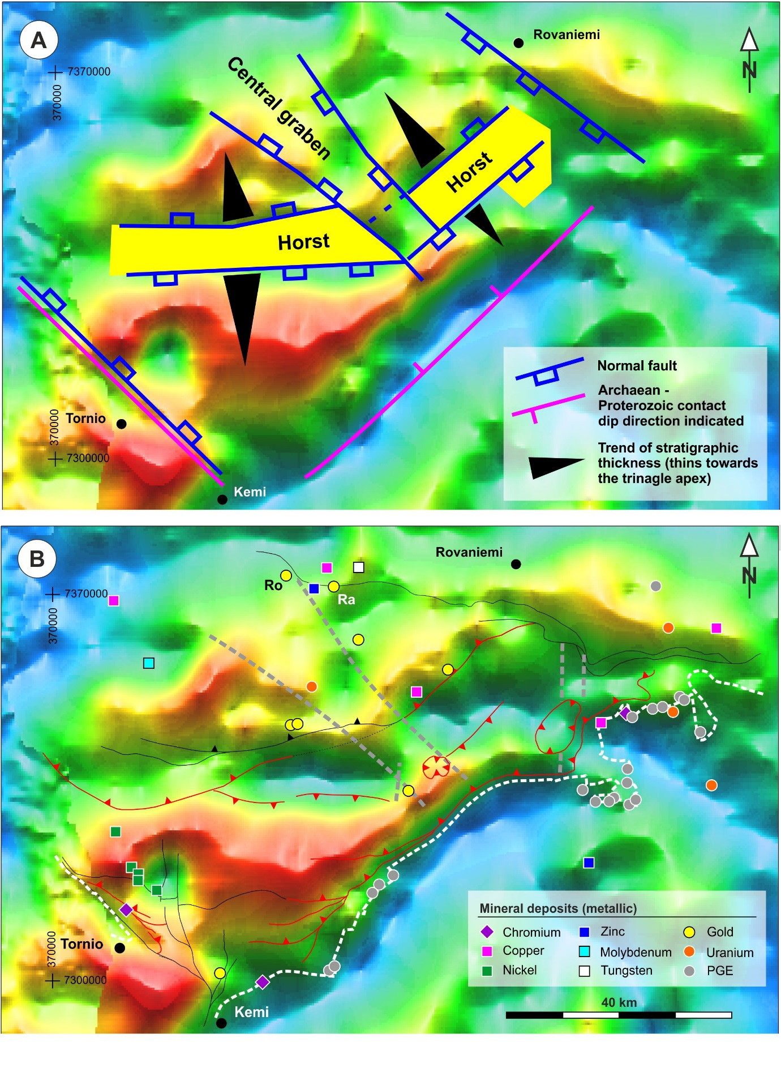
Fig. 10. Correlation between the structural interpretation and the Bouguer anomaly to delineate the basement structures and topography of the basement underlying the Peräpohja Belt. A: A generalized interpretation of the basement highs, major normal faults (blue) and thickening trends of the stratigraphic units. B: Form lines of the most significant structures (the dashed white line indicates the location of the Archaean-Proterozoic contact, other symbols as in Fig. 3). Ro and Ra = Rompas and Rajapalot prospects.Coordinates are in EUREF-FIN.

6.4. Prospectivity
Chromium and PGE deposits display primary lithological control as they are hosted within the mafic to ultramafic layered intrusions. Nickel deposits occur as a loosely defined NW-SE zone close to the Nosa intrusion, sub-parallel with the Kemi Fault Zone (Figs. 3, 10b). Their occurrence is also controlled by the host rock (mafic intrusives), but the emplacement of the intrusions was probably controlled by the underlying fault systems. For all the other commodities, there is an overall good correlation with the known mineral deposits and the main structural features as delineated within this paper. The majority of the known Au deposits (6 out of 8) are located in close proximity to (≤1 km) the first-order E-W to ENE-WSW and NW-SE deformation zones, including the Sihtuuna Fault and the Central Graben, and their intersections (Fig. 10b). Hence, the spatial distribution is similar to the orogenic gold systems e.g. in Central Lapland Greenstone Belt (e.g. Patison, 2007) and Kuusamo Belt (Pankka and Vanhanen, 1992). The Cu, Zn, U and W deposits associated with the studied supracrustal rocks all occur within 3 kilometres from the major deformation zones. A specifically important cluster of mineralizations, including the high-grade Rompas and Rajapalot targets (Fig. 10b) are located at the intersection of the eastern margin of the central graben and the WNW-ESE striking zone of structural overprint with inferred strike-slip deformation in the northern part of the PB (south of Rovaniemi surroundings; Figs. 3, 10b). Correlation of the central graben and the deposits suggests that the central graben is controlled by deep-seated basement structures allowing enhanced fluid flow through the crust, perhaps driven by igneous intrusions. This further supports the origin of the central graben as related to the primary rifting at 2.5-2.4 Ga even though the central graben does not cut the AP-contact in the south-east (e.g. Fig. 3).

7. Conclusions
- The main inversion responsible for the ductile structures of the Peräpohja Belt is caused by one tectonic event comprising an early phase of sub-horizontal detachment faulting mainly along the Petäjäskoski Detachment Zone, overprinted by reverse faulting and related asymmetric folding especially in the sequence above the sub-horizontal thrust sheets, all indicative of south- to south-east vergent thrusting.
- Strain localization during the inversion was controlled by i) the Petäjäskoski detachment zone developed within a mechanically weak layer and ii) reactivated major structural discontinuities within the underlying Archaean depositional basement
- Two approximately orthogonal major fault sets characterize the basement and provide the principal structural control of the belt
  - horsts bound by rift-related (~2.45 Ga) normal faults; recognised from interplay between structure and stratigraphy, reflecting N-S to NNW-SSE extension
  - the NW-SE central graben reflecting NE-SW extension
- The coupling between the Archaean basement and the Palaeoproterozoic cover rocks had two contrasting styles: hard link and soft-link styles.
- Most known mineralization are spatially correlated with the major structures, reactivated from their origin in the rifting stage of the Archaean continent at around 2.5 Ga.

8. Acknowledgements
K. H. Renlund Foundation, FQM Minerals Ltd. and Mawson Resources Ltd. are acknowledged for financial support during the field work, and access to data, Midland Valley Exploration for the use of MOVE under the Academic Software Initiative and the Geological Survey of Finland (GTK) for collegial support. Timo Kilpeläinen is acknowledged for comments on the early version of the manuscript and Prof. Randall Parrish for editorial handling and constructive comments and an anonymous journal reviewer for a critical review which all helped to improve the manuscript.

9. References
Ahtonen, N., Hölttä, P., Huhma, H., 2007. Intracratonic Paleoproterozoic granitoids in northern Finland: prolonged crustal melting revealed by Nd isotopes and U-Pb ages on zircon. Bulletin of the Geological Society of Finland 79, 143–174.
Alapieti, T. and Lahtinen, J. 2002. Platinum-Group Element Mineralization in Layered Intrusions of Northern Finland and Kola Peninsula, Russia. In: Cabri, L.J. (Ed.) The Geology, Geochemistry, Mineralogy and Mineral Beneficiation of Platinum-Group Elements. Canadian Institute of Mining, Metallurgy and Petroleum, Special Volume 54, 507–546.
Alapieti, T.T., Filèn, B.A., Lahtinen, J.J., Lavrov, M.M., Smolkin, V.F., Voitsekhovsky, S.N., 1990. Early Proterozoic layered intrusions in the northeastern part of the Fennoscandian Shield. Mineralogy and Petrology 42, 1–22.
Barnicoat, A.C., Sheldon, H.A., Ord, A., 2009. Faulting and fluid flow in porous rocks and sediments: implications for mineralisation and other processes. Mineralium Deposita 44, 705 – 718.
Bauer, T.E., Skyttä, P., Hermansson, T., Allen, R., Weihed, P., 2014. Correlation between distribution and shape of VMS deposits, and regional deformation patterns, Skellefte district, northern Sweden. Mineralium Deposita 49, 555–573.
Bleeker, W., 2003. The late Archean record: a puzzle in 35 pieces. Lithos, 99–134.
Bonini, L., Dallagiovanna, G., Seno, S. 2010. The role of pre-existing faults in the structural evolution of thrust systems: Insights from the Ligurian Alps (Italy). Tectonophysics 480, 73–87.
Bonini, M., Sani, F., Antonielli, B., 2012. Basin inversion and contractional reactivation of inherited normal faults: A review based on previous and new experimental models. Tectonophysics 522–523, 55–88.
Butler, R., Tavarnelli, E., Grasso, M., 2006. Structural inheritance in mountain belts: An Alpine–Apennine perspective. Journal of Structural Geology 28, 1893–1908.
Butler, R.W.H., Bond, C.E., Cooper, M.A., Watkins, H., 2018. Interpreting structural geometry in fold-thrust belts: Why style matters, Journal of Structural Geology (2018), doi: 10.1016/j.jsg.2018.06.019.
Cawood, A.J., Bond, C.E., 2018. 3D mechanical stratigraphy of a deformed multi-layer: Linking sedimentary architecture and strain partitioning. Journal of Structural Geology 106, 54–69.
Coward, M.P., 1983. Thrust tectonics, thin skinned or thick skinned, and the continuation of thrusts to deep in the crust. Journal of Structural Geology 5, 113–123.
Coward, M.P., 1994. Inversion Tectonics. In: Hancock, P.L. (Ed.), Continental Deformation. Pergamon, Oxford, pp. 289–304.
Eilu, P., Bergman, T., Bjerkgård, T., Feoktistov, V., Hallberg, A., Korsakova, M., Krasotkin, S., Muradymov, G., Nurmi, P. A., Lauri, L. S., Often, M., Perdahl, J.-A., Philippov, N., Sandstad, J. S., Stromov, V., Tontti, M. (comp.), 2016. Metallogenic Map of the Fennoscandian Shield 1:2 000 000. Second edition. Geological Survey of Finland, Geological Survey of Norway, Geological Survey of Sweden, The Federal Agency of Use of Mineral Resources of the Ministry of Natural Resources and Ecology of the Russian Federation.
Faulds, J.E., Hinz, N.H., 2015. Favorable Tectonic and Structural Settings of Geothermal Systems in the Great Basin Region, Western USA: Proxies for Discovering Blind Geothermal Systems. Proceedings World Geothermal Congress 2015 Melbourne, Australia, 19-25 April 2015
Gaál, G. 1990. Tectonic styles of Early Proterozoic Ore Deposition in the Fennoscandian Shield. Precambrian Research 46, 83–114.
Halkoaho, T.T.A., 1993. The Sompujärvi and Ala-Penikka PGE reefs in the Penikat layered intrusion, northern Finland: implications for PGE reef-forming processes. Acta Univ. Oul.A 249, Univ. of Oulu, Oulu, Finland.
Hanski, E., Huhma, H. and Vuollo, J. 2010. SIMS zircon ages and Nd isotope systematics of the 2.2 Ga mafic intrusions in northern and eastern Finland. Bulletin of the Geological Society of Finland, 82, 31–62.
Hanski, E. and Melezhik, V. 2012. Litho- and chronostratigraphy of the Karelian formations. In: Melezhik, V., Prave, A., Hanski, E., Fallick, A., Lepland, A., Kump, L. and Strauss, H. (Eds.) Reading the Archive of Earth’s Oxygenation. Volume 1: The Palaeoproterozoic of Fennoscandia as Context for the Fennoscandian Arctic Russia – Drilling Early Earth Project, Springer-Verlag, Berlin, 39–110.
Hitzman, M.W., Selley, D. and Bull, S. 2010. Formation of Sedimentary Rock-Hosted Stratiform Copper Deposits through Earth History. Society of Economic Geologists 105, 627–639.
Homberg, C., Bergerat, F., Philippe, Y., Lacombe, O., & Angelier, J., 2002. Structural inheritance and cenozoic stress fields in the Jura fold-and-thrust belt (France). Tectonophysics, 357, 137–158.
Hostettler, B., Reisdorf, A. G., Jaeggi, D., Deplazes, G., Blasi, H. R.,Hölttä, P., Huhma, H., Lahtinen, R., Nironen, M., Perttunen, V., Vaasjoki, M. and Väänänen, J. 2003. Introduction: modelling of orogeny in northern Fennoscandia. In: Eklund, O. (Ed.) Lapland – 2003. Excursion Guide to Swedish and Finnish Lapland, September 1–7, 2003. Geocenter Report 20, Turku University, Åbo Akademi, 6–27.
Hölttä, P. and Heilimo, E. 2017. Metamorphic map of Finland. In: Nironen, M. (Ed.) Bedrock of Finland at the scale 1:1 000 000 – Major stratigraphic units, metamorphism and tectonic evolution Geological Survey of Finland, Special Paper 60, 77–128.
Huhma, H., Cliff RA, Perttunen, V., Sakko, M., 1990. Sm-Nd and Pb isotopic study of mafic rocks associated with early Proterozoic continental rifting: the Peräpohja schist belt in northern Finland. Contributions to Mineralogy and Petrology 104:3, 369–379.
Huhma, H., Hanski, E., Kontinen, A., Vuollo, J., Mänttäri, I., Lahaye, Y., 2018. Sm–Nd and U–Pb isotope geochemistry of the Palaeoproterozoic mafic magmatism in eastern and northern Finland. Geological Survey of Finland, Bulletin 405, 150 pp.
Huhtelin, T. 2015. The Kemi chromite deposit. In: Maier, W.D., Lahtinen, R. and O’Brien, H. (Eds.) Mineral Deposits of Finland. Elsevier, Amsterdam, 165–178.
Iljina, M. & Hanski, E. 2005. Layered mafic intrusions of the Tornio–Näränkävaara belt. In: Lehtinen, M., Nurmi, P. A. & Rämö, O. T. (eds) Precambrian Geology of Finland – Key to the Evolution of the Fennoscandian Shield. Amsterdam: Elsevier, 101−138.
Iljina, M., Maier, W.D. and Karinen, T., 2015. PGE-(Cu-Ni) Deposits of the Tornio-Näränkävaara Belt of Intrusions (Portimo, Penikat, and Koillismaa). In: Maier, W.D., Lahtinen, R., O’Brien, H. (Eds.), Minerals Deposits of Finland, Elsevier, 2015, 133–164.
Kamber. B.S. 2015. The evolving nature of terrestrial crust from the Hadean, through the Archaean, into the Proterozoic. Precambrian Research 258, 48–82.
Karhu, J., Kortelainen, N.M., Huhma, H., Perttunen, V. and Sergeev, S. 2007. New time constraints for the end of the Paleoproterozoic carbon isotope excursion. 7th International Symposium on Applied Isotope Geochemistry, September 10-14, 2007, Stellenbosch, South Africa, 76–77.
Kyläkoski, M. 2007. Nickel, Copper and Platinum-group Element Ore Potential of the Jouttiaapa Formation, a ca. 2.1 Ga Continental Flood Basalt Sequence in the Peräpohja Belt, Northwestern Finland. Licentiate Thesis, Department of Geosciences, University of Oulu, 204 pp (in Finnish with English abstract).
Kyläkoski, M., Hanski, E. and Huhma, H. 2012. The Petäjäskoski Formation, a new lithostratigraphic unit in the Paleoproterozoic Peräpohja Belt, northern Finland. Bulletin of the Geological Society of Finland 84, 85–120.
Laajoki, K. 2005. Karelian supracrustal rocks. In: Lehtinen, M., Nurmi, P.A. and Rämö, O.T. (Eds.) Precambrian Geology of Finland – Key to the evolution of the Fennoscandian Shield. Elsevier, Amsterdam, 279–342.
Lahtinen, R., Huhma, H., Lahaye, Y., Jonsson, E., Manninen, T., Lauri, L.S., Bergman, S., Hellström, F., Niiranen, T. and Nironen, M. 2015a. New geochronological and Sm-Nd constraints across the Pajala shear zone of northern Fennoscandia: Reactivation of a Paleoproterozoic suture. Precambrian Research 256, 102–119.
Lahtinen, R., Mohammad, S., Karell, F. 2015b. Near-orthogonal deformation successions in the poly-deformed Paleoproterozoic Martimo belt: Implications for the tectonic evolution of Northern Fennoscandia. Precambrian Research 270, 22–38.
Lappalainen, M. 1995. The relationship between polyphase deformation of the bedrock and low-pressure metamorphism in the Rovaniemi area. Res Terrae, Series B, no. 18, 62 pp (in Finnish with English abstract).
Laubscher, H. P. 1985. The eastern Jura: Relations between thinskinned and basement tectonics, local and regional. Nagra Technischer Bericht, 85-53, 30 pp. Nagra, Wettingen, Switzerland. www.nagra.ch.
Laubscher, H. P. (1987). Die tektonische Entwicklung der Nordschweiz. Eclogae Geologicae Helvetiae, 80, 287–303.
Lauri, L.S., Andersen, T., Räsänen, J. and Juopperi, H. 2012. Temporal and Hf isotope geochemical evolution of southern Finnish Lapland from 2.77 Ga to 1.76 Ga. Bulletin of the Geological Society of Finland 84, 121–140.
Lehtonen, M., Airo, M-L., Eilu, P., Hanski, E., Kortelainen, V., Lanne, E., Manninen, T., Rastas, P., Räsänen, J. and Virransalo, P. 1998. The stratigraphy, petrology and geochemistry of the Kittilä greenstone area, northern Finland. A report of the Lapland Volcanite Project. Geological Survey of Finland, Espoo, Report of investigation140, 144 pp (in Finnish with English abstract).
Mitra, S., 2003. A unified kinematic model for the evolution of detachment folds. Journal of Structural Geology 25, 1659–1673.
Morris, A.P., Ferrill, D.A., McGinnis, R.N., 2009.Molli G., Doveri M., Manzella A., Bonini L., Botti F., Menichini M., Montanari D., Trumpy E., Ungari A., Vaselli L., 2015. Surface - subsurface structural architecture and groundwater flow of the Equi Terme hydrothermal area, Northern Tuscany Italy. Italian Journal of Geosciences 134, 1–16.
Nieminen, V., 2016. The structure of the Kakari-Narkaus area with implications to the structural evolution of the Palaeoproterozoic Peräpohja Belt, Northern Finland. Unpublished MSc Thesis, University of Turku, 68 pp.
Nironen, M. 2017. Structural interpretation of the Peräpohja and Kuusamo belts and Central Lapland, and a tectonic model for northern Finland. Geological Survey of Finland, Report of Investigation 234, 53 pp.
Nussbaum, C., Kloppenburg, A., Caër, T., Bossart, P., 2017. Tectonic evolution around the Mont Terri rock laboratory, northwestern Swiss Jura: constraints from kinematic forward modelling. Swiss Journal of Geosciences 110, 39–66.Nykänen, V., Niiranen, T., Molnar, F., Lahti, I., Korhonen, K., Cook, N., Skyttä P., 2017. Optimizing a knowledge driven prospectivity model for gold deposits within Peräpohja Belt, Northern Finland. Natural Resources Research; DOI: 10.1007/s11053-016-9321-4
Pankka, H.S. and Vanhanen, E.J. 1992. Early Proterozoic Au-Co-U mineralization in the Kuusamo district, northeastern Finland. Precambrian Research, 58, 387–400.
Patison, N.L. 2007. Structural control on gold mineralisation in the Central Lapland Greenstone Belt. Geological Survey of Finland, Special Paper 44, 107–124.
Perttunen, V. 1989. Volcanic rocks in the Peräpohja area, northern Finland: a report of the Lapland Volcanite Project. Geological Survey of Finland, Research report 92, 40 pp (in Finnish with English summary).
Perttunen, V. 1991. Pre-Quartenary rocks of the Kemi, Karunki, Simo and Runkaus map-sheet areas. Explanation to the Maps of Pre-Quartenary Rock, Sheets 2631 and 2633. Geological Map of Finland 1:100 000, Geological Survey of Finland, Espoo, 80 pp (in Finnish with English summary).
Perttunen, V. 2006. Pre-Quartenary rocks of the Ylitornio map-sheet area. Explanation to the Maps of Pre-Quartenary Rock, Sheets 2631 and 2633. Geological Map of Finland 1:100 000, Geological Survey of Finland, Espoo, 36 pp (in Finnish with English summary).
Perttunen, V., Hanski, E., Väänänen, J., Eilu, P. and Lappalainen, M. 1996. Pre-Quartenary rocks of the Rovaniemi map-sheet area. Explanation to the Maps of Pre-Quartenary Rock, Sheets 2631 and 2633. Geological Map of Finland 1:100 000, Geological Survey of Finland, Espoo, 63 pp (in Finnish with English summary).
Perttunen, V. and Hanski, E. 2003. Pre-Quartenary Rocks of the Törmäsjärvi and Koivu Map Sheet Areas. Explanation to the Maps of Pre-Quartenary Rock, Sheets 2631 and 2633. Geological Map of Finland 1:100 000, Geological Survey of Finland, Espoo, 88 pp (in Finnish with English summary).
Perttunen, V. and Vaasjoki, M. 2001. U-Pb geochronology of the Peräpohja schist belt, northwestern Finland. In: Vaasjoki, M. (Ed.) Radiometric age determinations from Finnish Lapland and their bearing on the timing of Precambrian volcano-sedimentary sequences. Geological Survey of Finland, Special Paper 33, 45–84.
Pfiffner, O.A. 1993. The structure of the Helvetic nappes and its relation to the mechanical stratigraphy. Journal of Structural Geology 15, 511–21.
Pfiffner, O.A. 2016. Basement-involved thin-skinned and thick-skinned tectonics in the Alps. Geological Magazine 153, 1085–1109.Picard, C., Lamothe, D., Piboule, M, Oliver, R. 1990. MAgmatic and geotectonic evolution of a Proterozoic oceanic basin system: the Cape Smith Thrust-Fold belt (New-Quebec). Precambrian Research 47, 223–249.
Piippo, S., Skyttä, P. and Holma, M. 2015. Recognising the structural control of mineral deposits in complexly deformed Precambrian terranes. 13th SGA Biennial Meeting: “Mineral Resources in a Sustainable World”, August 24–27, Nancy, France.
Ranta, J.P., Lauri, L.S., Hanski, E., Huhma, H., Lahaye, Y. and Vanhanen, E. 2015. U-Pb and Sm-Nd isotopic constraints on the evolution of the Paleoproterozoic Peräpohja Belt, northern Finland. Precambrian Research 266, 246–259.
Rodgers, J., 1949. Evolution of thought on structure of middle and southern Appalachians. American Association of Petroleum Geologists Bulletin 33, 1643–54.
Salonsaari, P. 1990. Deformation in the Bedrock of the Vanttauskoski Area. MSc Thesis, Department of Geosciences, University of Oulu, 62 pp. (in Finnish).
Selley, D., Broughton, D., Scott, R., Hitzman, M., Bull, S., Large, R., McGoldrick, P., Croaker, M., Pollington, N., Barra, F., 2005. A New Look at the Geology of the Zambian Copperbelt. Society of Economic Geologists, Inc., Tulsa, 100th Anniversary Volume, Hedenquist, J.W.,Thompson, J.F.H., Goldfarb, R.J., Richards, J.P., 965–1000.
Silvennoinen, A. 1972. On the stratigraphic and structural geology of the Rukatunturi area, northeastern Finland. Gological Survey of Finland Bulletin 257. 48 pp.
Skyttä, P., Piippo, S., Kloppenburg, A. (2019). 2. 45 Ga break-up of the Archaean continent in Northern Fennoscandia, Part II (basement): Rifting dynamics and the role of inherited structures within the Archaean basement. [The accompanying paper.]
Strand, K., Köykkä, J. 2012. Early Paleoproterozoic rift volcanism in the eastern Fennoscandian Shield related to the breakup of the Kenorland supercontinent. Precambrian Research 214-215, 95–105.
St-Onge, M.R., Lucas, S.B., Scott, D.J., Wodicka, N., 1999. Upper and lower plate juxtaposition, deformation and metamorphism during crustal convergence, Trans-Hudson Orogen (Quebec-Baffin segement), Canada. Precambrian Research 93, 27–49.
Turner, J.P., Williams, G.A., 2003. Sedimentary basin inversion and intra-plate shortening. Earth-Science Reviews 2004, 277–304.
Van Kranendonk, M., Altermann, W., Beard, B.L., Hoffman, P.F., Johnson, C.M., Kasting,J.F., Melezhik, V.A., Nutman, A.P., Papineau, D., Pirajno, F., 2012. A chronostrati-graphic division of the Precambrian. In: Gradstein, F.M., Ogg, J.G., Schmitz, M.D.,Ogg, G.M. (Eds.), The Geologic Time Scale 2012 – Volume 1. Elsevier, Oford, UK,pp. 299–392.
Vanhanen, E., Cook, N.D.J., Hudson, M.R., Dahlenborg, L., Ranta, J.P., Havela, T., Kinnunen, J., Molnár, F., Prave, A.R. and Oliver, N.H.S. 2015. The Rompas prospect, Peräpohja Schist Belt, northern Finland. In: Maier, W.D., Lahtinen, R. and O’Brien, H. (Eds.) Mineral Deposits of Finland. Elsevier, Amsterdam, 467–484.
Ward, P., Härkönen, I., Nurmi, P. A., Pankka, H. S. 1988. Structural studies in the Lapland greenstone belt, northern Finland and their application to gold mineralization. In: Autio, S. (ed.), Geological Survey of Finland: Current Research 1988. Geological Survey of Finland, Special Paper 10, 71–77.
Williams, H., Hoffman, P.F., Lewry, J.F., Monger, J.W.H., Rivers, T., 1991. Anatomy of North America; thematic geologic portrayals of the continent. Tectonophysics 187, 117–134.

