Bruce Johnson, Mila Oiva, Hannu Salmi, University of Turku et al.

Yves Montand in the USSR

Mixed messages of post-Stalinist/Western cultural encounters

“I feel as if I were in a newsreel.”
– Simone Signoret to Yves Montand, December 1956

A newsreel was screened throughout the Soviet Union in week 51 of 1956. It began in the Kremlin, with a talk from Khrushchev to farm workers, and ended with a motorcycle competition in Italy. The highlight of the newsreel was the arrival of the famous French/Italian singer and actor Yves Montand with his wife, the actress Simone Signoret at the Vnukovo airport in Moscow on 16 December 1956. Amazed by the enthusiastic reception, Montand said: “I am deeply moved. I am not a politician; I am only an artist. I have come here at a time when cultural exchanges are more important than ever, because they serve the cause of peace among peoples.”
In the newsreel, Montand’s peace message is presented along with a report from Hungary, recovering from the struggles of October and November 1956. The Soviet troops had entered the country, with devastating results. The newsreel shows the reconstruction of destroyed homes and the reopening of public transport in Budapest. Everything seems to be on track again. Obviously, Yves Montand’s visit took place amidst very turbulent events, not only from the perspective of the Eastern bloc, but at the same time in the US, where McCarthyisim had divided Hollywood into patriots and traitors, and France was involved both in Algiers and (with Britain) in the Suez crisis.
The arrival of Montand in the Soviet Union at this critical moment was partly a coincidence. Montand’s visit had, according to his own testimony, been planned as early as March 1956. In fact, it seems that the idea for the visit arose immediately following the first news of Khrushchev’s secret speech at the Twentieth Congress of the Soviet Communist Party in February 1956. After the Hungarian incident, Montand had hesitated over whether or not to proceed with the tour to the Soviet Union, but finally he decided to go. He arrived in late 1956, where his Soviet concerts – including some in factories – were packed with audiences of up to 20,000 each performance. Montand’s imminent tour became a matter of vitriolic debate in France, resulting in serious career damage.
Montand’s visit is related to the Soviet Union outreach towards the international community, a development that had begun after the death of Stalin in 1953 and became more active after Khrushchev’s secret speech. The Washington Post noted on 30 December 1956 that the Soviet Union seeks “wider cultural ties with other countries” and had just hosted the concert of “the French crooner”. The tour was of great propaganda value for the Soviet Union, exemplifying the deepening cultural ties. Accompanied by his wife Simone Signoret, the couple were fêted at receptions, and invited to a private dinner with the senior Soviet party leaders. The visit was a significant cultural, diplomatic and media event in the Soviet Union. In addition to the newsreel, and press coverage, the Central Documentary Film Studios (CDFS) very quickly produced the documentary film Yves Montand Sings (Поёт Ив Монтан, 1957).
Cold War era cultural diplomacy has recently been widely studied through the exchange of artists and tours “on the other side”, as well as through exhibitions and trade fairs. It is well established that the significance of informal international relations and non-state actors increased in mid-20th century diplomacy. Michael David-Fox has seen cultural diplomacy – “defined as the systematic inclusion of a cultural dimension to foreign relations, or the formal allocation of attention and resources to culture within foreign policy” – largely as a twentieth-century phenomenon. European states and diplomatic actors had already begun to manipulate public opinion, and deploy modern propaganda methods in foreign countries in the nineteenth century. However, the extension of voting rights, advancement of compulsory education, and the emergence of the mass circulation press changed the situation dramatically and emphasised a need to influence public opinion abroad. The research question driving this paper asks what is the relationship between the perceptions of Montand’s tour by various participants and witnesses and its representation in the ‘official’ film of the event. It analyses the Soviet media representations of Montand’s tour in the Soviet Union, as a major cultural diplomacy event, exploring the ambiguities of the tour from several perspectives, including its musical content and its cinematic representation. Placing the media representations in the contexts of the increased international tensions and the Soviet policy of opening up the country to international encounters in 1956-1957 allows us to study different meanings attached to the visit.
This chapter uses a variety of research methods for analysing the audio-visual video and textual newspaper sources, varying from analytical close-reading, -watching, and -listening to computer assisted text analysis. We deploy computer assisted research tools including topic modelling and collocation analysis. Computer assisted text analysis tools are often associated with analysis of very big data sets, but this chapter demonstrates that they can be helpful also in supplementing the analysis of smaller textual units. The computer assisted text analysis reveals patterns that a human reader would not necessarily see, providing as it were “another set of glasses” for the analysis. The human reader pays attention to the culturally significant features of the text, and seeks to understand it in the context known to him or her. Simultaneously the computer programs read the text in a “cold” manner: they do not understand the text, but they disclose patterns in the texts that the human reader is less likely to attend to. Combining and cross-reading the results of computer assisted and human analysis can generate new findings in the overall meaning of the text within its context.

The Significance of Montand
Why was Montand’s visit so important that CSDF decided to produce a full-length documentary instead of a newsreel? Yves Montand Sings is seventy-three minutes long, which means that it was intended to be either the main feature of a movie programme or a special product that could be screened at festivals and other occasions. Certainly it had particular cultural and political gravitas since Yves Montand was such a well-known figure. Nonetheless the decision to produce a full-length film was by no means inevitable, considering how few documentaries on concert tours were produced at the time.
The Montand tour – and the documentary film of the visit – was associated with the Soviet Union’s opening up to the West. In 1955 foreign trade relations expanded, leading to an increase in the number of foreign exhibitions, which would include the American exhibition in 1959, and lobbying for bilateral cultural exchanges with many countries. In February 1956 Nikita Khrushchev gave his Secret Speech, condemning the Stalinist crimes, and introducing the policy of peaceful coexistence. The following summer in 1957, after Montand’s visit, Moscow was about to host the International Youth festival, expecting 30 000 visitors from 140 countries. Simultaneously the number of foreign tourists visiting the Soviet Union began to revive and increase in the late 1950s.
At the time of his tour, Yves Montand was already a major star for the Soviet public. His films were shown in Moscow cinemas and Russians already knew his songs from recordings. He had met the Russian puppeteer Sergey Obraztsov (1901–1992), the director of the Moscow Marionette Theater, during his performances in Paris in 1954. Obraztsov had attended Montand’s concert at Étoile, bought all available recordings and taken them with him to Moscow. These records ended up on the Soviet radio stations and, according to Montand’s autobiography, the songs A Paris and Les feuilles mortes became familiar to millions of Soviet citizens. Wherever the couple went in the USSR they were received like royalty. All his shows were booked out, and after five performances the concert venue was moved to the newly built Luzhniki Stadium because it could accommodate 18,000 seated audiences. Significantly, his programme was exactly as it had been for his carefully rehearsed Paris concerts – that is, there was no adaptation to the Soviet audiences. Presenting a repertoire of dramatic narratives, chansons, and sentimental ballads, he sang and spoke in French, but the songs were translated into Russian in the programme and in newspapers. The ecstatic reviews focussed on three themes:
- Montand’s embodiment of and appeal to “simple”, ordinary people.
- He also evoked Paris, which for Russians was the “city of fashion”.
- And there was press appreciation of his pro-peace message.
Admiration for him reached cult-like proportions during his tour: the streets around the concert halls in Moscow, Leningrad and Kiev were crowded with girls waiting to catch a glimpse of the star, and outside the major cities enthusiasts organized Montand concerts, with lectures on French culture and playing recordings of Montand’s songs. Soviet singers also helped in making Montand popular: Gleb Romanov sang his songs in French and Leonid Utyosov in Russian, and Mark Bernes dedicated a song to Montand. This pre-publicity helps to explain the huge success of Montand’s concerts. Tens of thousands of tickets were sold in advance. In Paris, France-Soir reported that
a large crowd stood in line for tickets. There were ladies complete with chauffeur and limousine and astrakhan furs, the sons and daughters of the elite taking temporary leave of their institutes of higher learning, flocks of young female fans, old ladies, suffragettes of a century ago, squads of soldiers, young men and women from the factories. People kept all-night vigils.
At the same time, Yves Montand was famous for his socialist or communist connections. He was never a member of the French Communist Party, but his family members were activists. Montand was an Italian immigrant whose father had been the founder of a Communist cell in his hometown Monsummano, and had fled Italy because of the Fascist regime. Montand’s brother Julien Livi was an active party member in France. When the Soviet leaders met Montand, they were well aware of his working class reputation and his artistic profile, blending entertainment with social consciousness. After the Hungarian Revolution in October and November 1956, he struggled with the decision whether or not to visit Moscow or not, but finally decided to go, ostensibly because of his commitment to the international peace movement. Together with actor Gérard Philipe, he had been one of the first signatories of the Stockholm Appeal in 1950, to support the ban on nuclear weapons. This peace message was important also for the Soviet leadership and undoubtedly strengthened their desire to capitalise as much as possible on Montand’s tour.

Turning the tour into a documentary film
To document Montand’s visit, the film Yves Montand Sings (Поёт Ив Монтан, 1957) was produced with great speed. Planning for the film took place mostly in December 1956, when Montand had finally decided to come to the Soviet Union, and the official film production agreement was signed as early as February 1957, shortly after Montand and Signoret had left the USSR. It was produced by the Central Studio for Documentary Film (CSDF), that had been one of the main producers of documentaries since 1927. In the 1950s, the CSDF produced weekly newsreels for movie theatres, to showcase the country’s achievements, to comment on international affairs and to strengthen the unity of the Soviet republics.
The film employs voice-over narration to contextualise, and in the prologue the narrator even refers to the Cold War and the enemies who tried to ruin the planned visit. The film falls into three sections geographically: Moscow, Leningrad and Kiev. In the following, the songs of each sequence have also been listed:
1. Title Sequence and Prologue (0.00–4:58, c. 5 minutes)
0:00–0:52 Les Grands Boulevards
Images of Paris, sounds of Carmagnole, scene from René Clair’s Sous les tois de Paris, (1930), Montand’s arrival to Moscow

2. Moscow (4:58–47:30, c. 43 minutes)
6:15–6:34 Les feuilles mortes (background music)
Refence to Signoret’s career: a clip from Henri Calef’s film Ombre et lumière (1951) where Signoret plays a role of a pianist
8:35–11:15 Les Grands Boulevards
11:25–12:58 Quand un soldat
13:26–15:38 Les saltimbanques
18:05–20:20 Les feuilles mortes
20:30–24:00 Il fait des... (Le fanatique du jazz)
24:45–26:52 La Marie Vison
30:48–32:40 Un gamin de Paris
34:28–36:52 Les routiers (images of Wages of Fear shown)
40:37–43:13 A Paris

3. Leningrad (47:30–1:01:39, c. 14 minutes)
51:37–53:30 Car je t’aime
55:50–59:10 Les Cireurs de souliers de Broadway
59:20–1:01:30 C’est si bon

4. Kiev and the Ukrainian kolkhoz (1:01:39–1:05:30, c. 4 minutes)

5. Epilogue (1:05:30–1:13:10, c. 8 minutes)
1:06:09–1:09:15 Une Demoiselle sur une balancoire
1:09:40–1:13:00 C’est à l'aube
This table indicates that sixty-eight percent of the film focused on Montand’s and Signoret’s time in Moscow. Only nineteen percent of the total length is situated in Leningrad. The Ukrainian section is brief, but the director Mikhail Slutsky gives it particular emphasis by adding ethnographic colouring to it. These proportions reflect fairly accurately the stages of the visit itself, since Montand and Signoret stayed most of their time in Moscow. Furthermore, it is interesting to note how much the documentary foregrounds Montand’s music. Of the total length of seventy-three minutes, there are thirty-six minutes of music, almost half of the film.
In the planning of the film the authors reported that “1200-1300 meters of the footage have been reserved for Montand’s songs, which we need to record carefully. Each song will be accompanied by other film material that illustrates the idea and content of the song.”
The high production values of the film are unsurprising given that the best production team was behind the camera. The director of the film was three-time winner of the Stalin Prize Mikhail Slutsky (1907–1959) who was also the Honoured Artist of the Ukrainian SSR. After the Yves Montand film and before his untimely death in 1959, he made only one more film, a long documentary on the youth festival in Moscow 1957. Slutsky wrote the Montand film script together with Sergei Yutkevich (1904–1985) who, in spring 1956 had won the best director award for his Othello at the Cannes Film Festival. The camera operators were experienced professionals, Igor Bessarabov, Abram Krichevskiy and Ruvim Khalushakov. Stylistically, the film Yves Montand Sings builds on the tradition of Soviet documentary filmmaking. It also includes many features typical of Mikhail Slutsky himself. It draws on earlier footage, on previous documentaries and newsreels, on fiction film clips, including many works by Montand and Signoret, and presents some strong ethnographic elements.
The film Yves Montand Sings is structured chronologically so that it follows the itinerary of Montand and Signoret. The film opens with his signature song, “Les grand boulevards”. After the title sequence the film includes a prologue that positions Montand’s visit within a longer history of French-Soviet relations. It also emphasises personal connections, especially between Montand and Obraztsov (see above), and the emphasis on the personal level might even have been a suggestion from the Soviet Embassy for obscuring the obvious political agenda of the visit. This same strategy is clear in the beginning of the film, which underlines relations on a personal level. More generally, French culture was actively disseminated in the Soviet Union in 1955-1956. The Pushkin Museum in Moscow organized two exhibitions of French art within a short period, and Picasso´s art was exhibited in Moscow and Leningrad in autumn 1956. In July 1955 the Central Committee and the Council of Ministers passed a resolution “On the Expansion of Cultural Relations between the Soviet Union and France”. The French Prime Minister and the Minister of Foreign Affairs visited the Soviet Union in May 1956. The result of the visit was the Declaration on Cultural Exchange, which was announced in May 19th, 1956. Odessa and Marseille became sister cities in 1955, the first French film festival was organized in the Soviet Union and the first French-Soviet football match attracted an audience of 80,000. The Comédie-Française visited the Soviet Union in April 1954 and French actor Gérard Philipe and filmmaker René Clair visited the Soviet Union together with other French filmmakers in 1955, and later Soviet artists visited France.
Yves Montand Sings was one of the first Soviet documentary films depicting Soviet people meeting foreigners and Soviet peaceful coexistence with the rest of the world, but at a time when production of such “friendship films” was increasing. The reasons behind the decision to produce a high quality documentary may well also be connected to the attempt to develop the quality of the Soviet media in the late 1950s. An attractive documentary film that was distributed throughout the country to the numerous cinemas, could be the best medium for spreading the official view of the visit. In their proposal to the CDFS to make the documentary film, Slutsky and Yutkevich state that “it is particularly important now [to make such a film on French Soviet friendship and cultural contacts], when certain reactionary circles abroad use all their forces to break this friendship and these contacts, and we think that making this kind of a film will be a good response to detractors and spreaders of disinformation.” The discourse of friendship was thus a useful argument within the Soviet artistic circles to obtain funding and permission to make a film. Simultaneously, the rupture caused by the Hungarian events to the Soviet cultural outreach, motivated the Soviet leaders to emphasize their story with the help of attractive and good quality documentary film such Yves Montand Sings.

Encounters between politics and the arts, intellect and emotion
When discussing Yves Montand’s visit to the Soviet Union, the Soviet media depicted an image of a hugely popular French “artist-ambassador” Yves Montand visiting a friendly, cultured and peace-loving Soviet Union. International friendship – in terms of Khrushchevist policy of peaceful coexistence – was demonstrated in encounters of Yves Montand and Simone Signoret with the Soviet people where they exchanged artistic gifts by singing songs, or reciprocal dedications of poetry. To further emphasize the artistic bond of friendship between France and the Soviet Union, the film shows several visits of French artists, performances and art exhibitions in the Soviet Union, and Soviet artists visiting France, and mutual translations of fine literature. Press coverage of the visit also emphasized the idea of art as the appropriate medium for international communication among peoples.
The newspaper articles published on the visit varied from reporting briefly about the concerts and descriptions of Montand’s position as an artist in France, to flattering critiques of the concerts and interviews with the Soviet people enthusiastic about the concerts. Between December 12-31, 1956 Pravda, Izvestija and Literaturnaja Gazeta published twelve articles, varying from short notices to lengthy analyses of the concerts. A topic model analysis of the newspaper articles shows that although the articles discussed the visit from various points of view, the theme of art mediating international friendship across the borders was the ubiquitous underlying motif. That theme of art mediating international friendship both in the film and the newspaper texts is not surprising, since the high literacy rate and theatre and concert attendances were subjects of pride among the Soviets. Furthermore, following [deletion] the policy of peaceful coexistence, the Soviet leadership assigned to art an important role in the foreign exchanges. The sphere of fine art was regarded as a measurement of the quality of civilization and the political system, and therefore it was also an appropriate site for international and cross-bloc encounter.
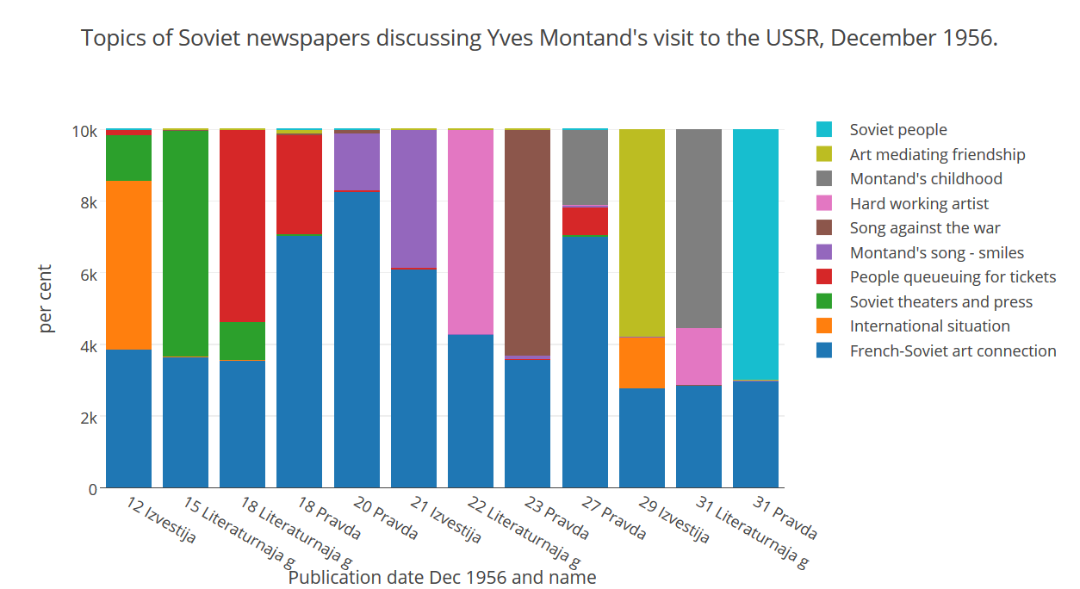
The film depicted the international encounter through art as an emotional- rather than knowledge-based, endeavour. The emotional character of the encounters was clearly visualized in the documentary film through the great number of smiling faces in the audience. Almost all the faces in the audience shown in closeup are smiling.

Smiling audiences listening to Montand’s songs.
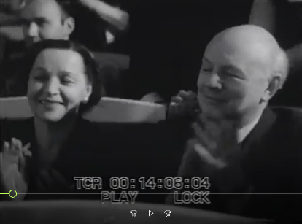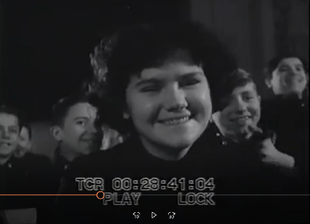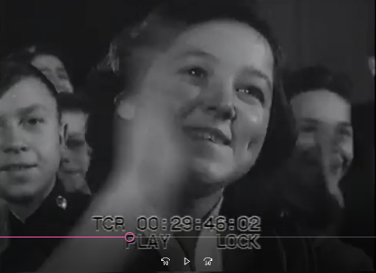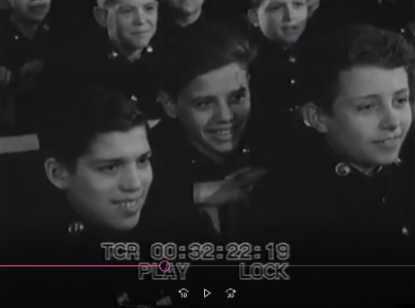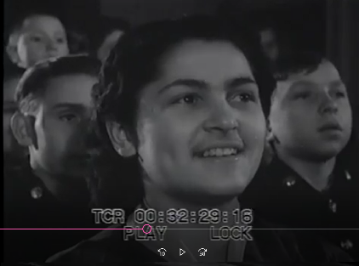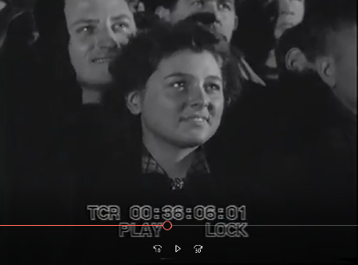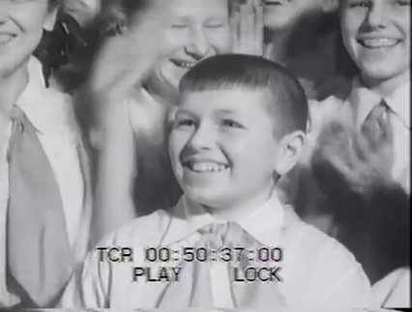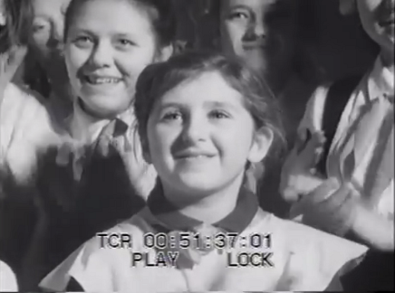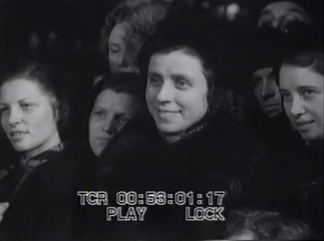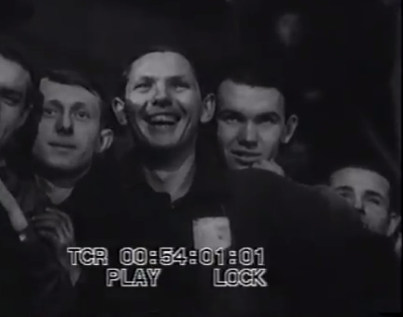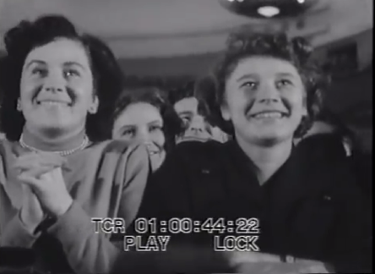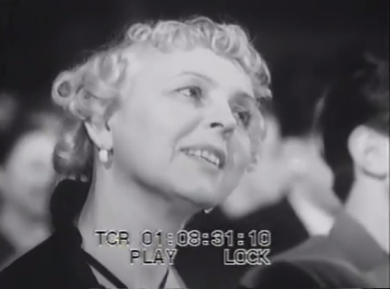
The faces in the audience remained serious only when the theme of the song is serious, such as war or capitalist-racist exploitation, as for example when Yves Montand sang Quand un soldat, and Les Cireurs de souliers de Broadway, a song about Afro American shoeshiners on Broadway.
The smiling faces are strategically located throughout the film, and many appear to be [delete] posed for the purpose. The smile, of course, has been a frequent feature in the Soviet propaganda posters, depicting happy Soviet life. Similarly, in the Khrushchev period, the Soviet media used smiles in depicting the international encounters in the spirit of Soviet policy of peaceful coexistence. In the film plan the film-makers indicated to the CSDF directors that they did not simply want to produce an advertisement for Montand, but also to present the Soviet people as “genuine lovers of everything progressive and talented”. In doing so, the newspaper articles also emphasised emotional rather than intellectual modes of communication between simple people (prostykh liudei). The positive emotions awakened by Montand’s performances included joy, friendship, respect, love, pride, hospitality. In an article in Literaturnaja gazeta a Soviet man declared that he would like to “shake hands with Montand”, and a young Soviet woman said that Montand sang “from one heart to another heart”.
The positive emotions were connected in the Soviet newspapers with the realm of international politics. A collocation analysis of the usage of the words friend, love and feeling in the newspaper texts shows that they were used in close connection to words usually associated with world politics. [Deletion] Revealing that the word friend appears most frequently in connection the words such as peace, people and nation – and not for example love and relationship – required the computer program´s “cold reading”. The analysis discloses a significant aspect of the way the friendship was understood in the Soviet newspaper discourse regarding Yves Montand and his tour. The emotional communication among people acquired international dimensions and meanings, when the people involved represent different nations across the Iron Curtain.

Collocation analysis of the word friend connected to words like peace, people, and nation.
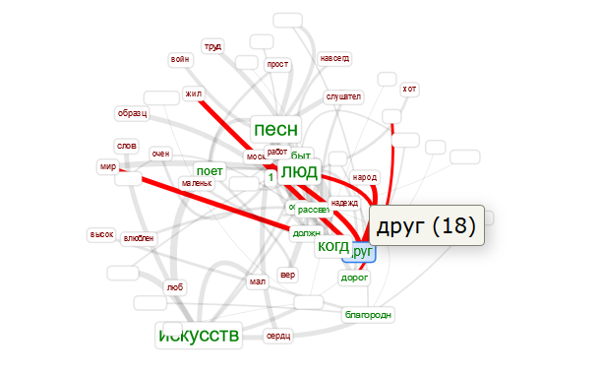
The emotions are connected not only to world politics in general, but also to the political compartmentalisation of the world. One of the Literaturnaja gazeta articles discusses Montand as a defender of peace and socialism when describing the situation in France, [comma added] and critical approaches to Montand because of his decision to perform in the Soviet Union despite the Suez and Hungarian crises. The article describes the ”progressive emotions” – instead of opinions – that Montand cannot conceal that have made him a target of “reactionary and Fascist-like” forces. Thus the emotions, rather than intellectual ideologies, drive Montand, and his “Fascist” opponents, and the world was divided into people with peace-loving positive feelings, and people with hostile and negative emotions.
Depictions of warm encounters were common in the Soviet media around the time when the documentary film was shown in the Soviet cinemas. The Soviet media showed that it was possible to sustain friendly relations with people from bourgeois countries, if they held “correct” political views. In the Soviet media the right kind of art and positive emotions were connected to the “peace loving socialist forces”, and decadent art and negative emotions were connected to “Fascist-like forces”. However, the division of the world was no longer simply based on geography, since approved friends could come also from France.

Musical messages in the cultural encounter
The state-run newspapers published very positive reviews of Montand’s performances. But was the diplomatic harmony between the star and the regime as complete as the carefully staged film and the press coverage of the tour suggest? One of his songs was the anti-militarist Quand un Soldat, which Montand had introduced into his repertoire in France during the French Indochinese war of 1946 to 1954. Given the importance of presenting Montand to the Russian public as an advocate for peace, Pravda reported that the song “evoked warm sympathies of the audience”, and Izvestija, approvingly, that he “reminds us of the horrors of the past war” and Literaturnaja gazeta that “he hates the same things we hate: war and its consequences”. In Signoret’s account however, the reception of this song was “chilly”. In short, there were clearly cross-currents under the harmonious surface portrayed by the Russian media, including the movie.
We can explore these tensions in relation to one particular song and the genre it refers to. The song is Au Fait des, also known as Le Fanatique du Jazz. This song was a staple of Montand’s repertoire well before the USSR tour. It ridicules the jazz fanatic whose eyes glaze over at the sound of classical music, “but who explodes to the sound of boogie-woogie”. A review of one of Montand’s concerts refers to this song as representing Montand’s humour in its presentation of what the writer calls “a stiljaga”. Likewise, the voice-over commentator in the movie refers to the jazz fanatic, or “in our vocabulary, simply a stiliaga. Montand laughs at them, these people exist, unfortunately, also in our own country”. A moment later we see that close up of a young male audience member wearing a tie that is conspicuously patterned and colourful, and a shot of his foot tapping in its thick-soled shoe. When the Moonlight Sonata is played, the Russian commentary says: “When this ‘expert’ is asked how he liked classical music, he will reply to you, ‘Oh yes, of course it is very … wonderful!’ … and he will fall asleep”.
The word “stiliaga” provides a focal point for a discussion of this song. Originally coined in 1949 it came to describe young people who adopted Western life-styles. The stiliaga was most frequently from the privileged levels of society, his parents likely to be professionals – doctors, lawyers, academics, diplomats – “the new Soviet elite”. Like so many other hedonistically-oriented youth subcultures emerging internationally in the postwar decade, the stiliagi proclaimed their identity through dress, demeanour and argot. For the male, tight trousers, “zoot suit” style colourful jackets and ties, an exaggerated quiff hair style, striped socks and shoes with thick soles. Again, as with so many subcultures, music was a decisive marker of group identity, and in the case of the stiliaga it was jazz. The hostility towards stiliagi softened with the Thaw, particularly regarding their music of choice, though jazz still remained ideologically suspect until the mid-1960s. Yet at the same time there were increasingly open debates about the music throughout the 1950s, and over 1954 and 1955 “several hundred jazz bands were founded in schools, universities and Houses of Culture”. In 1961, even the Komsomol opened its own jazz café. In the transition described as the Thaw, jazz was a musical focal point. On the face of it, Montand’s parody of the “jazz fanatic” aligns well with the official attitude to the stiliagi. It is interesting that the propaganda film presented the complete performance of this particular song, with elaborate editing, intercutting footage of stereotypical, US-referenced high-energy jiving, at times sped up to increase the sense of derangement on the part of the young dancers. Whether he knew it beforehand or not, Montand’s performance played directly to the official Russian hostility toward this subculture and its music.
So is there really a convergence of values here, as manifested in the attitude to jazz? This takes us to Montand’s own attitudes to the music. We can begin by noting that, while the lyrics of the song clearly portray the jazz fanatic as a simpleton, the actual music contains no hint of parody. When the pianist breaks into a boogie-woogie, the effect is compelling, and in fact we hear some audience members begin to clap or tap loudly along with the jazz. The intensity of the jazz feel should not be surprising. The entire band consisted of famous French jazz musicians. Bassist Emmanuel Soudieu had played with Django Reinhardt and with another long-time member of the Reinhardt groups, reed player Hubert Rostaing, who later “became responsible for [Montand’s] orchestrations”. Montand’s Musical Director since 1947 was pianist Bob Castella, who recalled auditioning for the position simply by playing “some jazz”, and that was enough. Castella was eminent in jazz circles and was close with guitarist Henri Crolla, musically “the equal of his friend Django Reinhardt” according to Montand. The three shared Montand’s Paris apartment, as well as musical kinship. With these two as musical collaborators, Montand recalls that he “began to create an authentic jazz band”.
Reviews of his early career suggest that Montand was himself a “jazz fanatique”, a major figure in the jazz-based “Americanitis” that invaded France in the 1940s. Reviewing this trend, the magazine Les Cahiers du Film referred to
a real “swing” professional, Yves Montand, whose eccentric gifts are on display in many a major theatre. Having no partner, he grimaces, writhes, yells, slides, and dislocates himself with enough energy for two. He is “swing” from head to toe, and since he’s well over six feet tall his swing-style shimmying and shaking seem to go on forever.
After 1951 Montand stopped performing in larger revues and was thus able to exercise full control over his shows, and as such, in his own words he “put together a group of musicians who played jazz the way he liked it”. When he presented his one man show, An Evening with Yves Montand, on Broadway in the US in 1961, produced by jazz impresario Norman Granz, his US band included leading US jazz musicians. Significantly, he performed “Le Fanatique du Jazz”, confirming again that, however the Russian audiences might have interpreted his performance, it was by no means inconsistent with a commitment to jazz.
The significant point to emerge from all this is that the message Montand was sending is not the message being received by the Soviet authorities. One very important difference is that the jazz fanatique does not have the same political meaning as the stiliaga, even though they appear to be the same social phenomenon. There is a crucial difference between what the “jazz fanatique” means in France and what the stiliaga means in the USSR. The stiliaga was interpreted as a threat to the State ideology. The USSR had laws against parasitism. The stiliagi were primarily from the privileged backgrounds that economically enabled them to be “parasitic” - that is, not in paid work. Montand’s “jazz fanatique” is merely a harmless idiot. The stiliaga is a potential criminal, subverting the state ideology. Here is a major semiotic discrepancy elided by the film.
So exactly what is the meaning of Montand’s stardom in relation to this music? When we think of Montand’s vast Soviet audiences, we must remember the heterogeneity of that category. They included conservatives who took unbridled pleasure in the parody of the “jazz fanatique”, but on the evidence of the film, the audiences also include stiliagi for whom the parodic representation of themselves is also an opportunity to tap their feet to some full-on jazz. Like similar “double coding” movements in relation to later rock in the USSR, the mocking of jazz culture was also an opportunity to provide the experience of jazz under the guise of ridicule, in keeping with the official line.
Thus, the superficially anti-jazz message is full of paradoxes. It is useful to conclude by enquiring into Montand’s own attitude to his tour and its propaganda function. The experience of the Soviet Union completely reversed his political sympathies. By the time the Russians were watching the propaganda film, Montand declared that “The events of 1956 and 1957 meant the loss of faith for me”. As reported in Le Figaro February 27 1958: “I feel all too clearly that I’ve been exploited, just like a shampoo or a drink”. Given the USSR’s objectives for the tour, it is ironic that its effect on Montand was, by his own account, to turn him completely away from communism.
This narrative thus brings together many critical moments in the history of twentieth century culture and politics, including the first great crisis in totalitarianism, a crisis of global significance. Montand’s tour lies at the central moment of these shifts and exposes all the contradictions they entail. When he sings about the jazz fanatic to the Soviet audiences, they are all hearing the same song, but the complex, multi-layered meanings of the jazz fanatic mean they are all receiving very different messages. In this exercise in cultural diplomacy, the semiotic dissonance could not be more complete.
On 19 December the couple were invited to a private official supper with Khruschchev[spelling corrected], Molotov, Bulganin, Malenkov and Mikoyan. To the dismay of their hosts, Montand and Signoret made it clear that the invasion of Hungary was, in their words, “unspeakable”. All was not so harmonious as the press and the film implied. Montand had been a life-long sympathiser with the left, and was represented in the film as a political “trophy” of the USSR, a celebrity endorsement of the new Soviet order. Yet ironically he concluded the tour irrevocably disillusioned with the regime. What was intended as a form of cultural diplomacy and rapprochement was in fact intersected by confused and confusing political messages.
During their tour, Yves Montand and Simone Signoret were conscious of the fact that they were filmed. Signoret whispered to Montand at the backstage of the Tchaikovsky Concert Center on 24 December 1956: “I feel as if I were in a newsreel.” But, strangely, both Montand and Signoret are silent about the long documentary. The tour took place in such a turbulent situation that “the Soviet tour” was not something to particularly advertise. One aspect of the film Yves Montand Sings, and what reveals its political strategy, is the fact that it isolates Montand’s tour in the Soviet Union from his wider itinerary in the Eastern bloc. The film gives an impression that Montand’s tour was confined to the USSR and does not give any clues of the bigger picture. This sounds strange from the perspective of solidarity within the Eastern bloc, but perhaps it suggests that the film was tailored for the Soviet market and was therefore emphasising the warm relationships between Montand and his Soviet audience. Montand’s whole tour of the Eastern bloc had the following route:
- 16 December 1956 Air France flight to Prague, and from there Aeroflot flight to Moscow (incl. trips to Leningrad and Kiev)
- In late January 1957 flight to Warsaw, arrival 18 January 1957
- From there, through East Germany, by train to Prague (according to Signoret, “a week in February”), a train to Bratislava
- By train to Romania, Bucharest (they were there at least on 22 February)
- By train to Sofia, Bulgaria
- By train to Beograd, 4 March 1957
- Arrival to Budapest on the second week of March 1957
- Flight from Budapest to Paris
In France, the collections of Gaumont Pathé Archives include a newsreel clip (01:53) from Montand’s concert in Prague, dated on 24 February 1957. The local audiences became familiar with the visit through newsreels. Interestingly, the Gaumont Pathé Archives show that this clip was never used in the French newsreels. Instead, Gaumont Pathé acquired Mikhail Slutsky’s film which is archived under the French title Yves Montand chante en URSS.

Conclusion: Whose cultural diplomacy?
It is clear from the foregoing that there were profound discrepancies between what the tour represented for Montand and Signoret, what it represented for the Soviet authorities and what it represented for the Soviet public: this exercise in “cultural diplomacy” was an asymmetrical conversation. If we understand cultural diplomacy as a form of soft power that emphasises the exchange of ideas and information, it is obvious that there were different layers of that diplomacy, or processes of cultural exchange, happening at the same time. The film Yves Montand Sings can be interpreted as a cultural diplomatic tool that drew on the tradition of Soviet newsreel and documentary film. It had elements of socialist realism in its representation of harmonious joy, of the emotions of mutual friendship and in its clear, although sparse, deployment of ethnographic elements. On the other hand, there were also features that refer to the changes in political climate. The idea of strongly foregrounding an international star was something new. Ultimately, the audience could choose to listen to the voice of Montand more than to the narrative voice-over that commented on the peaceful encounter of French and Soviet cultures.
Finally, then, one can ask whose cultural diplomacy is at stake. The film wanted to highlight Montand’s visit in the USSR, instead of the longer tour in the Eastern bloc. Montand himself had been under huge pressure before leaving France. Jean-Paul Sartre stated to Montand: “If you go, you stand surely for the Russians; if you stay, you stand surely for the reactionaries”. Both options were uncomfortable, and the French press discussed Montand’s actions very critically. It is understandable that, in the middle of this controversy, Montand referred to his interest in defending peace, and this was his first message in the USSR. From this perspective, it is reasonable to conclude that the larger tour in the Eastern bloc was also in his own interest. He wanted to show that it was not a question of the Soviet Union only: he wanted to speak for peace everywhere. It is tempting to speculate that perhaps the film’s conscious focus on the Montand’s visit to the USSR, and exclusion of his larger tour, also undermined his more general peace message through emphasising his devotion to the Soviet audience.
From the point of view of cultural diplomacy, the film and the tour were two different events, but it is essential also to see the difference between the interests of Montand’s hosts and his own position as a public figure whose activities were carefully followed not only by the French audience but by the international community.

Newsreel, Week 51, 1956, Net-Film Digital Database, https://www.net-film.ru/en/film-10342/
Yves Montand, Hervé Hamon, and Patrick Rotman, transl. Jeremy Leggatt. You See, I Haven’t Forgotten. London: Chatto & Windus, 1992, 269.
Newsreel, Week 51, 1956, https://www.net-film.ru/en/film-10342/. Unless otherwise stated, all the translations from Russian are by Oiva.
Montand. You See, I Haven’t Forgotten, 263. Montand stated in an interview in Le Figaro (12 November 1956) that “I made this commitment eight months ago”. Unless otherwise stated, all the translations from French are by Salmi.
Washington Post, 30 December 1956; Montand, You See, I Haven’t Forgotten, 258.
The Central Documentary Films Studios (Tsentral’naya Studija Dokumental’nykh Filmov TsSDF) was established in 1936. It was the major all-Union producer of documentary films in the Soviet Union. In addition to that, there were Mosfilm (artistic films), the Central Studios of Educational Films, Soyuzeksportfilm (organization of export cinema), the Gorkii Film Studio (producing films for children and youth) and the Cartoon Film Studios. In addition to the all-Union film studios, there were also regional and republican studios.
The film is available online at the Net-Film Digital Database at https://www.net-film.ru/en/film-4886/
Cultural diplomacy can be understood as a cultural activity that supports "objectives which have been defined through normal policy channels", although it is less focused on immediate outcomes as it aims to broadly influence the elite or mass public opinion of another nation. Its aim is to align the policies or views to the advantage of the influencing nation. For further details, see Graham Carr. “No Political Significance of Any Kind”: Glenn Gould’s Tour of the Soviet Union and the Culture of the Cold War. The Canadian Historical Review 95, no. 1 (2014): 3–4.
Sarah Davies. The Soft Power of Anglia: British Cold War Cultural Diplomacy in the USSR. Contemporary British History 27, no. 3 (2013): 297–323. doi:10.1080/13619462.2013.794695; György Péteri. Sites of Convergence: The USSR and Communist Eastern Europe at International Fairs Abroad and at Home. Journal of Contemporary History 47, no. 1 (2012): 3–12. doi: 10.1177/0022009411422373; Graham Carr, “No Political Significance of Any Kind”: Glenn Gould’s Tour of the Soviet Union and the Culture of the Cold War. The Canadian Historical Review 95, no. 1 (2014): 1–29.
Carr. “No Political Significance of Any Kind”: Glenn Gould’s Tour of the Soviet Union and the Culture of the Cold War, 12.
Michael David-Fox. Showcasing the Great Experiment: Cultural Diplomacy and Western Visitors to the Soviet Union, 1921–1941. New York: Oxford University Press, 2012, 14.
David-Fox. Showcasing the Great Experiment, 14–15.
This paper uses the Python based Text Processing web tool (http://text-processing.com/demo/stem/) for stemming the newspaper article texts, Voyant tools (https://voyant-tools.org/) and Mallet (http://mallet.cs.umass.edu/) for text analysis, and Plot.ly (https://plot.ly/) for visualizing the results of topic modelling. Stemming is a process which removes the word suffixes and leaves the common root forms of the words there. This process is needed in particular in a highly inflected language like Russian. The programs used are free and easy to use and can be used also by scholars with no coding experience.
Carr. “No Political Significance of Any Kind”: Glenn Gould’s Tour of the Soviet Union and the Culture of the Cold War, 7–8; Eleonory Gilburd. The Revival of Soviet Internationalism in the Mid to Late 1950s. In The Thaw: Soviet Society and Culture during the 1950s and 1960s, Eleonory Gilburd, Denis Kozlov, (eds.), 362–401. Toronto: University of Toronto Press, 2013; Mila Oiva. Creation of a Market Space. The Polish Clothing Industry, Soviet Union, and the Rise of Marketing, 1949–1961. Unpublished PhD, Cultural History, University of Turku, 2017.
Pia Koivunen. Friends, “Potential Friends”, and Enemies: Reimagining Soviet Relations to the First, Second, and Third Worlds at the Moscow 1957 Youth Festival. In Socialist Internationalism in the Cold War – Exploring the Second World, Patryk Babiracki, Austin Jersild (eds.), 219–247. Basingstoke: Palgrave Macmillan, 2016; M. Lebedeva and V. Chertikhin (eds.). Korotko o stranakh. Navstrechu VI Festivaliu. Moskva: Gosudarstvennoe izdatel’stvo politicheskoi literatury, 1957, 283.
Shawn Salmon. Marketing Socialism. Inturist in the Late 1950s and Early 1960s. In Turizm. The Russian and East European Tourist under Capitalism and Socialism, Anne E. Gorsuch, Diane P. Koenker (eds.), 186– 204, 190. Ithaca: Cornell University Press, 2006; Hanna Kuusi. Accidental Traders – Finnish Tourists in the Soviet Union in the 1950s–1970s. In Finnish Consumption. An Emerging Consumer Society between East and West, Visa Heinonen, Matti Peltonen (eds.), 206–227. Helsinki: Finnish Literature Society, 2013, 208.
Montand. You See, I Haven’t Forgotten, 259. See also Simone Signoret. Nostalgia Isn’t What It Used to Be. New York: Harper & Row, 1978, 155.
On Montand’s success see, for example, Vladislav Zubok. Zhivago's Children: The Last Russian Intelligentsia. Cambridge, Mass.: The Belknap Press, 2009, 99.
Gilburd. The Revival of Soviet Internationalism in the Mid to Late 1950s, 366.
Montand. You See, I Haven’t Forgotten, 263.
Montand. You See, I Haven’t Forgotten, 269–270.
On the French discussion on the Hungarian crisis, see Michael Scott Christofferson. French Intellectuals and the Repression of the Hungarian Revolution of 1956: The Politics of a Protest Reconsidered. In After the Deluge: New perspectives on the Intellectual and Cultural History of Postwar France, Julian Bourg (ed.), 253–271. Lanham: Lexington Books, 2004.
Joëlle Monserrat. Yves Montand. Paris: Éditions Pac, 1983, 61.
See documents in RGALI 2487/1/560 “Poet Iv Montan”, December 1956–March 1957.
Film plan “Signer of Paris” dated 21 December 1956, II version. RGALI 2487/1/560, "Poet Iv Montan", December 1956–March 1957.
Yves Montand Sings time stamps 0:04:06, 0:07:20. On the history of French-Soviet relations, see Sophie Coeuré and Rachel Mazuy. Cousu de fil rouge: Voyages des intellectuels francais en Union soviétique. Paris: CNRS Éditions, 2012, 173, 336, 340.
Susan E. Reid. Toward a New (Socialist) Realism. The Re-Engagement with Western Modernism in the Khrushchev Thaw. In Russian Art and the West: A Century of Dialogue in Painting, Architecture, and the Decorative Arts, Rosalind Polly Blakesley, Susan E. Reid, (eds.), 217–239. United States of America: Northern Illinois University Press, 2007; Mikkonen, Simo. Soviet-American Art Exchanges during the Thaw: from Bold Openings to Hasty Retreats. In Art and Political Reality, M. Kurisoo (ed.), 57–76. Proceedings of the Art Museum of Estonia (8). Tallinn: Art Museum of Estonia - Kumu Art Museum, 2013.
Gilburd. The Revival of Soviet Internationalism in the Mid to Late 1950s, 365.
Gilburd. The Revival of Soviet Internationalism in the Mid to Late 1950s, 366.
Nakanune odjezda (On the Eve of Departure). Literaturnaja gazeta, 15 December 1956, 4.
The Soviet documentaries dealt also the themes of Soviet leaders and the heroism of World War II, the Communist Party, agriculture, industries, scientific and technological development, Soviet and foreign culture, cinema, journalism, and sport. Tsentral’naja studia dokumental’nykh filmov (TsSDF), description of fond 3, RGAFD, http://ргафд.рф/nauchno-spravochnyi-apparat/obzor-fondov/fond-studiya-dok-filmov/fond-3-tsentralnaya-studiya-dokumentalnykh-filmov.shtml accessed 30 January 2017.
Simo Mikkonen. Stealing the Monopoly of Knowledge?: Soviet Reactions to U.S. Cold War Broadcasting. Kritika: Explorations in Russian and Eurasian History, 11, no 4 (2010) (New Series): 771–805, 772–775, 792–794.
Offer of M. Slutsky and S. Yutkevich to make a documentary film of visit of Yves Montand to the Soviet Union, no date. RGALI 2487/1/560 "Poet Iv Montan", December 1956–March 1957.
Mikkonen 2013.
Yves Montand Sings time stamps 0:01:51, 0:02:32, 0:05:02, 0:08:08, 0:08:40, 0:29:50, 0:31:39, 0:38:02, 0:39:33, 0:44:14, 0:54:36, and 1:05:19.
Topic modelling is a statistical text analysis method, which analyses which words were used most frequently in connection to each other, and thus form a topic discussed in the text. The granularity of the results depends on the amount of topics that the researcher chooses to focus on: a greater number of topics provides more fine-grained results, while a small number of topics provides a more rough understanding what the texts talk about. Because this chapter uses a small and pre-selected sample of texts that all discuss the tour of Montand in the Soviet Union over a short time period, breaking down the texts into ten topics provides information that is varied enough, but at the same time generalizes the texts. The results of the analysis with ten topics were verified by analysis with five and twenty topics, which both provided results pointing in the same direction. The analysis program deployed, Mallet, gave as the result of topic modelling analysis ten groups of words representing the topics, and percentages of each topic in each analysed article. After receiving the results of the program, we analysed the groups of words, and gave each of them an appropriate title (see the visualization of the topics below), based on the words emerging in the group.
Although “art mediating international friendship” is an overarching topic, we would not have necessarily identified it in the articles only based on close reading, although one can easily recognize it after receiving the topic modeling analysis results. The topic modeling result also gave words for describing the phenomenon identified earlier in the documentary film.
Mikkonen 2013.
Time stamps of the images: 0:14:06, 0:28:41, 0:29:46, 0:32:22, 0:32:29, 0:36:06, 0:50:37, 0:51:37, 0:53:00, 0:54:01, 1:00:43 and 1:08:31.
See, for example smiles in 0:14:06, 0:28:41, 0:29:46, 0:32:22, 0:32:29, 0:36:06, 0:50:37, 0:51:37, 0:53:00, 0:54:01, 1:00:43 and 1:08:31 and serious faces in 0:12:15, 0:13:32, 0:59:39, and 0:52:58.
See 0:13:32.
See 0:59:39.
Koivunen. Friends, “Potential Friends”, and Enemies, 229.
Film plan “Signer of Paris” dated 21 December 1956, II version. RGALI 2487/1/560 "Poet Iv Montan", December 1956–March 1957.
Nik Smirnov-Sokol'skii. Golos serdtsa. Literaturnaja gazeta, 22 December 1956, 3.
These were the adjectives used most frequently in close connection to the word chuvstvo – feeling in English.
Ochered no 10207 (Queue position number 10207). Literaturnaja gazeta, 18 December 1956, 1.
Originally a corpus linguistics method, collocation analysis has also been used in social sciences and humanities to understand the ways of discussing and understanding connections between the words in a text. See, for example Scott Blinder and William L. Allen. Constructing Immigrants: Portrayals of Migrant Groups in British National Newspapers, 2010–2012. International Migration Review 50, no 1 (2016): 3–40. doi:10.1111/imre.12206 and Tuuli Lähdesmäki and Albin Wagener. Discourses on governing diversity in Europe: Critical analysis of the White Paper on Intercultural Dialogue. International Journal of Intercultural Relations 44 (2015): 13–28. doi:10.1016/j.ijintrel.2014.11.002.
Nakanune odjezda (On the Eve of Departure). Literaturnaja gazeta, 15 December 1956, 4.
Koivunen. Friends, “Potential Friends”, and Enemies, 2016, 221–222, 226–230.
Montand. You See, I Haven’t Forgotten, 113.
Martin Lücke. The postwar campaign against jazz in the USSR (1945–1953). In Jazz Behind the Iron Curtain, Gertrud Pickhan, Rüdiger Ritter (eds.), 99–116. Frankfurt am Main: Peter Lang, 2010, 97.
Michel Abeßer. Between Cultural Opening, Nostalgia and Isolation - Soviet Debates on Jazz between 1953 and 1964. In Jazz Behind the Iron Curtain, Gertrud Pickhan, Rüdiger Ritter (eds.), 99–116. Frankfurt am Main: Peter Lang, 2010, 108.
Abeßer. Between Cultural Opening, Nostalgia and Isolation, 113.
Montand. You See, I Haven’t Forgotten, 159.
Montand. You See, I Haven’t Forgotten, 164.
Montand. You See, I Haven’t Forgotten, 74.
Montand. You See, I Haven’t Forgotten, 205.
Abeßer. Between Cultural Opening, Nostalgia and Isolation, 108.
Montand. You See, I Haven’t Forgotten, 282.
Montand. You See, I Haven’t Forgotten, 283.
Montand. You See, I Haven’t Forgotten, 275–276.
Signoret. Nostalgia Isn’t What It Used to Be, 164–166.
Quoted in Patricia A. DeMaio. Garden of Dreams: The Life of Simone Signoret. Jackson: University Press of Mississippi, 2014, 138.
Gaumont Pathé Archives, Yves Montand, 1957 9 21 NU, http://gaumontpathearchives.com/index.php?urlaction=doc&id_doc=37506&rang=47
Gaumont Pathé Archives, Yves Montand chante en URSS, 5700AKDOC02496, http://gaumontpathearchives.com/index.php?urlaction=doc&id_doc=271972
Quoted in Montand, You See, I Haven’t Forgotten, 267.

