Title: Effect of solvent / disinfectant ethanol on the micro surface structure and properties of multiphase denture base polymers.

Authors: Santhosh Basavarajappa^{a,}, Abdul Aziz Abdullah Al-Kheraif^{b}, Mohamed ElSharawy^{c}, Pekka K. Vallittu^{d}.
a. Lecturer, Dental Health Department, College of Applied Medical Sciences, King Saud University, Riyadh-11433, Kingdom of Saudi Arabia. sbasavarajappa@ksu.edu.sa
b. Dental Biomaterial Research Chair, Dental Health Department, College of Applied Medical Sciences, King Saud University, Riyadh-11433, Kingdom of Saudi Arabia. aalkhuraif@ksu.edu.sa
c.Biomedical Engineer, Researcher, Dental Biomaterials Reasearch Chair, King Saud University, Riyadh-11433, Kingdom of Saudi Arabia. malsharawy@ksu.edu.sa
d. Professor and Chair of Biomaterials Science and Turku Clincal Biomaterials Centre – TCBC, Institute of Dentistry, University of Turku and City of Turku Welfare Division, Oral Health Care, Turku, Finland, FI-20520. pekka.vallittu@utu.fi

Study conducted in: Dental Biomaterials Research Chair, Dental Health Department, College of Applied Medical Sciences, King Saud University, Riyadh 11433, Kingdom of Saudi Arabia.

Corresponding author:
Dr.Santhosh Basavarajappa, M.D.S
Lecturer, Dental Health Department,
College of Applied Medical Sciences
King Saud University,
Riyadh-11541, Kingdom of Saudi Arabia
sbasavarajappa@ksu.edu.sa
Contact no. +966537137042
Fax:+96611469350
Abstract
Aim of the study: The aim of this study was to evaluate the effect of solvent / disinfectant ethanol on the surface of denture base base polymers. Changes in surface roughness, topography and some nanomechanical properties were assessed by SEM and nanoindentation plotted against different concentrations of ethanol on heat cured and autopolymerised polymetyl methacrylate based acrylic denture base polymers.
Materials and methods: Test specimens (10x10x3 mm³) of heat-curing (HC) and auto polymerizing (AP) acrylic resin were prepared and polished to obtain uniform smoothness which were further grouped into 3 sub-groups HC1, HC2, HC3 and AP1, AP2, AP3 respectively 10 specimens (n) in each group. HC1 and AP1, HC2 and AP2, HC3 and AP3 were treated with 99.9%, 70% and 40% respectively for 30, 60 and 120 seconds followed by analysis of surface roughness (S_{a}), topographical changes and some nanomechanical properties.
Results: Both HC and AP resins showed changes in their S_{a} and nanomechanically measured modulus of elasticity and surface hardness after being treated at different concentrations of ethanol and at different lengths of time. Surface changes were most clearly seen in autopolymerizing denture base polymer, especially at the interface region between the PMMA polymer bead and polymer matrix. There was a correlation (R2=0.83, r= 0.91, p<0.001) between the time of treatment by ethanol and thickness of the affected area of denture base polymer. Conclusion: The present study demonstrated that denture base polymers, especially autopolymerized denture base polymer is prone for surface crazing and dissolving by solvent / disinfectant ethanol. The interphase region between the PMMA polymer bead and the polymer matrix was most affected by the ethanol.
Key words: Acrylic resin, Disinfectant, Ethanol, Crazing, Dissolving, PMMA.
Title: Effect of solvent / disinfectant ethanol on the micro surface structure and properties of multiphase denture base polymers.
1.Introduction.
Acrylic resins were introduced as denture base materials since 1937 and polymethyl methacrylate (PMMA) is still the most commonly used material in dental prosthesis, denture liners, various orthodontic appliances, temporary crowns ( Craig, 1993). PMMA is used in the form of powder-liquid system, mixed at different ratio for controlling the polymerization shrinkage and obtaining resin mixture or dough which is easy to handle (Vallitu, 1994). Monomer liquid system is predominantly methyl methacrylate but there are typically minor quantities of cross linking dimethacrylates (Ruyter and Svendsen, 1980 and Ruyter and Oysaed, 1982). Once PMMA beads and monomer system have been mixed, beads begin to be dissolved. Increasing the time before the monomers are cured, better the beads are dissolved and more homogeneous the polymers will be (Vallittu and Ruyter, 1997). When looking at the structure of PMMA based powder-liquid resin in detail, an interphase layer between the core of the polymer bead and matrix can be found (Kawakuchi et al., 2011). Polymer structure of the interphase is semi-interpenetrating polymer network (semi-IPN) where slightly cross-linked polymer matrix has been integrated in the polymer structure of the dissolved PMMA beads. The behavior of mechanical and biological properties of acrylic resin is determined by the amount of unconverted or unreacted residual monomer present in the polymerized resin (Melilli et al., 2009). Ideally the amount of free monomer, so-called residual monomer in heat cured acrylic resin material should not exceed more than 2.2% and for auto polymerized acrylic resin material 4.5% was the maximum allowable limit according to international standards (Miettinen and Vallittu, 1997, Vallittu et al., 1998 and Yilmaz et al., 2003). The residual monomer quantity when treated or immersed in ethanol showed changes in the physical properties particularly on the flexural strength and hardness and cytotoxicity caused by the leaching of the monomer in the oral cavity was reduced (Neves et al., 2013).
Chemical disinfectants have been used in order to combat bacterial contamination of the dental prosthesis (Cunegatti et al., 2008) and these disinfectants have an influence on the physicomechanical properties of the denture base resins (Shen et al., 1989). It was found that alcohol containing chemical disinfectant agents affected the flexural strength predominantly of the non cross linked denture base resins (Asad et al., 1992). Surface roughness is another important factor which governs the adherence of the bacterial colonization (Bollen et al., 1997) and use of disinfectants for cleansing of the denture base resins affects the surface roughness significantly (Pinto et al.,2010). It is also found that an increase in the threshold of surface roughness by 0.2 µm would substantially increase the accumulation of plaque (Bollen et al., 1997) and oral organisms (Waltimo et al., 1999). Certain chemical disinfectants may cause some change in the surface roughness of the denture base polymers by crazing (Schwindling et al., 2014).
Crazing which appears as an organized crack appears on the surface of materials preferably on the thermoplastic polymers, caused by the effect of weaker Van der Walls force and a strong covalent bond. It usually occurs in those areas of the polymer material, which have a high hydrostatic tension and localized yielding resulting in the formation of micro voids (McLeish et al., 1989). Crazing can be seen by the reflection of light from the fibrils that form the backbone of the polymeric chain. Initially crazing was considered to be as cracks until it was shown that they were made of polymer interfiling interconnecting the polymer that was not deformed by the solvent (Spurr and Niegisch, 1962) and thickness of the craze was determined by the width of the groove (Kambour and Kopp, 1969). Crazing relates to the capability of solvents to dissolve the polymer and therefore factors, which influence solubility of the polymers may play a role crazing. Ethanol, which as a solubility parameter of 13 (cal/cm³)^{1/2} and denture base resins made up of polymethyl methacrylate which as a solubility parameter of 8.9 – 12.7 (cal/cm³)^{1/2} (Brandrup, 1975 and Jacques and Wyzgoski, 1979) indicating that ethanol could dissolve or craze denture base polymer as it is already established that organic solvents which have solubility parameters as that of the polymer act as good solvent or crazing agents (Kambour, 1972). The behavior of ethanol prompted us to study on the nanomechanical (NMP) properties and its solvent tendency by varying its concentration.
Although there is some knowledge that ethanol could cause damage to the denture base polymer, there is no information at what location of the surface microstructure of multiphase denture base polymer the damage begins. Therefore, the aim of this study was to investigate solvent crazing and dissolving effect of autopolymerized and heat-polymerized denture base polymers by solvent / disinfectant with ethanol of various concentrations.

2. Materials and methods
2.1.Specimen preparation
Test specimens of size of 10 x 10 x 3 mm³ of heat curing (Interacryl Hot, Interdent, Opekarniska, Slovenia) and auto polymerizing acrylic resin (Orthoresin, DeguDent, Hanau, Germany) was prepared and their surfaces wet ground and polished to obtain uniform smoothness. Gross nodules and surface irregularities was finished with lathe mounted acrylic bur and 360-grit sand paper and final polishing was done using 600 grit silicon carbide disc for 30s at 100rpm with a load of 13N pressure using an automatic polishing machine (Automet 250/300, Power Head, Buehler, 41 Waukegan Road, Lake Bluff, Il 60044 USA). Heat cured (HC) and auto polymerized resin (AP) specimens were further grouped into 3 sub-groups HC1, HC2, HC3 and AP1, AP2, AP3 respectively 10 specimens (n) in each group. The polymer to the monomer ratio for both the heat cured and autopolymerizing resin was in the ratio of 3:1. Heat cured resin was cured for 90 minutes at 74ºC, 30 minutes boil at 100ºC and autopolymerizing resin cured in a pressure flask containing water at 45º-50ºC at 207 kPa for 9 minutes as recommended by the manufacturer.
2.2.Experimental method.
Surface of test specimens were subjected to the following analysis: the specimens were first evaluated for surface roughness (S_{a}), surface topography by scanning electron microscopy (SEM) and NMP which served as control values for repeated measurements after solvent/disinfectant ethanol treatment for various lengths of periods of time. Surface of resin was treated with 99.9%, 70% and 40% ethanol for 30 s, 60 s and 120 s and washed by water for further analysis.
2.2.1. Surface roughness (S_{a}) was determined using a non contact profilometer (Bruker, Contour GT, Tucson, AZ, USA) with 5 readings on each surface at different locations and the average S_{a} value was derived. S_{a} was measured for all the specimens at different concentrations of ethanol and various times of ethanol treatment. Along the surface roughness measurement, the surface topography changes were visually inspected from SEM images, (BOC EDWARDS, PV25MK, West Sussex, England, UK) which were taken before and after treatment with ethanol. Measurements by SEM were also taken to quantify the extent and location of dissolution of the polymer structure. Four measurements were made for each specimen and the average value was used in further calculations. Measurements were made only for autopolymerized resin specimens because no polymer structure changes were visible in the heat-cured resin specimens.
2.2.2. The specimens were also studied in terms of the NMP properties after being treated with solvent / disinfectant ethanol. The modulus of elasticity and surface nano hardness were measured by nanoindenter (Bruker, Tucson, AZ, USA) equipped with Berkowich diamond indentor. Test was done in low noise conditions and at controlled temperature of 23º C. The loading and unloading rate of 0.6 mN/s was used and 10 s of resting period at maximum load, varying the maximum load between 1 to 10 mN. Two readings were obtained from each specimen before and after treatment of solvent / disinfectant ethanol.
2.3. Statistical analysis
Data was statistically analyzed using one way ANOVA and Scheffe post hoc test at 5% significance level for comparison of mean S_{a} values, dissolution of the polymer on time interval and NMP properties among the specimens. Linear regression analysis was used to calculate correlation between the length of time of the ethanol treatment and measured thickness of the dissolved area for autopolymerized resin.

3.Results
Results for the S_{a} measurement showed that ethanol had some effect on surface roughness which varied between the HC and AP acrylic resins and between different concentrations of ethanol. For the HC resins it was seen that changes in S_{a} was not statistically significant when treated for 120 seconds by 70% ethanol concentrations whereas for the AP resins statistically significance change was seen when the specimens were treated with 99.9% ethanol for 60 and 120 seconds as shown in table-1.
SEM images showed that the HC resins had no surface topographic changes when treated with different ethanol concentrations for up to 120 seconds whereas the AP resins showed topographic changes which was attributed to surface crazing and dissolving effect by ethanol (Figure 1,2 and 3). The crazing and dissolving occurred at the region of semi-IPN layer, i.e. at the marginal region of the polymer bead and polymer matrix. Thickness of the affected layer increased, by prolonging the ethanol treatment time from 30 to 120 s as shown in table-2. Regression analysis demonstrated correlation (R2=0.83, r= 0.91, p<0.001) between the ethanol treatment time and thickness of the affected layer between the PMMA bead and polymer matrix as in figure-4. This study demonstrated first time that disinfectant ethanol with 40% concentration deteriorates the surface of multiphase denture base polymers. Deterioration occurs at the interface between polymer bead and the polymer matrix.
Nano mechanical properties for young’s modulus of elasticity and the hardness were affected when treated with ethanol at varying concentrations at different proportion of time. Both HC and AP resins showed statistically significant changes at varying concentrations and time period. Maximum hardness for both HC and AP was seen when 70% ethanol treatment was done for 30s. (table -3)

4.Discussion
In this present study emphasis was given to evaluate the effect of solvent / disinfectant ethanol in varying concentrations on the mechanical properties of the HC and AP acrylic resins. Chemical disinfectants have shown to cause some amount of dimensional changes in the resin structure (Cunegatti et al., 2008 and Shen et al., 1989) and surface damage (Ma et al., 1997). Acrylic resins contain various soluble materials such as the initiators, free monomers and also plasticizers (Tuna et al., 2008) and these are released by various chemicals based on the ionic concentration that varies among different disinfectant solutions (Machado et al., 2011). The physical properties of the polymer can be altered resulting in an increased chipping of the particles from the matrix (Hashiguchi et al., 2009). Acrylic resins by its chemical nature are polar in nature, the factor which makes it to absorb water from varying concentrations of ethanol in 70% and 40% and it has been shown that the absorbed water interferes with the polymer chains affecting the physical properties causing swelling of the resin network resulting in the relaxation of the stresses (Takahashi et al., 1998 and Yiu et al., 2004). Varying the time period of contact of the resin, the imbibed water molecules can bring about irreversible damage caused by the hydrolytic degradation and scission of the polymer also resulting in the formation of surface cracks (Pinto Lde et al., 2010). In this study we found that S_{a} was influenced by ethanol in varying concentrations and significant changes were seen in AP acrylic resins and studies have proved that the type of acrylic resin (heat-cured vs. autopolymerized) was an important factor in deciding the surface alteration (Lira et al., 2012). This is likely attributed to the monomer to polymer conversion ratio, which is higher in HC resins with less residual monomer (Zissis et al., 2008) and the amount of elution is higher in AP acrylic resins (Koda et al., 1989).
Polymer dissolution by a solvent occurs mainly by solvent diffusion and disentanglement of the polymeric chain. Diffusion of the solvent into the polymer becomes easy when uncrossed link monomers are present with a stable solvent. Solvent initially plasticizes the polymer forming a gel like swollen layer between the glassy polymer and the gel layer and also between the gel layer and the solvent following which there can be dissolution of the polymer or result in the formation of cracks. After a period of time further dissolution of the solvent reaches an end stage known as the quasistationary state (Ueberreiter, 1968). Polymer dissolution is mainly governed by the molecular weight of the material and within the same material it depends upon whether the material is polydisperse or monodisperse (Manjikow et al., 1987). At room temperatures it has been found that PMMA is insoluble in water and ethanol alone but soluble in mixture form (Brandrup et al., 1999 and Jewrajka et al., 2004). At 40-50 vol-% ethanol the solubility was attributed to the formation water cages in and around the hydrophobic ethanol molecules and at 80 vol-% the solubility was attributed to water and hydrogen bonding around the ester moieties of the resin polymer ( Piccarolo and Titomanlio, 1982 and Cowie et al., 1987). The solubility parameter of ethanol and PMMA is very close to each other thereby ethanol acts as a polymer solvent for PMMA. In our study the effect of ethanol on the PMMA resin at absolute concentration was attributed to the water and hydrogen bonding and at 40% it was mainly because of the formation of water cages and at 70% due to both the factors. In the AP resins surface crazing or cracks was evident which was attributed to the presence of the non cross linked monomers unlike in the HC resins and the time of contact of the ethanol in the HC resins was not more than 2 minutes for the necessary dissolution of the polymer. In the AP resins statistically significant dissolution of the resin was seen for all the three concentrations of ethanol and more dissolution was seen in the 40% ethanol treated specimens when compared to that of others. SEM images confirmed the same upon analysis of the surface topographical changes after the specimens were treated ethanol.
It was important to notice that the solvent / disinfectant ethanol mainly affected the semi-IPN layer between the polymer bead and polymer matrix. This suggests that the semi-IPN layer is more prone for dissolving than the slightly cross-linked polymer matrix or the core of the polymer bead. PMMA polymer beads are syndiotactic polymer and could resist dissolving and crazing more effectively than the interface with semi-IPN structure, which was actually swollen by methyl methacrylate monomers. It is also interesting to note that crazing and dissolving was not found with heat-cured PMMA. During doughing time the MMA monomers can penetrate through the PMMA polymer bead and therefore the polymer structure is more homogeneous, and it seems to be also more resistant for crazing and dissolving.
NMP properties of the resins were evaluated post polymerization treatment with ethanol for period of time. The residual monomer present in the polymer when replaced by the solvent materials results in increased plasticizing nature of the polymer (Ferracane, 2006 and Pedreira et al., 2009). In this study we found that the AP resins were affected by the plasticizing nature of ethanol where significant changes were seen affecting both the modulus of elasticity and also the hardness of the polymerized resin whereas in the HC resins no significant changes was seen which could be attributed to less amount of residual monomer in the HC resins.
The findings of this study suggest that ethanol containing disinfectant solutions could deteriorate the surface of denture base polymers and therefore their use is not recommended. Alternative disinfectants for denture bases could be found e.g. from other groups of disinfectants like chlorhexidine, glutaraldehyde and sodium hypochlorite.
5.Conclusions
The present study demonstrated that denture base polymers, especially autopolymerized denture base polymer is prone for surface crazing and dissolving by solvent / disinfectant ethanol. The interphase region between the PMMA polymer bead and the polymer matrix was most affected by the ethanol.

Conflict of interest: none to declare.

Acknowledgements:
The project was financially supported by king Saud University, Vice Deanship of Research Chairs. The study is also part of the research by the BioCity Turku Biomaterials Research Program (www.biomaterials.utu.fi).

References.
Asad,T., Watkinson, A.C, Huggett, R., 1992. The effect of disinfection procedures on flexural properties of denture base acrylics. J. Prosthet. Dent. 68, 191-195.
Bollen, C.M., Lambrechts, P., Quirynen ,M., 1997. Comparison of surface roughness of oral hard materials to the threshold surface roughness for bacterial plaque retention: a review of the literature. Dent. Mater. 13, 258-269.
Brandrup, J., 1975. Polymer Handbook. Second ed , John Wiley and Sons, New York, pp 340-354.
Brandrup, J., Immergut, E.H., Grulke, E.A., 1999. Polymer handbook. Fourth ed. Vol. 1 Wiley-Interscience, New York.
Cowie, J.M.G., Mohsin, M.A., McEwen, I.J., 1987. Alcohol water solvent systems for poly (methyl methacrylate. Polymer. 28, 1569-1572.
Craig, R.G., 1993. Restorative Dental Materials, ninth ed. CV Mosby, St. Louis, pp. 514- 530.
Cunegatti, Z.A., Caldas, C.D., Brasiliense, E.R., Mitsuo,S.O.H., Arai, S.R.S., 2008. Changes in hardness and surface topography of tissue conditioners submitted to chemical disinfection. Minerva. Stomotol. 57, 577-585.
Ferracane, J.L., 2006. Hygroscopic and hydrolytic effects in dental polymer networks. Dent. Mater. 22, 211-222.
Hashiguchi, M., Nishi, Y., Kanie ,T., Ban, S., Nagaoka, E., 2009. Bactericidal efficacy of glycine-type amphoteric surfactant as a denture cleaner and its influence on properties of denture base resins. Dent. Mater. J. 28, 307-314.
Jacques, H.M., Wyzgoski, M.G., 1979. Prediction of environmental stress cracking of polycarbonate from solubility consideration. J. Appl. Polymer. Sci. 23,1153-1166.
Jewrajka, S.K., Chatterjee, U., Mandal, B.M., 2004. Homogeneous atom transfer radical polymerization of methyl methacrylate at ambient temperature in aqueous ethanol. Macromolecules. 37, 4325-4328.
Kambour, R.P., Kopp ,R.W., 1969. Cyclic stress-strain behavior of the dry polycarbonate craze. J. polymer. Sci. PartA-2. 7, 183-200.
Kambour, R.P., 1972. A review of crazing and fracture in thermoplastics. General Electric Report no.72CRD285, October.
Kawakuchi, T., Lassila, L.V.J., Tokue, A., Takahaski, Y., Vallittu, P.K., 2011. Influence of molecular weight of polymethyl(methacrylate) beads on the properties and structure of cross-linked denture base polymer. J. Mech. Behav. Biomed. Mater. 4, 1846-1851.
Koda, T., Tsuchiya, H., Yamauchi,M., Hoshino, Y., Takagi, N., Kawano, J., 1989. High-performance liquid chromatographic estimation of eluates from denture base polymers. J. Dent. 17, 84-89.
Lira, A.F., Consani, R.L., Mesquita, M.F., Nobilo, M.A., Henriques ,G.E., 2012. Effect of toothbrushing, chemical disinfection and thermocycling procedures on the surface microroughness of denture base acrylic resins. Gerodontology. 29, 891-897.
Ma,T., Johnson, G.H., Gordon, G.E., 1997. Effects of chemical disinfectants on the surface characteristics and color of denture resins. J. Prosthet. Dent. 77,197-204.
Machado, A.L., Giampaolo, E.T., Vergani, C.E., Souza, J.F., Jorge, J.H., 2011. Changes in roughness of denture base and reline materials by chemical disinfection or microwave irradiation: surface roughness of denture base and reline materials. J. Appl.Oral. Sci. 19,521-528.
Manjkow, J., Papanu, J.S., Hess, D.W., Soane, D.S/, Bell, A.T., 1987. Influence of processing and molecular parameters on the dissolution rate of poly-(methyl mathacrylate) thin films. J. Electrochem. Soc. 134, 2003-2007.
McLeish, T.C.B., Plummer, C.J.G., Donald, A.M., 1989. Crazing by disentanglement: Non-diffusive reptation. Polymer. 30, p.1651.
Melilli, D., Curro, G., Perna, A.M., Cassaro, A., 2009. Cytotoxicity of four types of resins used for removable denture bases: in vitro comparative analysis. Minerva. Stomatol. 58, 425-34.
Miettinen, V.M., Vallittu, P.K., 1997. Release of residual methyl methacrylate into water from glass fiber polymethyl methacrylate composite used in dentures. Biomaterials. 18, 181-185.
Neves, C.B., Lopes, L.P., Ferrao, H.F., Miranda, J.P., Castro, M.F., Bettencourt ,A.F., 2013. Ethanol postpolymerization treatment for improving the biocompatibility of acrylic reline resins. Biomed. Res. Int. 485246, 9 pp.
Pedreira, A.P.R.V., Pegoraro, L.F., de Goes, M.F., Pegararo, T.A., Carvalho, R.M., 2009. Microhardness of resin cements in the intraradicular environment: effects of water storage and softening treatment. Dent. Mater. 25, 868-876.

Piccarolo, S., Titomanlio, G., 1982. Synergism in the swelling and solubility of poly (methyl methacrylate) in presence of ethanol/water mixtures. Makromol. Chem. Rapid. Commun. 3, 383-387.
Pinto, L.R., Acosta, E.J., Tavora, F.F., da Silva, P.M., Porto,V.C., 2010. Effect of repaeted cycles of chemical disinfection on the roughness and hardness of hard reline acrylic resins. Gerodontology. 27, 147-153.
Ruyter, I.E., Oysaed, H., 1982. Conversion in denture base polymers. J.Biomed.Mater. Res. 16,741-754.
Ruyter, I.E., Svendsen, S.A., 1980. Flexural properties of denture base polymers. J. Prosthet. Dent.43, 95-104.
Shen, C., Javid, N.S., Colaizzi, F.A.,1989. The effect of Glutaraldehyde base disinfectants on denture base resins. J. Prosthet. Dent. 61,583-589.
Schwindling, F.S., Rammelsberg, P., Stober,T., 2014. Effect of chemical disinfection on the surface roughness of denture base materials: a systematic review. Int. J. Prosthodont. 27, 215-225.
Spurr Jr, O.K., Niegisch, W.D., 1962. Stress crazing of some amorphous thermoplastics. J. Appl. Polymer. Sci. 6, 585-599.
Takahashi, Y., Chai, J., kawaguchi, M., 1998. Effect of water sorption on the resistance to plastic deformation of a denture base material relined with four different denture reline materials. Int. J. Prosthodont. 11, 49-54.
Tuna, S.H., Keyf, F., Gumus, H.O., Uzun, C., 2008. The evaluation of water sorption/solubility on various acrylic resins. Eur. J. Dent. 2, 191-197.
Ueberreiter, K., 1968. The solution process. In: Crank J, Park GS, editors. Diffusion in polymers. New York. Academic Press, p. 219-257.
Vallittu, P.K., 1994. Acrylic resin-fiber composite - Part II: the effect of polymerization shrinkage of polymethyl methacrylate applied to fiber roving on the transverse strength. J. Prosthet. Dent. 71,613-617.
Vallittu, P.K., Ruyter, I.E., 1997. Swelling of polymethyl(methacrylate) resin at the repair joint. Int. J. Prosthodont. 10, 254-258.
Vallittu, P.K., Ruyter, I.E., Buykuilmaz, S., 1998. Polymerization time and temperature affects the residual monomer content of denture base polymers. Eur. J. Oral. Sci.106, 588-593.
Waltimo, T., Tanner, J., Vallittu, P.K., Haapasalo, M.,1999. Adherence of Candida albicans to the surface of polymethylmethacrylate E glass fiber composite used in dentures. Int. J. Prosthodont. 12, 83-86.
Yilmaz, H., Aydin, C., Caglar, A., Yasar, A., 2003. The effect of glass fiber reinforcement on the residual monomer content of two denture base resins. Quintessence. Int. 34, 148-53.
Yiu, C.K., King, N.M., Pashley, D.H., Suh, B.I., Carvalho, R.M., Carrilho, M.R., Tay, F.R., 2004. Effect of resin hydrophilicity and water storage on resin strength. Biomaterials. 25, 5789-5796.
Zissis, A., Yanniaksis, S., Polyzois, G., Karrison, A., 2008. A long term study on residual monomer release from denture materials. Eur. J. Prosthodont. Restor. Dent. 16, 81-84.
Table-1: Statistical results of surface roughness (S_{a}) of heat cure and auto polymerizing acrylics.
Control 30 s 60 s 120 s
HC AP HC AP HC AP HC AP
99.9% Ethanol Mean  S.D  70% Ethanol Mean  S.D  40% Ethanol Mean  S.D |  | 0.164ª 0.245^{A} 0.171ª 0.243^{A} 0.169ª 0.267^{B} 0.178ª 0.291^{C}  0.01 0.006 0.01 0.001 0.01 0.005 0.01 0.003  0.145ª 0.219^{A} 0.145ª 0.210^{A} 0.146ª 0.214^{A} 0.164^{b} 0.209^{A}  0.005 0.003 0.003 0.003 0.005 0.003 0.005 0.003  0.185ª 0.199^{A} 0.212ª 0.207^{A} 0.192ª 0.203^{A} 0.195ª 0.207^{A}  0.002 0.003 0.007 0.005 0.009 0.005 0.009 0.01
Different superscript small and capital letters in the same row indicate statistically significant at P<0.01.

Table-2: Statistical results of measurements of thickness (µm) of the ethanol affected layer of self autopolymerized denture base resins
 |  |  | 30 s | 60 s | 120 s
99.9% ethanol |  | Mean | 2.44ª | 3.42^{b} | 5.6^{c}
 |  | S.D | 0.07 | 0.06 | 0.1
70% ethanol |  | Mean | 2.49ª | 3.61^{b} | 5.87^{c}
 |  | S.D | 0.07 | 0.1 | 0.06
40% ethanol |  | Mean | 3.69ª | 4.6^{b} | 6.4^{c}
 | S.D |  | 0.05 | 0.09 | 0.1
Different superscript small letters in the same row indicate statistically significant at P<0.01.

Table -3: Statistical results of NMP properties (Y*=modulus of elasticity in GPa, H#= relative surface hardness in GPa) of heat-cured and autopolymerized denture base polymers.
Control 30 s 60 s 120 s
HC AP HC AP HC AP HC AP
99.9% ethanol Y*  H#  70% ethanol Y*  H#  40% ethanol Y*  H# |  | 2.072^{AB} 0.618ª 1.915^{CD} 2.070ª 0.982^{AC} 1.899ª 1.211^{BD} 1.323ª  0.286^{AC} 0.044ª 0.232^{B} 0.123ª 0.155^{AB} 0.150ª 0.194^{C} 0.074ª  2.988^{A} 0.533^{ab} 3.010^{B} 1.191ª 2.585^{ABC} 1.193^{b} 2.940^{C} 1.012^{ab}  0.242^{AD} 0.069ª 0.332^{A} 0.134^{abc} 0.272^{BC} 0.093^{b} 0.313^{D} 0.077^{c}  3.054^{A} 0.410^{ab} 2.028^{A} 1.326^{b} 1.533^{A} 1.282ª 2.752^{A} 1.578ª  0.241^{A} 0.053^{ab} 0.201^{B} 0.129^{ab} 0.188^{AC} 0.078ª 0.246^{C} 0.099^{b}
Same superscript small and capital letters in the same row indicate statistically significant at P<0.05.

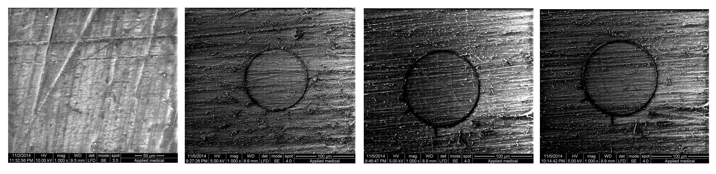
Figure -1. SEM images of control, after 30, 60 and 120 seconds (from the left to the right) of treatment of autopolymerized (AP) resin with 40% ethanol. Original magnification 1000x.

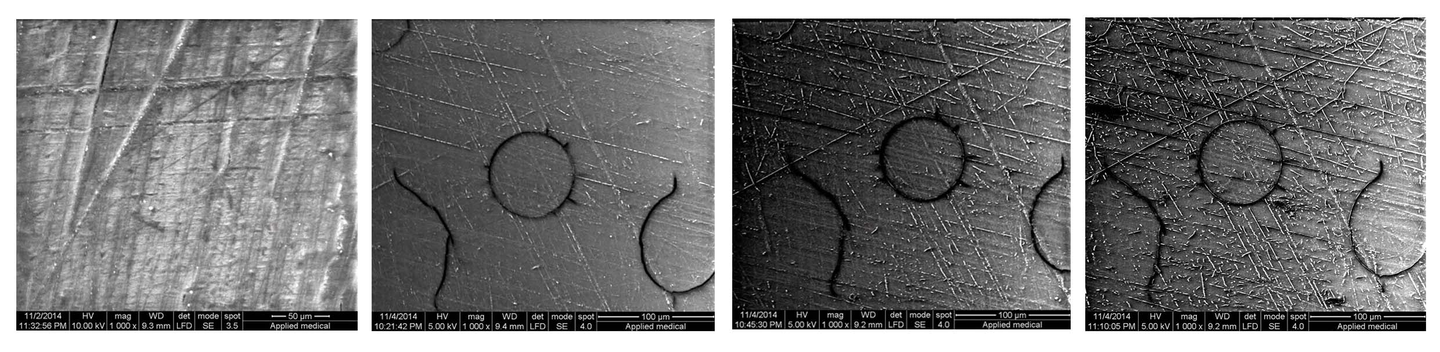
Figure -2. SEM images of control, after 30, 60 and 120 seconds (from the left to the right) of treatment of autopolymerized (AP) resin with 70% ethanol. Original magnification 1000x.

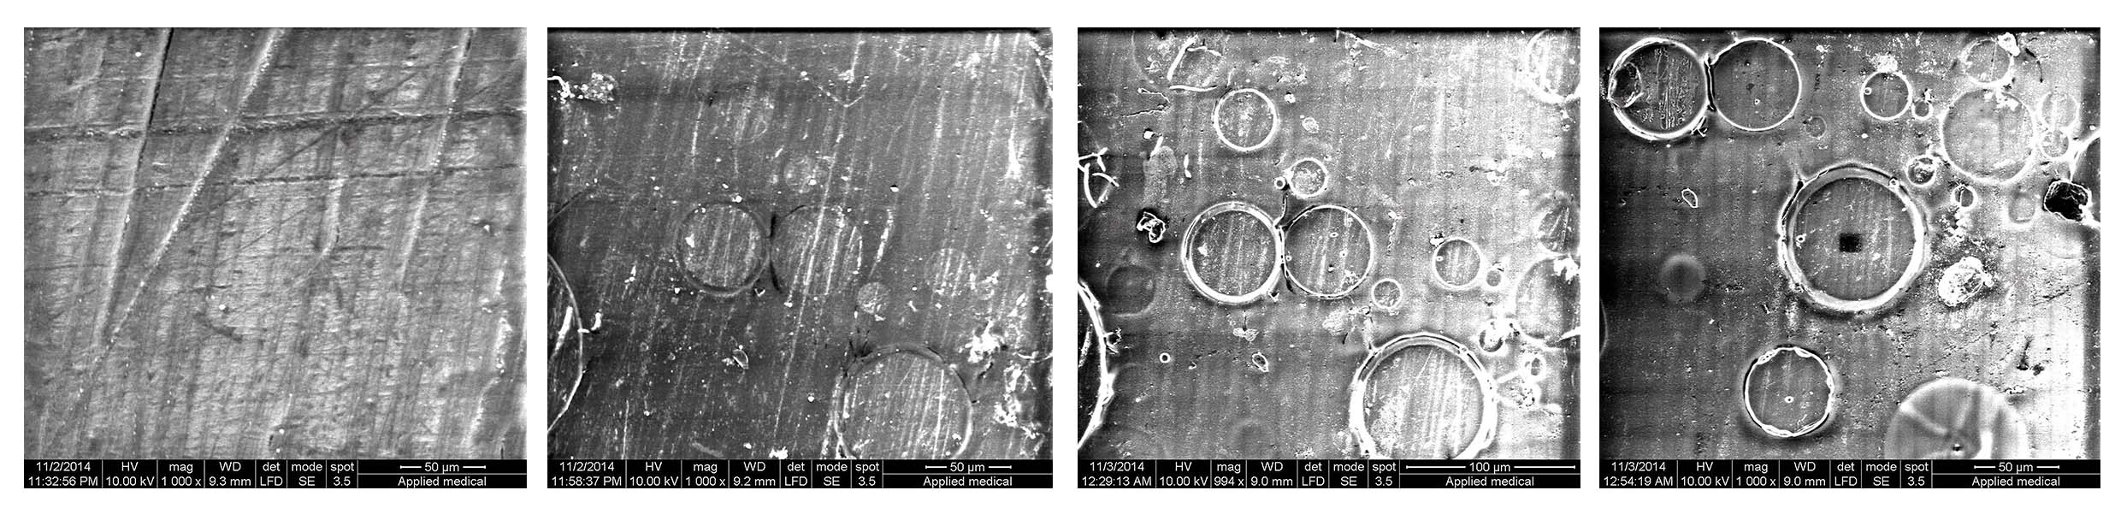
Figure -3. SEM images of control, after 30, 60 and 120 seconds (from the left to the right) of treatment of autopolymerized (AP) resin with 99.9% ethanol. Original magnification 1000x.

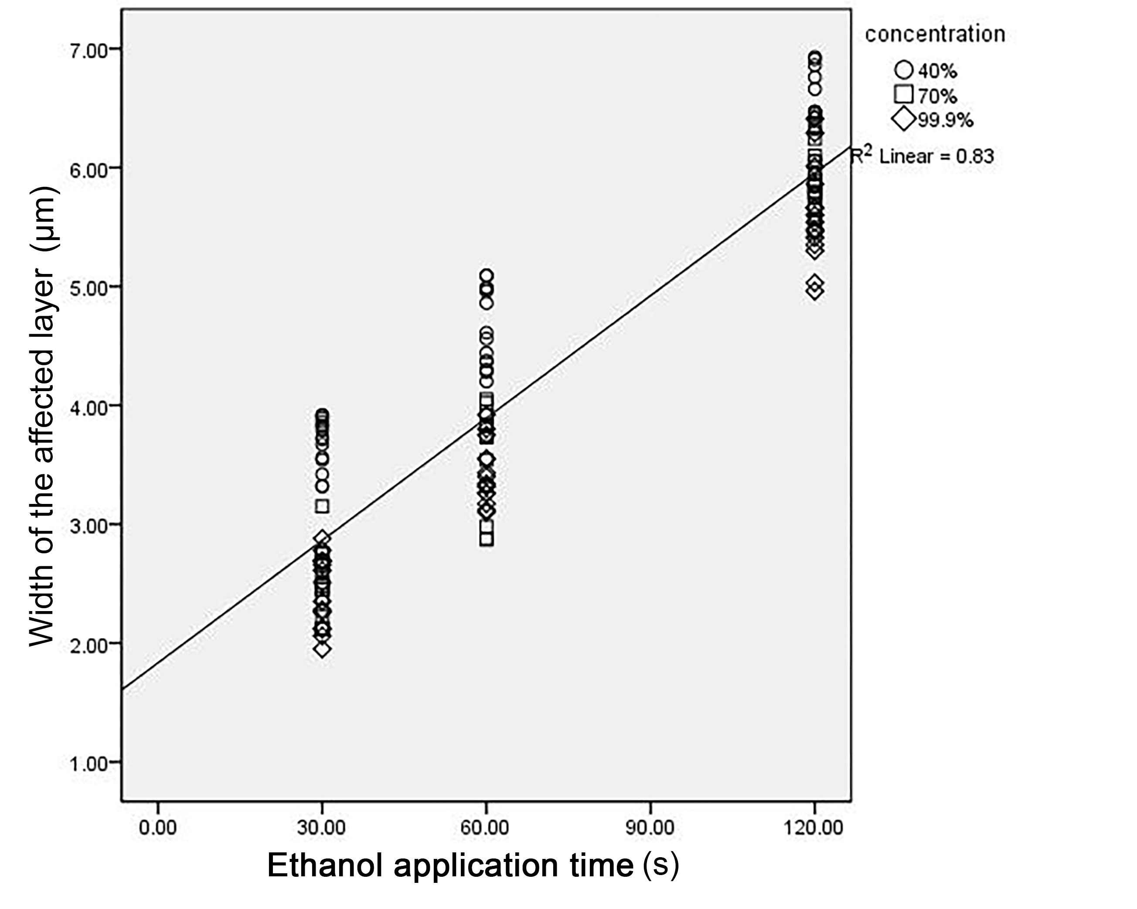
Figure-4. Regression line between the thickness of the affected layer at the interface between the PMMA bead and polymer matrix and the ethanol treatment time.

