Crowdfunding as an alternative finance for social economy
Mohamed Farhoud, Turku School of Economics
Our world has been facing a myriad of social and environmental crises in addition to, of course, the slower economic growth in many regions in the world. The fear of falling behind the global SDGs targets has fuelled an increasing interest in Social Economy as a way for social cohesion, inclusion and solidarity through market transactions (See here a monitor for SDG1). We might understand Social Economy, as defined by ILO, as “a concept designating enterprises and organizations, in particular cooperatives, mutual benefit societies, associations, foundations and social enterprises, which have the specific feature of producing goods, services and knowledge while pursuing both economic and social aims and fostering solidarity”. Social Economy policies are developed or under development in the UK, Ecuador, Spain, Italy, Korea, and South Africa to name a few. Social Enterprises continue to be a major player and partner with other state and non-state players in order to enabling a strong Social Economy environment, and ultimately achieve the SDGs targets.
The reason d’etre of Social Enterprises is to improve the socio/ecological-economic conditions for their customers. Striking the intricate balance between the financial goals and developmental goals are very difficult. However, whoever manage to develop a business model that marries these incongruous goals will have access to one of the largest untapped markets in the world. The Social Economy market is estimated as $5 trillion per year with an estimation of $9 trillion unregistered assets traded in informal transactions (see the global consumption data base and for more see The base of the pyramid promise).
The untraditional business models and sometimes frugal innovations of Social Entrepreneurs create a cultural barrier between them and traditional financiers such as banks and venture capitalists. As a result, they are struggling to access the needed finance for their operation. In fact, half of the worldwide social entrepreneurs continue to find raising fund is “very” or “extremely” challenging. Lack of early-stage capital remains a top challenge to the social entrepreneurship industry’s growth (See this HBR). As a consequence, and in addition to our little knowledge about alternative investments, there is an increasing interest in new alternative strategies of finance in order to enable the Social Entrepreneurship industry growth.
In the heart of the alternative finance solutions for Social Enterprises is Crowdfunding. Crowdfunding, by and large, has disrupted the financial system and its relationship to the society to an extent that possibly equal to or even larger than microfinance. We see a growing evidence around crowdfunding as a major alternative strategy to early finance social enterprises. An opportunity that every Social Entrepreneur should explore and navigate as an effective solution to the economic uncertainty and barriers to access other kinds of fund.
There are a growing number of crowdfunding platforms that are dedicated to Social Enterprises, on top of these is the reward-based model. A reward-based crowdfunding is an online platform on which Social Entrepreneurs can start fundraising campaigns. The platforms provide the necessary tools and setting to facilitate the communication between the crowd/backers and Social Entrepreneurs. This social interaction with like-minded people creates a sense of community and offer a bridge of commination between the crowd and the entrepreneur. The amount of raised money in addition to the information exchange on reward-based crowdfunding platforms have been found to increase the chances of the social enterprise’s survival and success. Social Enterprises are increasingly use crowdfunding platform to raise fund, in this respect: it is estimated that one third of all the funds raised on all crowdfunding platforms goes to social causes.
In reward-based crowdfunding model, the entrepreneur defines different types of rewards for the backers. These rewards differ following each campaign. To give an examplee, Brooke Da Cruz in her campaign on UpEffect has given access to exclusive VIP products, invitations and ongoing savings for those who contribute Euro 18 or more. What is interesting and unique though that the entrepreneur can, effectively, over-fund and exceed the capital goal for his or her enterprise, a unique feature of reward-based crowdfunding model. The graph below shows the prevalence of the rewards model (Check the original study here). The model is obviously superior to other models in both the average fund per backer (the crowd) and in achieving the funding goal. Here also you can find a list of why starting your campaign on reward-based crowdfunding platform is a good idea. And here is the European Commission guidelines to crowdfunding.
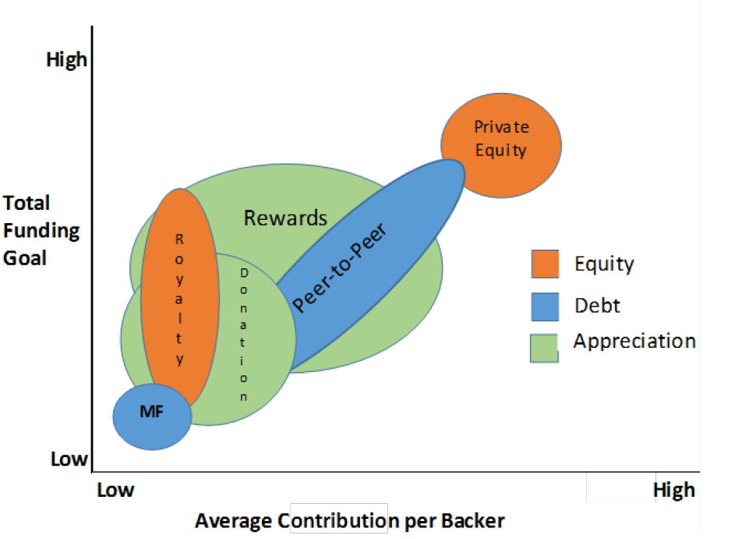
The quality of the campaign’s, characterised in a well-structured and extensively detailed content, is obviously important. However, raising money for a Social Enterprise is more than that. Crowdfunding is not as traditional as traditional-fundraising. The social enterprise’s campaign must seek to inspire and co-create with the backers. In a three-year project, a researcher from University of Oxford followed the crowdfunding journey of one of the Social Enterprises. He found that it is important to define who you are through good preparedness. He showed, for instance, how small spelling errors might suggest that the team is not competent. The frequent use of communication throughout the campaign was also found to drive success. How to prepare and communicate throughout the campaign can be accomplished by proper use of the crowdfunding campaign tools and advices.
However, Social Enterprises are sought after because they solve real social or environmental issues. Their supporters are already on board, this is why it is important to humanise and vouch for commitment. This authenticity and commitment to the cause is well demonstrated by this campaign Beat4life. The campaign has demonstrated huge success where 200% of the capital goal were secured. The campaigns video show how the cause personalisation influences success. Social Enterprises’ backers do not support their campaign because of well demonstration of assets, previous experience or collateral. They give their support because they believe in the cause. Do not forget the larger picture: Social Entrepreneurs follow untraditional path and deviate from the usual way of doing business to solve real problem for marginalised communities. Social enterprise’s Crowdfunding backers want to hear this. This is your community speak to them from your heart.

