Future Knowledge Management Challenges: Digital Twins Approach and Synergy Measurements?
DAVID PUBLISHING
D
Jari Kaivo-oja, Mikkel Stein Knudsen, Theresa Lauraeus
University of Turku, Turku, Finland
Kazimieras Simonavicius University, Vilnius, Lithuania
Osmo Kuusi
University of Turku, Turku, Finland
We are in the midst of a significant transformation regarding the way we produce products and deliver services thanks to the digitization of manufacturing and new connected supply-chains and co-creation systems. This article elaborates Digital Twins Approach to the current challenges of knowledge management when Industry 4.0 is emerging in industries and manufacturing. Industry 4.0 approach underlines the importance of Internet of Things and interactions between social and physical systems. Internet of Things (and also Internet of Services and Internet of Data) are new Internet infrastructure that marries advanced manufacturing techniques and service architectures with the I-o-T, I-o-S, and I-o-D to create manufacturing systems that are not only interconnected, but communicate, analyze, and use information to drive further intelligent action back in the physical world. This paper identifies four critical domains of synergy challenge: (1) man-to-man interaction; (2) man-to-machine interaction; (3) machine-to-man interaction; and finally (4) machine-to-machine interaction. Key conclusion is that new knowledge management challenges are closely linked to the challenges of synergic interactions between these four key interactions and accurate measurements of synergic interaction.
Keywords: Digital Twins Approach, human-machine interaction, synergy challenges, synergy measurements, Industry 4.0
Introduction
The digital twin has been defined as the virtual model of a process, product, or service. We will suggest also another interpretation of the concept. It allows the possibility that also a human being can have a digital twin. After looking at the concept of the digital twin as a virtual model, we will discuss the digital twin of a person. As a virtual model, a digital twin functions as a bridge between the physical and digital world. This pairing of the virtual and physical worlds allows digital twin to eliminate problems before they even occur, prevent downtime, develop new opportunities, and even plan for the future by using simulations.
In the near future, there will be promising applications of human digital twins. Digital twins as digital models are now useful for industries, firms, and other kind of organizations. Nowadays, the human digital twins are important in health care applications. In Gartner 2018 Report Trend Number 4: “A digital twin is a digital representation that mirrors a real-life object, process or system. Digital twins can also be linked to create twins of larger systems, such as a power plant or city”.
The Fourth Industrial Revolution, commonly known as Industry 4.0 transformation, is changing the way business models and platforms function and, by extension, the stakes by which they are forced to compete. We know that Industry 4.0 is a global concept, but it can take many different forms and transition paths, and names, around the world. In the United States, the Industry 4.0 focus tends to be more on a more holistic digital evolution, and many use the term digital supply network or digital supply-chain. Within Europe and in Germany, where the Industry 4.0 concept originated, the phenomenon tends to be more factory-based or manufacturing. While the Industry 4.0 terminology may differ, the overall concept remains largely the same and encompasses the same technologies and applications. Organizations today must decide how and where to invest in these new technologies and identify which ones might best meet their business needs and business model.
There are many digital technologies, which are relevant for Industry 4.0 approach. Without a full understanding of the changes and opportunities Industry 4.0 brings, companies risk losing ground of their operations. This is one key scientific motivation for this article and its conceptualization―to help organizations and firms to focus on key issues and systems.
In this article, we first discuss about key technical drivers of Industry 4.0 (Chapter 3: Technological Drivers of Industry 4.0 Era). In Chapter 2 (The Digital Twins Approach), we elaborate Digital Twins Approach with key ides of Digital Twin Thinking. We suggest a wider operationalization of this concept than commonly use d to date. In Chapter 4 (Man-Machine-interactions), we present key interactions between man and machine which are affected by this new digital twin idea. Chapter 5 (Integrative Elements of New Knowledge Management in the Industry 4.0 Era) is integrative chapter which identifies key needs of synergy measurements and system integration in knowledge management in organizations, when Digital Twin and Industry 4.0 approaches will be applied in real system development process. In Chapter 6 (Conclusions), final conclusions are drawn.
The Digital Twins Approach
An emerging key idea within Industry 4.0 is the concept of digital twins. We believe that understanding this concept will be paramount for the future tasks of knowledge management. The concept of a digital twin has been used around since 2002. The digital twin has been defined as the virtual model of a process, product, or service. Almost all hitherto considerations of digital twin technology has been related to manufacturing or “shop-floor digital twin” (Rosen, von Wichert, Lo, & Bettenhausen, 2015; Tao & Zhang, 2017; Tao, Cheng, Qi, M. Zhang, H. Zhang, & Sui, 2018). We will suggest in this paper wider interpretations of the concept. It allows the possibility of creating a digital twin of an organization and also for human beings to have digital twins. After looking at the concept of the digital twin as a virtual model, we will discuss the digital twin of a person.
As a virtual model, a digital twin functions as a bridge between the physical and digital world. The digital twin is composed of three components, which is physical entities in the physical world, virtual models in the virtual world, and the connected data between these two worlds (Qi & Tao, 2018). This pairing of the virtual and physical worlds allows analysis of data and monitoring of systems to eliminate problems before they even occur, prevent downtime, develop new opportunities, and even plan for the future by using simulations (Marr, 2017).
According to Panetta (2018, Trend 4) in Gartner Report:
A digital twin is a digital representation that mirrors a real-life object, process or system. Digital twins can also be linked to create twins of larger systems, such as a power plant or city. The idea of a digital twin is not new,
but
today’s digital twins are different in four ways: (1) The robustness of the models, with a focus on how they support specific business outcomes, (2) The link to the real world, potentially in real time for monitoring and control, (3) The application of advanced big data analytics and AI to drive new business opportunities, (4) The ability to interact with them and evaluate “what if” scenarios. (Panetta, 2018)
With the spread of IoT, the virtual models and digital twins have become cost-effective to implement in industries and services. Digital twins are now becoming almost a business imperative, covering the entire lifecycle of an asset or process and forming the foundation for connected products and services. We can claim that digital twins lead ubiquitous revolution. The Digital Twins Approach is based on complex cyclical flows. A complex flow occurs through an iterative series of three steps, collectively known as the physical-to-digital-to-physical (PDP) loop (see Figure 3). There are:
- Step 1: Physical to digital: Capture information from the physical world and create a digital record from physical data;
- Step 2: Digital to digital: Share information and uncover meaningful insights using advanced analytics, scenario analysis, and artificial intelligence;
- Step 3: Digital to physical: Apply algorithms to translate digital-world decisions to effective data, to spur action and change in the physical world.
To achieve this PDP process, various technological tools are available. Industry 4.0 combines relevant physical and digital technologies, including data analytics, additive manufacturing (Manufacturing 4.0), industrial and service robotics, high-performance computing, natural language processing, artificial intelligence (AI), cognitive technologies, advanced materials, and virtual or augmented reality (V/AR).
Many platforms include various PDP loops and have potential to create well-functioning digital twins, which operate in specific contexts of production and consumption. Understanding specific contexts of PDP loops is critical success factor of well-functioning platforms (Scoble & Israel, 2014). Platforms businesses are claiming a large growing share of the economy in every region of the world. A platform is a business based on enabling value-creating interactions between external producers and consumers (Parker, van Alstyre, & Choudary, 2016).

Applying the Digital Twin Approach Beyond Manufacturing
Manufacturing digital twin offers opportunity to simulate and optimize production systems, including logistical aspects, and enables detailed visualization of processes from single components to the entire assembly process (Kritzinger, Karner, Traar, Henjes, & Sihn, 2018). Within manufacturing industries, the approach has already become a key element in Product Lifecycle Management (Tao et al., 2018) and frontrunner organizations are integrating the approach into the entire lifecycle from product design, assembly to usage monitoring (Qi & Tao, 2018).
The new era for the Digital Twin Approach in knowledge management is applications beyond manufacturing contexts. The immediate challenge will be for organizations to manage the “physical to digital” step, and capture different types of data into a digital record.
We can use an office building as example. Today, people are employed at the premises to transport physical objects around the complex, for example, mail, stationery, or IT equipment, In the near future, all this might be transported faster and more cost-efficient by autonomous drones or robots, also reducing the need for decentralized storage and office space. However, for this to work effectively, digital records of the premises―effectively capturing four dimensions, including both the air and time―needs to be established in order to capture what humans today can capture immediately with their bare eyes. Those organizations succeeding in adapting digital twins will be those skilled at Semantic Data Management (Abraovici, Göbel, & Dang, 2016).

Figure 1. The physical-to-digital-to-physical (PDP) loop and Digital Twins Approach (Source: Deloitte, 2017, p. 3).

Similarly, we expect the challenge of capturing human and tacit knowledge into digital twins will be a dominant issue for the future of knowledge management in organizations. This connects to the rising term “Digital Twin of an Organization” (DTO) which enables the dynamic virtual representation of an organization in its full operational context, and which is considered by Gartner as one of the top 10 strategic technology trends for 2019 (Cearney, 2018).

From Individualized Marketing to Personal Digital Twins
Already for long time, marketers have successfully used rule-based personalization (e.g., “If a person falls into Segment A, then show him Experience X”) (Digital Growth Unleashed, 2018). Artificial intelligence has made possible to proceed from this segment based personalization towards the marketing practice that deserves the name “individualization”. From the point of view of the marketer of a product, the ideal individualization means that a person as a unique individual gets experience that in the most effective way promotes the buying of the product. Using machine-learning-based algorithms and predictive analytics, there are much better opportunities to produce this kind of experience than before.
The problem of the above kind of individualization is that there is no guarantee that the experience of an individual is also the best or even good from the point of view of the individual. We suggest Personal Digital Twins (PDT) as a smart tool or an algorithm that regularly provides from the available big data or other information sources the best experience from the point of view of a person.
In their Internet of People (IoP) manifesto, Miranda et al. (2015) suggested four guidelines for how the human interaction with machines should work. These principles with modifications are used in the definition of targeted features of a Personal Digital Twin:
(1) Be social. Interactions between a person, his or her Personal Digital Twin (PDT), other human beings and other machines should be social. A person and his or her PDT should have a platform of common learning in which they through continuously interacting develop mutual understanding. For example, when the PDT communicates with the person using human language, it should use the concepts of the language in similar meanings as the person. Based on mutual understanding, the PDT is able to be the trusted representative of the person in social interaction with other persons or machines.
(2) Be individualized. The Personal Digital Twin should promote genuine interests of the person. Interactions between the PDT and other people or machines must represent the person’s individual interests and not just the average interests of a group into which the person belongs.
(3) Be proactive. The interactions between the person and other people or machines should proactively take place, so that also the PDT can proactively initiate interactions. The person should, however, decide what kinds of interactions are acceptable and when these interactions are allowed.
(4) Be predictable. The content of interactions with other persons and machines started by the PDT must be predictable or they must follow before agreed principles between the person and his or her PDT. Especially important is that the person and the PDT agree how to share the information about the person and how to deliver the information/knowledge resources owned by the person.
Using the concepts introduced by Miranda et al. (2015), Personal Digital Twin belongs to companion devices of persons like recent smartphones or smart tools that use human language in the communication with their owners (e.g., Apple’s Siri or Amazon’s Alexa). Recent companion devices maintain contextual and sociological information concerning their owners and share that information to other companion or non-companion devices according to rules that are poorly controlled by the owners of the companion devices. A recent companion device may also start its own or its owner’s interaction with some other device or even independently give orders to a non-companion device e.g., to open a television.
A basic difference between a true Personal Digital Twin and recent companion devices of persons is that a true PDT should be a trusted promoter of interests of an individual. This is no way confirmed concerning companion devices that are used for marketing though in some connections they might function like a true PDT. An example is presented in the illustrating scenario of Miranda et al. (2015). In the scenario story, the smartphone of a driver starts to speak to the driver telling about a traffic accident and ways to handle the problem. The smartphone is also social sending informing messages to smartphones of other drivers.
Technological Drivers of Industry 4.0 Era
Dating back to around 1760, the First Industrial Revolution (Industry 1.0) was the transition to new manufacturing processes using water and steam. Steam power was a key driving force of Industry 1.0. It was hugely beneficial in terms of manufacturing a larger number of various goods and creating a better standard of living for some. The textile industry, in particular, was transformed by industrialization, as was transportation systems. The era of Industry 1.0 represented the period between the 1760s and around 1840 (Schwab, 2017).
Around 1840 is the time-period, where the second industrial revolution (Industry 2.0) picked up. Historians sometimes refer to this as “The Technological Revolution” occurring mainly in Britain, Germany, and America. During this period, new industrial technological systems were introduced, most notably superior electrical technology, which allowed for even greater production and more sophisticated machines. It began with the first computer era (Industry 3.0) (Schwab, 2017).
Around 1970, the Third Industrial Revolution (Industry 3.0) involved the use of electronics and information technology (IT) to further automation in production. Manufacturing and automation advanced considerably thanks to Internet access, connectivity, and renewable energy. Industry 3.0 introduced more automated systems onto the assembly line to perform human tasks. The use of programmable logic controllers (PLC) was introduced. Although automated systems were in place, they still relied on human input and intervention (Liffler & Tschiesner, 2013; Schwab, 2017). Some authors have noted that Industry 1-4 phases were: pre-electricity age, mid-electricity age, post-electricity age, pre-computer age, mid-computer age, post-computer age, pre-digital age, mid-digital age, and post-digital age (Goodwin, 2018).

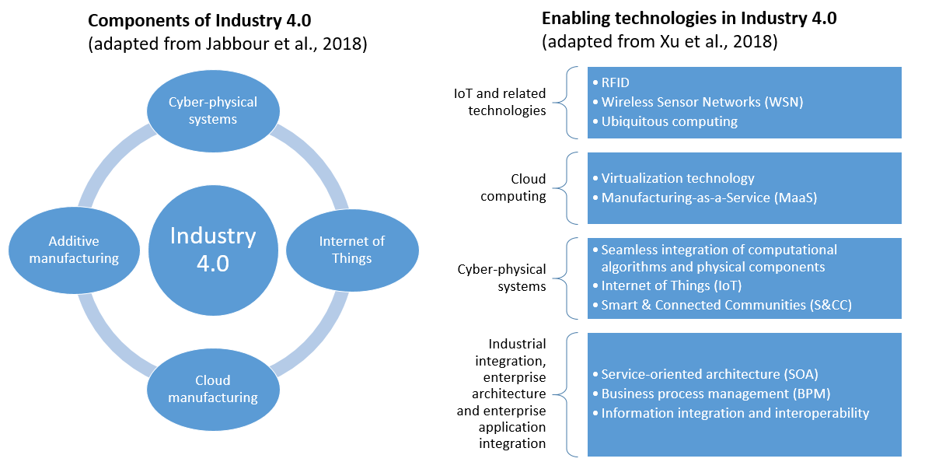
Figure 2. “Components” and “enabling technologies” in Industry 4.0 (Source: Knudsen & Kaivo-oja, 2018).

New Industry 4.0 era is expected to be founded on Cyber-Physical Systems (CPS) and the Internet of Things (IOT). Other key technologies are cloud computing, big data analytics, and extended ICT. The expected changes will lead to new integrated systems, where sensors, actuators, machines, robots, conveyors, etc. are connected to and exchange information automatically. Factories are expected to become conscious and intelligent enough to predict and maintain the machines and control the production process. Business models of Industry 4.0 imply complete communication network(s) between various companies, factories, suppliers, logistics, resources, and customers.
For business leaders and Knowledge Management Office (KMO) managers accustomed to traditional linear data and communications, the strategic shift to real-time access to data and intelligence enabled by Industry 4.0 would fundamentally transform the way they conduct business and manage their business model. The integration of digital information from many different sources and locations (big data) can drive the physical act of doing business, in an ongoing cycle. Throughout this cycle, real-time access to data and intelligence is driven by the continuous and cyclical flow of information and actions between the physical and digital worlds. After Industry 4.0, we can expect that there will be Industry 5.0, when you begin to allow customers to customize what they actually want in real-time.

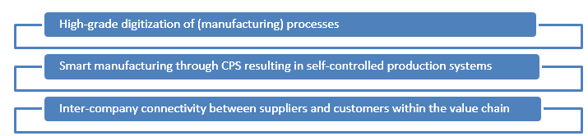
Figure 3. Three dimensions of Industry 4.0 (Source: Müller, Buliga, & Voight, 2018).
Man-Machine-Interactions

Man-Machine Synergy Puzzle
In Figure 4, we have presented key man-machine interactions. In the ubiquitous technology environment, it is important to understand that directions of influence in interaction are relevant issues. There are four critical interactions: (1) man-man interactions; (2) man-machine interactions; (3) machine-man interaction; and (4) machine-to-machine interactions (see Figure 4).
When we measure the nature of interactions, it is always good to find right variables to perform measurements. Expected explaining and explained variables must be carefully selected, when we measure synergies between human beings and machines. This aspect is going to be more critical issue in the field of organizational knowledge management. It is also good to understand that human beings are simultaneously influenced by other human beings and other machines. This implies that we need to measure synergy with combined synergy measurements. Final outcome of synergy is a combination of various man-machine interactions. This kind of perspective is highly relevant issue, if want to create positive welfare synergy between human beings and machines.

Learning Process Synergy Puzzle
In Figure 5, we present key learning processes. We can observe that in ubiquitous society, there four key learning processes: (1) a process where human being teach each other (X-Y process); (2) a process where AI/Robot apps teach human beings (X-X process); (3) a process where human beings teach AI/Robot apps (Y-Y-process); and finally (4) where AI/Robot apps teach other AI/Robot apps (Y-X process). This kind of complex interaction of learning processes will challenge knowledge management processes in organizations of digital networks. If want to create positive learning loops in modern organizations, we must start to analyze these four learning processes.

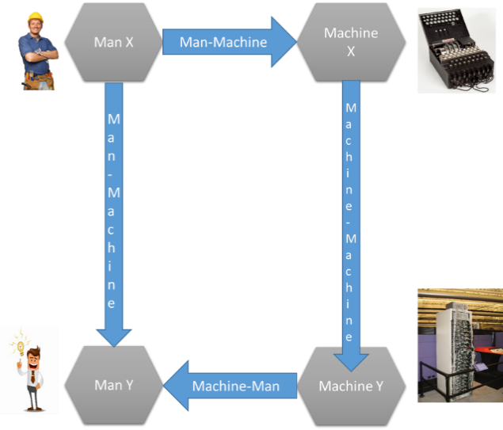
Figure 4. Four key interactions between Man X, Machine Y, Machine Y, and Man Y.

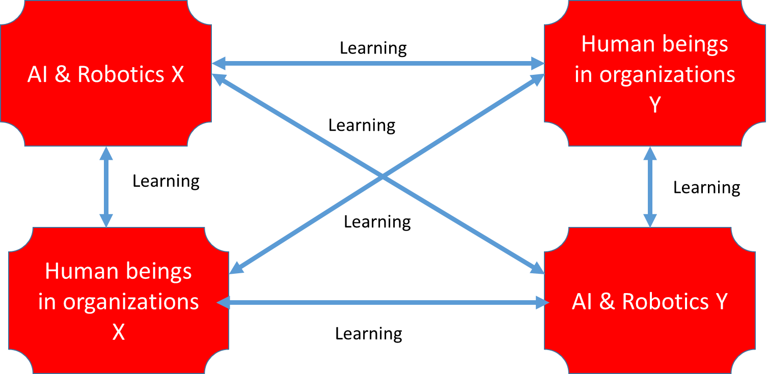
Figure 5. Four key learning processes in the ubiquitous society (Source: Kaivo-oja, 2017).
Integrative Elements of New Knowledge Management in the Industry 4.0 Era

Industry 4.0 Era and Management Challenges
As presented above, there are many needs for system integration between physical systems and non-physical digitalized systems. In the field of organizational management, there are own management systems of: (1) leadership (Asrar-ul-Hag & Anwar, 2018); (2) human resource managements (HMRR, 2018), and (3) digital data, web-engineering, and information management systems (especially pervasive Internet of Things (Zahoor & Mir, 2018). To see viable Industry 4.0 systems, Internet of Things and also Internet of Services and Internet of Data must be linked to leadership and Human Resource Management (HRM) functions.
System integration is needed, because Internet of Things embodies a vision of merging heterogeneous objects to establish seamless interaction among physical and virtual entities (Zahoor & Mir, 2018). Seamless interaction is not possible without system integration. If we want be successful in new era of system integration in Industry 4.0 systems, we must somehow integrate these three critical systems, which combine human resources, leaders and digital infrastructures and platforms.
In Figure 6, we have visualized obvious system integration challenge between these three elements of knowledge management in Industry 4.0 era. If we want to analyze relevant synergies between physical and digitalized systems (key technologies of Industry 4.0), we must create more integrative systems between leadership function, HRM systems and information, data and Web-engineering systems and focus our synergy analyses on these critical man-machine interactions.

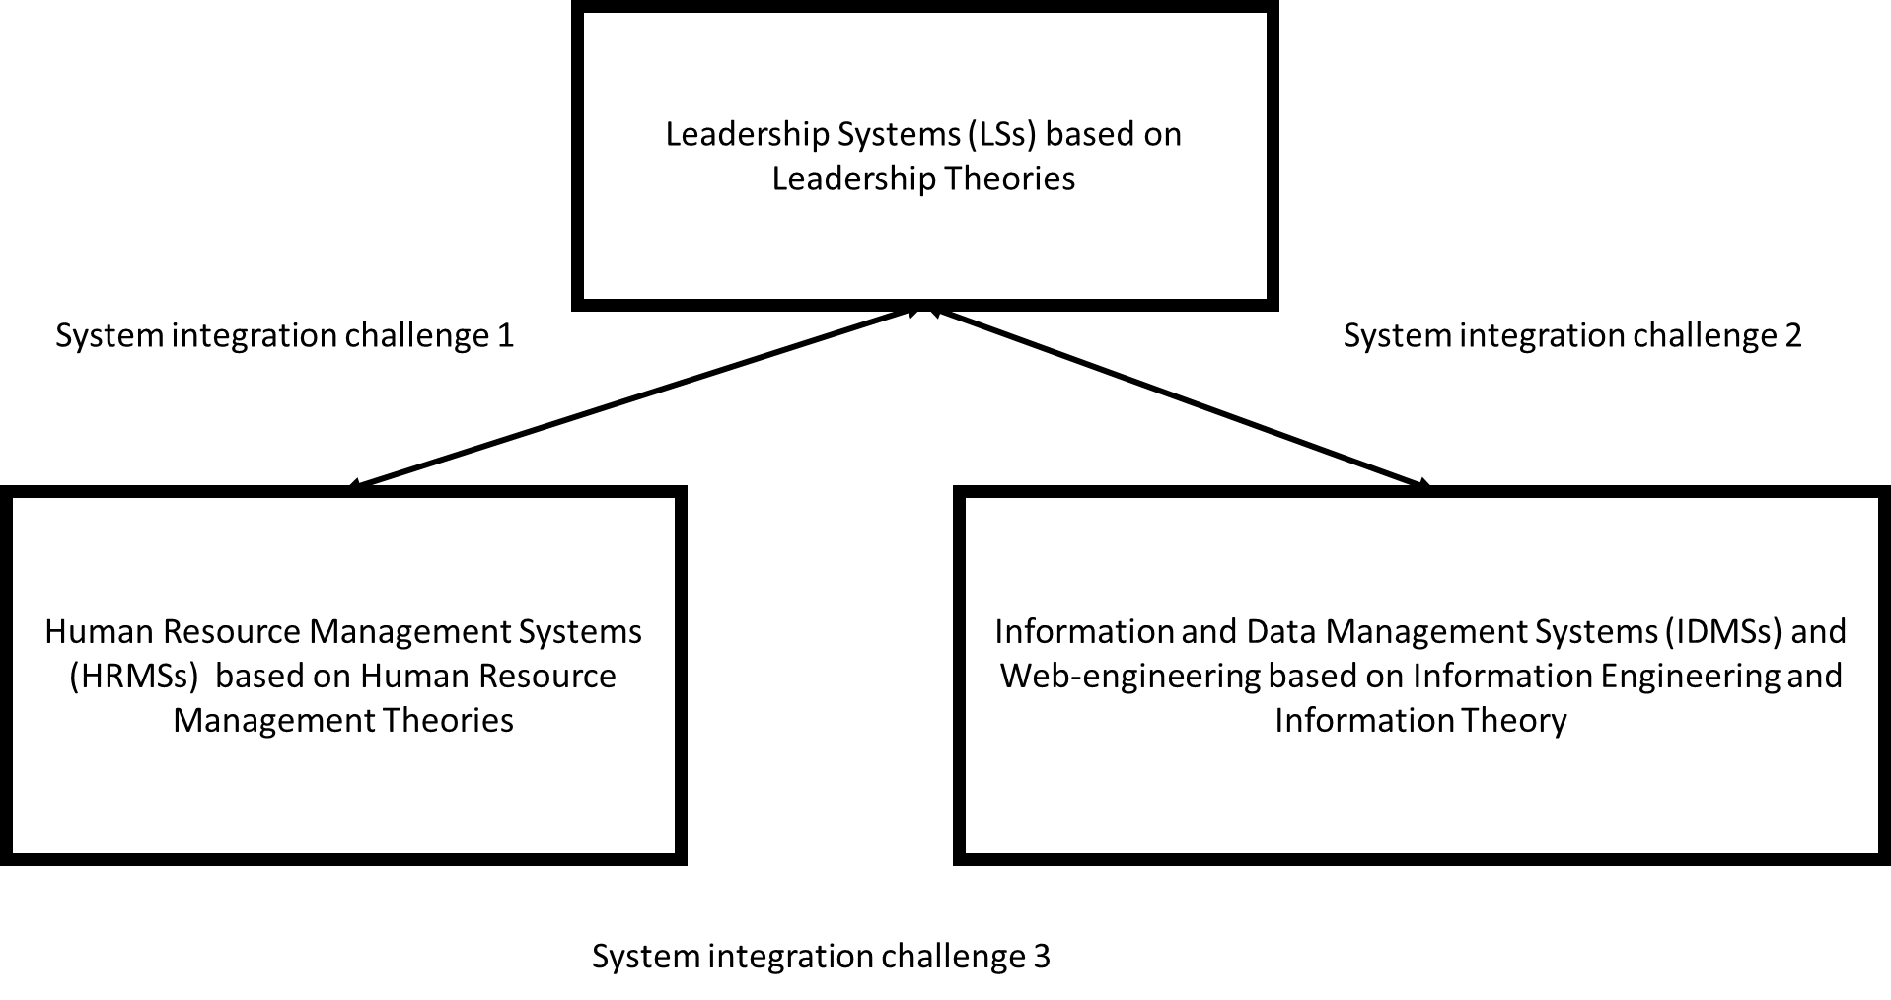
Figure 6. System integration challenges of Industry 4.0 era.

In the era of Industry 4.0, there are more or less challenging system integration challenges. As we have noted before, man-machine integration and learning process integration require special attention in organizations.
Conclusions
In the era of Industry 4.0 and Internet of Things, IoT devices and solutions are capable of sensing, processing, communicating, and storing the data acquired from physical world. New way of thinking is Digital Twin Approach, which is based on the physical-to-digital-to-physical (PDP) process. This approach is already a business imperative in the manufacturing industry sector, but in the future, the approach can be highly powerful beyond manufacturing as well. System integration enables Industrial Internet of Things and Industry 4.0 platforms.
In this article, we have discussed key needs of system integration and concludes that system integrations must be based on: (1) the understanding on human-machines interactions; (2) on the understanding of learning processes in organizations; and finally (3) on the understanding of leadership, Human Resource Management Systems, and Information and Data Management Systems and Web-engineering.
If we want to understand critical synergies of leadership functions, HRM and data and information flows, we must focus on critical interactions in the whole knowledge management system. Knowledge management in Industry 1.0, Industry 2.0 and Industry 3.0 was different compared to Industry 4.0. Many challenges are linked to system integration questions of learning and knowing human beings. Key system integration will be needed in the systems of leadership, HRM, and digital systems, when we discuss about knowledge management in organizations.
References
Abraovici, M., Göbel, J. C., & Dang, H. B. (2016). Semantic data management for the development and continuous reconfiguration of smart products and systems. CIRP Annals, 65(1), 185-188.
Asrar-ul-Hag, M., & Anwar, S. (2018). The many faces of leadership: Proposing research agenda through a review of literature. Future Business Journal, 4, 179-188.
Cearney, D. (2018). The top 10 strategic technology trends for 2019. Retrieved October 3, 2019, from https://www.slideshare.net/ratinecas/the-top-10-strategic-technology-trends-for-2019
Deloitte. (2017). Forces of change: Industry 4.0. A Deloitte series in Industry 4.0. Retrieved from https://www2.deloitte.com/content/dam/insights/us/articles/4323_Forces-of-change/4323_Forces-of-change_Ind4-0.pdf
De Sousa Jabbour, A. B. L., Jabbour, C. J. C., Foropon, C., & Godinho Filho, M. (2018). When titans meet―Can Industry 4.0 revolutionise the environmentally-sustainable manufacturing wave? The role of critical success factors. Technological Forecasting and Social Change, 132, 18-25.
Digital Growth Unleashed. (2018). The future of personalization with AI and machine learning. Retrieved October 3, 2019, from https://digitalgrowthunleashed.com/the-future-of-personalization-with-ai-and-machine-learning/
Goodwin, T. (2018). Digital Darwinism: Survival of the fittest in the age of business disruption. London, UK: Kogan Page Limited.
HMRR. (2018). Managing people in organizations: Integrating the study of HRM and leadership. Human Resource Management Review, 28, 249-257.
Kaivo-oja, J. (2017). The future of education―New methods and skills demanded by future professions. ThinkBDPST Conference, March 30, Budabest, Hungary.
Knudsen, M. S., & Kaivo-oja, J. (2018). Are we in the midst of a fourth industrial revolution? New Industry 4.0 insights from future technology analysis professionals. FFRC-blog. Retrieved from https://ffrc.wordpress.com/2018/08/20/are-we-in-the-midst-of-a-fourth-industrial-revolution/
Kritzinger, W., Karner, M., Traar, G., Henjes, J., & Sihn, W. (2018). Digital Twin in manufacturing: A categorical literature review and classification. IFAC-PapersOnLine, 51(11), 1016-1022.
Kuusi, O. (1999). Expertise in the future use of generic technologies. Helsinki: Government Institute for Economic Interest. Retrieved from https://core.ac.uk/download/pdf/153491932.pdf
Liffler, M., & Tschiesner, A. (2013). The Internet of Things and the future of manufacturing. McKinsey & Company. Retrieved from https://www.mckinsey.com/business-functions/digital-mckinsey/our-insights/the-internet-of-things-and-the-future-of-manufacturing
Marr, B. (2017). What is digital twin technology―And why is it so important? Forbes. Retrieved from https://www.forbes.com/sites/bernardmarr/2017/03/06/what-is-digital-twin-technology-and-why-is-it-so-important/#1f5e9eb32e2a
Miranda, J., Mäkitalo, N., Garcia-Alonso, J., Berrocal, J., Mikkonen, T., Canal, C., & Murillo, J. M. (2015). From the Internet of Things to the Internet of People. IEEE Internet Computing, 19(2), 40-47.
Müller, J. M., Buliga, O., & Voight, K. I. (2018). Fortune favors the prepared: How SMEs approach business model innovations in Industry 4.0. Technological Forecasting and Social Change, 132, 2-17.
Panetta, K. (2018). Gartner top 10 strategic technology trends for 2019. Gartner. Retrieved from https://www.gartner.com/smarterwithgartner/gartner-top-10-strategic-technology-trends-for-2019/
Parker, G. G., van Alstyre, M. W., & Choudary, S. P. (2016). Platform revolution. How networked markets are transforming the economy and how to make them work for you. New York and London: W. W. Norton Company.

Qi, Q., & Tao, F. (2018). Digital twin and big data towards smart manufacturing and Industry 4.0: 360 degree comparison. IEEE Access, 6, 3585-3593.
Rosen, R., von Wichert, G., Lo, G., & Bettenhausen, K. D. (2015). About the importance of autonomy and digital twins for the future of manufacturing. IFAC-PapersOnLine, 48(3), 567-572.
Schwab, K. (2017). The fourth industrial revolution. New York, USA: World Economic Forum. Retrieved from https://www.weforum.org/about/the-fourth-industrial-revolution-by-klaus-schwab
Scoble, R., & Israel, S. (2014). Age of context: Mobile, sensors, data and the future of privacy (1st ed.). USA: Patrick Brewster Press.
Tao, F., Cheng, J., Qi, Q., Zhang, M., Zhang, H., & Sui, F. (2018). Digital twin-driven product design, manufacturing and service with big data. International Journal of Advanced Manufacturing Technology, 94(9-12), 3563-3576.
Tao, F., & Zhang, M. (2017). Digital twin shop-floor: A new shop-floor paradigm towards smart manufacturing. IEEE Access, 5, 20418-20427.
Xu, L. D., Xu, E. L., & Li, L. (2018). Industry 4.0: State of the art and future trends. International Journal of Production Research, 56(8), 2941-2962.
Zahoor, S., & Mir, R. N. (2018). Resource management in pervasive Internet of Things: A survey. Journal of Kind Saud University―Computer and Information Sciences. Retrieved from https://doi.org/10.1016/j.jksuci.2018.08.014

Jari Kaivo-oja, Ph.D., research professor, Department of Finland Futures Research Centre, Turku School of Economics, University of Turku, Turku, Finland; Kazimieras Simonavicius University, Vilnius, Lithuania. Mikkel Stein Knudsen, M.Sc. (Econ.), Department of Finland Futures Research Centre, Turku School of Economics, University of Turku, Turku, Finland; Kazimieras Simonavicius University, Vilnius, Lithuania. Theresa Lauraeus, Ph.D., chief researcher, Department of Finland Futures Research Centre, Turku School of Economics, University of Turku, Turku, Finland; Kazimieras Simonavicius University, Vilnius, Lithuania. Osmo Kuusi, Ph.D., researcher, Department of Finland Futures Research Centre, Turku School of Economics, University of Turku, Turku, Finland. Correspondence concerning this article should be addressed to Theresa Lauraeus, Department of Finland Futures Research Centre, Turku School of Economics, University of Turku, Rehtorinpellonkatu 3, 20500 Turku, Finland.
The concept “genuine interest” is discussed, e.g., in Kuusi (1999).

