Six foresight frames
Classifying policy foresight processes in foresight systems according to perceived unpredictability and pursued change
Matti Minkkinen, Burkhard Auffermann, Ira Ahokas
Finland Futures Research Centre, University of Turku
13.09.2019
Abstract
Foresight is conducted in diverse ways drawing on particular sets of assumptions, and it increasingly takes place in networked foresight systems. We develop a typology of six foresight frames based on two dimensions: 1) level of perceived unpredictability and 2) level of pursued change. By frames, we mean the interpretive structures that underlie foresight actors’ work. The six foresight frames are the predictive, planning, scenaric, visionary, critical and transformative frames. The frames may be used to position phases of foresight, individual processes or, most usefully, interlinked foresight processes in a system. We develop the model based on futures literature and elaborate it in a study of comprehensive security foresight in Finland conducted during the Strategic Research Council project “From Failand to Winland”. Moreover, we test our typology with four additional foresight system cases: Singapore, United Kingdom, Wallonia and Russia. The six frames capture different sets of assumptions and different types of foresight which can be distributed to different actors in a foresight system. Thus we suggest that diversity of foresight frames is likely to be an element of successful foresight systems. However, this requires understanding the diversity of foresight frames and the competence to bridge different approaches.
Keywords: foresight; foresight system; public policy; framing; security; anticipation

Introduction
Foresight is not a monolith. Despite attempts at formulating general foresight process models and quality criteria, the diversity of foresight practices seems to defy simple definitions. Partly owing to the field’s different historical roots in science and technology policy, military planning and elsewhere, many actors conduct foresight with various approaches, and thus definitions of foresight need to be inclusive or they risk ignoring important future-oriented practices. On the other hand, there is a risk of overly complicating the largely practical field of foresight. To understand foresight, scenarios and futures thinking, typologies have been devised from various perspectives, some of them overlapping and some more complementary. The interdisciplinarity of the foresight field brings added complexity. Depending on the context and the background of the practitioners, foresight may be linked to risk management, innovation systems, knowledge management, cultural change, sociotechnical dynamics, long-range planning, radical political aspirations and so on. Differences in approach are often implicit, forming an assumed shared background, rather than spelled out.
In this article, we strive to make sense of this plurality of foresight by suggesting a generic typology of foresight frames based on literature and foresight system cases. By ‘frames’, we mean interpretive structures which give meaning to complex processes and guide action by focusing attention to what is deemed relevant, by connecting disparate elements of a process and by transforming how particular elements are seen (Snow, 2007). Our study approaches the plurality of foresight from two directions. On the one hand, foresight is not monolithic: there are significant differences in foresight approaches. On the other hand, the diversity of foresight types is not infinite. By cutting through real-life complexity and deriving ideal types, we can outline a manageable number of complementary basic types. Importantly, deriving ideal types is not only an academic exercise, but it can significantly help in making sense of the big picture of foresight systems. In brief, we argue that foresight is more like a cairn, a pile of stones to serve a purpose, than a monolith. The field of foresight consists of differently shaped and mutually supporting frames.
In order to investigate foresight frames, a clear but inclusive definition of foresight is necessary. Different approaches need to be identified as variations of a single general phenomenon. The history of foresight derives from the policy field as well as future-oriented studies of science and technology (Martin, 2010; Miles, 2010). The European Foresight Platform, supported by the European Commission, defines foresight as “a systematic, participatory, future-intelligence-gathering and medium-to-long-term vision-building process aimed at enabling present-day decisions and mobilizing joint actions” and emphasises the proactive shaping of the future as a characteristic of foresight (European Foresight Platform, 2010). Chia (2004, quoted in Selin, 2008) defines foresight as “refined sensitivity for detecting and disclosing invisible, inarticulate or unconscious societal motives, aspirations, and preferences and of articulating them in such a way as to create novel opportunities hitherto unthought and hence unavailable to a society or organization”. Piirainen & Gonzalez (2015) define foresight as an “organized social process […] to create actionable and domain/context specific information or knowledge about the future”. These definitions have several aspects in common: foresight is seen as a process which involves systematic inquiry into longer-term futures, including emerging and novel issues, which in turn enables present decision-making and action.
Several authors have recently discussed networked or collaborative foresight, which means foresight work conducted in inter-organisational networks with contributions from partners to benefit the partners and the network (Heger & Boman, 2015). Researchers have identified different scopes and foresight roles (van der Duin, Heger, & Schlesinger, 2014), explored the value of networked foresight (Heger & Boman, 2015), discussed challenges of collaboration partner selection (Gattringer, Wiener, & Strehl, 2017) and investigated multi-stakeholder foresight systems in science, technology and innovation policy (Meissner & Rudnik, 2017). While these studies are valuable, a simple and relatively context-independent classification of foresight approaches would also be useful to act as a middle ground between high-level categorisations of futures research paradigms (e.g. Tapio & Hietanen, 2002) and contextual investigations, which often discuss corporate foresight or science, technology and innovation policy.
For the purposes of this article, we are drawn to Dufva and Ahlqvist’s (2015) understanding of foresight as a system consisting of elements (actors, processes, documents and cognitive schemes) for two reasons. Firstly, this understanding brings into view the foresight actors with their characteristics and sensemaking practices, rather than framing foresight as an impersonal process. Secondly, the systems view enables seeing plurality, that is, different varieties of foresight processes that are systemically linked. This answers Sardar’s (2010) critique that foresight is singular. Considering plurality is also important because at present, the foresight landscape is increasingly distributed with numerous future-oriented processes with different goals and approaches (Georghiou & Keenan, 2006). Dufva & Ahlqvist (2015) define a foresight system as “a transient ensemble of agents, set up to catalyse future-oriented insights, decisions and actions in a certain context”, and foresight processes as “dynamic and provisory analyses of the components of present and potential drivers of change, in order to understand the present contexts and particularities of present conditions, and, through these insights, build robust, accessible, plausible and disruptive future alternatives”. We accept these inclusive definitions, with one reservation: for us, future alternatives need not necessarily be disruptive to warrant the term foresight.
In this article, we develop a categorisation of six foresight frames which can be used to position phases of foresight processes, individual foresight processes or, perhaps most usefully, interconnected foresight processes in a foresight system. We begin our article with a review of criteria used to distinguish different types of foresight or scenarios. Our review is structured around a new five-dimensional model of futures consciousness (Ahvenharju, Minkkinen, & Lalot, 2018) which indicates relevant dimensions but does not provide a ready typology to understand differences. Then we construct our own typology based on two dimensions derived from the futures consciousness model: 1) level of perceived unpredictability and 2) level of pursued change. The typology is described and compared with existing typologies. Next, we elaborate the frames in the case of the foresight system around comprehensive security in Finland. The study was conducted in the Strategic Research Council project “From Failand to Winland” and utilised public documents and interviews for studying three foresight processes. Finland is an interesting case study because the country has an established tradition of using long-term thinking in government (Joyce, 2015, p. 35) and a distinctive concept for comprehensive security (The Security Committee, 2017). Then we test the model with a tentative mapping of four other foresight system cases: Singapore, United Kingdom, Wallonia and Russia. In the discussion section, we highlight policy implications for integrating foresight frames in a foresight system and argue that diversity of foresight and constructive interplay between foresight frames are crucial for high-quality future-oriented policy work.

Review of distinguishing criteria in foresight typologies
This section reviews existing foresight and futures typologies before constructing our own categorisation in the next section. The objective of the review is to clarify relevant axes for distinguishing between essentially different foresight frames in a sufficiently simple model. The frames are understood as interpretive structures that give meaning to the social activity of foresight processes, which in turn are understood as dynamic analyses of drivers of change in order to understand present contexts and to build future alternatives (Dufva & Ahlqvist, 2015; Snow, 2007). Moreover, foresight processes are seen as one element in broader foresight systems also encompassing actors, relations and documents (Dufva & Ahlqvist, 2015). For our purpose of developing a generic typology, we employ an inclusive understanding of foresight that does not draw sharp distinctions between explicit foresight, futures research and futures thinking in general. Nevertheless, we are interested in explicit anticipation rather than implicit unconscious anticipation (Poli, 2017, pp. 266–268). Furthermore, we focus on organised social activities where actors make sense of phenomena in a future-oriented manner for decision-making, although the scope, rigour and many contextual features are different.
The concept of frames brings a novel analytical level for empirically studying actually existing foresight. Existing typologies of foresight and futures thinking are primarily either descriptive summaries of the features of foresight activities or prescriptive models of how foresight should be done. Frames, in contrast, point to the actual interpretive structures employed by foresight actors. The simplified typology developed in this article is one approach to capturing these complex structures, but the concept of frames can also open many other analytical possibilities such as in-depth ethnography and studies of frame alignment.
An abductive approach was adopted in the research process, since we had initial ideas about relevant dimensions but we were not testing specific hypotheses about foresight frames. Abductive reasoning moves back and forth between theory and empirical material and involves imaginative conjectural leaps (Alvesson & Karreman, 2011, pp. 58–59; Tavory & Timmermans, 2014). The categorisation was developed in an interplay between the futures and foresight literature and the qualitative material of the comprehensive security case introduced in a later section. The initial notions about relevant dimensions came from a novel framework of the five dimensions of futures consciousness. The framework was developed through a literature review on future consciousness, future orientation and related terms, and it includes the following dimensions: 1) time perspective, 2) agency beliefs, 3) openness to alternatives, 4) systems perception and 5) concern for others (Ahvenharju et al., 2018). The dimensions are summarised in Table 1.

Table 1: Dimensions of futures consciousness (Ahvenharju et al., 2018)
Dimension | Description
Time perspective | Length of time horizon, ability to think about the long-term future
Agency beliefs | Assumptions about the ability to influence future outcomes
Openness to alternatives | Consideration of uncertainty and alternative futures
Systems perception | Perceiving systemic interconnectedness
Concern for others | Ethical consideration of others beyond one’s own reference group
The framework was selected because it seems to capture essential aspects of foresight and futures thinking due to the extensive literature review. The futures consciousness dimensions were chosen to represent characteristics that describe future-oriented actors. Thus the framework has the potential for developing a novel typology of foresight that focuses on the interpretive structures of foresight actors rather than an outward description of activities. However, there are numerous existing typologies of foresight, futures thinking and scenarios which need to be acknowledged. In the following, criteria used in existing categorisations are organised according to the futures consciousness dimensions before presenting our own classification in the next section. Scenario typologies are prominently featured because they are generally explicit about the criteria that are used to differentiate approaches. While scenarios may be seen as a particular family of methods or a paradigm, it can also be understood as a microcosm of foresight methods, because scenario techniques cover dozens of different approaches (Bishop, Hines, & Collins, 2007).
The simplifications offered in this section cannot do justice to the typologies presented in previous research, and our classification is meant as a simple supplementary classification rather than a replacement. In particular, it is important to bear in mind that particular types of foresight have been developed after the Second World War for certain needs, such as policy development, military purposes or environmental modelling (e.g. Ahlqvist & Rhisiart, 2015). However, our intention is to develop a relatively context-independent typology which should be complemented with contextual understanding in particular applications. While foresight approaches can be seen as an evolving chronology, we argue that several ‘generations’ can and do coexist.

Time perspective

Table 2: Criteria related to time perspective
Typology | Criteria related to time perspective
Scenario typology (van Notten, Rotmans, van Asselt, & Rothman, 2003) | Time scale, temporal nature (chain/snapshot)
Scenario typology (Wilkinson & Eidinow, 2008) | Time matters (single/multiple, continuity/discontinuity)
Scenario typology (Börjeson, Höjer, Dreborg, Ekvall, & Finnveden, 2006) | Time-frame (short/long)
Historical scenario typology (Bradfield, Wright, Burt, Cairns, & Van Der Heijden, 2005) | Horizon year (varies in all types)
Foresight method typology and selection criteria (Popper, 2008) | Time horizon
The approach to temporality is an obvious distinguishing characteristic among foresight approaches, and it has been identified by numerous classifications (Table 2). Interestingly, issues of continuity/discontinuity and temporal nature are considered in addition to simply selecting a horizon year. Bradfield et al. (2005) also indicate that the horizon year may vary in all of the three scenario schools that they discuss, which suggests that short versus long time-frame may not be a fundamental differentiating factor among different approaches.

Agency beliefs

Table 3: Criteria related to agency beliefs
Typology | Criteria related to agency beliefs
Scenario typology (van Notten et al., 2003) | Vantage point (forecasting/backcasting)
Scenario typology (Wilkinson & Eidinow, 2008) | Purpose (contingency planning / shaping futures / institutional innovation), strategy and innovation (exploitation/exploration)
Scenario typology (Wilkinson, Kupers, & Mangalagiu, 2013) | Purpose (‘seeing’ and preparing / ‘seeding’ and generating actionable options)
Scenario typology (Börjeson et al., 2006) | Principal question (“What will happen?” / “What can happen?” / “How can a target be reached?”), focus on internal or external factors
Historical scenario typology (Bradfield et al., 2005) | Purpose (making sense, learning / developing policy and decisions / extrapolative prediction)
Scenario aims (Hughes, 2013) | Scenario process aims (protective / proactive / consensus building between actors)
Tools for working with the future (Sharpe, Hodgson, Leicester, Lyon, & Fazey, 2016) | Agency (high/low)
Classification of futures field (Amara, 1981) | Objectives (open up and alert / analyse and evaluate / examine preferences and guide choices)
Questions around the agency of the foresight actor primarily concern the purpose of the foresight exercise or process, as indicated by Table 3. Agency seems to be a somewhat dichotomous variable that distinguishes between foresight aimed at analysing foreseeable developments and foresight aimed at actively shaping future outcomes within the foresight actor’s influence. Of course, foresight processes may utilise both approaches, and moreover the difference between ‘dominating’ and ‘masterable’ aspects of the future (de Jouvenel, 1967) may be difficult to identify beforehand, but the difference in the foresight actor’s primary intention is easily understandable.

Openness to alternatives

Table 4: Criteria related to openness to alternatives
Typology | Criteria related to openness to alternatives
Scenario typology (van Notten et al., 2003) | Dynamics (peripheral/trend), level of deviation (alternative/conventional), institutional conditions (open/constrained)
Scenario typology (Bruun, Hukkinen, & Eklund, 2002) | Epistemic approach (conventional/unconventional), variance in development (trend-based/event-based)
Scenario typology (Wilkinson & Eidinow, 2008) | Approach to uncertainty (reducing/embracing/navigating), decision culture/context (accuracy/plausibility/plausibility across worldviews), view of environment (continuous/discontinuous/turbulent)
Historical scenario typology (Bradfield et al., 2005) | Probabilities attached to scenarios (yes/no), number of scenarios, evaluation criteria (novelty / rigour / verifiability)
Tools for working with the future (Sharpe et al., 2016) | Uncertainty (high/low)
Foresight method typology and selection criteria (Popper, 2008) | Capabilities of methods to gather or process information based on evidence, expertise, interaction or creativity
Classification of futures field (Amara, 1981) | Practitioners and roles (image-driven visionaries / analysts / charismatic leaders)
Ways of using the future (Miller et al., 2018) | Consideration of complexity and openness of systems
Openness to alternative futures is one of the defining factors of foresight and contemporary futures research as opposed to deterministic predictive approaches. However, there are clear differences in the level of openness and the consideration of uncertainty, as identified in Table 4. For instance, Amara (1981) identifies distinct roles of conceiving many possible paths (“visionary”), examining paths in detail (“analytical”) and working to implement particular paths (“charismatic”), and Wilkinson & Eidinow (2008) distinguish between scenarios aimed at reducing, embracing and navigating uncertainty. The scenario typology presented by Bruun et al. (2002) is arguably based on differences in openness, in terms of the breadth of epistemic approach and consideration of trends or discontinuities. The key question seems to be how to tackle uncertainty and unpredictability in a productive way for generating actionable insights from foresight work.

Systems perception

Table 5: Criteria related to systems perception
Typology | Criteria related to systems perception
Scenario typology (van Notten et al., 2003) | Subject (issue/area/institution), spatial scale, variables (heterogeneous, homogeneous), level of integration
Scenario typology (Wilkinson & Eidinow, 2008) | Focus (objective/organisation-specific/wicked problems), foreground (factors/actors/interactions)
Scenario typology (Wilkinson et al., 2013) | Setting of scenario work (organisational scale / inter-organisational and problem-centric)
Scenario typology (Börjeson et al., 2006) | System structure (one/several/changing)
Historical scenario typology (Bradfield et al., 2005) | Scope (narrow/broad)
Tools for working with the future (Sharpe et al., 2016) | Complexity (uncertainty and agency combined)
Foresight method typology and selection criteria (Popper, 2008) | Geo-R&D context, domain coverage, territorial scale
Table 5 shows the criteria related to consideration of systems. The systems issues are mostly related to the intended scope of foresight work which delimits the system under study. The clear defining factor here is whether foresight work is organisation-specific, with a relatively clear delineation of focal actor and their environment, or problem-centric, discussing a broader phenomenon and its context. In the latter case, the question of the foresight actor’s agency becomes more complex because there is no clear focal actor or because the system is not primarily modelled according to the focal actor’s or network’s ability to influence it.

Concern for others

Table 6: Criteria related to concern for others
Typology | Criteria related to concern for others
Scenario typology (van Notten et al., 2003) | Inclusion of norms (descriptive/normative)
Scenario typology (Börjeson et al., 2006) | Preserving/transforming
Historical scenario typology (Bradfield et al., 2005) | Perspective (descriptive/normative)
Foresight method typology and selection criteria (Popper, 2008) | Participation scale
Typology of futures research paradigms (Tapio & Hietanen, 2002) | Level of public participation
The final futures consciousness dimension, concern for others, was less apparent in the investigated typologies, if it is interpreted strictly as ethical consideration of a broad set of stakeholders or even all of humanity (Table 6). However, the inclusion of normative judgments in foresight exercises and processes may be interpreted as an indication of concern for others, and the level of participation is another criterion.
In addition to the criteria classified according to the futures consciousness dimensions, some other criteria were also identified by authors (Table 7). These primarily relate to more methodological or contextual issues such as usage of qualitative or quantitative data, the role of external experts and sponsorship of foresight. While these are important to differentiate foresight activities, they not directly indicative of the underlying interpretive frames.

Table 7: Other criteria
Typology | Other criteria
Scenario typology (van Notten et al., 2003) | Data (qualitative/quantitative), data collection method, resources
Scenario typology (Wilkinson & Eidinow, 2008) | Research approach, information context, scenario building methods, storytelling, process, emphasis of scenarios
Börjeson | Quantitative/qualitative approaches
Historical scenario typology (Bradfield et al., 2005) | Methodological orientation, scenario team participants, role of external experts, tools, starting point (decision/phenomenon), identification of driving forces, establishing the scenario set, output
Foresight method typology and selection criteria (Popper, 2008) | Nature of method (qualitative/quantitative/semi-quantitative), sponsorship, target groups, codified outputs, methods mix

Constructing a typology of six foresight frames
The aim of constructing the foresight frames is to discover simple criteria for distinguishing between essentially different approaches to foresight. In reality, foresight approaches differ in countless ways, including many methodological, institutional, historical and contextual features. The previous section gives support for utilising the futures consciousness dimensions to draw distinctions. However, treating the five dimensions of futures consciousness as dichotomous variables (high/low) would still yield 32 types of foresight (2⁵), which is an overly complicated model. Thus the dimensions need to be reduced to capture relevant differences.
Agency beliefs, openness to alternatives and systems perception are prominent dimensions in many classifications. Time perspective is prominent, but it is more complicated than simply high/low, with authors also identifying multiple time frames, discontinuity and temporal chains or snapshots. Time may be considered in qualitative different ways, for instance as emerging, anarchic and discontinuous (Selin, 2006). In addition, the time horizon varies greatly across different phenomena. For instance, a long timeframe for anticipating emerging technologies may be short for planning new energy infrastructure. As Poli (2017, p. 67) argues, forecasting can be conducted with either very short (econometric modelling) or very long perspectives (climate change models). Therefore time perspective seems like a complicated starting point for distinguishing underlying frames.
Criteria concerning openness to alternatives and systems perception seem to be related. Systems perception indicates the scope of the examination and the amount of complexity, while openness to alternatives indicates the number of alternatives, the level of uncertainty and the comparative emphasis on imagination or analytical rigour. Both openness and systems perception relate to the complexity and openness of systems, ranging from relatively closed systems with a tight focus to open systems with unclear boundaries and indeterminate futures. “Perceived unpredictability” is chosen as the name for the first dimension which combines openness and systems perception. ‘Unpredictability’ is chosen rather than ‘uncertainty’ because unpredictability implies a more fundamental ontological point about complex open systems rather than epistemic uncertainty due to lack of adequate understanding of systems (Tuomi, 2019). Of course, openness and systems perception are different aspects, and extensive consideration of systemic connections can also be combined with a closed deterministic mindset. Thus openness to alternatives can be considered the primary defining factor of this axis.
In the previous section, it was noted that agency beliefs is perhaps the most coherent of the dimensions, relating to the purpose, aim, objective or vantage point of foresight exercises. Due to this framing of agency in the foresight literature, it is justified to consider it as an aspect of goals and intentionality rather than strictly beliefs about influence. Intentions and beliefs about agency are likely to be connected, but it is conceivable that foresight actors could influence futures but choose not to. The converse is also plausible, that foresight actors (or their clients) sometimes take a ‘leap of faith’ and commit to action without a firm belief in its efficacy. Moreover, the intention to influence futures is closely linked to the concern for others dimension, since action and inaction are also ethical choices. The second dimension of our categorisation combines agency beliefs and concern for others and it is titled “level of pursued change”. However, this dimension should not be interpreted simply as low or high agency and concern for others, but rather as different kinds of agency and concern, seeking protection and resilience (low level of change) or proactively driving change. In this context, ‘change’ means a future that is interpreted as significantly different from the status quo. While agency beliefs is the primary dimension, concern for others is indirectly connected since driving change implies a different ethical orientation than seeking preparedness and protection. The latter raise the thorny questions ‘protection for whom’ and ‘from what or whom’.
The two dimensions correspond to Roy Amara’s premises of the futures field (Amara, 1981). The first dimension (level of perceived unpredictability) relates to Amara’s premises number one and two: the future is not predictable and the future is not predetermined, allowing for alternative futures. The second dimension (level of pursued change) relates to Amara’s premise number three: the future can be influenced by individual choices, although the outcomes are not guaranteed. The dimensions could be treated as dichotomous variables (high/low) and organised into a simple two-by-two matrix, yielding four types of foresight. However, the foresight literature gives reason to distinguish further in terms of unpredictability. In particular, Tuomi (2019) distinguishes between a ‘possibilistic’ foresight approach which considers multiple scenarios and a ‘constructivist’ approach which takes a more radical stance towards unpredictability and renounces the effort to formulate coherent plausible scenarios, opting instead for experimental “multi-voiced” future designs that include heterogeneous meaning systems and new modes of agency. Similar points have been argued by other anticipation theorists (Miller, 2018b; Poli, 2017). Therefore, we have included three levels of unpredictability together with two levels of pursued change which yields six foresight frames, as illustrated in Fig. 1. The frames are presented as ideal types, that is, synthetic views of complex phenomena (Clegg, 2017). Many real-world foresight processes may not fall neatly under one frame, but the six frames act as simplified reference points when considering the complex interpretive structures that make foresight processes meaningful.

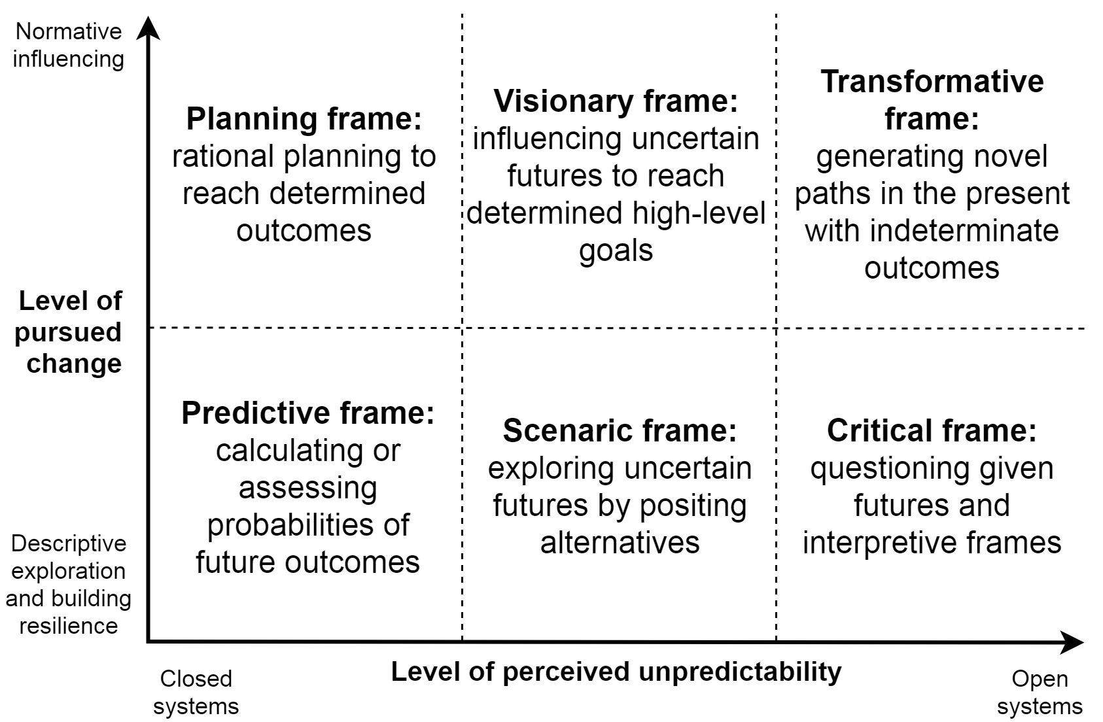
Fig. 1: Six foresight frames
The predictive frame underlies foresight work which seeks to either formally calculate or heuristically assess probabilities of future outcomes. Trend extrapolation, predictive modelling and many expert-oriented methods such as Delphi are examples of this orientation. In the planning frame, foresight work is intended to change the future by systematically determining the necessary means and steps to reach desired outcomes. Traditional backcasting is an example of this approach (Robinson, 1990). The predictive and planning frames are united by the assumption that the dynamics of the systems under study can be understood to the extent that probabilistic forecasting and rational planning are reasonable approaches.
The scenaric and visionary frames, in contrast, begin from the assumption that futures are deeply uncertain and the assessment of probabilities is problematic if not dangerous (e.g. Derbyshire, 2017). In the scenaric frame, uncertainty is tackled by positing and fleshing out alternatives with no probabilities assigned, as in the intuitive logics scenario tradition (Bradfield et al., 2005). In the visionary frame, high-level goals are determined to influence uncertain futures towards them, although the path to the desired future is less certain than in the planning frame. Visions are characterised by a tension between transformational and motivational qualities, on the one hand, and plausibility on the other hand (Wiek & Iwaniec, 2014). Sustainability visioning, policy visions and participatory pluralistic backcasting are examples of this orientation (Tuominen, Tapio, Varho, Järvi, & Banister, 2014; van der Helm, 2009; Wiek & Iwaniec, 2014).
In the critical and transformative frames, the consideration of unpredictability is taken further, and foresight work is explicitly intended to make sense of present assumptions and opportunities rather than representing futures. Miller (2018b, p. 20) calls this “anticipation-for-emergence”, distinguished from “anticipation-for-the-future”. The critical frame points to foresight which uncovers and questions present assumptions, as in causal layered analysis and the ‘reveal’ phase of futures literacy laboratories (Inayatullah, 1998; Miller, 2018a). The critical frame is closely connected with the transformative frame where the focus is on expanding the scope of possibilities and generating novel paths in the present without defining future outcomes. For instance, in causal layered analysis and the futures literacy framework, both critical and transformative aspects are present. Nevertheless, it is useful to analytically distinguish between the two frames, because in some foresight cases, and certainly in scholarly futures work, it may be desirable to analyse present assumptions about futures without explicit transformative intention. These two frames challenge traditional notions of foresight, and it is likely that some practitioners do not consider them as foresight. The boundaries between, for instance, foresight and societal change-making are contested and perhaps should not be drawn definitively.
The dimensions of unpredictability and pursued change are both related to the issue of control over futures. Foresight work within the predictive frame and especially the planning frame presumes that many aspects of the future can be intentionally steered. In comparatively closed systems this is a reasonable assumption and enables effective long-term policymaking. However, the literature on wicked problems (Rittel & Webber, 1973) and ‘feral futures’ (Ramírez & Ravetz, 2011) suggests that treating unpredictable situations as predictable may be dangerous. Foresight within the scenaric, visionary, critical and transformative frames, in contrast, relinquishes control over futures to a large extent. In the latter two frames, it is ambiguous whether constructing plausible scenarios is an appropriate approach due to unpredictability and complexity. Some authors have argued for critical variants of scenario methods (e.g. Cairns, Śliwa, & Wright, 2010; Miller, 2007; Ramírez & Ravetz, 2011), while others have promoted narrative foresight and heterogeneous dialogical storytelling that arguably goes beyond scenarios (Milojević & Inayatullah, 2015; Tuomi, 2019). The dividing lines between the foresight frames are somewhat fuzzy, but as ideal types they help to consider the assumptions in foresight processes. The objective is to be able to use “anticipation for different ends, in different ways and in different contexts” (Miller, 2018b, p. 34).
Returning to the complex issue of time perspective, what is the role of temporality in the different frames? It is tempting to claim that there is a linear relationship between time horizon and unpredictability: a longer time horizon means more unpredictability. However, the relationship is more complicated. As Poli (2017, p. 67) states, forecasting can be done at very short or very long timeframes. Scenario and visioning work can also dynamically utilise different time frames, and the critical and transformative frames are explicitly oriented towards present action while considering its future implications. Rather than a linear relationship, it seems more accurate to assume that the different frames have a qualitatively different relationship to temporality. Using cultural sociologist John R. Hall’s temporal registers of action, predictive and planning frames seem to utilise diachronic time, clock and calendar time, while scenaric and visionary frames are more oriented towards strategic time, trying to influence contingent outcomes in competition or conflict (Hall, 2016). Critical and transformative frames, in turn, focus on the here-and-now, the embodied present in which people live (Hall, 2016). These two frames can also be linked to the Ancient Greek notion of time as kairos, the right time of opportunity in contrast to chronos, measurable clock time (Jacques, 1990). The in-depth discussion of temporality is beyond the scope of this article.
In Table 8, the foresight frames are compared to previous classifications in terms of three features: the general view of futures and time (Amara, 1981; Groves, 2017; Hall, 2016; Selin, 2006), the corresponding futures research paradigms (Inayatullah, 1998; Mannermaa, 1991; Poli, 2017; Tapio & Hietanen, 2002; Tuomi, 2019) and the general type of futures thinking (Anderson, 2010; De Smedt, Borch, & Fuller, 2013; Miller, 2018b; Sharpe et al., 2016; Szpunar, Spreng, & Schacter, 2016). The types of futures thinking are of particular interest here because they are at a higher level of abstraction than typologies based on method or disciplinary paradigm. Miller et al. (2018) distinguish between preparation, planning and novelty as general modes of ‘using the future’. Godet (e.g. 2006) distinguishes between five basic attitudes to the future: passive, reactive, preactive, proactive and anticipactive, the last of which skilfully combines the other attitudes. De Smedt et al. (2013) identify seven modes of futures thinking: intuitive, conventional, eventuality, predictive, visionary, technocratic and evolutionary. Selin (2006) suggests a somewhat similar list of ‘timescapes’: trajectories, discontinuous, path dependence, emerging and indeterminate. Cognitive psychologists, in turn, have presented a taxonomy of four basic types of of future thinking and mental time travel: simulation (construction of a mental representation of the future), prediction (estimation of the likelihood of, or one’s reaction to, an outcome), intention (setting goals) and planning (organising steps for achieving goals) (Szpunar et al., 2016). While everyday futures thinking is different from organised foresight, the two may be closely linked, since foresight is made by humans with inherent cognitive limitations and tendencies.

Table 8: Comparison of the six foresight frames with typologies of foresight and futures
Frame | View of futures | Type of futures thinking | Futures research paradigm
Predictive | Probable futures (Amara, 1981), abstract futures (Groves, 2017), time as trajectories (Selin, 2006), diachronic time (Hall, 2016) | Preparatory (Miller, 2018b); conventional and predictive (De Smedt et al., 2013; Szpunar et al., 2016), reactive/preactive (Godet, 2006), first horizon (Sharpe et al., 2016), calculative (Anderson, 2010) | Descriptive/predictive-empirical (Inayatullah, 1990; Mannermaa, 1991), probabilistic/forecasting (Poli, 2017; Tuomi, 2019)
Planning | Preferable and probable futures (Amara, 1981), empty futures (Groves, 2017), time as path-dependent (Selin, 2006), diachronic time (Hall, 2016) | Creative reform (Miller, 2018b, p. 32), technocratic (De Smedt et al., 2013), planning-type prospection (Szpunar et al., 2016), planning-oriented anticipatory systems (Miller, 2018b), calculative (Anderson, 2010), proactive (Godet, 2006) | Forecasting (Poli, 2017), Comtean positivism (Tapio & Hietanen, 2002)
Scenaric | Possible futures (Amara, 1981), abstract futures (Groves, 2017), time as disruptive/discontinuous (Selin, 2006), strategic time (Hall, 2016) | Preparatory (Miller, 2018b), intuitive/eventuality (De Smedt et al., 2013), simulation (Szpunar et al., 2016), preactive attitude (Godet, 2006), imagining futures (Anderson, 2010) | Cultural-interpretative, scenario paradigm (Inayatullah, 1990; Mannermaa, 1991), possibilistic (Tuomi, 2019)
Visionary | Preferable and possible futures (Amara, 1981), empty futures (Groves, 2017), strategic time (Hall, 2016) | Creative reform (Miller, 2018b, p. 32), visionary (De Smedt et al., 2013), intentional (Szpunar et al., 2016), proactive (Godet, 2006), third horizon (Sharpe et al., 2016), imagining futures (Anderson, 2010) | ‘Scenarised utopias’ (Mannermaa, 1991), optimistic and pluralistic humanism, polling democracy (Tapio & Hietanen, 2002)
Critical | Possible futures (Amara, 1981), lived futures (Groves, 2017), the embodied present (Hall, 2016) | ‘Strategic thinking’: identifying paradigms (Miller, 2018b, p. 33), questioning futures (Marien, 2002) | Complexity-oriented and critical (Inayatullah, 1990; Mannermaa, 1991; Wilkinson et al., 2013)
Transformative | Preferable futures (Amara, 1981), lived futures (Groves, 2017), time as emerging and indeterminate (Selin, 2006), the embodied present (Hall, 2016) | Novelty-oriented (Miller, 2018b), evolutionary (De Smedt et al., 2013), ‘anticipactive’ (Godet, 2006), second horizon (innovations) (Sharpe et al., 2016) | Complexity-oriented and critical (Inayatullah, 1990; Mannermaa, 1991; Wilkinson et al., 2013), design-based/anticipation (Poli, 2017; Tuomi, 2019), pragmatism, democratic anarchism (Tapio & Hietanen, 2002)
The heuristic comparison in Table 8 cannot do justice to the different typologies. However, it indicates that the frames capture many earlier distinctions in a relatively simple model. The predictive frame corresponds rather directly with predictive-empirical futures research approaches that consider probable futures, with variables abstracted from contextual circumstances. The approach to the future is preparatory and calculative. The planning frame presents a more proactive variant of this calculative orientation, considering the future as an empty terrain to be rationally planned (Groves, 2017). The scenaric frame corresponds with possibilistic exploratory foresight which aims at preparing for imagined futures and building resilience. The visionary frame, in turn, is connected to visioning where imagination and proactive human agency are seen as a key determinants of the future. The critical frame corresponds with complexity approaches and the notion of futures as ontologically and epistemologically complex lived realities (Groves, 2017). Finally, the transformative frame relates to the turbulent second horizon of experimentation, search for evolutionary pathways and invention of novelty with unpredictable consequences (De Smedt et al., 2013; Miller, 2018b; Sharpe et al., 2016). The transformative frame is similar to the constructivist chronotope presented by Tuomi (2019) which in turn is connected to design-based foresight, expansive learning and realisation of latent opportunities.
What is the added value of another typology compared to previous categorisations, including the ones referenced above? We argue that our model is on a different analytical level, focusing on interpretive structures employed by foresight actors rather than an outward description of activities. A simple typology of frames acts as a bridge between foresight activities and the contexts in which they take place. On the one hand, we may consider what kinds of foresight activities are appropriate within a given frame. On the other hand, we may ask what kinds of frames are suitable for a given context such as long-term policymaking or business strategy. Differentiated from specific activities and surrounding contexts, frames are a suitable level of abstraction for mapping different kinds of foresight. It is useful to clarify the contribution in relation to certain key typologies, indicated in Fig. 2. Tuomi (2019) differentiates between probabilistic, possibilistic and constructivist chronotopes of foresight, which corresponds to our horizontal axis. Anderson (2010) makes a distinction between practices based on calculating, imagining and performing futures, which links to the same axis. However, these models do not explicitly address the level and type of pursued change. Miller (2018b), in turn, differentiates between anticipatory systems oriented towards preparation, planning and novelty. The first two correspond to our influence dimension, while the third corresponds to the transformative frame. However, the threefold model does not differentiate between a predictive/probabilistic orientation and an orientation towards imagining possible or plausible futures, which is a significant difference between different futures and scenario traditions (e.g. Bradfield et al., 2005; Ramírez & Selin, 2014). Our model also finds a middle path between the methodological specificity of foresight and scenario typologies (Börjeson et al., 2006; Popper, 2008; van Notten et al., 2003; Wilkinson & Eidinow, 2008) and the high level of abstraction of futures research paradigms (Inayatullah, 1990; Mannermaa, 1991; Tapio & Hietanen, 2002).

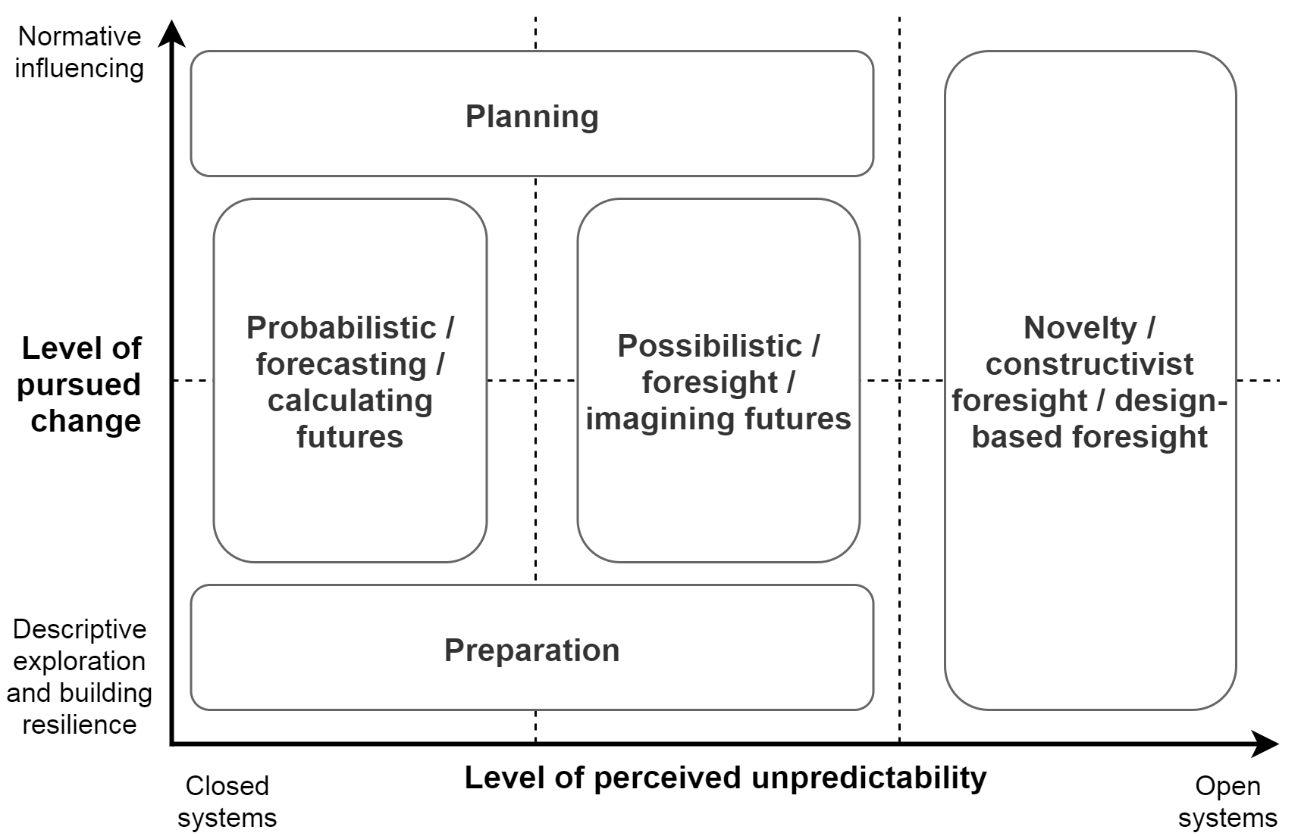
Fig. 2: Comparison with the models of Tuomi (2019), Anderson (2010) and Miller (2018b)

Elaborating and testing the foresight frames

Elaborating the foresight frames: the case of comprehensive security in Finland
Our study on comprehensive security foresight was initiated by an observation at a security foresight event in Helsinki, Finland in November 2017. At the event, five foresight actors, including our Winland project, presented their ongoing foresight processes which were connected to the Finnish concept for comprehensive security. It was evident that there are many parallel security foresight processes which use different approaches and have different aims. Thus researchers could add value to foresight by structuring and making sense of different foresight approaches rather than adding to the amount of foresight. Moreover, it seemed to us that not only are there different kinds of foresight processes, but there are networks of foresight actors and processes with varying levels of interconnectedness. While mixes of foresight methods in particular processes have been discussed in the literature (e.g. Popper, 2008), we were unable to find discussions of mapping different types of foresight in multi-actor foresight systems.
‘Comprehensive security’ is a Finnish administrative term which dates back to a 2012 government resolution, although the roots of a comprehensive approach to security go back much further. In a nutshell, the Finnish concept for comprehensive security entails a cooperation model between societal sectors to create preparedness across society. In particular, seven vital functions need to be secured: 1) leadership, 2) international and EU activities, 3) defence capability, 4) internal security, 5) economy, infrastructure and security of supply, 6) functional capacity of the population and services and 7) psychological resilience (The Security Committee, 2017). In the latest Security Strategy for Society, foresight is explicitly made a part of the preparedness process. However, at the time of our study, the foresight component was still taking shape. Thus we decided to conduct an analysis to map the foresight approaches in the key foresight processes.
For analysing the processes, we used two sources of material: publicly available documents and interviews. The foresight processes under investigation, responsible actors and relevant documents are summarised in Table 9.

Table 9: Foresight processes related to the Finnish concept for comprehensive security
Process | Responsible actor | Document material
Comprehensive security foresight | Security Committee | - Security strategy for society (2017)  - Summaries of comprehensive security Delphi exercises
Security of supply scenarios | National Emergency Supply Agency | - Security of supply scenarios 2030 (2018)
Finnish government’s foresight process | 12 Finnish ministries | - The Government’s common drivers for change (2017)  - Futures reviews of five ministries: Prime Minister’s Office, Ministry of Agriculture and Forestry, Ministry of the Environment, Ministry of the Interior, Ministry of Defence (2018)
To deepen our understanding provided by the documents, we conducted 9 interviews with experts and foresight practitioners from the following organisations:
- Background interviews
  - Sitra, the Finnish Innovation Fund (2 interviewees)
  - Committee for the Future, Parliament of Finland
  - Police University College
- Substance interviews
  - Prime Minister’s Office (2 interviewees)
  - Ministry of Agriculture and Forestry (2 interviewees)
  - Ministry of the Environment
  - Ministry of the Interior
  - National Emergency Supply Agency (2 interviewees)
  - Security Committee (2 interviewees)
The six substance interviews were semi-structured with three broad themes:
- How was the foresight process implemented (target group, goals and the extent of reaching them, challenges and next steps)?
- Which approaches to foresight were utilised?
- What connections exist to other foresight processes (including potential challenges in cooperation)?
The documents and interviews were recorded, trascribed and thematically coded according to the five dimensions of futures consciousness, along with more data-driven codes such as ‘continuous foresight’ and ‘sustainable development’. In addition to coding, memos were also written as novel questions emerged while coding and reading the material. While this article focuses on foresight frames, a project report in Finnish also utilised the more substance-based coding of the material.
In Table 10, indicative quotes for each frame and their dimensions are presented to give an idea of the excerpts that helped to classify foresight processes in the frames. The quotes have been translated from Finnish by the authors and the interviewees’ organisations are not mentioned in order to preserve anonymity.
Table 10: Indicative quotes from documents and interviews for different frames
Frame / dimension | Level of perceived unpredictability | Level of pursued change
Predictive frame | “issues that experts consider important in the short term”; “participants assessed the impact and probability of their ‘product’”; “We want to build [understanding] what the security environment looks like in coming years.” | “at best, preparation preempts formation of new threats”; “if foresight produces early warnings of significant phenomena for preparation and we prepare for them, then we are changing the future”
Planning frame | “what kind of mechanisms ensure that […] politics spanning across government terms and involving a big change is not turbulent”; “stability is kind of a prerequisite for making changes” | “[the Common Drivers for Change] were more a description of the operating environment, and the futures reviews are more steering, […] some of them include quite a lot of foresight that aims at building a particular future”
Scenaric frame | “making scenario-type work, we can easily present alternatives […] Bringing radical ideas that differ from today and from already achieved things is more challenging”; “The scenario descriptions are not intended for predicting a single future. The goal is to guide into thinking about possible future development paths in a multi-faceted and coherent way” (Security of Supply Scenarios 2030) | “there’s an effort towards a neutral image of the future, presenting how it looks and then politicians can make the decisions […] the most important thing is that we recognise genuinely important issues for the next years or decades”; “The goal is to […] improve the ability to interpret contemporary phenomena and make planning and reacting more efficient.” (Security of Supply Scenarios 2030)
Visionary frame |  | “we started from the goal that in 2030 we have a goal, for instance biodiversity loss has been stopped. What measures do we need to take to get there. 2030 is a long way”
Critical frame | “we can’t have knowledge about the future but we can have knowledge about anticipation, about our expectations”; “if we have tame problems, we are really good […] if we talk about really nasty wicked problems, […] our responses are intuitive at best” | “the problem is maybe culture […] what kind of know-how we have and what kind of culture”
Trans-formative frame |  | “The task of the Government is to support ecosystems where different actors can solve societal challenges also by experimenting” (Futures Review, Prime Minister’s Office)
With an initial understanding of the six foresight frames, we placed the comprehensive security foresight processes on a ‘map’ of the different frames, as indicated in Fig. 3. The placing of the processes was done interactively through discussions by the authors, and it was also tested in a workshop with stakeholders involved in the studied processes. Connections between foresight processes are indicated with arrows.

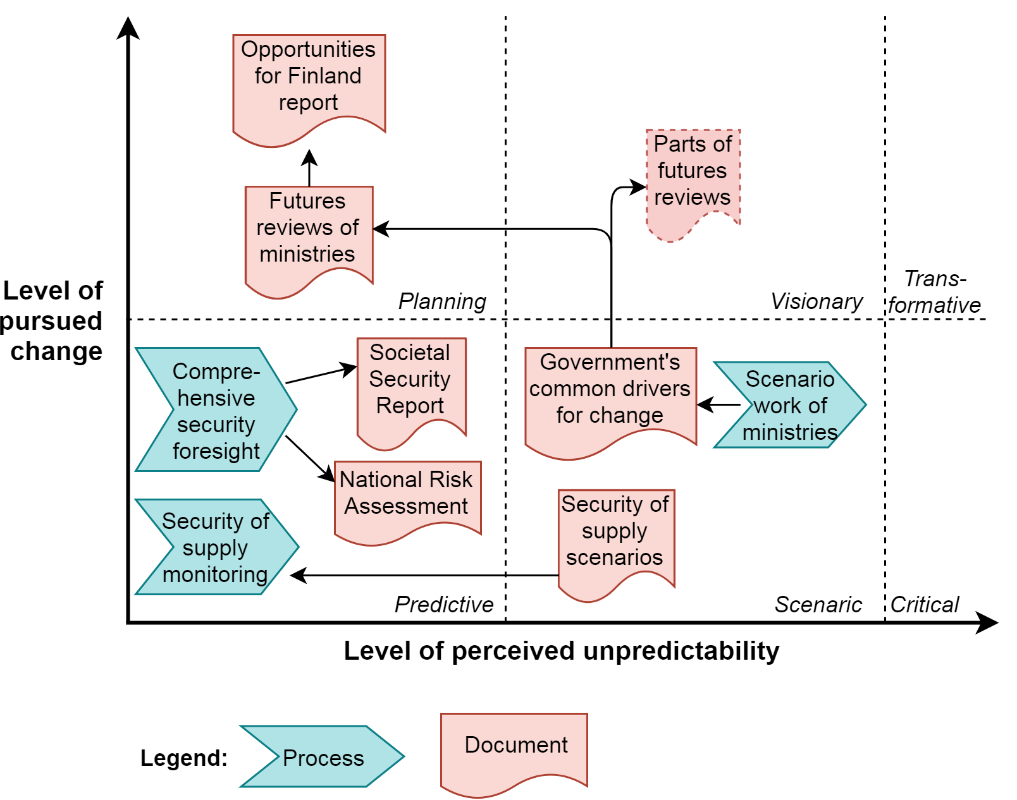
Fig. 3: Finnish comprehensive security foresight processes mapped according to the modes of foresight
In the Finnish comprehensive security case, the predictive frame means monitoring particular phenomena in the near-term future to support preparedness work. The planning frame refers to sector-specific or cross-sectoral policy foresight directly connected to policy planning activities, and the distinction between foresight and policy planning may be blurred in practice. Both of these are oriented towards risk-based calculation, rational planning and controlling uncertainty with knowledge (Ramírez & Selin, 2014). The scenaric frame, in the comprehensive security case, means a longer-term analysis of drivers for change and scenario work which highlights systemic interlinkages. In this more intuitive foresight work, uncertainty is seen as an inseparable element of imagining futures (Ramírez & Selin, 2014).
Four key insights may be gathered from the mapping. Firstly, different modes of foresight are mostly allocated to different foresight processes or different stages in the extended process of government foresight work. Secondly, the typical direction of the processes seems to be from greater unpredictability towards more probabilistic approaches. Thirdly, there are two ‘streams’ of foresight with different orientations: the government foresight work and the explicit security foresight. Finally, in our interpretation, three foresight frames are not explicitly present: the visionary, critical and transformative frames. While there were some indications of these frames, particularly the visionary frame, none of the studied processes can be unequivocally placed under these frames. Partly this can be explained by our focus on the interlinked core foresight processes, which excludes, for instance, classified foresight exercises, sector-specific long-term strategies and the National Commission on Sustainable Development, which are not clearly linked with comprehensive security. Value-driven visioning may also be difficult to combine with security thinking which tends to focus on preparation and building resilience. Nevertheless, the value of visioning for security foresight should be considered, particularly when employing a comprehensive conception of security. The importance of positive visions as well as discussion on differing visions was expressed by comprehensive security stakeholders in a workshop conducted by the Winland project in October 2018 where our analysis was presented.

Testing the foresight frames with four foresight system cases
The framework of six foresight frames is tested in an exploratory manner with four different foresight system cases based on information available in public documents. Cases were selected where there was a clear link to public policy, where sufficient information was publicly available and where at least three interlinked foresight processes were identified, suggesting that it is justified to consider it as a foresight system. Four cases are discussed: Singapore, United Kingdom, Wallonia (Belgium) and Russia (Fig. 4). The cases are discussed as snapshots of the time of the respective sources, and particularly for Singapore and United Kingdom the information may be partly outdated. The intention of the mapping exercise is to test the typology rather than evaluate the foresight systems in these countries. For evaluation, a deeper understanding of the context and processes would be necessary.

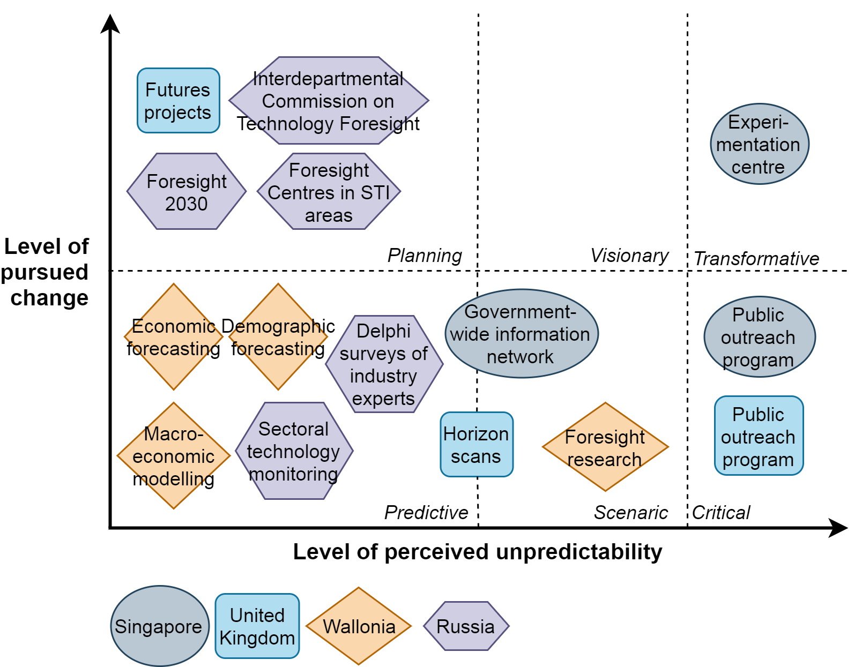
Fig. 4: Foresight frames in four foresight system cases
Habegger (2010) identifies three elements in the Singaporean foresight system at the time of writing. Firstly, a government-wide information network combines 20 agencies, documents results of strategic scans and facilitates collaboration and exchange of data. The system seems to be highly software-driven and data-driven, but on the other hand it incorporates concepts from systems thinking and complexity analysis. The Experimentation Centre (REC) focuses on technology scanning and experimentation. Its ‘transformative’ aspect, however, is limited to improving the foresight system itself. Finally, the public outreach process engages universities and international partners to provide feedback on the system and organises seminars and workshops. The foresight system described by Habegger (2010) focuses on national security and could be described as protective rather than proactive.
The United Kingdom Foresight Programme has its roots in science and technology policy but since 2002 the scope has been widened to societal, environmental and other issues (Habegger, 2010). In 2010, the programme included three key components: horizon scans, futures projects and the public outreach program. The horizon scans are placed into the scenaric frame because they may range up to 50 years into the future and the resulting ‘issue papers’ may include weak signals, scenarios and wildcards in addition to forecasts (Habegger, 2010). The futures projects, in turn, are more focused, they need a sponsoring minister and they are linked to establishing policy recommendations, and therefore they seem to fit under the planning frame, although they may also include scenario building. These two aspects of the UK Foresight Programme seem to be similar to the scenario and change driver work in ministries and the futures reviews in the Finnish case, covering the scenaric frame and the planning frame. Finally, the public outreach program brings together experts to discuss “new ideas, innovative thinking, and good practice” (Habegger, 2010), which could produce a contribution representing the critical frame.
In the Wallonian case, Jean & Brunet (2017) discuss different anticipatory practices of the Walloon Institute for Evaluation, Foresight Studies and Statistics (IWEPS). The authors indicate that the anticipatory culture continues to be oriented towards prediction, reducing uncertainty and providing knowledge about the future. Since 2011, several explorative foresight pojects have been launched, and the authors also mention one normative backcasting scenario. Based on the description by the authors, change-oriented and critical foresight frames are not present in the system, although those roles may be taken by other Belgian foresight actors.
The Russian science, technology and innovation foresight network is continuously developed and includes more than 650 organisations and 1200 experts (Ena, Chulok, & Shashnov, 2017). The descriptions based on the available literature emphasise connections to strategic planning, expertise and setting of priorities for specific science and technology areas and for the country as a whole. An important recent process was the Science and Technology Foresight 2030 initiated by the Ministry of Education and Science which aimed at identifying the most promising areas of science and technology development (Gokhberg et al., 2017). Kryukov et al. (2019) state that the draft document discusses two scenarios, technological adaptation and technological leap, which differ only slightly and the latter is chosen as the target scenario. The Russian foresight system has its roots in long-term planning and the system has since evolved into identification of opportunities and supporting innovation activities (Gokhberg & Sokolov, 2017). At least in the publicly available literature, it is difficult to find discussion on alternative, radically different scenarios, and therefore it seems justified to place the described foresight activities in the predictive and planning foresight frames. However, the same caveat remains as in the other cases: other actors in the broader national foresight network may represent the other frames.
How should we read this kind of mapping of foresight frames? First of all, the placing of processes into frames is a sensemaking process rather than a strict scientific classification. Especially in an interactive workshop setting, the placing of particular processes could stir critical discussion on the features, strengths and weaknesses of foresight processes. Moreover, the absence of certain frames does not simply mean deficiencies in a foresight system. Instead, emphases on particular foresight frames in a system should be seen in historical context, and the overall aims of the foresight system need to be considered. For instance, the apparent lack of visionary frames in these foresight systems may be due to the scope of the study, policy foresight may be considered separate from visioning for historical or other reasons, or our criteria for what constitutes visioning may be excessively strict. Even though this kind of mapping of foresight frames is not scientifically exact, we argue that it provides a relatively simple way of perceiving the big picture of a foresight system and the distinct roles of interlinked foresight processes.

Discussion

Policy implications: integrating foresight frames in a foresight system
The most important implication of the analysis of foresight frames is that different frames can complement each other and form a foresight system where different foresight actors, processes, methods and approaches play different roles (Amanatidou, 2014; Dufva & Ahlqvist, 2015). The operational environment may justify placing emphasis on specific frames. For example, the predictive or scenaric frame make sense for small players in a reasonably stable environment, while highly turbulent times may demand critical and transformative outlooks. Perhaps in the ideal case, all actors could be able to use each frame at different phases of a comprehensive foresight process. However, the frames imply different individual and organisational competences. Given the reality of scarce resources for foresight work, different organisations are likely to prioritise different competences while utilising their networks and contractors for other kinds of work. On a more general level, the question is when foresight should be organised as a single-actor process with multiple stages and when it should be distributed to several interlinked processes with different actors. This question cannot be discussed at length here but it merits future research. The important point is that different foresight frames are necessary and useful even though every actor need not utilise the whole spectrum. This perspective is becoming increasingly important as foresight work is becoming increasingly networked, distributed and collaborative (Georghiou & Keenan, 2006; Wiener, Gattringer, & Strehl, 2018). One intriguing implication is that a foresight system could be interpreted as a kind of distributed and/or extended system of futures cognition where anticipation is an “environmentally distributed capacity” (Arnau, Estany, Solar, & Sturm, 2014; Groves, 2017).
This also implies a contribution to the discussion on foresight evaluation (Amanatidou & Guy, 2008; Georghiou & Keenan, 2006). Rather than a simple continuum from low-quality to high-quality foresight, different foresight frames are likely to have different quality criteria, because they are essentially doing different things with the future. In the case of foresight in the predictive and planning frames, high-quality data and rigorous analysis are of paramount importance. The background assumptions utilised in models and analyses should also be transparent. Knowledge of foresight methods is crucial in order to develop sound questions in a Delphi study, for instance. Considering scenaric and visionary foresight, by contrast, important factors are dialogue with multiple perspectives, continuous questioning of assumptions and the courage to present unconventional ideas. Because organisational systems typically favour ideas that are in line with the status quo, long-term foresight should foster plurality in thinking and a ‘culture of curiosity’ in order to seriously consider future uncertainties (van Notten, 2013). The critical and transformative frames are largely similar to the scenaric and visionary ones in this sense, although a stronger authorial voice may be desirable in sharp critical approaches. In terms of methods, certain methods may initially be deemed suitable for specific foresight frame, for instance evidence-based and expert-led methods as suited to probabilistic foresight and interactive, creative methods to possibilistic or transformative foresight (Popper, 2008). However, more unconventional combinations may also be valuable, since particular methods such as Delphi can be used with different objectives. While method combinations can be experimented with, using quality criteria from another approach may be misleading or even dangerous, for instance in the case of continuous questioning of basic assumptions in short-term monitoring of a specific phenomenon, or misleading precision in exploratory long-term foresight.
One general characteristic of high-quality foresight, however, can be derived from the analysis: the awareness of different foresight frames and their inherent assumptions. Firstly there should be an awareness that foresight is plural by nature and, secondly, some understanding of what the different frames are. In networked foresight, actors can and should specialise in foresight driven by different frames. In the case of security foresight, defence actors naturally think in terms of preparation, while education actors, for instance, take care of planning the long-term prerequisites of a peaceful society. However, a basic understanding of different foresight frames is crucial for all actors to ensure cooperation. Awareness of foresight frames can broaden different actors’ notions of foresight and futures work. Special attention should be paid when foresight outputs cross from one frame to another, for instance when utilising long-term visions in planning. Otherwise there is a danger of misreading foresight results from other approaches, for instance demanding that visions should include detailed data.
On the system level, the overall implication is that diversity of foresight is a desirable characteristic in a foresight system. Rather than optimising a single ‘high-quality’ foresight frame, foresight actors should be encouraged to specialise in different foresight frames which, taken together, complement one another and potentially produce more valuable foresight outputs than single foresight exercises by one actor. As Ramírez & Ravetz (2011, p. 485) put it, there is “complementarity between the aesthetic or intuitive sensibility and the ratiocinative sensibility. Neither can stand on its own”. One of our interviewees argued in a similar vein that not being surprised by futures “doesn’t mean predicting but raising futures competences to a high level, having variety in thinking”. We may then assume that a diverse foresight system generates robust future-oriented decisions, although justifying this claim requires further empirical study.
However, it is important to note that different foresight frames may also be in tension with one another rather than simply harmoniously complementing each other. These tensions may be apparent both at individual and structural levels. At the individual level, for example planning-oriented experts may question the value of possibilistic long-term scenario exercises. On the structural/institutional level, there may be competition for funding between different foresight approaches. It is likely that some amount of tension between different approaches will always exist in a complex foresight system. Moreover, some amount of tension may be desirable. The key issue is to find ways to generate constructive tension between different approaches, so that foresight actors challenge each other to conduct more rigorous foresight and together contribute to producing robust, multi-faceted foresight outputs. Indeed, it may be undesirable to integrate foresight processes too tightly. For instance, if visioning exercises are strongly tied to preparedness and planning work from the outset, no-one would challenge the assumptions in strategy work and open new long-term future alternatives.
A more specific question is how to implement critical foresight in practice. This frame is perhaps the most difficult to imagine as driving a foresight process, while at the same time there is clearly need for critical sensemaking of complex phenomena, including currently prevailing ideas of the future. One answer is that these critical perspectives should be part of all high-quality foresight processes. On the other hand, the role of critical analyst is distinctive and it may be difficult to assume in a serious way by actors that are also concerned with achieving actionable results. Can academia then play the role of foresight critic, and does public participation and outreach ensure the presence of the critical frame, as was speculated in the Singaporean and United Kingdom cases? These questions could be addressed by future research, drawing for example on the constructivist approach to foresight (Tuomi, 2019).

Limitations
Finally, the limitations of this study should be considered. The typology of foresight presented in this article was largely developed and elaborated in a single case study of a particular field in a small Nordic country, although the work on the dimensions of futures consciousness dates back to 2015 and the model is intended as a generic framework. The tentative testing with four additional cases provides some backing for the model. The benefit of a small case study is that the empirical material is manageable by a small team, which makes it possible to discuss about our hypotheses throughout the study rather than using a fixed interpretive frame. In addition, the empirical material is by no means exhaustive even within this limited case. Ideally, the material would include extensive ethnographic observations and field notes to indicate how foresight work actually took place, comparable to what van Asselt, Mesman, & van’t Klooster (2007) did with Dutch foresight practitioners. Unfortunately this kind of extensive ethnographic study was not possible within our research project. Due to the limited material, generalisations need to be made cautiously.
Moreover, our exploratory study did not discuss causality, that is, the potential causes and consequences of different foresight frames, nor did we discuss systematic means of measuring which foresight frame prevails in a particular process. Thus it remains for subsequent studies to test, challenge and potentially corroborate the usefulness of the typology in different contexts. In fact, at the time of writing, we are conducting a project to map and assess the national foresight ecosystem in Finland using this framework together with other assessment methods. This project will certainly bring new insights into the framework and test its usefulness.

Conclusion
Why is yet another typology of foresight needed in addition to all the existing typologies and characterisations of foresight? Foresight is a context-specific practical activity, so why do we need new abstract categorisations which never accurately portray real-life processes? We have argued that by discussing the interpretive structures of foresight actors, our typology opens a novel analytical level that bridges foresight activities and their surrounding contexts. Frames are connected to but different from both descriptions of particular activities and the features of the context in which they take place. Moreover, by presenting a simple set of ideal types, we can support the development of diverse foresight systems where different actors specialise in different kinds of foresight and where quality criteria and connections between interlinked processes are clearly specified. We have presented a typology of six general foresight frames based on a review of foresight typologies and a study of comprehensive security foresight in Finland. Two variables are crucial for distinguishing foresight frames: 1) level of perceived unpredictability and 2) level of pursued change. This opens many potential avenues for future research, including case studies of foresight systems and investigating links between foresight and future-oriented cognition.
More generally, this article intends to broaden the discussion on future orientation in planning, policy-making and social action in general. There is no single ‘futures mindset’ or ‘prospective attitude’, nor should there be. Instead there is a plurality of frames for engaging with the future, each of which relates to the future in a different way and uses the future for different purposes. On the system level, the diversity of foresight approaches is crucial rather than simply building better foresight processes of the same kind. Foresight systems should thus include appropriate bridges between foresight frames together with the required space for diversity. The typology presented in this article is certainly not the final word in identifying different types of foresight, especially since it is elaborated based on a limited case study of a small Nordic country. However, our typology is systematic by utilising the five dimensions of futures consciousness and futures and foresight literature, and empirical by utilising interview and document material. Even if language does not permit it, foresight is plural: it is a cairn, not a monolith.

Acknowledgments
This research was funded by the Strategic Research Council (SRC) though the project “From Failand to Winland” (No. 303623). We thank our partners in the Winland consortium and the participants in the Winland workshops and panels as well as our counterparts in ministries, the Prime Minister’s Office and other institutions.

References
Ahlqvist, T., & Rhisiart, M. (2015). Emerging pathways for critical futures research: Changing contexts and impacts of social theory. Futures, 71, 91–104. https://doi.org/10.1016/j.futures.2015.07.012
Ahvenharju, S., Minkkinen, M., & Lalot, F. (2018). The five dimensions of Futures Consciousness. Futures, 104, 1–13. https://doi.org/10.1016/j.futures.2018.06.010
Alvesson, M., & Karreman, D. (2011). Qualitative research and theory development: Mystery as method. Sage Publications.
Amanatidou, E. (2014). Beyond the veil — The real value of Foresight. Technological Forecasting and Social Change, 87, 274–291. https://doi.org/10.1016/j.techfore.2013.12.030
Amanatidou, E., & Guy, K. (2008). Interpreting foresight process impacts: Steps towards the development of a framework conceptualising the dynamics of “foresight systems”. Technological Forecasting and Social Change, 75(4), 539–557. https://doi.org/10.1016/j.techfore.2008.02.003
Amara, R. (1981). The futures field: Searching for definitions and boundaries. The Futurist, 15(1), 25–29.
Anderson, B. (2010). Preemption, precaution, preparedness: Anticipatory action and future geographies. Progress in Human Geography, 34(6), 777–798. https://doi.org/10.1177/0309132510362600
Arnau, E., Estany, A., Solar, R. G. del, & Sturm, T. (2014). The extended cognition thesis: Its significance for the philosophy of (cognitive) science. Philosophical Psychology, 27(1), 1–18. https://doi.org/10.1080/09515089.2013.836081
Bishop, P., Hines, A., & Collins, T. (2007). The current state of scenario development: An overview of techniques. Foresight, 9(1), 5–25. https://doi.org/10.1108/14636680710727516
Börjeson, L., Höjer, M., Dreborg, K.-H., Ekvall, T., & Finnveden, G. (2006). Scenario types and techniques: Towards a user’s guide. Futures, 38(7), 723–739. https://doi.org/10.1016/j.futures.2005.12.002
Bradfield, R., Wright, G., Burt, G., Cairns, G., & Van Der Heijden, K. (2005). The origins and evolution of scenario techniques in long range business planning. Futures, 37(8), 795–812. https://doi.org/10.1016/j.futures.2005.01.003
Bruun, H., Hukkinen, J., & Eklund, E. (2002). Scenarios for coping with contingency: The case of aquaculture in the Finnish Archipelago Sea. Technological Forecasting and Social Change, 69(2), 107–127. https://doi.org/10.1016/S0040-1625(01)00134-2
Cairns, G., Śliwa, M., & Wright, G. (2010). Problematizing international business futures through a ’critical scenario method’. Futures, 42(9), 971–979. https://doi.org/10.1016/j.futures.2010.08.016
Clegg, S. (2017). Ideal Type. In The Blackwell Encyclopedia of Sociology (pp. 1–2). American Cancer Society. https://doi.org/10.1002/9781405165518.wbeosi001.pub2
de Jouvenel, B. (1967). The Art of Conjecture. New York: Basic Books.
Derbyshire, J. (2017). The siren call of probability: Dangers associated with using probability for consideration of the future. Futures, 88(November 2016), 43–54. https://doi.org/10.1016/j.futures.2017.03.011
De Smedt, P., Borch, K., & Fuller, T. (2013). Future scenarios to inspire innovation. Technological Forecasting and Social Change, 80(3), 432–443. https://doi.org/10.1016/j.techfore.2012.10.006
Dufva, M., & Ahlqvist, T. (2015). Elements in the construction of future-orientation: A systems view of foresight. Futures, 73, 112–125. https://doi.org/10.1016/j.futures.2015.08.006
Ena, O. V., Chulok, A. A., & Shashnov, S. A. (2017). Networking for sustainable Foresight: A Russian study. Technological Forecasting and Social Change, 119, 268–279. https://doi.org/10.1016/j.techfore.2016.05.014
European Foresight Platform. (2010). What is Foresight? Retrieved January 17, 2019, from http://www.foresight-platform.eu/community/forlearn/what-is-foresight/
Gattringer, R., Wiener, M., & Strehl, F. (2017). The challenge of partner selection in collaborative foresight projects. Technological Forecasting and Social Change, 120, 298–310. https://doi.org/10.1016/j.techfore.2017.01.018
Gentner, D., Imai, M., & Boroditsky, L. (2002). As time goes by: Evidence for two systems in processing space → time metaphors. Language and Cognitive Processes, 17(5), 537–565. https://doi.org/10.1080/01690960143000317
Georghiou, L., & Keenan, M. (2006). Evaluation of national foresight activities: Assessing rationale, process and impact. Technological Forecasting and Social Change, 73(7), 761–777. https://doi.org/10.1016/j.techfore.2005.08.003
Godet, M. (2006). Creating futures: Scenario planning as a strategic management tool (2nd ed.). London: Economica.
Gokhberg, L., & Sokolov, A. (2017). Technology foresight in Russia in historical evolutionary perspective. Technological Forecasting and Social Change, 119, 256–267. https://doi.org/10.1016/j.techfore.2016.06.031
Gokhberg, L., Sokolov, A., Sokolov, A., Sokolov, A., & Chulok, A. (2017). Russian S&T Foresight 2030: Identifying new drivers of growth. Foresight, 19(5), 441–456. https://doi.org/10.1108/FS-07-2017-0029
Groves, C. (2017). Emptying the future: On the environmental politics of anticipation. Futures, 92, 29–38. https://doi.org/10.1016/j.futures.2016.06.003
Habegger, B. (2010). Strategic foresight in public policy: Reviewing the experiences of the UK, Singapore, and the Netherlands. Futures, 42(1), 49–58. https://doi.org/10.1016/j.futures.2009.08.002
Hall, J. R. (2016). Social futures of global climate change: A structural phenomenology. American Journal of Cultural Sociology, 4(1), 1–45. https://doi.org/10.1057/ajcs.2015.12
Heger, T., & Boman, M. (2015). Networked foresight—The case of EIT ICT Labs. Technological Forecasting and Social Change, 101, 147–164. https://doi.org/10.1016/j.techfore.2014.02.002
Hughes, N. (2013). Towards improving the relevance of scenarios for public policy questions: A proposed methodological framework for policy relevant low carbon scenarios. Technological Forecasting and Social Change, 80(4), 687–698. https://doi.org/10.1016/j.techfore.2012.07.009
Inayatullah, S. (1990). Deconstructing and reconstructing the future: Predictive, cultural and critical epistemologies. Futures, 22(2), 115–141. https://doi.org/10.1016/0016-3287(90)90077-U
Inayatullah, S. (1998). Causal layered analysis: Poststructuralism as method. Futures, 30(8), 815–829.
Jacques, E. (1990). The Enigma of Time. In J. Hassard (Ed.), The Sociology of Time (pp. 21–34). London: Palgrave Macmillan UK. https://doi.org/10.1007/978-1-349-20869-2
Jean, M. P., & Brunet, S. (2017). Does anticipation matter for public administration? The case of the Walloon Region (Belgium). Foresight, 19(3), 280–290. https://doi.org/10.1108/fs-10-2016-0049
Joyce, P. (2015). Strategic Management in the Public Sector (1 edition). London: Routledge.
Kryukov, V. A., Suslov, V. I., Baranov, A. O., Blam, Y. S., Zabolotskii, A. A., Kravchenko, N. A., … Churashev, V. N. (2019). Russia 2030: Science and Technology Foresight: Revisiting the Draft. Studies on Russian Economic Development, 30(3), 261–267. https://doi.org/10.1134/S1075700719030080
Mannermaa, M. (1991). In search of an evolutionary paradigm for futures research. Futures, 23(4), 349–372.
Marien, M. (2002). Futures studies in the 21st Century: A reality-based view. Futures, 34(3), 261–281. https://doi.org/10.1016/S0016-3287(01)00043-X
Martin, B. R. (2010). The origins of the concept of ’foresight’ in science and technology: An insider’s perspective. Technological Forecasting and Social Change, 77(9), 1438–1447. https://doi.org/10.1016/j.techfore.2010.06.009
Meissner, D., & Rudnik, P. (2017). Creating sustainable impact from Foresight on STI Policy. Foresight, 19(5), 457–472. https://doi.org/10.1108/FS-06-2016-0021
Miles, I. (2010). The development of technology foresight: A review. Technological Forecasting and Social Change, 77(9), 1448–1456. https://doi.org/10.1016/j.techfore.2010.07.016
Miller, R. (2007). Futures literacy: A hybrid strategic scenario method. Futures, 39(4), 341–362. https://doi.org/10.1016/j.futures.2006.12.001
Miller, R. (2018a). Futures Literacy Laboratories (FLL) in practice: An overview of key design and implementation issues. In R. Miller (Ed.), Transforming the future: Anticipation in the 21st century (pp. 95–109). Abingdon, Oxon ; New York, NY: Routledge.
Miller, R. (2018b). Sensing and making-sense of Futures Literacy: Towards a Futures Literacy Framework (FLF). In R. Miller (Ed.), Transforming the future: Anticipation in the 21st century (pp. 15–50). Abingdon, Oxon; New York, NY: Routledge.
Miller, R., Poli, R., & Rossel, P. (2018). The discipline of anticipation: Foundations for futures literacy. In R. Miller (Ed.), Transforming the future: Anticipation in the 21st century. Abingdon, Oxon ; New York, NY: Routledge.
Milojević, I., & Inayatullah, S. (2015). Narrative foresight. Futures, 73, 151–162. https://doi.org/10.1016/j.futures.2015.08.007
Piirainen, K. A., & Gonzalez, R. A. (2015). Theory of and Within Foresight — "What Does a Theory of Foresight Even Mean?". Technological Forecasting and Social Change, 96, 191–201. https://doi.org/10.1016/j.techfore.2015.03.003
Poli, R. (2017). Introduction to anticipation studies (Vol. 1). Springer.
Popper, R. (2008). How are foresight methods selected? Foresight, 10(6), 62–89.
Ramírez, R., & Ravetz, J. (2011). Feral futures: Zen and aesthetics. Futures, 43(4), 478–487. https://doi.org/10.1016/j.futures.2010.12.005
Ramírez, R., & Selin, C. (2014). Plausibility and probability in scenario planning. Foresight, 16(1), 54–74. https://doi.org/10.1108/fs-08-2012-0061
Rittel, H. W. J., & Webber, M. M. (1973). Dilemmas in a general theory of planning. Policy Sci, 4(2), 155–169. https://doi.org/10.1007/bf01405730
Robinson, J. B. (1990). Futures under glass: A recipe for people who hate to predict. Futures, 22(8), 820–842. https://doi.org/10.1016/0016-3287(90)90018-D
Sardar, Z. (2010). The Namesake: Futures; futures studies; futurology; futuristic; foresight—What’s in a name? Futures, 42(3), 177–184. https://doi.org/10.1016/j.futures.2009.11.001
Selin, C. (2006). Time matters: Temporal harmony and dissonance in nanotechnology networks. Time & Society, 15(1), 121–139. https://doi.org/10.1177/0961463x06061786
Selin, C. (2008). The Sociology of the Future: Tracing Stories of Technology and Time. Sociology Compass, 2(6), 1878–1895. https://doi.org/10.1111/j.1751-9020.2008.00147.x
Sharpe, B., Hodgson, A., Leicester, G., Lyon, A., & Fazey, I. (2016). Three Horizons: A pathways practice for transformation. Ecology and Society, 21(2). https://doi.org/10.5751/ES-08388-210247
Snow, D. A. (2007). Frame. In The Blackwell Encyclopedia of Sociology. American Cancer Society. https://doi.org/10.1002/9781405165518.wbeosf064
Szpunar, K. K., Spreng, R. N., & Schacter, D. L. (2016). Toward a Taxonomy of Future Thinking. In Seeing the Future: Theoretical Perspectives on Future-Oriented Mental Time Travel (pp. 21–35). Oxford University Press.
Tapio, P., & Hietanen, O. (2002). Epistemology and public policy: Using a new typology to analyse the paradigm shift in Finnish transport futures studies. Futures, 34(7), 597–620. https://doi.org/10.1016/S0016-3287(02)00003-4
Tavory, I., & Timmermans, S. (2014). Abductive analysis: Theorizing qualitative research. Chicago: The University of Chicago Press.
The Security Committee. (2017). Security Strategy for Society. Government Resolution. The Security Committee. Retrieved from https://turvallisuuskomitea.fi/wp-content/uploads/2018/04/YTS_2017_english.pdf
Tuomi, I. (2019). Chronotopes of Foresight: Models of time-space in probabilistic, possibilistic and constructivist futures. Futures & Foresight Science, 1(2). https://doi.org/10.1002/ffo2.11
Tuominen, A., Tapio, P., Varho, V., Järvi, T., & Banister, D. (2014). Pluralistic backcasting: Integrating multiple visions with policy packages for transport climate policy. Futures, 60, 41–58. https://doi.org/10.1016/j.futures.2014.04.014
van Asselt, M. B., Mesman, J., & van’t Klooster, S. A. (2007). Dealing with prognostic uncertainty. Futures, 39(6), 669–684. https://doi.org/10.1016/j.futures.2006.11.011
van der Duin, P., Heger, T., & Schlesinger, M. D. (2014). Toward networked foresight? Exploring the use of futures research in innovation networks. Futures, 59, 62–78. https://doi.org/10.1016/j.futures.2014.01.008
van der Helm, R. (2009). The vision phenomenon: Towards a theoretical underpinning of visions of the future and the process of envisioning. Futures, 41(2), 96–104. https://doi.org/10.1016/j.futures.2008.07.036
van Notten, P. W. F. (2013). After the Arab Spring: An opportunity for scenarios. European Journal of Futures Research, 2(1). https://doi.org/10.1007/s40309-013-0028-z
van Notten, P. W. F., Rotmans, J., van Asselt, M. B. A., & Rothman, D. S. (2003). An updated scenario typology. Futures, 35(5), 423–443. https://doi.org/10.1016/S0016-3287(02)00090-3
Wiek, A., & Iwaniec, D. (2014). Quality criteria for visions and visioning in sustainability science. Sustainability Science, 9(4), 497–512. https://doi.org/10.1007/s11625-013-0208-6
Wiener, M., Gattringer, R., & Strehl, F. (2018). Collaborative open foresight - A new approach for inspiring discontinuous and sustainability-oriented innovations. Technological Forecasting and Social Change. https://doi.org/10.1016/j.techfore.2018.07.008
Wilkinson, A., & Eidinow, E. (2008). Evolving practices in environmental scenarios: A new scenario typology. Environmental Research Letters, 3(4). https://doi.org/10.1088/1748-9326/3/4/045017
Wilkinson, A., Kupers, R., & Mangalagiu, D. (2013). How plausibility-based scenario practices are grappling with complexity to appreciate and address 21st century challenges. Technological Forecasting and Social Change, 80(4), 699–710. https://doi.org/10.1016/j.techfore.2012.10.031

Author biographies
Matti Minkkinen is a project researcher and doctoral candidate at Finland Futures Research Centre, University of Turku. His research interests cover qualitative futures research methodology, futures consciousness and the topic areas of privacy, security and digital futures.
Dr. phil. Burkhard Auffermann is Senior Research Fellow at Finland Futures Research Centre, University of Turku. His research includes International Relations and European integration studies, security analysis, energy policy and Futures Studies theoretical and methodological development.
Ira Ahokas is a project manager at Finland Futures Research Centre, University of Turku. Her current research interests include security and safety, regional studies and urban development. She has conducted a numerous security research at national and international level.

The Winland project explored future energy and food security in Finland in the context of comprehensive security.
An intriguing question in terms of agency is the distinction between two different metaphorical mappings of time and space in the English language. The first mapping has been called the ego-moving metaphor, where the observer is progressing towards the future. The second mapping is the time-moving metaphor, where time is conceived as a kind of conveyor belt on which events are moving towards the observer (Gentner, Imai, & Boroditsky, 2002).
During the analysis, the comprehensive security foresight process was moved under the Prime Minister’s Office. The significance of this change remains to be seen, and our analysis represents a snapshot of the situation before the change.
The long-term goal fits under the visionary frame but the backcasting approach is also related to planning.
The “Opportunities for Finland” report was the next step in the government foresight work after the futures reviews. The report was not yet available at the time of conducting the analysis but it was mentioned in the interviews.

