Antecedents and consequences of destination brand love – Case Ylläs

Kaisa Aro
M.Sc. (Econ. & Bus. Adm.)
M.Sc. (Food Sciences)
P.o. Box 170
(Pohjoisranta 11 A)
FI-28101 Pori
Finland
kaisa.m.aro@utu.fi
+ 358 50 4125944

Dr. Kati Suomi
Postdoctoral research fellow
P.o. Box 170
(Pohjoisranta 11 A)
FI-28101 Pori
Finland
kati.suomi@utu.fi
+ 358 50 520 0790

Dr. Saila Saraniemi
Senior lecturer in marketing
Oulu Business School
University of Oulu
P.O. Box 4600
90014 Oulu
Finland
saila.saraniemi@oulu.fi
+358 50 524 9532

Antecedents and consequences of destination brand love – Case Ylläs

- Introduction
Notable part of consumers love also things other than people, including brands (Batra, Ahuvia & Bagozzi, 2012). Brand love is relatively new concept in academic discussion, and demonstrates consumers’ changed relationships with brands. The area is relevant for study, given the tightening competition in tourism sector for visitors, funding and support from different stakeholder groups.
Studies focusing on relationships between people and places/destinations as brands, are scarce. Particularly studies examining consumers’ love towards place/destination brands are very few. However, there are two studies focusing on brand love in the context of destination brands: Swanson (2015, 2017) and Lee and Hyun’s (2016). Thus, understanding on the concept is still limited, in terms of its construct, antecedents and consequences. Given the current weaknesses in existing knowledge on destination brand love, the purpose of this study is to conceptualize the antecedents and consequences of destination brand love.

- Theoretical background
Brand love
Brands have been studied for a long through measuring customer satisfaction (e.g. Fournier & Mick, 1999), and brand loyalty (e.g. Oliver, 1999). Brand love has been noted as enhancing loyalty (e.g. Carroll & Ahuvia, 2006). In the context of brands, Baldinger and Rubinson (1996) suggest a definition of loyalty that includes both attitudinal and behavioural aspects, as loyalty should not be considered repeat-buying pattern only, but also strong attitude toward the brand. Carroll and Ahuvia (2006, p. 81) refer to brand love as: “the degree of passionate emotional attachment a satisfied consumer has for a particular trade name”. The definition is adopted in the present study. Figure 1 summarises, on the basis of our literature review, antecedents of brand love, discussed in prior studies conserning mainly physical brands.

Insert Figure 1 here

Figure 2 presents suggested consequences of brand love detected from prior literature in the context of physical brands.

Insert Figure 2 here

Emotional bonding towards destination brands

Next we continue the discussion of brand love in the context of destinations. Place brands are result of interaction of place’s internal identity and external image (c.f. Hanna & Rowley, 2011). In tourism literature can be found two ruling aspects of emotional people-place relationships: place bonding and place attachment. These two concepts are partly overlapping, and in some studies they are dealt synonymously (see Cheng & Kuo, 2015; Hammitt et al., 2009). Concept of brand love has not settled its place in studies of people-place relationships. However, two recent studies (Lee & Hyun 2016; Swanson, 2015, 2017) indicate that brand love is a phenomenon, worth of research, in the case of tourist destinations.

Place bonding is described as emotional attachment and the perception of an identity that one associates with a specific place. It is noted, that tourists create emotional bonds while visiting places, calling for further knowledge on tourists’ behavior (Gu & Ryan, 2008; Tsai, 2012). Further, place attachment is the most common concept describing emotional bond in the academic literature on destinations. It can be regarded as emotional and psychological bond between a consumer and a specific place (e.g. Hwang, Lee & Chen, 2005; Prayag & Ryan, 2011; Tsai, 2012).

- Methodology
The research followed abductive logic, in terms of constantly going back and forth between different research activities, and particularly empirical observations and theory (Dubois & Gadde, 2002, 556). The single-case design was deemed suitable, as in-depth exploration in antecedents and consequences of brand love was pursued (Creswell, 2003). The case in question is Ylläs, which is a tourist destination for active outdoor holidays throughout the year that is located in the middle of wilderness in Finnish Lapland. At the moment, Ylläs is increasing its interest also among international tourists.
The first author conducted semi-structured interviews between November and December 2016. The data gathering ended after ten interviews. The interviews were recorded and transcribed afterwards to improve reliability (Silverman, 2001).

- Results and discussion

The purpose of this study was to conceptualize the antecedents and consequences of destination brand love. Figure 3 demonstrates our findings within the empirical grounded framework.

Insert Figure 3 here

The findings indicate that the concepts of place bonding and place attachment seem to be partly overlapping with the concept of destination brand love (see Cheng & Kuo, 2015), as they all deal with emotional bonds between people and place. We propose that destination brand love could be seen as an individual form of place bonding, as it concentrates on destination brands and is very strong form of bonding, as its consequences indicate. We consider attachment to place as being an antecedent of destination brand love.
Further, in case of destination brand love, some of the consequences are rather powerful, such as anticipated separation distress. This implies that destination brand love can be considered a stronger bond than place attachment. Interestingly, consumer’s interest in the wellbeing of the brand is presented in this study first time in relation to brand love. The cultural aspect is relevant as it appears that there are differences between countries in this respect. US-based studies have found that love-word is likely to be used related to objects and activities as frequently as related to people (Ahuvia, 2005). The findings of this study are closer to the results of Albert, Merunka and Valette-Florence (2008), and Batra et al. (2012), which suggest that consumers prefer other expressions than “to love” when speaking about objects other than people. Nevertheless, in this study, although a person did not verbally express love towards the destination brand, the way in which the person described his/her brand relationship revealed the same elements than brand relationships of people who verbally expressed brand love.

References
Ahuvia, A. C. (2005). Beyond the extended self: Loved objects and consumers’ identity narratives. Journal of Consumer Research, 22(1), 171-184.
Ahuvia, A. C., Batra, R., & Bagozzi, R. (2009). Love, desire and identity: A conditional integration theory of love of things. The handbook of brand relationships, D. J. MacInnis – C. Whan Park – J. R. Priester, 342-357. Armonk, NY: M. E. Sharpe.
Albert, N., Merunka, D., & Valette-Florence, P. (2008). When consumers love their brands: Exploring the concept and its dimensions. Journal of Business Research. 61(10), 1062-1075.
Baldinger, A. L., & Rubinson, J. (1996). brand loyalty: the link between attitude and behavior. Journal of Advertising Research. 36(6)22-34
Batra, R., Ahuvia, A. C., & Bagozzi, R. (2012). Brand love. Journal of Marketing, 76(2), 1-16.
Bauer, H., Heinrich, D., & Albrecht, C-M. (2009). All you need is love: Assessing consumers’ brand love. Proceedings of the American marketing association summer educators conference, M. Kamin – I. M. Martin, 252-253. American Marketing Association, Chicago.
Carroll, B. A., & Ahuvia, A. C. (2006). Some antecedents and outcomes of brand love. Marketing Letters, 17, 79-89.
Cheng, C.-K., & Kuo, H.-Y. (2015). Bonding to new place never visited: Exploring the relationship between landscape elements and place bonding. Tourism Management, 46, 546-560.
Creswell, J. W. (2003). Research design. Qualitative, quantitative, and mixed methods approaches. 2nd ed. Sage Publications, Thousand Oaks, CA.
Fournier, S., & Mick, D. G. (1999). Rediscovering satisfaction. Journal of Marketing, 63, 5-23.
Gu, H., & Ryan, C. (2008). Place attachment, identity and community impacts of tourism – the case of Beijing hutong. Tourism Management, 29, 637-647.
Hammitt, W. E., Kyle, G. T., & Oh, C.-O. (2009). Comparison of place bonding models in recreation resource management. Journal of Leisure Research, 41(1), 57-72.
Hwang, S.-N., Lee, C., & Chen, H.-J. (2005). The relationship among tourists’ involvement, place attachment and interpretation satisfaction in Taiwan’s national parks. Tourism Management, 26(2), 143-156.
Lee, K-H., & Hyun, S. S. (2016). The effects of perceived destination ability and destination brand love on tourists’ loyalty to post-disaster tourism destinations: The case of Korean tourists to Japan. Journal of Travel & Tourism Marketing, 33, 613-627.
Oliver, R. L. (1999). Whence consumer loyalty. Journal of Marketing, 63, 33-44.
Prayag, G., & Ryan, C. (2011). Antecedents of tourists’ loyalty to Mauritius: The role and influence of destination image, place attachment, personal involvement, and satisfaction. Journal of Travel Research, 1(1), 1-15.
Roy, S. K., Eshghi, A., & Sarkar, A. (2013). Antecedents and consequences of brand love. Journal of Brand Management, 20(4), 325-332.
Silverman, D. (2001). Interpreting Qualitative Data. Methods for Analyzing Talk, Text and Interaction, Sage Publications Ltd, London.
Swanson, K. (2015). Place brand love and marketing to place consumers as tourists. Research notes. Journal of Place Management and Development, 8(2), 142-146.
Swanson, K. (2017). Destination brand love: managerial implications and applications to tourism businesses. Journal of Place Management and Development, 10(1), 88-97.
Tsai, S-P. (2012). Place attachment and tourism marketing: Investigating international tourists in Singapore. International Journal of Tourism Research, 14(2), 139-152.
.

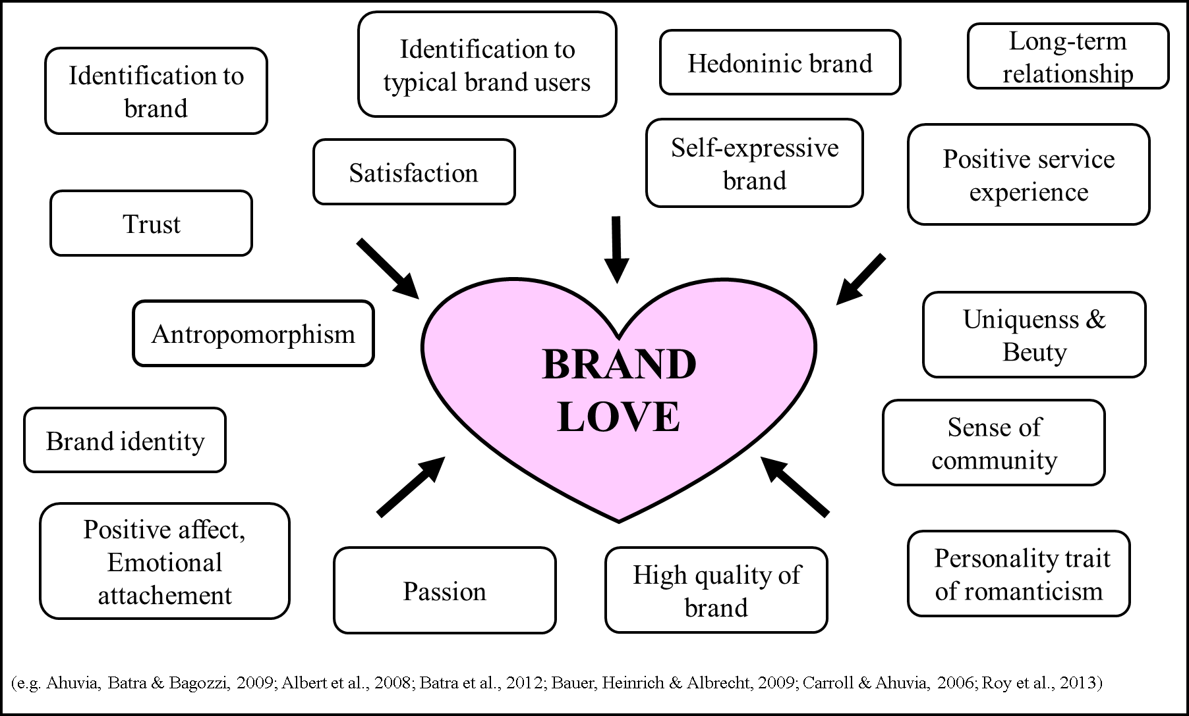
Figure 1. Antecedents of brand love

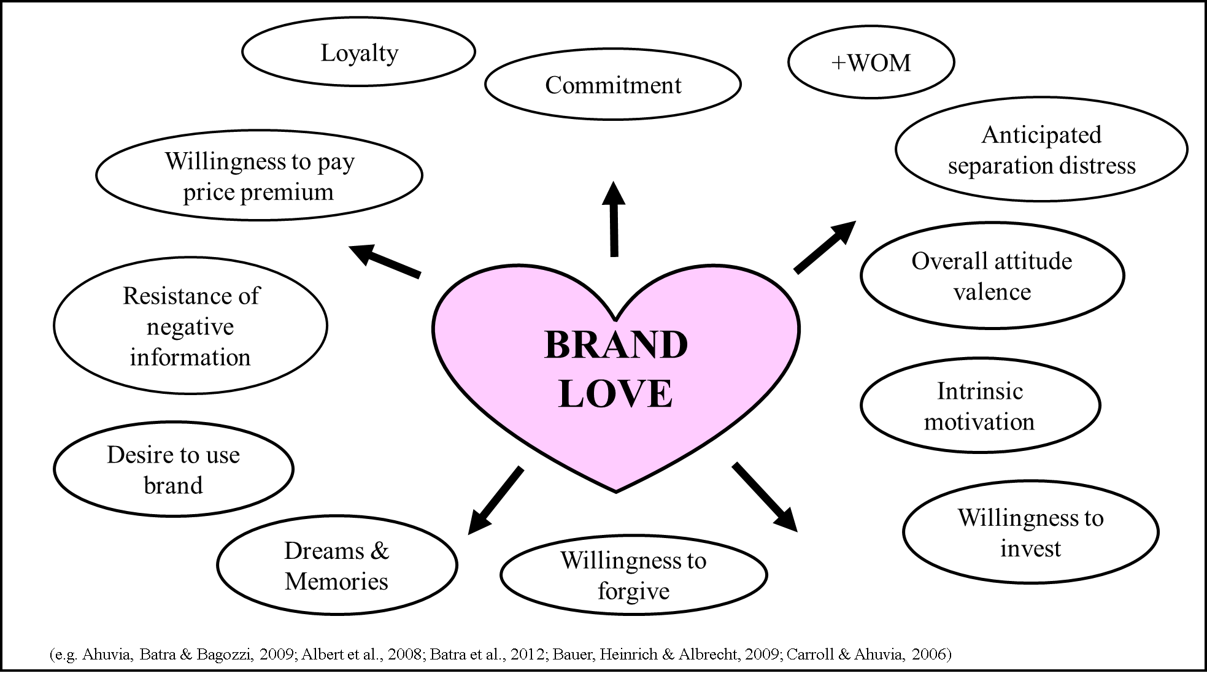
Figure 2. Consequences of brand love

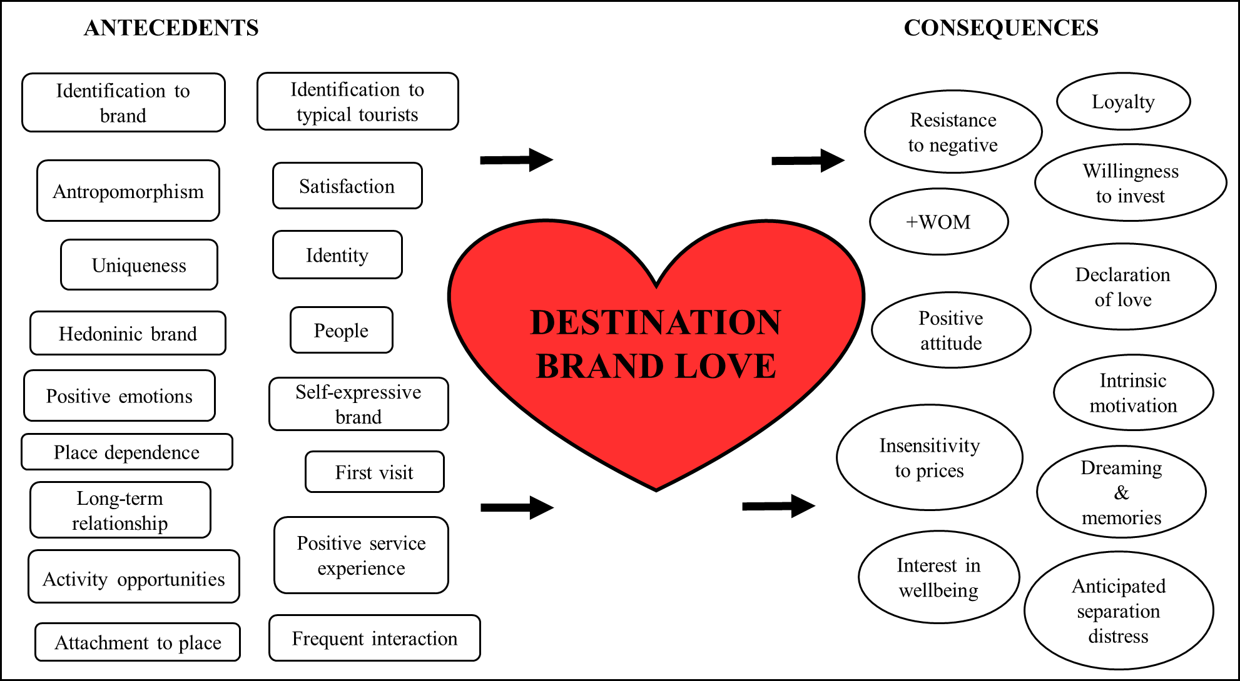
Figure 3 Empirically grounded framework of antecedents and consequences of destination brand love

