Why Do Boys and Girls Perform Differently on PISA Reading in Finland?
The Effects of Reading Fluency, Achievement Behavior, Leisure Reading, and Homework Activity

Submitted to J of Research in Reading 22.9.2016
Corresponding author: Minna Torppa¹
(minna.p.torppa@jyu.fi)
phone: +358408053538

Kenneth Eklund²
(kenneth.m.eklund@jyu.fi)
Sari Sulkunen³
(sari.sulkunen@jyu.fi)
Pekka Niemi⁴
(peknie@utu.fi)
Timo Ahonen²
(timo.p.s.ahonen@jyu.fi)

¹ Department of Teacher Education, P.O. Box 35, 40014 University of Jyväskylä, Finland;
² Department of Psychology, P.O. Box 35, 40014 University of Jyväskylä, Finland;
³ Department of Languages, P.O. Box 35, 40014 University of Jyväskylä, Finland;
⁴ Department of Psychology, 20014, University of Turku, Finland

Abstract

Background and Methods: The present study examined gender gap in PISA Reading and mediators of the gender gap in a Finnish sample (n = 1,309). We examined whether the gender gap in PISA Reading performance can be understood via the effects of reading fluency, achievement behavior (mastery orientation and task-avoidant behavior), or the amount of time spent with leisure reading and homework.
Results: Girls outperformed boys in all measures except for achievement behavior. The models explaining PISA Reading were not different: For boys and girls, reading fluency, mastery orientation, leisure book reading and homework explained the variance in PISA Reading scores. The gender effect on PISA Reading was, however, for the most part mediated by differences in reading fluency.
Conclusions: These findings suggest that while mastery orientation, homework activity and leisure book reading are concurrent predictors of PISA Reading over and above reading fluency they do not explain gender difference.
Keywords: PISA reading, reading comprehension, reading fluency, task avoidance, mastery orientation, and reading activity

Highlights

What is already known about this topic
• Despite the influence of PISA reading assessments on educational policy globally, research on PISA Reading including external measures in scarce.
• There is a gender gap in PISA Reading in favor of girls

What this paper adds
• Examination of reading fluency, achievement behavior, leisure reading, and homework activity as explanations for gender gap in PISA Reading.
• PISA Reading had similar concurrent predictors among boys and girls: reading fluency, mastery orientation, homework activity, and leisure book reading
• Gender gap was not large and it was explained for the most part by reading fluency

Implications for theory, policy or practice
• For both boys and girls, differences in basic reading fluency continue to be an important predictor of more functional reading skill (PISA Reading) at adolescence. Additional support for those who struggle with slow reading is needed also after early grade levels.
• Although gender gap was not strongly explained by mastery orientation, homework or leisure reading, they were linked to PISA Reading over and above reading fluency among both boys and girls. Therefore they can be important targets of support via which adolescent functional reading skills are improved.

Why Do Boys and Girls Perform Differently on PISA Reading in Finland?
The Effects of Reading Fluency, Achievement Behavior, Leisure Reading, and Homework Activity
Gender differences in favor of girls in reading have raised concern over the last few decades. Girls’ advantages in reading, spelling, and writing have been reported in many studies (e.g., Berninger, Nielson, Abbott, Wijsman, & Raskind, 2008; Clinton et al., 2014; Quinn & Wagner, 2013; Rajchert, Zultak, & Smulczyk, 2014; Voyer & Voyer, 2014), including large-scale international studies, for example, the Reading Literacy Study of the International Association for the Evaluation of Educational Achievement (IEA; Elley, 1992), the Progress in International Reading Literacy Study (PIRLS; e.g., Mullis, Martin, Foy, & Drucker, 2012; Mullis, Martin, Kennedy, & Foy, 2007), and the Program for International Student Assessment (PISA; Stoet & Geary, 2013, 2015). Boys are also more often identified as reading impaired in many studies (see e.g. Quinn & Wagner, 2013). Despite the widespread concern over boys’ lag in reading, the debate on the size and reasons underlying the gap continues (e.g., Hyde, 2014; Watson, Kehler, & Martino, 2010; White, 2007). Not all studies show clear or practically meaningful gender differences in reading (e.g., Hyde & Linn, 1988; McGeown, Goodwin, Henderson, & Wright, 2012; White, 2007; Voyer & Voyer, 2014) or in frequency of reading difficulty (e.g., Jimenez et al., 2011; Moll, Kunze, Neuhoff, Bruder, & Schulte-Körne, 2014).
Mixed findings in previous studies regarding the size of gender differences in language and literacy skills may reflect differences in cultures, age of participants, and measures used. The size of the gender gap in reading varies across countries (e.g., Chiu & McBride-Chang, 2006; Organization for Economic Cooperation and Development [OECD], 2010a). Gender differences in reading also seem to be somewhat larger in adolescent samples than in younger samples (Mullis, Martin, Foy, & Drucker, 2012; OECD, 2013). Finally, the gender gap varies as a function of the measures of reading used (e.g., Lie, Linnakylä, & Roe, 2003; Quinn & Wagner, 2013; Roe & Taube, 2003). For example, Roe and Taube’s (2003) study indicated that on PISA Reading, boys are closer to the level of girls in tasks that required retrieving information than in tasks that required evaluating and reflecting on the given material. In addition, the requirement to write down the answer instead of responding to multiple-choice questions may play a role because more boys than girls show spelling and writing deficits (Berninger et al., 2008; Moll et al., 2014).
The present study focuses on the reasons underlying the gender gap on PISA Reading in a Finnish sample of adolescents, among whom a gender gap has been reported to be among the largest of all countries that participate in PISA. The PISA Reading tasks tap comprehension of written material but also involve reflecting on and using written material from real-world-like contexts. The tasks are designed to measure the extent to which 15-year-olds’ reading skills and knowledge coincide with the requirements of the modern world. PISA Reading involves the ability to “understand, use and reflect on texts as well as engagement in reading that is needed in today’s knowledge-society in future studies, in work life and in everyday life as an active citizen” (OECD, 2010c, p. 37). The PISA Reading test tasks explicitly aim to assess skills that go beyond retrieving facts from text passages. The tasks require interpreting and evaluating written information presented in texts, graphs, and tables. Despite the test’s widely accepted stature and influence on the global educational debate and policy making, empirical research on the PISA Reading test that includes external measures is scarce (see, however, Arnbak, 2012; Artelt, Schiefele, & Schneider, 2001; Rajchert et al., 2014).
Several potential reasons for the gender differences in reading have been suggested from the level of society, culture, or school environments and from pedagogical approaches that allegedly favor girls (e.g., Stoet & Geary, 2013). In addition, various theoretical frameworks have been adopted (Hyde, 2014), including evolutionary theories, cognitive social learning theory, sociocultural theory, and motivational theories such as expectancy-value theory. Boy–girl differences in reading frequency, interest in, enjoyment of, and attitude toward reading have been frequent explanations for boy–girl differences in reading performance. For example, an OECD (2010a, p. 99) report stated, “The large gender gap in reading is not a mystery: it can be attributed to differences that have been identified in the attitudes and behaviours of boys and girls.” This motivational explanation is based on frequent findings that boys read for pleasure less than girls (e.g., Artelt et al., 2013; OECD, 2010d; Wigfield et al., 2013) and findings that poor readers, on average, read less and are less interested in reading than skilled readers (see e.g. a recent review by Mol & Bus, 2011). In addition, Chiu and McBride-Chang (2006) showed that reading enjoyment mediated 42% of the gender effect on reading comprehension. The link between reading motivation and reading performance might come about because frequent reading provides self-generated opportunities to practice reading skills (e.g., Wigfield & Guthrie, 2000). Similarly, it has been suggested that homework could be a reason for the gender gap in academic skills since girls spend more time doing homework (e.g., Gershenson & Holt, 2015). If one invests time and effort in homework, one may gain content knowledge, knowledge of structures of text, and vocabulary that are assets in reading comprehension.
Interpreting the findings of gender differences and the correlations between reading skills and reading motivation measures as evidence of a causal effect from reading motivation to reading skill is problematic, however. Children enter school with different skills and face different challenges when acquiring reading skills. Children who will develop reading difficulties show a wide range of language and literacy-related problems years before they enter school (e.g., Elbro, Borstrøm, & Petersen, 1998; Gallagher, Frith, & Snowling, 2000; Scarborough, 1990; Torppa, Lyytinen, Erskine, Eklund, & Lyytinen, 2010). Furthermore, there is strong evidence that reading difficulties run in families and family risk is mainly attributable to genetic factors (e.g., Hallgren, 1950; Olson & Byrne, 2005; Swagerman et al., in press). Therefore, gender difference in reading is likely explained by different cognitive vulnerabilities, as suggested by Quinn and Wagner (2013). Studies have shown that gender differences in favor of girls exist also in many reading-related cognitive abilities, but the effect sizes have typically been quite small (e.g., Hyde, 2014; Lange, Euler, & Zaretsky, 2016; Palejwala & Fine, 2015; van de Sluis et al., 2006). Of the cognitive abilities, processing speed seems to show a robust and stable gender difference in favor of girls (e.g., Irwing, 2012; Keith et al., 2011; Palejwala & Fine, 2015) and has been suggested to contribute to gender differences in reading development (Palejwala & Fine, 2015).
Another intriguing domain that can be expected to be linked to PISA Reading performance is achievement behavior: the tendency or willingness to complete difficult tasks as opposed to the tendency to avoid or give up when confronting difficult tasks (e.g., Guthrie & Klauda, 2015; Park, 2011; Schiefele, Schaffner, Möller, & Wigfield, 2012). Achievement behavior presumably reflects inner motivational processes (e.g., self-concept of ability and task-value beliefs) that energize and direct behavior (see Eccles & Wang, 2012; Guthrie & Klauda, 2015; Reeve, 2012; Skinner & Pitzer, 2012). In reading tests, particularly reading comprehension tasks and PISA Reading, participants are required to engage in challenging tasks for a long period, and it is logical that achievement behavior can play a role in performance. Achievement behavior has been shown to be linked to reading (e.g., Georgiou, Manolitsis, Nurmi, & Parrila, 2010; Hirvonen, Georgiou, Lerkkanen, Aunola, & Nurmi, 2010; Stephenson, Parrila, Georgiou, & Kirby, 2008). However, evidence of links between these factors and PISA Reading performance is not yet available.
The strongest predictors of reading comprehension, and most probably of PISA Reading performance, are accurate and fluent reading as well good linguistic comprehension (e.g., Florit & Cain, 2011; Gough & Tunmer, 1986; Kirby & Savage, 2008; Stuart, Stainthorp, & Snowling, 2008). When adolescents take the PISA test (age 15), many are still slow and struggling readers (e.g., Kairaluoma, Torppa, Westerholm, Ahonen, & Aro, 2013; Rasinski et al., 2005). Eklund, Torppa, Aro, Leppänen, & Lyytinen (2015) showed that Finnish eighth graders with reading difficulties had a reading speed similar to that of average third graders. Thus, it is possible that the problems in reading fluency are linked to the students’ reading comprehension. Studies on the link between reading comprehension and fluency that extend beyond age 12 (Artelt et al., 2001; Cutting & Scarborough, 2006; Eason, Sabatini, Goldberg, Bruce, & Cutting, 2013; Rasinski et al., 2005) have shown that although the effect of reading fluency on reading comprehension seems to be smaller than in earlier grades, the effect does not cease to exist. In studies reporting on PISA Reading, basic reading skills (accuracy or fluency) are not typically included. A study by Artelt et al. (2001), however, reported that, in a sample of 6,104 15-year-old German students, reading fluency, metacognition, and the number of books at home explained 46% of PISA Reading performance. The finding on reading fluency and PISA Reading link is difficult to interpret, however, because the authors used a time-limited cloze task of reading fluency that included a strong comprehension component. The authors also did not focus on explaining gender differences.
The Present Study
The present study examined gender differences in PISA Reading performance using a sample of Finnish adolescents in Grade 9 (ages 15–16). In addition to examining gender differences in the level of PISA performance, we also examined whether reading fluency, achievement behavior, the amount of leisure reading, and homework activity explained individual differences in PISA Reading performance similarly among boys and girls. Finally, we examined whether the gender effect on PISA Reading performance was explained by reading fluency, achievement behavior, leisure reading, or homework activity. Because it has been shown that different task types may have different links to gender (e.g., Berninger et al., 2008; Moll et al., 2014; Roe & Taube, 2003), we examined, in addition to the total PISA score, questions with different response types (multiple choice questions, questions that require written response) and questions that require different types of information processing (retrieval of facts, interpretation of the material, and evaluation and reflection of the material) separately.
Method
Participants
The participants were 1,309 Finnish-speaking ninth graders from 95 classrooms in Finland. They were recruited as part of the Jyväskylä Longitudinal Study of Dyslexia (JLD) that has followed about 200 children since birth (Lyytinen et al., 2008). The participants in this study are the JLD follow-up children and their classmates assessed in Grade 9 (ages 15–16). All of the classrooms were typical Finnish secondary school classrooms that organize teaching according to the national curriculum. A total of 1,375 students from 142 classrooms were assessed. However, 54 JLD follow-up students were omitted from this study because their classmates were not tested, thus rendering the analysis of classroom effect impossible. Furthermore, 12 students who had a native language other than Finnish (0.9%) were also removed from the analyses.
Measures
Testing was carried out by trained testers (university researchers or final-phase psychology graduate students) in Grade 9 classrooms from March to April 2010-2012.
PISA Reading. The reading tasks were the PISA Reading link items used repeatedly in each cycle of the survey to ensure the comparability of the measurement (OECD, 2010b, p. 26; 2013, p. 45). In the booklet, there were eight different texts for which the students were asked to read and answer several questions. The reading materials included texts, tables, graphs, and figures. There were 15 multiple-choice questions and 16 questions that required written responses. Of the questions, 12 required students to access and retrieve information, 12 to integrate and interpret information, and 7 to reflect and evaluate information. Students had 60 min to complete the task. A total score for all PISA Reading items was calculated. Cronbach’s alpha reliability coefficients in this sample were .80 for the total score, .70 for the multiple choice questions, .77 for the written response questions, .65 for the access and retrieve questions, .72 for the integrate and interpret questions, and .53 for the reflect and evaluate questions.
Reading fluency. Reading fluency was assessed with three tasks.
Sentence reading. The task was to read as many statements as possible in 2 min and decide if each was true by answering yes or no. The sentences were short and easy and required a minimal amount of comprehension or specialized knowledge (e.g., A ball is round or Blueberries are yellow). The measure was the number of correct answers minus the number of incorrect answers.
Error search task. The task was to proofread words written on a sheet of paper and mark as many incorrectly spelled words (either a wrong letter, an extra letter, or a missing letter) as possible in 3 min. The measure was the number of correct answers minus the number of incorrect answers.
Word chains. The task was to mark with a pencil as many word boundaries as possible in 90 sec. The words were written together on a sheet of paper without any spaces in between four consecutive words. The measure was the number of correctly found word boundaries minus the number of incorrect answers. Students were instructed to do all tasks as accurately and as quickly as possible. The measure for reading fluency was the mean of the standardized scores of the three group-administered tasks. Cronbach’s alpha reliability coefficient for the reading fluency composite score was .78.
Achievement behavior: Task avoidance and mastery orientation. Task-avoidant behavior and persistence were measured using the Behavioral Strategy Rating Scale (BSR; Onatsu, & Nurmi, 1995). The statements were assessed on a 5-point Likert scale (1 = not true; 5 = true). A composite score was created by computing a mean of the five items. The task avoidance measure includes five statements concerning behavior when facing difficult tasks (e.g., When facing difficulties, I have a tendency to find something else to do instead of focusing on the task at hand). Cronbach’s alpha reliability coefficient for the five items was .79. For the persistence measure, the students were asked to respond to four statements concerning their behavior when facing difficult tasks (e.g., I attempt to solve even difficult tasks). A composite score was created by computing a mean of the four items. Cronbach’s alpha reliability coefficient for the four items was .71.
Frequency of leisure reading. Students were asked to evaluate how often they read various types of printed materials with a 5-point Likert scale (1 = every day, 2 = 4–6 times a week, 3 = 1–3 times a week, 4 = less than once a week, 5 = never). There were three items: one for books, one for comics, and one for newspapers and magazines. For the analyses, the scale was transposed (i.e., 1 = never…5 = every day). Note that for leisure reading, separate measures are reported for books, magazines/newspapers, and comics because their intercorrelations were low (resulting in a Cronbach alpha of .48).
Homework time. Time spent with homework was reported by the adolescents by answering the following open-ended question: How many hours do you spend per week doing homework? The answers were recoded as 1 = half an hour or less, 2 = more than half an hour but less than an hour, 3 = more than an hour but less than 2 hours, 4 = more than 2 hours but less than 4 hours, and 5 = more than 4 hours.
Data Analysis
In the questionnaire measures (reading self-concept, task avoidance, persistence, and leisure reading), 8% of the items were missing, and in reading fluency, 2% of the items were missing. The PISA scores had complete data as these scores were the selection criteria for the study. The reason for the missing values in the questionnaire items was not related to student characteristics but to practical limitations in data collection. When a choice had to be made due to the time limits in the participating schools, the skill assessments were preferred over questionnaire items. Similarly, the missing values in the reading fluency tasks were not systematically related to the other study variables.
Outliers and distributions. The distributions of the composite scores approximated normal distribution. There were five outliers (very slow readers) in the reading fluency score in Grade 9 who were moved to the tail of the distribution, retaining the order of the participants.
Analysis strategy. First, we conducted gender comparisons in each measure (Table 1). In addition to the PISA total score, we calculated scores for multiple-choice questions, questions with written response, questions that required fact retrieval, questions that required interpretation of the material, and questions that required evaluation and reflection of the material. First, the associations of PISA Reading variables and the other study variables were examined separately for boys and girls (Figures 1–6) with Mplus version 7.3. The differences in the boys’ and girls’ model estimates were examined with a multigroup procedure in which all regression paths were first set free and next constrained equal across genders. Chi-square difference testing was used to examine if the model fit deteriorated significantly after all paths were fixed to be equal. Next, mediation models for each PISA variable (total score and the subscales) were estimated. In these models, gender was entered as a dummy-coded variable, and the effect of gender on PISA performance was examined, direct effects and the mediated effects via the measures of reading fluency, task avoidance, mastery orientation, homework activity, and leisure reading of books, magazines, and comics.
Due to the nested nature of the data (students within classrooms), the size of the effects of classroom membership (intraclass correlations, ICC) on the measures included were examined in a multilevel model. The classroom level effects were not strong, which is typical in Finland (e.g., Torppa et al., 2007; Yang, Hansen, Gustafsson, & Rosen, 2014). In the present sample, the ICCs were .10 for the PISA Reading composite, .07 for fact retrieval, .12 for interpretation, .06 for evaluation, .14 for multiple choice, and .08 for written response, .05 for reading fluency, .07 for homework, and between .01 and .04 for the leisure reading items, task avoidance, and mastery orientation measures. Because no classroom-level measures were available and because the individual-level measures were the focus of interest, the final models were estimated with the COMPLEX option in Mplus 6 (Muthén & Muthén, 1998–2010), which corrects standard errors according to the nested data structure.
Results
Descriptive Statistics and Gender Comparisons
Table 1 reports descriptive statistics and gender comparisons. There were significant gender differences in reading fluency, PISA Reading performance, and homework activity all in favor of girls. Boys, however, reported being somewhat more mastery oriented than girls. There was no gender difference in task avoidance. Girls reported reading more books (χ²(4) = 71.50, p < .001) and magazines (χ² (4) = 30.18, p < .001) than boys did. Boys read more comics than girls did (χ² (4) = 80.49, p < .001).
In addition to lower mean levels, boys also had more variability, particularly in the reading measures. Inspection of the distributions among boys and girls showed that there were more boys in the lower tail of the skill distributions. For the PISA total score, 15% of the boys (100 boys) whereas only 6.2% of the girls (44 girls) were in the lowest-performing 10th percentile. On the other way around, of the 144 children performing at or below the lowest 10% level, 70% were boys. This suggests that the risk for boys to belong to the lowest tail of PISA Reading was 2.4 times higher than that for girls. For reading fluency composite, 17.0% of the boys (106 boys) whereas only 2.4% of the girls (26 girls) were in the lowest-performing 10th percentile. This suggests that the risk for boys to belong to the lowest tail of reading fluency was 4.4 times higher than that for girls. According to the chi-square test for the cross-tabulations with gender and the dichotomous reading difficulty variables (lowest 10th percentile vs. above the 10th percentile) suggested that the gender difference was significant for the difficulty of reading fluency (χ² (1) = 59.60, p < .001) and PISA Reading performance (χ² (1) = 28.03, p < .001).
Gender Comparison Models: PISA Reading Performance Explained by Reading Fluency, Achievement Behavior, Leisure Reading, and Homework Activity
The models in which each PISA Reading measure was explained by reading fluency, achievement behavior, leisure reading, and homework activity were first fitted separately for boys and for girls. The similarity between the boys’ and girls’ models was examined by setting all regression parameters equal across the models. According to the chi-square test, the models were not statistically different for boys and girls. Therefore, the full models with boys’ and girls’ combined data are reported. Table 2 reports standardized path estimates from each explanatory variable to PISA Reading scores and the amounts of explained variance in each model. All models were saturated. The strongest predictor of PISA Reading performance in all models was reading fluency predicting 8–15% of the variance on PISA. The amount of leisure reading of books and mastery orientation added significantly to the explanation for all PISA Reading measures. Homework activity had a small but significant additional effect on the PISA total score, as well as on the subscales that measured performance in written responses, retrieval of facts, and evaluation of the material. The models explained 14–28% of the variance in the PISA Reading measures.
Mediation Models: The Effect of Gender Mediated via Reading Fluency, Achievement Behavior, Leisure Reading, and Homework Activity
Next, the effect of gender on the PISA Reading measures was examined with mediation models (see Figures 1–6). The gender effect of the PISA Reading measures was first examined without other variables. The standardized regression estimates varied between –.13 and –.20 depending on the PISA measure, indicating that between 1.7% and 4% of the variance in the PISA measures was explained by gender alone. Of the PISA total score, 4% was predicted by gender. All models were saturated. In all mediation models, gender was linked to reading fluency, homework activity, leisure book reading, and leisure comics reading. In all but the PISA evaluation subscale model (Figure 7), the effect of gender was mediated via reading fluency, leisure book reading and homework activity. In all mediation models, the majority of the indirect effect from gender to PISA Reading performance was mediated via reading fluency.
When models were built that included only reading fluency as the mediator variable, the amount of explained variance in the PISA scores by gender dropped approximately to half (that is, 2–4%) and was no longer significant except for the PISA evaluation subscale and the PISA total score. For the PISA evaluation subscale, the standardized score for the gender effect remained significant (.14 and continued to predict an additional 2% of the PISA evaluation subscale variance). For the PISA total scale, the standardized score for the gender effect regression path remained significant albeit very small, (.08 and continued to predict an additional 0.6% of the PISA total score variance). These mediator models showed that gender effect on PISA scores was mediated via reading fluency except for evaluation sub-scale and for the total score.
When the mediator models were fitted without reading fluency (all other mediators included), the effect of gender on all PISA measures remained significant, which was very similar to the model with only gender as the predictor. In these models the amount of explained variance by gender in all but the evaluation subscale of the PISA scores dropped 0.5–1%, and the effect remained significant for all PISA scores. For the evaluation subscale, the gender effect dropped more, 2%, but remained significant. These mediator models showed that gender effect on PISA scores was partially mediated via achievement behavior, leisure reading, or homework activity reading. Gender effect on PISA scores remained significant after inclusion of these mediators.
Discussion
The present study focused on the gender gap in PISA Reading performance in a Finnish sample. We included measures of reading fluency, leisure reading, homework activity, and achievement behavior and examined whether these factors could explain PISA Reading performance similarly among boys and girls. In addition, we examined whether the gender gap can be understood via differences in reading fluency, frequency of leisure reading, homework activity, or achievement behavior. As in many previous studies, in this sample, girls performed better in reading, reported more leisure reading, and spending more time doing homework. However, the models that explained PISA Reading performance were similar for boys and girls. For boys and girls, reading fluency, mastery orientation, and the amount of time spent on leisure book reading and homework explained PISA Reading performance significantly. The gender effect on the PISA Reading measures, except for the PISA evaluation subscale, was mainly explained by differences in reading fluency, although minor effects were also mediated via leisure reading of books and homework activity.
The finding of a gender difference in reading skills (fluency and PISA Reading) supports studies that have found gender differences in reading (e.g., Berninger et al., 2008; Clinton et al., 2014; Quinn & Wagner, 2013; Rajchek et al., 2014; Stoet & Geary, 2013). However, an examination of the effect sizes showed that the differences were at small or at medium level. For the PISA Reading interpretation subscales, retrieval of facts, and multiple-choice questions, the Cohen ds were below .30 suggesting a small effect for gender. For reading fluency, the PISA total score, and the written responses and evaluation subscales, the effects sizes were somewhat larger, supporting the findings in previous studies that reading comprehension task types that require written responses (Berninger et al., 2008; Moll et al., 2014), and evaluation of and reflection on the material (Roe & Taube, 2003) show the clearest gender differences. In the path models, gender predicted only 2–6% of the variance in the PISA measures. These findings suggest that the discussion regarding the practical relevance of boy–girl differences in reading is just (e.g., Hyde & Linn, 1988; Jimenez et al., 2011; McGeown et al., 2012; Moll et al., 2014). However, the finding that boys have a larger variance due to the large number of boys in the lowest tail of the skill distributions is also important (see also e.g. Lange et al., 2016). The risk of being among the lowest-scoring 10% on PISA was 2.4 times higher for boys than for girls. The risk of being among the lowest-scoring 10% in reading fluency was even higher, 4.4 times higher for boys than for girls. This finding corroborates previous studies that showed reading impairments are more common among boys (see e.g. Quinn & Wagner, 2013; Stoet & Geary, 2013).
Reading fluency provided the strongest explanation for PISA Reading performance in the models for boys and girls. For all PISA Reading measures except the evaluation subscale, the effect from gender to PISA Reading was mainly mediated via reading fluency. The finding of the link between reading fluency and reading comprehension among adolescents was expected (e.g., Eason et al., 2013; Klauda & Guthrie, 2008; Rasinski et al., 2005; Silverman, Speece, Harring, & Ritchey, 2013) and supports the suggestion that basic reading skills explain PISA Reading performance (Arnbak, 2012; Artelt et al., 2001). This finding suggests that the basic reading skill level may restrain PISA Reading among Finnish 15-year-olds. The link may be based on cognitive load, meaning the automaticity level in reading among some students is not sufficient to lend space for comprehension processes (e.g., LaBerge & Samuels, 1974; Perfetti, 1985; Perfetti & Stafura, 2014). The finding of a 5-year lag in reading fluency level among poor readers in Grade 8 (Eklund et al., 2015) suggests that this explanation has potential. The amount of explained variance in PISA Reading performance by reading fluency was, however, only 15% or less, depending on the PISA measure in question. In addition, previous studies have shown that the explanatory power of reading fluency decreases as children grow (e.g., Florit & Cain, 2011; Torppa et al., in press). This is because the reading skill of an increasing number of children becomes automatic enough for comprehension processes, and therefore, other skills start to be more important predictors of individual differences in reading comprehension. Of such skills, language skills are the most prominent candidates (e.g., Florit & Cain, 2011; Gough & Tunmer, 1986; Kirby & Savage, 2008). In addition, common underlying factors might explain slow reading speed and poorer PISA Reading performance. The slowly reading boys might have language difficulties that explain their slow reading and PISA Reading difficulties. Unfortunately, we do not have data on cognitive skills for these adolescents and thus cannot examine the possible different cognitive basis in reading fluency and comprehension for boys and girls.
In addition to reading difficulties, boys also reported reading fewer books and magazines and spending less time doing homework as was expected based on previous studies (e.g., Artelt et al., 2013; OECD, 2010a; Wigfield et al., 2013). Boys reported, however, that they read more comics and are more mastery oriented. The effect size for gender difference in mastery orientation was marginal, however (d = .11), and we may conclude that achievement behavior was very similar for boys and girls. For boys and girls, book reading and homework activity, as well as mastery orientation, were significant explanatory variables of PISA Reading performance over and above reading fluency. The effects were similar for boys and girls, which means that for boys and girls the adolescents who read more books, spent more time with homework, and were mastery oriented (i.e., enjoyed difficult tasks) performed better on the PISA Reading test even irrespective of their reading fluency level. These findings are in line with the suggestions and findings of previous research on the importance of leisure book reading (e.g., Mol & Bus, 2011), homework activity (e.g., Gershenson & Holt, 2015), and mastery orientation (e.g., Park, 2011; Schiefele et al., 2012; Wolters, Denton, York, and Francis, 2014).
The finding of gender differences in leisure book reading, homework behavior, and reading skills and the similarity of the explanatory models of PISA Reading do not, however, necessarily mean that the reason for the gender difference in PISA performance is explained by these measures. Therefore, we ran additional mediation models to examine whether the effect of gender is mediated via the other study variables. These models showed that the gender effect was mainly mediated via reading fluency, book reading, and homework behavior. However, achievement behavior, leisure reading, or homework behavior alone without reading fluency did not explain the link between gender and PISA Reading performance. This suggests that the gender effect on PISA Reading performance is mainly linked to boys’ poorer basic reading fluency, and to a lesser extent to their book reading and homework habits. In other words, the reason boys are slower readers is also the main reason they perform more poorly on the PISA Reading test. The reasons boys are slower readers and poorer in PISA Reading needs further research. As discussed above, the typical answer has been the “print exposure” or motivational explanation because boys read less and their attitude toward reading is more negative (e.g., OECD, 2010a). The gender difference was not, however, strongly explained by these measures, and the reason for boys’ slower reading is also not likely their leisure reading and homework habits as the correlations were all low (between –.02 and .21). To show that leisure reading variables explain the gender difference in reading, additional studies that use a more elaborate and multifaceted assessment of print exposure and explicitly examine whether the gender difference in different reading measures can be explained with such measures are required. We also need to examine the early development of skills, reading interest, and activity longitudinally, starting before children enter school to see when the reciprocal development begins. Another possibility is that boys have more cognitive vulnerabilities for reading development that affect their reading fluency and comprehension (Quinn & Wagner, 2013). The processing speed of linguistic material is one possible candidate for such a vulnerability as it shows a robust gender gap (e.g., Irwing, 2012; Keith et al., 2011; Palejwala & Fine, 2015).
Although the present study reports the links of several potentially relevant predictors of PISA Reading performance, many were not included. Torgesen et al. (2007) identified six factors underlying proficient reading after early grades: (a) reading fluency, (b) vocabulary and knowledge of the meaning of words, (c) use of reading strategies, (d) prior knowledge of the content of the text, (e) higher-level reasoning and thinking skills, and (f) motivation and engagement. In the present study, we covered only two of these aspects: (a) reading fluency and (f) motivation and engagement. However, the gender effect was explained by the measures included, and additional measures were not needed for understanding the boy–girl difference except for the evaluation subscale. It does not exclude the possibility that for reading fluency and PISA Reading performance some of these other aspects are involved. Second, although we controlled the effect of classroom membership variation in the standard errors of the model parameters, we did not include classroom- or school-level factors. They are potentially important (Pianta, Belsky, Vandergrft, Houts, & Morrison, 2008). Third, our measures on achievement behavior were not provided specifically in the context of reading activities. Had we had reading specific achievement behavior measure, we could have shown stronger associations to reading outcomes (e.g. Becker et al., 2010; Wigfield, 1997). Fourth, our measure on the frequency of leisure reading did not include a wide range of reading materials that are typical to youth today (e.g., digital literacy activities). A measure that would have reflected reading habits of adolescents more widely (e.g., Clark, 2011) would have been better. Fifth, all analyses were based on cross-sectional data, and thus, no inferences on causal direction can be drawn based on these analyses.
The findings of the present study suggest that the gender difference in PISA performance is mainly explained by reading fluency. However, mastery orientation, homework activity, and leisure book reading are significantly linked to different types of PISA Reading measures for boys and girls. There are still gaps in knowledge regarding the developmental paths leading to the gender difference in PISA Reading performance and reading fluency. Answers to this question are important for understanding the developmental processes linked to PISA Reading performance and for the development of good teaching and support systems for those who struggle with literacy.

Table 1
Gender Comparison: Levene Test and t Test Results
 | Girls (n = 707) |  |  | Boys (n = 668)
 | M | SD |  | M | SD |  | t test |  | Cohen d | Levene
PISA Reading composite | 23.25 | 5.84 |  | 20.71 | 6.81 |  | 7.45*** |  | –.40 | 19.78***
Interpret | 9.34 | 2.69 |  | 8.66 | 2.98 |  | 4.48*** |  | –.24 | 10.61**
Evaluate | 6.25 | 2.36 |  | 4.97 | 2.69 |  | 9.38*** |  | –.51 | 20.89***
Retrieve | 5.88 | 1.45 |  | 5.48 | 1.69 |  | 4.73*** |  | –.25 | 14.47***
Multiple choice | 8.58 | 1.99 |  | 8.02 | 2.18 |  | 4.99*** |  | –.27 | 7.46**
Written response | 12.89 | 4.16 |  | 11.10 | 4.76 |  | 7.44*** |  | –.40 | 19.21***
Reading fluency^{z} | 0.28 | 0.90 |  | -0.31 | 1.01 |  | 11.12*** |  | –.62 | 5.89*
Error search | 58.35 | 19.43 |  | 48.69 | 22.09 |  | 7.90*** |  | –.46 | .54
Word chains | 69.88 | 15.77 |  | 59.84 | 16.97 |  | 10.46*** |  | –.61 | 5.88*
Sentence reading | 36.94 | 7.98 |  | 32.59 | 9.75 |  | 8.68*** |  | –.49 | 10.01**
Task avoidance | 3.12 | 0.79 |  | 3.04 | 0.76 |  | 1.88 |  | –.10 | 5.09*
Mastery orientation | 2.80 | 0.74 |  | 2.88 | 0.73 |  | –1.96* |  | .11 | .63
Homework activity (h/week) | 3.12 | 1.28 |  | 2.00 | 1.99 |  | 6.98*** |  | –.67 | 16.70***
Note. Ns for reading fluency and questionnaire items vary between 589 and 664 for girls and 571 and 625 for boys. z = composite score of standardized items.
* p ≤ .05, ** p ≤ .01, *** p ≤ .001.

Table 2
Standardized Path Estimates from Each Explanatory Variable to PISA Reading Scores

 | PISA  total score | PISA  multiple choice | PISA  written response | PISA  retrieve facts | PISA  interpret | PISA  evaluate
Reading fluency | .39*** | .31*** | .36*** | .25*** | .34*** | .34***
Task avoidance | .02 | .04 | .01 | .02 | .04 | .00
Mastery orientation | .19*** | .13*** | .20*** | .17*** | .15*** | .17***
Homework time | .09** | .05 | .09** | .07* | .03 | .12***
Leisure reading: books | .17*** | .15*** | .16*** | .08* | .15*** | .15***
Leisure reading: magazines | .03 | .03 | .03 | .03 | .01 | .01
Leisure reading: comics | .01 | .02 | .02 | .01 | .01 | .04
R² | .29 | .18 | .28 | .14 | .21 | .24
* p ≤ .05, ** p ≤ .01, *** p ≤ .001.
References
Arnbak, E. (2012). To what extent do basic skills predict students’ PISA reading score? In N. Egelund (Ed.), Northern lights on PISA 2009: Focus on reading (pp. 75–90). Copenhagen, Denmark. Nordic Council of Ministers.
Artelt, C., Schiefele, U., & Schneider, W. (2001). Predictors of reading. European Journal of Psychology of Education, 16(3), 363–383. doi:10.1007/BF03173188
Becker, M., McElvany, N., & Kortenbruck, M. (2010). Intrinsic and extrinsic reading motivation as predictors of reading literacy: A longitudinal study. Journal of Educational Psychology, 102, 773-785. doi: 10.1037/a0020084
Berninger, V. W., Nielson, K. H., Abbott, R. D., Wijsman, E., & Radskind, W. (2008). Gender differences in severity of writing and reading disabilities. Journal of School Psychology, 46, 151–172. doi:10.1016/j.jsp.2007.02.007
Chiu, M. M., & McBride-Chang, C. (2006). Gender, context, and reading: A comparison of students in 43 countries. Scientific Studies of Reading, 10(4), 331-362. doi: 10.1207/s1532799xssr1004_1
Clark, C. (2011). Setting the Baseline. The National Literacy Trust’s first annual survey into young people’s reading – 2010. London; UK: National Literacy Trust.
Clinton, V., Seipel, B., van den Broek, P., McMaster, K. L., Kendeou, P., Carlson, S., & Rapp, D. N. (2014). Gender differences in inference generation by fourth-grade students. Journal of Research in Reading, 37(4), 356–374. doi:10.1111/j.1467-9817.2012.01531.x
Cutting, L. E., & Scarborough, H. S. (2006). Prediction of reading comprehension: Relative contributions of word recognition, language proficiency, and other cognitive skills can depend on how comprehension is measured. Scientific Studies of Reading, 10, 277–299. doi:10.1207/s1532799xssr1003_5
Eason, S. H., Sabatini, J., Goldberg, L., Bruce, K., & Cutting, L. E. (2013). Examining the relationship between word reading efficiency and oral reading rate in predicting comprehension among different types of readers. Scientific Studies of Reading, 17, 199–223. doi:10.1080/10888438.2011.652722
Eccles, J., & Wang, M. (2012). Part I commentary: So what is student engagement anyway? In S. L. Christenson, A. Reschly, & C. Wylie (Eds.), Handbook of research on student engagement (pp. 133–149). New York, NY: Springer.
Eklund, K., Torppa, M., Aro, M., Leppänen, P. H. T., & Lyytinen, H. (2015). Literacy skill development of children with familial risk for dyslexia through grades 2, 3, and 8. Journal of Educational Psychology, 107(1), 126–140. doi:10.1037/a0037121
Elbro, C., Borstrøm, I., & Petersen, D. K. (1998). Predicting dyslexia from kindergarten: The importance of distinctness of phonological representations of lexical items. Reading Research Quarterly, 33, 36–60. doi:10.1037/0022-0663.96.4.660
Elley, W. B. (1992). How in the world do students read? IEA Study of Reading Literacy.
Florit, E., & Cain, K. (2011). The simple view of reading: Is it valid for different types of alphabetic orthographies? Educational Psychology Review, 23, 553–576. doi:10.1007/s10648-011-9175-6
Gallagher, A. Frith, U., & Snowling, M. J. (2000). Precursors of literacy delay among children at genetic risk of dyslexia. Journal of Child Psychology and Psychiatry, 41, 203–213. doi:10.1111/1469-7610.00601
Georgiou, G., Manolitsis, G., Nurmi, J.-E., & Parrila, R. (2010). Does task-focused versus task avoidance behavior matter for literacy development in an orthographically consistent language? Contemporary Educational Psychology, 35, 1–10. doi:10.1016/j.cedpsych.2009.07.001
Gersherson, S., & Holt, S. B. (2015). Gender gaps in high school students’ homework time. Educational Researcher, 44, 432–441. doi:10.3102/0013189X15616123
Gough, P. B., & Tunmer, W. E. (1986). Decoding, reading, and reading disability. RASE: Remedial & Special Education, 7, 6–10. doi:10.1177/074193258600700104
Guthrie, J. T., & Klauda S. L. (2015). Engagement and motivational processes in reading. In P. Afflerbach (Ed.), Handbook of individual differences in reading New York, NY: Routledge.
Hallgren, B. (1950). Specific dyslexia (“congenital word-blindness”): A clinical and genetic study. Acta Psychiatrica et Neurologica Scandinavia, 65(Supplement), 1–287.
Hirvonen, R., Georgiou, G., Lerkkanen, M.-K., Aunola, K., & Nurmi, J.-E. (2010). Task-focused behaviour and literacy development: A reciprocal relationship. Journal of Research in Reading, 33(3), 302–319. doi:10.1111/j.1467-9817.2009.01415.x
Hyde, J. S. (2014). Gender similarities and differences. Annual Review of Psychology, 65, 373–398. doi:10.1146/annurev-psych-010213-115057
Hyde, J. S., & Linn, M. C. (1988). Gender differences in verbal ability: A meta-analysis. Psychological Bulletin, 104, 53–69. doi: 10.1037/0033-2909.104.1.53
Irwing, P. (2012). Sex differences in g: An analysis of the U.S. standardization sample in the WAIS-III. Personality and Individual Differences, 53, 126–131. doi:10.1016/j.paid.2011.05.001
Jimenez, J. E., Garcia de, L. C., Siegel, L. S., O’Shanahan, I., Garcia, E., & Rodriguez, C. (2011). Gender ratio and cognitive profiles in dyslexia: A cross-national study. Reading and Writing, 24, 729–747. doi:10.1007/s11145-009-9222-6
Kairaluoma, L., Torppa, M., Westerholm, J., Ahonen, T., & Aro, M. (2013). The relation between RAN, phonological and reading skills in adolescence. Scientific Studies of Reading, 17, 315–332. doi:10.1080/10888438.2012.701257
Keith, T. Z., Reynolds, M. R., Matthew, R., Roberts, L. G., Winter, A. L., & Austin, C. A. (2011). Sex difference in latent cognitive abilities ages 5 to 17: Evidence from the differential ability scales–second edition. Intelligence, 39(5), 389–404. doi:10.1016/j.intell.2011.06.008
Kirby, J. R., & Savage, R. S. (2008). Can the simple view deal with the complexities of reading? Literacy, 42, 75–82. doi:10.1111/j.1741-4369.2008.00487.x
Klauda, S. L., & Guthrie, J. T. (2008). Relationship of three components of reading fluency to reading comprehension. Journal of Educational Psychology, 100, 310–321. doi:10.1037/0022-0663.100.2.310
LaBerge, D., & Samuels, S. J. (1974). Towards a theory of automatic information processing in reading. Cognitive Psychology, 6, 293–323. doi:10.1016/0010-0285(74)90015-2
Lange, B. P., Euler, H. A., & Zaretsky, E. (2016). Sex differences in language competence of 3- to 6-year-old children. Applied Psycholinguistics. doi:10.1017/S0142716415000624
Lie, S., Linnakylä, P., & Roe, A. (2003). Northern lights on PISA: unity and diversity in the Nordic countries in PISA 2000. Department of Teacher Education and School Development, University of Oslo.
McGeown, S., Goodwin, H., Henderson, N., & Wright, P. (2012). Gender differences in reading motivation: does sex or gender identity provide a better account? Journal of Research in Reading, 35(3), 328-336. doi: 10.1111/j.1467-9817.2010.01481.x
Mol, S. E., & Bus, A. G. (2011). To read or not to read: A meta-analysis of print exposure from infancy to early adulthood. Psychological Bulletin, 137, 267–296. doi:10.1037/a0021890
Moll, K., Kunze, S., Neuhoff, N., Bruder, J., & Schulte-Körne, G. (2014). Specific learning disorder: Prevalence and sex differences. PLoS ONE, 9(7), e103537. doi:10.1371/journal.pone.0103537
Mullis, I. V. S., Martin, M. O., Kennedy, A. M., & Foy, P. (2007). PIRLS 2006 International report: IEA’s progress in international reading literacy study in primary schools in 40 countries. Boston, MA: Lynch School of Education, Boston College.
Mullis, I., Martin, M., Foy, P. & Drucker, K. (2012). PIRLS 2011 International results in reading. TIMSS & PIRLS International Study Center, Lynch School of Education, Boston College.
Muthén, L. K., & Muthén, B. (1998–2010). Mplus user’s guide (Version 6). Los Angeles, CA: Author.
Niemivirta, M. (2002). Task-value scale. Helsinki, Finland: University of Helsinki.
Olson, R. K., & Byrne, B. (2005). Genetic and environmental influences on reading and language ability and disability. In H. Catts & A. G. Kamhi (Ed.), The connections between language and reading disabilities (pp. 173–200). Mahwah, NJ: Erlbaum.
Onatsu, T., & Nurmi, J.-E. (1995). The reading skills test. Helsinki, Finland: University of Helsinki.
OECD. (2010a). PISA 2009 results: Learning to learn. Student engagement, strategies and practices (Vol. III).
OECD. (2010b). PISA 2009 results: Learning trends: Changes in student performance since 2000 (Vol. V).
OECD. (2010c). PISA 2009 results: What students know and can do: Student performance in reading, mathematics and science (Vol. I).
OECD. (2010d). PISA 2009 results: Executive summary.
OECD. (2013). PISA 2012 results: What students know and can do: Student performance in mathematics, reading and science (Vol. I).
Palejwala, M. H., & Fine, J. G. (2015). Gender differences in latent cognitive abilities in children aged 2 to 7. Intelligence, 48, 96-108. doi:10.1016/j.intell.2014.11.004
Park, Y. (2011). How motivational constructs interact to predict elementary students’ reading performance: Examples from attitudes and self-concept in reading. Learning and Individual Differences, 21, 347–358. doi:10.1016/j.lindif.2011.02.009
Perfetti, C. A. (1985). Reading ability. New York, NY: Oxford University Press.
Perfetti, C., & Stafura, J. (2014). Word knowledge in a theory of reading comprehension. Scientific Studies of Reading, 18, 22–37. doi:10.1080/10888438.2013.827687
Pianta, R., Belsky, J., Vandergrift, N., Houts, R., & Morrison, F. (2008). Classroom effects on children’s achievement trajectories in elementary school. American Educational Research Journal, 45(2), 365–397. doi:10.3102/0002831207308230
Quinn, J. M., & Wagner, R. K. (2013). Gender differences in reading impairment and in the identification of impaired readers: Results from a large-scale study of at-risk readers. Journal of Learning Difficulties, 48, 433–445. doi:10.1177/0022219413508323
Rajchert, J. M., Zultak, T., & Smulczyk, M. (2014). Predicting reading and its improvement in the Polish national extension of the PISA study: The role of intelligence, trait- and state-anxiety, socio-economic status and school-type. Learning and Individual Differences, 33, 1–11. doi:10.1016/j.lindif.2014.04.003
Rasinski, T. V., Padak, N. D., McKeon, C. A., Wilfong, L. G., Friedauer, J. A., & Heim, P. (2005). Is reading fluency a key for successful high school reading? Journal of Adolescent and Adult Literacy, 49, 22–27. doi:10.1598/JAAL.49.1.3
Reeve, J. (2012). A self-determination theory perspective on student engagement. In S. L. Christenson, A. Reschly, & C. Wylie (Eds.), Handbook of research on student engagement (pp. 149–172). New York, NY: Springer.
Roe, A., & Taube, K. (2003). Reading achievement and gender differences. In S. Lie, P. Linnakylä, & A. Roe (Eds.), Northern lights on PISA (p. 21–37). Oslo, Norway: Department of Teacher Education and School Development, University of Oslo.
Scarborough, H. S. (1990). Very early language deficits in dyslexic children. Child Development, 61, 1728–1743. doi:10.1111/j.1467-8624.1990.tb03562.x
Schiefele, U., Schaffner, E., Möller, J., & Wigfield, A. (2012). Dimensions of reading motivation and their relation to reading behavior and competence. Reading Research Quarterly, 47, 427–463. doi:10.1002/RRQ.030
Silverman, R., Speece, D. L., Harring, J. R., & Ritchey, K. (2013). Fluency has a role in the simple view of reading. Scientific Studies of Reading, 17(2), 108–133. doi:10.1080/10888438.2011.618153
Skinner, E. A., & Pitzer, J. (2012). Developmental dynamics of engagement, coping, and everyday resilience. In S. L. Christenson, A. Reschly, & C. Wylie (Eds.), The handbook of research on student engagement (pp. 21–45). New York, NY: Springer.
Stephenson, K. A., Parrila, R. K., Georgiou, G. K., & Kirby, J. R. (2008). Effects of home literacy, parents’ beliefs, and children’s task-focused behavior on emergent literacy and word reading skills. Scientific Studies of Reading, 12, 24–50. doi:10.1080/10888430701746864
Stoet, G., & Geary, D. C. (2013). Gender differences in mathematics and reading achievement are inversely related: Within- and across-nation assessment of 10 years of PISA data. PLoS ONE, 8. doi:10.1371/journal.pone.0057988
Stoet, G., & Geary, D. C. (2015). Sex differences in academic achievement are not related to political, economic, or social equality. Intelligence, 48, 137–151. doi:10.1016/j.intell.2014.11.006
Swagerman, S. C., van Bergen, E., Dolan, C., de Geus, E. J., Koenis, M. M., Pol, H. E. H., & Boomsma, D. I. (in press). Genetic transmission of reading ability. Brain and Language. doi:10.1016/j.bandl.2015.07.008
Torgesen, J. K., Houston, D. D., Rissman, L. M., Decker, S. M., Roberts, G., Vaughn, S., . . . Lesaux, N. (2007). Academic literacy instruction for adolescents: A guidance document from the Center on Instruction. Portsmouth, NH: RMC Research Corporation, Center on Instruction.
Torppa, M., Georgiou, G.K., Lerkkanen, M.-K., Niemi, P., Poikkeus, A.-M., & Nurmi, J.-E. (in press). Examining the Simple View of Reading in a transparent orthography: A longitudinal study from Kindergarten to Grade 3. Merrill-Palmer Quarterly.
Torppa, M., Lyytinen, P., Erskine, J., Eklund, K., & Lyytinen, H. (2010). Language development, literacy skills, and predictive connections to reading in Finnish children with and without familial risk for dyslexia. Journal of Learning Disabilities, 43, 308–321.
Torppa, M., Tolvanen, A., Poikkeus, A-M. Eklund, K., Lerkkanen, M-K., Leskinen, E., & Lyytinen, H. (2007). Reading development subtypes and their early characteristics. Annals of Dyslexia, 57, 3-32. doi: 10.1007/s11881-007-0003-0
van der Sluis, S., Posthuma, D., Dolan, C. V., de Geus, E. J., Colom, R., & Boomsma, D. I. (2006). Sex differences on the Dutch WAIS-III. Intelligence, 34(3), 273–289. doi:10.1016/j.intell.2005.08.002
Voyer, D., & Voyer, S. D. (2014). Gender differences in scholastic achievement: A meta-analysis. Psychological Bulletin, 140, 1174-1204. doi:10.1037/a0036620
Watson, A., Kehler, M., & Martino, W. (2010). The problem of boys’ literacy underachievement: Raising some questions. Journal of Adolescent & Adult Literacy, 53, 356–361. doi:10.1598/JAAL.53.5.1
White, B. (2007). Are girls better readers than boys? Which boys? Which girls? Canadian Journal of Education, 30, 554–581. doi: 10.2307/20466650
Wigfield, A. (1997). Reading motivation: A domain-specific approach to motivation. Educational Psychologist, 32, 59-68. doi: 10.1207/s15326985ep3202_1
Wigfield, A., & Guthrie, J. T. (2000). Engagement and motivation in reading. In Kamil, M.L., Mosethal, P.B., Pearson, P.D., & Barr, R (Eds.), Handbook of Reading Research, Vol 3 (pp. 403-422). Routledge.
Wigfield, A., Guthrie, J. T., Perencevich, K. C., Taboada, A., Klauda, S. L, McRae, A., & Barbosa, P. (2008). Role of reading engagement in mediating effects of reading comprehension instruction on reading outcomes. Psychology in the Schools, 45, 432–445. doi:10.1002/pits.20307
Wolters, C. A., Denton, C. A., York, M. J., & Francis, D. J. (2014). Adolescents’ motivation for reading: Group differences and relation to standardized achievement. Reading and Writing, 27, 503–533. doi:10.1007/s11145-013-9454-3
Yang Hansen, K., Gustafsson, J.-E., & Rosén, M. (2014). School performance differences and policy variations in Finland, Norway and Sweden. In K. Yang Hansen, J.-E. Gustafsson, M. Rosén, S. Sulkunen, K. Nissinen, P. Kupari, R. Ólafsson, J. Björnsson, L. Grønmo, L. Rønberg, J. M., I. Borge, & A. Hole (Eds.), Northern lights on TIMSS and PIRLS 2011. Differences and similarities in the Nordic countries (pp. 25–47). Copenhagen, Denmark: Nordic Council of Ministers.

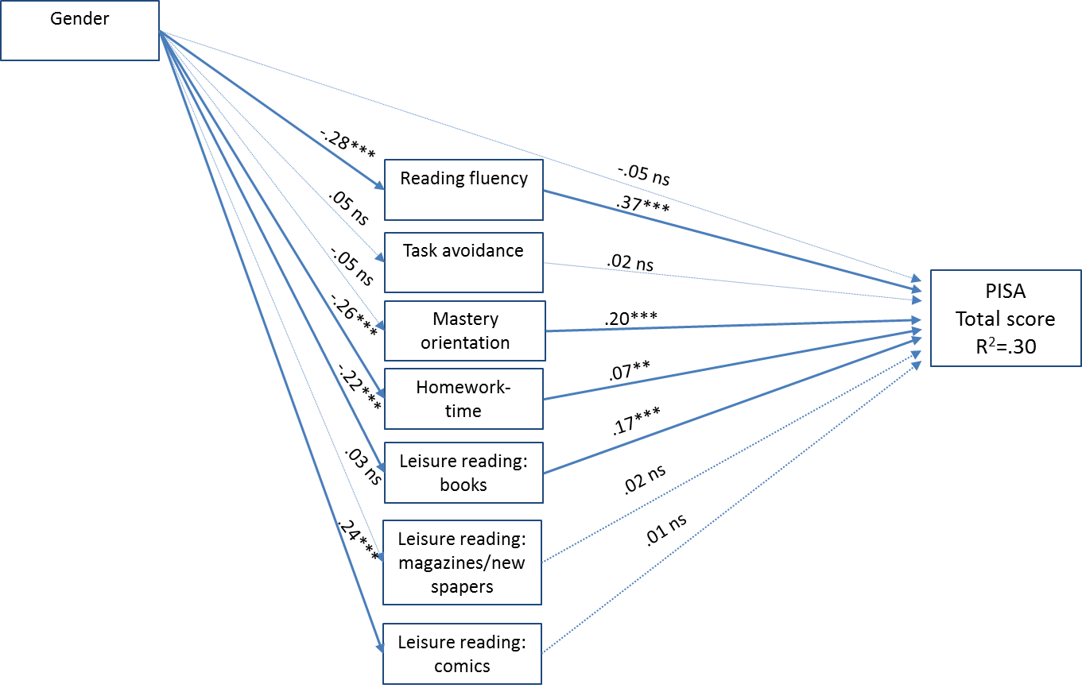

Figure 1. Mediation model for the PISA total score.
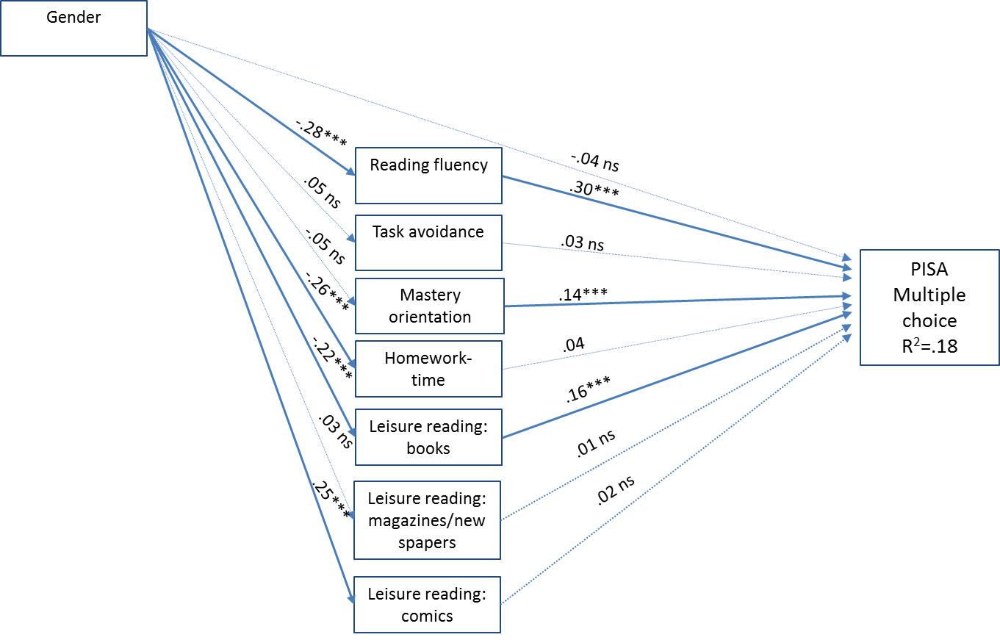

Figure 2. Mediation model for PISA multiple-choice questions.

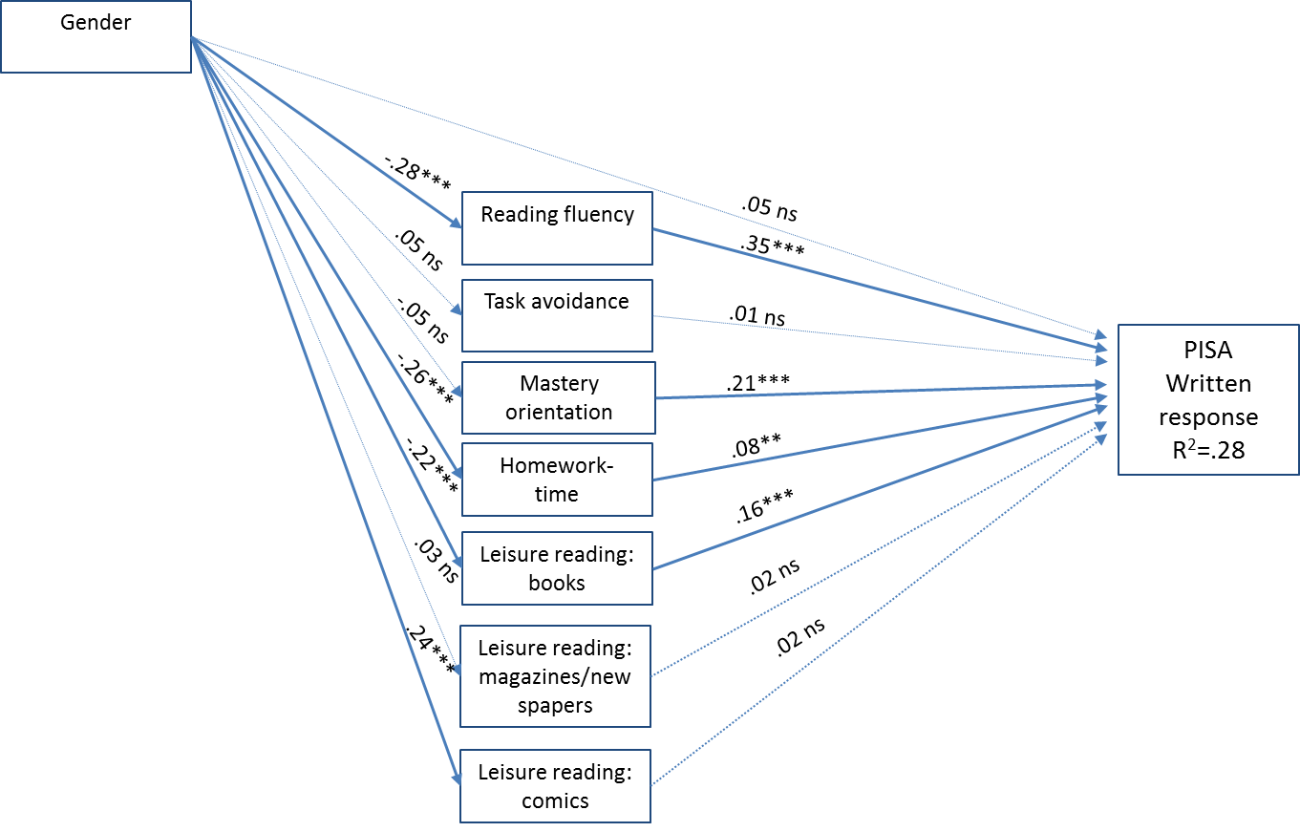

Figure 3. Mediation model for the PISA questions that required written responses.

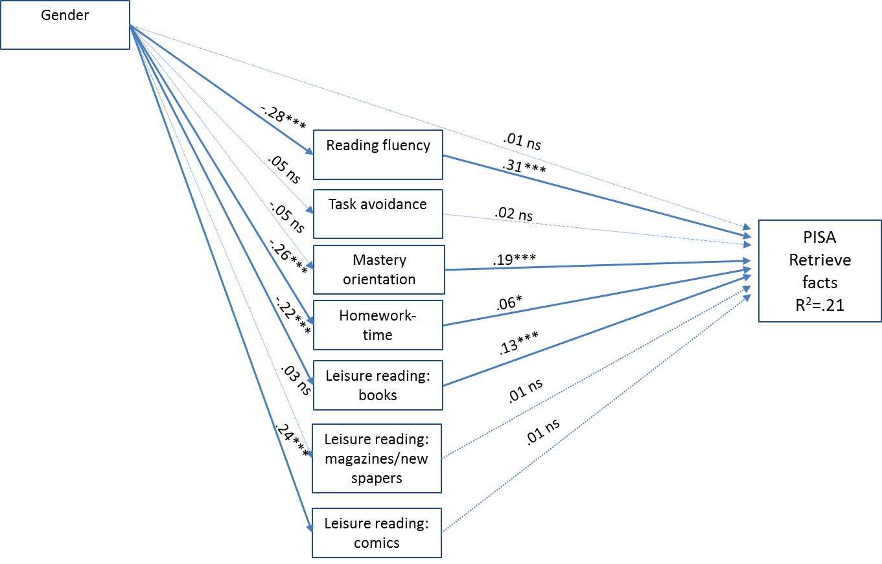

Figure 4. Mediation model for the PISA questions that required fact retrieval.

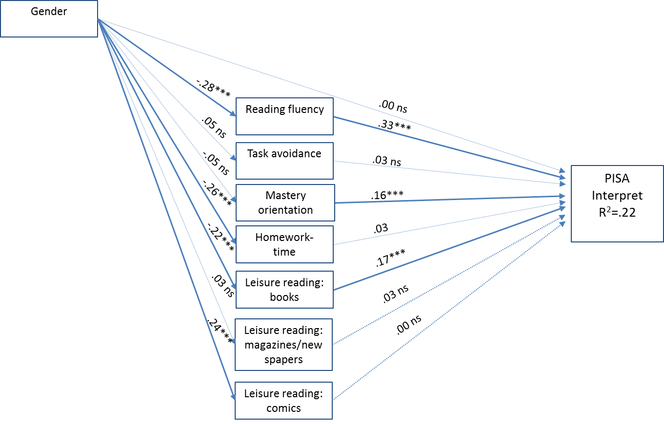

Figure 5. Mediation model for the PISA questions that required interpretation of the material.

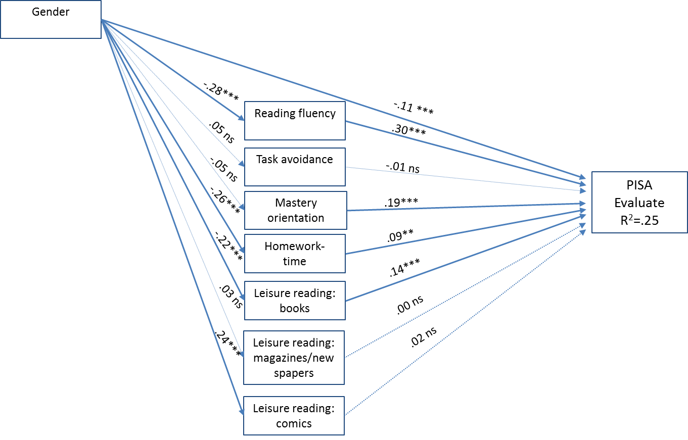
Figure 6. Mediation model for the PISA questions that required evaluation and reflection.

