Does Bi form clusters in GaAs_{1-x}Bi_{x} alloys?
M. P. J. Punkkinen,^{1*} P. Laukkanen,¹ M. Kuzmin,^{1,2} H. Levämäki,¹ J. Lång,¹ M. Tuominen,¹ M. Yasir,¹ J. Dahl,¹ S. Lu,³ E. K. Delczeg-Czirjak,⁴ L. Vitos,^{3,4,5} K. Kokko¹
¹ Department of Physics and Astronomy, University of Turku, FI-20014 Turku, Finland and
Turku University Centre for Materials and Surfaces (MatSurf), Turku, Finland
² Ioffe Physical-Technical Institute, Russian Academy of Sciences, St. Petersburg 194021, Russian Federation
³ Applied Materials Physics, Department of Materials Science and Engineering, Royal Institute of Technology, SE-10044 Stockholm, Sweden
⁴ Department of Physics and Astronomy, Division of Materials Theory, Uppsala University, Box 516, SE-75120, Uppsala, Sweden.
⁵ Wigner Research Centre for Physics, Institute for Solid State Physics and Optics, H-1525 Budapest, P.O. Box 49, Hungary.
Abstract. GaAs_{1-x}Bi_{x} alloys attract significant interest due to their potentiality for several applications, including solar cells. Recent experiments link the crucial optical properties of these alloys to Bi clustering at certain Bi compositions. Using ab initio calculations, we show that there is no thermodynamical driving force for the formation of small GaBi clusters incorporating As substitutional sites. However, the Ga vacancies should gather Bi atoms leading to small Bi clusters, and the Ga vacancies can act as nucleation centers for phase separation. The formation energy of the GaAs_{1-x}Bi_{x} with respect to GaAs and GaBi shows a maximum at intermediate Bi concentrations. Thermodynamics and kinetics of the GaAs_{1-x}Bi_{x} film growth is discussed. High Bi solubility is obtained, if the Bi atoms on the energetically favorable atom positions in the subsurface layer are relatively frozen. The Ga vacancy concentration may be increased by the incorporation of Bi. The Bi atoms can also prevent the out diffusion of Ga vacancies.
*Corresponding author; E-mail: marpunk@utu.fi
Keywords: gallium arsenide, bismide, cluster, vacancy, ab initio calculations, formation energy, bulk, surface

1. Introduction
Bi-alloyed GaAs has attracted a great deal of interest recently since the discovery of huge band gap reduction upon Bi incorporation [1-5]. The band gap reduction (88 meV/% Bi) [3] makes the GaAs_{1-x}Bi_{x} alloy very potential for commercial multijunction solar cells, in which different parts of solar spectrum are collected by almost lattice-matched materials. Bi alloying degrades electron mobility less than N alloying [6]. On the other hand, combined Bi and N alloying can reduce the lattice mismatch with the GaAs compared to pure Bi or N alloying. Giant increase in spin-orbit coupling accompanies the band gap reduction opening new possibilities in spintronics [7]. Valence band states, close to the energy gap, are reformed due to the interaction between the Bi induced impurity states, which are located within the top of the valence band, and host states at the top of the valence band. The energy gap and valence band structure evolution upon Bi alloying has been explained by band anticrossing (BAC) model [8,9] (BAC model has been applied also for many other systems, including, e.g., GaAs_{1-x}N_{x}) and band broadening [10].
Bi atom clustering (short-range order) should have remarkable effect on the crucial electronic and optical properties of GaAs_{1-x}Bi_{x} alloys, because Bi induced impurity states are located close to the valence band maximum [11-14]. However, the experimental evidence considering the Bi clustering is inadequate and partly conflicting. Bi clusters have been suggested [15] and overruled [16] on the basis of photoluminescence measurements. Ciatto et al. conclude on the basis of extended x-ray absorption fine structure (EXAFS) spectroscopy measurement interestingly that clusters begin to form upon Bi alloying when x exceeds 0.019 [11,12]. The Bi atoms are located randomly, if x ≤ 0.012 or x ≥ 0.054 [11,12]. Lu et al. found maximum photoluminescence intensity at Bi concentration of 4.5% [17]. Thus, the suggested non-linear dependence of clustering on Bi concentration follows the same trend as the photoluminescence results. Similar non-linear behavior with the Bi concentration has been related also to exciton reduced mass [18] and Bi-related acceptor states [19]. Different kind of ordering phenomenon was found by transmission electron microscopy studies [20]. The Bi atoms are preferentially located in every second {111}B plane (CuPt_{B} ordering) [20]. The mechanism of this type of ordering has been explained for SiGe(100)(2×1) surface, where the Ge atoms, which have a larger atomic volume than Si atoms have, occupy preferentially surface layer dimer positions and third layer positions between surface dimers [21]. These occupations are buried under additional layers during the crystal growth. Thermodynamically this ordering should not exist [21]. At the GaAs_{1-x}Bi_{x} (100)(2×1) surface the Bi atoms prefer same sites as Ge atoms at the SiGe (100)(2×1) surface. However, this mechanism alone hardly would lead, e.g., to complete pairing of Bi atoms at Bi concentration of 1.9% [11], because there is no preference for Bi atom positions within the {111}B planes. Sales et al. report Bi clustering. However, the clustering seems to be rather weak [22]. Very recently Bi clustering was reported to occur after annealing for samples grown at very low temperatures (around 200-250 ͦC) [23,24]. The annealing is a frequently used method to improve the quality of semiconductor materials. Therefore, it is also important to understand the processes during the annealing.
In the light of the above issues, it is of significant interest to examine theoretically, whether Bi atoms form clusters in the GaAs_{1-x}Bi_{x} alloys, and if so, which kind of? One should also understand, which kind of thermodynamic and kinetic factors and conditions contribute to the Bi clustering?

2. Computational approach
Calculations were performed using an ab initio density functional theory (DFT) total energy method within the local density approximation (LDA) [25,26]. The approach is based on the plane wave basis and projector augmented wave method [27,28] (Vienna ab initio simulation package, VASP) [29-32]. The optimization of the atomic structure was performed using the conjugate-gradient minimization of the total energy with respect to the atomic coordinates. Atoms were relaxed until the remaining forces were less than 20 meV/Å. Bulk calculations were performed using a cubic 512 atom supercell consisting of 64 simple cubic GaAs unit cells (a = 5.63 Å). Supercell volume was also relaxed in all bulk calculations. The plane wave cutoff energy of 350 eV was used. Ga 3d electrons were treated as core electrons. The k point sampling was carried out using the Monkhorst-Pack scheme [33] by a 2 × 2 × 2 mesh with the origin shifted to the Γ point.
Thermodynamics of clustering in bulk is calculated at different Bi concentrations by substituting 2, 4, 8, and 16 As atoms by Bi atoms in the 512 atom supercell. These numbers correspond to Bi concentrations equal to 0.78, 1.56, 3.13, and 6.25 %. Alloys without short-range order are modeled by supercells in which the substitutional Bi atoms are positioned as far from each other as possible (denoted by lone-Bi). For x = 0.0625, the total energies were calculated also using special quasi-random structure in 64 and 512 atom unit cells (SQS; disordered or random face-centred cubic sublattice). The SQS, the best periodic supercell approximation to the true disordered state, was searched for by an efficient stochastic generation algorithm [34]. Correlation functions of eight two-body, seven three-body, and 16 four-body component figures [35,36] were considered. Errors in the correlation functions with respect to the perfectly disordered state are smaller than 0.01 for the 512 atom cell. For this relatively small Bi concentration the errors are about an order of magnitude larger for the 64 atom cell. The total energy difference between the SQS and lone-Bi is 0.027 and -0.008 eV/Bi atom for 64 and 512 atom cells, respectively (the SQS giving the smaller total energy for the larger cell), which is a small energy. (Compare, e.g., with the formation energy of GaAs_{1-x}Bi_{x} given in the next Section.) Alloys with short-range order are modeled by introducing either only Bi pairs (Bi – Ga – Bi complex) or Bi tetramers (four Bi atoms connected through a centering Ga atom) positioned maximally distant from each other (denoted by cluster-Bi). A Bi tetramer buried in the GaAs matrix is shown in Figure 1. Clustering energy is defined to be the total energy difference between the cluster-Bi and lone-Bi calculations. The effect of spin-orbit coupling on clustering energy was tested using a smaller 64 atom cell and x = 0.0625. The change in the clustering energy of a Bi pair was less than 1 meV.
Surface calculations were performed using a slab cell with a square surface area equal to the face area of the cubic bulk cell. The GaAs_{1-x}Bi_{x} (100)(2×1) surface was modeled using a 12 layer slab (six III-V double layers). The surface layer of this reconstruction consists of Bi atoms, which form Bi-Bi dimer bonds [37-39]. Considered Bi concentrations below the surface Bi layer were 2.08 and 4.17 %. The dangling bonds of the bottom surface Ga atoms were passivated by fractionally charged pseudohydrogen atoms (Z = 1.25), and the two bottom layers of the slab were fixed to ideal bulk positions. Other atoms were relaxed until the remaining forces were less than 20 meV/Å. The k mesh was 2 × 2 × 1.
3. Results and discussion
3.1. Bi clusters on substitutional sites
Bi atoms substitute As atoms in the GaAs_{1-x}Bi_{x} alloy. Due to the large volume of Bi, the formation energies of Bi interstitial defects are of the order of several eVs, which makes their existence unlikely. The Bi-Bi dimer or split interstitial defect is unstable (even metastable state was not found for this defect). GaAs_{1-x}N_{x} alloys are quite different in this respect, because the N-N and N-As split interstitial defects have the lowest interstitial defect formation energies [40-42]. In contrast to the GaAs_{1-x}N_{x} alloys [42], the Bi interstitial defect surrounded by Ga atoms has also large formation energies which are 5.97 eV in the neutral state and 4.60 eV in strongly n-type doped material in the -3 charge state (the corresponding values are about 2.5 eV and 0 eV in the GaAs_{1-x}N_{x}, respectively [42]). Furthermore, the Ga interstitial defects were found in the GaAs_{1-x}N_{x} alloys [43,44]. However, the proposed formation mechanism for the Ga interstitial defects in the GaAs_{1-x}N_{x} alloys does not function in the GaAs_{1-x}Bi_{x} alloys [45].
Ciatto et al. reported the formation of Bi pairs and Bi tetramers on substitutional sites at around x = 0.02 by fitting the experimental EXAFS spectra using the theoretical EXAFS spectra, calculated using model structures including a Bi pair or a Bi tetramer [11]. First, the thermodynamics of small Bi clusters in bulk, formed by Bi atoms on As substitutional sites, (i.e., Bi pairs and Bi tetramers) is considered.
Clustering energies are shown in Table I. These values are very insignificant compared, e.g., to the formation energy of the GaAs_{1-x}Bi_{x}. Even thermal energy k_{B}T is larger than the clustering energies (except one value which is not negative) at GaAs_{1-x}Bi_{x} growth temperatures. Furthermore, entropy favors random alloys. Therefore, we conclude that there is no thermodynamic driving force for Bi clustering on substitutional sites in ideal bulk. This conclusion is enforced by very similar total energies obtained from the lone-Bi and SQS calculations within the considered Bi concentration range. We note that the N atoms avoid nearest neighboring substitutional sites in the GaAs_{1-x}N_{x} alloys [45].

3.2. Pure Bi clusters
The formation energy of the GaAs_{1-x}Bi_{x} can be expressed by
E_{form} = E(GaAs_{1-x}Bi_{x}) – E(GaAs) – xμ(Bi) + xμ(As) + q[E_{F} + E_{v} +∆V]
where μ(Bi) and μ(As) are the chemical potentials of the Bi and As, correspondingly. The chemical potential of the As depends on the growth (formation) conditions. The lower (-6.04 eV; Ga-rich/As-poor conditions) and upper (-5.39 eV; Ga-poor/As-rich conditions) bounds of the μ(As) can be calculated by the chemical potential of the metallic bulk As and the formation energy of the bulk GaAs. The upper bound is equal to the chemical potential of the bulk As. The difference between the upper and lower bounds is equal to the formation energy of the bulk GaAs. The chemical potential of the Bi is determined by the chemical potential of the metallic bulk Bi which corresponds to the Bi-rich growth conditions. The chemical potential of the metallic bulk Ga is also calculated to determine the formation energy of the bulk GaAs. The chemical potentials of the As, Bi, and Ga were calculated using six atom hexagonal (As and Bi) [46] and eight atom orthorhombic (Ga) unit cells [47, 48]. Thus, the chemical potentials of the elemental metallic phases were approximated by DFT energies. This may cause some errors, because the formation energy is influenced by DFT energies of metallic and semiconducting systems [49]. The last term in the equation above denotes the chemical potential of an electron, and it is needed to calculate the formation energies of charged defects [45]. This term depends on the position of the Fermi level, and thus, on doping. The Fermi energy (E_{F}) is given with respect to the top of the valence band (E_{v}) [45]. For charged systems, a neutralizing background is introduced to the supercell. Through the potential correction ∆V the valence band maxima of different systems are aligned. This is estimated by calculating the average electrostatic potential at the ion cores. The average electrostatic potential at an ion core far from the defect is compared to the corresponding atom in the bulk supercell [42,45]. Due to the well known problems of the LDA to reproduce experimental band gaps, the position of the Fermi level is allowed to vary in the energy range determined by the experimental band gap of 1.52 eV [50].
First, one should note that the formation energy of the GaAs_{1-x}Bi_{x} is large and positive [1,51]. We obtained 0.46 eV per Bi atom under Ga-rich and Bi-rich conditions for a dilute alloy without spin-orbit coupling using a 512 atom unit cell (x = 0.0039). The corresponding formation energy for the infinitely dilute alloy in the Ref. [51] is 0.57 eV per Bi atom calculated using spin-orbit coupling. The spin-orbit coupling was estimated to increase the formation energy by 0.09 eV per Bi atom or less [51]. Thus, there is a strong thermodynamic driving force for phase separation in the GaAs_{1-x}Bi_{x} alloys. This is the main reason for the serious difficulties to grow these alloys, and it leads to the Bi surface segregation (i.e., Bi acts as a surfactant). The phase separation can be inhibited for several kinetic reasons, one of which is low diffusion of different atomic species at low growing temperatures (at below 400 ͦC). Other potential reasons are the non-existence of energetically favored small clusters (nucleation centers) and large interface energies between the separated phases.
One should note that the formation energy of the GaAs_{1-x}Bi_{x} depends strongly on the growth conditions also through the available Bi reference/reservoir. If, for example, the formation of Bi metal is inhibited, and instead the GaBi acts as a source/sink for Bi for kinetic reasons, then the formation energy of the GaAs_{1-x}Bi_{x} is decreased in the dilute limit by about 25 % [51]. If the reference GaBi is strained to the underlying GaAs substrate, then the formation energy is decreased substantially to 0.14 eV per Bi atom [51].
The formation energy of a Ga vacancy in the neutral charge state is 2.58 eV under As-rich conditions and 3.23 eV under Ga-rich conditions (the difference being equal to the formation energy of GaAs). These values agree well with the recent values of El-Mellouhi and Mousseau [52] (2.94 eV under stoichiometric conditions). The experimental value for the formation of a neutral Ga vacancy is 3.2 eV [53]. The lowest formation energy is obtained for the Ga vacancy in the -3 charge state [54]. The formation energy of a Ga vacancy in the -3 charge state under Ga-rich conditions is 3.67 eV, when the Fermi energy is at the top of the valence band. Janotti et al. obtained 3.60 eV for the same quantity under Ga-rich conditions [55]. The value of El-Mellouhi and Mousseau is somewhat larger (3.9 eV in stoichiometric conditions). The formation energy of a Ga vacancy decreases significantly, when the Fermi level moves to the bottom of the conduction band which corresponds to strong n-type doping. Then, the formation energy is -1.54 eV under As-rich conditions and -0.89 eV under Ga-rich conditions. However, negatively charged Ga vacancy acts as an acceptor which leads to a shift of the Fermi level away from the bottom of the conduction band in n-type doped GaAs.
Experiments have shown that, indeed the Ga vacancy concentrations are increased by n-type doping and increased As vapor pressure [53]. High-temperature annealing (at above 600 ͦC) decreases Ga vacancy concentrations, because the Fermi level moves away from the bottom of the conduction band due to the increased amount of intrinsic carriers [53]. However, even larger Ga vacancy concentrations (1-2 × 10¹⁸ cm⁻³) were obtained in undoped GaAs by very low growth temperature (220 ͦC) [56]. This shows that kinetics contributes significantly to the Ga vacancy formation at low growth temperatures, which has been shown also for GaN [57].
Next we consider the formation energy of a defect complex consisting of a Ga vacancy surrounded by four nearest Bi atoms (Bi tetramer). The formation energy of this defect complex in a neutral state is 2.36 eV under Ga-rich conditions and 4.31 eV under As-rich conditions. The Ga-rich conditions lead to the lower value due to the As-substituting Bi atoms. The formation energy of the corresponding defect complex in the -3 charge state is -0.54 eV under Ga-rich conditions and 1.42 eV under As-rich conditions, when the Fermi level is at the bottom of the conduction band.
As noted above, the formation energies depend significantly on the growth conditions also through the reference states which may be kinetically constrained. On the other hand, kinetics can directly affect the formation of defects. Therefore, it is instructive to consider the energetics of Ga vacancies and Bi substitutional atoms within a bulk GaAs_{1-x}Bi_{x} alloy. In this case, the Ga vacancies and Bi atoms are not in the equilibrium with the Ga and Bi reference states on the sample surface. It is remarkable that Ga vacancies can act as nucleation centers and Bi atoms tend to gather around these vacancies. For example, at x = 0.016 (four Bi atoms in the 511 atom bulk cell including one Ga vacancy) the total energy of the system is decreased by 2.77 eV, when the Bi atoms cluster around the Ga vacancy. (The energy decrease is 1.50 eV for a Ga vacancy in the -3 charge state.) In this process the Bi atoms move far from the vacancy to the corners of the tetrahedron surrounding the vacancy. This may simulate post annealing process, in which the Ga vacancies formed in the crystal growth and atoms can move relatively easily. Experiments showed that the Ga vacancies assist As diffusion [58], and it was assumed that Bi diffusion is also assisted by the Ga vacancies [23,24]. Three, two, and one Bi atoms decrease the total energy by 2.25, 1.67, and 0.95 eV, respectively. Thus, our results show that there is no thermodynamic driving force for small GaBi cluster formation incorporating substitutional sites, and that the total energy of the system is decreased remarkably, if the Bi atoms cluster around Ga vacancies. It is suggested that the clustering is driven by the available Ga vacancies in the early stages of the clustering, which are partly consumed by the growing Bi cluster. Thus, the Ga vacancies may contribute to the clustering in two ways, by giving a thermodynamic driving force for the small cluster formation and facilitating the diffusion needed for the clustering.
Experiments showed very recently the formation of Bi-rich Ga(As,Bi) zincblende and pure Bi rhombohedral clusters of sizes within 5-20 nm in samples grown at low temperature (220 ͦC) with high temperature annealing (600-800 ͦC) [23,24]. The samples were free of clusters before the annealing [24]. Larger zincblende Ga(As,Bi) clusters began to transform into rhombohedral Bi clusters [24]. The phase separation into Bi-poor and Bi-rich Ga(As,Bi) clusters is thermodynamically driven, which is shown by the formation energy GaAs_{1-x}Bi_{x} with respect to GaAs and GaBi reference states in Fig. 2. The formation energy of the GaAs_{1-x}Bi_{x} was calculated for the entire Bi concentration range (0 ≤ x ≤ 1) using the SQS generated for a 64 atom cell (32 atom face-centred sublattice cell) in the Ref. [59]. However, our results for small substitutional Bi clusters show that there exists a limiting cluster size below which the clustering on substitutional sites is not thermodynamically driven without Ga vacancies. One should note that the clustering induced strain should affect the energies of the reference states GaAs and GaBi especially, if the clusters are formed within the bulk. No Bi out diffusion was found in the Ref. [23], whereas the number of surface clusters was far less than the number of clusters within the samples in the Ref. [24]. The fact that the Bi diffuses out of the samples relatively weakly may indicate that the out diffusion is kinetically limited. This may be due to the relatively low total energy provided by the bulk phase separation.
The smallest Bi cluster with well-defined interfaces between the cluster and the GaAs matrix is shown in Fig. 3 (the Ga atom site is occupied by a vacancy). The stability of this cluster is compared to the tetrahedral four-atom cluster presented above. The reference system includes a Bi tetramer with a Ga vacancy and four lone Bi atoms far from the tetramer and from each other. The total energy of the eight atom cluster is 0.19 eV lower. Thus additional Bi atoms per Ga vacancy (in addition to those of the Bi tetramer) may decrease the total energy, although the decrease is smaller than for the first four neighboring Bi atoms. The cluster and the host have {111} and {100} interface planes. It was reported that depending on the annealing conditions some Bi-rich zincblende clusters transform into the pure rhombohedral Bi clusters [24]. The pure rhombohedral Bi part of the transient cluster tends to have interfaces parallel to the zincblende {111} planes [24]. Thus the experimentally found pure Bi clusters tend to have interfaces parallel to the faces of the cluster shown in Fig. 3. This is understood, because such a cluster does not break the bonds through the interface, which probably keeps the interface energy relatively low assuming that the strain between the parts separated by the interface is not too high.
Next we substitute four As atoms by Bi atoms and place these Bi atoms either far from the eight atom cluster or onto the eight atom cluster (thus increasing the cluster size). The increased cluster has a lower total energy by 0.07 eV. This shows that the Ga vacancy assisted clustering may lead to structures which are not pure Bi clusters. This might be energetically favorable especially for the interfaces of the larger clusters due to the relatively large volume difference between the rhombohedral bulk Bi and face-centred cubic Bi (structure of the eight atom cluster). It is noted that the total energy of the bulk Bi (unlike the total energy of the bulk As) is quite insensitive to rhombohedral distortions, which may facilitate the formation of the Bi clusters.
It is noted that the strong tendency for Bi clustering around Ga vacancies in GaAs_{1-x}Bi_{x} alloys is at least partly due to the relatively suitable volumes of bulk GaAs and Bi. At x = 0.016 (four Bi atoms in the 511 atom bulk cell including one Ga vacancy) the total energy of the InSb_{1-x}Bi_{x} is decreased only by 0.96 eV, when the Bi atoms cluster around a neutral Ga vacancy. The lattice parameter of the InSb is 6.46 Å, whereas the lattice parameter of the GaAs is 5.63 Å. The corresponding clustering energy is increased to 4.42 eV in the GaP_{1-x}Bi_{x}. The lattice parameter of the GaP is 5.43 Å. The Bi-Bi distance in the considered clusters is 3.41 Å, 3.65 Å, 3.34 Å within the GaAs, InSb, and GaP, respectively.
Charge density difference isosurface in Fig. 4 reveals increased bond-like charge density features between Bi atoms. This might be related to the energetically favored Bi clustering process around the Ga vacancies.

3.3. Bi clusters at surface
The GaAs_{1-x}Bi_{x} alloys are formed by growing them “through” a surface [60]. Therefore, it is relevant to consider clustering also at the surface. The Bi/GaAs(100)(2×1) is a relatively simple, and one of the Bi-induced reconstructions found [37-39]. Figure 5 shows the atomic structure of the Bi/GaAs(100)(2×1) reconstruction in which the surface layer is occupied by the Bi atoms. Here we consider the Bi incorporation into the GaAs substrate for a dilute alloy in the early stages of the alloy growth (where the substrate below the Bi surface layer is pure GaAs) to compare with our bulk results. The formation energy of the GaAs_{1-x}Bi_{x} under Ga-rich and Bi-rich conditions obtained from the surface calculations does not generally show significant layer- or position-dependence. The formation energy varies between 0.40 – 0.52 eV per Bi atom except for the Bi atom position in the third layer between the surface Bi-Bi dimers (atom position 2 in Fig. 5). The formation energy is only 0.05 eV per Bi atom on this exceptional atom position in the third layer. The low formation energy on this atom position is due to the strain relief. The same phenomenon was found for the GaAs_{1-x}N_{x} alloys [61,62]. However, due to the atom size difference the N atoms favor the atom position below surface dimers (position 1 in Fig. 5).
The above results suggest that Bi solubility is quite high, if the Bi incorporation takes place through the atom position 2, and during the growth Bi diffusion from the deeper layers to the surface is inhibited due to kinetics. In experiments exceptionally low growing temperatures, compared to temperatures used to grow GaAs, are needed to incorporate Bi. Lewis et al. were able to produce GaAs_{1-x}Bi_{x} alloy films up to exceptionally high x = 0.22 at 200 ͦC (under Ga-rich and Bi-rich conditions) [63]. Using the formation energies presented above to calculate [64] the Bi concentration x in the third layer at 200 ͦC, we get x = 0.22. However, if there is an As atom in the (first) surface layer occupied mostly by the Bi dimer atoms (corresponding to As occupation of 1/32 in the surface layer in our calculations) and a Bi atom in the third layer, the system can decrease its total energy by about 1.5 eV by interchanging the As atom in the first layer and the Bi atom in the third layer. This shows, how strongly Bi segregation is thermodynamically favored.
We considered Bi clustering first on substitutional sites at the (100)(2×1) surface by comparing atom configurations, in which the number of Bi atoms in different surface layers is the same. As in bulk, no tendency for GaBi clustering on substitutional sites was found. The Bi atoms favor {111}B planes, but no tendency for clustering within these planes was found.
In the following we discuss the surface effects on the vacancy formation and Bi clustering around Ga vacancies. The Ga vacancy formation energy under Ga-rich conditions is 1.35 eV at the surface, and varies between 3.17-3.57 eV in the deeper layers. The deepest Ga vacancy defect is within the sixth atomic layer. The relative stabilization of the Ga vacancy at the surface is due to a strong geometrical relaxation. The formation energies in the deeper layers are comparable to the corresponding bulk value (3.23 eV). The formation energy of the Bi surrounded Ga vacancy is decreased more at the surface. The value of it is 0.88 eV under Ga-rich conditions at the surface, and varies between 1.74-2.13 eV in the deeper layers. The corresponding bulk value is 2.36 eV. One should note that the formation energy of the Ga vacancy or Bi surrounded vacancy at the surface is probably lower in the -3 charge state as in the bulk. Due to technical reasons we can not calculate a charged defect at the surface. Therefore, our results suggest that the Bi-covered surface and Bi incorporation may increase the Ga vacancy concentration. The calculated alloy and defect formation energies in bulk and at surface are presented in Table II.
We also note that, if a Bi tetramer is already formed at the surface, the formation of a Ga vacancy within the tetramer increases the system energy only by 0.42 eV under Ga-rich conditions. This could happen, e.g., when the film grows at a stepped surface. At stepped surface the surface can keep the low-energy (2×1) reconstruction (compared to Ga-rich surfaces) during the growth. When the edge of the step moves laterally during the film growth, a Bi atom might be locked to the energetically unfavorable atom position in the third layer. The surface can relief some strain by introducing a complete Bi tetramer including a vacancy as the step edge moves further.
If the diffusivity of the vacancies is relatively large, part of the vacancies could diffuse to the surface region, when the vacancy including Bi tetramers go deeper into the bulk during the growth (where the Ga vacancy becomes less stable).

4. Conclusions
We have shown that Bi does not tend to form small GaBi clusters on substitutional sites in GaAs_{1-x}Bi_{x} alloys. However, if there are Ga vacancies in the alloy, the Bi atoms tend strongly to surround the Ga vacancies. We propose that the Bi clustering process proceeds by Ga vacancies, which are partly consumed in the process. The Ga vacancies can act as nucleation centers for phase separation, which is thermodynamically driven without vacancies at a larger scale. The formation energy of the GaAs_{1-x}Bi_{x} with respect to GaAs and GaBi has a maximum at intermediate Bi concentrations. The interface between a large Bi cluster and the alloy could be based on the small cluster form presented. High Bi solubility is obtained, if the Bi atoms on the energetically favorable sites in the subsurface layer are relatively frozen. Formation energies of Ga vacancies and Bi surrounded Ga vacancies were calculated for bulk and the Bi-induced (2×1) surface. The Bi incorporation may increase the Ga vacancy concentration and lock the Ga vacancies into the sample bulk.

Acknowledgments
The calculations were performed using the facilities of the Finnish IT Center for Science (CSC) and the FGI project (Finland).

References
[1] A. Janotti, S.-H. Wei, and S. B. Zhang, Phys. Rev. B 65, 115203 (2002).
[2] S. Tixier, M. Adamcyk, T. Tiedje, S. Francoeur, A. Mascarenhas, P. Wei, and F. Schiettekatte, Appl. Phys. Lett. 82, 2245 (2003).
[3] S. Francoeur, M.-J. Seong, A. Mascarenhas, S. Tixier, M. Adamcyk, and T. Tiedje, Appl. Phys. Lett. 82, 3874 (2003).
[4] J. Yoshida, T. Kita, O. Wada, and K. Oe, Jpn. J. Appl. Phys., Part 1, 42, 371 (2003).
[5] Y. Zhang, A. Mascarenhas, and L.-W. Wang, Phys. Rev. B 71, 155201 (2005).
[6] D. G. Cooke, F. A. Hegmann, E. C. Young, and T. Tiedje, Appl. Phys. Lett. 89, 122103 (2006).
[7] B. Fluegel, S. Francoeur, A. Mascarenhas, S. Tixier, E. C. Young, and T. Tiedje, Phys. Rev. Lett. 97, 067205 (2006).
[8] K. Alberi, J. Wu, W. Walukiewicz, K. M. Yu, O. D. Dubon, S. P. Watkins, C. X. Wang, X. Liu, Y.-J. Cho, and J. Furdyna, Phys. Rev. B 75, 045203 (2007).
[9] M. Usman, C. A. Broderick, A. Lindsay, and E. P. O’Reilly, Phys. Rev. B 84, 245202 (2011).
[10] H.-X. Deng, J. Li, S.-S. Li, H. Peng, J.-B. Xia, L.-W. Wang, and S.-H. Wei, Phys. Rev. B 82, 193204 (2010).
[11] G. Ciatto, E. C. Young, F. Glas, J. Chen, R. Alonso Mori, and T. Tiedje, Phys. Rev. B 78, 035325 (2008).
[12] G. Ciatto, M. Thomasset, F. Glas, X. Lu, and T. Tiedje, Phys. Rev. B 82, 201304 (2010).
[13] L. Bellaiche and A. Zunger, Phys. Rev. B 57, 4425 (1998).
[14] A. Lindsay, E. P. O’Reilly, A. D. Andreev, and T. Ashley, Phys. Rev. B 77, 165205 (2008).
[15] S. Francouer, S. Tixier, E. Young, T. Tiedje, and A. Mascarenhas, Phys. Rev. B 77, 085209 (2008).
[16] A. Mascarenhas, R. Kini, Y. Zhang, R. France, and A. Ptak, Phys. Stat. Sol. (b) 246, 507 (2009).
[17] X. Lu, D. A. Beaton, R. B. Lewis, T. Tiedje, and Y. Zhang, Appl. Phys. Lett. 95, 041903 (2009).
[18] G. Pettinari, A. Polimeni, J. H. Blokland, R. Trotta, P. C. M. Christianen, M. Capizzi, J. C. Maan, X. Lu, E. C. Young, and T. Tiedje, Phys. Rev. B 81, 235211 (2010).
[19] G. Pettinari, H. Engelkamp, P. C. M. Christianen, J. C. Maan, A. Polimeni, M. Capizzi, X. Lu, and T. Tiedje, Phys. Rev. B 83, 201201 (2011).
[20] A. G. Norman, R. France, and A. J. Ptak, J. Vac. Sci. Tech. B 29, 03C121 (2011).
[21] F. K. LeGoues, V. P. Kesan, S. S. Iyer, J. Tersoff, and R. Tromp, Phys. Rev. Lett. 64, 2038 (1990).
[22] D. L. Sales, E. Guerrero, J. F. Rodrigo, P. L. Galindo, A. Yanes, M. Shafi, A. Khatab, R. H. Mari, M. Henini, S. Novikov, M. F. Chisholm, and S. I. Molina, Appl. Phys. Lett. 98, 101902 (2011).
[23] J. Puustinen, M. Wu, E. Luna, A. Schramm, P. Laukkanen, M. Laitinen, T. Sajavaara, and M. Guina, J. Appl. Phys. 114, 243504 (2013).
[24] M. Wu, E. Luna, J. Puustinen, M. Guina, and A. Trampert, Nanotechnology 25, 205605 (2014).
[25] D. M. Ceperley and B. J. Alder, Phys. Rev. Lett. 45, 566 (1980).
[26] J. P. Perdew and A. Zunger, Phys. Rev. B 23, 5048 (1981).
[27] P. E. Blöchl, Phys. Rev. B 50, 17953 (1994.)
[28] G. Kresse and D. Joubert, Phys. Rev. B 59, 1758 (1999).
[29] G. Kresse and J. Hafner, Phys. Rev. B 47, 558 (1993).
[30] G. Kresse and J. Hafner, Phys. Rev. B 49, 14251 (1994).
[31] G. Kresse and J. Furthmüller, Comput. Mat. Sci. 6, 15 (1996).
[32] G. Kresse and J. Furthmüller, Phys. Rev. B 54, 11169 (1996).
[33] H. J. Monkhorst and J. D. Pack, Phys. Rev. B 13, 5188 (1976).
[34] A. van de Walle, P. Tiwary, M. De Jong, D. L. Olmsted, M. Asta, A. Dick, D. Shin, Y. Wang, L.-Q. Chen, and Z.-K. Liu, Calphad Journal 42, 13 (2013).
[35] A. Zunger, S.-H. Wei, L. G. Ferreira, and J. E. Bernard, Phys. Rev. Lett. 65, 353 (1990).
[36] S.-H. Wei, L. G. Ferreira, J. E. Bernard, and A. Zunger, Phys. Rev. B 42, 9622 (1990).
[37] P. Laukkanen, M. P. J. Punkkinen, H.-P. Komsa, M. Ahola-Tuomi, K. Kokko, M. Kuzmin, J. Adell, J. Sadowski, R. E. Perälä, M. Ropo, T. T. Rantala, I. J. Väyrynen, M. Pessa, L. Vitos, J. Kollár, S. Mirbt, and B. Johansson, Phys. Rev. Lett. 100, 086101 (2008).
[38] M. P. J. Punkkinen, P. Laukkanen, H.-P. Komsa, M. Ahola-Tuomi, N. Räsänen, K. Kokko, M. Kuzmin, J. Adell, J. Sadowski, R. E. Perälä, M. Ropo, T. T. Rantala, I. J. Väyrynen, M. Pessa, L. Vitos, J. Kollár, S. Mirbt, and B. Johansson, Phys. Rev. B 78, 195304 (2008).
[39] A. Duzik, J. C. Thomas, A. van der Ven, and J. M. Millunchick, Phys. Rev. B 87, 035313 (2013).
[40] S. B. Zhang and S.-H. Wei, Phys. Rev. Lett. 86, 1789 (2001).
[41] P. Carrier, S.-H. Wei, S. B. Zhang, and S. Kurtz, Phys. Rev. B 71, 165212 (2005).
[42] K. Laaksonen, H.-P. Komsa, T. T. Rantala, and R. M. Nieminen, J. Phys.: Condens. Matter 20, 235231 (2008).
[43] X. J. Wang, I. A. Buyanova, F. Zhao, D. Lagarde, A. Balocchi, X. Marie, C. W. Tu, J. C. Harmand, and W. M. Chen, Nat. Mater. 8, 198 (2009).
[44] X. J. Wang, Y. Puttisong, C. W. Tu, A. J. Ptak, V. K. Kalevich, Yu. Egorov, L. Geelhar, H. Riechert, W. M. Chen, and I. A. Buyanova, Appl. Phys. Lett. 95, 241904 (2009).
[45] P. Laukkanen, M. P. J. Punkkinen, J. Puustinen, H. Levämäki, M. Tuominen, K. Schulte, J. Dahl, J. Lång, H. L. Zhang, M. Kuzmin, K. Palotas, B. Johansson, L. Vitos, M. Guina, and K. Kokko, Phys. Rev. B 86, 195205 (2012).
[46] D. Schiferl and C. S. Barrett, J. Appl. Cryst. 2, 30 (1968).
[47] V. Heine, J. Phys. C 1, 222 (1968).
[48] M. Bernasconi, G. L. Chiarotti, and E. Tosatti, Phys. Rev. B 52, 9988 (1995).
[49] S. Lany, Phys. Rev. B 78, 245207 (2008).
[50] I. Vurgaftman, J. R. Meyer, and L. R. Ram-Mohan, J. Appl. Phys. 89, 5815 (2001).
[51] H. Jacobsen, B. Puchala, T. F. Kuech, and D. Morgan, Phys. Rev. B 86, 085207 (2012).
[52] F. El-Mellouhi and N. Mousseau, Phys. Rev. B 71, 125207 (2005).
[53] J. Gebauer, M. Lausmann, F. Redmann, R. Krause-Rehberg, H. S. Leipner, E. R. Weber, and Ph. Ebert, Phys. Rev. B 67, 235207 (2003).
[54] S. B. Zhang and J. E. Northrup, Phys. Rev. Lett. 67, 2339 (1991).
[55] A. Janotti, S.-H. Wei, S. B. Zhang, S. Kurtz, and C. G. Van de Walle, Phys. Rev. B 67, 161201 (2003).
[56] J. Gebauer, R. Krause-Rehberg, S. Eichler, M. Luysberg, H. Sohn, and E. R. Weber, Appl. Phys. Lett. 71, 638 (1997).
[57] F. Tuomisto, J.-M. Mäki, C. Rauch, and I. Makkonen, J. Cryst. Growth 350, 93 (2012).
[58] Z. Liliental-Weber, X. W. Lin, J. Washburn, and W. Schaff, Appl. Phys. Lett. 66, 2086 (1995).
[59] J. Von Pezold, A. Dick, M. Friák, and J. Neugebauer, Phys. Rev. B 81, 094203 (2010).
[60] See, e.g., Bismuth-containing compounds. Ed. H. Li & Z. M. Wang, Springer Series in Materials Science, Vol. 186 (Springer, New York, 2013).
[61] S. B. Zhang and A. Zunger, Appl. Phys. Lett. 71, 677 (1997).
[62] H. Abu-Farsakh and J. Neugebauer, Phys. Rev. B 79, 155311 (2009).
[63] R. B. Lewis, M. Masnadi-Shirazi, and T. Tiedje, Appl. Phys. Lett. 101, 082112 (2012).
[64] P. Laukkanen, M. P. J. Punkkinen, N. Räsänen, M. Ahola-Tuomi, J. Sadowski, J. Adell, M. Kuzmin, J. Lång, R. Perälä, M. Ropo, K. Kokko, L. Vitos, B. Johansson, M. Pessa, and I. J. Väyrynen, Phys. Rev. B 81, 035310 (2010).

Figure and Table captions
Figure 1. A Bi tetramer within the GaAs matrix. Bi, As, and Ga atoms are shown by green, red, and blue spheres, respectively.
Figure 2. Formation energy (eV/anion) of the GaAs_{1-x}Bi_{x} with respect to the GaAs and GaBi reference states calculated by 64 atom special quasirandom structures (32 atom sublattice unit cells) generated in the Ref. [59].
Figure 3. An eight atom Bi cluster. The Ga atom position shown is occupied by a vacancy. Four faces of the parallelepiped formed by the Bi atoms are along the {111} planes. Bi and Ga atoms are shown by green and blue spheres, respectively.
Figure 4. Charge density difference isosurface. The charge density difference is between the Bi and As surrounded Ga vacancies. The isovalue is 0.02 e/Å³. The Bi atoms are shown by green spheres.
Figure 5. Structure of the Bi/GaAs(100)(2×1) surface reconstruction with a monolayer coverage of Bi. Top figure shows the side view and bottom figure shows the top view of the surface structure. Atom site 2 between the surface dimers is energetically much more favorable for Bi incorporation than the atom site 1 in the third surface layer. Bi, As, and Ga atoms are shown by green, red, and blue spheres, respectively.

Table I. Relative Bi pair and tetramer clustering energies (eV/Bi atom) at different Bi concentrations (x = 0.0078, 0.016, 0.031, and 0.063). Positive energy means that the clustering increases total energy.

Bi concentration Clustering energy (eV/Bi atom)
x | Lone Bi atoms | Bi pairs | Bi tetramers
0.0078 | 0 | 0.006 | -
0.016 | 0 | -0.030 | -0.005
0.031 | 0 | 0.023 | 0.004
0.063 | 0 | 0.006 | 0.087

Table II. Formation energy of the GaAs_{1-x}Bi_{x} alloy for a dilute alloy under Ga-rich conditions (eV / Bi atom). The bulk result is compared with the result of the theoretical Ref. 51. Ga vacancy and Bi surrounded Ga vacancy (Ga vacancy + Bi tetramer) formation energies in a neutral state (eV). The bulk Ga vacancy formation energy is compared with the theoretical (Ref. 52) and experimental (Ref. 53) results. The 3rd, 4th, and 7th surface layers show two non-equivalent atoms positions shown by Fig. 5.
 | GaAs_{1-x}Bi_{x} | Ga vacancy | Ga vacancy  + Bi tetramer
Bulk
Ga-rich | 0.46 0.48ª | 3.23 3.4^{b} | 2.36
As-rich |  | 2.58 2.5^{b}
Expt. |  | 3.2^{c}
Surface
Ga-rich
2nd layer |  | 1.35 | 0.88
3rd layer (1) | 0.45
3rd layer (2) | 0.05
4th layer (1) |  | 3.17 | 1.74
4th layer (2) |  | 3.57 | 1.68
5th layer | 0.41
6th layer |  | 3.52 | 2.13
7th layer (1) | 0.52
7th layer (2) | 0.40

ªRef. 51
^{b}Ref. 52
^{c}Ref. 53

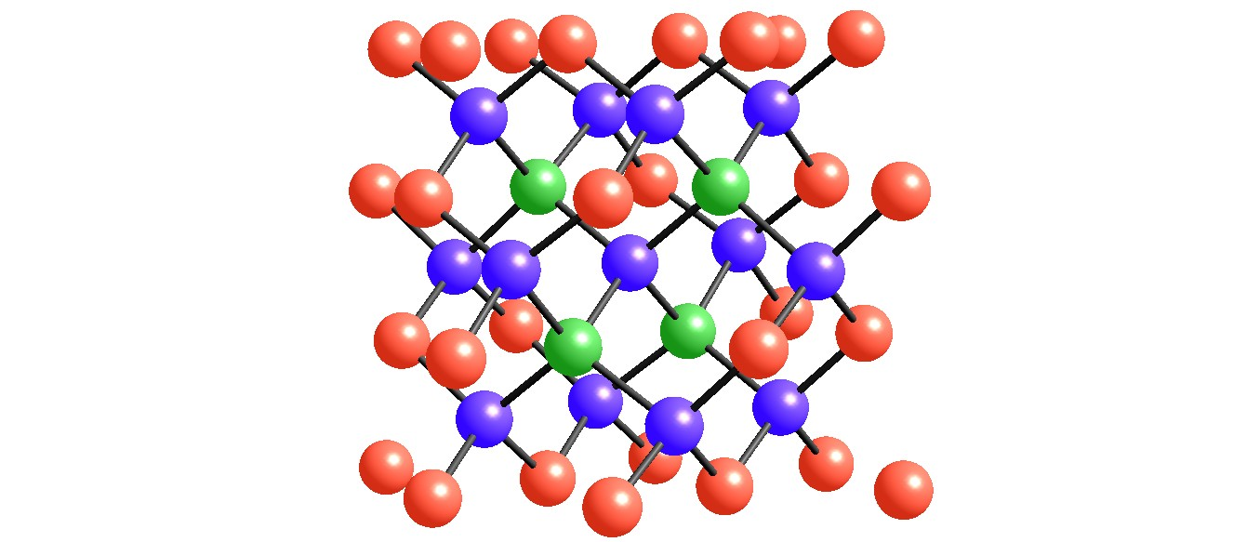

Figure 1

Figure 2

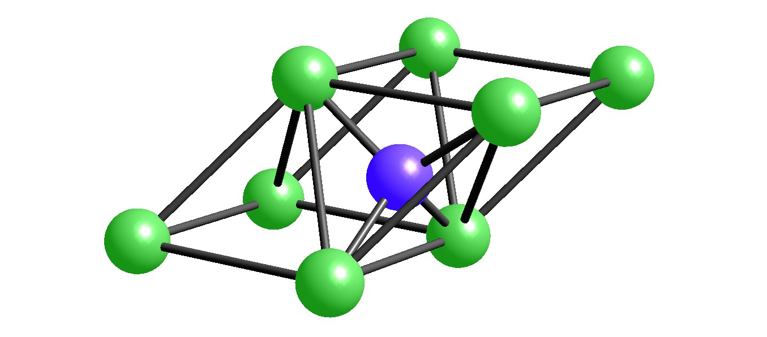

Figure 3

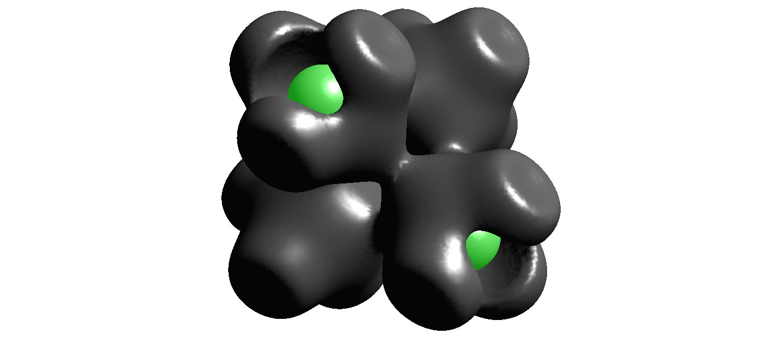

Figure 4

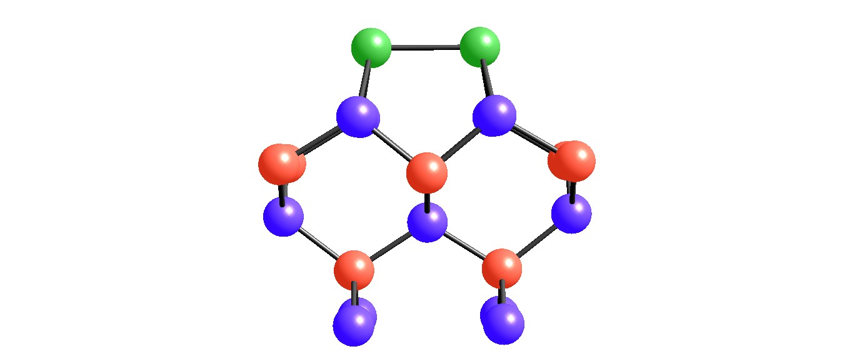
2
1

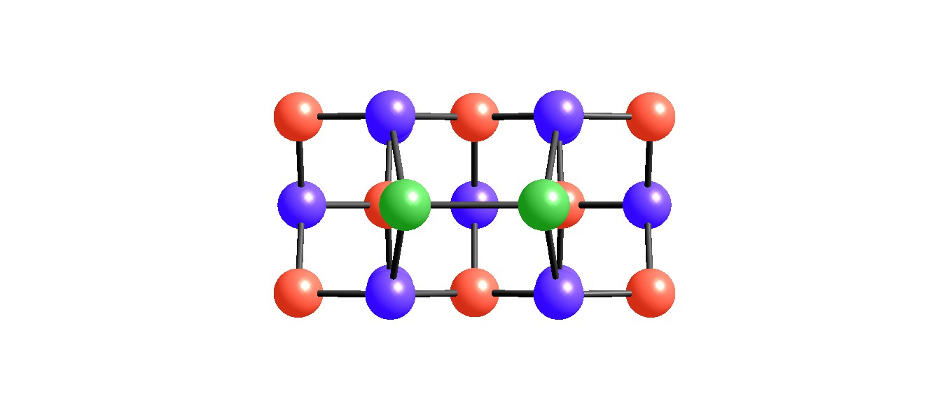
1
2

Figure 5

