Comparison of the biodegradable polymer everolimus-eluting stent with contemporary drug-eluting stents: a systematic review and meta-analysis

Fabien Picard, MD, MSc ^{1,2}; Michele Pighi, MD³; Quentin de Hemptinne, MD⁴; Flavio Ribichini, MD³, Juhani Airaksinen, MD⁵; Giulia Vinco, MD³, Aurélien de Pommereau, MD¹; Fausto Biancari*, MD, PhD^{5,6,7}; Olivier Varenne*, MD, PhD^{1,2}.

*: These authors contributed equally as senior author

Affiliations:
1: Department of Cardiology, Hôpital Cochin, AP-HP, Paris, France
2: Université Paris Descartes, Faculté de Médecine, Paris, France
3: Department of Medicine, University of Verona, Verona, Italy
4: Department of Cardiology, CHU Saint-Pierre, Université Libre de Bruxelles, Brussels, Belgium
5: Heart Center, Turku University Hospital, Turku, Finland
6: Department of Surgery, University of Turku, Turku, Finland
7: Department of Surgery, University of Oulu, Oulu, Finland

Address for correspondence: Fabien Picard, Hopital Cochin, Département de Cardiologie, 27 rue du Faubourg Saint-Jacques, 75014, Paris; Fax: +33 158411666; Phone: +33 158412750; E-mail: Fabien.picard@aphp.fr

Running title: Biodegradable polymer everolimus-eluting stent: a meta-analysis

Funding: This research did not receive any specific grant from funding agencies in the public, commercial, or not-for-profit sectors.

Relationship with industry: FP reports consulting fees from Biotronik. OV reports personal fees from Boston Scientific and Abbott Vascular. The other authors declare that they have no known conflicts of interest.

Abstract
Background: Prior meta-analyses have established superiority of biodegradable polymer-drug eluting stents (BP-DES) over bare-metal stents and first-generation durable polymer (DP)-DES. Despite similar efficacy and safety profile in pilot studies, BP-DES appear to have potential benefit over latest generation DP-DES by facilitating vessel healing, therefore reducing inflammation and neoatherosclerosis leading to enhanced clinical safety. Therefore, we sought to perform a meta-analysis of randomized clinical trials (RCTs) comparing the safety and efficacy of everolimus-eluting BP-DES (BP-EES) to second-generation DP-DES.
Methods: We conducted a systematic review and meta-analysis to examine the safety and efficacy of BP-EES in patients treated for coronary artery disease. We searched PubMed, Scopus, and the Cochrane Library through February 2018 for RCTs that included outcome data on BP-EES. Outcomes of interest included cardiac death, myocardial infarction (MI), stent thrombosis (ST), target lesion revascularization (TLR), restenosis, and composite endpoints. Pooled estimates of longest available clinical outcomes at a minimum of one-year follow-up are presented as odds ratios (OR) with [95% confidence intervals from random-effect models.
Results: We identified four eligible studies, which included a total of 4,631 patients. Three studies reported a follow-up of one year and another study of five years. The BP-EES group, included 2,315 patients and the DP-DES group included 2,316 patients (1,143 treated with DP-EES and 1,173 treated with zotarolimus eluting DP-DES). Patient’s characteristics were comparable between the two groups except for higher prevalence of prior MI in the DP-DES group (22.5 vs. 25.7%, respectively; p=0.001). Procedural characteristics were comparable among groups except for a longer lesions in the BP-EES group compared to the DP-DES group (mean, 15.1 vs. 14.9 mm, p=0.04). No significant differences were observed for cardiac mortality (p=0.72), occurrence of MI (p=0.64), any TLR (p=0.93), ST (p=0.85) or major adverse cardiac event (p=0.43).
Conclusion: Overall, BP-EES had similar clinical outcomes to contemporary DP-DES at mid-term. Whether these devices could enhance clinical safety remains to be evaluated at longer follow-up.
Keywords: Everolimus; biodegradable polymer; SYNERGY; durable polymer; coronary artery disease

Abbreviations

BP: biodegradable polymer

DES: drug-eluting stent

DP: durable polymer

EES: everolimus-eluting stent

MI: myocardial infarction

PCI: percutaneous coronary intervention

PRISMA: Preferred Reporting Items for Systematic Reviews and Meta-Analyses

PtCr: platinum chromium

ST: stent thrombosis

ZES: zotarolimus-eluting stent

Introduction
The implantation of a drug-eluting stent (DES) is now considered the standard approach for percutaneous coronary intervention (PCI).¹ While the addition of a drug-eluting polymer to the coronary stent marked a major advance in reducing restenosis, the lifelong presence of a durable polymer (DP) in a coronary artery induces vessel wall inflammation, delayed arterial healing, and occasionally cause serious complications such as stent thrombosis (ST) and myocardial infarction (MI).² These drawbacks motivated the development of stents with biodegradable coatings that leave only a bare metal stent after polymer resorption and raises the obvious question of whether development of biodegradable-polymer drug-eluting stents (BP-DES) will improve outcomes.² Metal alloy coronary stent platforms with biodegradable polymers are associated with improved clinical outcomes when compared with newer DP-DES and the possible influence of additional factors, including polymer composition and stent strut thickness,³ have been topics of debate.⁴ It is important to note that there is significant variability in the strut thickness of available BP-DES, which may partly account for the failure of BP-DES to demonstrate superiority over DP-DES. Today, novel biodegradable polymer stents are available with uncoated struts and up to half as thick as the struts of the first generation BP-DES.² The SynergyTM stent (Boston Scientific Corporation) is a thin-strut (74-79µm) platinum chromium (PtCr) metal alloy stent that elutes everolimus from a bioabsorbable Poly (D,L-lactide-co-glycolide) polymer only applied to the abluminal surface (BP-EES). ⁵
The results of the recently published EVOLVE II trial⁶ are encouraging and suggest that PCI with BP-EES or with DP-DES (PromusTM, Boston Scientific Corporation) is similar. We sought to investigate the efficacy of this BP-EES in the present meta-analysis of randomized controlled trials (RCTs) comparing clinical outcomes of patients treated with BP-EES compared to latest generation DP-DES.

Methods

MEDLINE, Scopus, and the Cochrane Library database were systematically searched for manuscripts through February 2018. Articles were recorded by using the following search strategy: “Synergy” OR “everolimus” AND “stent” AND “bioabsorbable polymer” OR “bioresorbable polymer” OR “biodegradable polymer”. The systematic review was performed according to the Preferred Reporting Items for Systematic Reviews and Meta-Analyses (PRISMA) Statement⁷. We limited our search to articles published in English. Reference lists of the original papers were retrieved and meticulously hand-searched to identify other relevant studies. This study is registered with PROSPERO, number CRD42018088511.
We limited our data to studies on the SynergyTM stent (Boston Scientific Corporation). We included all RCTs which: 1) examined the use of BP-EES in adult humans, 2) were compared to a durable-polymer DES and, 3) reported on at least one of the following safety and efﬁcacy outcomes: vessel restenosis, ST, target-lesion revascularization (TLR), myocardial infarction (MI), cardiac death, all-cause mortality, and major adverse cardiac events (MACE) or device oriented clinical endpoints (DOCE). Inclusion was restricted to studies published in English. In cases of duplicate publications, the most recent one including the outcomes of interest was selected. We excluded non-randomized studies, animal studies, letters to the editor, editorials, poster or oral presentations, reviews, and studies that did not examine BP-EES as an intervention. Relevant abstracts from conference proceedings were included to provide interim results from ongoing investigations.

Data Extraction. Two investigators (FP and MP) independently reviewed the studies and reported the results in a structured database. Disagreements between the investigators regarding the inclusion of each trial were resolved by consensus by a third independent investigator (OV). Pre-specified data were extracted from each study including: study design and period, demographic and clinical characteristics of the study population, and duration of the follow-up. Outcomes of interest as cardiac death, MI, TLR, TLF, ST, all-cause mortality, vessel restenosis, and MACE, were extracted as counts and percentages and recorded according the intention-to-treat principle. The quality of the studies included in the present analysis was assessed according to the National Heart, Lung, and Blood Institute (NHLBI) quality assessment tool (https://www.nhlbi.nih.gov/health-topics/study-quality-assessment-tools).

Data synthesis and analysis. Baseline risk factors and outcomes are reported as pooled proportions or mean differences with 95% confidence intervals (CI). The average effects for the outcomes (odd ratios, ORs) and 95% confidence intervals (CIs) were calculated by using a random-effects method.⁸ Heterogeneity among trials were estimated with I² statistics (I² >40% indicating substantial heterogeneity) and by assessing funnel plots. Statistical significance for hypothesis testing was set at the 0.05 level. Statistical analysis was performed using Reviewer Manager version 5.3 (The Nordic Cochrane Centre, The Cochrane Collaboration, 2014) and Open Meta-analyst (http://www.cebm.brown.edu/openmeta/, accessed on March 4th, 2018) statistical softwares.

Results
Search Results. Our search identified a total of 4,180 potentially relevant publications. Following our exclusion criteria, 64 publications were retrieved and evaluated for eligibility. A total of 4 RCTs met our inclusion criteria.^{5,6,9,10} We used the published data with the longest available follow-up. Our study flowchart summarizing the study selection process in accordance with the PRISMA Statement is shown on Figure 1.
A total of four studies including 4,631 patients were analysed in the present analysis. These four RCTs were of good quality (Suppl. Tab. 1) according to the NHLBI criteria. Among these patients, 2,315 were randomized to receive a BP-EES, and 2,316 patients to receive a DP-DES (DP-EES (n=1,143) and DP-zotarolimus eluting stent (ZES), n=1,173). The characteristics of these RCTs are presented in Table 1.

Patients and procedural characteristics.
Baseline patient’s characteristics are reported in Table 2. There was no difference in age (pooled mean, 61.7 vs 61.9 years, p=0.67), male sex (71.4 vs 72.8%, p=0.33), smoking habit (37.5 vs 40.3%, p=0.34), diabetes (22.6 vs 23.5%, p=0.84), hypertension (60.9 vs 61.3%, p=0.98) or dyslipidaemia (51.0 vs 51.7%, p=0.36). Patients who received DP-DES had a higher prevalence of prior MI (22.5 vs 25.7%, p=0.001) compared to BP-EES.

Procedural characteristics are presented in Table 3. There was no difference among treated vessels (46.9 vs 47%, p=0.45 were treated on the left anterior descending artery; 28.0 vs 29.1%, p=0.18 were treated on the left circumflex artery; 37.2 vs 34%, p=0.15 were treated on the right coronary artery; and 0.7 vs 0.8%, p=0.95 were treated on the left main coronary artery). Reference vessel diameter, minimal lumen diameter, stenosis diameter and stent length were similar among the study groups, whereas patients treated with BP-EES patients had longer lesions (pooled mean, 15.1 vs 14.9 mm, p=0.04).

BP-EES vs. DP-DES on efficacy outcomes.
Study-level outcomes at longest available follow-up for major adverse cardiac event (MACE), the individual components of MACE, TLR, and ST are summarized in Table 4 and Figure 2. Three studies reported a follow-up of one year and another study of five years.
MACE occurred in 7.0% of the patients treated with BP-EES and in 6.2% of the patients treated with DP-EES (OR 1.10, 95%-CI: 0.87–1.39, p = 0.43; heterogeneity: I²= 0%).
The rate of cardiac death and TLR were also similar for patients treated with BP-EES and DP-DES (OR 0.88, 95%-CI 0.44-1.77, p = 0.72 and OR 0.97, 95%-CI 0.53-1.79, p = 0.93, respectively).

BP-EES vs DP-DES on safety outcomes.
During the follow-up, the rate of definite-or-probable stent thrombosis was similar among both groups (0.4% vs. 0.5%; OR 0.68, 95%-CI: 0.28-1.65, p = 0.85; heterogeneity: I²= 0). In addition, target lesion failure and MI were also similar among groups (4.2% vs. 4.6%; OR 0.90, 95%-CI: 0.63-1.28, p=0.95; heterogeneity: I²= 0% and 3.3% vs. 2.8%; OR 1.02, 95%-CI: 0.74-1.42, p=0.64; heterogeneity: I²= 0%, respectively). There was no difference in dual antiplatelet therapy duration between BP-EES and DP-DES of these studies.

Discussion

This meta-analysis showed no significant differences in clinical outcomes at mid-term in patients treated with BP-EES or DP-DES. While there was a numerical reduction in definite or probable ST with BP-EES, this was not statistically significant, with low rates in both groups. There was also no difference in cardiac death, MI, TLR and TLF when comparing the BP-EES with all DP-DES. There was a numerically higher rate of MACE in the BP-EES group, also non-significant.
Interestingly, there was a trend for less TVR associated with BP-EES in the EVOLVE study,¹¹ while the present meta-analysis of all available RCTs did not show any significant difference among BP-EES and DP-DES. These data, while not demonstrating superiority of BP-EES, provide reassurance that the BP-EES is comparable to contemporary, widely used DP-DES. Furthermore, given the concerns regarding scaffold thrombosis seen with the AbsorbTM (Abbott Vascular) bioresorbable vascular scaffold,¹² this data does not raise safety concerns for the BP-EES. Indeed, whether metal alloy coronary stent platforms with BP are associated with improved clinical outcomes when compared with newer DP-DES has been a topic of debate⁴ and may be influenced by additional factors, including polymer composition and stent strut thickness.³ It is important to note that there is significant variability in the strut thickness of available BP-DES, which may account for the failure of BP-DES to demonstrate improvement over DP-DES.¹³ Today, some new drug coated stents are available with uncoated struts and up to half as thick as the struts of the early BP-DES.² In addition, the benefits of thin struts and BP are appealing and may be very useful in certain clinical scenarios, such as in-stent restenosis or small-vessel PCI. However, the push toward reduction in strut thickness must be tempered against the need to maintain adequate radial support to prevent late lumen loss. Thin struts may reduce the incidence of side branch closure and periprocedural MI. Of note, other available thin-strut BP-DES eluting sirolimus also demonstrated similar efficacy and safety outcomes, as compared to contemporary DP-DES.¹⁴
Early RCTs as well as meta-analyses suggested that BP-DES were associated with lower rates of late/very late stent thrombosis when compared with either first generation DES or bare metal stents¹⁵. Conversely, more recent network meta-analyses and observational studies have suggested that the newer generation cobalt chromium (CoCr) and PtCr durable polymer (polyvinylidene uoride) EES are associated with even lower rates of ST when compared with other durable polymer DES, early biodegradable polymer DES, and even bare metal stents.^{4,16} Finally, a large-scale RCT comparison of the CoCr EES versus the NoboriTM (Terumo) BP- DES demonstrated similar long-term outcomes for both stents.¹⁷ These apparent inconsistencies may be partially explained by differences in BP-DES platform design. Both the time course and extent of endothelial stent coverage, as well as the function and maturation of endothelial cells may be influenced by multiple factors, including metal alloy, stent strut thickness, polymer composition, distribution and the time course for polymer bioresorption.^{3,18} These aspects highlight the importance of performing device specific rather than stent class analyses.
There are several limitations related to this study. Patient-level meta-analysis allows a more accurate comparison, while our data are limited to a study-level comparison. Another limitation is the lack of raw or uniform data. Our study demonstrated very low heterogeneity when comparing clinical outcomes among different trials with the use of random-effects pooling. As we included only RCTs and utilized all available study data, the likelihood of publication bias appears to be low. While a large number of patients (n = 4,631) were included in this meta-analysis, the sample size may still be too small to assess differences in the occurrence of rare adverse events such as ST. The BP-EES technology is still relatively new, and as such, the majority of the randomized trials included in the present study presented outcome data at 12 months from the index procedure. Therefore, data on longer follow-up is needed to assess the long-term safety and efficacy of BP-EES beyond the first year after treatment.

Conclusion
In conclusion, BP-EES has similar clinical outcomes compared with the latest generation DP-DES. These results support the safety of the BP-EES in patients undergoing PCI. Further studies, with long-term results are warranted to evaluate whether a reduction in ST could be observed.

Acknowledgments

None

Legend to figures
Figure 1: Study flowchart which illustrates the study selection process in accordance with the Preferred Reporting Items for Systematic Reviews and Meta-Analyses (PRISMA) Statement.
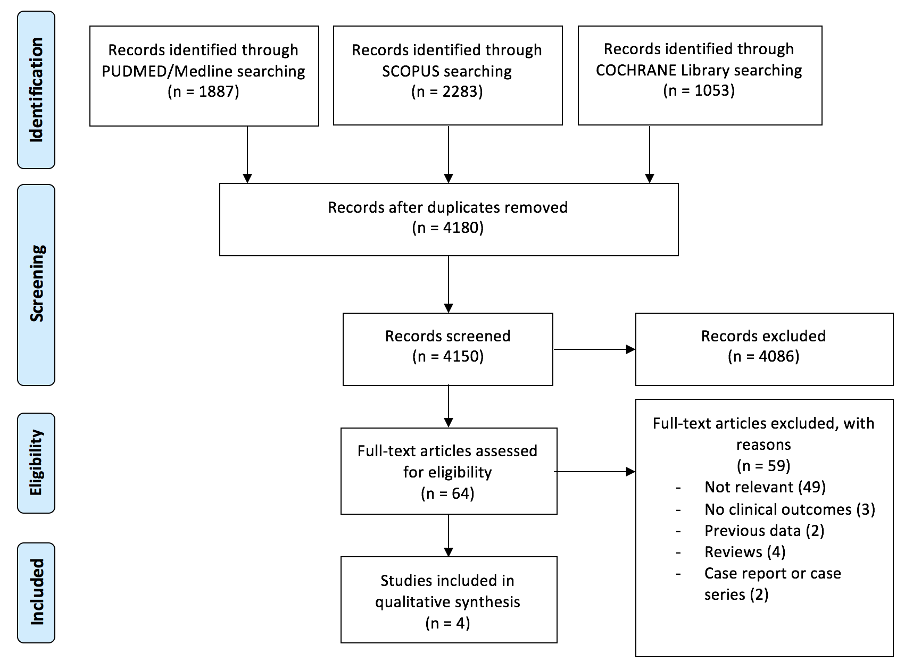

Figure 2. Forest plots comparing the outcomes of patients undergoing biodegradable polymer everolimus-eluting stent (BP-EES) or durable polymer drug-eluting stents (DP-DES).

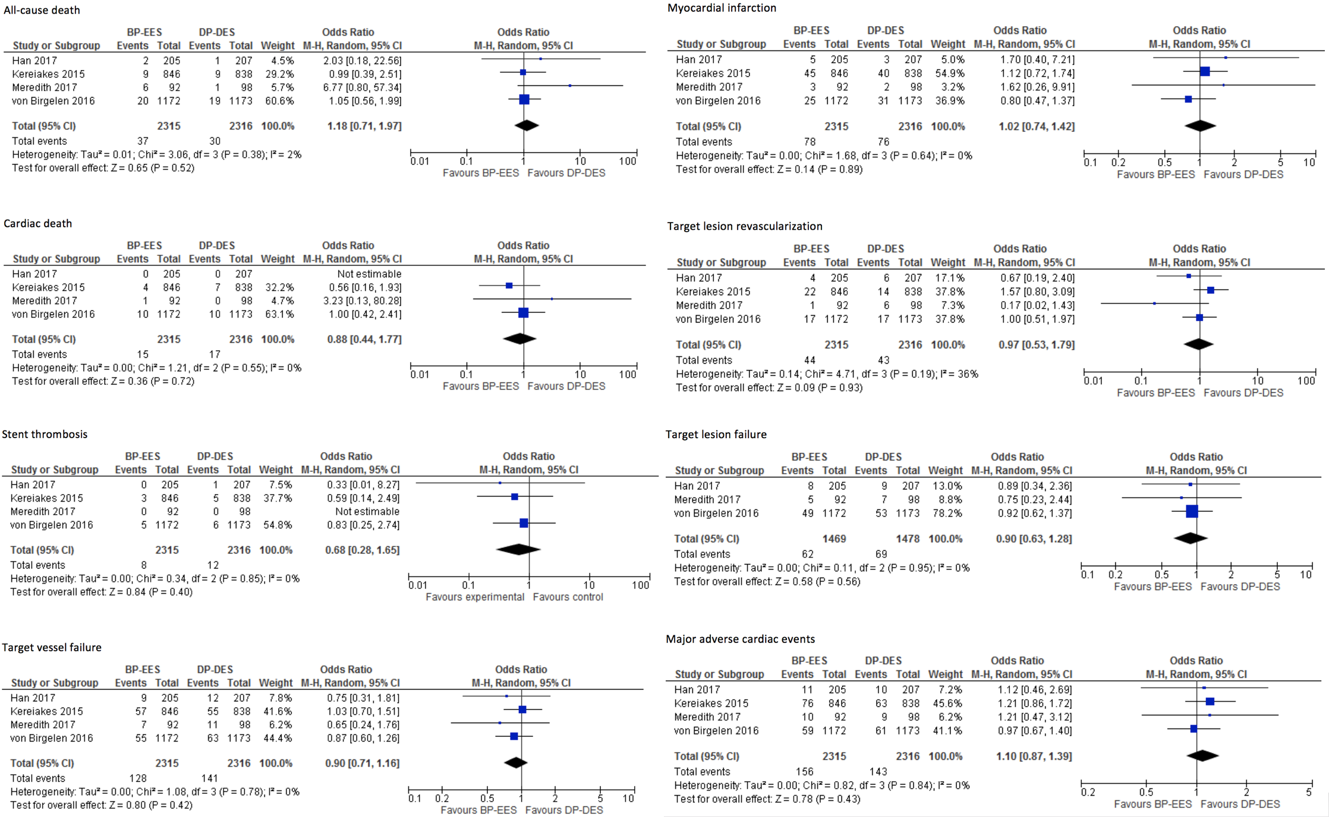

References
1. Windecker S, Kolh P, Alfonso F, Cremer J, Collet J-P, Falk V, Filippatos G, Head SJ, Hamm C, Jüni P, Kastrati A, Kappetein AP, Knuuti J, Landmesser U, Laufer G, Neumann F-J, Richter DJ, Schauerte P, Sousa Uva M, Taggart DP, Stefanini GG, Torracca L, Valgimigli M, Wijns W, Witkowski A, Authors/Task Force Members. 2014 ESC/EACTS Guidelines on myocardial revascularization: The Task Force on Myocardial Revascularization of the European Society of Cardiology (ESC) and the European Association for Cardio-Thoracic Surgery (EACTS)Developed with the special contribution of the European Association of Percutaneous Cardiovascular Interventions (EAPCI). Eur Heart J 2014;35:2541–2619.
2. Byrne RA, Stone GW, Ormiston J, Kastrati A. Coronary balloon angioplasty, stents, and scaffolds. The Lancet Elsevier; 2018;390:781–792.
3. Palmaz JC, Bailey S, Marton D, Sprague E. Influence of stent design and material composition on procedure outcome. YMVA 2002;36:1031–1039.
4. Kang S-H, Park KW, Kang D-Y, Lim W-H, Park KT, Han J-K, Kang H-J, Koo B-K, Oh B-H, Park Y-B, Kandzari DE, Cohen DJ, Hwang S-S, Kim H-S. Biodegradable-polymer drug-eluting stents vs. bare metal stents vs. durable-polymer drug-eluting stents: a systematic review and Bayesian approach network meta-analysis. Eur Heart J 2014;35:1147–1158.
5. Meredith IT, Verheye S, Dubois C, Dens J, Farah B, Carrié D, Walsh S, Oldroyd K, Varenne O, El-Jack S, Moreno R, Christen T, Allocco DJ. Final five-year clinical outcomes in the EVOLVE trial: A randomized evaluation of a novel bioabsorbable polymer-coated, everolimus-eluting stent. EuroIntervention 2017.
6. Kereiakes DJ, Meredith IT, Windecker S, Lee Jobe R, Mehta SR, Sarembock IJ, Feldman RL, Stein B, Dubois C, Grady T, Saito S, Kimura T, Christen T, Allocco DJ, Dawkins KD. Efficacy and safety of a novel bioabsorbable polymer-coated, everolimus-eluting coronary stent: the EVOLVE II Randomized Trial. Circulation: Cardiovascular Interventions 2015;8:e002372–e002372.
7. Moher D, Liberati A, Tetzlaff J, Altman DG, PRISMA Group. Preferred reporting items for systematic reviews and meta-analyses: the PRISMA statement. J Clin Epidemiol. 2009. p. 1006–1012.
8. DerSimonian R, Laird N. Meta-analysis in clinical trials. Controlled Clinical Trials Elsevier; 1986;7:177–188.
9. Han Y, Liu H, Yang Y, Zhang J, Xu K, Fu G, Su X, Jiang T, Pang W, Chen J, Yuan Z, Li H, Wang H, Hong T, Liu H, Sun F, Allocco DJ, Zhang M, Dawkins KD. A randomised comparison of biodegradable polymer- and permanent polymer-coated platinum-chromium everolimus-eluting coronary stents in China: the EVOLVE China study. EuroIntervention 2017;13:1210–1217.
10. Birgelen PhD von PC, MD MMK, van der Heijden MD LC, PhD PWD, MD CES, MD MS, MD RMTJG, PhD SS, van Houwelingen MD KG, PhD MGS, de Man PhD FHAF, MD JHWL, PhD MH, MD PZ, PhD GCML, van der Palen PhD PJ, PhD CJMD, PhD MMLW. Articles Very thin strut biodegradable polymer everolimus-eluting and sirolimus-eluting stents versus durable polymer zotarolimus-eluting stents in allcomers with coronary artery disease (BIO-RESORT): a three-arm, randomised, non-inferiority trial. The Lancet Elsevier Ltd; 2016;:1–11.
11. Meredith IT, Worthley SG, Whitbourn RJ, Antonis P, Montarello JK, Newcomb AE, Lockwood S, Haratani N, Allocco DJ, Dawkins KD. Transfemoral aortic valve replacement with the repositionable Lotus Valve System in high surgical risk patients: the REPRISE I study. EuroIntervention 2014;9:1264–1270.
12. Ali ZA, Gao R, Kimura T, Onuma Y, Kereiakes DJ, Ellis SG, Chevalier B, Vu M-T, Zhang Z, Simonton CA, Serruys PW, Stone GW. Three-Year Outcomes With the Absorb Bioresorbable Scaffold: Individual-Patient-Data Meta-Analysis From the ABSORB Randomized Trials. Circulation 2018;137:464–479.
13. Foin N, Ng J, Wong P, Di Mario C. Current bioresorbable scaffold technologies for treatment of coronary artery diseases: Do polymer and Magnesium platforms differ? Int J Cardiol Elsevier Ireland Ltd; 2016;223:526–528.
14. Lipinski MJ, Forrestal BJ, Iantorno M, Torguson R, Waksman R. A comparison of the ultrathin Orsiro Hybrid sirolimus-eluting stent with contemporary drug-eluting stents: A meta-analysis of randomized controlled trials. Cardiovasc Revasc Med 2018;19:5–11.
15. Navarese EP, Kubica J, Castriota F, Gibson CM, De Luca G, Buffon A, Bolognese L, Margheri M, Andreotti F, Di Mario C, De Servi S. Safety and efficacy of biodegradable vs. durable polymer drug-eluting stents: evidence from a meta-analysis of randomised trials. EuroIntervention 2011;7:985–994.
16. Palmerini T, Benedetto U, Biondi-Zoccai G, Riva Della D, Bacchi-Reggiani L, Smits PC, Vlachojannis GJ, Jensen LO, Christiansen EH, Berencsi K, Valgimigli M, Orlandi C, Petrou M, Rapezzi C, Stone GW. Long-Term Safety of Drug-Eluting and Bare-Metal Stents: Evidence From a Comprehensive Network Meta-Analysis. J Am Coll Cardiol 2015;65:2496–2507.
17. Natsuaki M, Kozuma K, Morimoto T, Kadota K, Muramatsu T, Nakagawa Y, Akasaka T, Igarashi K, Tanabe K, Morino Y, Ishikawa T, Nishikawa H, Awata M, Abe M, Okada H, Takatsu Y, Ogata N, Kimura K, Urasawa K, Tarutani Y, Shiode N, Kimura T. Final 3-Year Outcome of a Randomized Trial Comparing Second-Generation Drug-Eluting Stents Using Either Biodegradable Polymer or Durable Polymer: NOBORI Biolimus-Eluting Versus XIENCE/PROMUS Everolimus-Eluting Stent Trial. Circulation: Cardiovascular Interventions 2015;8:e002817.
18. Eppihimer MJ, Sushkova N, Grimsby JL, Efimova N, Kai W, Larson S, Forsyth B, Huibregtse BA, Dawkins KD, Wilson GJ, Granada JF. Impact of stent surface on thrombogenicity and vascular healing: a comparative analysis of metallic and polymeric surfaces. Circulation: Cardiovascular Interventions 2013;6:370–377.

Table 1. Study characteristics.
Name of the study | First author | Year | Type of study | Study quality | BP-EES  (no. patients) | DP-DES  (no. patients) | Total no. of patients | Type of durable polimer stent | BP-EES  (no. stents) | DP-DES  (no. stents) | BP-EES  (no. lesions) | DP-DES  (no. lesions) | BP-EES  Length follow-up  (days) | DP-DES  Length follow-up  (days)
EVOLVE | Meredith | 2017 | RCT | Good | 92 | 98 | 190 | EES | 94 | 98 | 94 | 98 | 1 834 | 1 834
EVOLVE II | Kereiakes | 2015 | RCT | Good | 846 | 838 | 1684 | EES | 1011 | 1079 | 1059 | 1043 | 365 | 365
EVOLVE China | Han | 2017 | RCT | Fair | 205 | 207 | 412 | EES | 217 | 226 | 217 | 226 | 365 | 365
BIO-RESORT | von Birgelen | 2016 | RCT | Good | 1172 | 1173 | 2345 | ZES | - | - | - | - | 365 | 365
The study quality was assessed according to the National Heart, Lung, and Blood Institute criteria. BP-EES, bioabsorbable polymer evelimus-eluting stent; DP-DES, durable polymer drug-eluting stent; RCT, randomized controlled trial; EES, everolimus-eluting stent; ZES, zotarolimus-eluting stent.

Table 2. Patients characteristics.
Baseline characteristics | No. of studies | BP-EES | DP-DES | Random-effects  Estimates | p-value | I²
Age, years | 4 | 61.7 (57.8-65.6) | 61.9 (59.6-64.3) | -0.39, -2.15-1.37 | 0.67 | 85%
Male | 4 | 71.4 (0.70-0.73) | 72.8 (70.9-64.6) | 0.94, 0.83-1.07 | 0.33 | 0%
Smoking habit | 3 | 37.5 (12.1-63.0) | 40.3 (15.4-65.2) | 0.93, 0.82-1.06 | 0.34 | 0%
Diabetes | 4 | 22.6 (14.4-30.8) | 23.5 (15.9-31.1) | 0.98, 0.86-1.13 | 0.84 | 0%
Hypertension | 4 | 60.9 (41.2-80.7) | 61.3 (0.44-0.78) | 1.01, 83.5-1.21 | 0.98 | 41%
Dyslipidaemia | 4 | 51.0 (26.1-76.0) | 51.7 (27.2-76.1) | 0.94, 0.83-1.07 | 0.36 | 0%
Prior CABG or PCI | 4 | 30.1 (20.2-40.0) | 30.1 (18.4-41.8) | 0.98, 0.86-1.11 | 0.72 | 0%
Prior myocardial infarction | 4 | 22.5 (16.0-29.0) | 25.7 (20.0-31.4) | 0.80, 0.69-0.92 | 0.001 | 0%
Unstable angina | 4 | 25.5 (16.3-54.8) | 36.0 (17.6-54.3) | 0.93, 0.81-1.06 | 0.26 | 0%
Values are proportions, mean differences or odds ratios with 95% confidence intervals (in parentheses). BP-EES, biodegradable polymer everolimus-eluting stent; DP-DES, durable polymer drug-eluting stent; CI, confidence interval; CABG, coronary artery bypass grafting; PCI, percutaneous coronary intervention.

Table 3. Procedural characteristics.
Baseline characteristics | No. of studies | BP-EES | DP-DES | Random-effect  Estimates | p-value | I²
Treated vessels
LAD | 4 | 46.9 (39.8-54.0) | 47.0 (40.5-53.7) | 1.03 (0.92-1.16) | 0.45 | 0%
Cx | 4 | 28.0 (21.7-34.2) | 29.1 (24.1-34.0) | 0.91 (0.75-1.10) | 0.18 | 40%
RCA | 4 | 37.2 (30.9-43.4) | 34.0 (24.7-43.4) | 1.07 (0.89-1.28) | 0.15 | 43%
Left main | 4 | 0.7 (0.0-1.6) | 0.8 (0.0-1.7) | 0.87 (0.51-1.48) | 0.95 | 0%
Reference vessel diameter, mm | 4 | 2.7 (2.6-2.8) | 2.7 (2.6-2.8) | 0.01 (-0.03-0.04) | 0.76 | 0%
Minimal lumen diameter, mm | 4 | 0.8 (0.7-0.9) | 0.8 (0.6-0.9) | 0.0 (-0.02-0.02) | 0.99 | 38%
Total lesion length, mm | 4 | 15.1 (14.0-16.2) | 14.9 (14.0-15.8) | 0.5 (0.0-0.9) | 0.04 | 35%
Stenosis diameter | 3 | 71.4 (65.3-77.5) | 70.8 (65.9-75.8) | 0.7 (-0.5-1.8) | 0.29 | 68%
Stent length, mm | 3 | 27.3 (18.6-36.0) | 27.3 (17.7-36.9) | -0.02 (-0.92-0.87) | 0.96 | 64%
Values are proportions, mean differences or odds ratios with 95% confidence intervals (in parentheses). BP-EES, biodegradable polymer everolimus-eluting stent; DP-DES, durable polymer drug-eluting stent; CI, confidence interval; LAD, left anterior descending artery; Cx, circumflex artery; RCA, right coronary artery.

Table 4. Pooled outcomes
Outcomes | No. of studies | BP-EES | DP-DES | Odds ratio (95%CI) | p-value | I²
All-cause death | 4 | 1.4 (0.6-2.2) | 1.1 (0.6-1.6) | 1.18 (0.71-1.97) | 0.52 | 2%
Cardiac death | 4 | 0.6 (0.3-0.9) | 0.7 (0.3-1.0) | 0.88 (0.44-1.77) | 0.72 | 0%
Myocardial infarction | 4 | 3.3 (1.5-5.1) | 2.8 (1.4-4.2) | 1.02, (0.74-1.42) | 0.64 | 0%
TLR | 4 | 1.8 (1.2-2.4) | 1.8 (1.0-2.6) | 0.97 (0.53-1.79) | 0.93 | 36%
TVR | 4 | 2.7 (1.6-3.8) | 3.6 (2.1-5.1) | 0.77 (0.50-1.19) | 0.25 | 26%
Non-TLR TVR | 3 | 1.3 (0.2-2.3) | 2.1 (0.1-3.1) | 0.70 (0.38-1.30) | 0.60 | 0%
Stent thrombosis | 4 | 0.4 (0.1-0.6) | 0.5 (0.2-0.8) | 0.68 (0.28-1.65) | 0.85 | 0%
TVF | 4 | 5.5 (4.1-5.9) | 6.1 (4.8-7.3) | 0.90 (0.71-1.16) | 0.78 | 0%
TLF | 3 | 4.2 (3.2-5.3) | 4.6 (3.3-5.7) | 0.90 (0.63-1.28) | 0.95 | 0%
MACE | 4 | 7.0 (4.4-9.6) | 6.2 (4.5-7.8) | 1.10 (0.87-1.39) | 0.43 | 0%
Values are proportions or odds ratios with 95% confidence intervals (in parentheses). BP-EES, biodegradable polymer everolimus-eluting stent; DP-DES, durable polymer drug-eluting stent; CI, confidence interval; TLR, target lesion revascularization; TVR, target vessel revascularization; TVF, target vessel failure; TLF, target lesion failure; MACE, major adverse cardiac event.

Supplemental Tab. 1. Study quality assessment according to the National Heart, Lung, and Blood Institute criteria.
Criteria | EVOLVE | EVOLVE II | EVOLVE China | BIO-RESORT
1. Was the study described as randomized, a randomized trial, a randomized clinical trial, or an RCT? | Yes | Yes | Yes | Yes
2. Was the method of randomization adequate (i.e., use of randomly generated assignment)? | Yes | Yes | NR | Yes
3. Was the treatment allocation concealed (so that assignments could not be predicted)? | Yes | No | NR | Yes
4. Were study participants and providers blinded to treatment group assignment? | No | No | No | No
5. Were the people assessing the outcomes blinded to the participants' group assignments? | Yes | Yes | NR | Yes
6. Were the groups similar at baseline on important characteristics that could affect outcomes (e.g., demographics, risk factors, co-morbid conditions)? | Yes | Yes | Yes | Yes
7. Was the overall drop-out rate from the study at endpoint 20% or lower of the number allocated to treatment? | Yes | Yes | Yes | Yes
8. Was the differential drop-out rate (between treatment groups) at endpoint 15 percentage points or lower? | Yes | Yes | Yes | Yes
9. Was there high adherence to the intervention protocols for each treatment group? | Yes | Yes | Yes | Yes
10. Were other interventions avoided or similar in the groups (e.g., similar background treatments)? | Yes | Yes | Yes | Yes
11. Were outcomes assessed using valid and reliable measures, implemented consistently across all study participants? | Yes | Yes | Yes | Yes
12. Did the authors report that the sample size was sufficiently large to be able to detect a difference in the main outcome between groups with at least 80% power? | Yes | Yes | Yes | Yes
13. Were outcomes reported or subgroups analyzed prespecified (i.e., identified before analyses were conducted)? | Yes | Yes | Yes | Yes
14. Were all randomized participants analyzed in the group to which they were originally assigned, i.e., did they use an intention-to-treat analysis? | Yes | Yes | Yes | Yes
Quality rating | Good | Good | Fair | Good
Quality rating: good, fair or poor.
CD, cannot determine; NA, not applicable; NR, not reported

