Testing Transformative Energy Scenarios through Causal Layered Analysis Gaming

Sirkka Heinonenª Matti Minkkinen^{b} Joni Karjalainen^{c} & Sohail Inayatullah^{d}

ª Finland Futures Research Centre, University of Turku, Korkeavuorenkatu 25 A 2, 00130 Helsinki
^{b} Finland Futures Research Centre, University of Turku, Rehtorinpellonkatu 3, 20500 Turku
^{c} Finland Futures Research Centre, University of Turku, Korkeavuorenkatu 25 A 2, 00130 Helsinki
^{d} Tamkang University, Taiwan and University of the Sunshine Coast, Australia

Corresponding author’s e-mail address:
sirkka.heinonen@utu.fi

Abstract:
This paper presents the results of an innovative pilot experiment on elaborating transformative energy scenarios by using a causal layered analysis (CLA) game. CLA is an integrative and communicative method, which divides issues into four layers: litany, systemic causes, worldviews, and metaphors. In the piloted CLA game, four existing scenario drafts from the Neo-Carbon Energy project: “Radical Startups”, “Value-Driven Techemoths”, “Green DIY Engineers” and “New Consciousness” were used. The CLA game session, as depicted in this paper, worked through the CLA layers sequentially per each scenario, contributed new elements to the scenario narratives, and utilised roleplay for the worldview and metaphor layers. This CLA game highlighted the complexity, polyphony and actor dynamics of the future worlds. We identify four key benefits: developing the CLA game scenario methodology, gaming-based social learning, deepening of sociocultural energy scenario drafts and exploration of energy transformation towards renewable energy based futures. As a new type of CLA workshop, the game expanded the method’s boundaries. Recommendations are presented for developing serious gaming further in scenario processes.

Key words:
CLA, action learning, serious gaming, energy transformation, scenarios, Neo-Carbon Energy, renewable energy

Introduction
Transforming the energy system is one of the greatest global challenges. Climate change is caused by the increase of global atmospheric concentrations of greenhouse gases. In particular, the level of carbon dioxide (CO₂) is increasing at a worrying rate, if we want to restrict global warming below +2°C degrees (IPCC 2014; NOAA/ESRL 2016). Despite an increasing appreciation of renewable energy, around 80 per cent of the world’s primary energy is still produced with fossil fuels (IEA 2015). In the recent decades it has become clear that for reaching a sustainable future, business as usual approaches are inadequate, and therefore more radical and discontinuous scenarios are urgently needed. However, the field of energy is a complex environment-society system whose evolution is difficult to model because it includes societal responses (Valkering 2012). Hence, radical approaches and experimentation are needed, not only in the content of scenarios, but in scenario methodology itself.
This paper presents the process and results of an innovative experiment on elaborating transformative energy scenarios by using a causal layered analysis (CLA) game. The experiment of combining scenarios, CLA and gamification took place during the International Conference “Futures Studies Tackling Wicked Problems” in Finland in June 2015. Scenarios from the Neo-Carbon Energy project were used as materials for the game. The aim was to test and elaborate existing scenario sketches in a participatory setting. The interactive three-hour game was moderated by a game team which included the authors of the Neo-Carbon Energy scenarios.
In the first two sections, we will discuss the role of serious gaming in futures studies and the interlinkages between the CLA method, serious gaming and scenario-building. Then, we will illustrate how this causal layered analysis game was conducted. The choices made during planning and execution of the CLA game are explained and critically discussed. In the discussion section, we will explain what the benefits of our CLA game approach are. We argue that through the CLA game, we were able to promote methodological development of scenarios and CLA and generate a setting for social learning for the workshop participants. Gaming can be used to deepen sociocultural energy scenarios and ultimately strive to promote transformation of the energy sector. We explain practical considerations that need to be taken into account in a gaming session, and make suggestions how a gaming approach that uses scenarios could be improved in the future. The causal layered analysis game is presented as a pilot case study which may be further elaborated in subsequent workshops. In future research, closer investigation of the hypothesised learning outcomes of such gaming exercises is warranted. Translating the societal implications of the scenarios into energy policy remains a challenge.

Literature overview: scenarios, gamification and causal layered analysis

Sociocultural energy scenarios
The CLA game exercise brought together three futures research approaches: sociocultural energy scenarios, gaming, and causal layered analysis. In the past, various scenario building methods have been used to make climate and energy scenarios. Forecasting approaches have traditionally been influential in policy-making, while backcasting approaches have become increasingly relevant. In forecasting, formal quantitative models, often based on rigid assumptions about system dynamics, are used to forecast total energy consumption and the level of CO₂ emissions (Hong 2014; Hong et al. 2016; Silberglitt, Hove, and Shulman 2003). Transition and backcasting approaches, in turn, have been developed to find sustainable energy solutions and to move beyond the limits of extrapolating from past or present trends (Grubler 2012; Kemp 2010). Recently there have also been increasing calls for participatory approaches to scenario building to take into account stakeholder views and qualitative sociocultural factors such as values and lifestyles (Cairns et al. 2013; Cairns, Wright, and Fairbrother 2016; Wangel 2011).
Clear methodological guidelines have been proposed for transformational sustainability research (Wiek and Lang 2016). We define transformative energy scenarios as explicitly normative scenarios which take the necessity of radical change as the starting point (Börjeson et al. 2006). As a distinctive qualitative approach to scenario-making, sociocultural energy scenarios are narratives that seek to account for the broad economic and political context of possible energy futures (Upham, Klapper, and Carney 2016; Miller et al. 2015). Within qualitative sociocultural scenarios, the ‘intuitive logics’ method remains the most established scenario technique (Wright, Bradfield, and Cairns 2013).
In the literature, scenarios are seen as learning devices which are meant to produce “epistemic value-added” and tackle uncertainty (Aligica 2005; Rhisiart et al. 2015). In particular, scenarios help to challenge and reframe perceptions about the dynamics of complex systems (Wilkinson, Kupers, and Mangalagiu 2013; Wright, Bradfield, and Cairns 2013). Trutnevyte, Guivarch, Lempert and Strachan (2016) suggest that scenarios should not only be produced but they should be iteratively evaluated and improved, focusing on scenario users’ needs. Thus scenarios can be expected to provide a vehicle for continuous learning about complex systems and the boundaries of uncertainty.

Serious gaming
In the CLA game, existing sociocultural energy scenarios were evaluated and iteratively improved through gaming. The use of gaming has a long history in the field of futures studies, from the war games developed by Herman Kahn and others after World War II to more recent applications in simulating students’ future careers, in prediction markets and in business strategy (Kahn 2007; Ollila et al. 2014; Prokesch et al. 2014; Schwarz 2013).
In futures studies, gamification is closely related to the concepts of experimental and immersive futuring. We consider experimental futuring as a broad frame which encompasses immersive futuring and game-based futuring (see Figure 1). Scenarios as such can be seen as thought experiments which anticipate the implications of action (Aligica 2005; Andreescu et al. 2013). Experimental futuring takes this characteristic further by experimenting with novel combinations of methods. The methods may involve multisensory immersion in the depicted futures which allows participants to experience multiple futures (Dator 2009; Heinonen and Hiltunen 2012; Heinonen and Kurki 2011; Selin 2015). This is analogous to virtual reality where immersive techniques are used to create impressions of real life. Various immersive tools can be used to create the impression of being in the future: for instance collages, videos and narratives in physical or digital space. In particular, Vervoort et al. (2010, 609) highlight the role of visualisation in communicating scenarios and making them immersive and experiential.
Immersion in futures can also be achieved through serious gaming, which means playing a game that has a societally important goal. Homo Ludens (Man the Player) is a concept originally coined by Dutch historian Johan Huizinga (1939), who suggested that play is a meaningful activity, free from practical life and its requirements. Gamification as a tool is gaining increasing interest (e.g. Bontoux et al. 2016; Burke 2014; McGonigal 2011), and it has significant potential for addressing complex global challenges such as developing sustainable energy systems. Like scenarios, games have communicative power and they can be conceived as instruments for learning (Vervoort et al. 2010, 608). Power Grid (Funkenschlag), designed by Friedemann Friese, is an example of a popular board game about energy, and future-oriented interactive games have been used to educate consumers on sustainable energy (Barrios-O’Neill and Hook 2016). Haug et al. (2011, 969) point out that policy games have been frequently used to stimulate learning on issues of global environmental change. In the corporate sector, games are increasingly adopted to improve leadership skills, test key strategies and enhance the ability to adapt to change (Kinley and Ben-Hur 2015). Gaming promotes experiential and relational learning, which improves the ability to co-operate and understand other participants’ mindsets (Haug et al 2011, 970).
The Institute for the Future (IFTF) is a pioneer in serious gaming in the field of futures studies. In 2013 they launched a game “Catalysts for Change” where the goal was no less than finding ways out of poverty. Director of Game R&D at IFTF, Jane McGonigal (2011) claims that gaming channels positive attitude, sense of meaning, motivation and collaboration in a real world context. McGonigal has designed alternate reality games aimed at solving huge real life problems such as hunger or climate change. Some games, such as Superbetter (McGonigal 2015), focus on improving the health and self-resilience of players.
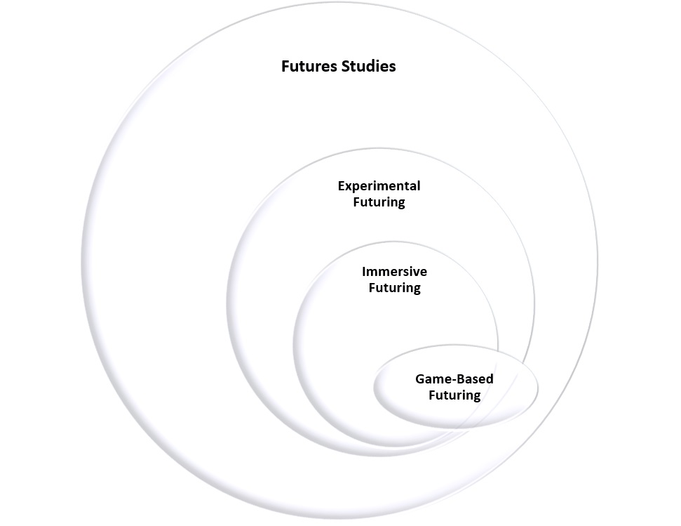
Figure 1. Gamification within the conceptual framework of future studies, experimental and immersive futuring.
The causal layered analysis game presented in this article is an example of game-based futuring that is immersive and experimental, although all game-based futuring need not have these characteristics. The objective of this serious game is to test and elaborate transformative energy scenarios. Gaming has previously been connected to scenario planning for instance through role-playing stakeholder reactions to scenario storylines (Wright, Bradfield, and Cairns 2013) and simulating society-environment dynamics through possible interactions among advocacy coalitions (Valkering et al. 2013). Notably, the European Commission’s Joint Research Centre together with the University of Hawaii developed a serious game titled the JRC Scenario Exploration System (Bontoux et al. 2016). In this game, participants role-played developments related to a sustainable EU economy, in order to discover alternative futures and to foster stakeholder engagement.

Causal layered analysis
The CLA game on Neo-Carbon Energy scenarios presented in this paper contributes to the discussion on scenarios and gaming by using causal layered analysis (CLA) as the methodological framework for the game. CLA is a method developed by Sohail Inayatullah and later applied by several futures researchers and practitioners to a wide range of topics (Inayatullah & Milojevic 2015; Inayatullah 2015a; 2015b; 2008; 2004). Causal layered analysis is a communicative method which uses storytelling and narratives to explore and construct possible futures. A key assumption is that the framing of problems determines how policy solutions are seen (Inayatullah 1998, 820).
In causal layered analysis, representations of the future are divided into four layers: litany, system, worldview, and metaphor (Inayatullah 1998, 2004a, 11−15; see Figure 2). Each of the four layers exposes distinct aspects of a scenario: 1) litany refers to quantitative problems, trends that are often exaggerated and used for political purposes; 2) the system layer focuses on the social scientific explanations of quantitative data and systemic connections, as illustrated by morphological analysis, for instance; 3) worldview is concerned with ideologies and paradigms that support or challenge the status quo, and 4) metaphor, or the mythic layer, deals with deep stories, collective archetypes, and images which give meaning to disconnected events and are often difficult to articulate in words (Inayatullah 2004a). In any social setting, the layers are interconnected, and it is crucial to move back and forth between the layers in the course of scenario analysis (Inayatullah 2004a, 11−15).
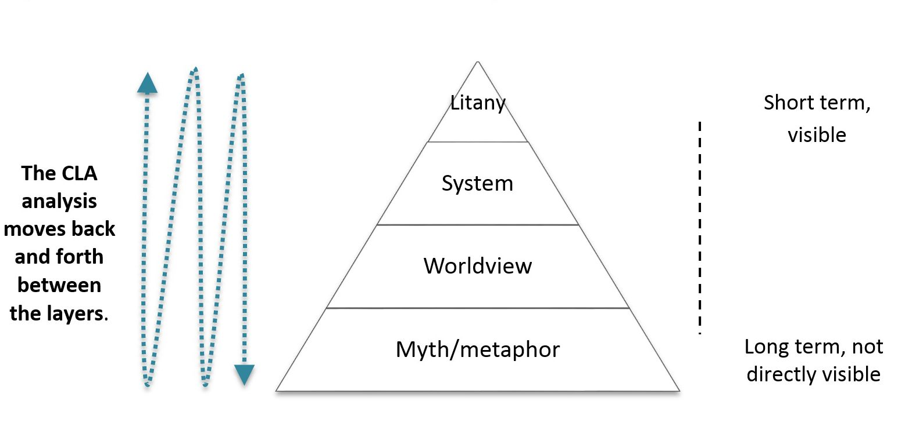
Figure 2. The causal layered analysis pyramid (modified from Inayatullah 2004b).
In Figure 2, the structure of CLA is shaped as a pyramid to suggest that the bottom layers are more comprehensive and actors are less conscious of them. It could also be illustrated by an iceberg metaphor where the tip of the iceberg represents the litany layer, whereas the other layers remain hidden under the sea. Changing the underlying layers is more difficult and requires more time than changing the litany and system. However, changes in them enable more radical transformation because the deeper layers frame and construct problems as they are seen on the litany layer (Inayatullah 2004a, 3).
The CLA method enables a deep investigation of alternative futures by studying individuals’ culturally influenced beliefs and assumptions. In addition to the vertical layers, the search for ‘horizontal’ alternatives is crucial. This makes CLA compatible with the dominant principle in futures studies that there is not just one future, but many alternative ones. There are also many alternative ways to utilise CLA. Therefore, causal layered analysis has been described as a meta-method rather than a method because it is compatible with many different futures research methods including scenarios (Wright 2002, 534).
CLA may be used in academic research to study how language constructs social reality and to deconstruct ways of thinking (Derrida 1997; Foucault 2002; Inayatullah 2004a, 7). In the CLA game, the method is used to promote collective action learning through communication in a workshop context (Inayatullah 2004a, 6; 2013). The game mode of CLA was invented in 2003 during a workshop for the Australian Government Department of Agriculture, Fisheries and Forestry. It has since been played nearly a hundred times across the world. Typically, CLA games are conducted in four groups corresponding to the four layers respectively. The groups communicate with each other and exchange views back and forth in iterative turns (Inayatullah 2015). This original CLA game proceeds from choosing a topic to the headline provided by a litany group. Then, back-and-forth interaction takes place between the three other groups: system, worldview and metaphor. The outcome from such a game session is a new litany based on the discussion in and between the groups. For the CLA game on Neo-Carbon Energy scenarios, this game was significantly altered. Our novel model of the CLA game will be discussed in the next chapter.

Testing and analysing transformative scenarios with a CLA game

Neo-Carbon Energy project and transformative energy scenarios 2050
This section documents the causal layered analysis game that was conducted in June 2015 during the “Futures Studies Tackling Wicked Problems” conference in Finland. The aim of the CLA game was to test and deepen sociocultural energy scenarios from the Neo-Carbon Energy project in a participatory setting. The Neo-Carbon Energy project studies an emission-free energy system based on renewable energy, especially solar and wind energy. The foresight part of the project examines how society and economy are transformed, if energy production is decentralised, manufacturing increasingly localized, and materials based on fossil fuels replaced with synthetic ones.
As background material, the CLA game participants received summaries of the research project’s scenarios. In the project, four transformative scenarios had been sketched to depict societal and energy futures until 2050. The scenarios are qualitative, long-term, global and exploratory rather than serving as direct decision support (van Notten et al. 2003). All four scenarios explore radical changes, and thus they are transformative according to the scenario archetype approach (Dator 2009). The scenarios were based on horizon scanning and they were constructed using the intuitive logics approach with two axes of uncertainty, resulting in four scenarios (Ralston & Wilson 2006, Ch. 3). The project team paid particular attention to weak signals and discontinuities.
Figure 3 illustrates the two axes that form the basis of the future worlds. The scenario axes are derived from the vision of a transformed world of ‘neo-growth’ where economic growth is ecologically sustainable (Malaska 2010), the energy system is based on distributed and renewable energy (Breyer, Heinonen and Ruotsalainen 2016, see also Lund 2014; Rifkin 2011), and society has re-organised into peer-to-peer networks. A peer-to-peer organised society implies that hierarchies within organisations, or even more broadly within the civil society, fade away (X-axis). Ecological awareness, in turn, shapes technological progress, and citizens have either a deeply ecological assertiveness (Naess 1984, 1973; Devall and Sessions 1985), or they at least recognise the environmental impacts of their actions (Y-axis). The four scenarios are summarised in the following.
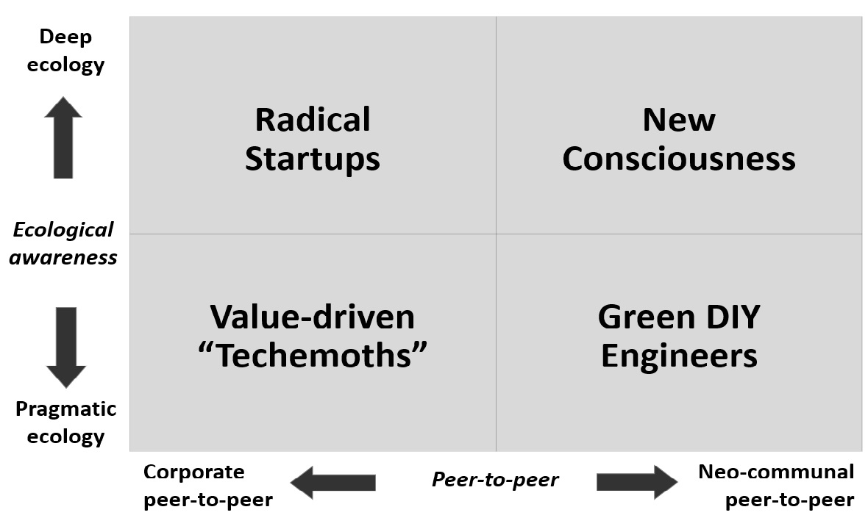
Figure 3: Four transformative scenarios 2050 of the Neo-Carbon Energy project.

3.1.1 “Radical Startups” scenario (deep ecology + corporate-driven peer-to-peer society)
In the Radical Startups scenario, the economy is driven by a multitude of small-scale startups that are known for their radical values and approaches. These startups are drivers of new, deep-ecological lifestyles and novel working practices that emphasise bottom-up management approaches and self-expression. Environmental problems are solved first and foremost commercially. Society is business-oriented, but the selling point of startups to the broader society is their promise to do societal and environmental good. The innovative startups develop new energy technologies, services and solutions which drive emissions reductions.

3.1.2 “Value-Driven Techemoths” scenario (pragmatic ecology + corporate-driven peer-to-peer society)
In the Techemoths scenario, markets are assumed to take care of environmental issues and the peer-to-peer ethos is manifested especially within technology giants, or so-called “techemoths”. These techemoths are driven by ethics and values, in particular the Silicon Valley values of emancipation, creativity and open source. They invest in ambitious energy and technology projects, among other things. However, this vision may appear to be somewhat self-contradictory. While the techemoths cherish the ‘libertarian’ hacker mentality, at the same time their employees tend to live tightly inside the corporate walls. The citizens of the techemoth society are not committed to energy issues in a heartfelt way – they assume that such matters are “automated”, taken care of by someone else.

3.1.3 “Green DIY Engineers” scenario (pragmatic ecology + neo-communal society)
In the Green Do-It-Yourself Engineers scenario, countries have failed to escape the fossil fuel economy, and consequently, the world has faced an ecological collapse. There have been considerable changes in weather patterns and species extinctions have accelerated. Because of decaying infrastructure, environmental problems of the future are solved locally with a practical “do-it-yourself” attitude. Engineer-minded citizens have organised themselves as local communities to survive. Global trade has plummeted and communities have to cope mostly with low-tech solutions. Communities are densely built with lots of shared public spaces. Lifestyles are localised and travelling long distances is rare. Some communities are off-grid and totally self-reliant on their own energy production. National cultures, and nation-states as such, have more or less withered away.

3.1.4 “New Consciousness” scenario (deep ecology + neo-communal society)
The ecological crisis, ubiquitous information and communication technologies (ICTs), and small conflicts of hybrid warfare akin to a “World War III” have surfaced an entirely new kind of consciousness. The worldview is systems-oriented, and everything is seen to be connected to everything else. Values of deep ecology have become the norm: people conceive themselves as parts of nature and are deeply intertwined with other humans. In a unified global system, society collaborates openly and globally to share information and resources. Energy is ‘sacred’ and citizens consider it as the source of all life, which explains why they are extremely committed to energy decisions and policies to fight climate change.

CLA game – Causal layered analysis on energy futures
The game participants were speakers and participants at an academic conference on “Futures Studies Tackling Wicked Problems” held in June 2015. They represented diverse age groups, nationalities, cultures and organizations. Several of them, although not all, were familiar with futures research and the CLA method. This is different from Debbie Terranova’s (2015, 374) application of the CLA game, where participants were not familiar with the CLA methodology. The game organisers worked for the research project and briefed the group moderators with gameplay instructions.
The rules of the CLA game were designed to strike a balance between structured gameplay and free-form discussion. On the one hand, the game was considerably more linear than Inayatullah’s model where there is continuous moving back and forth between the CLA layers (Inayatullah 2015a). On the other hand, the CLA game was more free-form than the Joint Research Centre’s Scenario Exploration System which included a game board, rounds and scoring (Bontoux et al. 2016).
Our CLA game was a three-hour session that was divided into an introduction, a gaming session and a debriefing session that altogether constitute six phases:
- Whole group
  - Introduction to CLA and the Neo-Carbon scenarios
- CLA exercise in small groups, one group per scenario
- Litany
- System
- Worldview
- Metaphor
- Whole group
- Debriefing and feedback

3.2.1 Introduction – setting the stage and explaining the rules
The session started with a short presentation of the CLA method, an introduction to this version of the CLA game, and the research project’s four transformative scenarios followed by a practical briefing about the game rules. The participants were then divided into groups according to the Neo-Carbon Energy scenarios because the intention was that each group explore one scenario in depth (“Radical Startups”, “Value-Driven Techemoths”, “Green DIY Engineers” and “New Consciousness”). As material for the CLA game, each group was given a front page of a future newspaper, a large sheet of paper with a PESTEC Table and a stack of role cards for a role-playing exercise.

3.2.2 Litany layer – immersion into the scenario
The scenarios were set in the relatively far future, the year 2050, and in the beginning of the game the intention was to immerse participants within this future world. The key characteristics of each scenario (the litany) were presented as a short future newspaper article which was unique for each scenario group. There were thus four pre-written journal headlines: “Radical Startups to Save the World”, “Cool Things That Matter – Techemoths Offer Platforms for Talent”, “DIY Engineers Fix It”, and “We the Post-Humans” (see Figure 4).
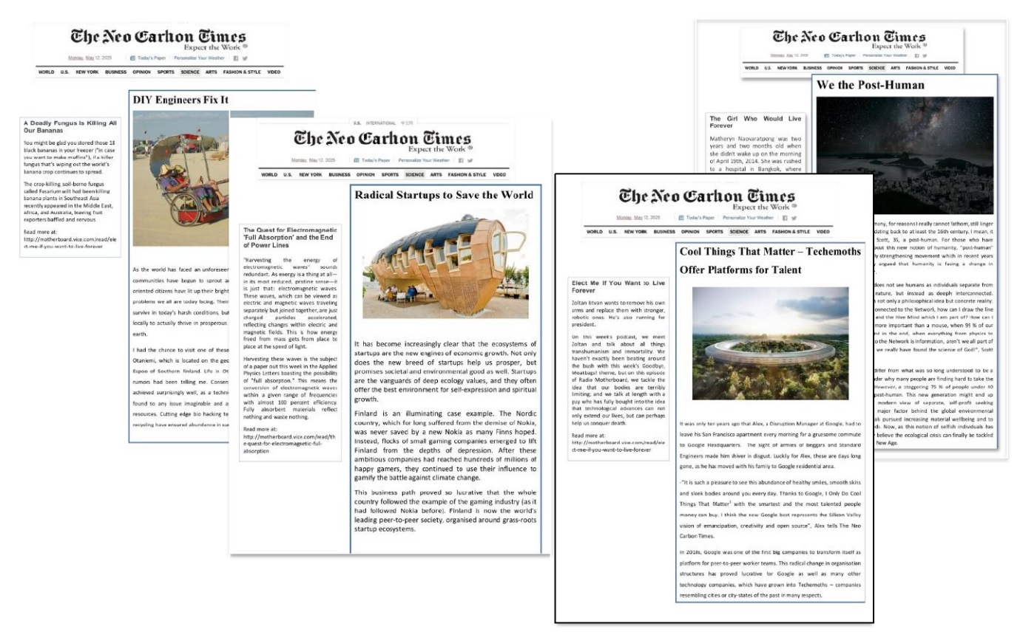
Figure 4: Litany layer – Front pages of a future newspaper in line with the transformative energy scenarios 2050.
The articles were written in such a way that they immerse the participants into an alternative future and make a transformative scenario seem attainable. In this CLA game, each participant read the newspaper article individually. In future CLA games, the scenario group moderator could read the litany out loud as a news report and highlight vividly the details that evoke the core of a particular scenario. If time permits, participants could even perform the litany themselves, as a newscast.

3.2.3 System layer – systemic logic and social causes
The objective of the CLA system layer is to break a scenario down into components and explore its systemic and causal logic. In the system phase of the CLA game, this was achieved with the help of a PESTEC table. The PESTEC method allows a systematic exploration of political, economic, social, technological, ecological and cultural factors that underpin a scenario. Compared to the original PEST method (Aguilar 1967), PESTEC includes ecological issues and the ‘soft’ perspectives of actors, culture and norms (see also Barrios-O’Neill and Hook 2016; Tibbs 2011). Our “C” component, which stands for culture, also includes consumers’ and citizens’ perspectives. Terranova (2015, 375) has used a similar approach in her CLA workshops.
Having read the litany, the participants were asked to come up with systemic causes across all the six PESTEC dimensions. Each group member wrote down elements that support the scenario on Post-It notes. Then they explained to the other members in their group how each cause contributes to achieving such a future. Then the group selected the most important cause for each dimension. Post-It notes were used to ensure all group members can contribute, justify and explain their reasoning. In future CLA games, it may be beneficial to instruct each participant to contribute a minimum number of causes before the discussion to ensure that the most outspoken individuals do not impose their views on the systemic logic. The PESTEC table of the “Value-Driven Techemoths” scenario group, as depicted in Table 1, illustrates this phase.

Table 1: An example of systemic causes invented into a PESTEC table taken from the Value-Driven Techemoths scenario group. The group selected the most important cause in each dimension, highlighted by the grey colour.

POLITICAL | Eco-liberalism  Large companies with internal democratic structures | Hive-ism | Low government regulation of big business | Governments have failed at producing welfare | Companies replace governments | Humans are de-sexed and transform into hierarchically arranged workers
ECONOMIC | Dominated by large companies, inequality | Value is defined in economic terms and profit | Small companies only exist to make bigger companies | Ecological goods and services are bought and sold on the markets | Competition for talent | Exchange economy is illegal
SOCIAL | Techemoths are closed hubs for social activities | Inequality becomes systemic | If you are not in the company, you are poor | People outside of techemoths are poor and lack social security | Isolation of groups of people
TECHNO-LOGICAL | ICTs are ubiquitous | Internet of Things automatizes individual decision-making | Hi-tech is the core driver of human existence | Investments in technology have been intense, driven by companies | Break-through  in carbon capture  and geo- engineering | Technologies integrated as service packages, offered by techemoths
ECOLOGIC | Environmental decisions are automated through technology | Earth is paved with silicon solar panels | Humans live below the panels and project skymaps on the backside | You are unable to do bad environmental decisions | Nature is only protected, if it has value on the market | Environment seen as existential threat to society
CULTURAL  CONSUMER  CITIZEN | Citizens allow inequality in return for environmental security | Corporate monocultures – corporate autocracy makes individuals almost slaves | Resistance to centralised power is appropriated by centralised power itself | Leisure activities such as virtual competition  and all-in-one company | Culture of struggle against system | Belonging into larger whole pleases individuals

3.2.4 Worldview layer – role play, identification of allies and enemies
After a review of the systemic logic, the participants in each group chose a role for a roleplaying exercise that corresponds to the worldview layer of CLA. They could either choose from a set of pre-defined roles, specific for each scenario, or invent an entirely new role. The pre-defined roles were designed to include ‘winners’, ‘losers’ and ambivalent characters in each scenario. We find it useful to include imaginative characters that may not exist today but could have an important role in the future, because socio-technological change will create new professions and societal groups (Webster 1995).
The participants used role cards as tools to investigate the actor dynamics, worldviews and metaphors of a given scenario. From the perspective of their character, each participant filled in a role card which included motivating and threatening factors in the scenario as well as other actors that they considered allies and enemies. An example of a role card is depicted in Figure 5. After filling in their role cards, the participants discussed and justified, still in character, the motivating and threatening factors, the other characters that they are most likely to collaborate with (allies) and who they identify as their worst enemies.
Deep Ecologist
Motivating | Threatening
- Sustainable communities in harmony with nature  - Re-development of locality | - Short-term profits  - Extensive use of natural resources  - New economy
Best ally | Worst enemy
- University teacher  - Artist | - Multinational corporation employee  - Synthetic biologist

Figure 5: An example of a role card. The Deep Ecologist was one of the characters in the “Green DIY Engineers” scenario group.
By choosing the motivating and threatening factors and the allies and enemies, each participant can explore their character’s worldview as well as the relationships and conflicts between the characters in the scenario. Group members are free to choose a role similar to their real-life position or a very different role. At first glance, the pre-defined actor roles are likely to view the Neo-Carbon scenarios either positively or negatively. However, participants are free to choose how they enact those roles, based on their own notion of how that actor would perceive and act in the particular scenario. This also adds an element of surprise. An example of acting in the roles is shown in Figure 6.

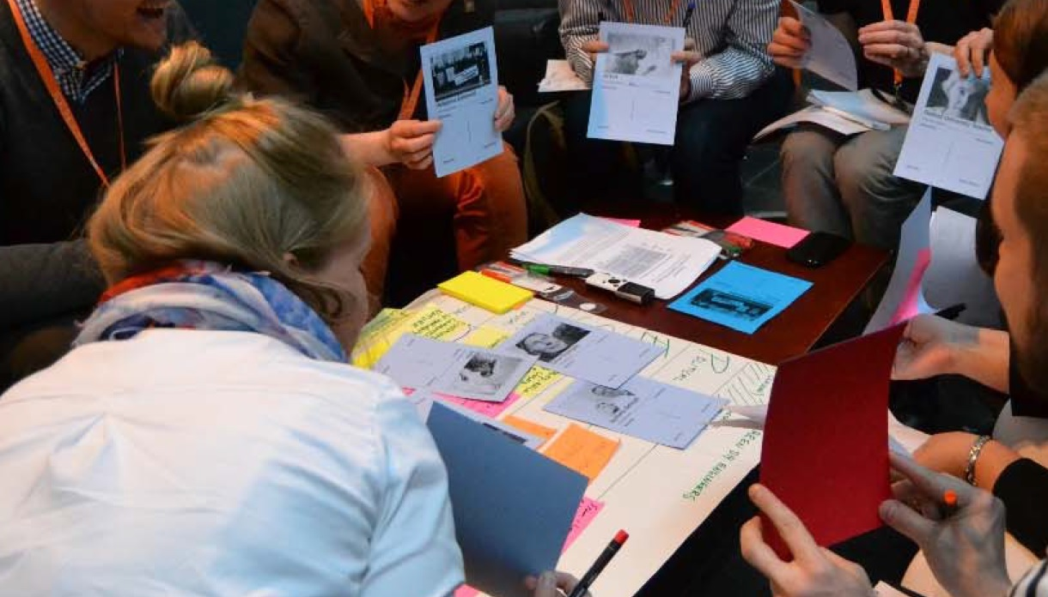
Figure 6: Roleplaying phase in the CLA Game – the group members present their roles.

3.2.5 Metaphor layer – moving deeper in the scenario roles
The fourth and final layer of causal layered analysis is a consideration of key metaphors that illustrate a scenario. In the CLA game, each player invented a metaphor for the scenario from the perspective of their character. The intention was to illustrate how their character would perceive the scenario. In addition, the groups were asked to work together to select or create a metaphor that best described the scenario as a whole. The objective was to first explore a plurality of differing perspectives and then collaboratively synthesise these into a dominant metaphor. An example of metaphors is presented in Figure 7.
Butterfly
(Citizen
activist)
Spiral
(Secularist dissident)
All is Same
(Representative of
world government 1)
Ying Yang
(Secularist dissident)
Youthful Governance
(Representative of
world government 2)
We
(Retired
civil servant)
Age of Love
(Artist)

Figure 7: The metaphors developed in the “New Consciousness scenario” group. The game character is indicated in brackets.

3.2.6 Debriefing – cross-fertilization and reflection of results
After the CLA exercise, the players were immersed in the game and it was decided that the interactive wrap-up phase would be conducted in character. Each group presented their work as vividly as possible to transmit the different characters’ experience of that scenario and to ‘sell’ their scenario to the other groups. Members from other scenario groups, remaining in character, then commented critically on the scenarios from their character’s perspective. In our experiment this back-and-forth discussion between the scenarios revealed unexpected questions about the scenario logics, for instance whether the ‘techemoth’ worldview could exploit the world presented in the “New Consciousness” scenario. The importance of a debriefing session cannot be overstated because it makes the scenarios interact with each other, and allows cross-fertilization, learning, and evaluation of the gaming process. According to Inayatullah (2013, 5) it is crucial to have a reflection period in a game not only for all the groups jointly, but also for the individuals in each group. Only after such reflections the game is complete.

Social network analysis
As described above, the participants identified enemies and allies in the role play. After the game, the research team conducted an exploratory social network analysis using the data from the role play. The analysed players’ relations are illustrated as dynamic partnership schemas in Figure 8. A green arrow signifies an identified ally and a red arrow refers to an enemy of the scenario character. Grey boxes, in turn, illustrate allies or enemies who were not acted by the other members as characters in a scenario group, but who were identified during the workshop session.

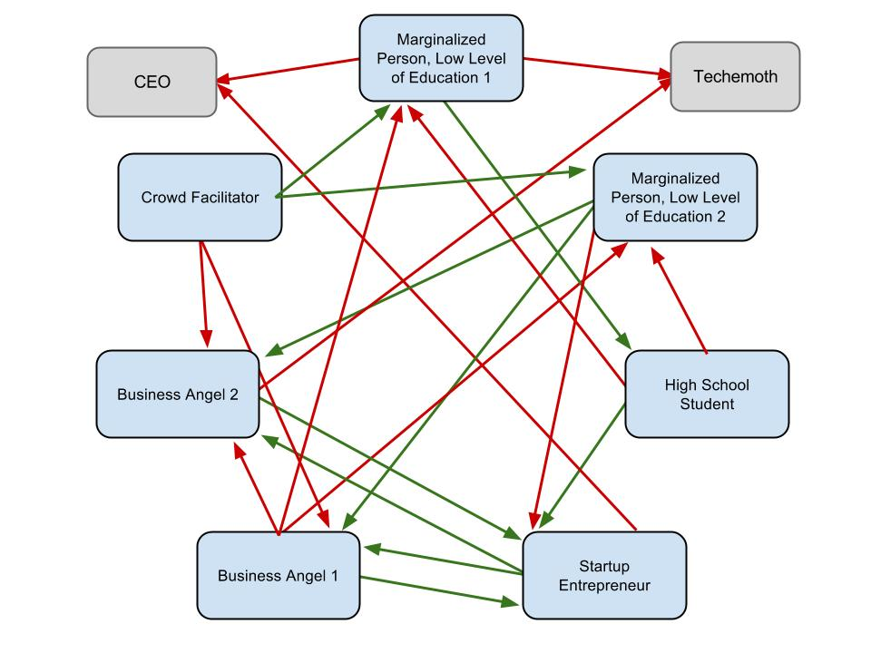
Figure 8: Social network analysis of the Radical Startups scenario. Green arrows are pointing to allies, red arrows toward enemies that the players identified during the CLA game.
The social network analysis was conducted because the focus in the CLA game was to understand a scenario’s systemic logic, its internal tensions and pressures for change. It can reveal mutual alliances, conflicts and also ‘mismatches’, that is, a relationship which one actor considers an alliance while the other considers it an antagonism. For example, in Figure 8, the marginalized person and the high school student have a mismatch that illustrates an ambivalent relationship. The student wishes to identify with the successful entrepreneur and views marginalisation as a threatening possible future, while for the marginalised person the student may represent hope and an open future. The business angels and startup entrepreneurs, in turn, can form a ‘winning’ coalition. The crowd facilitator tries to subvert this coalition by reaching out to the two marginalised persons, and they potentially form a competing actor-network.
In each scenario, certain actors might thrive and others feel threatened. Drawing on systems thinking, social network analysis allows an identification of leverage points in a given scenario (Meadows 2008; see also Abson et al. 2016). These can be for instance beneficial alliances that are not identified, but could potentially be built. In Figure 8, the startup entrepreneur could also consider how they could help the marginalised persons to be included into a world of radical startups. Leverage points could be useful also in the study of energy futures. Our roleplay suggests that companies who aspire to be ‘value-driven’ really have to pay attention to convince citizens.
If a scenario is intended as a preferred future, anticipating conflicts may help their mitigation. The metaphors identified in the CLA game can assist in examining and potentially resolving them. For instance, in the Radical Startups scenario, illustrated in Figure 8, the business angel’s chosen metaphor was “a lottery, where few win but all are hopeful”. In contrast, the marginalised persons in the same group felt that they are “on the outside looking in, excluded by a hidden glass barrier”. These two metaphors are clearly incompatible: a lottery, though based on chance, should be inclusive and fair. Therefore, the “Radical Startups” scenario can either be envisioned more like a fair lottery or an entirely different metaphor could be selected. A polyphonic image with competing metaphors makes a scenario richer and less stable than it appears at first glance. All in all, this step can be used add credibility and depth to the scenarios.

Discussion and suggestions for further steps in developing the scenario-based CLA game
The aim of this novel version of the CLA game was to elaborate existing scenario drafts and to incorporate points of view that arose from the gaming session. For scenario methodology, the key question is what added value and impact can be achieved with a game. In the following, we discuss some of the game design choices. We then list some benefits of our CLA game process, its contribution to scenario methodology and suggest further improvements. We also explain the limitations of this pilot game.
Having the groups assigned according to scenarios rather than CLA layers was a conscious choice. At first, the organising team considered having one small group for each CLA layer, so that each group would cover all scenarios. This was deemed undesirable because in this mode the groups could not have discussed the links between the CLA layers. Another option would have been to divide participants first into scenario groups and then into sub-groups based on the CLA layers. However, this setting could have made the structure overly complicated. Moreover, in both options, we would have lost the role-playing aspect. We wanted to avoid having too many participants in one group to ensure fruitful group dynamics. It was decided that groups are assigned according to scenarios and the number of participants in each group does not exceed seven, as has been suggested to be an optimal size of a work group (Heinonen & Ruotsalainen 2013). Even if each group only discussed one of the transformative scenarios, the de-briefing phase ensured that the four scenarios were also considered together.
We suggest that the CLA game setting can provide four types of benefits. The suggested benefits are illustrated in Figure 9, from the most direct to the most indirect: 1) methodological benefits (scenarios, serious gaming, CLA method) 2) future-oriented insights for the participants through social learning, 3) additional depth to the sociocultural energy scenarios of a research project, and ultimately, 4) the possibility of promoting changes within the change-resistant energy sector. These benefits remain somewhat speculative because a detailed investigation of learning outcomes on the participants was beyond the scope of a pilot study.

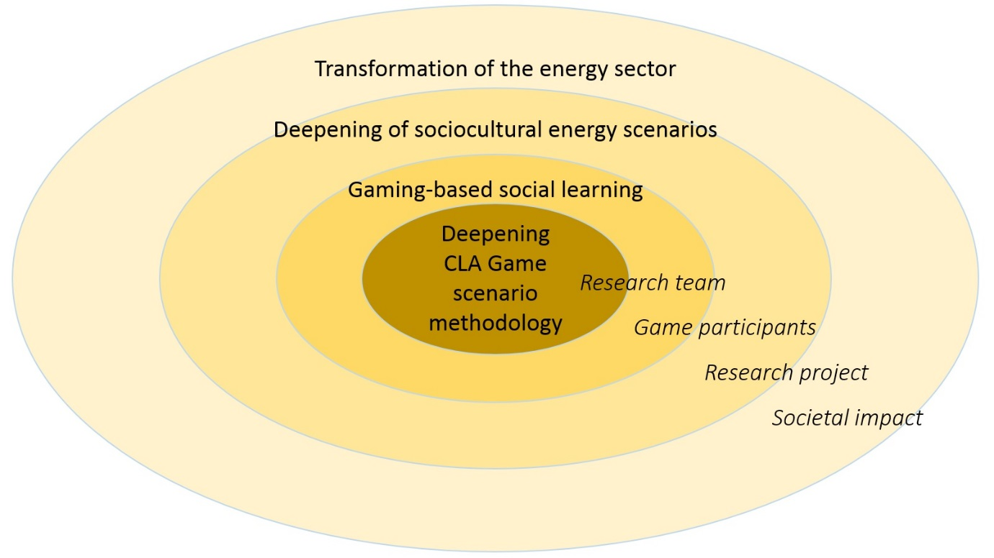
Figure 9. Benefits of the CLA-based gaming, listed from the most direct to indirect.

Developing the CLA Game methodology
The scenario-based CLA game was an experimental process to test and elaborate scenarios. This experience suggests that CLA gaming may reveal implicit causalities and tensions in scenarios, as illustrated by the different motivational factors for the roleplay characters. These could be difficult to conceptualise with conventional analytical tools. In subsequent gaming sessions, the interaction between the CLA layers could be more deeply examined by developing feedback from the worldview and the metaphor layer to systemic causes and actor dynamics. If metaphors influence the worldview, the systems, and the litanies, the metaphors should indicate how various actors engage in the scenarios. Elaborating the layers’ connections could reveal if a strategic decision of a decision-maker contradicts underlying metaphors and if certain stakeholders resist a particular image of the future
(Inayatullah 2015b, 232).
In this CLA game, the scenarios, the litanies and most actor roles were pre-given which evidently limited the freedom of the participants to imagine alternative futures. While this choice provided the session with necessary focus, a top-down approach can marginalise participants who do not agree with the scenarios (Andreescu 2013). Participants must have freedom in imagining their characters to avoid the game being influenced too much by the initial choice of roles. Differences in personality, cognitive styles and ways of expressing oneself can make certain group members influential over others (Dufva & Ahlqvist 2015), especially in multicultural settings like ours. This can be mitigated with careful preparation, instructions and skilful moderation of social dynamics.

One crucial limitation is that this kind of CLA game requires time and effort. Preparation and post-game analysis are the ‘real’ resource inputs for an organising research team. Constructing scenarios alone is demanding, making a CLA analysis for the scenarios is time-consuming, and a CLA game experiment for the scenarios is a triple effort. When compared to the separate two-day testing sessions and ten gaming sessions of the Joint Research Centre’s Scenario Exploration System game, the schedule was much stricter (Bontoux et al. 2016). On the other hand, the CLA game on Neo-Carbon Scenarios may be seen as a leaner and more agile approach. It was quicker, featured more free discussion and few rules of gameplay. A virtual game application could be a worthwhile option for future CLA games. Vervoort et al. (2010, 606–614) underscore the benefits of face-to-face collaboration and propose that the “particular benefits of live participation and online participation should be used to complement each other”. Whether a CLA game is fit for scenario development depends on the circumstances. A critical question certainly is whether the value generated is greater than the investments.

Gaming-based social learning
Because a transition to renewable energy involves social and political change, energy as a resource must be managed in ways that are equally social (Sheikh 2016; Barrios-O’Neill and Hook 2016). Use of the scenarios sketches in the game set an effective learning opportunity for the participants to engage in futures from an energy-society perspective. To motivate participants into transformative problem-solving, one alternative in future games would be to tell a short story in the beginning of the CLA game. In our case, a lesson learned from the history of energy politics might work well.
By immersing the participants, the CLA game provides an opportunity to reframe perceptions about the complex dynamics of energy systems. To an extent, the participants’ contributions aligned with the original scenario logic, as could be expected. But several new elements and ideas were also generated and the nuances of the argumentation in groups are especially interesting. Due to the high number of participants, our game had two different groups that worked on the “New Consciousness” scenario. In the game beginning, both groups seemed to share common reasoning, but as the game progressed, the groups ended up with rather different outcomes.
Our game was a pilot exercise, and studying collective learning was hindered by the fact that participants were an ad hoc group from different countries and organisations rather than a single organisation or stakeholders of the scenario process. Therefore, as in the Joint Research Centre’s Scenario Exploration System, the benefits are difficult to measure (Bontoux et al. 2016). In subsequent workshops immediate learning effects could be measured with a survey tool, such as the one developed by Rhisiart et al. (2015), and new systematic ways of measuring learning outcomes could be developed, even if it may be difficult to motivate participants for yet another task after a long workshop day (Haug et al. 2011, 971)

Deepening of sociocultural energy scenarios
The contributions of the CLA game to the scenario testing may be discussed according to the CLA layers. The litany layer laid out a vivid picture of a scenario and immersed the participants into a possible future world. On the system layer, where the group collectively generated novel elements with the PESTEC method, the research team could observe what aspirations and reactions the scenarios provoke. At best, this may broaden the context of the scenarios. Inevitably, some of the players’ contributions will not align with the logic of the initial scenario sketches. The research team needs to discuss these contributions during the game or in the post-game analysis. The most interesting ideas could be included into the scenario narratives and conflicting ideas could be used to further contextualise the research scope.
The main benefits emerge from the roleplay, which sheds light on the worldview layer, and how a particular future feels for different actors. Actor interaction and coalitions make the scenarios more dynamic (Valkering et al. 2012), and social network analysis can be used to document the tensions and coalitions. The alliances, antagonisms and other coalitional dynamics between actors could be further played out or simulated in future sessions. We noticed that most players seemed to accept the scenario premises as part of the game. What is more, ecological thinking, entrepreneurialism, and a do-it-yourself ethos worked as attractive drivers of change, as could be expected. Those acting as children or young people were open to creativity and diversity, while the ones acting as civil servants focused on governance.
Any single scenario is in itself a mosaic: it is a pluralistic world because of the diversity of actors’ perceptions of that world – one individual’s utopia may be another’s dystopia. The metaphors created by each participant in their roles illustrate the metaphorical aspects which are always present in a scenario narrative. As Peter Schwartz (1996, 43) writes, “in writing scenarios we spin myths”. The CLA game provides three benefits: it clarifies already existing implicit metaphorical elements in a scenario, it demonstrates how a scenario may imply different metaphors for different stakeholders, and it helps to deepen a scenario by incorporating new metaphors into it. Taken together, these factors highlight the complexity of the possible future worlds. The use of metaphors is part of a narrative approach which can provide insights that inform policy questions (Strachan & Foxon 2012, 75).
Even though the scenarios primes participants to think of a future radically different from the present, the players are nonetheless influenced by their present frames of reference and mental models. Therefore, the metaphors generated in a CLA game are present perceptions of how possible future actors view a possible future world. Of course, while it is impossible to predict what worldviews will exist in 2050, it is worth remembering that those people who live to see the future could have entirely new metaphors to draw upon. The point of the roleplay is not to predict, but to open up the scenarios by imagining how different types of people could thrive, fail, interact and view these future worlds.
In future CLA games, the transformative nature of the metaphors could be further explored. Inayatullah (2015c) argues that the CLA game can be used to imagine transformative metaphors in addition to an examination of existing ones. In the case of transformative energy scenarios, the key question is: “How could the metaphors of individual actors be changed so that these actors help shape transformational energy futures?” The reframing of metaphors may be a key toward modelling how the actors in the scenarios act to create their transformational futures. In the CLA game presented in this article, for example, a secular dissident in the New Consciousness scenario can become an agent of transformation, if his metaphor is changed from “[Downward] Spiral” to a positive and aspirational image such as “All Earth’s Species United”. In the Value-Driven Techemoths scenario, the metaphor of a technology giant’s employee was “Luxury Isolation in a Penthouse Skyscraper”. She could contribute to transformation, if her metaphor is changed to “All of Society Sharing in Abundance”. Ideally, these transformed metaphors should come from the participants rather than the research team. Metaphor inversion as a research phase can also be used in a backcasting sense and applied to present-day actors such as company employees, teachers, government officials, startup founders and investors.

Transformation of the energy sector
Ultimately the scenarios should influence decision-making (Wiek and Lang 2016). The topic of this CLA game was the global energy system and exploring a major energy transformation is still quite unconventional. The importance of narrative for energy transition has been stated (see e.g. Upham, Klapper, and Carney 2016; Miller et al. 2015), but rarely in conjunction with gaming. The energy sector is highly resistant to change because of actors, institutions, networks, infrastructure and existing investments (Jacobsson and Bergek 2004). In our game, the majority of participants were not energy system stakeholders. Thus the next challenge in the game development is to transfer the gaming results to the energy system stakeholders, and perhaps to test the game itself with these stakeholders.
In the CLA game, the players examine energy futures that differ radically from the present, and assess their pros and cons. Depending on the depth of the background work, the game can open up a discussion on values and the interconnections of energy, economy, and society (new business models, sharing economy, virtual economy, renewable energy, ecological awareness). Another type of energy-related gaming session could explore other critical topics such as risks, environmental impacts, or the rebound effect (Jevons 1865; see e.g. Gillingham et al. 2013). CLA game as a qualitative method could also be combined with quantitative assessments or market studies on energy transformation (see Zhao et al. 2016). Understanding the CLA game as part of a research process that has a follow-up phase planned can help maximise its policy relevance. This way, the time invested in gaming can yield maximal impact with regard to the topic under study.

Conclusions
For improving scenario methodology, our contribution is a new recipe for testing scenarios through gaming in a future-oriented, immersive and interactive fashion. The CLA game session confirms that causal layered analysis is a versatile method that can be adapted to different practical aims. CLA, as a broad framework, allows methodological innovation. While previous CLA games are documented in the literature (Inayatullah, 2015a; Terranova 2015), this game was largely modified by the organising team and in this form, the game was the first of its kind. Therefore, the game session acted as a pilot to test both the practical application of a particular CLA approach in a workshop and the sociocultural renewable energy scenarios of a foresight research project.
As a module in a broader research framework, testing scenarios with a game was successful, useful and fun. The CLA game used the Neo-Carbon Energy scenarios and was motivating and educational for the organisers and the participants, even if perhaps for different reasons. As a methodological experiment, the game aroused interest before the game and participants were interested in the results after the game. This particular game was organised at a futures research conference where most participants were already familiar with futures research, scenarios and the CLA method. The next step in the game development is to achieve impact beyond academia. This includes transferring the lessons learned in the game through research, as well as testing the game with other types of stakeholders.
As Henrichs (2007) and Wodek & Neale (2015) point out, it is difficult not only to find a standard recipe for success in developing scenarios, but it is equally hard to measure their success. We did not systematically measure the benefits, but the experience suggests that a CLA game can be used as one tool to analyse the quality of scenario work. In addition, some of the issues we discuss in this paper may apply to scenario testing and energy policy more generally. Scenarios are not just an analytic exercise but they need to convince others that the depicted future is plausible and compelling. This relates experimental and game-based futuring to the normative tradition in futures studies, pioneered by Ossip Flechtheim and Wendell Bell (Bell 1997; Flechtheim 1970). According to Amara’s (1981) third principle, we can have an impact on the future and in Bell’s (1997) view, futures researchers can advocate a specific future. These two lines of thinking reflect the claim made by Dator that the main task of futures studies is to empower social change (Dator 2009). Serious gaming, such as this experiment, may contribute to this task by liberating our thinking about alternative, even transformational futures.
Scenario assumptions influence game design, and the gaming method can have practical implications for the gaming outcomes. In this CLA game, all of the four energy scenarios had been constructed as transformative. Therefore, the CLA game was an evaluative tool to test whether the scenarios are transformative enough. This CLA game allowed participants to explore and invent novel causal dynamics and social relations into the scenarios. In the immersive roleplay, they adopted the worldviews of future actors and created novel metaphors. This exemplifies how gaming based on scenarios enables a participatory study of radical changes. From deconstructing and testing scenarios, we can get the ingredients for reconstructing preferred futures.
We believe that this kind of scenario game and dissemination of its results can support decision-making about energy transitions. As a serious game, it could be played with the public and private sector, or with local citizens. The use of scenario-based gaming results for policy-making is also motivating for the participants. A scenario workshop provides a learning experience to envision and deliberate energy futures. This is also the case with our CLA game experiment. To conclude, we recommend that CLA gaming, as a qualitative method, is further combined with quantitative assessments or market-based analyses about emissions pathways. This way, the policy relevance of such gaming exercises can be maximised.

Acknowledgements
The authors gratefully acknowledge the public financing of Tekes, the Finnish Funding Agency for Innovation, for the ‘Neo-Carbon Energy’ project under the number 40101/14. The following researchers are acknowledged for their contribution to the CLA game experimentation at Finland Futures Research Centre (FFRC): Nick Balcom Raleigh, Juho Ruotsalainen, Marjukka Parkkinen, Sofi Kurki and Amos Taylor.

REFERENCES
Abson, D, Joern Fischer, Julia Leventon, Jens Newig, Thomas Schomerus, Ulli Vilsmaier, Henrik von Wehrden, Paivi Abernethy, Christopher D. Ives, Nicolas W. Jager, Daniel J. Lang (2016). “Leverage Points for Sustainability Transformation.” Ambio, pp. 1-10. doi:10.1007/s13280-016-0800-y
Aguilar, Francis J. 1967. Scanning the business environment. New York: Macmillan.
Aligica, P. D. 2005. “Scenarios and the Growth of Knowledge: Notes on the Epistemic Element in Scenario Building.” Technological Forecasting and Social Change 72 (7): 815–24. doi:10.1016/j.techfore.2005.01.001.
Amara, R., 1981. The futures field: searching for definitions and boundaries The Futurist, 15(1), 25-29.
Andreescu, Liviu, Radu Gheorghiu, Marian Zulean, and Adrian Curaj. 2013. “Understanding Normative Foresight Outcomes: Scenario Development and the ‘veil of Ignorance’ Effect.” Technological Forecasting and Social Change 80 (4): 711–22. doi:10.1016/j.techfore.2012.09.013.
Barrios-O’Neill, Danielle and Alan Hook 2016. Future energy networks and the role of interactive gaming as simulation. Futures, In Press, Corrected Proof, doi:10.1016/j.futures.2016.03.018
Bell, W., 1997. Foundations of Futures Studies. Human Science for a New Era. Volume 1: History, Purposes, and Knowledge. London.
Bontoux, Laurent, Daniel Bengtsson, Aaron Rosa, and John A. Sweeney. 2016. ‘The JRC Scenario Exploration System - From Study to Serious Game’. Journal of Futures Studies 20 (3): 93–108. doi:10.6531/JFS.2016.20(3).R93.

Breyer C, Heinonen S and Ruotsalainen J (2016). New consciousness: A societal and energetic vision for rebalancing humankind within the limits of planet earth, Technological Forecasting and Social Change (Article in Press), doi: 10.1016/j.techfore.2016.06.029
Burke, B., 2014. Gamify: How Gamification Motivates People to Do Extraordinary Things. Bibliomotion Inc.
Börjeson, Lena, Mattias Höjer, Karl-Henrik Dreborg, Tomas Ekvall, and Göran Finnveden. 2006. ‘Scenario Types and Techniques: Towards a User’s Guide’. Futures 38 (7): 723–39. doi:10.1016/j.futures.2005.12.002.

Cairns, George, Iftekhar Ahmed, Jane Mullett, and George Wright. 2013. “Scenario Method and Stakeholder Engagement: Critical Reflections on a Climate Change Scenarios Case Study.” Technological Forecasting and Social Change 80 (1): 1–10. doi:10.1016/j.techfore.2012.08.005.

Cairns, George, George Wright, and Peter Fairbrother. 2016. “Promoting Articulated Action from Diverse Stakeholders in Response to Public Policy Scenarios: A Case Analysis of the Use of ‘Scenario Improvisation’ Method.” Technological Forecasting and Social Change 103 (February): 97–108. doi:10.1016/j.techfore.2015.10.009.

Dator, J., 2009. Alternative futures at the Manoa School. Journal of Futures Studies, 14:1−18.
Derrida, J., 1997. Of Grammatology. Baltimore: Johns Hopkins University Press.
Devall, Bill and Sessions, George (1985), Deep Ecology: Living as if Nature Mattered, Gibbs Smith
Dufva, M., and Ahlqvist, T. 2015. Knowledge Creation Dynamics in Foresight: A Knowledge Typology and Exploratory Method to Analyse Foresight Workshops. Technological Forecasting and Social Change, 94, 251–268. http://doi.org/10.1016/j.techfore.2014.10.007
Flechtheim O. K. 1970. Futurologie − Der Kampf um die Zukunft. Köln: Wissenschaft und Politik.
Fortes, Patrícia, António Alvarenga, Júlia Seixas, and Sofia Rodrigues. 2015. “Long-Term Energy Scenarios: Bridging the Gap between Socio-Economic Storylines and Energy Modeling.” Technological Forecasting and Social Change 91 (February): 161–78. doi:10.1016/j.techfore.2014.02.006.
Foucault, M., 2002. Archaeology of Knowledge. Routledge classics. London: Routledge.
Gillingham, K., Kotchen, M. J., Rapson, D. S. & Wagner G., 2013. Energy policy: The rebound effect is overplayed. Nature 493, 475–476 doi:10.1038/493475a
Glenn, J. & Gordon, T., 2009. Futures Research Methodology V. 3.0. Millennium Project, CD. Washington D.C. http://www.millennium-project.org/millennium/FRM-V3.html
Grubler, A. 2012. Energy transitions research: Insights and cautionary tales, Energy Policy, Volume 50, November 2012, Pages 8-16, ISSN 0301-4215, http://dx.doi.org/10.1016/j.enpol.2012.02.070.
Haug, C., Huitema, D. & Wenzler, I., 2011. Learning through games? Evaluating the learning effect of a policy exercise on European climate policy. Technological Forecasting & Social Change 78(2011) 968-981.
Heinonen, S., Balcom Raleigh, N., 2015. Continuous Transformation and Neo-Carbon Energy Scenarios. FFRC eBOOK 10/2015. Finland Futures Research Centre, University of Turku, Turku, 69 p. https://www.utu.fi/fi/yksikot/ffrc/julkaisut/e-tutu/Sivut/home.aspx
Heinonen, Sirkka, and Kurki, Sofi. 2011. "Transmedial Futuring in Creative Foresight Space." In: Wagner, Cynthia G. (ed.) Moving from Vision to Action. Essays published in conjunction with the World Future Society's annual meeting. Bethesda, Maryland: World Future Society, 2011, pp. 119-128.
Heinonen, S., Ruotsalainen, J. 2013a. Energy Futures 2030: Towards the Neo-Growth Paradigm of the Sixth-Wave Era. FFRC e-Book 1/2013, Finland Futures Research Centre, http://www.utu.fi/fi/yksikot/ffrc/julkaisut/e-tutu/Documents/eBook_2013-1.pdf
Heinonen, S., Ruotsalainen, J., 2013b. Futures Clinique − method for promoting futures learning and provoking radical futures. European Journal of Futures Research (2013) 15:7, DOI 10.1007/s40309-013-0007-4, 11 p.
Heinonen, S., Hiltunen, E. 2012. Creative Foresight Space and the Futures Window: Using Visual Weak Signals to Enhance Anticipation and Innovation. Futures, vol. 44, 248−256.
Heinonen, S., Balcom Raleigh, N., Karjalainen, J., Minkkinen, M., Parkkinen, M. and Ruotsalainen, J. 2015. CLA game report: Causal layered analysis game on Neo-Carbon energy scenarios. FFRC e-Book 12/2015. http://www.utu.fi/fi/yksikot/ffrc/julkaisut/e-tutu/Documents/eBook_12-2015.pdf
Heinonen, S., Karjalainen, J, Ruotsalainen, J. 2015. Towards the third industrial revolution. Neo-Carbon Energy Project Futures Clinique I “Creating the third industrial revolution”. FFRC eBook 6/2015. Finland Futures Research Centre, University of Turku, 74 p. https://www.utu.fi/fi/yksikot/ffrc/julkaisut/e-tutu/Sivut/home.aspx
Henrichs, T., 2007. Environmental scenario analysis: course book. Roskilde: Partnership for European Environmental Research.
Herbst, Andrea, Felipe Toro, Felix Reitze, and Jochem Eberhard (2012), Introduction to Energy Systems Modelling, Swiss Journal of Economics and Statistics, 2012, Vol. 148 (2), p. 111–135 http://www.irees.de/irees-wAssets/docs/publications/journal-reviewed/Herbst-et-al-2012_Introduction-to-Energy-Systems-Modelling_SJES.pdf
Hong, T 2014. Energy Forecasting: Past, Present, and Future. Foresight: The International Journal of Applied Forecasting 32, pp. 43-48.
Hong, T, Pierre Pinson, Shu Fan, Hamidreza Zareipour, Alberto Troccoli, Rob J. Hyndman, Probabilistic energy forecasting: Global Energy Forecasting Competition 2014 and beyond, International Journal of Forecasting, Volume 32, Issue 3, July–September 2016, Pages 896-913, ISSN 0169-2070, http://dx.doi.org/10.1016/j.ijforecast.2016.02.001.
Huizinga, Johan (1939). Homo Ludens. Versuch einer Bestimmung des Spielelements der Kultur. Basel: Burg-Verlag.
IEA (2015). Energy and Climate Change: World Energy Outlook Special Report. Paris: Organisation for Economic Co-operation and Development/International Energy Agency. https://www.iea.org/publications/freepublications/publication/WEO2015SpecialReportonEnergyandClimateChange.pdf
Inayatullah, S., 2015a. The Continued Evolution of the Use of CLA: Using practice to trans-form in S. Inayatullah & I. Milojevic (eds.) CLA 2.0: Transformative research in theory and practice (pp. 13–21). Tamkang University Press.
Inayatullah, S. 2015b. What Works: Case Studies in the Practice of Foresight. Tamsui: Tamkang University Press, 249 p.
Inayatullah, S. 2015c. From Used Futures to Transformative Metaphors: The CLA Game and Inner Stories. In S. Inayatullah. What Works: Case Studies in the Practice of Foresight (pp. 225–239). Tamsui: Tamkang University Press.
Inayatullah, S., 2013. Using Gaming to Understand the Patterns of the Future – The Sarkar Game in Action. Journal of Futures Studies, 18(1), 1-12.
Inayatullah, S., 2008. Six pillars: Futures thinking for transforming. Foresight, 10(1), 4−21.
Inayatullah, S., 2004a. Causal Layered Analysis: Theory, historical context, and case studies. In S. Inayatullah (Ed.). The Causal Layered Analysis (CLA) Reader: Theory and Case Studies of an Integrative and Transformative Methodology (pp. 1−52). Tamsui: Tamkang University Press.
Inayatullah, S., 2004b. Appendix: The causal layered analysis pyramid. In S. Inayatullah (Ed.). The Causal Layered Analysis (CLA) Reader: Theory and Case Studies of an Inte-grative and Transformative Methodology (p. 543). Tamsui: Tamkang University Press.
Inayatullah, S., 1998. Causal layered analysis: poststructuralism as method. Futures, 30(8), 815–829. Retrieved from http://www.sciencedirect.com/science/article/pii/S001632879800086X
Inayatullah, S. 2015. The Continued Evolution of the Use of CLA: Using Practice to Transform. In S. Inayatullah & I. Milojevic (eds.) CLA 2.0: Transformative Research in Theory and Practice, Tamsui: Tamkang University Press.
Inayatullah, S. & Milojevic, I (eds.) 2015. CLA 2.0: Transformative Research in Theory and Practice, Tamsui: Tamkang University Press.
IPCC 2014. Climate Change 2014: Synthesis Report. Contribution of Working Groups I, II and III to the Fifth Assessment Report of the Intergovernmental Panel on Climate Change [Core Writing Team, R.K. Pachauri and L.A. Meyer (eds.)]. IPCC, Geneva, Switzerland, 151 pp. Retrieved from https://www.ipcc.ch/pdf/assessment-report/ar5/syr/SYR_AR5_FINAL_full_wcover.pdf
Jacobsson, S. and Bergek A. 2004, Transforming the energy sector: the evolution of technological systems in renewable energy technology. ICC (2004) 13 (5): 815-849 doi:10.1093/icc/dth032
Jevons, W. S., 1865. The Coal Question. Macmillan.
Kahn, H. 2007. On thermonuclear war (Transaction ed). New Brunswick (U.S.A.): Transaction Publishers.
Kemp, R. 2010. The Dutch energy transition approach. International Economics and Economic Policy. August 2010, Volume 7, Issue 2, pp 291–316
Kinley, Nik, and Shlomo Ben-Hur. 2015. ‘Gamification’. In Changing Employee Behavior. Palgrave Macmillan. http://www.palgraveconnect.com/doifinder/10.1057/9781137449566.0013.

Lund, H., 2014. Renewable Energy Systems: A Smart Energy Systems Approach to the Choice and Modeling of 100% Renewable Solutions, Academic Press 2nd Edition.
Malaska, P., 2010. A More Innovative Direction Has Been Ignored. In: Understanding Neogrowth − An Invitation to Sustainable Productivity. TeliaSonera Finland Plc. Helsinki, p. 200-210. http://www.sonera.fi/media/13069ab55806de22e8955bc2a3f1afeab17b28bd/Understanding_Neogrowth.pdf
McGonigal, J., 2015. SuperBetter: A Revolutionary Approach to Getting Stronger, Happier, Braver, and More Resilient. Penguin Press. New York.
McGonigal, J., 2011. Reality Is Broken: Why Games Make Us Better and How They Can Change the World. New York.
Meadows, D., 2008. Thinking in Systems. White River Junction, Vermont: Chelsea Green Publishing.
Miller C.A., O’Leary, J. Graffy, E., Stechel, E. B., Dirks, G. 2015. Narrative futures and the governance of energy transitions, Futures, Volume 70, June 2015, Pages 65-74, ISSN 0016-3287, http://dx.doi.org/10.1016/j.futures.2014.12.001.
Naess, Arne (1973). The Shallow and the Deep Long-Range Ecology Movement. Inquiry 16: 95-100
Naess, Arne (1984). A defence of the deep ecology movement. _Environmental Ethics_ 6 (3):265-270.
NOAA/ESRL 2016. Trends in Atmospheric Carbon Dioxide: Recent Global CO2. National Oceanic and Atmospheric Administration and Earth System Research Laboratory. Retrieved from: www.esrl.noaa.gov/gmd/ccgg/trends/global.html
Ollila, J., Jokinen, L., & Ilkkala, V. 2014. Get a Life! A Future Work Life Simulation Tool for University Students. In L. G. Chova, A. L. Martinez, & I. C. Torres (Eds.), Inted2014: 8th International Technology, Education and Development Conference (pp. 1459–1465). Valencia: INTED2014: 8th International Technology, Education and Development Conference.
Prokesch, T., von der Gracht, H. A., & Wohlenberg, H. 2015. Integrating prediction market and Delphi methodology into a foresight support system — Insights from an online game. Technological Forecasting and Social Change, 97, 47–64. http://doi.org/10.1016/j.techfore.2014.02.021
Ralston, B., & Wilson, I. 2006. The Scenario-planning Handbook: A Practitioner’s Guide to Developing and Using Scenarios to Direct Strategy in Today’s Uncertain Times. Thomson South-Western.
Rhisiart, Martin, Riel Miller, and Simon Brooks. 2015. “Learning to Use the Future: Developing Foresight Capabilities through Scenario Processes.” Technological Forecasting and Social Change 101 (December): 124–33. doi:10.1016/j.techfore.2014.10.015.

Rifkin, J., 2011. Third Industrial Revolution: How Lateral Power Is Transforming Energy, the Economy, and the World. New York: Palgrave MacMillan
Rikkonen, Pasi, and Petri Tapio. 2009. “Future Prospects of Alternative Agro-Based Bioenergy Use in Finland—Constructing Scenarios with Quantitative and Qualitative Delphi Data.” Technological Forecasting and Social Change 76 (7): 978–90. doi:10.1016/j.techfore.2008.12.001.
Schwartz, P., 1996. The Art of the Long View: Paths to Strategic Insight for Yourself and Your Company. New York: Currency Doubleday.
Schwarz, J. O. 2013. Business wargaming for teaching strategy making. Futures, 51, 59–66. http://doi.org/10.1016/j.futures.2013.06.002
Selin, C. 2015. Merging art and design in foresight: Making sense of Emerge. Futures, 70, 24–35. http://doi.org/10.1016/j.futures.2014.12.006
Sheikh, Nasir J., Dundar F. Kocaoglu and Loren Lutzenhiser 2016. Social and political impacts of renewable energy: Literature review. Technological Forecasting & Social Change 108: 102-110
Silberglitt, Richard, Anders Hove, and Peter Shulman. 2003. “Analysis of US Energy Scenarios.” Technological Forecasting and Social Change 70 (4): 297–315. doi:10.1016/S0040-1625(02)00254-8.
Slaughter, R., 2004. Beyond the Mundane: Reconciling Breadth and Depth in Futures Enquiry. In S. Inayatullah (Ed.). The Causal Layered Analysis (CLA) Reader: Theory and Case Studies of an Integrative and Transformative Methodology (pp. 147–161). Tamsui: Tamkang University Press.
Strachan, N., Foxon, T. J. 2012. A Low-Carbon Transition. In: Herring, H. (ed.). Living in A Low-Carbon Society 2050. Energy, Climate and the Environment Series. London, 75−81.
Terranova, D., 2015. Causal Layered Analysis in Action: Case studies from an HR practitioner’s perspective. In S. Inayatullah & I. Milojevic (Eds.), CLA 2.0: Transformative research in theory and practice (pp. 371−384). Tamsui: Tamkang University Press.
Tibbs, Hardin 2011. Changing Cultural Values and the Transition to Sustainability. Journal of Futures Studies 15 (3): 13-32.
Trutnevyte, Evelina, Céline Guivarch, Robert Lempert, and Neil Strachan. 2016. “Reinvigorating the Scenario Technique to Expand Uncertainty Consideration.” Climatic Change 135 (3-4): 373–79. doi:10.1007/s10584-015-1585-x.
Upham, Paul, Rita Klapper, and Sebastian Carney. 2016. ‘Participatory Energy Scenario Development as Dramatic Scripting: A Structural Narrative Analysis’. Technological Forecasting and Social Change 103: 47–56. doi:10.1016/j.techfore.2015.10.003.

Valkering, P., R. van der Brugge, A. Offermans, M. Haasnoot, and H. Vreugdenhil. 2013. ‘A Perspective-Based Simulation Game to Explore Future Pathways of a Water-Society System Under Climate Change’. Simulation & Gaming 44 (2–3): 366–90. doi:10.1177/1046878112441693.

Van Notten, Philip W.F., Jan Rotmans, Marjolein B.A. van Asselt, and Dale S. Rothman. 2003. “An Updated Scenario Typology.” Futures 35 (5): 423–43. doi:10.1016/S0016-3287(02)00090-3.
Vervoort, J. M., Kok, K., van Lammeren, R. & Veldkamp, T., 2010. Stepping into futures: Exploring the potential of interactive media for participatory scenarios on social-ecological sytems. Futures 42 (2010) 604-616.
Wangel, J., 2011. Change by whom? Four ways of adding actors and governance in backcasting studies. Futures 43(8): 880−889.
Webster, Frank (1995). Theories of the Information Society. London: Routledge.
Wiek, A. and D. J. Lang. 2016. Transformational sustainability research methodology. Pp. 31-41 In: Heinrichs, H., P. Martens, G. Michelsen and A. D. Wiek eds., Sustainability Science: An Introduction. Springer.
Wilkinson, Angela, Roland Kupers, and Diana Mangalagiu. 2013. “How Plausibility-Based Scenario Practices Are Grappling with Complexity to Appreciate and Address 21st Century Challenges.” Technological Forecasting and Social Change 80 (4): 699–710. doi:10.1016/j.techfore.2012.10.031.
Wodak, J., Nealy, T., 2015. A Critical Review of the Application of environmental scenario exercises. Technological Forecasting & Social Change. Futures 73 (2015) 176-186.
Wright, George, Ron Bradfield, and George Cairns. 2013. “Does the Intuitive Logics Method – and Its Recent Enhancements – Produce ‘effective’ Scenarios?” Technological Forecasting and Social Change 80 (4): 631–42. doi:10.1016/j.techfore.2012.09.003.

Wright, D. L., 2002. Applying Foucault to a future-oriented layered analysis in a post-bubble Japanese community. Futures, 34(6), 523−534. Retrieved from http://www.sciencedirect.com/science/article/pii/S0016328701000787
Zhao, Rui, Xiao Zhou, Jiaojie Han, Chengliang Liu 2016. For the sustainable performance of the carbon reduction labeling policies under an evolutionary game simulation, Technological Forecasting and Social Change, Available online 24 March 2016, ISSN 0040-1625, http://dx.doi.org/10.1016/j.techfore.2016.03.008

The future energy system has high shares of solar and wind energy which are used to produce electricity that – in combination with carbon dioxide (CO₂) and hydrogen (H₂) – can be further used as feedstock to produce synthetic chemicals, gases and materials.
The foresight study “Neo-Carbon Enabling Neo-Growth Society – Transformative Scenarios 2050” is conducted at Finland Futures Research Centre (FFRC), together with VTT Technical Research Centre of Finland Ltd and Lappeenranta University of Technology (LUT). See http://www.neocarbonenergy.fi/ and https://www.utu.fi/en/units/ffrc/research/projects/energy/Pages/neo-fore.aspx
This paper focuses on methodological issues. For a more extensive report of the results, see Heinonen, Balcom Raleigh, Karjalainen, Minkkinen, Parkkinen & Ruotsalainen (2015).

